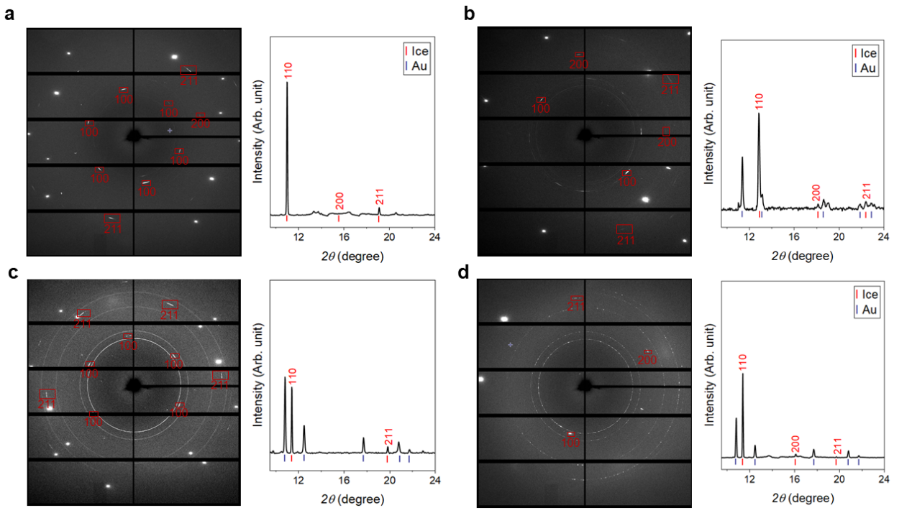
Extended Data Fig. 1 | Representative X-ray diffraction image and pattern of ice at high P-T conditions. a, 8.2 GPa and 500 K. b, 70.6 GPa and 500 K. c, 13.7 GPa and 700 K. d, 17.4 GPa and 900 K. The pattern was integrated into 1-D data using DIOPTAS software. Ice is labeled with Miller indices (hkl). The incident wavelength λ is 0.4344 Å.

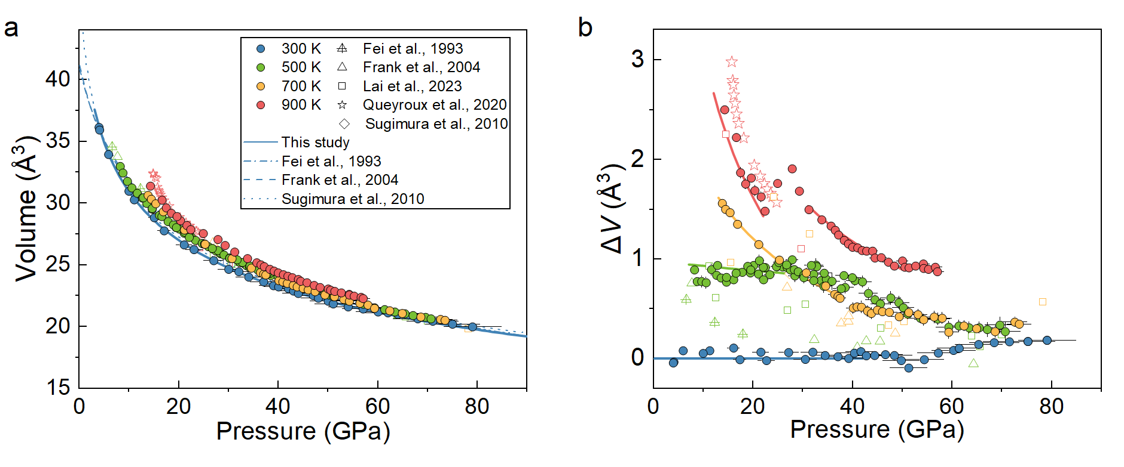
Extended Data Fig. 2 | Equation of state of ice at high P-T conditions compared to literature studies. a, Unit-cell volume. b, Volume difference (ΔV) between high P-T data and equation state of ice VII at 300 K. Blue circles and lines: data and equation of state of ice at 300 K⁵⁶, and the data below 40 GPa were used to constrain the EoS of ice VII; green: 500 K; orange: 700 K; red: 900 K; solid symbols: this study; open symbols: literature results ^{30,72-75}.

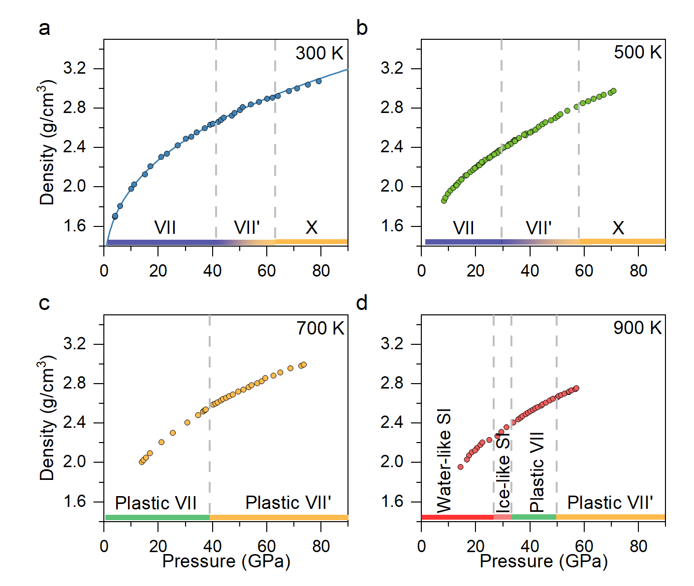
Extended Data Fig. 3 | The density of ice along different isotherms. a, 300 K. b, 500 K. c, 700 K. d, 900 K. The gray dashed lines indicate the phase boundary among each phase.
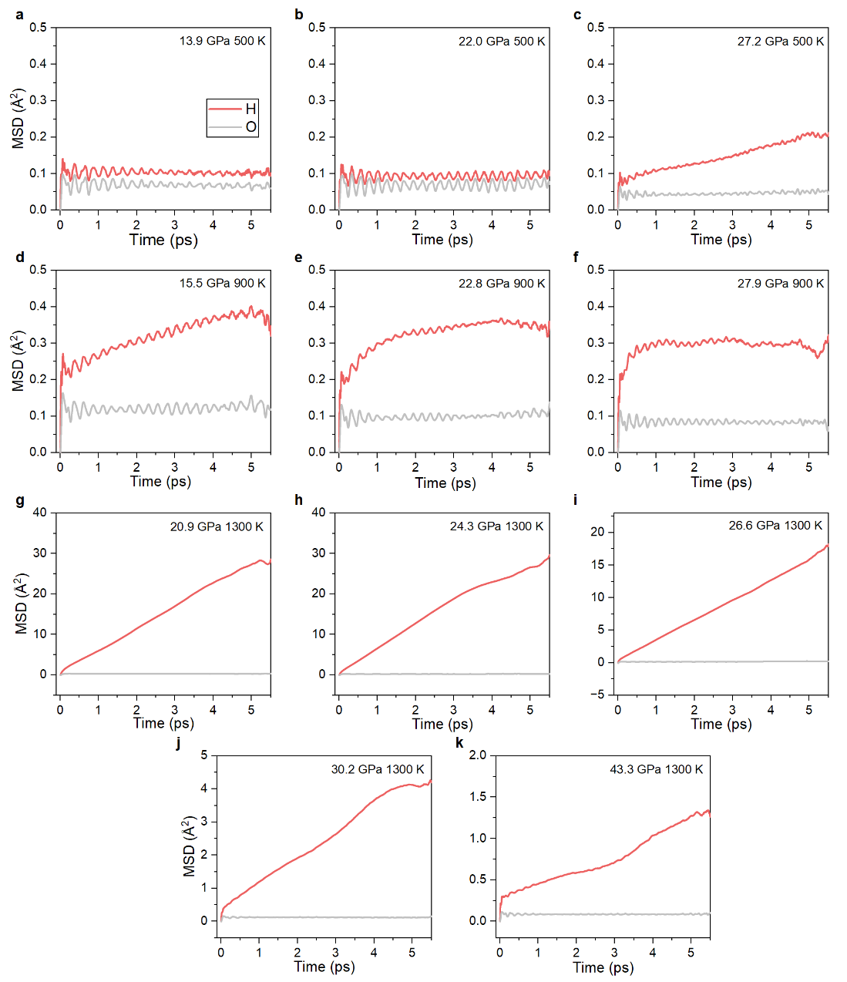
Extended Data Fig. 4 | Mean square displacement (MSD) of hydrogen and oxygen at different P-T conditions. a, 13.9 GPa and 500 K. b, 22.0 GPa and 500 K. c, 27.2 GPa and 500 K. d, 15.5 GPa and 900 K. e, 22.8 GPa and 900 K. f, 27.9 GPa and 900 K. g, 20.9 GPa and 1300 K, h, 24.3 GPa and 1300 K. i, 26.6 GPa and 1300 K. j, 30.2 GPa and 1300 K. k, 43.3 GPa and 1300 K. Grey: oxygen; Red: hydrogen.
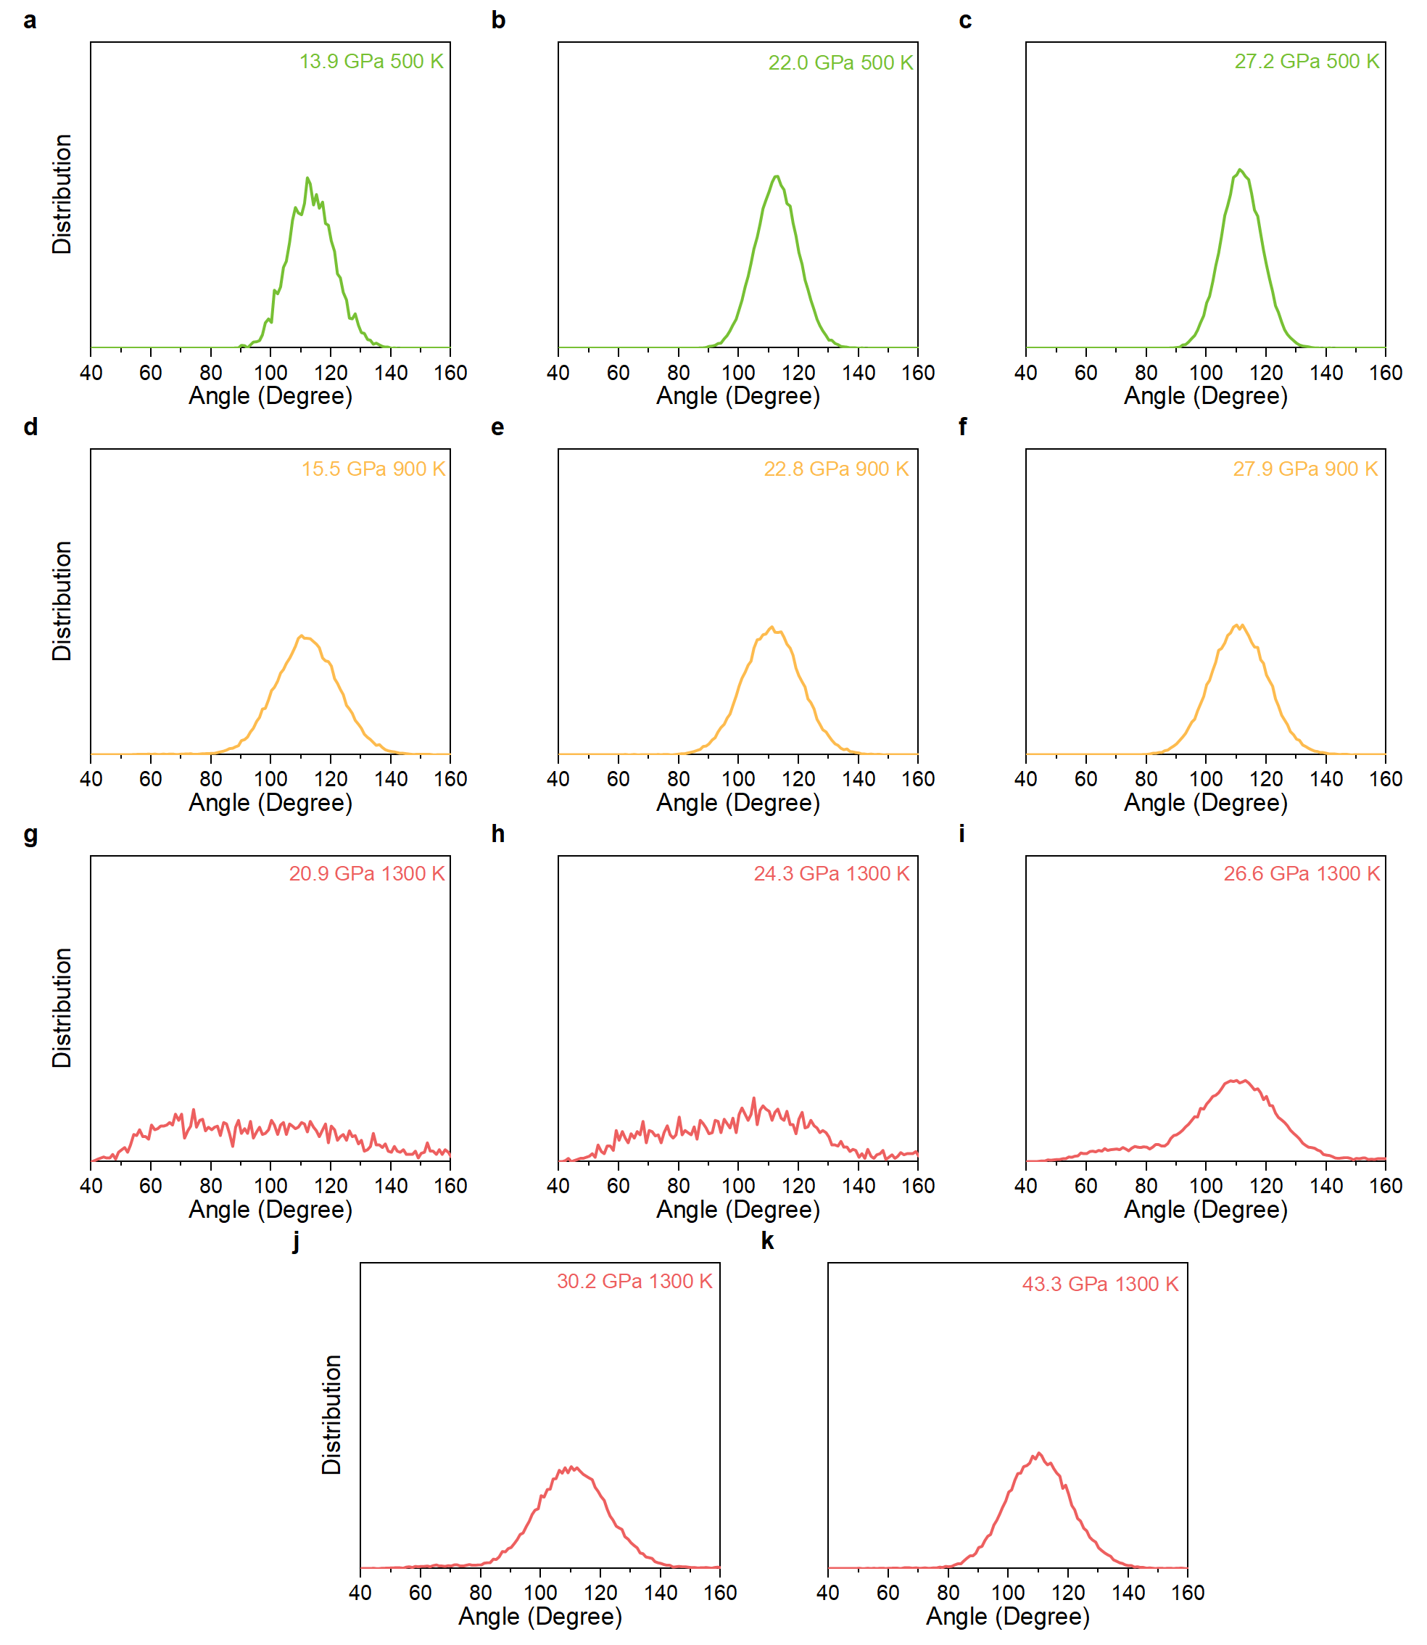
Extended Data Fig. 5 | Calculated angle distribution of hydrogen bond at different P-T conditions. a, 13.9 GPa and 500 K. b, 22.0 GPa and 500 K. c, 27.2 GPa and 500 K. d, 15.5 GPa and 900 K. e, 22.8 GPa and 900 K. f, 27.9 GPa and 900 K. g, 20.9 GPa and 1300 K, h, 24.3 GPa and 1300 K. i, 26.6 GPa and 1300 K. j, 30.2 GPa and 1300 K. k, 43.3 GPa and 1300 K.
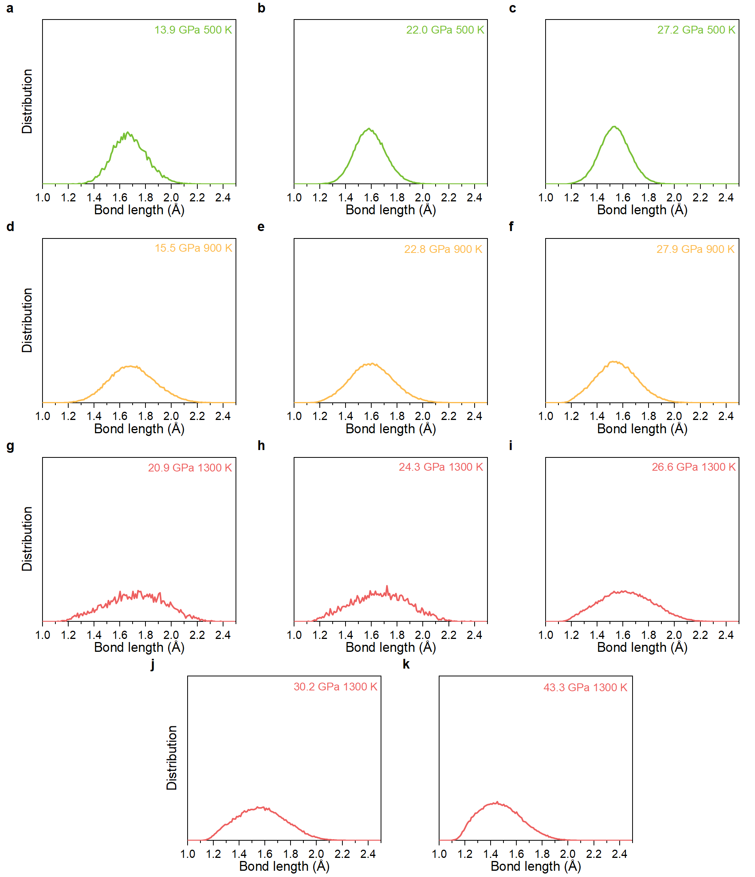
Extended Data Fig. 6 | Calculated length distribution of hydrogen bond at different P-T conditions. a, 13.9 GPa and 500 K. b, 22.0 GPa and 500 K. c, 27.2 GPa and 500 K. d, 15.5 GPa and 900 K. e, 22.8 GPa and 900 K. f, 27.9 GPa and 900 K. g, 20.9 GPa and 1300 K, h, 24.3 GPa and 1300 K. i, 26.6 GPa and 1300 K. j, 30.2 GPa and 1300 K. k, 43.3 GPa and 1300 K.
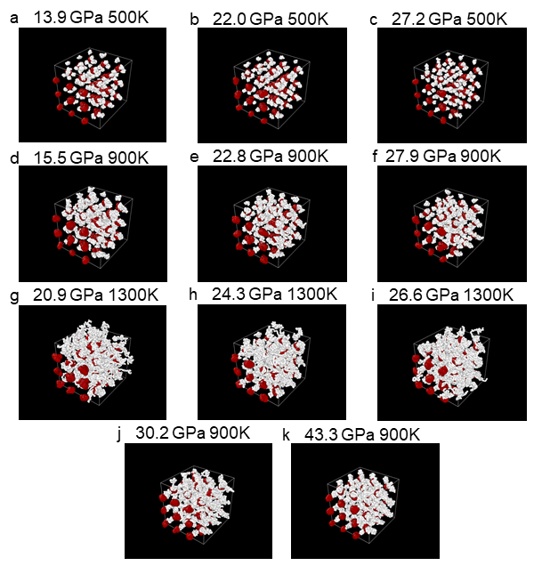
Extended Data Fig. 7 | Calculated trajectory of the H and O atoms at different conditions. a, 13.9 GPa and 500 K. b, 22.0 GPa and 500 K. c, 27.2 GPa and 500 K. d, 15.5 GPa and 900 K. e, 22.8 GPa and 900 K. f, 27.9 GPa and 900 K. g, 20.9 GPa and 1300 K, h, 24.3 GPa and 1300 K. i, 26.6 GPa and 1300 K. j, 30.2 GPa and 1300 K. k, 43.3 GPa and 1300 K.
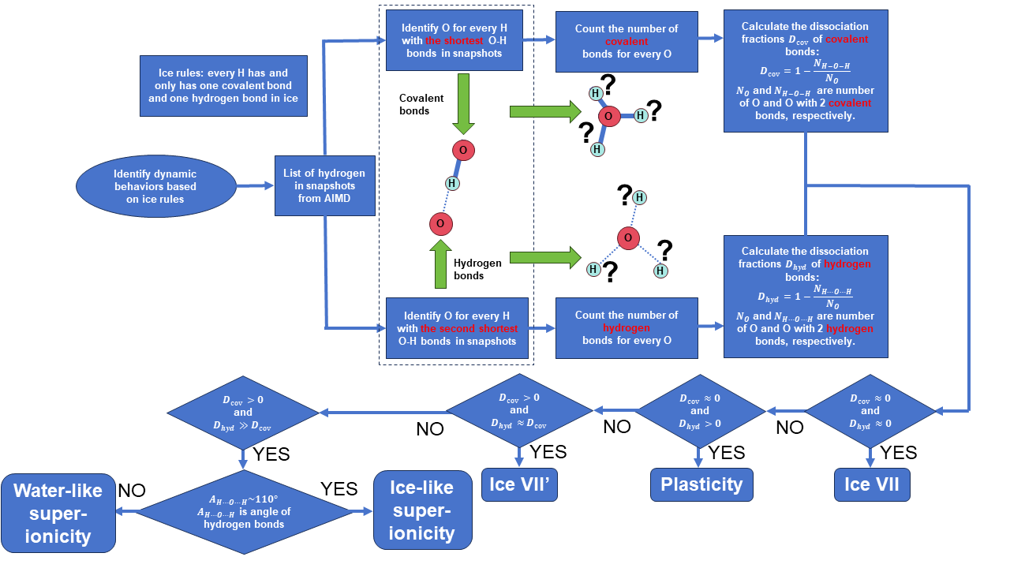
Extended Data Fig. 8 | Flowchart depicting the process of determining the structure of ice phases. Following the process of AIMD, we judge the structure of ice phases based on dissociation fractions of covalent and hydrogen bond. The details of each step are shown in Supplementary Information section 2.
Extended Data Table 1 | EOS parameters of ice VII determined from this study and previous studies.
 | K₀ (GPa) | K’ | V₀ (Å³)
Liu et al. (1982)⁷⁶ | 24.6(9) | 4.4 | 42.2(3)
Hemely et al. (1987)⁷⁷ | 23.7(9) | 4.15(7) | 40.9(9)
Fei et al. (1993)⁷² | 23.9(7) | 4.2(5) | 40.9(7)
Wolanin et al. (1997)⁷⁸ | 14.9(8) | 5.4(1) | 41.1(3)
Loubeyre et al. (1999)²⁰ * | 4.26 | 7.75 | 48.2
Frank et al. (2004)⁷³ | 21.3(13) | 4.4(1) | 41.2(1)
Sugimura et al. (2008)²¹ * | 5.02(43) | 7.51(28) | 48.2(fixed)
Bezacier et al. (2014)⁷⁹ | 20.77(26) | 4(fixed) | 41.3(0.7)
Frank et al. (2006)⁸⁰** | 26.2(14) | 4.08(18) | 39.1(2)
Lai et al. (2023)⁷⁴ | 21.0(4) | 4.45(6) | 40.9
Berrada et al. (2025)⁷⁰ | 16.6(9) | 5.4(1) | 41.5(4)
This study** | 4.36(17) | 7.59(110) | 49.1(22)
* Fitted with Vinet equation of state.
** Sample was NaCl-ice (0.5 wt% NaCl).

