Table of Contents
Supplementary Table 1. Baseline characteristics for study cohort of patients diagnosed with WHO grade 4 gliomas. 3
Supplementary Table 2. Multivariable analyses examining association between pathogenic variants and seizure incidence or seizure frequency. 4
Supplementary Figure 1. Distribution of exome variants for by patient sample. 5
Supplementary Figure 2. Lollipop genomic plots displaying SNVs within exonic regions of A) PTEN, B) PIK3CA, C) TP53 and D) EGFR. 6
Supplementary Figure 3. Combinatorial linear discriminant model accuracy for seizure presentation classification. 8

 | All Patients |  | No Seizures |  | Early Seizures |  | Late Seizures |  | P-value
 | N | Statistic | N | Statistic | N | Statistic | N | Statistic
Age, mean (SD) | 949 | 61.0 (13.7) | 535 | 63.7 (13.5) | 261 | 57.6 (13.2) | 153 | 57.2 (13.4) | < 0.001*
Sex
Male | 950 | 598 (62.9%) | 536 | 328 (61.2%) | 261 | 170 (65.1%) | 153 | 100 (65.4%) | 0.444
Female | 950 | 352 (37.1%) | 536 | 208 (38.8%) | 261 | 91 (34.9%) | 153 | 53 (34.6%) | 0.444
Resection Type
Sub-total Resection | 637 | 192 (30.1%) | 336 | 104 (31.0%) | 190 | 51 (26.8%) | 111 | 37 (33.3%) | 0.215
Near-total Resection | 637 | 151 (23.7%) | 336 | 87 (25.9%) | 190 | 38 (20.0%) | 111 | 26 (23.4%) | 0.215
Gross-total Resection | 637 | 294 (46.2%) | 336 | 145 (43.2%) | 190 | 101 (53.2%) | 111 | 48 (43.2%) | 0.215
Laterality
Left | 949 | 441 (46.5%) | 536 | 246 (45.9%) | 260 | 124 (47.7%) | 153 | 71 (46.4%) | 0.093
Right | 949 | 461 (48.6%) | 536 | 255 (47.6%) | 260 | 131 (50.4%) | 153 | 75 (49.0%) | 0.093
Midline/Both | 949 | 47 (5.0%) | 536 | 35 (6.5%) | 260 | 5 (1.9%) | 153 | 7 (4.6%) | 0.093
Location
Frontal Lobe | 950 | 340 (35.8%) | 536 | 166 (31.0%) | 261 | 107 (41.0%) | 153 | 67 (43.8%) | 0.002*
Parietal Lobe | 950 | 281 (29.6%) | 536 | 158 (29.5%) | 261 | 65 (24.9%) | 153 | 58 (37.9%) | 0.020*
Temporal Lobe | 950 | 356 (37.5%) | 536 | 207 (38.6%) | 261 | 111 (42.5%) | 153 | 38 (24.8%) | 0.001*
Occipital Lobe | 950 | 100 (10.5%) | 536 | 70 (13.1%) | 261 | 17 (6.5%) | 153 | 13 (8.5%) | 0.012*
Other Location | 949 | 130 (13.7%) | 536 | 95 (17.7%) | 260 | 18 (6.9%) | 153 | 17 (11.1%) | < 0.001*
Radiation | 944 | 813 (86.1%) | 532 | 425 (79.9%) | 259 | 242 (93.4%) | 153 | 146 (95.4%) | < 0.001*
Chemotherapy (Cytotoxic) | 945 | 767 (81.2%) | 532 | 394 (74.1%) | 260 | 237 (91.2%) | 153 | 136 (88.9%) | < 0.001*
Chemotherapy (Biologic Target) | 942 | 401 (42.6%) | 531 | 169 (31.8%) | 259 | 143 (55.2%) | 152 | 89 (58.6%) | < 0.001*
Priori Low-Grade Glioma | 948 | 70 (7.4%) | 536 | 35 (6.5%) | 259 | 27 (10.4%) | 153 | 8 (5.2%) | 0.078
KPS at Diagnosis, median (IQR) | 898 | 80 (70, 90) | 494 | 80 (70, 90) | 257 | 90 (80, 90) | 147 | 80 (80, 90) | < 0.001*
Supplementary Table 1. Baseline characteristics for study cohort of patients diagnosed with WHO grade 4 gliomas.
Patients were stratified by seizure status, with patients in No Seizure (n = 536), Early Seizure (n = 261), or Late Seizure (n = 153) groups. Differences between groups were analyzed using one-way ANOVA or Kruskal-Wallis tests. Categorical variables were assessed by χ² or Fisher’s exact tests. Significant p-values determined at α = 0.05 were denoted by *. Data for this patient cohort and associated p-values were published previously (Rilinger et al.).⁷
Abbreviations: KPS, Karnofsky performance status.
 | Early Seizure  (Yes vs. No)  Logistic Regression |  | Time to Late Seizure  Cox Proportional Hazards |  | Initial Seizure Frequency  (1+ vs. 0)  Logistic Regression |  | Average Seizure Frequency  Over 1st 6 months  (Any vs. 0)  Logistic Regression
 | Odds Ratio  (95% CI) | P-value | Hazard Ratio  (95% CI) | P-value | Odds Ratio  (95% CI) | P-value | Odds Ratio  (95% CI) | P-value
Deletion 1p | 2.20 (1.01, 4.73) | 0.303 | 1.18 (0.54, 2.58) | 1.000 | 1.74 (0.61, 5.33) | 1.000 | 0.86 (0.30, 2.46) | 1.000
Deletion 19q | 0.94 (0.45, 1.89) | 1.000 | 0.58 (0.24, 1.38) | 1.000 | 1.83 (0.64, 5.73) | 1.000 | 1.69 (0.62, 4.79) | 1.000
Pathogenic IDH1 variant | 2.26 (0.87, 5.95) | 0.549 | 0.73 (0.21, 2.56) | 1.000 | 1.85 (0.46, 8.30) | 1.000 | 0.12 (0.02, 0.54) | 0.069
MGMT promoter methylation | 1.14 (0.71, 1.82) | 1.000 | 0.87 (0.51, 1.47) | 1.000 | 0.76 (0.40, 1.46) | 1.000 | 0.99 (0.51, 1.92) | 1.000
Ki-67 expression (per 10% increase) | 1.03 (0.92, 1.15) | 1.000 | 1.02 (0.90, 1.15) | 1.000 | 0.91 (0.77, 1.06) | 1.000 | 0.86 (0.73, 1.01) | 0.391
EGFR amplification | 1.48 (0.91, 2.39) | 0.549 | 0.72 (0.45, 1.16) | 1.000 | 1.99 (1.01, 4.01) | 0.349 | 1.12 (0.56, 2.23) | 1.000
p53 expression (per 10% increase) | 0.93 (0.84, 1.01) | 0.549 | 0.92 (0.85, 1.01) | 0.486 | 1.05 (0.92, 1.20) | 1.000 | 1.14 (0.99, 1.32) | 0.391
A)

B)

 |  | Early Seizure  (Yes vs. No)  Logistic Regression |  |  | Time to Late Seizure  Cox Proportional Hazards |  |  | Initial Seizure Frequency  (1+ vs. 0)  Logistic Regression |  |  | Average Seizure Frequency  Over 1st 6 months  (Any vs. 0)  Logistic Regression
 | N | Odds Ratio  (95% CI) | P-value | N | Hazard Ratio  (95% CI) | P-value | N | Odds Ratio  (95% CI) | P-value | N | Odds Ratio  (95% CI) | P-value
Deletion 1p | 950 | 2.52 (1.52, 4.16) | 0.002* | 689 | 0.72 (0.35, 1.52) | 1.000 | 950 | 1.50 (0.88, 2.55) | 0.838 | 950 | 0.87 (0.51, 1.47) | 1.000
Deletion 19q | 950 | 0.96 (0.58, 1.58) | 1.000 | 689 | 0.75 (0.43, 1.33) | 1.000 | 950 | 1.04 (0.62, 1.72) | 1.000 | 950 | 1.02 (0.59, 1.77) | 1.000
Pathogenic IDH1 variant | 950 | 2.95 (1.35, 6.46) | 0.041* | 689 | 0.56 (0.20, 1.61) | 1.000 | 950 | 1.77 (0.80, 3.91) | 0.838 | 950 | 0.26 (0.09, 0.76) | 0.102
MGMT promoter methylation | 950 | 1.13 (0.77, 1.67) | 1.000 | 689 | 0.75 (0.47, 1.20) | 1.000 | 950 | 1.01 (0.69, 1.47) | 1.000 | 950 | 1.02 (0.70, 1.48) | 1.000
ki-67 expression (per 10% increase) | 950 | 1.01 (0.93, 1.08) | 1.000 | 689 | 1.01 (0.93, 1.10) | 1.000 | 950 | 0.99 (0.92, 1.07) | 1.000 | 950 | 0.97 (0.89, 1.05) | 1.000
EGFR amplification | 950 | 1.60 (1.13, 2.26) | 0.041* | 689 | 0.85 (0.59, 1.23) | 1.000 | 950 | 1.50 (0.97, 2.32) | 0.461 | 950 | 1.08 (0.74, 1.57) | 1.000
p53 expression (per 10% increase) | 950 | 0.96 (0.90, 1.02) | 0.669 | 689 | 0.97 (0.91, 1.03) | 1.000 | 950 | 0.96 (0.90, 1.03) | 1.000 | 950 | 1.01 (0.95, 1.08) | 1.000
Supplementary Table 2. Multivariable analyses examining association between pathogenic variants and seizure incidence or seizure frequency.
All pathogenic variants were included in the same model for each outcome, and complete case analysis was used. All models were adjusted for the following covariates: age, sex, gross total resection, laterality, location (frontal lobe, parietal lobe, temporal lobe, occipital lobe, other), KPS at diagnosis, radiation therapy, chemotherapy (cytotoxic), and chemotherapy (biological target). For Supplementary Table 2A, complete case analysis for the molecular markers resulted in only 49.6% (471/950) of patients being included in the analysis. Holm’s method was used to correct for multiple comparisons. Significant p-values were determined at α = 0.05 denoted by *. Missing data were handled in Supplementary Table 2A) without imputation and 2B) with multiple imputation.
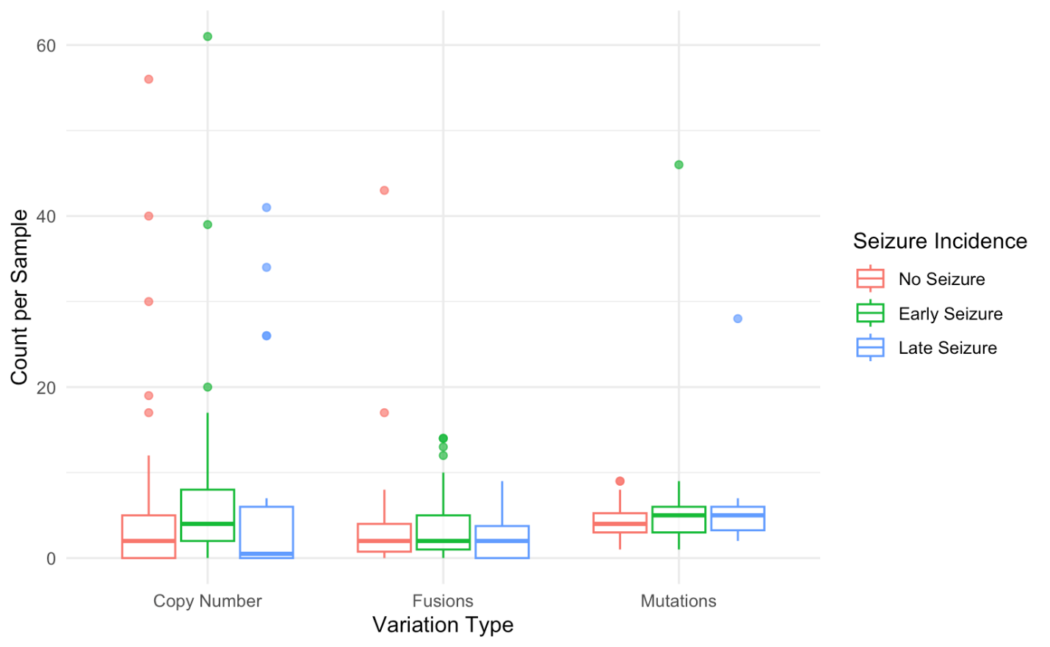

Supplementary Figure 1. Distribution of exome variants by patient sample.
Whole-exome sequencing of 83 patient samples was included. Exome variants included CNAs, fusions, and mutations or SNVs. Patient samples were stratified by seizure incidence and color-coded accordingly (No Seizure = red, Early Seizure = green, Late Seizure = blue). Box plots depict interquartile range with median shown as horizontal lines inside the boxes. Total exome variant counts did not differ significantly based on seizure incidence (Kruskal-Wallis rank sum test, p > 0.05).
Abbreviations: CNA, Copy number alteration. MGMT, O⁶-methylguanine DNA methyltransferase. MSI, Microsatellite instability. SNV, Single nucleotide variant.

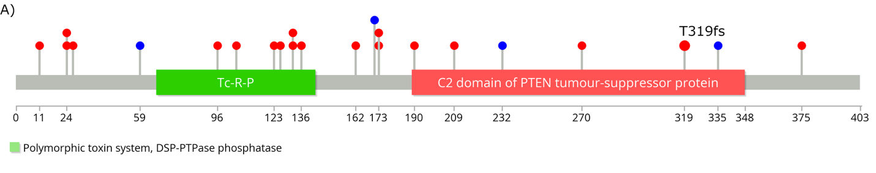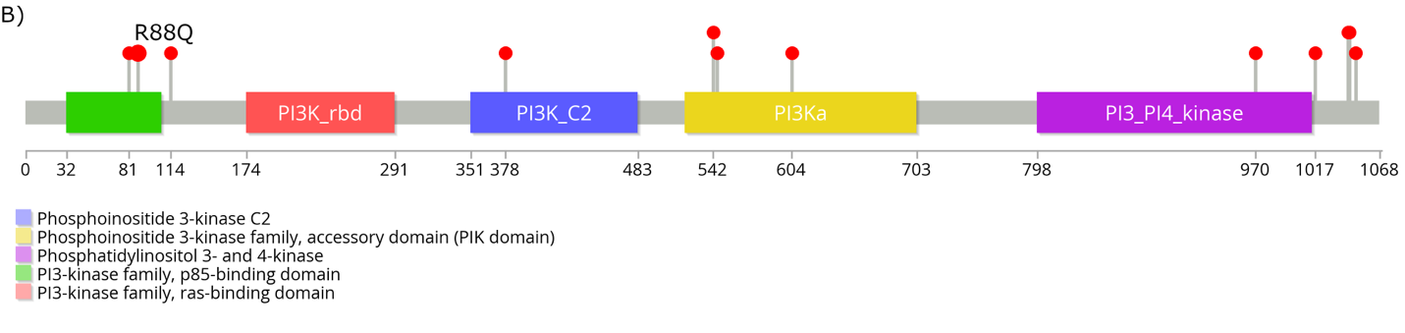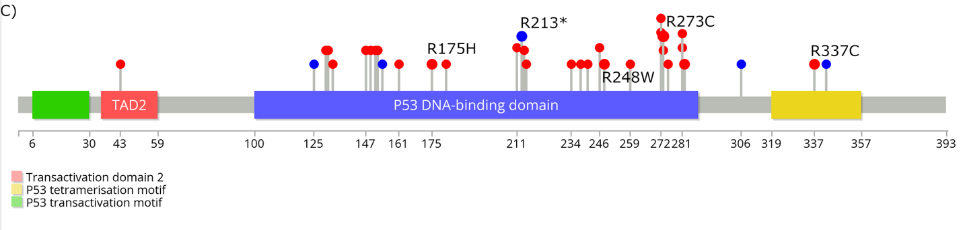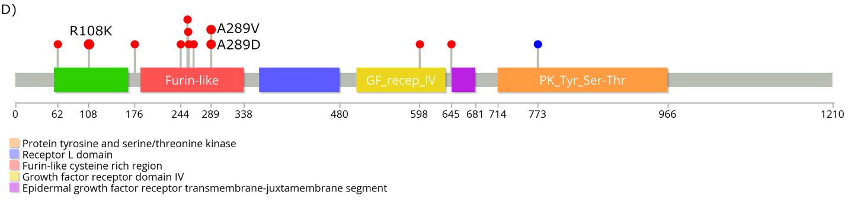

Supplementary Figure 2. Lollipop genomic plots display SNVs within exonic regions of A) PTEN, B) PIK3CA, C) TP53 and D) EGFR.
The size of the marker corresponds to the number of samples with a given SNV, and the x-axis describes the position within the exon sequence. Marker color is blue for synonymous mutations and red for non-synonymous mutations. SNVs present in more than one sample are labelled. Gene segments are displayed horizontally with relevant exon segments and topology (extracellular, transmembrane, cytoplasmic). Vertical lines indicate SNVs along gene. The most common SNV in EGFR was A289D/V, and the most common point mutation in TP53 was R273C/H.
Abbreviations: SNV, Single nucleotide variant.

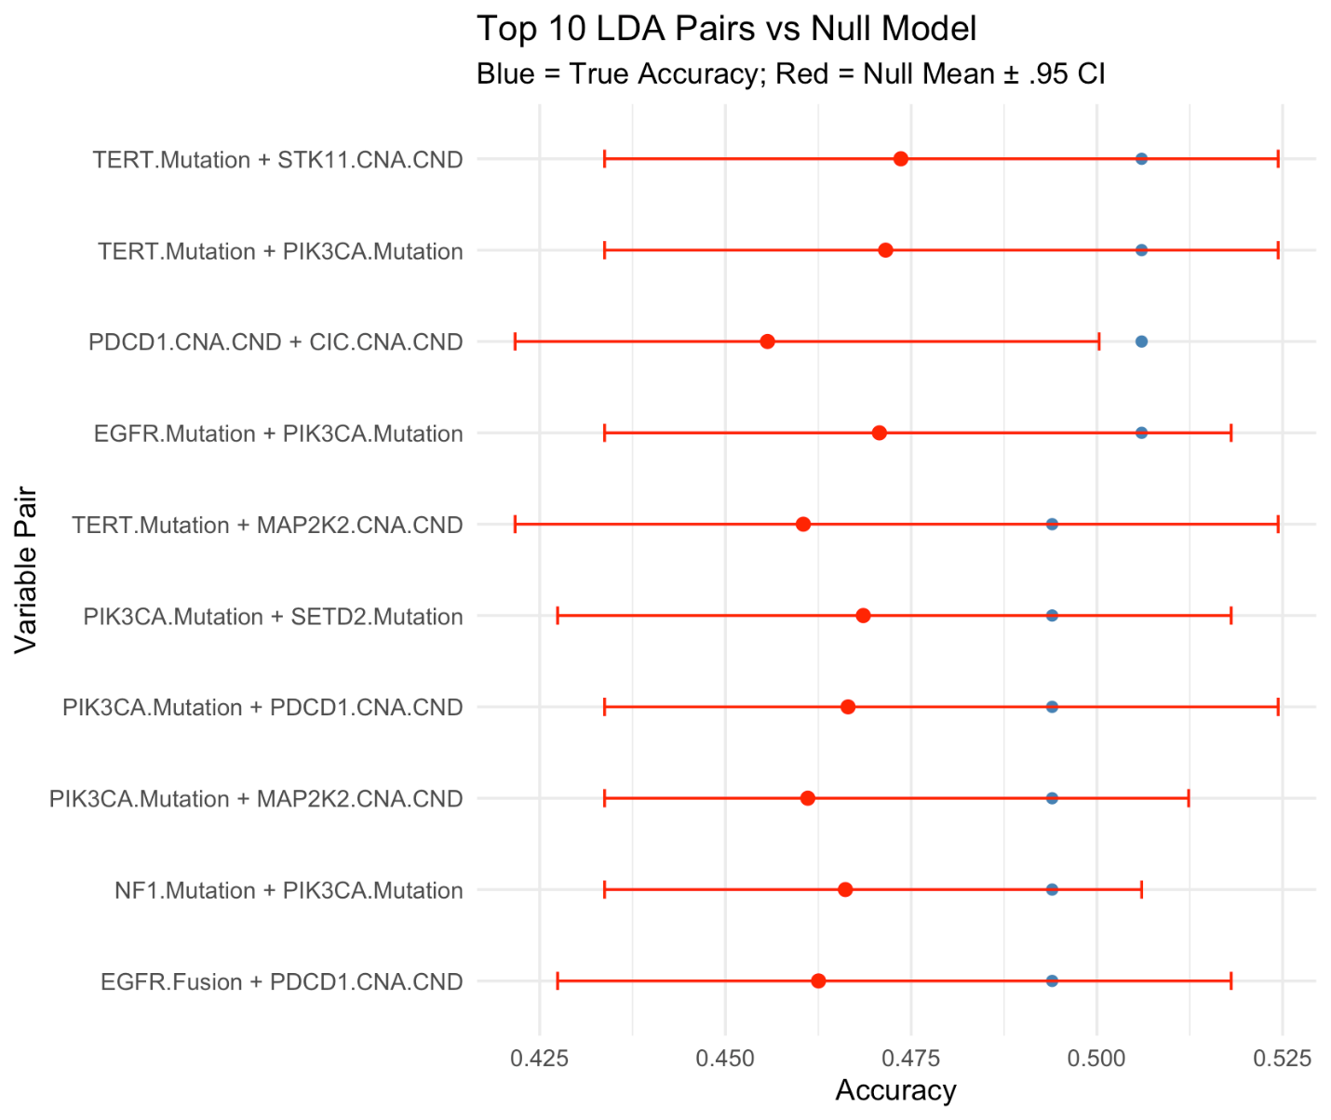

Supplementary Figure 3. Combinatorial linear discriminant model accuracy for seizure presentation classification.
Linear discriminant analysis model accuracy (bar, dark blue) and 95% CI of the null model (red). The 95% CI is obtained from 100 bootstrapped linear discriminant analysis models using shuffled predictor values. Most (9 out of 10) trained models attain accuracies within the 95% CI, not outperforming the null (bootstrapped) model. PDCD1 and CIC CNA alterations slightly outperform the null model. Variable pair combination (left) denotes variables used to train the model and predict seizure presentation class.

