Supplementary Materials
Results for Association of Patient Risk Groups with PFS
PFS is another key parameter commonly used to describe underlying disease progression in patients with advanced melanoma. It has not been applied for either model development or derivation of the scoring system. However, given the value of PFS in describing disease progression in advance melanoma patients, we attempted to further understand the association of patient risk groups with PFS.
Based on the development dataset, there is a clear separation in low-risk, moderate-risk, and high-risk patients on PFS (Figure S1(A)). Considering all therapies together, the estimated median PFS are 10.5 months (95% CI: 8.1-12.2) for the low-risk group, 4.8 months (95%CI: 4.0-5.6) for the moderate-risk group, and 2.7 months (95% CI: 2.6-2.8) for the high-risk group. Hazard ratio between low-risk versus high-risk group is 0.36 (95% CI of 0.32-0.40), and between moderate-risk versus high-risk group is 0.55 (95% CI of 0.49-0.61). The difference of survival among the three groups is significant (P-value < 0.01 based on log-rank test) (Figure S1(A) a and Table S1). This trend is similar in each therapy, with lower risk groups consistently demonstrating longer PFS (Figure S1(A) b-f and Table S1). Taking PD-1 monotherapy as an example, the PFS for low-, moderate- and high-risk group are 12.5 months (95% CI: 8.1-17.3), 4.2 months (95% CI: 3.5-6.0), and 2.6 months (95% CI: 2.4-2.8), respectively. The hazard ratios between low-risk versus high-risk group, and moderate-risk and high-risk group each reported as 0.33 (95% CI: 0.28-0.39) and 0.49 (95% CI: 0.42-0.57). Each therapy group follows the same pattern. The separation on PFS across low-risk, moderate-risk and high-risk groups is consistently significant (P-value < 0.01 based on log-rank test).
Testing / external validation dataset confirmed the same pattern - PFS is consistently shorter in higher risk groups (Figure S1(B) and Table S1). Considering patients with all therapies, the median PFS is 11.3 months (95% CI: 8.0-17.9) for low-risk group, 5.4 months (95% CI: 4.1-6.7) for moderate-risk group, and 2.6 months (95% CI: 2.6-2.8) for high-risk group (Figure S1(B) a and Table S1). The estimated hazard ratio for low-risk group versus high-risk group and moderate-risk group versus high-risk group are 0.37 (95% CI: 0.30-0.45) and 0.57 (95% CI: 0.46-0.70), respectively. Log-rank test revealed that the difference on PFS among the three groups are significant (P-value < 0.01). This pattern appears to be consistent across each therapy(Figure S1(B) b-f and Table S1). For example, the PFS in low-risk, moderate-risk, and high-risk patients receiving a combination of PD-1 inhibitor and CTLA-4 inhibitor were reported to be 52.8 months (95% CI: 21.9 – NR), 11.1 months (95% CI: 8.4-11.1) and 2.8 months (95% CI: 2.6-4.4), respectively. The hazard ratio between low-risk versus high-risk group is 0.31 (95% CI: 0.21-0.45), and between moderate-risk versus high-risk group is 0.53 (95% CI: 0.37-0.77). The difference on PFS among the three groups are significant (P-value < 0.01 based on log-rank test). The findings are consistent across PD-1 monotherapy and CTLA-4 monotherapy.

Theoretical Derivation for Methodology
Gumbel-SoftMax Trick:
ScoreNet’s feature selection strategy benefits from the Gumbel-Softmax trick, which smoothing the discrete categorical distribution into a continues distribution therefore enables gradient descent through back propagation. In this way, ScoreNet directly select the optimal feature set without post hoc analysis, such as feature importance visualization. To demonstrate the Gumbel-softmax reparameterization trick, we start with a categorical distribution $S$ of $n$ classes with probability $,π_{1}…, π_{n}$:
$$S=(π_{1},…, π_{n})$$
We sample a noise $g_{i}$ from a standard Gumbel distribution:
$$g_{i}∼\text{G }\left(0,1\right)$$
We add the Gumbel noise to the logits and scale by a temperature parameter $τ$ ($τ>0$):
$$y_{i}=\frac{log⁡(π_{i})+g_{i}}{τ}$$
After applying a softmax function to the perturbed logits above, we get a continuous approximation:
$$σ({y)}_{i}=\frac{\exp\left(\left(\log{{(π}_{i})}+g_{i}\right)/τ\right)}{\sum_{j=1}^{n}{\exp\left(\left(\log{(π_{j})}+g_{j}\right)/τ\right)}}$$
Which yields a softmax vector $σ\left(y\right)=(σ({y)}_{1}, σ({y)}_{2}, σ({y)}_{3},…, σ({y)}_{n})$, which is a differentiable approximation of $C$.
In addition, the Gumbel-Top $k$ relaxation extends the Gumbel-Softmax trick to enable sampling $k$ elements without replacement from the categorical distribution $C$ (Xie and Ermon 2019).While for one-hot sampling, the logit is:
$$y_{i}^{1}=\frac{\log{π_{i}}+g_{i}}{τ},$$
If we want to sample $k$ classes from the total of $n$ classes, we constantly sample one class from the remaining classes for k times. When $y_{i}^{j}$ is known, the logits of sampling j+1 classes can be expressed as:
$$y_{i}^{j+1}=y_{i}^{j}+\log\left(1-{σ(y)}_{i}^{j}\right) ( j=1,…,k-1;i=1,…,n)$$
Then the approximation of sampling k classes from n classes is:
$${σ(y)}_{i}^{k}=\left(\sum_{j=1}^{k}{{σ(y)}_{i}^{j}},i=1,…,n\right)$$
Which is a differentiable approximation of k-hot vector, where the location k largest elements represent the index of selected elements.
In both Gumbel-Softmax reparameterization and Gumbel-Top $k$ relaxation, temperature $τ$ presents a trade-off between smoothness of sampling and variances of the gradient estimations during model training (Jang, et al. 2016). Usually, an annealing schedule to the temperature τ is employed to a specified value, to achieve as low as temperature as possible, but cannot reach 0, when Gumbel-Softmax becomes a discrete step function. Also, ScoreNet directly generate the parameters for a checklist, which is also an undifferentiable discrete function. The Straight-Through (ST) strategy is used in both scenarios, to still create gradient through back propagation for discrete functions. The Straight Through strategy can be explained straight-forwardly as, during forward pass, we used the original discrete functions (i.e., argmax or indicator), while during backward pass, we use a continues function that approximate the discrete function (i.e., softmax or sigmoid) to generate the gradient, which can be expressed during programming as follows:
$$ST\left(f\left(x\right)\right)=g\left(x\right)-StopGradient\left(g\left(x\right)\right)+f(x)$$
Where the gradient for $f(x)$ during backward pass can be approximated as $g\left(x\right)-StopGradient\left(g\left(x\right)\right)$. During forward pass, $ST\left(f\left(x\right)\right)= f(x)$, since $g\left(x\right)-StopGradient\left(g\left(x\right)\right)$ = 0.
Based on the above theories, in this paper, we generate two operators to select optimal features from n classes with feature with unnormalized categorical distribution $S=\left(S_{1},S_{2},…,S_{n}\right)$:
$$Gumbel_Softmax\left(S,τ\right)=\left(\frac{\exp\left(\left(S_{i}+g_{i}\right)/τ\right)}{\sum_{j=1}^{n}{\exp\left(\left(S_{j}+g_{j}\right)/τ\right)}}\right)-StopGradient\left(\frac{\exp\left(\left(S_{i}+g_{i}\right)/τ\right)}{\sum_{j=1}^{n}{\exp\left(\left(S_{j}+g_{j}\right)/τ\right)}}\right)+ArgMax\left(S_{i}+g_{i}\right) for i=1,…,n$$
Which is used to approximate a one-hot mask to select the top one feature.
And:
$Gumbel_Top_k\left(S,τ,k\right)=Z_{n}^{k}-StopGradient\left(Z_{n}^{k}\right)+ArgTopk\left(S_{i}+g_{i},i=1,…,n\right)$.
Which is the top k relaxation of $Gumbel_Softmax$, and can be used to approximate a k-hot mask to select the top k features.
The Straight-Through method also enables us to learn a predesignated “cutoff” for ScoreNet. Let’s define the input value as $x_{1}$ and the predesignated cutoff as $x_{2}$, the output of comparison between input and cutoff can be expressed by the indictor function $1_{x_{1}-x_{2}≥0}$, which is a discrete value. Using Straight-Through method, we can generate a differentiable operator that approximate $1_{x_{1}-x_{2}≥0}$:
$$ST_{indicator}\left(x_{1}, x_{2}, C\right)= Sigmoid\left(\frac{x_{1}- x_{2}}{C}\right)-StopGradient\left(Sigmoid\left(\frac{x_{1}- x_{2}}{C}\right)\right)+1_{x_{1}-x_{2}≥0}$$
Where $C$ is a scale factor.
ScoreNet Model Components:
Using the operator, we constructed above, the ScoreNet can inherently train a checklist consist of the below constitutional blocks:
Let’s define the below as input data:
$$v=\left(v_{1},…,v_{n}\right)$$
Feature Selection: To select the top k features from the n input features, we try to approximate a k-hot vector $Mask_{n}^{k}$ by using $Gumbel_Top_k$ operator. We denote the unnormalized learnable probability $S_{k_of_n}=\left({S_{π}}_{1},…,{S_{π}}_{n}\right)$ of the k-hot distribution. Then $Mask_{n}^{k}$ can be defined as
$$Mask_{n}^{k}=Gumbel_Top_k\left(S_{k_of_n},τ,k\right)$$
Then the input data after selection is the dot product of the input features and $Mask_{n}^{k}$:
$$Mask_{n}^{k}⊙v=\left(0,v_{2},0,…,v_{n}\right)$$
Which includes exact $k$ components from $v$ and $n-k$ zero terms that’s not selected.
Feature Binarization: The ScoreNet learns a checklist that whether a condition is yes (√) or no (×), which is achieved by fitting parameters in the Feature Binarization module. The Feature Binarization module is designed to efficiently convert continuous variables into binary representations, which is either larger (>) or smaller (<) than an optimal cutoff. To find the optimal cutoff, we predefine a set of cutoffs, which are selected based on $J^{th}$quantiles (e.g., the 20th, 30th quantiles) of the variable $v_{i}$'s distribution:
$c_{v_{i}}=(c_{v_{i}}^{1},…,c_{v_{i}}^{J})$,
And the selection of optimal cutoff can also be achieved by applying Gumbel-Softmax to approximate a one-hot vector. We define a categorical distribution for all $J$ cutoffs of $v_{i}$:
$$S_{c_{v_{i}}}=(S_{c_{v_{i}}^{1}},…,S_{c_{v_{i}}^{J}})$$
Which approximate a one-hot vector $Mask_{J}^{1}$ that can be used to select the optimal cutoff $v_{i}^{j_{0}}$:
$$\hat{c_{v_{i}}^{J}}=\sum_{j=1}^{J}{Mask_{J}^{1}⊙c_{v_{i}}}=\sum_{j=1}^{J}{Gumbel_Softmax\left(S_{c_{v_{i}}},τ\right)⊙c_{v_{i}}}$$
The binarized output $b_{i}$ of the comparison of input value $v_{i}$ with selected cutoff can be approximated using $ST_{indicator}$:
$$b_{v_{i}>\hat{c_{v_{i}}^{J}}}=ST_{indicator}\left(v_{i},\hat{c_{v_{i}}^{J}},C\right)$$
As the indicator function only indicates the comparison from one direction ($v_{i}>\hat{c_{v_{i}}^{J}})$ , we use another output to express the binarized output from the other direction ($v_{i}<\hat{c_{v_{i}}^{J}})$:
$$b_{v_{i}<\hat{c_{v_{i}}^{J}}}=ST_{indicator}\left(\hat{c_{v_{i}}^{J}},v_{i},C\right)$$
Feature Weight: The ScoreNet learns an integer score for each of the binarized conditions $b_{i}$. And this score can be learned by the feature weight component, which also utilized the Gumbel softmax trick to select the optimal score out of a set of predesignated integer scores (i.e. -4 to 4). Let’s define $H$ predesignated scores $W_{i}$:
$$W_{i}=(w_{1},…,w_{H})$$
Which follows the categorical distribution $S_{weight_{i^{0}}}$:
$$S_{W_{i}}=(S_{W_{i}}^{1},…,S_{W_{i}}^{H})$$
Which can be also approximated by the Gumbel-softmax operator to a one-hot vector $Mask_{H}^{1}$:
$$Mask_{H}^{1}= Gumbel_Softmax\left(S_{W_{i}},τ\right)$$
Therefore, the selected integer weight is:
$$w_{i}=\sum_{h=1}^{H}{Mask_{H}^{1}}⊙W_{i}= Gumbel_Softmax\left(S_{W_{i}},τ\right) ⊙W_{i}$$
We put the above modules together and forming the ScoreNet:
$${ScoreNet}_{n}^{k}= \sum_{i}^{k}{Mask_{n}^{k}⊙}\left( b_{i}⊙ w_{i}+ b_{-i}⊙ w_{-i}\right)$$
Since all three modules are differentiable, ScoreNet is differentiable by the chain rule.

Figure Legend

Figure S1: Progression-Free Survival in Low-, Moderate- and High-Risk Patients Across All Therapies (a) and Stratified by Different Therapies (b-d) Based on Development Dataset (A) and Testing/External Validation Dataset (B)

Figure S2: A Diagram on Data Used for Model Development and Testing/External Validation

Figure S3: Schematic of the ScoreNet Model Architecture

Table
Table S1: Median Progression Free Survival in Low-, Moderate- and High-Risk Groups in All and Stratified Therapies Based on Development Dataset and Test/External Validation Dataset

Figure S1
Figure S1: Progression-Free Survival in Low-, Moderate- and High-Risk Patients Across All Therapies (a) and Stratified by Different Therapies (b-d) Based on Development Dataset (A) and Testing Dataset (B)
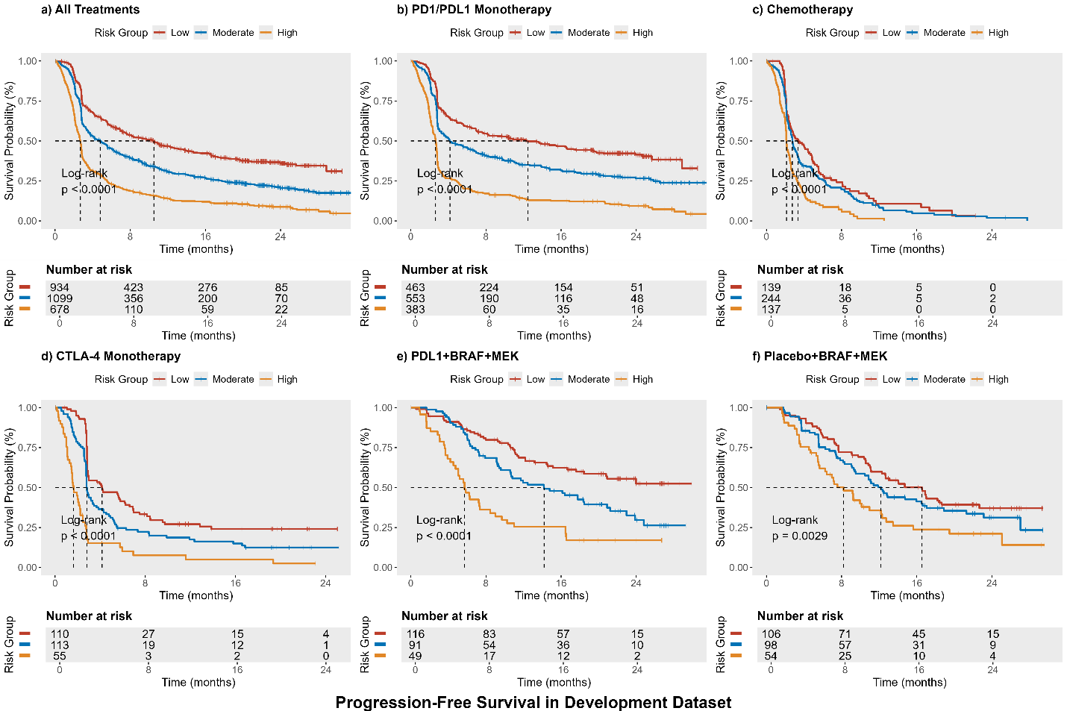

(A)
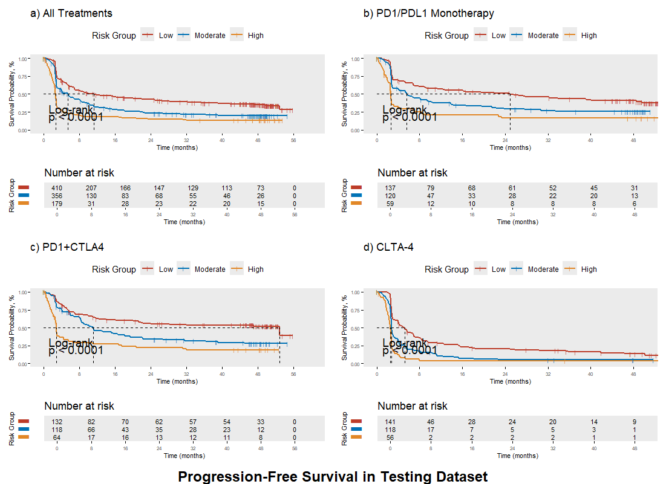

Figure S2
Figure S2: A Diagram on Data Used for Model Development and Testing Validation
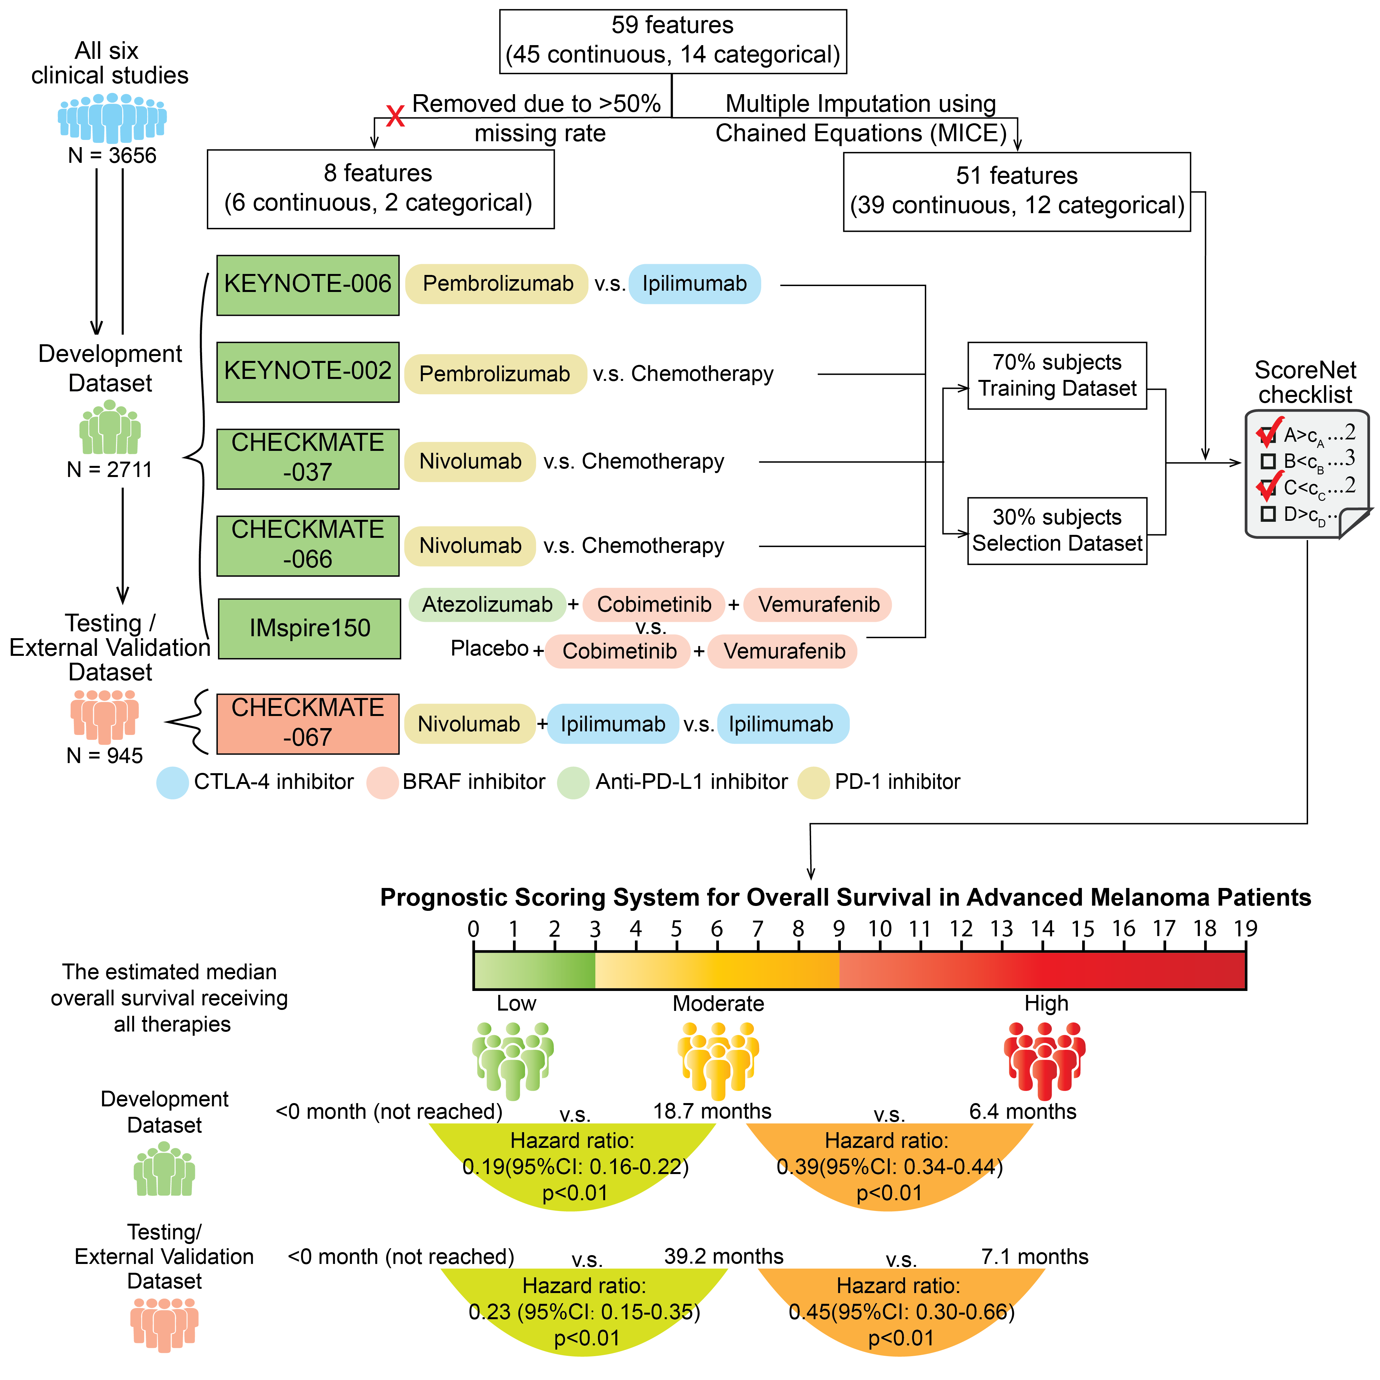

Figure S3
Figure S3: Schematic of the ScoreNet Model Architecture
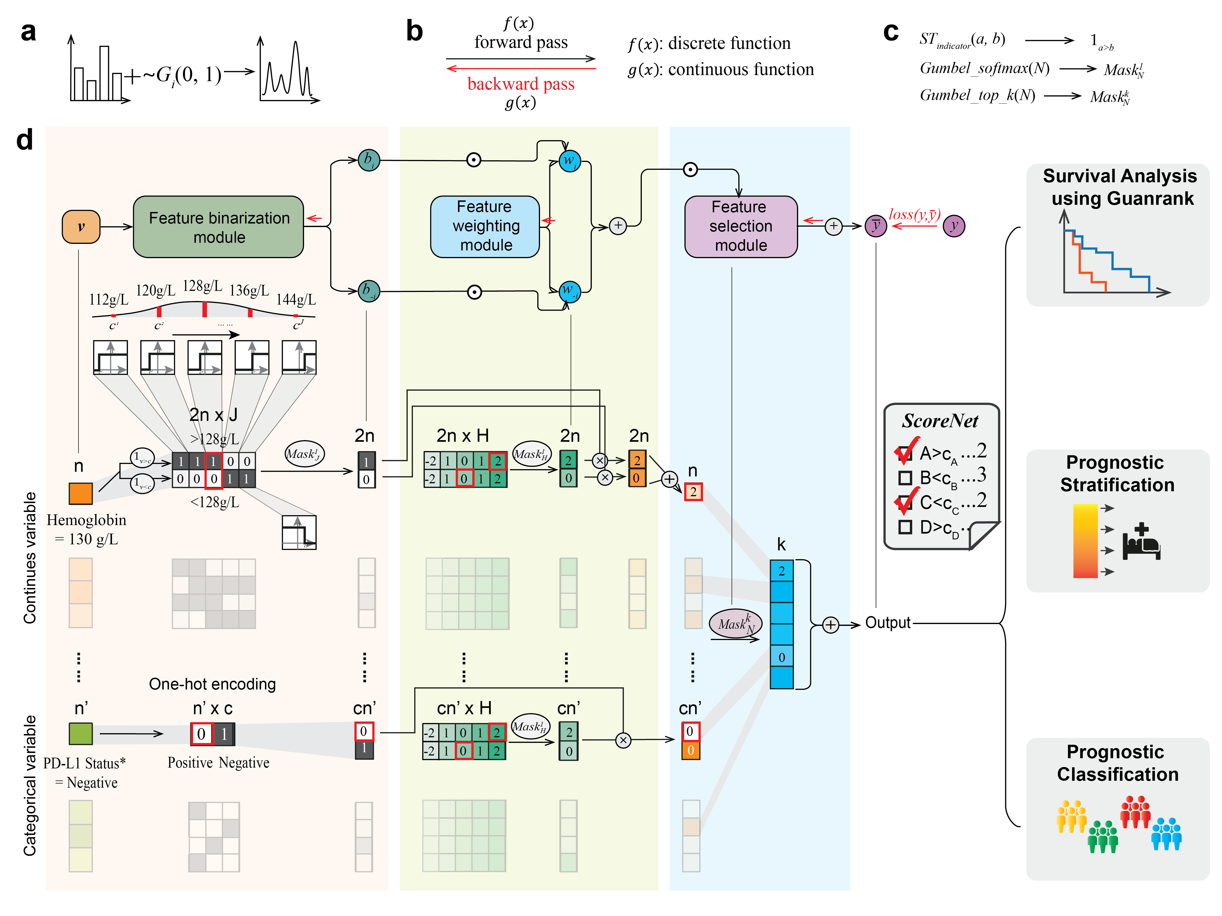

a. A demonstration of the Gumbel-Softmax trick: By adding noise from a Gumbel distribution ($G\sim (0, 1)$), a discrete distribution can be transformed into a continuous distribution, enabling differentiation. b. A demonstration of the straight-through trick: Applied during backpropagation in ScoreNet, this technique allows the model to approximate a discrete function. c. Important functions for ScoreNet to generate differential checklist: The combination of the Gumbel-Softmax function, Gumbel top-k function (a relaxation of Gumbel-Softmax), and straight-through indicator function enables the implementation of feature binarization, weighting, and selection. d. Overview of ScoreNet's architecture, comprising three primary modules: feature binarization, feature weighting and feature selection. The feature binarization block converts input features into binary labels using an optimal cutoff learned from predefined thresholds. The feature weighting block assigns integer scores to each binarized feature, effectively defining the "Score" of each feature. The feature selection block, represented as a k-hot vector, identifies the top k features that are binarized and multiplied by their respective scores. The final output of ScoreNet is the dot product of these three components

Table S1
Table S1: Median Progression-Free Survival in Low-, Moderate- and High-Risk Groups in Pooled and Stratified Therapies Based on Development Dataset and Test Dataset
 |  | Low-Risk Group  [0-3] | Moderate-Risk Group  [4-9] | High-Risk Group  [10-19]
Development Dataset
All Therapies | Sample Size | N=934 | N=1099 | N=678
All Therapies | Progression-Free Survival (Months)  (95% CI) | 10.5 (8.1-12.2) | 4.8 (4.0-5.6) | 2.7 (2.6-2.8)
All Therapies | Hazard Ratio  (95% CI) | 0.36 (0.32-0.40) | 0.55 (0.49-0.61) | 1 [Reference]
PD1/PDL1 Monotherapy | Sample Size | N=463 | N=553 | N=383
PD1/PDL1 Monotherapy | Progression-Free Survival (Months)  (95% CI) | 12.5 (8.1-17.3) | 4.2 (3.5-6.0) | 2.6 (2.4-2.8)
PD1/PDL1 Monotherapy | Hazard ratio  (95% CI) | 0.33 (0.28-0.39) | 0.49 (0.42-0.57) | 1 [Reference]
Chemotherapy | Sample Size | N=139 | N=244 | N=137
Chemotherapy | Progression-Free Survival (Months)  (95% CI) | 3.4 (2.6-4.9) | 2.8 (2.6-3.2) | 2.1 (2.1-2.5)
Chemotherapy | Hazard Ratio  (95% CI) | 0.47 (0.36-0.62) | 0.56 (0.44-0.71) | 1 [Reference]
CTLA-4 Monotherapy | Sample Size | N=110 | N=113 | N=55
CTLA-4 Monotherapy | Progression-Free Survival (Months)  (95% CI) | 4.2 (2.9-6.6) | 2.8 (2.8-3.4) | 1.6 (1.4-2.2)
CTLA-4 Monotherapy | Hazard Ratio  (95% CI) | 0.27 (0.19-0.40) | 0.43 (0.30-0.60) | 1 [Reference]
PDL1+BRAF+MEK | Sample Size | N=116 | N=91 | N=49
PDL1+BRAF+MEK | Progression-Free Survival (Months)  (95% CI) | NR (18.5-NR) | 14.2 (10.6-21.2) | 5.7 (4.8-9.0)
PDL1+BRAF+MEK | Hazard Ratio  (95% CI) | 0.27 (0.17-0.41) | 0.47 (0.31-0.71) | 1 [Reference]
BRAF+MEK | Sample Size | N=106 | N=98 | N=54
BRAF+MEK | Progression-Free Survival (Months)  (95% CI) | 16.6 (12.3-22.7) | 12.2 (9.5-17.1) | 8.2 (6.2-12.2)
BRAF+MEK | Hazard Ratio  (95% CI) | 0.50  (0.34-0.75) | 0.62  (0.42-0.94) | 1  [Reference]
Testing Dataset
All Therapies | Sample Size | N=410 | N=356 | N=179
All Therapies | Progression-Free Survival (Months)  (95% CI) | 11.3  (8.0-17.9) | 5.4  (4.1-6.7) | 2.6  (2.6-2.8)
All Therapies | Hazard Ratio  (95% CI) | 0.37  (0.30-0.45) | 0.57  (0.46-0.70) | 1  [Reference]
PD1/PDL1 Monotherapy | Sample Size | N=137 | N=120 | N=59
PD1/PDL1 Monotherapy | Progression-Free Survival (Months)  (95% CI) | 24.9  (11.3-48.5) | 5.6  (3.0-10.0) | 2.6  (2.6-3.2)
PD1/PDL1 Monotherapy | Hazard ratio  (95% CI) | 0.36  (0.25-0.53) | 0.56  (0.38-0.81) | 1  [Reference]
PD1+CTLA4 | Sample Size | N=132 | N=118 | N=64
PD1+CTLA4 | Progression-Free Survival (Months)  (95% CI) | 52.8  (21.9-NR) | 11.1  (8.4-18.1) | 2.8  (2.6-4.4)
PD1+CTLA4 | Hazard Ratio  (95% CI) | 0.31  (0.21-0.45) | 0.53  (0.37-0.77) | 1  [Reference]
CTLA-4 Monotherapy | Sample Size | N=141 | N=118 | N=56
CTLA-4 Monotherapy | Progression-Free Survival (Months)  (95% CI) | 5.0  (4.0-6.8) | 2.8  (2.7-3.1) | 2.6  (2.3-2.7)
CTLA-4 Monotherapy | Hazard Ratio  (95% CI) | 0.30  (0.21-0.43) | 0.54  (0.38-0.77) | 1  [Reference]

