Supplementary information

Mn²⁺ Induced Significant Improvement and Robust Stability of Radioluminescence in Cs₃Cu₂I₅ for High Performance Nuclear Battery
Xiaoming Li, Jiaxin Chen, Dandan Yang, Xi Chen, Dongling Geng, Lianfu Jiang, Ye Wu, Cuifang Meng, Haibo Zeng*

Experimental Sections
Chemicals：Cesium iodide (CsI, 99.9%), Cuprous iodide (CuI, 99.5%), MnCl₂·4H₂O (99%) were purchased from Aladdin. All the chemicals were used without further purification.

Synthesis of Cs₃Cu₂I₅:Mn halides: A series of Cs₃Cu₂I₅: xMn²⁺ (0.3 ≤x≤0.25) were synthesized by a solid-state reaction method. The experimental steps were as follows: CsI, CuI, MnCl₂.4H₂O were put into the mortar or ball grinding tank in a certain proportion to get uniform mixtures. Subsequently, the resulting mixtures were encapsulated in a vacuum quartz tube and placed in a muffle furnace for calcination at 340~450 ℃. The reaction time was 6~48 h. After the reaction finished and cooled naturally to room temperature, the calcined product was taken out and grinded to obtain light yellow Cs₃Cu₂I₅:Mn²⁺ powders. Finally, the powder was dried under vacuum at 80 degrees for 12 hours to obtain the final scintillator material.

Fabrication of nuclear batteries: First of all, a polystyrene (PS) toluene solution (0.2 g mL⁻¹) was prepared as the matrix. Then, different weights (100-600 mg) of Cs₃Cu₂I₅: Mn 15% were mixed with 1 mL PS solution. The mixtures were stirred rigorously for 4 hours and casted on a thin glass substrate for the fabrication of scintillation layers. The thick films were dried under vacuum at room temperature, which were then covered on a GaAs solar cell (1 cm* 1 cm) sealed with a thin glass.

Characterizations: Powder X-ray diffraction was characterized by an X-ray diffractometer (Bruker D8 Advance XRD system), and the morphology and elements of Cs₃Cu₂I₅:Mn were detected by a scanning electron microscope (SEM, FEI Quanta 250F). X-ray photoelectron spectroscopy (XPS) measurements were performed using an achromatic Al Kα source (1486.6 eV) and a double pass cylindrical mirror analyzer (PHI QUANTERA II). The thermal gravimetric analyses were conducted on STA7000, HITACHI. Emission and excitation spectra were collected on Varian Cary Eclipse instrument. The PL lifetimes were measured by FLSP920 (EDINBURGH INSTRUMENTS LTD) equipped with both ns and μs light sources. The absolute quantum yield of the samples was determined using a Quantaurus-QY absolute photoluminescence quantum yield spectrometer (C9920-02G, Hamamatsu Photonics, Japan). The X-ray source is produced from a commercial Amptek mini-x tube with Ag target and a maximum output power of 4 W. All the radioluminescence and temperature-dependent spectra were recorded with a fiber spectrometer (QE65PRO, Ocean Optics). The nuclear battery performances were measured with Keithley 2400 under the irradiation of X-ray.

Computational details: The structural optimizations and electronic structure calculations are performed based on density functional theory as implemented in VASP code.¹ Exchange correlation energies are considered by the generalized gradient approximation (GGA) using the Perdew-Burke-Ernzerh (PBE) functional.² The wave functions are constructed using a projected augmented wave approach with plane wave cutoff energy of 500 eV. The convergence threshold was set as 10⁻⁴ eV in energy and 10⁻³ eV/ Å in force. The Brillouin zone integration is sampled using a set of 3 × 3 × 3 Monkhorst-Pack k-points.
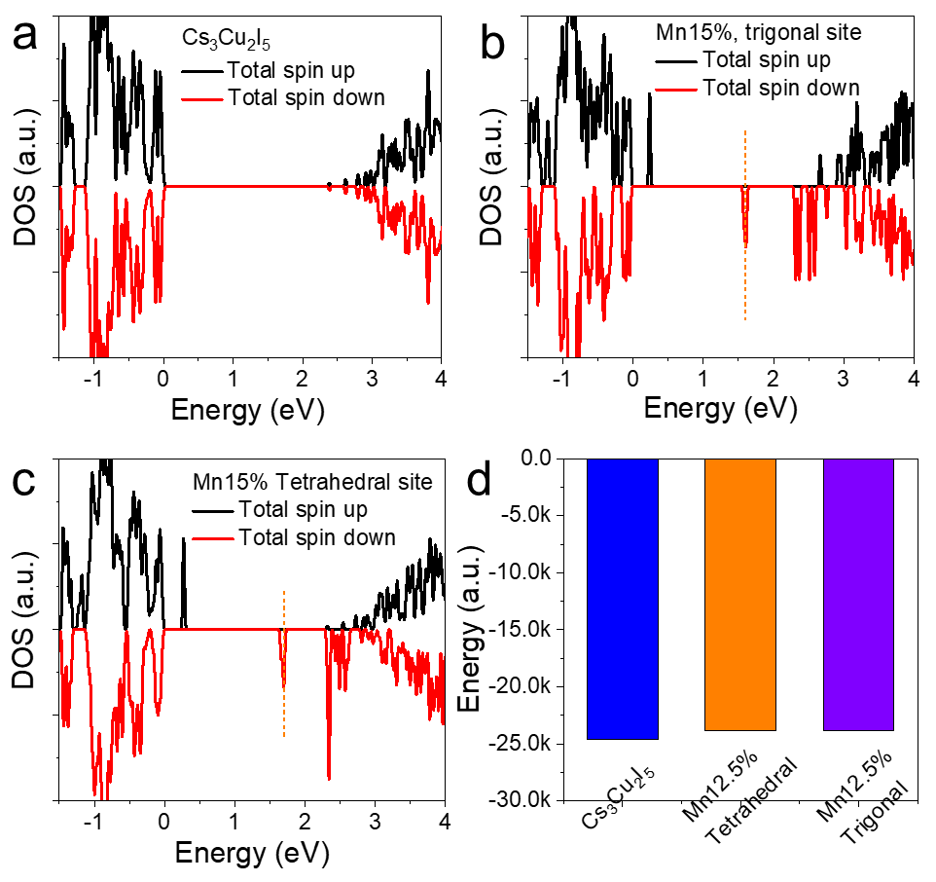
Supplementary Figure 1. Total DOS of (a) intrinsic Cs₃Cu₂I₅, (b) Mn3%, and (c) Mn15%. (d) Calculated system energy of Cs₃Cu₂I₅ and doped Cs₃Cu₂I₅ with different doping sites.
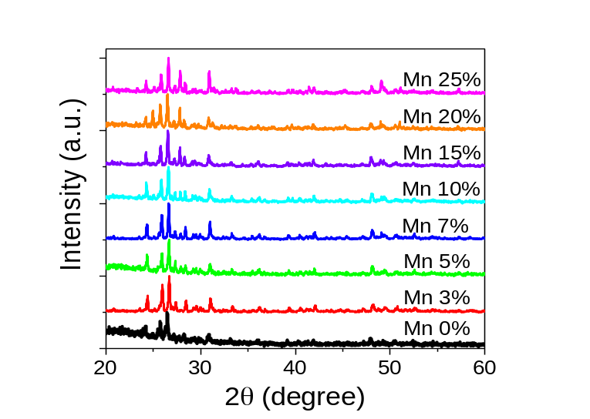
Supplementary Figure 2. XRD patterns with wide diffraction degree range of undoped and doped Cs₃Cu₂I₅ powders.

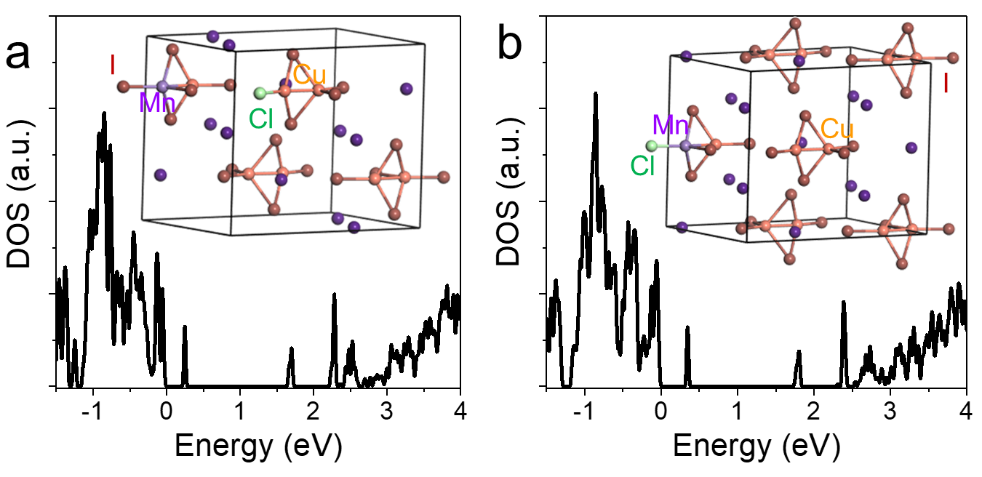
Supplementary Figure 3. Total DOS of Cs₃Cu₂I₅: Mn with co-doping of Cl ions at different sites. We can see the incorporation of Cl ions does not change the electronic structures significantly compared to that in Figure S1 except for the change of band gap. The detailed effects of Cl ions in lattice will be investigated in the future, including both the crystal and optical characteristics.

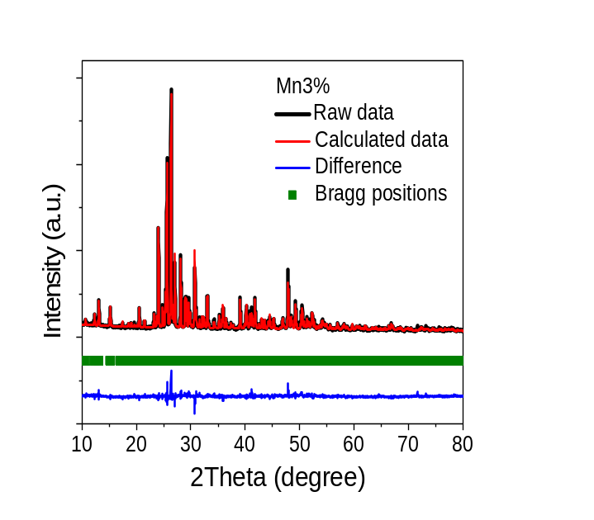
Supplementary Figure 4. Rietveld refinement of Mn3%.

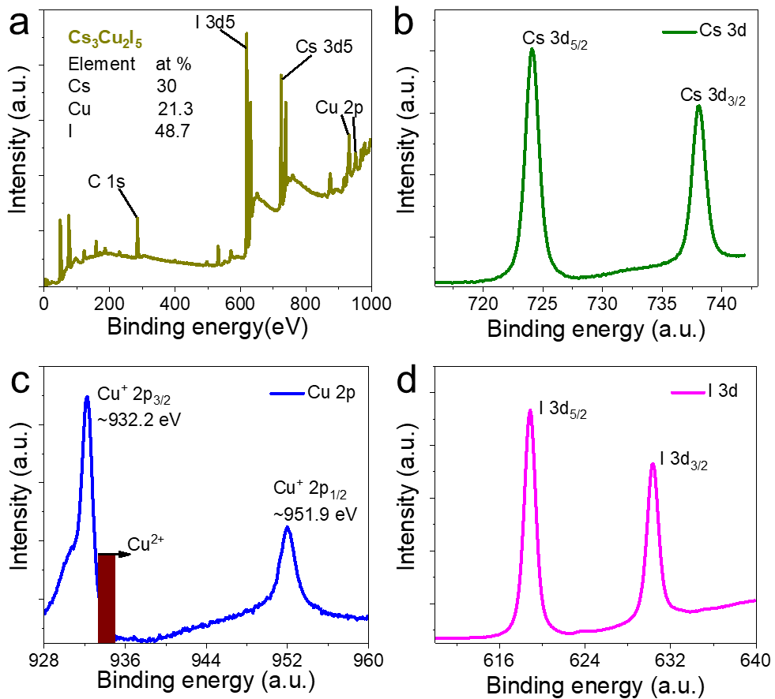
Supplementary Figure 5. XPS results of undoped Cs₃Cu₂I₅. (a) XPS survey spectrum of Cs₃Cu₂I₅ and refined curves of (b) Cs 3d, (c) Cu 2p, and (d) I 3d.

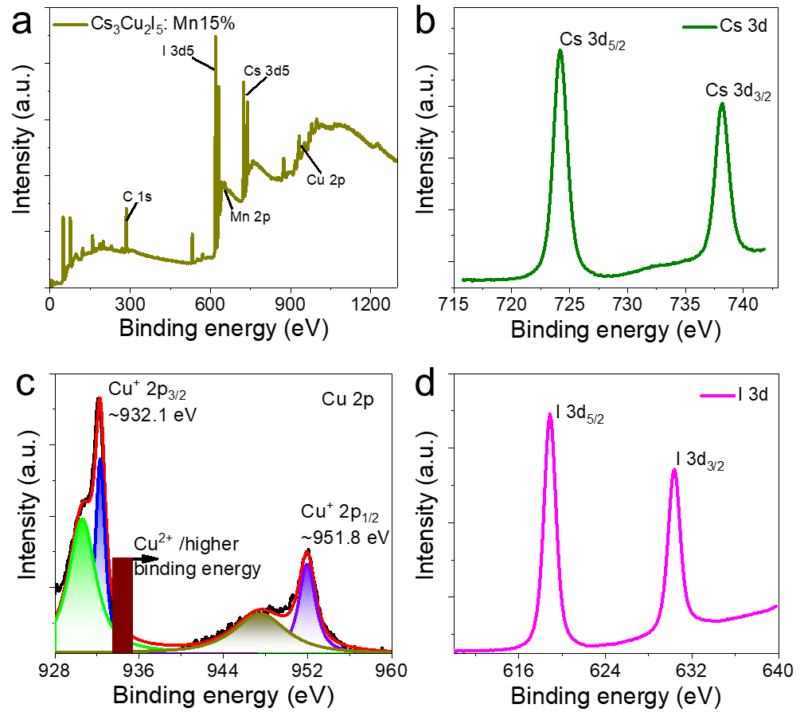
Supplementary Figure 6. XPS results of Cs₃Cu₂I₅: Mn15%. (a) XPS survey spectrum and refined curves of (b) Cs 3d, (c) Cu 2p, and (d) I 3d.

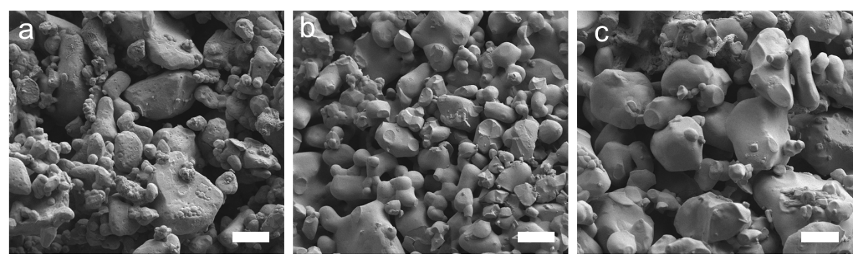
Supplementary Figure 7. SEM images of typical samples with different Mn²⁺ doping concentrations, (a) 0%, (b) 3%, and (c) 15%. The scale bars are 2 μm.

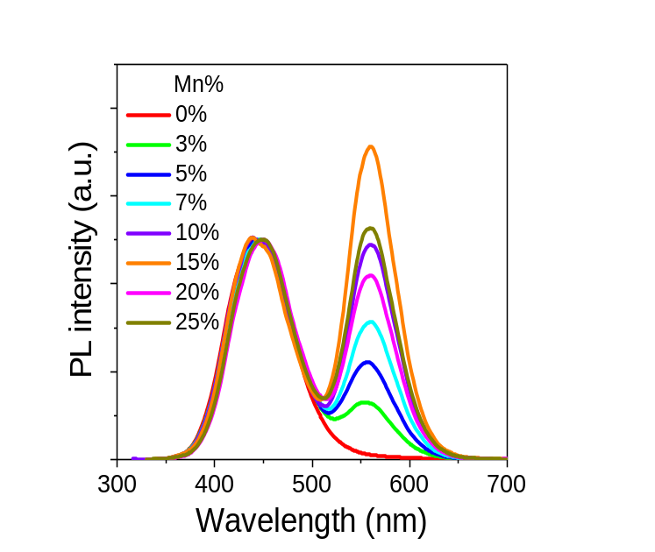
Supplementary Figure 8. Normalized (the intrinsic part) PL spectra of Cs₃Cu₂I₅: Mn with different doping concentrations.
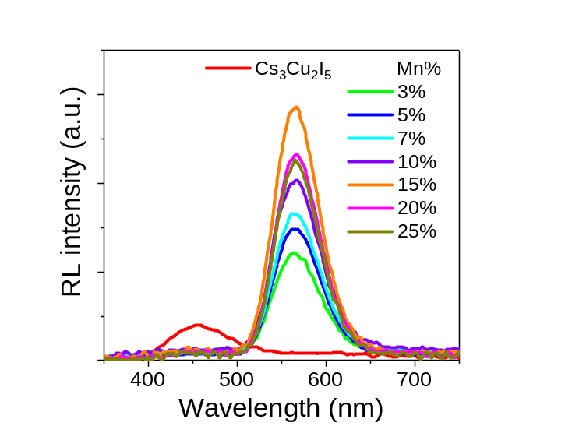
Supplementary Figure 9. RL spectra of Cs₃Cu₂I₅: Mn with different doping concentrations.

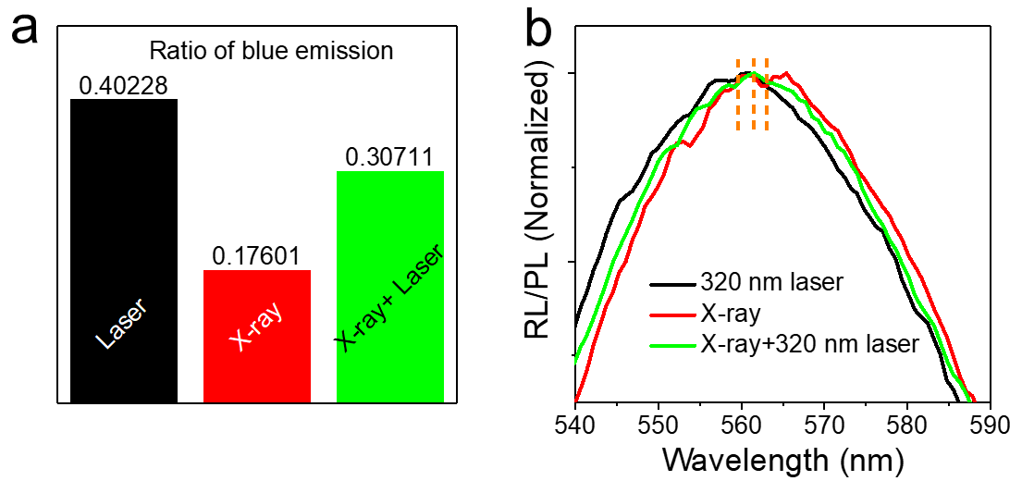
Supplementary Figure 10. (a) The blue emission ratio of curves in Fig. 3a. (b) Enlarged PL and RL spectra of Mn15% film.

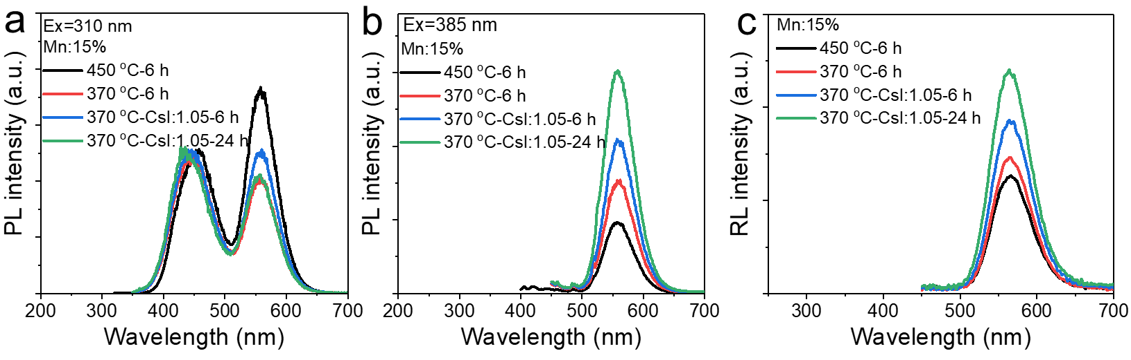
Supplementary Figure 11. Emission spectra of Mn15% with various reaction parameters under different excitations of (a) 310 nm, (b) 385 nm, and (c) X-ray, respectively.

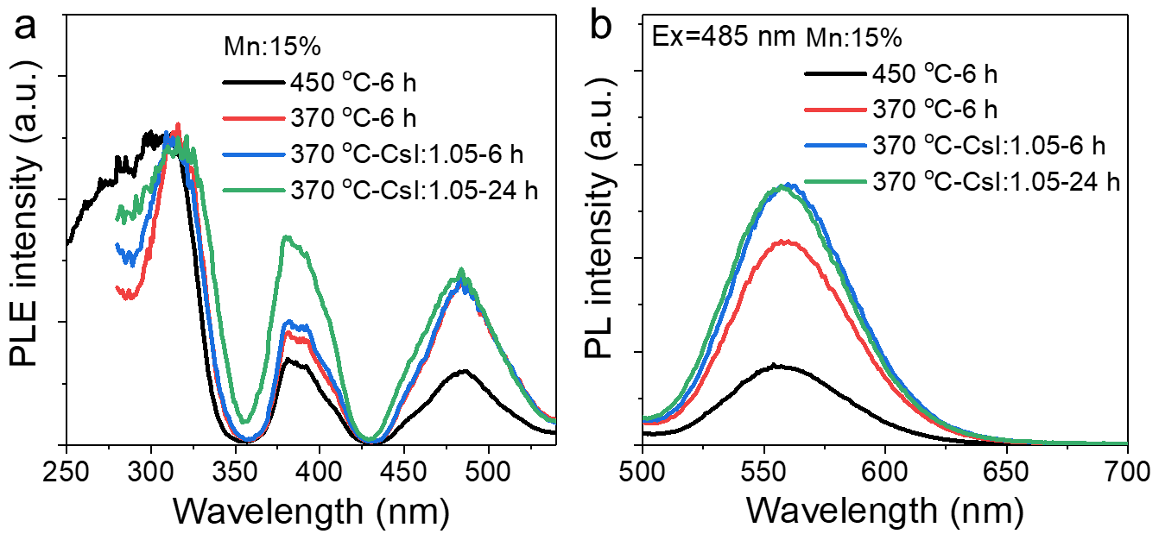
Supplementary Figure 12. (a) PLE spectra of samples with different preparation parameters monitored at 556 nm. Emission spectra of Mn15% with various reaction parameters under excitation of 485 nm light.

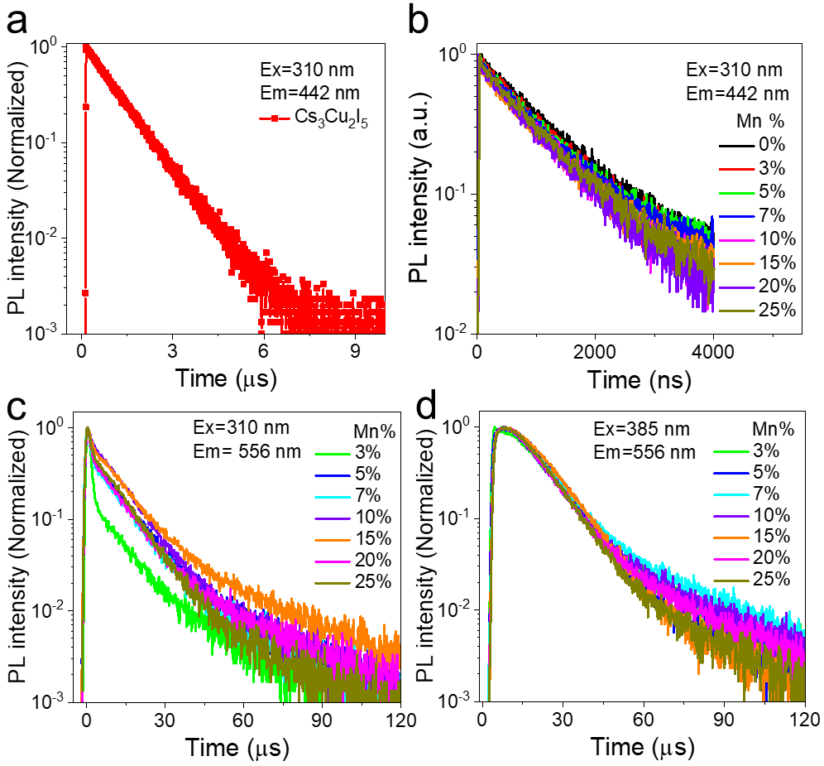
Supplementary Figure 13. PL decay curves of (a) Cs₃Cu₂I₅ and (b) Cs₃Cu₂I₅: Mn with monitor wavelengths of 442 nm under 310 nm pulse light excitation. Decay curves of Cs₃Cu₂I₅: Mn under the excitation of (c) 310 and (d) 385 nm, respectively.
Generally, Mn²⁺ related emission exhibits long PL lifetime to a magnitude of millisecond.³ Herein, not only the intrinsic Cs₃Cu₂I₅ shows a fast decay of 0.96 μs (Fig. S13a) but the Mn²⁺ doped powders also exhibit short average PL lifetime of around ten μs under both indirect and direct excitations (Fig. S13c and d). Such a short luminescence lifetime is adequate for many applications.⁴ The fast PL decay can be assigned to strong spin-orbit coupling resulted from heavier halide.⁵ All the intrinsic blue luminescence show short decay time less than 1 μs (Fig. S13b). It should be noted all the ET related emissions show biexponential decay behavior with both fast and slow recombination routes. On the contrary, directly excited emissions show obvious mono-exponential decay (Fig. S13d). Additionally, the indirectly excited emissions possess shorter decays compared to corresponding results under direct excitations. The detailed lifetime information can be found in Table S3 and S4.

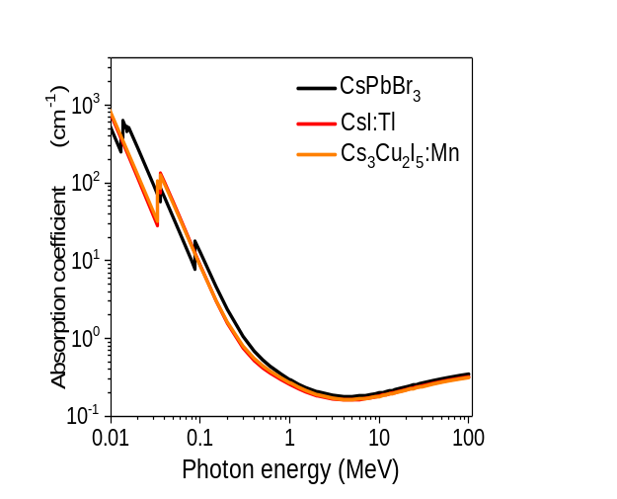
Supplementary Figure 14. Absorption coefficient of different materials as a function of X-ray photon energy.

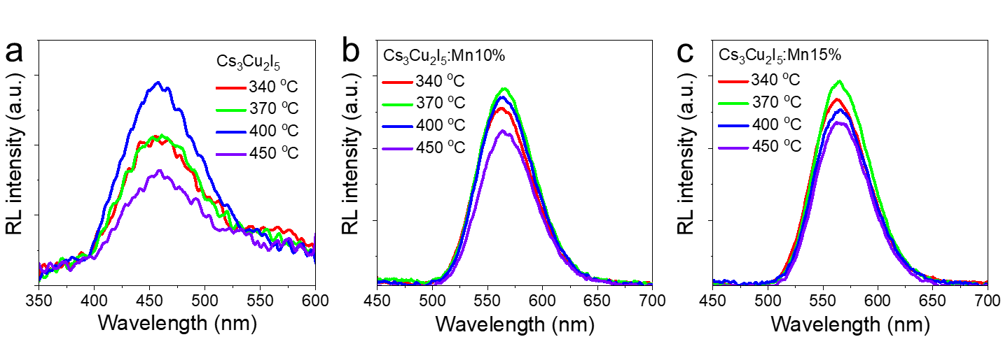
Supplementary Figure 15. RL curves of (a) Cs₃Cu₂I₅, (b) Mn10%, and (c) Mn15% prepared under different reaction temperatures.

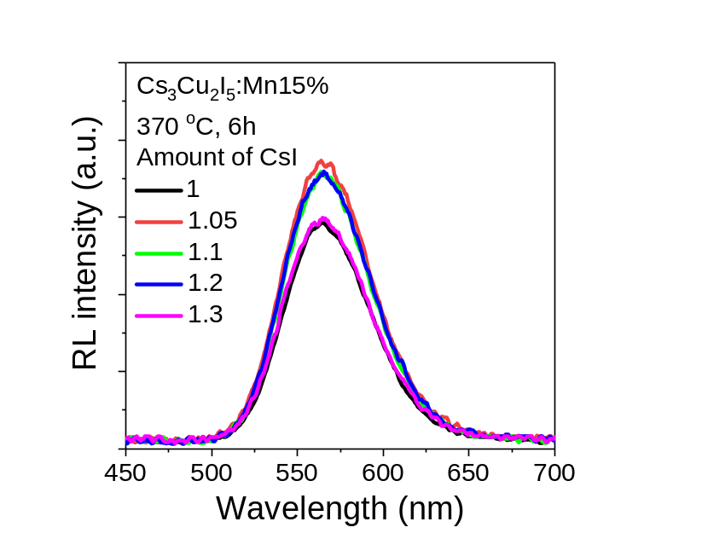
Supplementary Figure 16. RL curves of Mn15% with different CsI mole ratio. All other reaction parameters were kept the same.

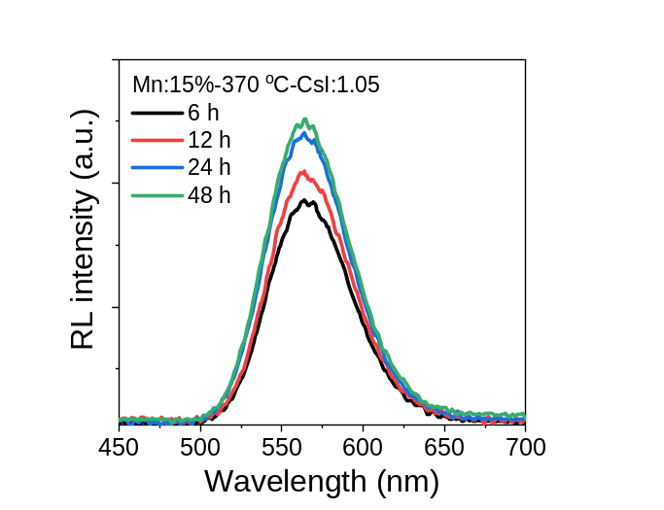
Supplementary Figure 17. RL spectra of Mn15%-CsI 1.05 with different reaction time at 370 ºC.

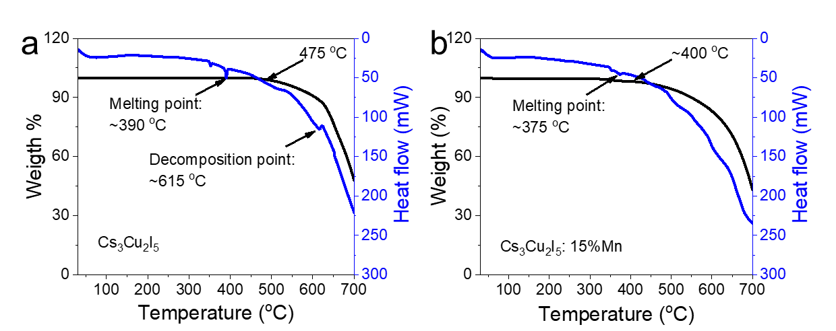
Supplementary Figure 18. Thermal gravimetric analysis (black) and differential scanning calorimetry (blue) TGA/DSC plots for (a) Cs₃Cu₂I₅ and (b) Mn15%.
We can see that doping results in decreased melting point. Additionally, the optimal reaction temperatures are related to melting points that the best RL performance was achieved at 400 ºC for Cs₃Cu₂I₅ while the highest RL intensity was obtained at 370 ºC for Mn15%. In fact, the reaction parameters need more investigations for better performance, which are still under research.

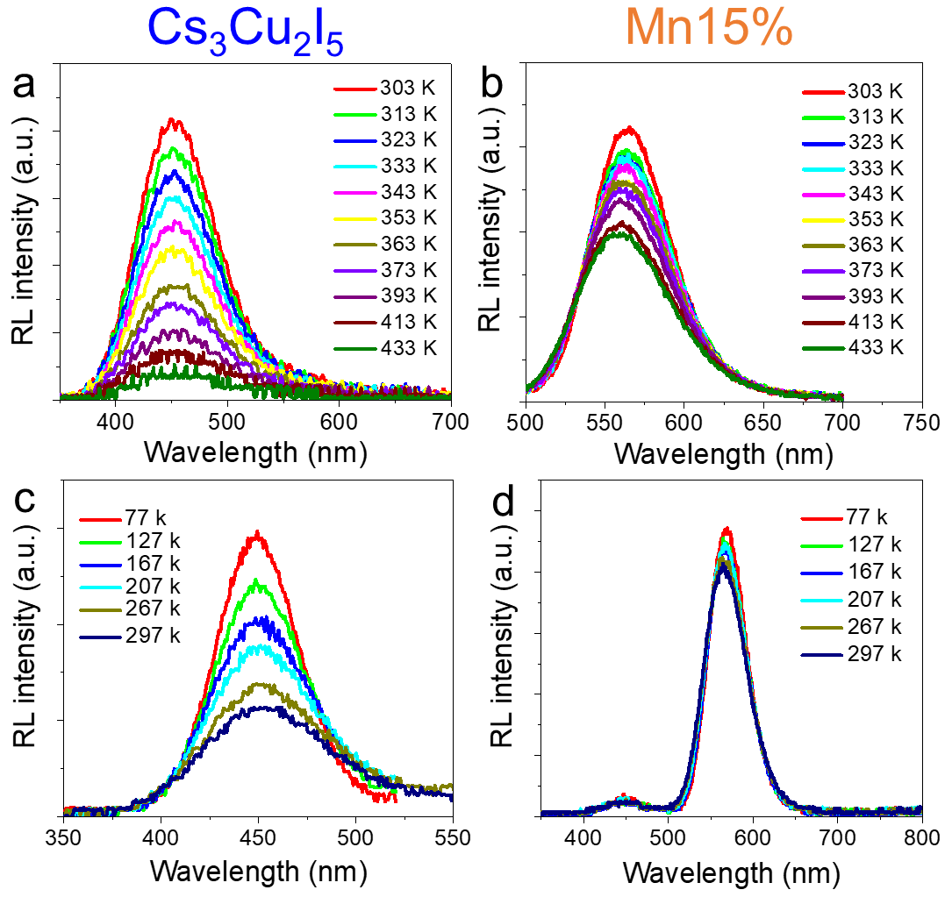
Supplementary Figure 19. RL spectra of (a) Cs₃Cu₂I₅ and (b) Mn15% at elevated temperatures. RL spectra of (c) intrinsic and (d) doped Cs₃Cu₂I₅ at low temperature. Obviously, without doping, the RL intensity increases upon the decrease of temperature, while the RL intensity almost keep the same.

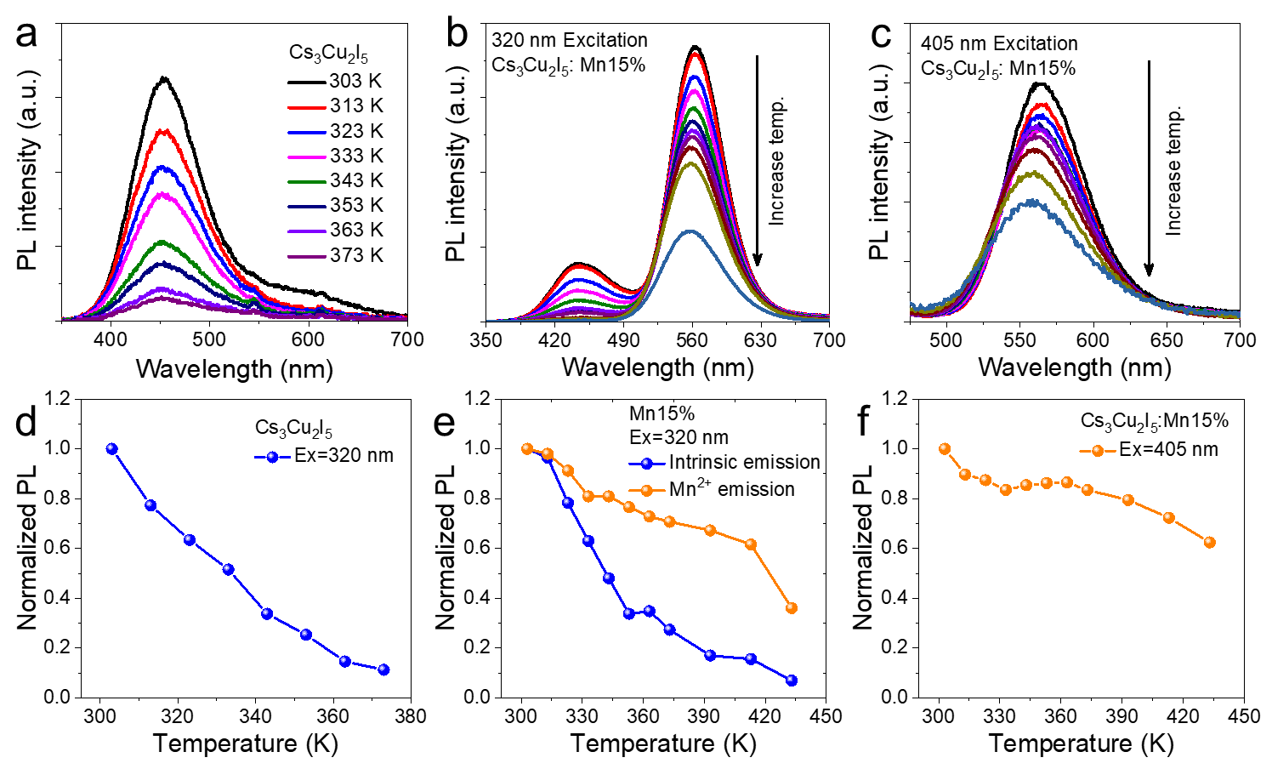
Supplementary Figure 20. Temperature dependent PL spectra of (a) Cs₃Cu₂I₅, (b) Mn15% with 320 nm laser excitation, and (c) Mn15% with 405 nm laser excitation. (d-f) Corresponding PL intensity variation of above three samples versus temperature.
Both samples exhibit PL intensity deterioration with the rise of temperature but obvious difference can be observed. For pure Cs₃Cu₂I₅, the intensity decreased quickly and only ~10% of its initial value maintained at 373 K. When exciting Mn15% with 320 nm laser light, the intrinsic and Mn²⁺ emission intensities decreased simultaneously but the ET induced yellow emission exhibits a much lower rate. Fig. S20c shows the temperature-dependent PL spectra under the direct excitation of Mn²⁺. The intensity first decreased with the increase of temperature, which then exhibited a stable intensity in the range of 333 to 363 K, and around 60% of its initial intensity was reserved at 433 K. ET induced and direct Mn²⁺ emissions possess similar thermal stability. Besides, it seems direct excitation leads to better stability, which is consistent with other Mn²⁺ related halides.⁶ Such robust resistance to temperature can be assigned to the contribution of thermo-assisted exciton ET and high activation energy of thermal quenching,^{4, 7} indicating their potential applications in many fields.

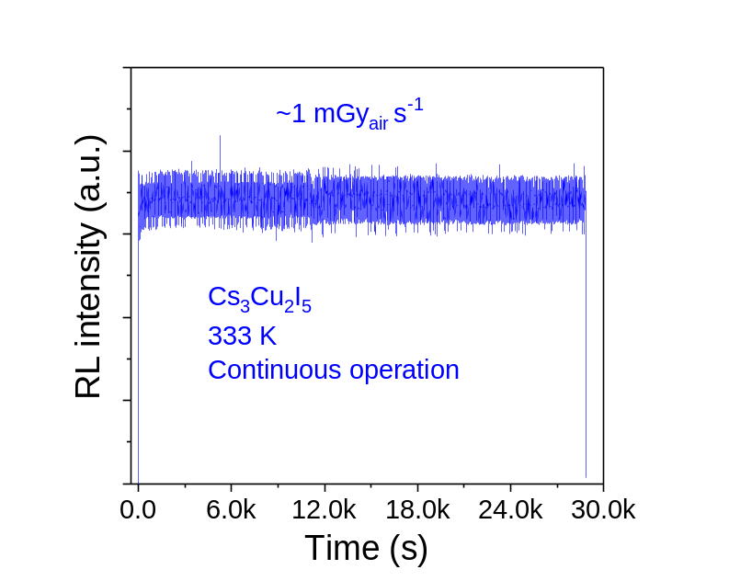
Supplementary Figure 21. RL stability of Cs₃Cu₂I₅ against long-term operation at high temperature (333 K).

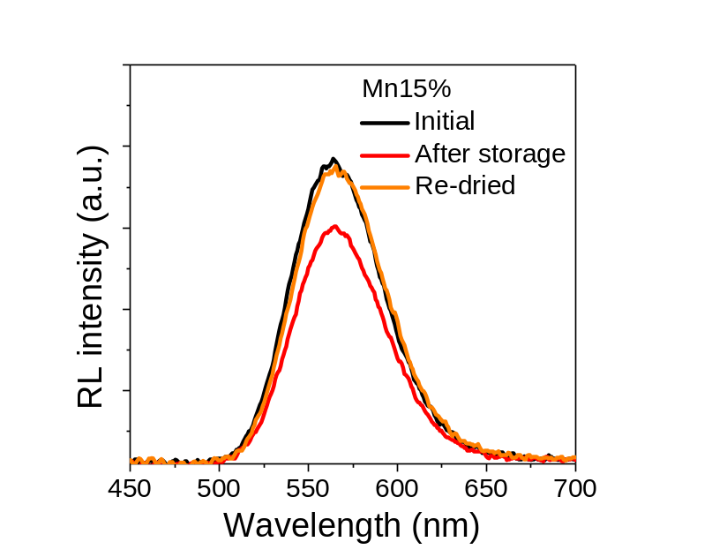
Supplementary Figure 22. RL stabilities of Mn15% after long-term storage.

Supplementary Table S1. Main parameters of processing, refinement, and fractional atomic coordinates of the Mn3% and Mn15% samples.

Formula |  | Cs₃Cu₂I₅:Mn²⁺(3%) |  |  | Cs₃Cu₂I₅:Mn²⁺(15%)
Space group |  | Pbnm (62) orthorhombic
Cell  parameters |  | a=14.3462  b=10.1589  c=11.6369  v=1696.00 |  |  | a=14.3573  b=10.1613  c=11.6445  v=1698.80
Reliability  factors |  | Rp=5.55  Rwp=7.03  χ²=2.86 |  |  | Rp=3.46  Rwp=5.21  χ²=4.19
Cs₃Cu₂I₅:Mn²⁺(3%) halides
Atoms | x |  | y | z |  | occupancy
I2 | 0.79251 |  | 0.84335 | 0.75000 |  | 0.57068
Cs2 | 0.67741 |  | 1.05330 | 0.98935 |  | 1.14268
Cu1 | 0.63139 |  | 0.75634 | 0.75000 |  | 0.49155
Cs1 | 0.44929 |  | 0.40016 | 0.75000 |  | 0.52933
I1 | 0.55315 |  | 0.69025 | 0.56129 |  | 1.17250
I4 | 0.28017 |  | 0.70106 | 0.75000 |  | 0.55978
Cu2 | 0.45207 |  | 0.79094 | 0.75000 |  | 0.49324
I3 | 0.48786 |  | 1.03319 | 0.75000 |  | 0.56410
Mn1 | 0.63139 |  | 0.75634 | 0.75000 |  | 0.00845
Mn2 | 0.45207 |  | 0.79094 | 0.75000 |  | 0.00676
Cs₃Cu₂I₅:Mn²⁺(15%) halides
Atoms | x |  | y | z |  | occupancy
I2 | 0.79518 |  | 0.83911 | 0.75000 |  | 0.62482
Cs2 | 0.67969 |  | 1.06108 | 0.99148 |  | 1.14403
Cu1 | 0.62996 |  | 0.76144 | 0.75000 |  | 0.49715
Cs1 | 0.45327 |  | 0.39830 | 0.75000 |  | 0.49395
I1 | 0.55100 |  | 0.69088 | 0.55929 |  | 1.11281
I4 | 0.27805 |  | 0.70018 | 0.75000 |  | 0.51262
Cu2 | 0.44708 |  | 0.79052 | 0.75000 |  | 0.41738
I3 | 0.48823 |  | 1.02854 | 0.75000 |  | 0.60761
Mn1 | 0.44708 |  | 0.79052 | 0.75000 |  | 0.08262
Mn2 | 0.62996 |  | 0.76144 | 0.75000 |  | 0.00285

Supplementary Table S2. Detailed QY results of samples with different Mn²⁺ doping concentrations under both indirect and direct excitations.
Samples | QY/310 nm (%) | QY/385 nm (%)
Cs₃Cu₂I₅ | 38.3 | --
Mn3%  Mn5% | 10.6  11.6 | 2.7  2.8
Mn7% | 16.5 | 3.4
Mn10%  Mn15% | 18.1  23.1 | 8.7  10.3
Mn20% | 12.9 | 4.9
Mn25% | 11.7 | 5.8
Mn15%-370 ºC | 23.3 | 14.6
Mn15%-370 ºC/1.05/6 h | 28.1 | 18.4
Mn15%-370 ºC /1.05/24 h | 29.9 | 22.7

Supplementary Table S3. PL decay of samples with different Mn²⁺ doping concentrations under indirect (310 nm) excitations with a monitor peak of 442 nm.
Samples | Lifetime (ns)
Cs₃Cu₂I₅ | 960
Mn3%  Mn5% | 904  863
Mn7% | 852
Mn10%  Mn15% | 850  833
Mn20%  Mn25% | 857  860

Supplementary Table S4. PL decay of samples with different Mn²⁺ doping concentrations under indirect (310 nm) or direct (385 nm) excitations with a monitor peak of 556 nm.

Samples | Lifetime/310 nm (μs) | τ_{average}  (μs) | Lifetime /385 nm (μs)
Cs₃Cu₂I₅ | 0.96 | -- | --
Mn3%  Mn5% | 1.03/46.1%, 13.48/53.9%  1.27/13.9%,  12.08/86.1% | 7.74  10.58 | 16.84  15.01
Mn7% | 1.10/11.9%,  12.53/88.1% | 11.14 | 14.95
Mn10%  Mn15% | 0.99/6.2%, 12.42/93.8%  0.95/4.6%,  11.40/95.4% | 11.71  10.92 | 16.09  13.02
Mn20%  Mn25% | 1.08/12.2%,  11.44/87.8%  1.27/9.4%,  11.38/90.6% | 10.17  10.42 | 13.25  13.43

Reference
1. Kresse, G. & Hafner, J. Ab initio molecular dynamics for liquid metals. Physical Review B 47, 558-561 (1993).
2. Perdew, J.P., Burke, K. & Ernzerhof, M. Generalized Gradient Approximation Made Simple. Physical Review Letters 77, 3865-3868 (1996).
3. Xie, R.-J., Hirosaki, N., Liu, X.-J., Takeda, T. & Li, H.-L. Crystal structure and photoluminescence of Mn2+–Mg2+ codoped gamma aluminum oxynitride (γ-AlON): A promising green phosphor for white light-emitting diodes. Applied Physics Letters 92, 201905 (2008).
4. Du, P., Luo, L. & Cheng, W. Neoteric Mn2+-activated Cs3Cu2I5 dazzling yellow-emitting phosphors for white-LED. Journal of the American Ceramic Society 103, 1149-1155 (2020).
5. Morad, V. et al. Manganese(II) in Tetrahedral Halide Environment: Factors Governing Bright Green Luminescence. Chemistry of Materials 31, 10161-10169 (2019).
6. Su, B., Molokeev, M.S. & Xia, Z. Mn2+-Based narrow-band green-emitting Cs3MnBr5 phosphor and the performance optimization by Zn2+ alloying. Journal of Materials Chemistry C 7, 11220-11226 (2019).
7. Ni, J. et al. Novel luminescent properties and thermal stability of non-rare-earth Ca-α-sialon:Mn2+ phosphor. Journal of Luminescence 202, 514-522 (2018).

