Supplementary Figures
(see attached document for supplementary tables)
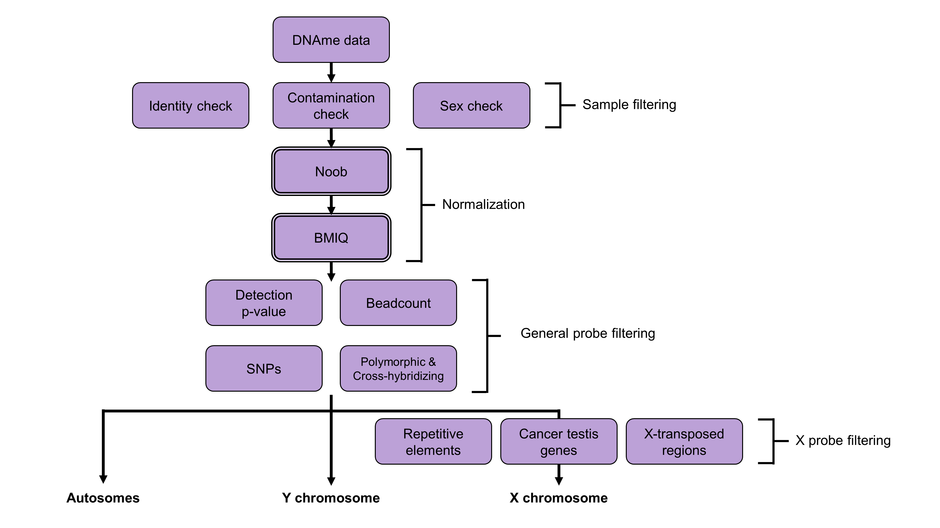 Supplementary figure 1. Illumina DNAme data QC and processing for autosomes and X/Y.

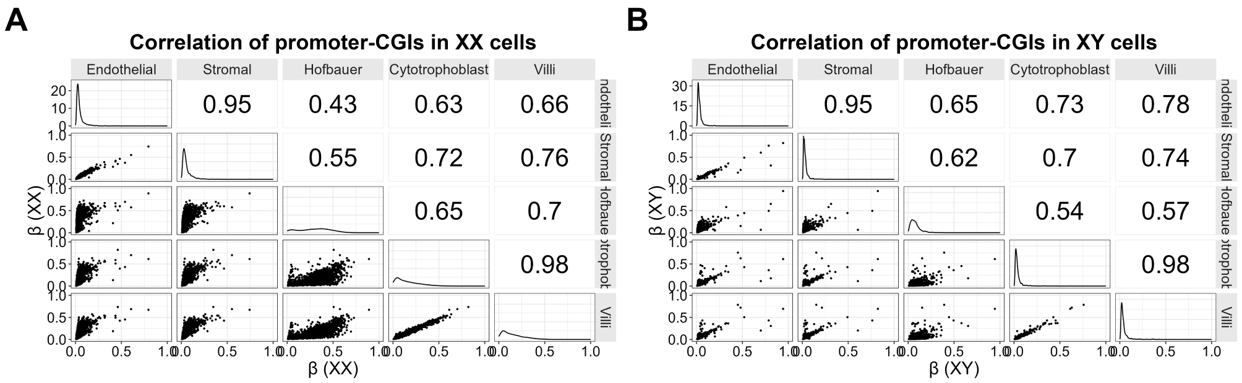
Supplementary figure 2. DNAme correlation of the X-chromosome in XX and XY placental cells. (A) Correlation of promoter-CGIs in XX cells. (B) Correlation of promoter-CGIs in XY cells.

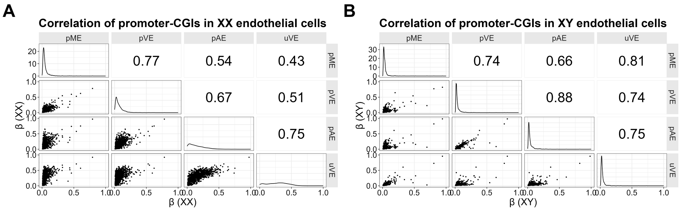
Supplementary figure 3. DNAme correlation of the X-chromosome in XX and XY placental and umbilical endothelial cells. (A) Correlation of promoter-CGIs in XX cells. (B) Correlation of promoter-CGIs in XY cells.

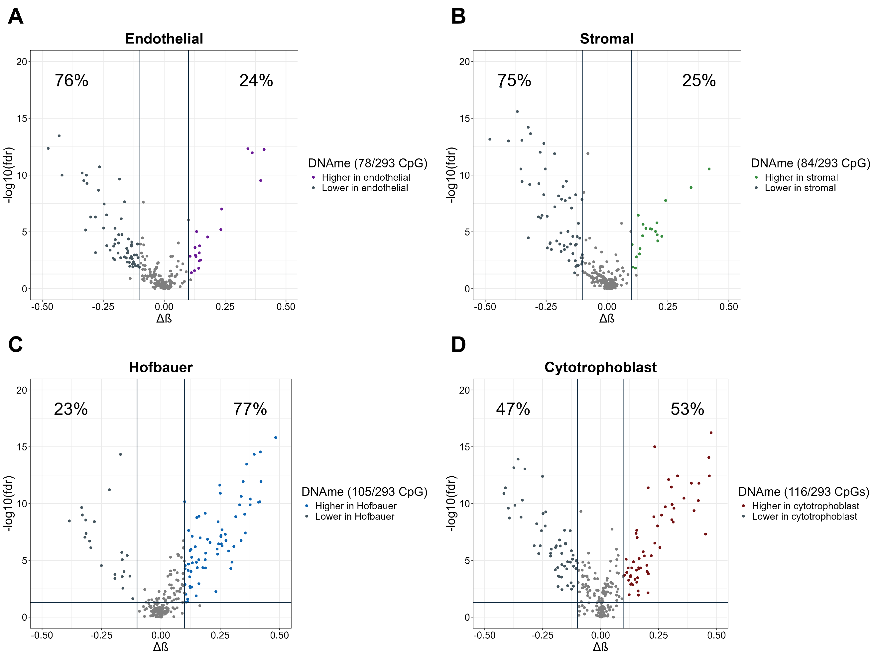
Supplementary figure 4. Volcano plots of cell-influenced differentially methylated CpGs (DMCs) in the Y-chromosome showing higher and lower DNAme in a given cell type versus the average of other cell types. (A) Cell-influenced DMCs of endothelial cells in the Y-chromosome (n_{CpGs} = 78). (B) Cell-influenced DMCs of stromal cells in the Y-chromosome (n_{CpGs} = 84). (C) Cell-influenced DMCs of the Hofbauer cells in the Y-chromosome (n_{CpGs} = 105). (D) Cell-influenced DMCs of cytotrophoblast in the Y-chromosome (n_{CpGs} = 116).

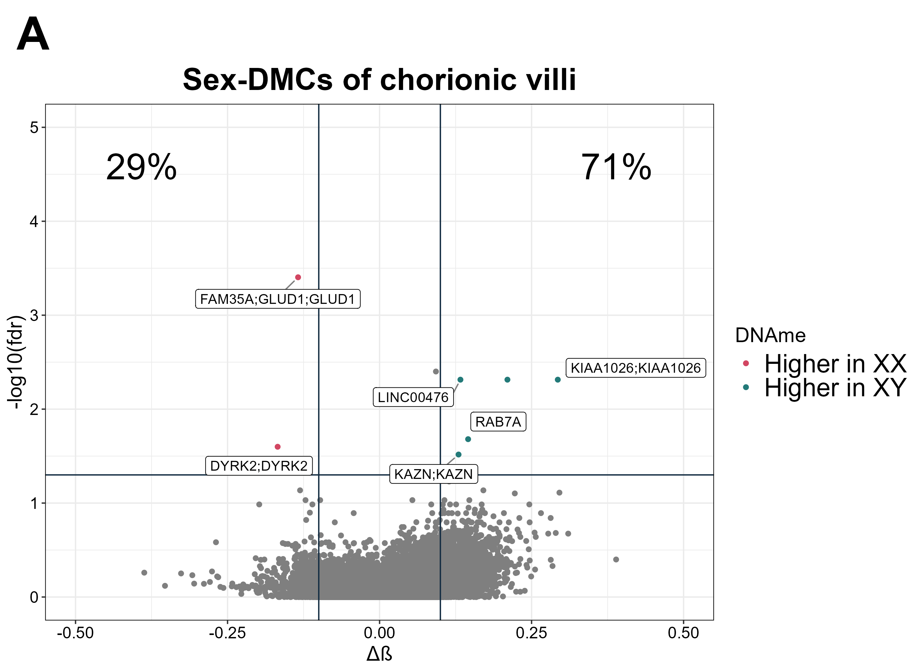
Supplementary figure 5. Volcano plots of sex-influenced differentially methylated autosomal CpGs (DMCs) in whole chorionic villi. (A) Sex-DMCs of chorionic villi.

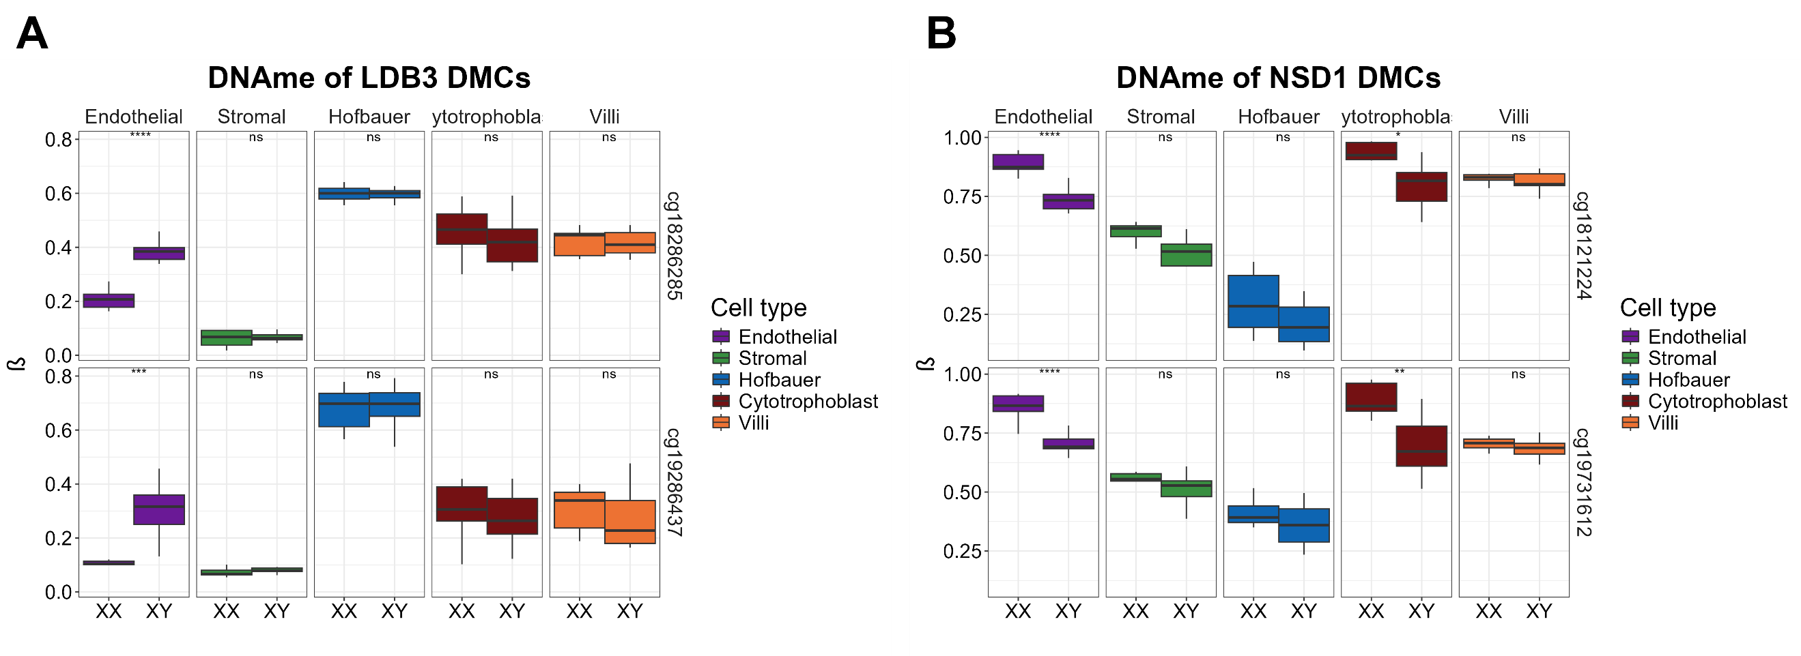
Supplementary figure 6. Average DNAme of significant sex-DMCs for LDB3 and NSD1 genes. (A) Average DNAme of LDB3 DMCs. (B) Average DNAme of NSD1 DMCs.

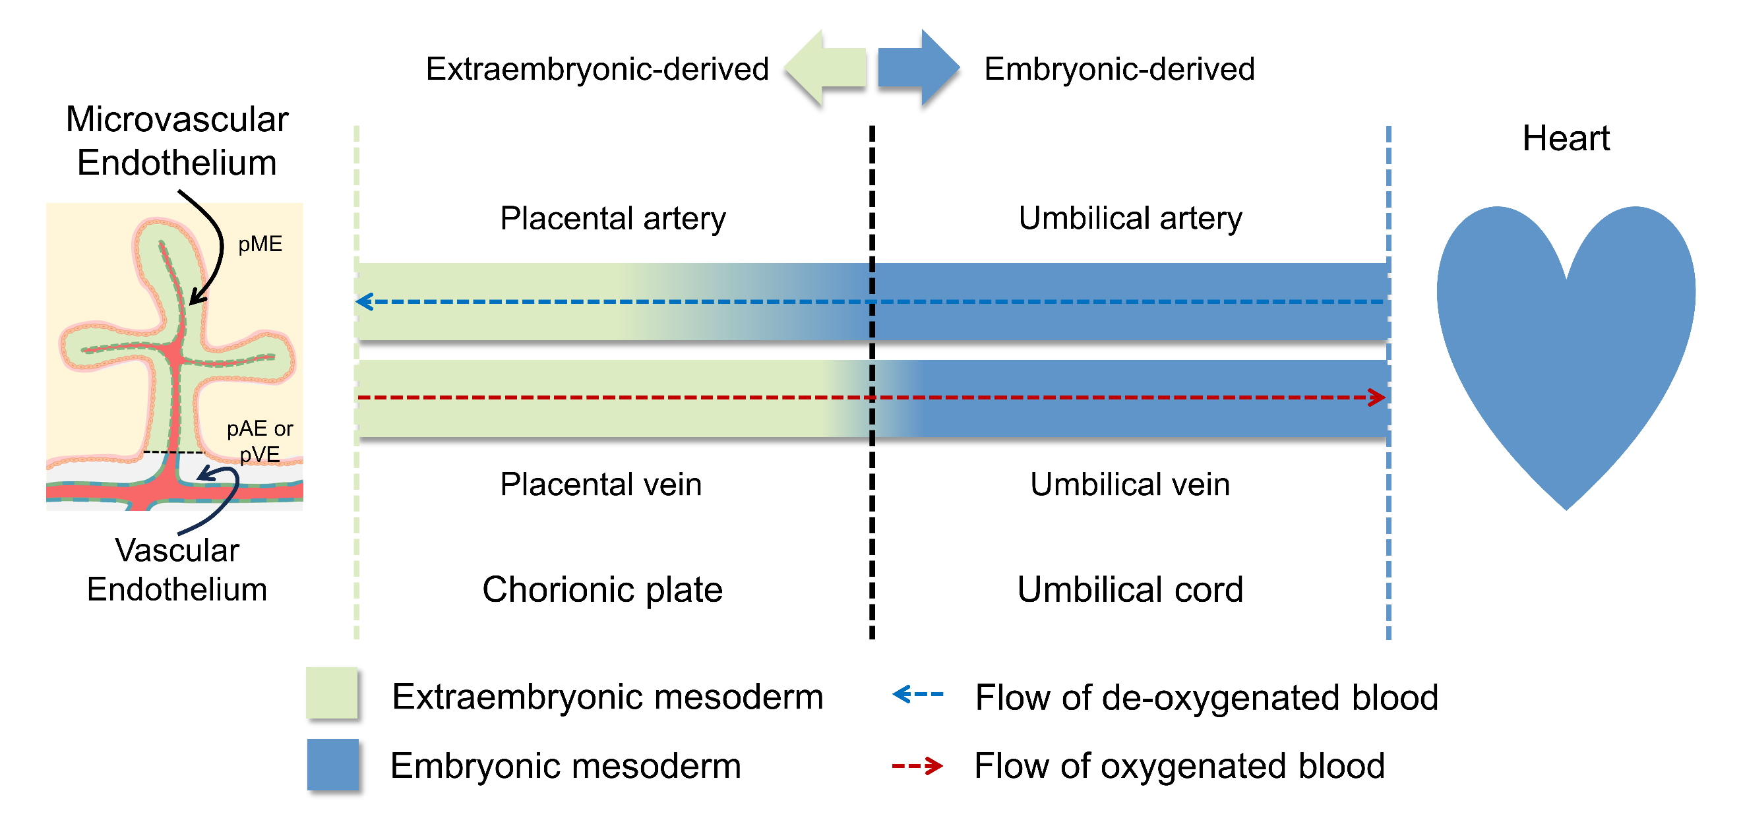
Supplementary figure 7. Expected projection of embryonic and extraembryonic origin derived vessels.

