Overcoming IGF1R-Mediated Resistance to Oncolytic HSV1 and Radiotherapy via Triple Combination Therapy

Alexandra A. Miller^{1,2*}, Min-Hye Noh^{1*}, Jin Muk Kang^{1,3}, Jiyeon Kim¹, Amanda S. Kouaho¹, Grace Nguyen^{1,4}, Minxin Huang^{1,5}, Stephanie M. Bean¹, Sunil Krishnan^{1,2}, Zhongming Zhao^{2,6}, E. Antonio Chiocca⁷, Tae Jin Lee^{1,2#}, and Ji Young Yoo^{1,2#}
¹Department of Neurosurgery, McGovern Medical School, The University of Texas Health Science Center at Houston, Houston, TX, 77030, USA. ²The University of Texas MD Anderson Cancer Center UTHealth Houston Graduate School of Biomedical Sciences, Houston, TX 77225, USA. ³Department of Pediatric Hematology & Oncology, University Hospitals Cleveland Medical Center, Cleveland, OH, 44106, USA. ⁴Southwestern Graduate School of Biomedical Sciences, The University of Texas, Dallas, TX, 75235, USA. ⁵Molecular and Cellular Pharmacology Program, Stony Brook University Graduate School, Stony Brook, NY, 11794, USA ⁶Center for Precision Health, McWilliams School of Biomedical Informatics, The University of Texas Health Science Center at Houston, Houston, TX 77030, USA. ⁷Department of Neurosurgery, Mass General Brigham and Harvard Medical School, Boston, MA, 02115, USA.

Supplementary Western Blot Proofs.
Original image of Western blotting analysis. Sample orders are given from left to right.
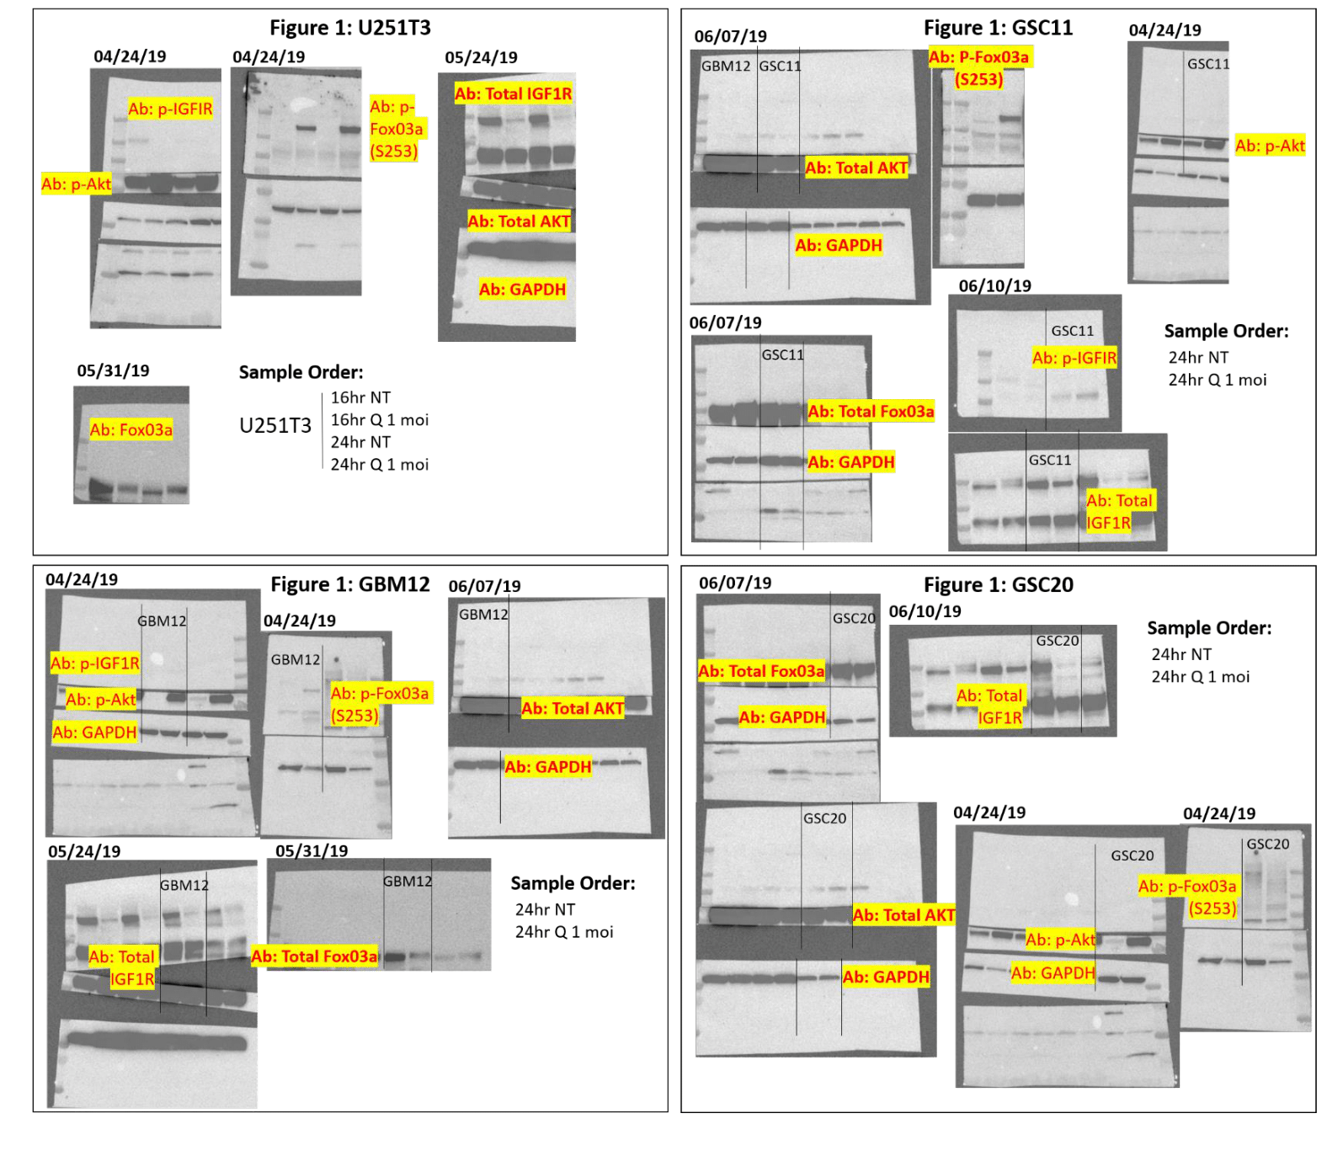
Figure 2: GBM12
Figure 2: GSC20
Figure 2: GSC11
Figure 2: U251T3

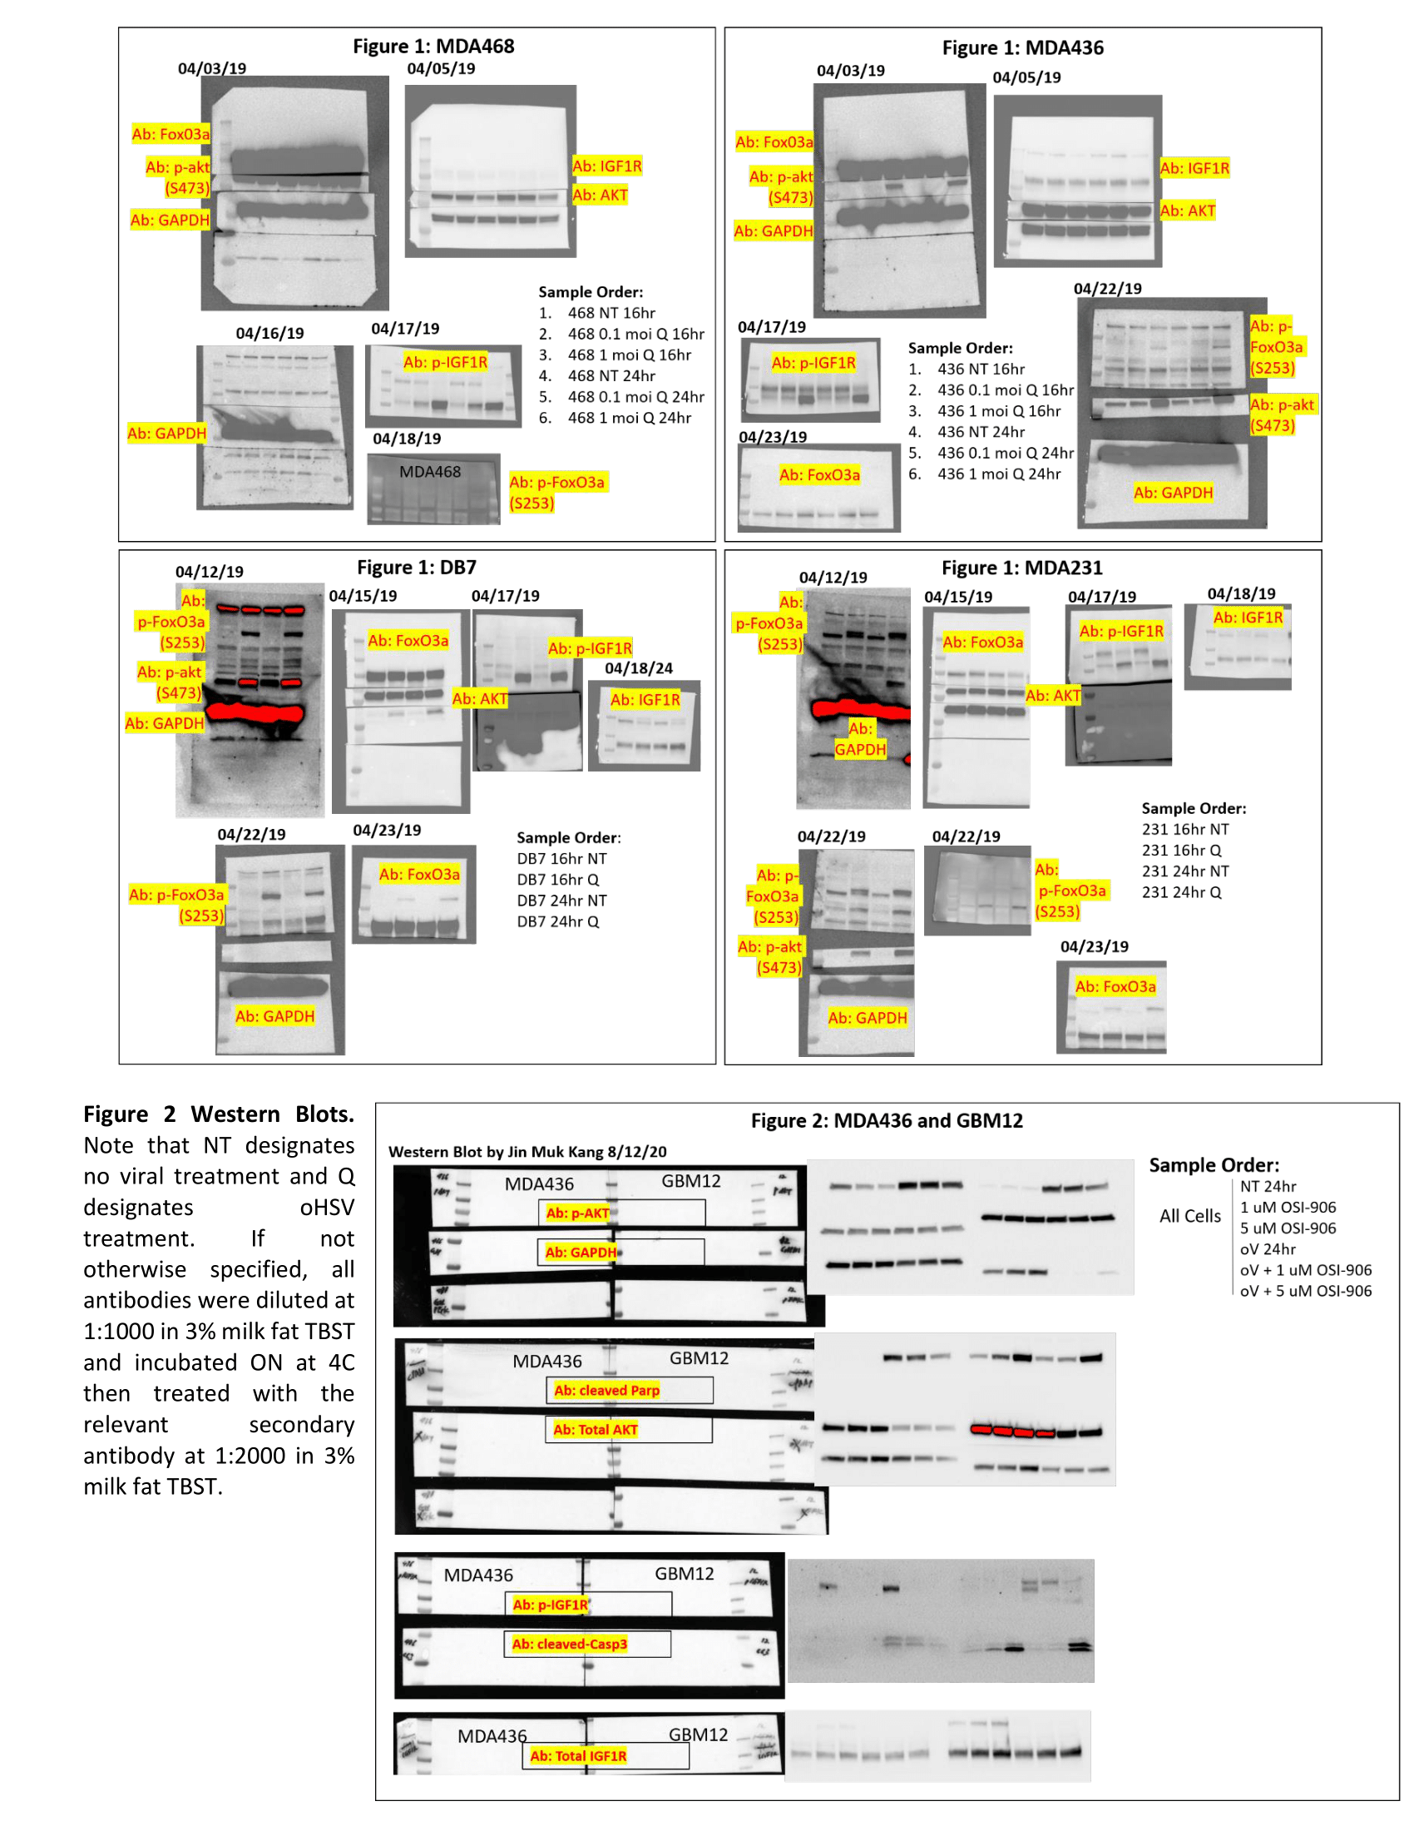
Figure 2: DB7
Figure 2: MDA231
Figure 2: MDA436
Figure 2: MDA468
Figure 3: MDA436 and GBM12
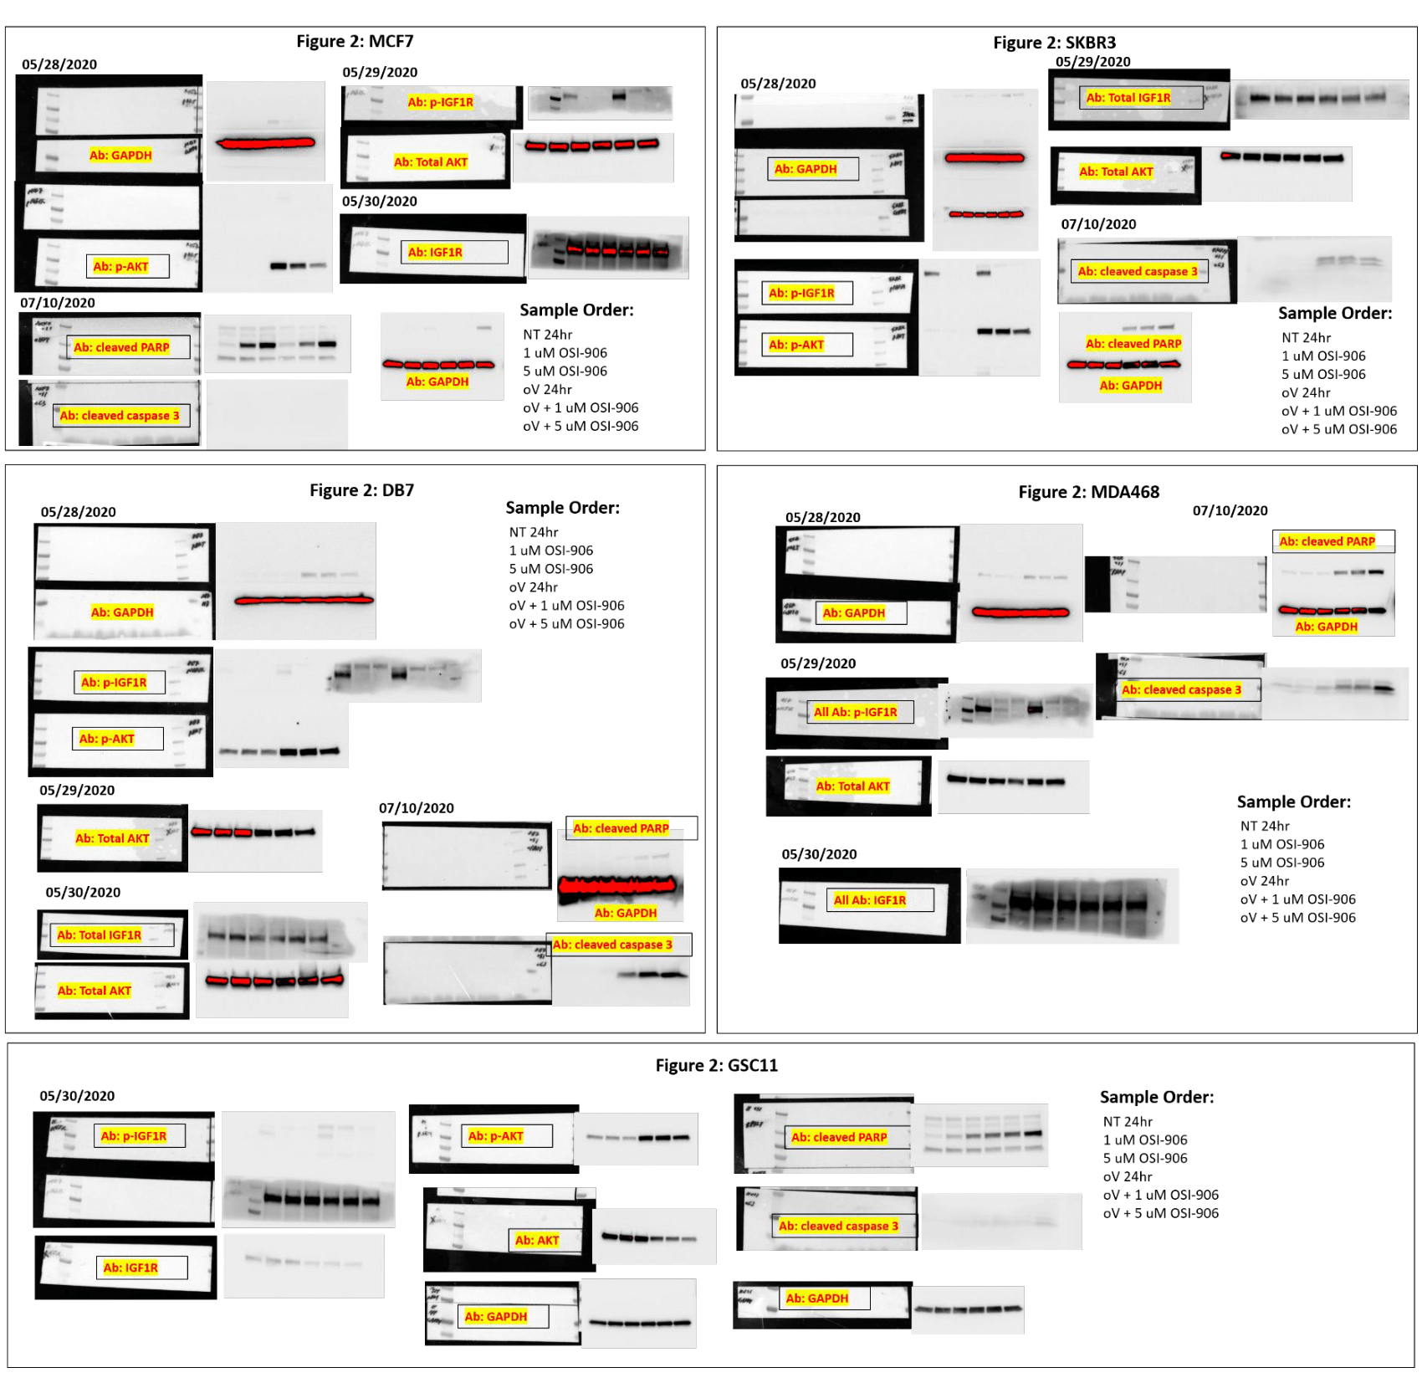
Figure 3: SKBR3
Figure 3: MCF7
Figure 3: DB7
Figure 3: MDA468
Figure 3: GSC11

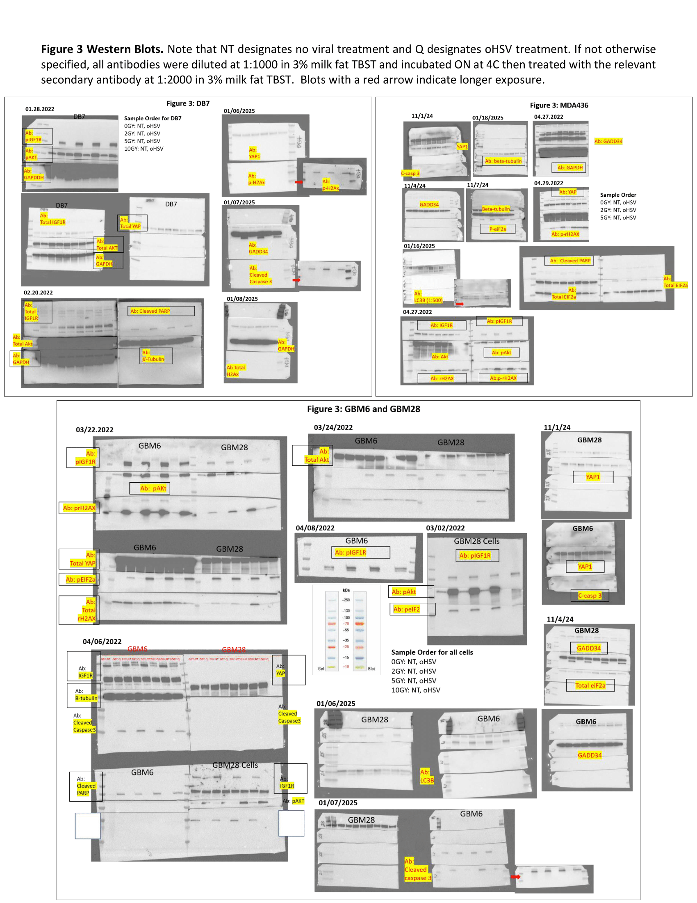
Figure 4: MDA436
Figure 4: DB7
Figure 4:
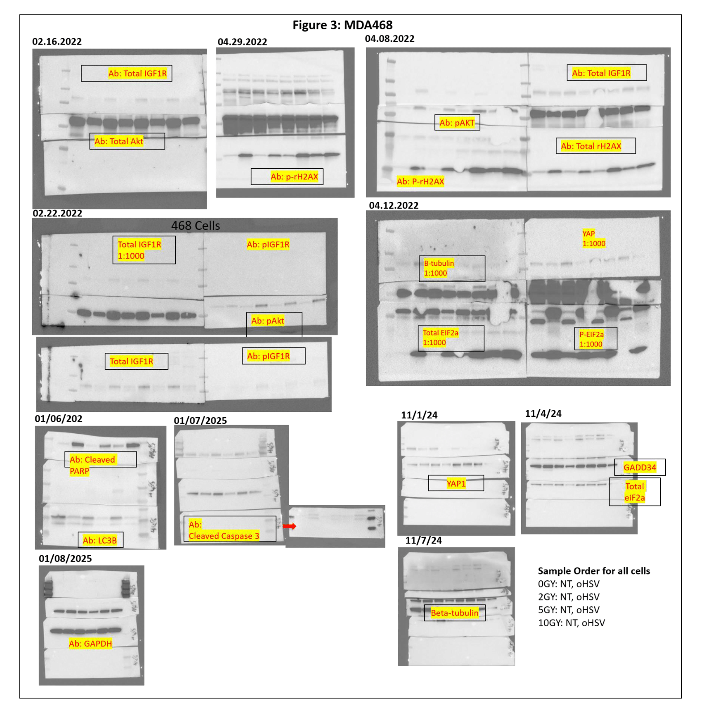
Figure 4:

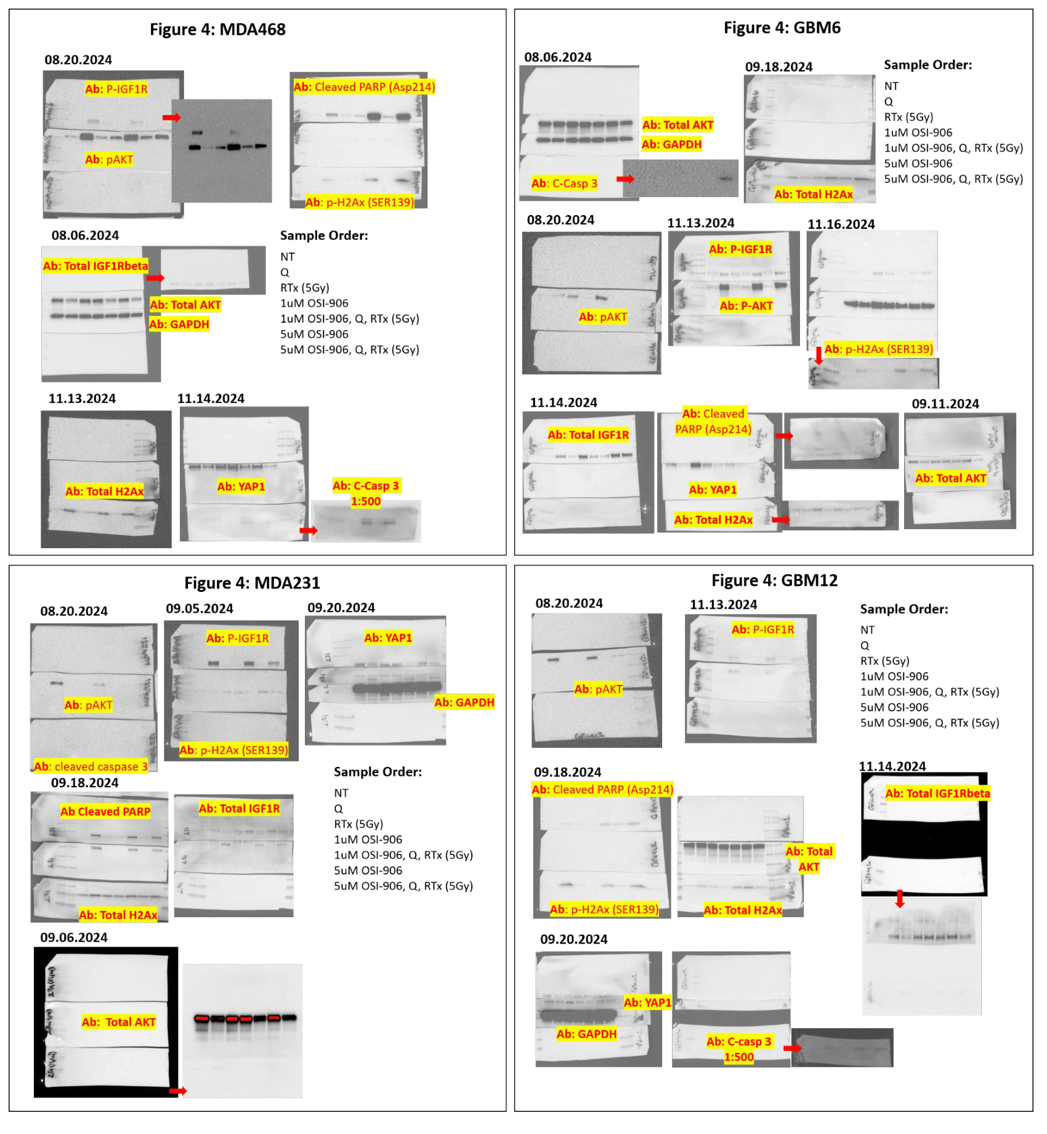
Figure 5:
Figure 5:
Figure 5:
Figure 5:

