Supplementary Materials

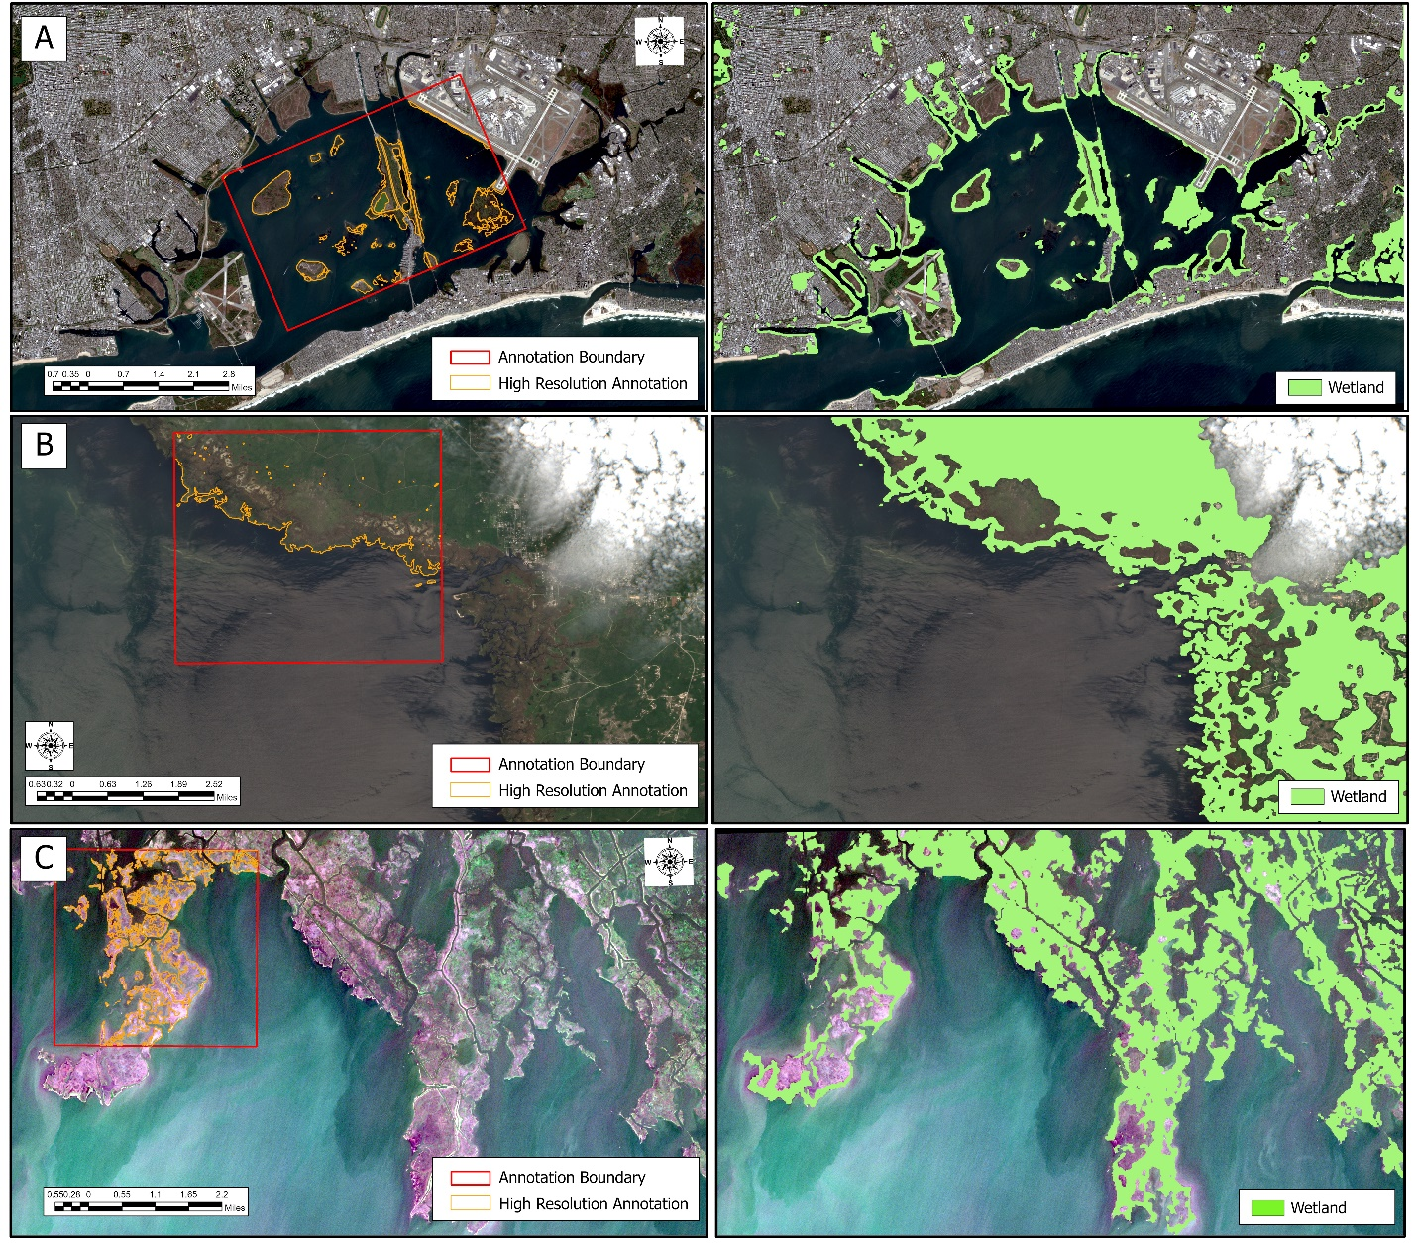
Figure S1. A comparison of the Sentinel-2 imagery with the segmented images of Jamaica Bay (A), the Big Bend region (B), and south of Pointe aux Chenes (C) using the DeepLabV3+ paired with the dice loss function. Note how the model overestimates the wetland extent compared to the ResUNet34 model, particularly in the urban regions. For the purposes of illustration, the non-wetlands class has been masked.
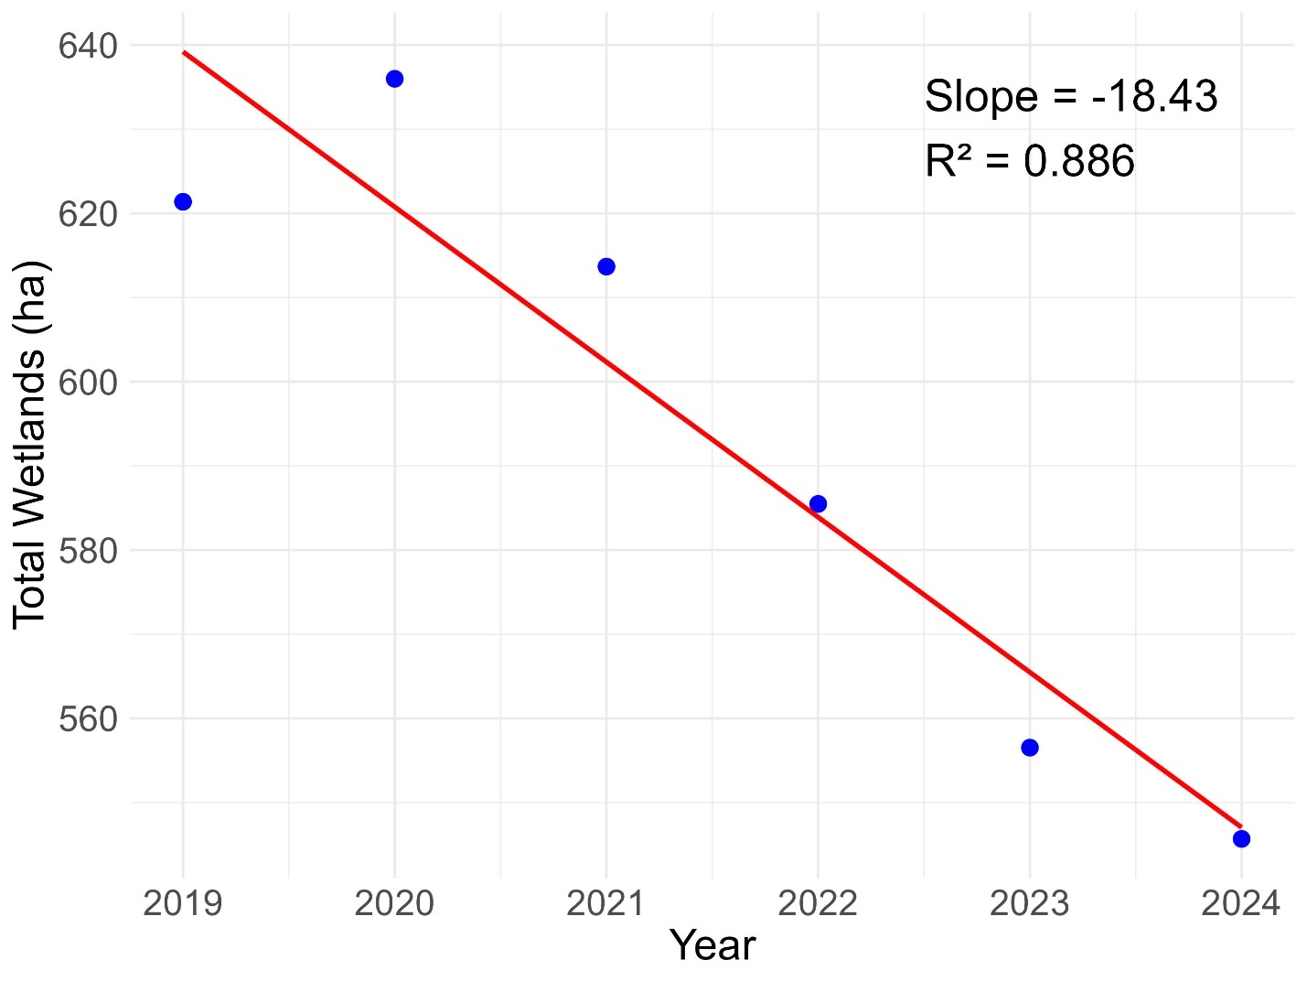
Figure S2. Plot of wetland areas detected by Swamp-Eye for all islands in Jamaica Bay in the five-year period of 2019 – 2024. Shown in red is the line of best fit, the slope of this line was used to estimate annual change in the extent of these wetlands.
Table S1. The training and validation performance of the 15 candidate models.
 | Loss Function | Validation IoU | Validation OA (%) | Validation Loss | Training IoU | Training OA (%) | Training Loss
ResUNet34 | BCE + Dice | 0.85 | 0.92 | 0.66 | 0.79 | 0.90 | 0.76
ResUNet34 | BCE | 0.88 | 0.94 | 0.19 | 0.78 | 0.90 | 0.25
ResUNet34 | Dice | 0.75 | 0.86 | 1.34 | 0.59 | 0.75 | 1.47
ResUNet34 | Focal + Dice | 0.88 | 0.93 | 1.45 | 0.72 | 0.85 | 1.60
ResUNet34 | Focal | 0.71 | 0.83 | 0.03 | 0.73 | 0.88 | 0.03
DeepLabV3+ | BCE + dice | 0.78 | 0.88 | 0.68 | 0.75 | 0.88 | 0.79
DeepLabV3+ | BCE | 0.93 | 0.96 | 0.15 | 0.75 | 0.88 | 0.28
DeepLabV3+ | Dice | 0.83 | 0.91 | 1.36 | 0.61 | 0.77 | 1.48
DeepLabV3+ | Focal + Dice | 0.56 | 0.72 | 1.58 | 0.78 | 0.90 | 1.57
DeepLabV3+ | Focal | 0.79 | 0.88 | 0.02 | 0.64 | 0.84 | 0.03
ResNet18 | BCE + Dice | 0.82 | 0.90 | 0.77 | 0.79 | 0.90 | 0.78
ResNet18 | BCE | 0.74 | 0.85 | 0.36 | 0.79 | 0.90 | 0.27
ResNet18 | Dice | 0.77 | 0.87 | 1.35 | 0.62 | 0.78 | 1.51
ResNet18 | Focal + Dice | 0.80 | 0.89 | 1.55 | 0.76 | 0.88 | 1.58
ResNet18 | Focal | 0.55 | 0.72 | 0.04 | 0.72 | 0.88 | 0.03

Table S2. The test set performance of the five top-performance candidate models at each of the three test locations.
 | Model | Loss Function | Overall Accuracy (%) | Producer Accuracy (%) | User Accuracy (%) | IoU
Big Bend | DeepLabV3+ | Dice | 0.89 | 0.76 | 0.98 | 0.75
Big Bend | DeepLabV3+ | BCE | 0.59 | 0.05 | 0.96 | 0.05
Big Bend | ResUNet | Focal + Dice | 0.89 | 0.74 | 1.00 | 0.74
Big Bend | ResUNet | BCE | 0.82 | 0.59 | 1.00 | 0.59
Big Bend | ResUNet | BCE + Dice | 0.68 | 0.27 | 1.00 | 0.27
Jamaica Bay | DeepLabV3+ | Dice | 0.97 | 0.83 | 0.78 | 0.67
Jamaica Bay | DeepLabV3+ | BCE | 0.96 | 0.59 | 0.85 | 0.53
Jamaica Bay | ResUNet | Focal + Dice | 0.98 | 0.85 | 0.86 | 0.75
Jamaica Bay | ResUNet | BCE + Dice | 0.97 | 0.74 | 0.87 | 0.66
Jamaica Bay | ResUNet | BCE | 0.97 | 0.66 | 0.94 | 0.63
Point aux Chenes | DeepLabV3+ | BCE | 0.92 | 0.70 | 0.91 | 0.66
Point aux Chenes | DeepLabV3+ | Dice | 0.92 | 0.82 | 0.81 | 0.69
Point aux Chenes | ResUNet | BCE + Dice | 0.96 | 0.86 | 0.92 | 0.80
Point aux Chenes | ResUNet | BCE | 0.95 | 0.85 | 0.92 | 0.80
Point aux Chenes | ResUNet | Focal + Dice | 0.95 | 0.79 | 0.94 | 0.75

