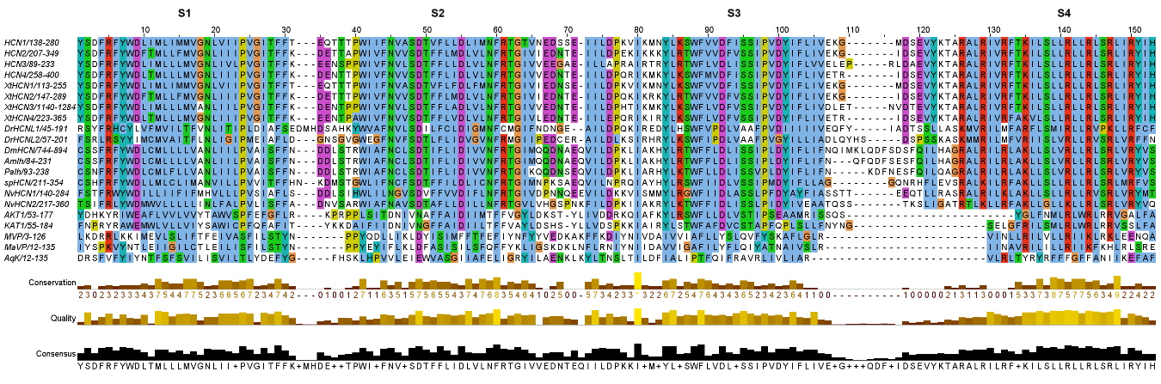
Suppl. Fig. 1. Multiple sequence alignment of channels showing similarity with Hyperpolarization-Activated Cyclic Nucleotide-Gated (HCN) channels, comparing the four transmembrane segments from the voltage sensor domain (VSD) present in channels showing de cyclic nucleotide binding domain (CNBD) in bacteria (AqK), archaebacterial channels lacking the CNBD (MVP, MaVP), plant ion channels (KAT1, AKT1), two putative HCN channels from the sea anemone Nematostella vectensis (NvHCN1 and NvHCN2), sea urchin (spHCN), HCN channels from Drosophila melanogaster (DmHCN), Apis mellifera (AmIh), lobster (PaIh), HCN-like channels from zebrafish (DrHCNL1 and DrHCNL2), HCN channels from Xenopus tropicalis (XtHCN1-4) and human (HCN1-4) viewed in Jalview. Residues are colored using clustalW standars.

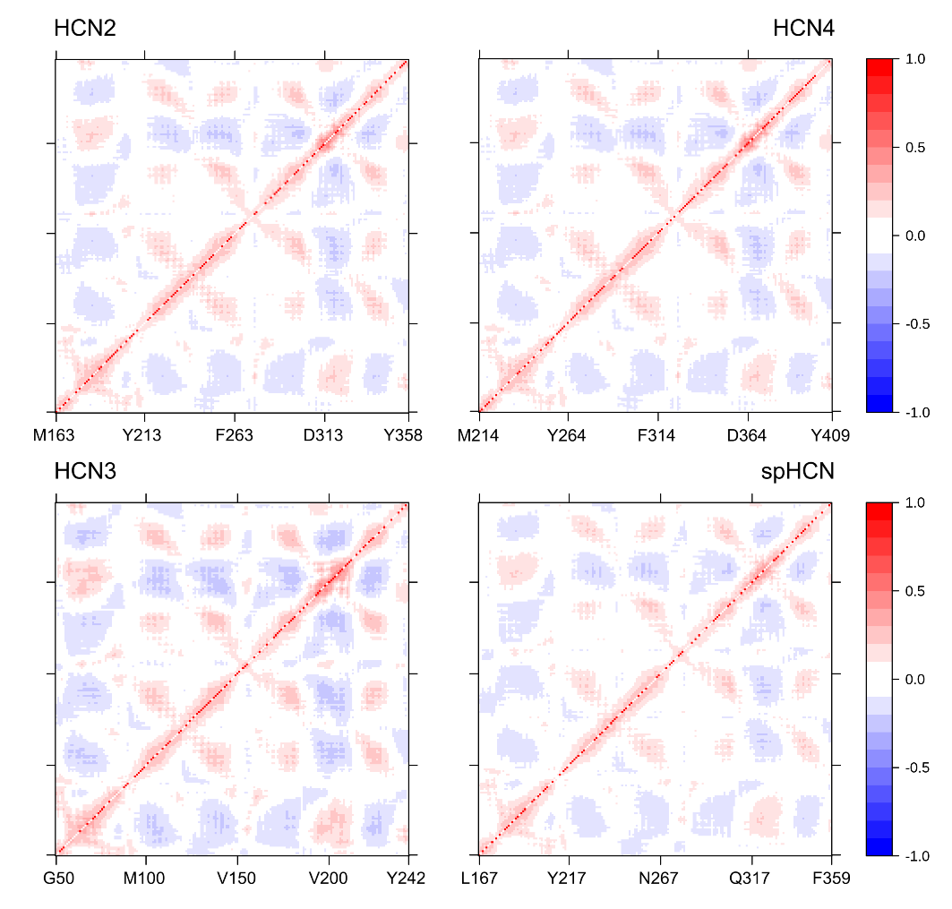
Suppl. Fig. 3. Dynamic cross-correlation maps (DCCM) predicted by DynaMut for Cα atoms around their mean positions in the HCND-VSD domain of four selected HCN channels. Each correlation map reveals correlated/flexible (red) and anticorrelated/rigid (blue) regions in the structure of each structure.

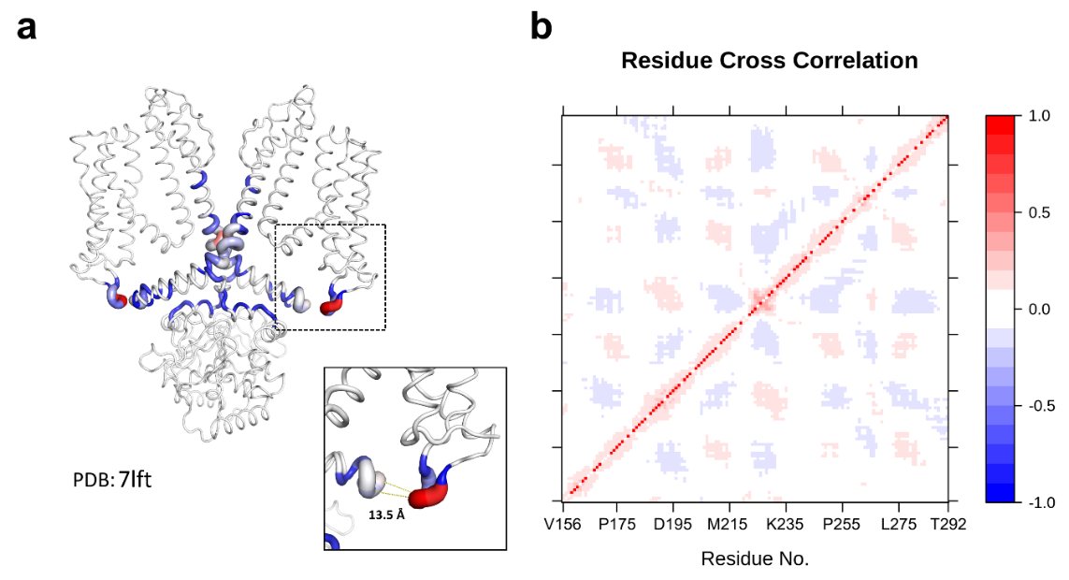
Suppl. Fig. 4. DCCM predicted by DynaMut for the cyclic nucleotide-gated channel CNGA1 in the absence of cAMP and in the presence of K⁺/Ca²⁺.

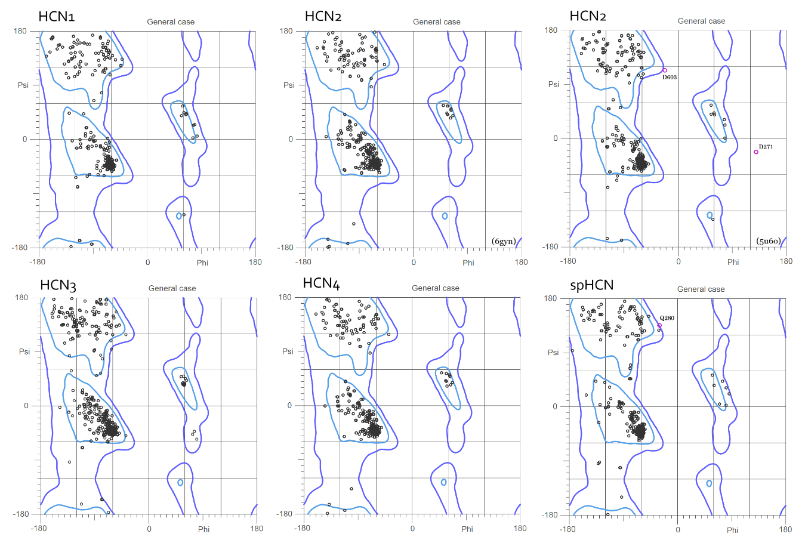
Suppl. Fig. 4. Ramachandran plot of HCN channels generated using the Swiss-Model server. Residue D271 in HCN2 is located in the S2-S3L linker as well as Q280 in spHCN, a region of relative mobility in these proteins.

Suppl. Table 1. Sequence identity of VSDs in the four HCN isoforms of human channels
Pair | Identity  (%) | Overlapping residues | Score | Gap Frequency  (%)
HCN1/HCN2 | 80.9 | 141 | 607 | 0.0
HCN1/HCN3 | 73.4 | 143 | 549 | 1.4
HCN1/HCN4 | 82.3 | 141 | 608 | 0.0
HCN2/HCN3 | 77.6 | 143 | 573 | 1.4
HCN2/HCN4 | 89.4 | 141 | 654 | 0.0
HCN3/HCN4 | 80.4 | 143 | 591 | 1.4

