Supplementary Material: Thermoregulation in two syntopic Galápagos land iguanas: the role of microhabitat selection and skin pigmentation

Lorenzo Garizio¹, Marco Gargano¹⁻², Paolo Gratton³, Silvio Marta⁴, Giuliano Colosimo³, Christian Sevilla⁵, Leonardo Vignoli⁶, Monica Carosi⁶, Gabriele Gentile³

¹PhD Program in Evolutionary Biology and Ecology, Department of Biology, University of Rome Tor Vergata, Rome, Italy
²Department of Life and Environmental Sciences, Marche Polytechnic University, Ancona, Italy
³Department of Biology, University of Rome Tor Vergata, Rome, Italy
⁴Institute of Geosciences and Earth Resources, CNR, Pisa, Italy
⁵Galápagos National Park Directorate, Galápagos, Ecuador
⁶Department of Sciences, Roma Tre University, 00146 Rome, Italy
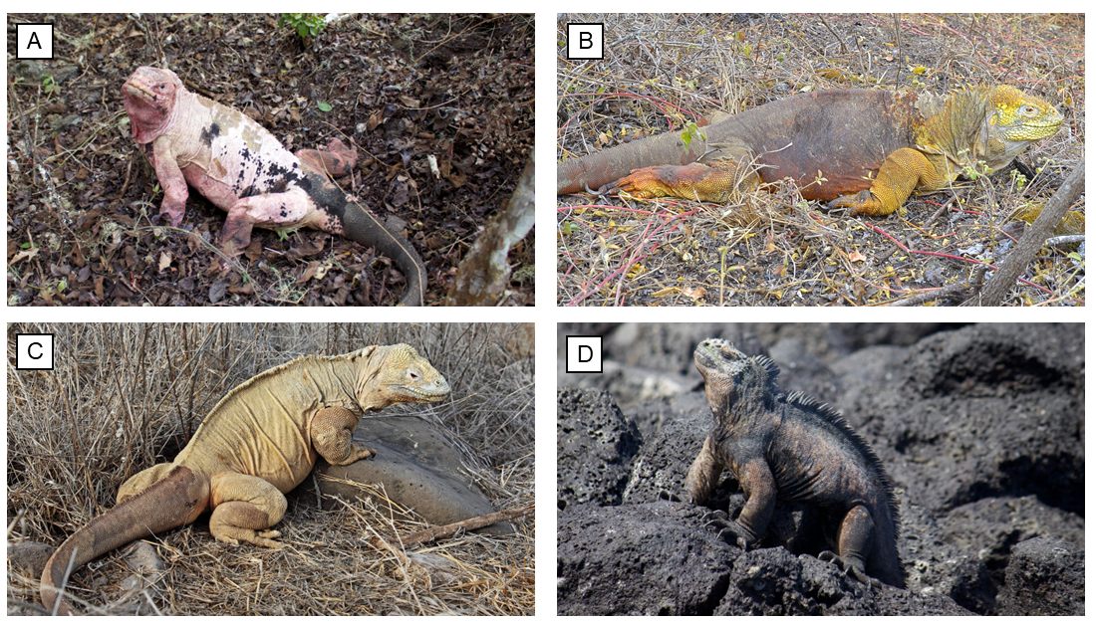
Figure S1. Skin coloration of the four Galapagos iguanas’ species: Conolophus marthae (A; © Giuliano Colosimo), C. subcristatus (B; © Lorenzo Garizio), C. pallidus (C; © https://en.wikipedia.org/wiki/Conolophus_pallidus#/media/File:Conolophuspallidus-santafe.jpg), Amblyrhynchus cristatus (D; © Giuliano Colosimo).
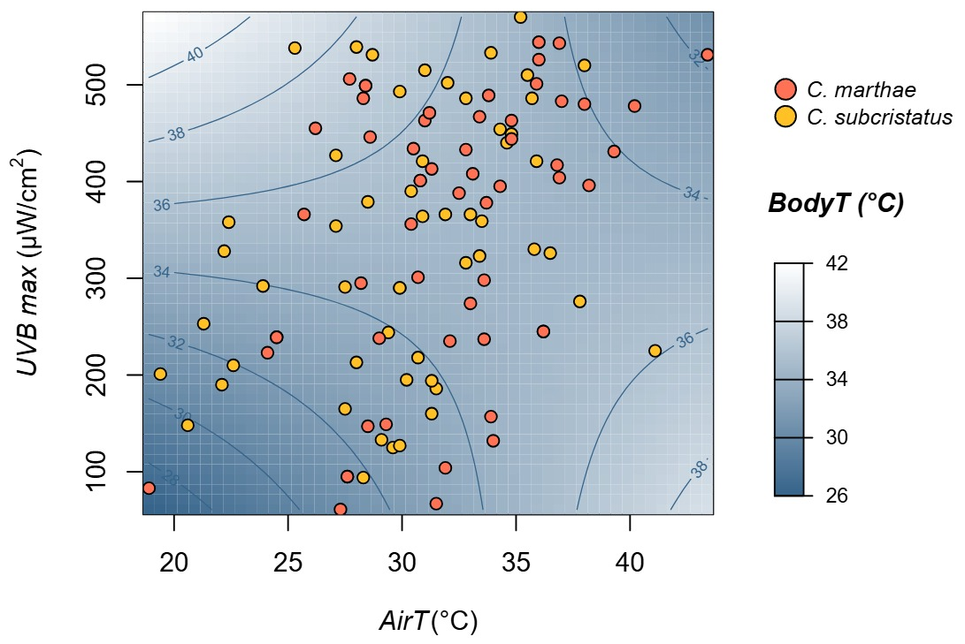
Figure S2. The effect of the tensor product smooth interaction between the air temperature (airT) and the maximum UVB irradiance in the environment (UVB max) on the body temperatures (bodyT) of C. marthae and C. subcristatus estimated by fitting a Generalized Additive Model (GAM). The background colors represent the predicted bodyT of both iguanas. Blue lines report 2°C changes in bodyT. Dots report the position of C. marthae (in red) and C. subcristatus (in yellow).
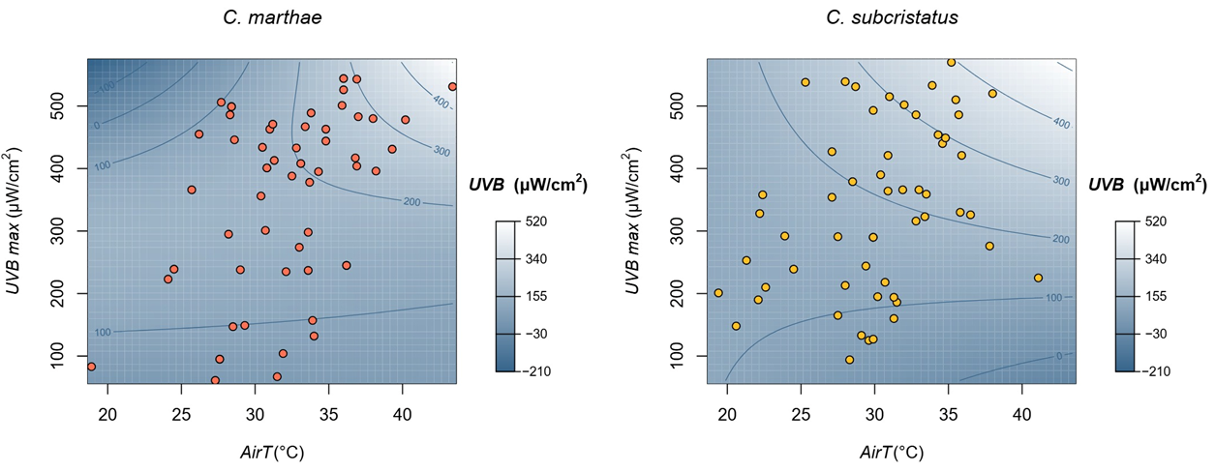
Figure S3. The effect of the tensor product smooth interaction between the air temperature (airT) and the maximum UVB irradiance in the environment (UVB max) on UVB levels at sighting positions (UVB) of C. marthae and C. subcristatus estimated by fitting a Generalized Additive Model (GAM). The background colors represent the predicted UVB. Blue lines indicate 100 µWatt/cm² changes in UVB. Dots report the position of C. marthae (in red) and C. subcristatus (in yellow).
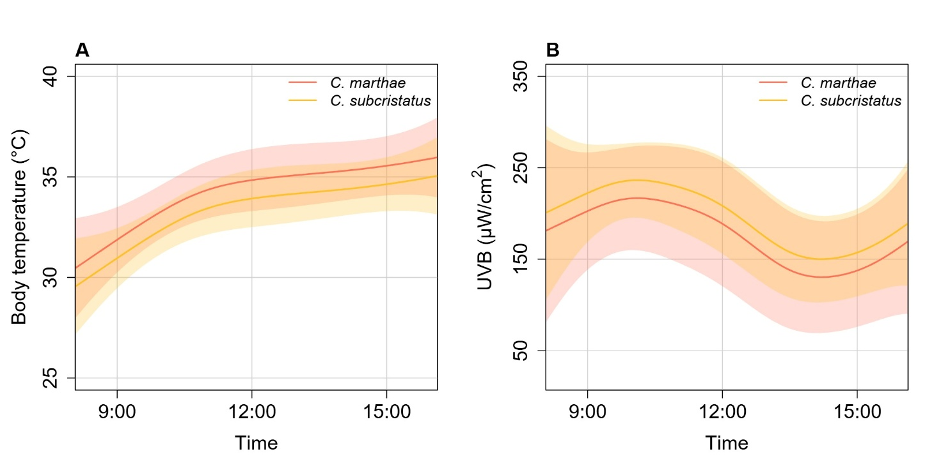
Figure S4. The effect of the time of capture (time) on body temperatures (A) and UVB levels at sighting positions (B) of C. marthae and C. subcristatus estimated by fitting a Generalized Additive Model (GAM). Lines represent the estimated trends for C. marthae (in red) and C. subcristatus (in yellow). Shading areas report 95% Confidence Intervals.

Table S1. Pairwise Pearson correlation matrix among continuous predictor variables used in the bivariate Generalized Additive Models (GAMs) with iguanas’ body temperature and UVB at sighting locations as response variables. Values represent pairwise correlations between the maximum UVB irradiance in the environment (UVB max), air temperature (airT) and time of day (time).
 | UVB max | airT | time
UVB max | 1 | 0.40 | -0.13
airT | 0.40 | 1 | 0.39
time | -0.13 | 0.39 | 1

Table S2. Concurvity estimates among predictor terms included in the bivariate Generalized Additive Models (GAMs) with iguanas’ body temperature and UVB at sighting locations as response variables. Values represent the worst-case, observed, and estimated concurvity between each smooth term and the remaining predictors in the model, reported separately for models of body temperature (bodyT) and UVB at sighting positions (UVB).
bodyT | UVB max, airT | time
worst | 0.787 | 0.782
observed | 0.372 | 0.666
estimate | 0.228 | 0.549

UVB | UVB max, airT - C. marthae | UVB max, airT - C. subcristatus | time
worst | 0.928 | 0.829 | 0.884
observed | 0.427 | 0.408 | 0.707
estimate | 0.193 | 0.257 | 0.661

Table S3. Results of the likelihood ratio tests (LRT) applied to Generalized Additive Models (GAMs) with single response (bodyT and UVB) to test species-dependent interactions in smooth terms. Models’ formula (Formula), degrees of freedom (df), and p-value from the Chi-square test (p) are reported in the table.
LRT – bodyT

Formula | df | Deviance | p
bodyT~species+sex+mass+te(UVB max,airT)+s(time) | NA | NA | NA
bodyT~species+sex+mass+te(UVB max,airT,by=species)+s(time) | 4.46 | 53.84522 | 0.2330
bodyT~species+sex+mass+te(UVB max,airT)+s(time,by=species) | 2.46 | 29.91076 | 0.2472
bodyT~species+sex+mass+te(UVB max,airT, by=species)+s(time,by=species) | 3.91 | 36.32865 | 0.3719

LRT - UVB

Formula | df | Deviance | p
UVB~species+sex+mass+te(UVB max,airT)+s(time) | NA | NA | NA
UVB~species+sex+mass+te(UVB max,airT,by=species)+s(time) | 6.17 | 137328.35 | 0.0426
UVB~species+sex+mass+te(UVB max,airT)+s(time,by=species) | -1.62 | -38113.15 | 0.1134
UVB~species+sex+mass+te(UVB max,airT, by=species)+s(time,by=species) | 2.45 | 13155.15 | 0.6315

Table S4. Results of the likelihood ratio tests (LRT) applied to Generalized Additive Models (GAMs) with binomial error distribution and logit link function to test the significance of the interaction between species and time in predicting the detection probability in the two microhabitat categories (1 = “sun”; 0 = “shade”). Models’ formula (Formula), degrees of freedom (df), and p-value from the Chi-square test (p) are reported in the table.
LRT

Formula | df | Deviance | p
microhabitat~species+sex+mass+s(time) | NA | NA | NA
microhabitat~species+sex+mass+ s(time,by=species) | 0.68 | 0.75543 | 0.2660

Table S5. Model coefficients estimated by fitting a Generalized Additive Model (GAM) with binomial error distribution and logit link function to predict the detection probability in the two microhabitat categories (1 = “sun”; 0 = “shade”). Estimated model values (Estimate), standard errors (Standard error), and p-values (p-value) for linear predictors (Term) are reported for each separated response. Effective degrees of freedom (edf), Chi-squared statistics (Chisq) and p-values (p) are shown to report the approximate significance of smooth terms.
 | Microhabitat
Term | Estimate | Standard error | p
intercept | 0.6408 | 0.8793
speciesC. subcristatus | 0.8723 | 0.4368 | 0.0458
sexMale | 0.1529 | 0.4288 | 0.7214
mass | -0.1044 | 0.1836 | 0.5696
Approximate significance of smooth terms
Smooth term | edf | Chisq | p
time | 2.248 | 10.2 | 0.011

Data used for the study
ID | Date | Time | Air T | UVB max | Microhabitat | Body temp | UVB | Mass | Species | Sex
W600 | 14/06/2014 | 0,528 | 32,7 |  |  | 32,4 | 287 | 6,25 | C. subcristatus | F
W601 | 14/06/2014 | 0,569 | 32,1 |  |  | 29,4 | 119 | 7,1 | C. subcristatus | F
W602 | 14/06/2014 | 0,597 | 25,6 |  | partial_shade | 29,7 | 10 | 5,22 | C. subcristatus | F
W605 | 14/06/2014 | 0,663 | 24,6 |  |  | 27 | 48 | 5,54 | C. marthae | M
W606 | 15/06/2014 | 0,328 | 19,1 |  |  | 24,1 | 43 | 3,65 | C. marthae | M
W607 | 15/06/2014 | 0,363 | 21,8 |  |  | 20,2 | 43 | 6,47 | C. marthae | M
W608 | 15/06/2014 | 0,394 | 25,6 |  |  | 24,7 | 87 | 5,61 | C. marthae | M
W609 | 15/06/2014 | 0,415 | 28,3 |  | sun | 25,4 | 232 | 7,36 | C. subcristatus | M
W610 | 15/06/2014 | 0,440 | 31,5 |  | sun | 31,9 | 275 | 8,34 | C. subcristatus | M
W611 | 15/06/2014 | 0,465 | 30,8 |  | sun | 27 | 220 | 4,46 | C. marthae | M
W613 | 15/06/2014 | 0,536 | 32,9 |  | full_shade | 29,3 | 183 | 5,52 | C. marthae | M
W614 | 15/06/2014 | 0,553 | 32,8 |  | full_shade | 36,8 | 230 | 5,69 | C. marthae | M
W615 | 15/06/2014 | 0,582 | 33,6 |  | partial_shade | 33,4 | 41 | 4,16 | C. marthae | F
W616 | 15/06/2014 | 0,583 | 28,4 |  |  | 33,5 | 25 | 5,49 | C. marthae | M
W617 | 15/06/2014 | 0,635 | 27,9 |  | full_shade | 36,1 | 57 | 5,13 | C. marthae | F
W618 | 15/06/2014 | 0,656 | 26,2 |  |  | 30,3 | 68 | 6,25 | C. marthae | F
W619 | 15/06/2014 | 0,678 | 28,3 |  | full_shade | 30,2 | 15 | 4,97 | C. marthae | M
W621 | 16/06/2014 | 0,365 | 23,4 |  | partial_shade | 30,1 | 18 | 3,99 | C. marthae | F
W622 | 16/06/2014 | 0,390 | 27,6 |  | sun | 30,9 | 236 | 6,92 | C. subcristatus | M
W623 | 16/06/2014 | 0,408 | 32,5 |  | sun | 33,6 | 81 | 6,5 | C. subcristatus | M
W624 | 16/06/2014 | 0,435 | 32,6 |  | sun | 30,8 | 95 | 4,25 | C. marthae | M
W625 | 16/06/2014 | 0,450 | 34,9 |  | sun | 34,3 | 450 | 3,49 | C. marthae | F
W626 | 16/06/2014 | 0,481 | 32,1 |  | sun | 31,6 | 98 | 5,72 | C. marthae | F
W628 | 16/06/2014 | 0,566 | 27,6 |  | partial_shade | 28 | 74 | 5,65 | C. marthae | F
W629 | 16/06/2014 | 0,585 | 29,1 |  | sun | 34,6 | 43 | 7,34 | C. subcristatus | F
W630 | 16/06/2014 | 0,611 | 26 |  | sun | 26,2 | 87 | 7,25 | C. subcristatus | M
W631 | 16/06/2014 | 0,626 | 26 |  | partial_shade | 31,2 | 121 | 3,62 | C. marthae | F
W632 | 16/06/2014 | 0,644 | 25,5 |  | partial_shade | 31 | 66 | 5,8 | C. marthae | M
W633 | 16/06/2014 | 0,658 | 25,1 |  | partial_shade | 30,2 | 33 | 4,02 | C. marthae | M
W635 | 17/06/2014 | 0,394 | 25,7 | 366 | sun | 35,6 | 350 | 3,66 | C. marthae | F
W636 | 17/06/2014 | 0,681 | 34,8 | 444 | sun | 36,5 | 388 | 4,9 | C. marthae | F
W637 | 17/06/2014 | 0,440 | 37 | 483 | partial_shade | 38 | 366 | 5,57 | C. marthae | F
W638 | 17/06/2014 | 0,538 | 33,4 | 323 | sun | 34,7 | 320 | 3,96 | C. subcristatus | F
W639 | 17/06/2014 | 0,562 | 35,2 | 570 | sun | 31,5 | 514 | 4,9 | C. subcristatus | F
W640 | 17/06/2014 | 0,596 | 34,6 | 440 | sun | 34,2 | 281 | 6,75 | C. subcristatus | M
W641 | 17/06/2014 | 0,618 | 34,3 | 395 | sun | 34,3 | 200 | 3,64 | C. marthae | M
W644 | 18/06/2014 | 0,347 | 18,9 | 83 | sun | 22,1 | 63 | 6,1 | C. marthae | M
W645 | 18/06/2014 | 0,372 | 20,6 | 148 | sun | 22,7 | 81 | 7,23 | C. subcristatus | F
W647 | 18/06/2014 | 0,422 | 33 | 274 | sun | 34,7 | 256 | 5,13 | C. marthae | M
W648 | 18/06/2014 | 0,437 | 30,5 | 434 | partial_shade | 29,8 | 66 | 3,71 | C. marthae | F
W649 | 18/06/2014 | 0,481 | 33,9 | 533 | sun | 27,5 | 480 | 5,3 | C. subcristatus | M
W650 | 18/06/2014 | 0,500 | 34,8 | 463 | partial_shade | 31,9 | 251 | 6,29 | C. marthae | M
W651 | 18/06/2014 | 0,564 | 32,5 | 388 | sun | 34 | 226 | 6,3 | C. marthae | F
W652 | 18/06/2014 | 0,581 | 36,8 | 417 | partial_shade | 35,8 | 92 | 6,37 | C. marthae | F
W653 | 18/06/2014 | 0,601 | 38,2 | 396 | sun | 35 | 200 | 4,26 | C. marthae | F
W654 | 18/06/2014 | 0,625 | 36,5 | 326 | sun | 27,5 | 108 | 6,32 | C. subcristatus | M
W655 | 18/06/2014 | 0,656 | 33,6 | 237 | sun | 35,6 | 198 | 4,61 | C. marthae | F
W656 | 18/06/2014 | 0,681 | 31,3 | 160 | sun | 33 | 123 | 4,71 | C. subcristatus | F
W658 | 19/06/2014 | 0,394 | 22,2 | 328 | sun | 24,2 | 253 | 6,33 | C. subcristatus | M
W659 | 19/06/2014 | 0,411 | 28,5 | 379 | sun | 23,6 | 242 | 6,7 | C. subcristatus | F
W660 | 19/06/2014 | 0,426 | 32,8 | 433 | sun | 34 | 420 | 4,9 | C. marthae | M
W661 | 19/06/2014 | 0,457 | 39,3 | 431 | partial_shade | 30 | 150 | 6,18 | C. marthae | M
W662 | 19/06/2014 | 0,483 | 35,9 | 501 | sun | 34,6 | 392 | 3,6 | C. marthae | M
W663 | 19/06/2014 | 0,507 | 43,4 | 531 | sun | 29,6 | 502 | 5,7 | C. marthae | M
W664 | 19/06/2014 | 0,565 | 35,7 | 486 | partial_shade | 35,3 | 101 | 6,46 | C. subcristatus | M
W665 | 19/06/2014 | 0,582 | 34 | 132 | sun | 34,1 | 76 | 3,74 | C. marthae | F
W666 | 19/06/2014 | 0,602 | 31,9 | 104 | sun | 34,7 | 80 | 4,94 | C. marthae | M
W667 | 19/06/2014 | 0,622 | 33,9 | 157 | sun | 34 | 113 | 5,56 | C. marthae | M
W668 | 19/06/2014 | 0,639 | 31,5 | 67 | partial_shade | 34,1 | 28 | 5,92 | C. marthae | M
W669 | 19/06/2014 | 0,651 | 28,3 | 94 | full_shade | 30,5 | 43 | 5,93 | C. subcristatus | M
W670 | 19/06/2014 | 0,670 | 27,3 | 61 | sun | 36,6 | 52 | 5,4 | C. marthae | M
W671 | 20/06/2014 | 0,350 | 19,4 | 201 | sun | 27,9 | 172 | 4,71 | C. subcristatus | M
W672 | 20/06/2014 | 0,370 | 23,9 | 292 | sun | 32,9 | 210 | 3,76 | C. subcristatus | F
W673 | 20/06/2014 | 0,397 | 30,9 | 364 | sun | 34,1 | 342 | 4,45 | C. subcristatus | F
W674 | 20/06/2014 | 0,413 | 30,9 | 421 | sun | 33,3 | 228 | 4,45 | C. subcristatus | F
W675 | 20/06/2014 | 0,443 | 32 | 502 | sun | 38 | 380 | 6,95 | C. subcristatus | M
W676 | 20/06/2014 | 0,485 | 36,9 | 543 | sun | 32,6 | 460 | 6,36 | C. marthae | M
W677 | 20/06/2014 | 0,500 | 36 | 544 | partial_shade | 34,6 | 62 | 3,95 | C. marthae | F
W678 | 20/06/2014 | 0,559 | 37,8 | 276 | sun | 32,3 | 292 | 6,2 | C. subcristatus | M
W679 | 20/06/2014 | 0,576 | 35,5 | 510 | sun | 30,9 | 455 | 7,66 | C. subcristatus | M
W680 | 20/06/2014 | 0,593 | 38 | 480 | sun | 34,5 | 480 | 5,77 | C. marthae | M
W681 | 20/06/2014 | 0,612 | 36,9 | 404 | full_shade | 32,5 | 99 | 3,6 | C. marthae | F
W682 | 20/06/2014 | 0,654 | 32,1 | 235 | partial_shade | 35,4 | 60 | 5 | C. marthae | M
W684 | 20/06/2014 | 0,677 | 28,5 | 147 | sun | 32,8 | 97 | 6,9 | C. marthae | M
W685 | 21/06/2014 | 0,399 | 22,4 | 358 | sun | 33,4 | 272 | 3,9 | C. subcristatus | F
W686 | 21/06/2014 | 0,426 | 27,1 | 427 | sun | 36 | 396 | 3,98 | C. subcristatus | F
W688 | 21/06/2014 | 0,503 | 36 | 526 | partial_shade | 35,8 | 288 | 4,07 | C. marthae | F
W689 | 21/06/2014 | 0,565 | 31 | 515 | partial_shade | 33 | 82 | 7,34 | C. subcristatus | M
W690 | 21/06/2014 | 0,574 | 33,8 | 489 | partial_shade | 33 | 25 | 6,51 | C. marthae | M
W691 | 21/06/2014 | 0,589 | 34,3 | 454 | partial_shade | 29 | 66 | 4,62 | C. subcristatus | F
W692 | 21/06/2014 | 0,603 | 34,8 | 449 | sun | 37,3 | 407 | 4,12 | C. subcristatus | F
W693 | 21/06/2014 | 0,622 | 33,5 | 359 | full_shade | 35,8 | 27 | 5,53 | C. subcristatus | M
W694 | 21/06/2014 | 0,639 | 32,8 | 316 | sun | 31,3 | 279 | 5,53 | C. subcristatus | M
W695 | 21/06/2014 | 0,660 | 29,6 | 125 | full_shade | 26,5 | 24 | 5,09 | C. subcristatus | M
W696 | 22/06/2014 | 0,350 | 24,1 | 223 | sun | 28 | 182 | 5,17 | C. marthae | M
W697 | 22/06/2014 | 0,363 | 27,5 | 291 | partial_shade | 31,1 | 25 | 7,78 | C. subcristatus | M
W698 | 22/06/2014 | 0,382 | 29,9 | 290 | sun | 31,6 | 160 | 6,54 | C. subcristatus | M
W699 | 22/06/2014 | 0,400 | 29,9 | 290 | sun | 29,1 | 16 | 4,79 | C. subcristatus | F
W700 | 22/06/2014 | 0,419 | 31,5 | 186 | sun | 31,6 | 154 | 3,87 | C. subcristatus | F
W701 | 22/06/2014 | 0,431 | 30,2 | 195 | sun | 28,7 | 160 | 6,93 | C. subcristatus | M
W702 | 22/06/2014 | 0,443 | 29,1 | 133 | sun | 35,9 | 124 | 7,93 | C. subcristatus | M
W703 | 22/06/2014 | 0,459 | 29 | 238 | sun | 33,8 | 161 | 6,16 | C. marthae | M
W704 | 22/06/2014 | 0,476 | 29,9 | 127 | sun | 28,3 | 81 | 7,49 | C. subcristatus | M
W705 | 22/06/2014 | 0,494 | 31,3 | 194 |  | 30 | 161 | 6,96 | C. subcristatus | M
W706 | 22/06/2014 | 0,503 | 30,4 | 356 | sun | 37,5 | 281 | 3,99 | C. marthae | F
W708 | 22/06/2014 | 0,603 | 29,4 | 244 | partial_shade | 34,9 | 132 | 7,45 | C. subcristatus | M
W709 | 22/06/2014 | 0,625 | 29,3 | 149 | sun | 29,9 | 94 | 5,28 | C. marthae | M
W710 | 22/06/2014 | 0,642 | 27,6 | 95 | sun | 34,2 | 56 | 5,65 | C. marthae | M
W711 | 22/06/2014 | 0,649 | 27,6 | 95 | sun | 32,4 | 56 | 5,4 | C. marthae | F
W712 | 23/06/2014 | 0,358 | 22,1 | 190 | sun | 22,8 | 180 | 5,2 | C. subcristatus | M
W713 | 23/06/2014 | 0,375 | 24,5 | 239 | sun | 26,3 | 180 | 3,98 | C. subcristatus | F
W714 | 23/06/2014 | 0,391 | 24,5 | 239 | sun | 25,2 | 180 | 5,5 | C. marthae | M
W715 | 23/06/2014 | 0,408 | 30,4 | 390 | sun | 31,5 | 353 | 7,57 | C. subcristatus | F
W716 | 23/06/2014 | 0,425 | 33,1 | 408 | partial_shade | 28,7 | 221 | 5,2 | C. marthae | M
W717 | 23/06/2014 | 0,451 | 31 | 463 | sun | 38,8 | 423 | 4,76 | C. marthae | F
W718 | 23/06/2014 | 0,481 | 32,8 | 486 | sun | 39 | 416 | 3,41 | C. subcristatus | M
W719 | 23/06/2014 | 0,551 | 33,4 | 467 | partial_shade | 32,7 | 76 | 4,6 | C. marthae | M
W720 | 23/06/2014 | 0,566 | 35,8 | 330 | partial_shade | 36,8 | 63 | 4,04 | C. subcristatus | F
W721 | 23/06/2014 | 0,580 | 35,9 | 421 | sun | 34,6 | 315 | 3,39 | C. subcristatus | M
W722 | 23/06/2014 | 0,590 | 33,7 | 378 | partial_shade | 34,2 | 190 | 5,84 | C. marthae | M
W723 | 23/06/2014 | 0,608 | 33 | 366 | sun | 35,6 | 229 | 7,18 | C. subcristatus | F
W724 | 23/06/2014 | 0,632 | 33,6 | 298 | partial_shade | 33,1 | 96 | 3,48 | C. marthae | F
W725 | 23/06/2014 | 0,658 | 30,7 | 218 | sun | 32,1 | 96 | 4,6 | C. subcristatus | M
W748 | 31/08/2016 | 0,382 | 22,6 | 210 | partial_shade | 28 | 39 | 7,14 | C. subcristatus | F
W749 | 31/08/2016 | 0,413 | 27,1 | 354 | sun | 37 | 169 | 7,52 | C. subcristatus | F
W750 | 31/08/2016 | 0,438 | 25,3 | 538 | partial_shade | 38,2 | 81 | 8,24 | C. subcristatus | F
W751 | 31/08/2016 | 0,458 | 28,4 | 499 | partial_shade | 34,1 | 52 | 3,5 | C. marthae | M
W752 | 31/08/2016 | 0,472 | 28,4 | 499 | partial_shade | 40,1 | 52 | 3,82 | C. marthae | M
W753 | 31/08/2016 | 0,554 | 27,7 | 506 | partial_shade | 33,2 | 49 | 5,48 | C. marthae | M
W754 | 31/08/2016 | 0,568 | 28,2 | 295 | partial_shade | 33,9 | 35 | 4,24 | C. marthae | F
W755 | 31/08/2016 | 0,587 | 28,6 | 446 | partial_shade | 35,6 | 54 | 4,34 | C. marthae | M
W756 | 31/08/2016 | 0,604 | 31,3 | 413 | partial_shade | 34,2 | 178 | 5,66 | C. marthae | M
W757 | 01/09/2016 | 0,347 | 36,2 | 245 | sun | 27,1 | 143 | 4,62 | C. marthae | M
W758 | 01/09/2016 | 0,361 | 36,2 | 245 | sun | 27,2 | 143 | 3,82 | C. marthae | F
W759 | 01/09/2016 | 0,424 | 31,2 | 471 | sun | 38,8 | 180 | 4,45 | C. marthae | F
W762 | 01/09/2016 | 0,625 | 31,9 | 366 | partial_shade | 32,7 | 87 | 7,3 | C. subcristatus | M
W763 | 01/09/2016 | 0,646 | 30,7 | 301 | sun | 37,3 | 165 | 4,7 | C. marthae | M
W764 | 01/09/2016 | 0,660 | 41,1 | 225 | partial_shade | 37,5 | 125 | 6,71 | C. subcristatus | M
W765 | 02/09/2016 | 0,385 | 30,8 | 401 | sun | 38 | 247 | 5,56 | C. marthae | M
W766 | 02/09/2016 | 0,399 | 30,8 | 401 | partial_shade | 33,6 | 247 | 4,15 | C. marthae | F
W767 | 02/09/2016 | 0,413 | 26,2 | 455 | sun | 32,1 | 283 | 4,61 | C. marthae | F
W768 | 02/09/2016 | 0,438 | 29,9 | 493 | sun | 36,4 | 322 | 4,6 | C. subcristatus | F
W769 | 02/09/2016 | 0,566 | 38 | 520 | full_shade | 39,2 | 230 | 4,82 | C. subcristatus | F
W770 | 02/09/2016 | 0,590 | 40,2 | 478 | sun | 30,4 | 336 | 4,53 | C. marthae | M
W771 | 03/09/2016 | 0,503 | 28,3 | 486 | partial_shade | 34,3 | 359 | 5,14 | C. marthae | M
W772 | 03/09/2016 | 0,653 | 21,3 | 253 | sun | 29,2 | 103 | 8,16 | C. subcristatus | M
W774 | 04/09/2016 | 0,508 | 28,7 | 531 | sun | 33,7 | 352 | 4,55 | C. subcristatus | F
W775 | 04/09/2016 | 0,531 | 28 | 539 | partial_shade | 38 | 271 | 6,74 | C. subcristatus | M
W776 | 04/09/2016 | 0,601 | 28 | 213 | partial_shade | 35,1 | 129 | 5,61 | C. subcristatus | M
W777 | 04/09/2016 | 0,618 | 27,5 | 165 | sun | 32,1 | 84 | 6,54 | C. subcristatus | M

