Supplementary results A – Eye kinematics results

Modeling the main sequence for each participant was performed using a two-parameter exponential model. Considering the variability of the estimated parameters relative to the inter-individual variability of oculomotor kinematics¹, an unsupervised classification algorithm (KMeans) was used to distinguish the participants into two groups, “Group A” with main sequence profiles above those of “Group B”. For each group, Figure S1a and Table S1 illustrate the mean (± s.e) saccadic characteristics of the main saccade, such as duration, size, peak velocity and percentage of post-saccadic oscillations. Post-saccadic oscillations are brief, low-amplitude oscillatory movements occurring at the end of the deceleration phase of the eye. Their origin is primarily mechanical: they arise from the physical dynamics of the eyeball and the elastic and viscoelastic properties of the extraocular muscles, causing the eye to slightly “bounce” around its final position after the saccade. They represent an idiosyncratic feature of saccadic dynamics ². Post-saccadic oscillations were computed for both participant groups because several studies have shown that the key saccadic parameters associated to post-saccadic oscillations are peak velocity, duration and amplitude, in relation to eye deceleration^{2,3}. The deceleration phase was defined as the interval between the time the eye reached its peak velocity and the saccade offset (provided by the EyeLink eye tracker). Within this interval the presence of post-saccadic oscillations was identified by detecting zero crossings in the velocity profile (Figure S1b). Only post-saccadic oscillations with durations longer than 5 ms were included.
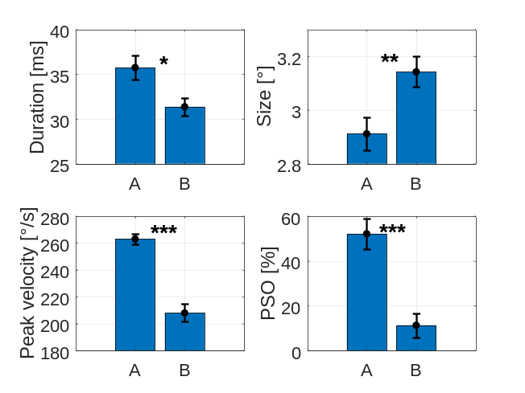 | 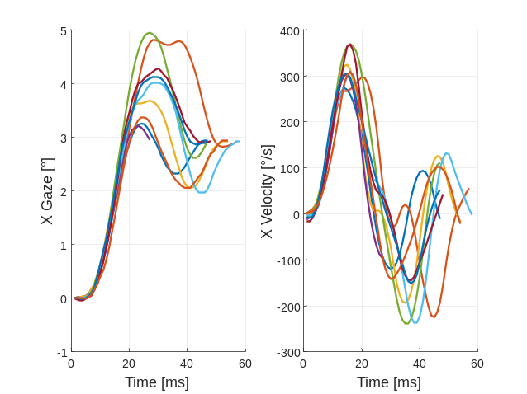
(a) | (b)

Figure S1. (a) For each group, mean (± s.e) duration, size, peak velocity and post-saccadic oscillations (PSOs) percentage of the main saccade, based on individual means; (b) Example of horizontal gaze and velocity profiles with PSOs for nine saccades ranging in size from 2.91° to 2.96° for the same participant.
Student's t-tests on each characteristic revealed that saccade duration (t(27) = 2.671, p = 0.0127), peak velocity (t(27)= 7.266, p < 0.0001) and post-saccadic oscillations percentage (t(27) = 4.670, p < 0.0001) were significantly greater for Group A than for Group B. On the other hand, saccade size was significantly smaller for Group A than for Group B (t(27) = -2.779, p = 0.0098). At first glance, it may seem counterintuitive that Group A exhibited longer saccade durations despite having smaller sizes and higher peak velocities, as the main-sequence relationship typically predicts the opposite. However, this apparent discrepancy can be explained by post-saccadic oscillations, which are included within the saccade interval as defined by the EyeLink eye tracker. Because post-saccadic oscillations were more frequent in Group A, they extended the measured duration of the saccade, resulting in longer average durations for this group compared to Group B.
Table S1. For each group, mean (± s.e) duration, size, peak velocity and post-saccadic oscillations (PSOs) percentage of the main saccade, based on individual means.

 | Duration (ms) | Size (°) | Peak velocity (°/s) | PSOs (%)
Group A | 35.74 ± 1.31 | 2.91 ± 0.06 | 263.05 ± 4.02 | 52.15 ± 6.75
Group B | 31.36 ± 0.96 | 3.14 ± 0.06 | 207.99 ± 6.56 | 11.39 ± 5.45
Supplementary results B –
B‑spline placement based on the predictor’s distribution

For each participant and configuration (STIM‑Detect and CTRL‑NoDetect), the EFRP at saccade offset was estimated by deconvolution using spline regression. For each combination, the set of B‑splines was adjusted to the observed distribution of the predictor variable (temporal frequency or saccade amplitude). This adjustment involved selecting the minimum, median, and maximum values of each distribution. For illustration, Figure S2 shows an example of three second‑order B‑splines defined over a distribution ranging from 6 Hz to 34 Hz, with a median value of 21 Hz.
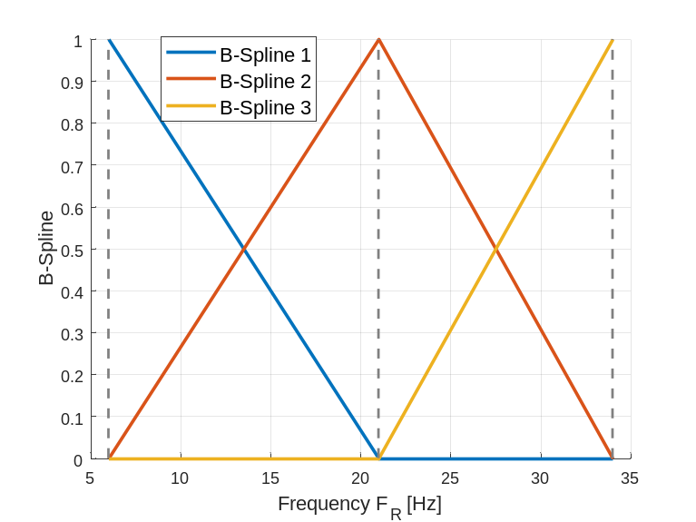
Figure S2. Illustration of a set of second‑order B‑splines defined over a frequency range from 6 Hz to 34 Hz. In this example, the knot points correspond to the extreme (6 Hz and 34 Hz) and median (21 Hz) values of the frequency distribution.

Supplementary results C – Results in electrode space
In electrode space, the EFRP at saccade onset was estimated at the temporal frequency of 20 Hz ($F_{T0}$) using Equation 6. Figure S3 provides an overview of the averaged EFRP for both configurations, STIM-Detect and CTRL-NoDetect. These estimates were averaged across nine predefined electrode clusters (each consisting of 5–7 electrodes, as specified in Table S2). The clusters were evenly distributed across the scalp, spanning from frontal to parieto-occipital regions and from the left to the right hemisphere.

Table S2. Definition of the electrode clusters; F: Frontal; C: Central; P: Parietal; O: Occipital

 | Left (L) |  | Median (M) |  | Right (R)
LFC | F7, F3, FC5, F5, AF7 | MFC | F7, F3, FC5, F5, AF7 | RFC | F8, F4, FC6, AF8, F6
LCP | T7, C3, TP7, CP5, C5 | MCP | Cz, CP1, CP2, Pz, C1, C2, CPz | RCP | Cz, CP1, CP2, Pz, C1, C2, CPz
LPO | P3, P7, PO7, P5, PO3 | MO | O1, O2, Oz, POz, Iz | RPO | P8, P4, PO8, P6, PO4

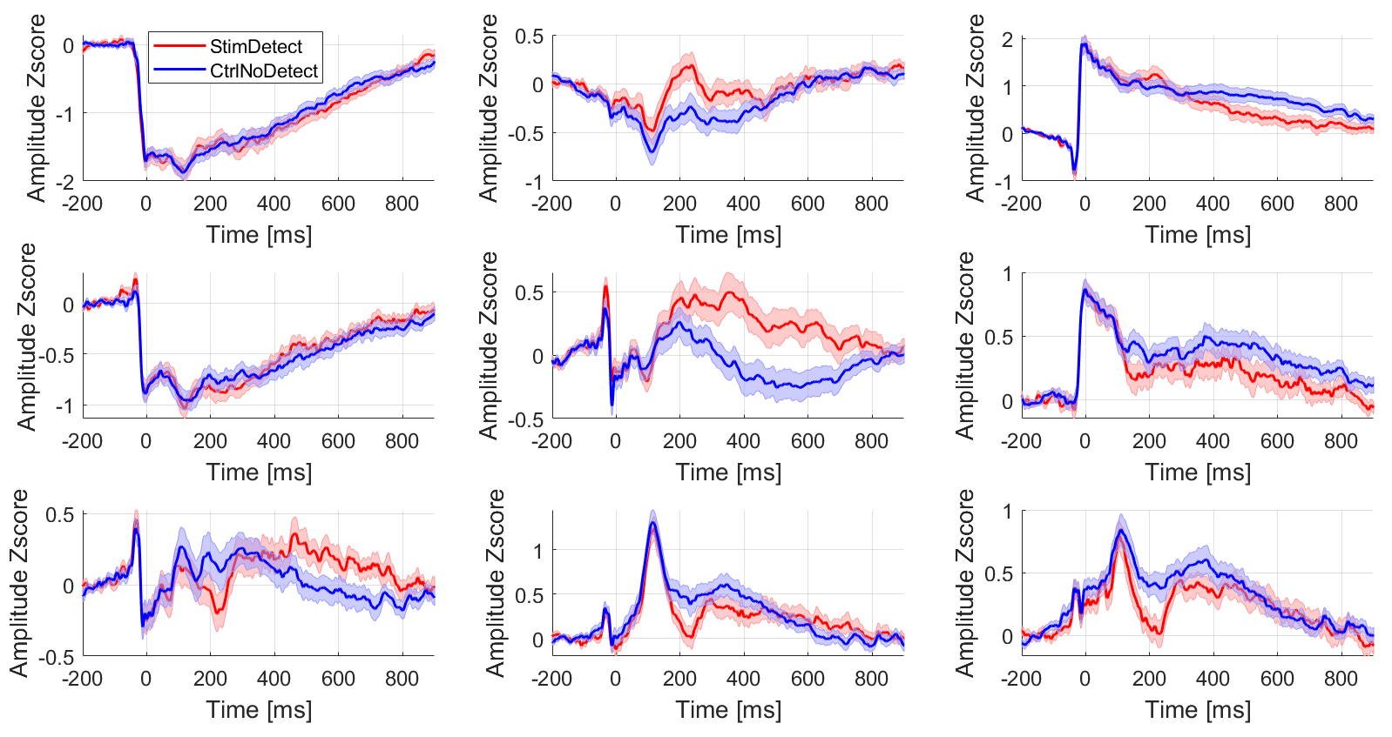
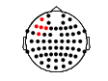
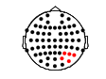
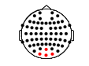
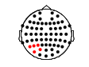
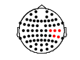
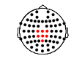
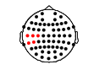
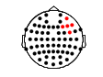
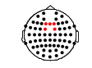
In this figure, the saccadic spike potential, the Lambda component and the posterior N1 component in the occipital region, the anterior N1 component in the anterior region and the P300 component in the central region are notable. To explore the difference between both configurations along time, three two-tail nonparametric cluster-based permutations tests were performed. Three latency windows were a priori defined such as: (i) very early latencies, encompassing the main saccade onset [-120 - 80] ms, (ii) early latencies, encompassing the Lambda component and the N1 component [60 - 260] ms and (iii) late latencies encompassing the P300 component [240 - 440] ms.

Figure S3. Overview of EFRPs reconstructed at temporal frequency $F_{T0}$ equal to 20 Hz for the two configurations STIM-Detect (red) and CTRL-NoDetect (blue) averaged over the nine a priori electrode clusters. The definition of each electrodes cluster is indicated in each graph. The solid line represents the average of the evoked potential and the transparent area represents the inter-participant standard error at each time sample, based on individual means.

Cluster-based permutation tests revealed significant differences between the two configurations STIM-Detect and CTRL-NoDetect, in a negative cluster (p = 0.0012, Cohen’s d between 0.381 and 0.932, 0.544 in average) during the early latency window and in a positive cluster (p = 0.0048, Cohen’s d between 0.383 and 0.864, 0.563 in average) during the late latency window. A trend was also revealed in a positive cluster during the early latency window (p = 0.0852, Cohen’s d between 0.383 and 0.803, 0.552 in average). No difference was revealed by the cluster-based permutation test during the very early latency window.
Specifically, the significant negative cluster indicated a more negative amplitude for STIM-Detect compared to CTRL-NoDetect over a time window extending from approximately 150 ms to 250 ms and with a predominant spatial distribution in occipital regions (Figure S4). The maximum effect was reached at approximatively 230 ms at channel ‘P6’. At the beginning of the time window, the spatial distribution of the effect was located in the right occipital region, then expanded to encompass the medial occipital region, then towards the end of the time window, the spatial distribution of the effect was located over both the right and left occipital regions.

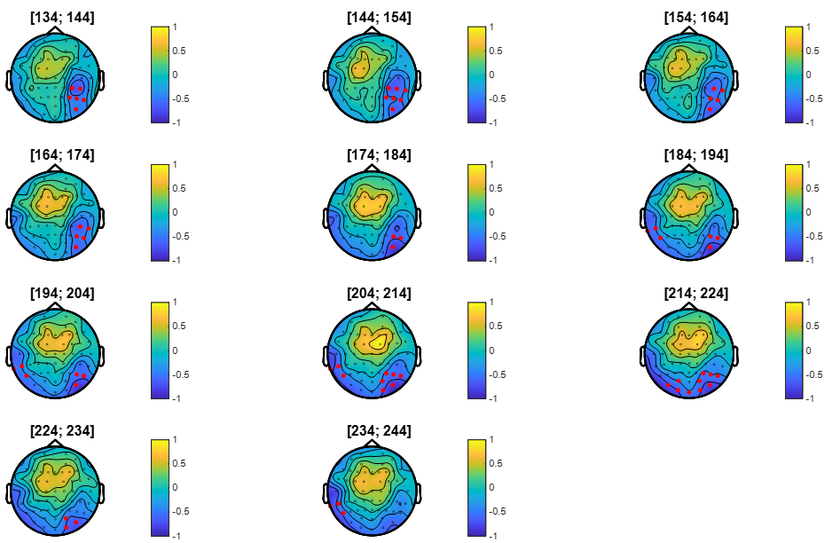

Figure S4. Topographic distribution by 10 ms steps, of the signed Cohen’s d during the time interval of the significant negative cluster [134 - 244] ms. Electrodes belonging to the cluster are highlighted with red points.

Specifically, the trend positive cluster indicated a more positive amplitude for STIM-Detect compared to CTRL-NoDetect over a time window extending from approximately 150 ms to 180 ms and with a predominant spatial distribution in the left anterior region (Figure S5). The maximum effect was reached at approximatively 180 ms at channel ‘FC1’.

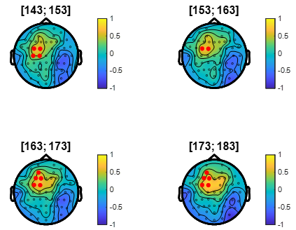

Figure S5. Topographic distribution by 10 ms steps, of the signed Cohen’s d during the time interval of the trend positive cluster [143 - 183] ms. Electrodes belonging to the cluster are highlighted with red points.

Specifically, the significant positive cluster indicated a more positive amplitude for STIM-Detect compared to CTRL-NoDetect over a time window extending from approximately 300 ms to 450 ms and with a predominant spatial distribution in the central region (Figure S6). The maximum effect was reached at approximatively 420 ms at channel ‘C3’.

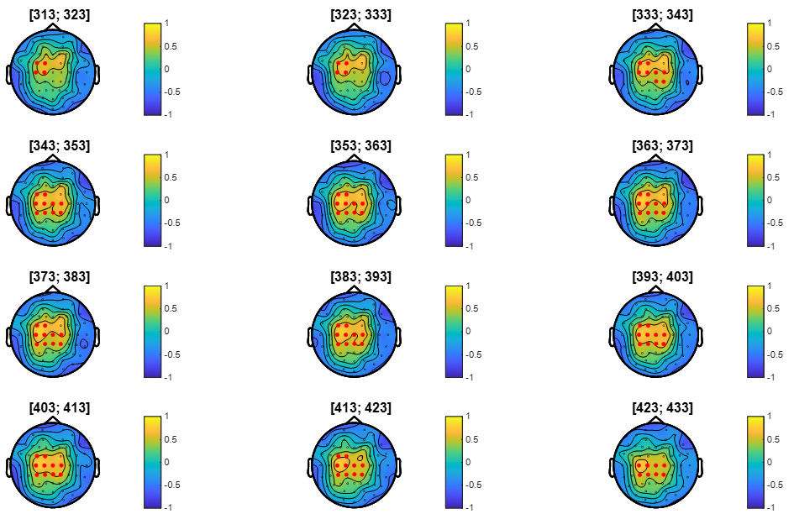

Figure S6. Topographic distribution by 10 ms steps, of the signed Cohen’s d during the time interval of the significant positive cluster [313 - 433] ms. Electrodes belonging to the cluster are highlighted with red points.

Supplementary results D –
Results (figures and tables) in source space
Table S3. Summary of permutation test results for each visual ROI, time window (“Early”, “Late”) and temporal frequency range (“Low”, “High”). For each cluster, its p-value, its location in time (ms) × temporal frequency (Hz), its Cohen's d interval [min; max] and its $\overline{mean}$ value are reported. The characteristics of the trend clusters are indicated in italics.

Pathway | Dorsal |  | Ventral
ROI | Left | Right | Left | Right
V1 | Early, Low: p = 0.0172  [51; 178] × [6.0; 20.0]  dC [0.316; 1.069];  $\overline{\text{0.51}\text{1}}$ | Early, Low: p = 0.0319  [51; 184] × [6.0; 20.0]  dC [0.317; 0.943];  $$\overline{\text{0.508}}$$  Early, High: p = 0.0345  [51; 135] × [20.0; 31.0]  dC [0.317; 0.736];  $$\overline{\text{0.448}}$$ | Early, Low: p = 0.0180  [56; 177] × [6.0; 20.0]  dC [0.321; 0.973];  $\overline{\text{0.474}}$  Early, High: p = 0.0371  [63; 165] × [20.0; 31.0]  dC [0.321; 0.669];  $\overline{\text{0.43}\text{9}}$  Late, Low: p = 0.0180  [325; 413] × [6.0; 20.0]  dC [0.322; 0.808];  $\overline{\text{0.4731}}$ | Early, Low: p = 0.0541  [51; 93] × [6.0; 20.0]  dC [0.316; 0.678];  $\overline{\text{0.469}}$  Early, High: p = 0.0345  [53; 135] × [20.0; 31.0]  dC [0.323; 0.860];  $\overline{\text{0.549}}$
V2 | Early, Low: p = 0.0300  [51; 169] × [6.0; 20.0]  dC [0.316; 0.763];  $$\overline{\text{0.48}\text{6}}$$ | Early, Low: p = 0.0212  [54; 169] × [6.0; 20.0]  dC [0.316; 0.914];  $\overline{\text{0.509}}$
V3 | Early, Low: p = 0.0012  [51; 212] × [6.0; 20.0]  dC [0.317; 1.016];  $$\overline{\text{0.499}}$$
hV4 |  |  | Early, Low: p = 0.0117  [57; 185] × [6.0; 20.0]  dC [0.317; 0.601];  $$\overline{\text{0.43}\text{7}}$$
MT/V5 |  | Early, Low: p = 0.0262  [84; 209] × [14.5; 20.0]  dC [0.317; 0.707];  $\overline{\text{0.43}\text{7}}$  Late, Low: p = 0.0056  [257; 372] × [6.0; 20.0]  dC [0.319; 0.922];  $\overline{\text{0.515}}$
PHC

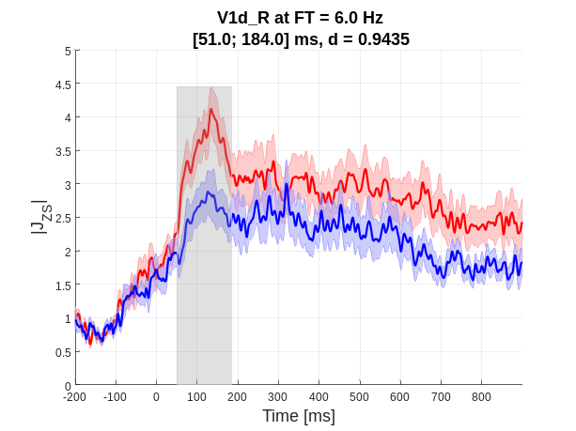 | 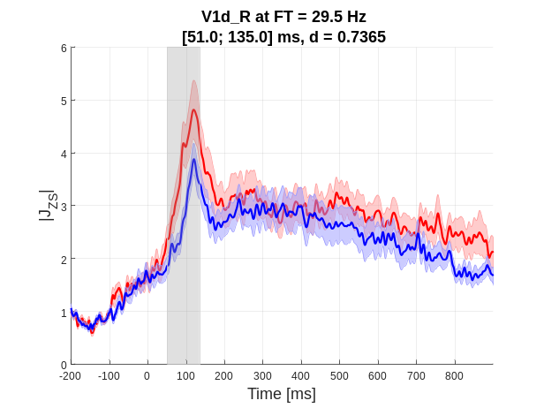
(a) | (b)
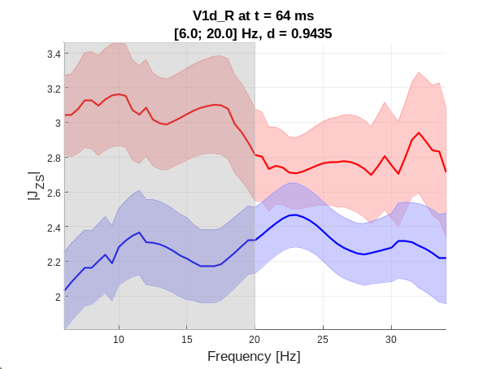 | 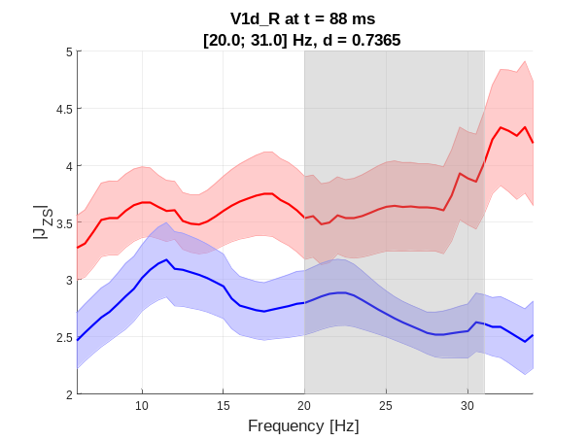
(c) | (d)
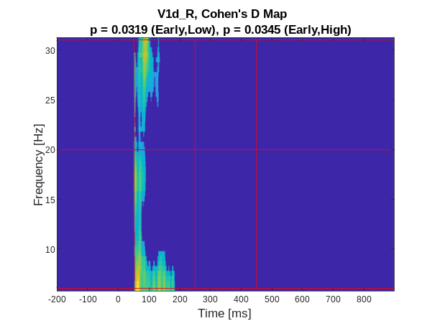
(e)

Figure S7. Right dorsal V1. EFRPs over time, reconstructed at the temporal frequency $F_{T}$ corresponding to the maximum Cohen's d value within the cluster: (a) cluster “Early”, range “Low”, ${\text{F}}_{\text{T}} \text{=} \text{6.0}$ Hz; (b) cluster “Early”, range “High”, ${\text{F}}_{\text{T}} \text{=} \text{29.5}$ Hz. EFRPs over temporal frequency, reconstructed at the time point t corresponding to the maximum Cohen's d value within the cluster: (c) cluster “Early”, range “Low”, $\text{t} \text{=}\text{ 64}$ ms; (d) cluster “Early”, range “High”, $\text{t }\text{=} \text{88}$ ms. The solid line represents the mean across participants, and the shaded area indicates the standard error of the mean (s.e.m) at each point, based on individual participant averages. (e) Cluster location in time × temporal frequency domain.

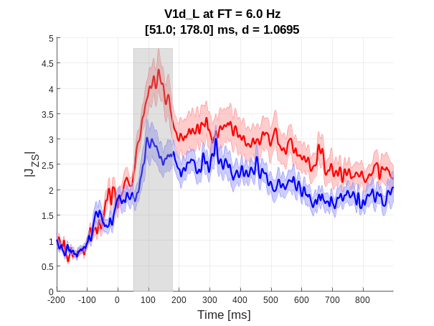 | 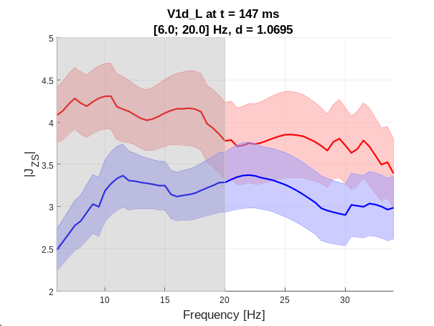
(a) | (b)
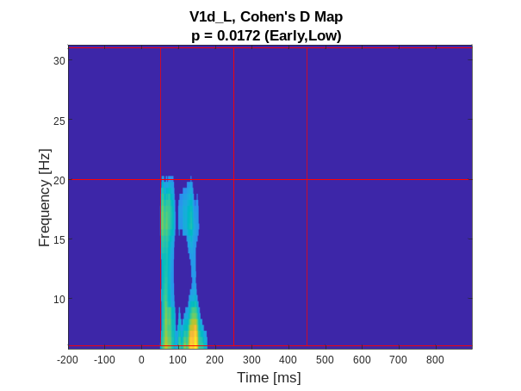
(c)

Figure S8. Left dorsal V1. EFRPs over time, reconstructed at the temporal frequency $F_{T}$ corresponding to the maximum Cohen's d value within the cluster: (a) Cluster “Early”, range “Low”, ${\text{F}}_{\text{T}} \text{=} \text{6.0}$ Hz. EFRPs over temporal frequency, reconstructed at the time point t corresponding to the maximum Cohen's d value within the cluster: (b) Cluster “Early”, range “Low”, $\text{t} \text{=} \text{147}$ ms. The solid line represents the mean across participants, and the shaded area indicates the standard error of the mean (s.e.m) at each point, based on individual participant averages. (c) Cluster location in the time × temporal frequency domain.

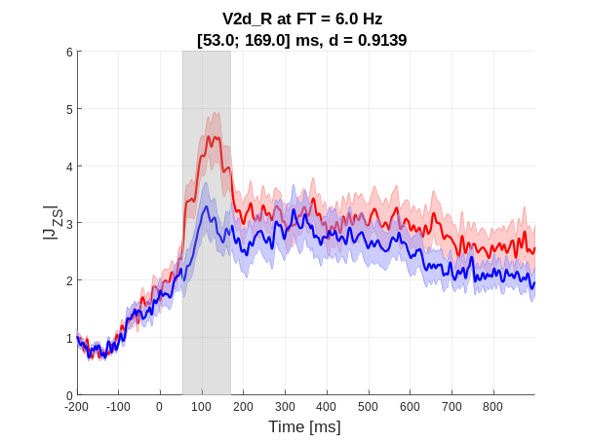 | 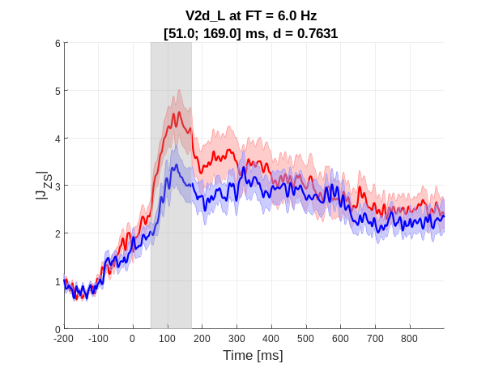
(a) | (b)
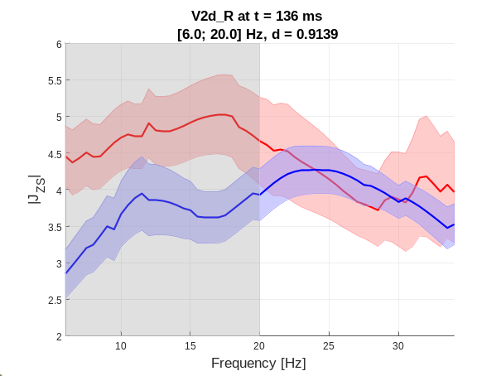 | 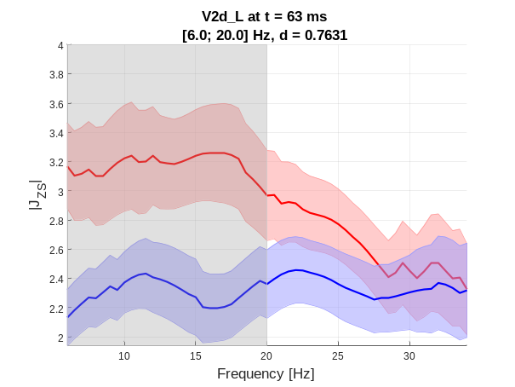
(c) | (d)
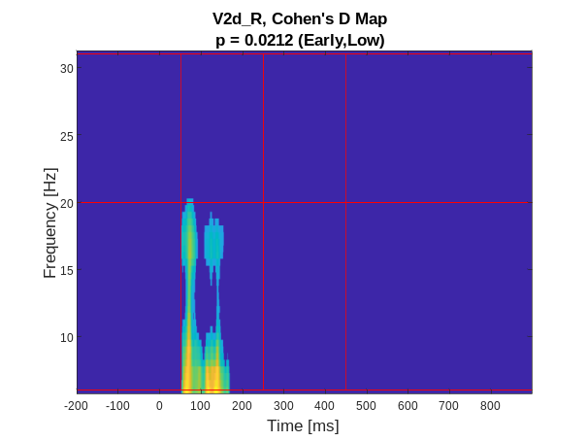 | 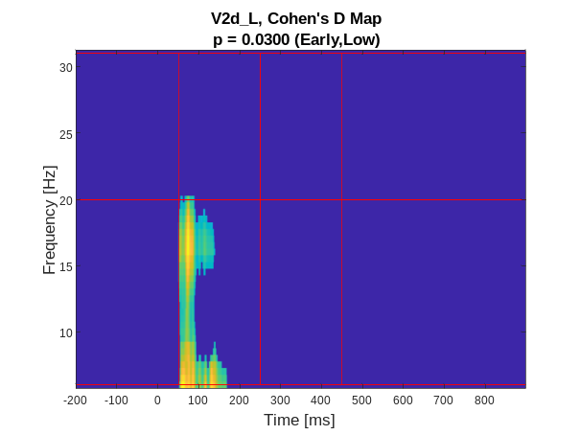
(e) | (f)

Figure S9. Right and left dorsal V2. EFRPs over time, reconstructed at the temporal frequency $F_{T}$ corresponding to the maximum value of Cohen's d in the cluster “Early”, “Low”, ${\text{F}}_{\text{T}} \text{=} \text{6.0}$ Hz: (a) V2d Right and (b) V2d Left. EFRPs over temporal frequency, reconstructed at the time t corresponding to the maximum value of Cohen's d in the cluster “Early”, “Low”: (c) V2d Right at $\text{t }\text{=} \text{136}$ ms and (d) V2d Left at t = 63 ms. The solid line represents the average and the shaded area indicates the standard error of the mean (s.e.m) at each point, based on individual participant averages. Cluster location in time × temporal frequency domain: (e) V2d Right and (f) V2d Left.

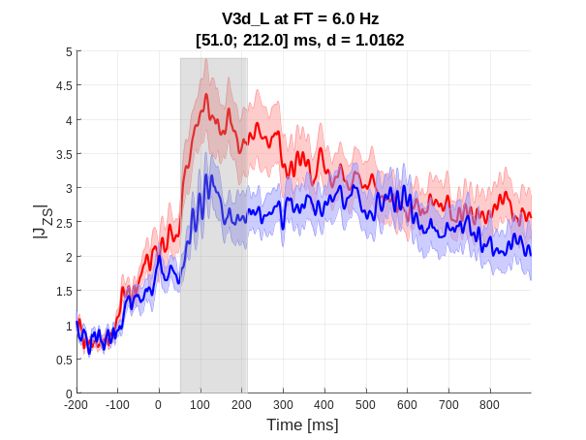 | 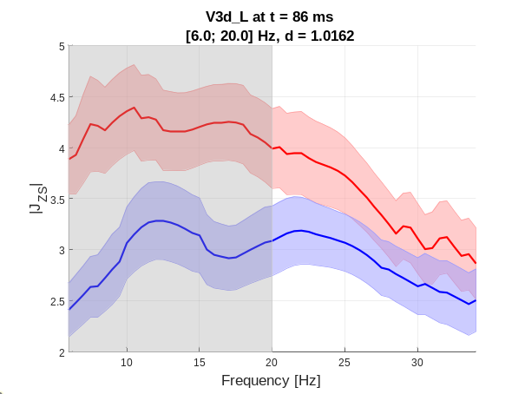
(a) | (b)
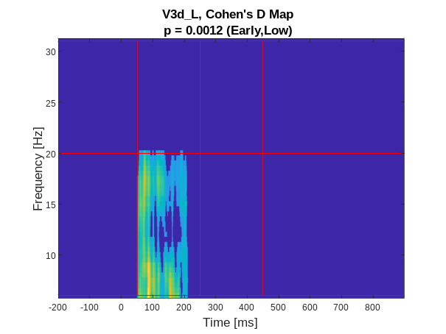
(c)

Figure S10. Left dorsal V3. EFRPs over time, reconstructed at the temporal frequency $F_{T}$ corresponding to the maximum value of Cohen's d in the cluster: (a) cluster “Early”, “Low”, ${\text{F}}_{\text{T}} \text{=} \text{6.0}$ Hz. EFRPs over temporal frequency, reconstructed at the time t corresponding to the maximum value of Cohen's d in the cluster: (b) cluster “Early”, “Low”, $\text{t }\text{=} \text{86}$ ms. The solid line represents the average and the shaded area indicates the standard error of the mean (s.e.m) at each point, based on individual participant averages. (c) Cluster location in time × temporal frequency domain.

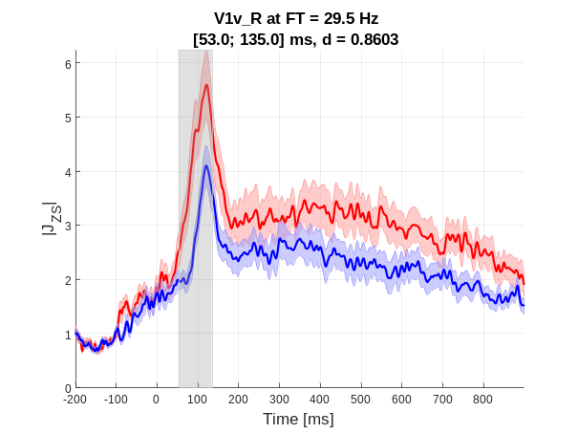 | 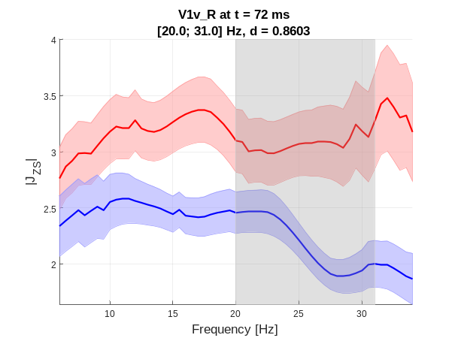
(a) | (b)
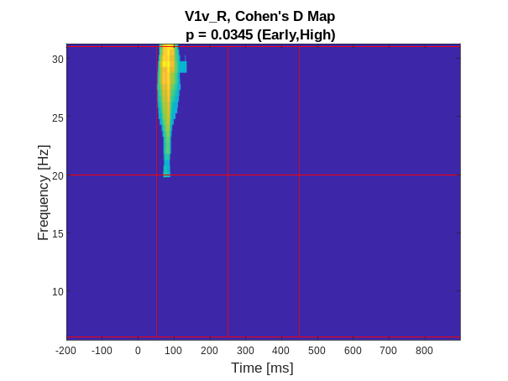
(c)

Figure S11. Right ventral V1. EFRPs over time, reconstructed at the temporal frequency $F_{T}$ corresponding to the maximum value of Cohen's d in the cluster: (a) cluster “Early”, “High”, ${\text{F}}_{\text{T}} \text{=} \text{29.5}$ Hz. EFRPs over temporal frequency, reconstructed at the time t corresponding to the maximum value of Cohen's d in the cluster: (b) cluster “Early”, “High”, $\text{t }\text{=} \text{72}$ ms. The solid line represents the average and the shaded area indicates the standard error of the mean (s.e.m) at each point, based on individual participant averages. (C) Cluster location in time × temporal frequency domain.

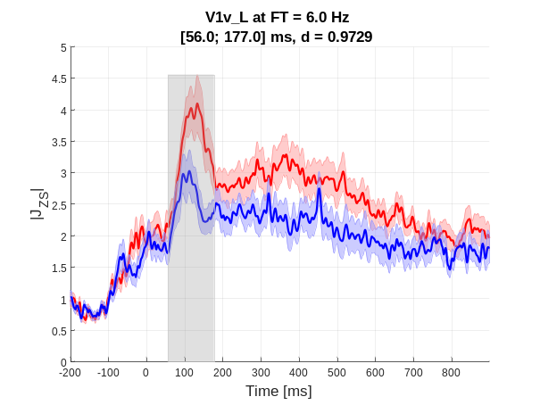 | 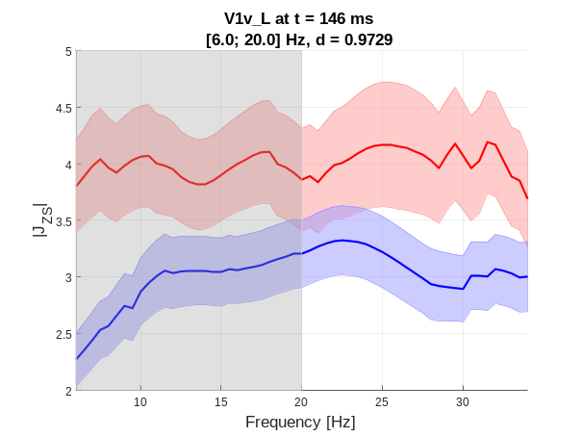
(a) | (b)
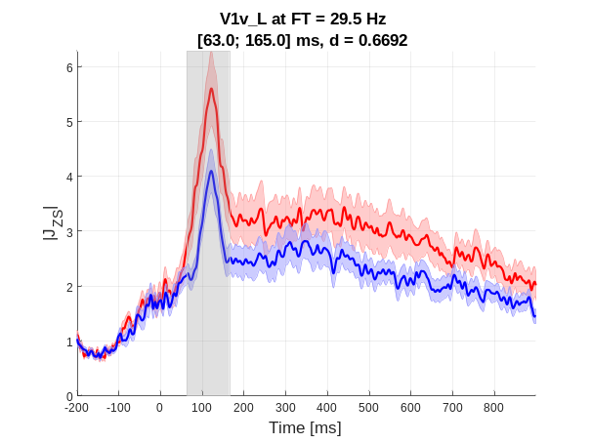 | 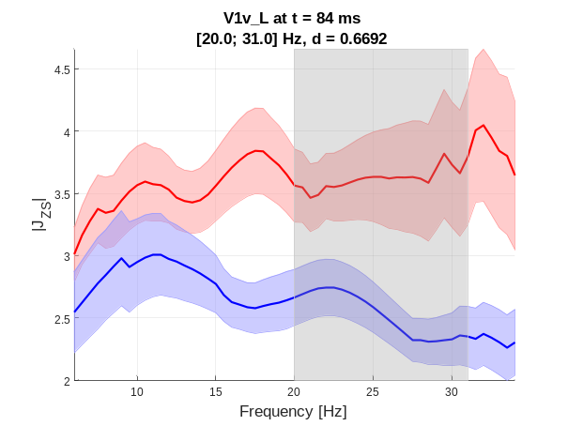
(c) | (d)
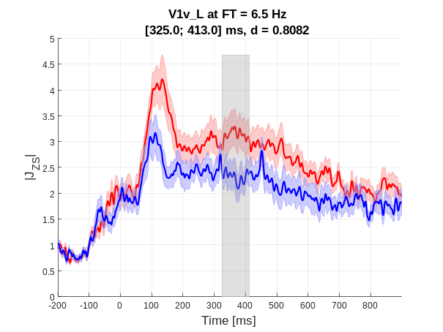 | 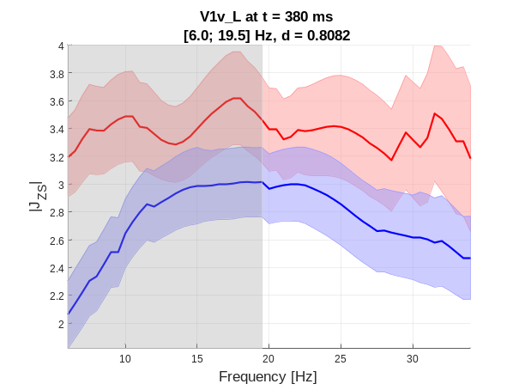
(e) | (f)
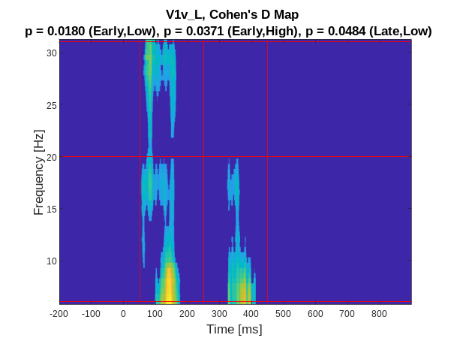
(g)

Figure S12. Left ventral V1. EFRPs over time, reconstructed at the temporal frequency $F_{T}$ corresponding to the maximum value of Cohen's d in the cluster: (a) “Early”, “Low”, ${\text{F}}_{\text{T}} \text{=} \text{6.0}$ Hz; (c) “Early”, “High”, ${\text{F}}_{\text{T}} \text{=} \text{29.5}$ Hz; (e) “Late”, “Low”,${\text{F}}_{\text{T}} \text{=} \text{6.5}$ Hz. EFRPs over temporal frequency, reconstructed at the time t corresponding to the maximum value of Cohen's d in the cluster: (b) “Early”, “Low”, $\text{t }\text{=} \text{146}$ ms; (d) “Early”, “High”, $\text{t }\text{=} \text{84}$ ms; (f) “Late”, “Low”, $\text{t }\text{=} \text{380}$ ms. The solid line represents the average and the shaded area indicates the standard error of the mean (s.e.m) at each point, based on individual participant averages. (g) Cluster location in time × temporal frequency domain.

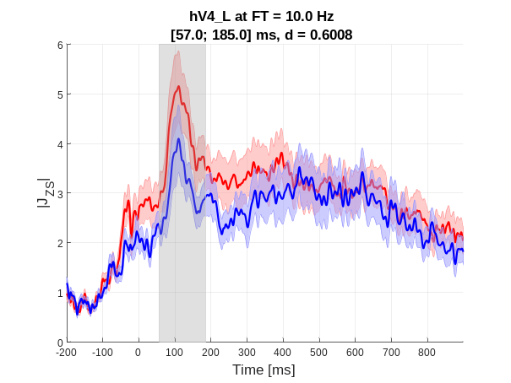 | 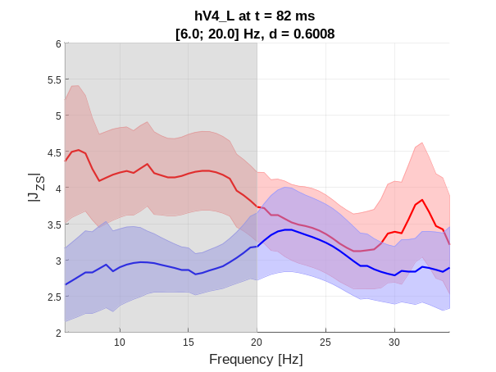
(a) | (b)
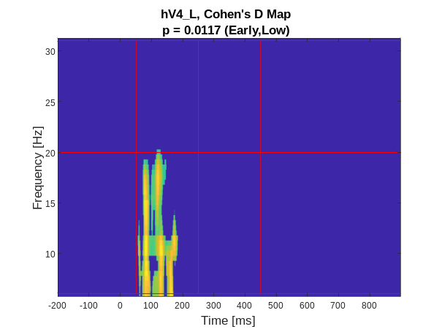
(c)

Figure S13. Left hV4. EFRPs over time, reconstructed at the temporal frequency $F_{T}$ corresponding to the maximum value of Cohen's d in the cluster: (a) cluster “Early”, “Low”, ${\text{F}}_{\text{T}} \text{=} \text{10.0}$ Hz. EFRPs over temporal frequency, reconstructed at the time t corresponding to the maximum value of Cohen's d in the cluster: (b) cluster “Early”, “Low”, $\text{t }\text{=} \text{82}$ ms. The solid line represents the average and the shaded area indicates the standard error of the mean (s.e.m) at each point, based on individual participant averages. (c) Cluster location in time × temporal frequency domain.

Table S4. Summary of permutation test results for each oculomotor ROI, time window (“Early”, “Late”). For each cluster, its p-value, its location in time (ms) × saccade size (°), its Cohen's d interval [min; max] and its $\overline{mean}$ value are reported. The characteristics of the trend clusters are indicated in italics.

ROI | Left | Right
IPS | Early: p = 0.0082  [51; 250] × [2.5; 4.1]  dC [0.316; 1.192];  $\overline{\text{0.50}\text{1}}$  Late: p = 0.0233  [250; 450] × [2.4; 5.1]  dC [0.316; 0.742];  $$\overline{\text{0.428}}$$ | Early: p = 0.0729  [51; 102] × [2.5; 4.5]  dC [0.316; 0.883]; $\overline{\text{0.526}}$  Late: p = 0.0421  [250; 450] × [3.0; 4.01]  dC [0.316; 0.785];  $\overline{\text{0.473}}$
FEF

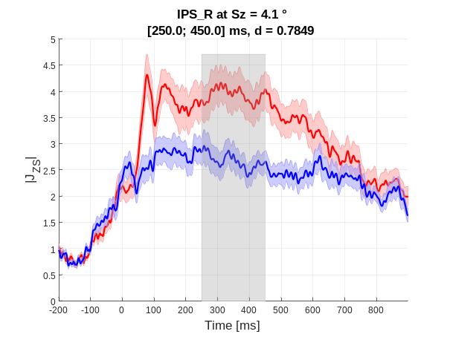 | 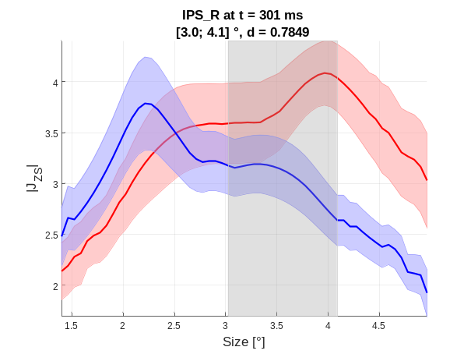
(a) | (b)
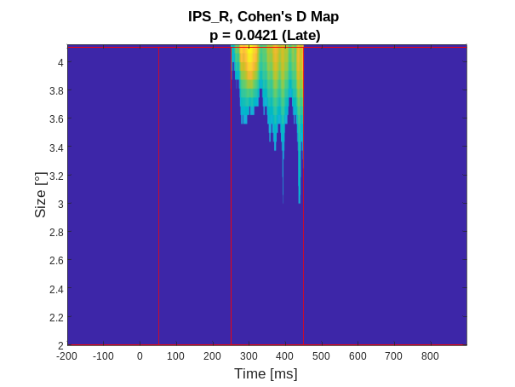
(c)

Figure S14. Right IPS. EFRPs over time, reconstructed at the saccade size $S_{z}$ corresponding to the maximum value of Cohen's d in the cluster: (a) cluster “Early”, ${\text{S}}_{\text{z}} \text{=} \text{4.1}$°. EFRPs over saccade size, reconstructed at the time t corresponding to the maximum value of Cohen's d in the cluster: (b) cluster “Early”, $\text{t }\text{=} \text{301}$ ms. The solid line represents the average and the shaded area indicates the standard error of the mean (s.e.m) at each point, based on individual participant averages. (c) Cluster location in time × saccade size domain.
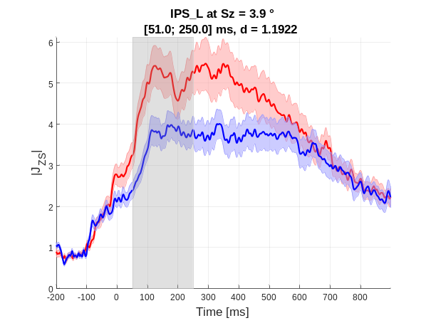 | 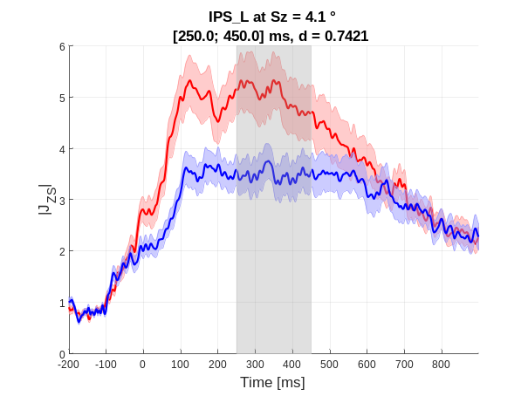
(a) | (b)
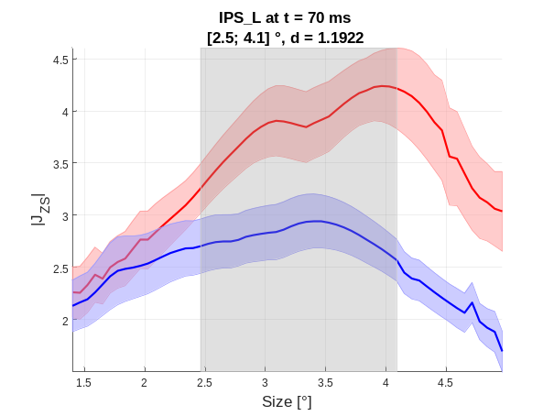 | 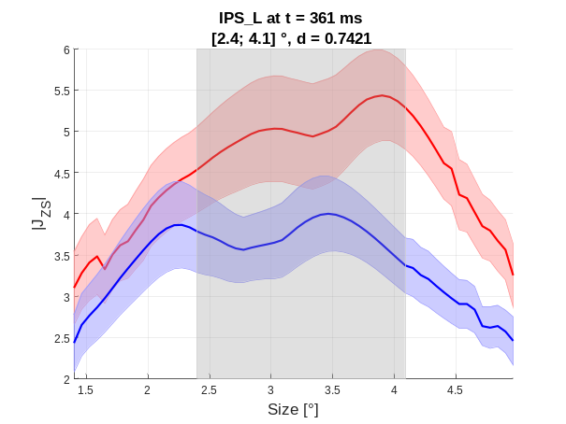
(c) | (d)
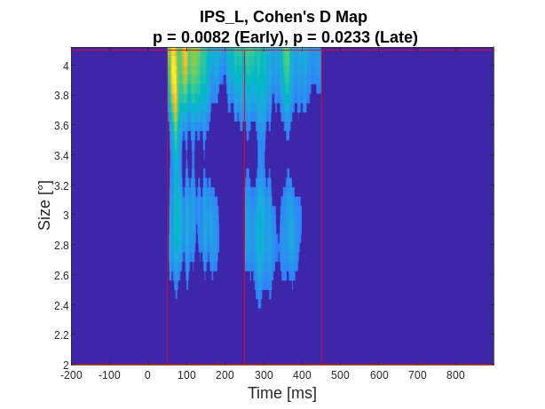
(e)

Figure S15. Left IPS. EFRPs over time, reconstructed at the saccade size $S_{Z}$ corresponding to the maximum value of Cohen's d in the cluster: (a) cluster “Early”, ${\text{S}}_{\text{z}}\text{=} \text{3.9}$°; (b) cluster “Late”, ${\text{S}}_{z}\text{=} \text{4.1°}$. EFRPs over saccade size, reconstructed at the time t corresponding to the maximum value of Cohen's d in the cluster: (c) cluster “Early”, $\text{t} \text{=} \text{70}$ ms; (d) cluster “Late”, $\text{t} \text{=} \text{363}$ ms. The solid line represents the average and the shaded area indicates the standard error of the mean (SE), based on individuals means (s.e.m) at each point, based on individual participant averages. (e) Cluster location in time × saccade size domain.

Supplementary results E - Selection of the main saccade
Five criteria were defined to ensure that (i) the saccade of interest, designated as the main saccade, was the only saccade between $T_{2}$ and $T_{3}$ that could induce an intra-saccadic motion percept, and (ii) no saccade occurring before $T_{2}$ or after $T_{3}$ could elicit such a percept.
The five criteria were as follows:
- No eye blink occurred during the trial, from the onset of contrast rise ($T_{1}$) to the end of contrast stabilization ($T_{2}$);
- During the contrast rise, there was no saccade with a peak velocity ($V_{Peak}$) yielding a temporal frequency ($F_{T}$) between two thresholds ($ξ_{FL}$ and $ξ_{FH}$, see details below);
- Only one saccade occurred after timestamp $T_{2}$ with a peak velocity ($V_{Peak}$) corresponding to a temporal frequency $(F_{T})$ within the same range ($ξ_{FL}$ and $ξ_{FH}$);
- The rank order of the saccade after $T_{2}$, whose amplitude was closest to the target eccentricity, was equal to one or two;
- The peak velocity of the saccade ($V_{Peak}$) was lower than a given threshold ($ξ_{V}$, see details below). Saccades exceeding this threshold were considered outliers.

For the second and the third criteria, the introduction of $F_{T}$ frequency allowed us to apply the same thresholds in step 2, for selecting the main saccade in both conditions and to obtain comparable numbers of rejected saccades. Based on this criterion., the low threshold $ξ_{FL}$ was set to 2 Hz and the high threshold $ξ_{FH}$ was set to 4 Hz, consistent with the range of the temporal frequency selectivity of the magnocellular pathway^{4,5}. Consequently, if more than one saccade produced a temporal frequency$F_{T},$ between $ξ_{FL}$ and $ξ_{FH}$, identification of the main saccade was considered ambiguous (criterion 3). Moreover, the threshold $ξ_{FL}$ ensured that only main saccades with peak velocities ($V_{Peak})$lower than the speed of the stimulus were retained. The threshold $ξ_{V}$ ((°/s)) for the fifth criterion corresponded to a statistical cutoff used to detect outliers in the distribution of peak velocities ($V_{Peak})$across trials, computed for each participant as follows:
$$ξ_{V} = Q_{75\%}+ 1.5*\left(Q_{75\%}-Q_{25\%}\right),$$

with $Q_{25\%}$ and $Q_{75\%}$ represent, respectively, the first and third quartiles of the distribution.

A sixth criterion was introduced to ensure that the latency of the main saccade did not take extreme values, reflecting either a rushed initiation or a lack of attentional engagement. The accepted range was [50; 900] ms. This six-step procedure was identically applied to trials in both the STIM and CTRL conditions.

References
1. Schmidt, D., Abel, L. A., DellOsso, L. F. & Daroff, R. B. Saccadic velocity characteristics- Intrinsic variability and fatigue. Aviation, space, and environmental medicine, 50, 393–395 (1979).
2. Hooge, I., Nyström, M., Cornelissen, T. & Holmqvist, K. The art of braking: Post saccadic oscillations in the eye tracker signal decrease with increasing saccade size. Vision research, 112, 55–67 (2015).
3. Li, M. et al. Spatiotemporal characteristics of postsaccadic dynamic overshoot in young and elderly subjects. Iscience, 24, (2021).
4. Hawken, M. J., Shapley, R. M. & Grosof, D. H. Temporal-frequency selectivity in monkey visual cortex. Visual Neurosciences, 13, 477–492 (1996).
5. Movshon, J. A. & Newsome, W. T. Visual response properties of striate cortical neurons projecting to area MT in macaque monkeys. Journal of Neurosciences, 16, 7733–7741 (1996).

