Table 2. Differentially expressed genes increased in CHS.
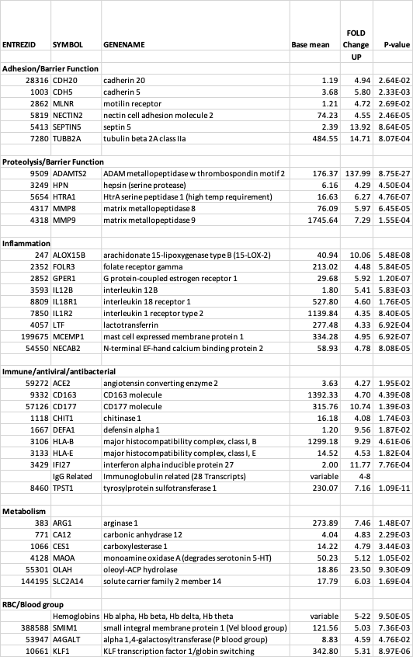

Table 3. Differentially expressed genes decreased in CHS.
