Supplementary Information

Cluster analysis
The goal of the cluster analysis is to identify homogeneous policy profiles among the 112 municipalities under study, based on a dataset of five continuous variables in the range [0, 1], each representing the percentage coverage of the taxonomy for the macro-areas (A, B, C, D, E). For each municipality, the number of taxonomy items used in at least one of the annually submitted plans (each municipality submits a new plan every year by March) was counted for each macro-area (see Section 2 of the paper for details on Family Plans and the taxonomy) This count was then divided by the total number of taxonomy items defined for that macro-area.

List of macro-areas:

A – Governance and network actions
B – Economic measures
C – Information and communication
D – Educating community
E – Territorial welfare and sustainability

An initial exploratory analysis (Analysis 1), conducted on the full dataset (N=112×5), was carried out to determine the latent structure of the data. The first step involved using the Elbow and Silhouette methods to identify the optimal number of clusters (k) for a cluster analysis. The Elbow method (based on Total Within-Sum-of-Squares, WSS) showed its most pronounced “elbow” at k=3 (WSS=12.13), the point at which the marginal gain in reducing within-cluster variance decreased substantially (ΔWSS from k=2 to k=3 was 4.05, while from k=3 to k=4 it dropped to 2.21). In parallel, the Silhouette method (which maximises internal cohesion and external separation) indicated a global maximum at k=2 (Average Silhouette=0.368), with k=3 as the second-best option (0.330). We therefore proceeded with K-means clustering using k=3 (consistent with the Elbow method), running 25 random initial partitions (nstart=25) to reduce the risk of local minima and ensure stability.

A Principal Component Analysis (PCA) performed on this dataset showed that while the First Principal Component (PC1, 57.8% var.) could be interpreted as a latent factor of overall “completeness” of the plan (positively correlated with all five variables), the Second Principal Component (PC2, 14% var.) was almost entirely driven by variable C (Information and Communication). This occurred because variable C, based on only two taxonomy items, assumed only three possible values in the dataset (0, 0.5, or 1). This reduced cardinality induced an artificial “banding” in the multidimensional space, giving disproportionate weight to a single macro-area (C), which in turn dominated cluster formation. Cluster 3, for instance, consisted exclusively of municipalities that had adopted both items in the Communication macro-area, while Cluster 2 (with only two exceptions) included only municipalities that had adopted one. Cluster 1, finally, grouped municipalities with generally few actions and either none or only one item in macro-area C.

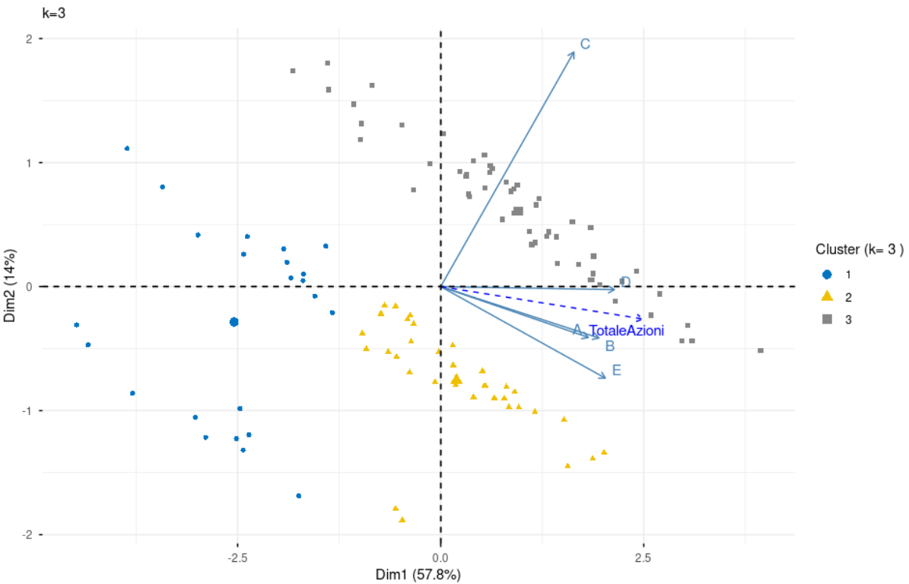
Figure 1. PCA results on the full dataset

The results of this first analysis were therefore unsatisfactory, as they placed excessive weight on a marginal macro-area with only two taxonomy items—items that are not directly associated with family well-being outcomes, but rather with disseminating information about actions taken in other macro-areas.

To correct this distortion, a second analysis (Analysis 2) was carried out, excluding variable C, thus focusing on the four substantive policy macro-areas (A, B, D, E). PCA on this refined dataset (N=112×4) revealed a more interpretable and theoretically meaningful structure: PC1 (64.2% var.) again represented overall completeness, while PC2 (15% var.) emerged as a policy trade-off axis contrasting macro-area A (Governance) with macro-area B (Economic measures). Diagnostic metrics again suggested a low number of clusters (k=2 for Silhouette, Avg. Sil.=0.359; k=3 or k=4 per Elbow, WSS=6.98 and 6.03 respectively).

However, these partitions (k=2, 3, 4) proved theoretically weak. A comparative visual inspection of the biplots for increasing k showed that these solutions segmented the data almost exclusively along PC1 (coverage level), failing to differentiate policy models (i.e., the PC2 dimension).

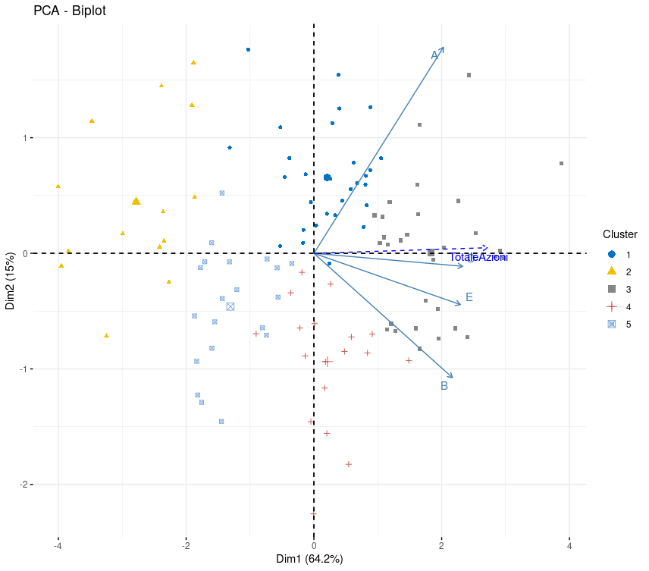
Figure 2. PCA results after excluding macro-area C

A five-cluster solution (k=5; WSS=5.35, Avg. Sil.=0.228) was therefore selected as the best compromise between statistical parsimony and interpretability. While statistically suboptimal according to standard metrics, this solution allowed effective segmentation of municipalities along both the completeness axis (PC1) and the policy-model axis (PC2). Specifically, k=5 was the minimum k needed to isolate distinct profiles among municipalities with “intermediate” coverage levels (center of PC1), distinguishing them according to their strategic orientation (positive vs. negative PC2 scores, indicating a focus on macro-area A vs. B).

The five resulting clusters were therefore profiled as follows, based on their average position on the principal components and on the means of the original variables:

- Intermediate overall coverage, with a focus on macro-area A (positive PC2);
- Low overall coverage (negative PC1);
- High overall coverage (positive PC1);
- Intermediate overall coverage, with a focus on macro-area B (negative PC2);
- Medium-low coverage across the taxonomy, with particularly low levels in macro-area A.

The data used for the cluster analysis come from the information system of the Agency for Social Cohesion of the Autonomous Province of Trento. All Family Plans of the municipalities that have obtained the Family in Trentino certification are available in PDF format at the following address: https://www.trentinofamiglia.it/Documentazione/Pubblicazioni

