Landscape Complexity Shapes the Role of Network Density and Diversity in Collective Adaptation Under Disruption - Supplementary Information

1. Disruption Profiles
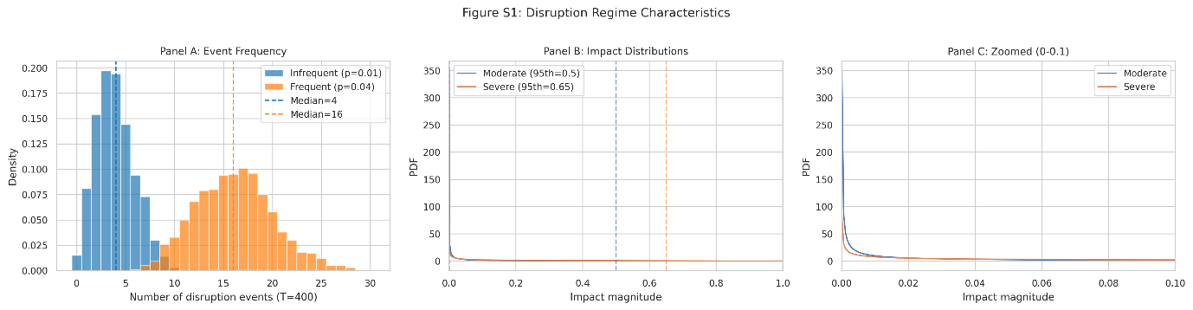Figure S1. Disruption regime characteristics generated from parameters. (A) histogram of disruption Bernoulli process for infrequent (p = 1/100) and frequent (p = 1/25) regimes across 400 timesteps. (B and C) Impact distributions generated from 5th and 95th percentile values, Moderate and Severe have 5th percentile = 0.01, moderate 95th = 0.5, severe 95th = 0.65.
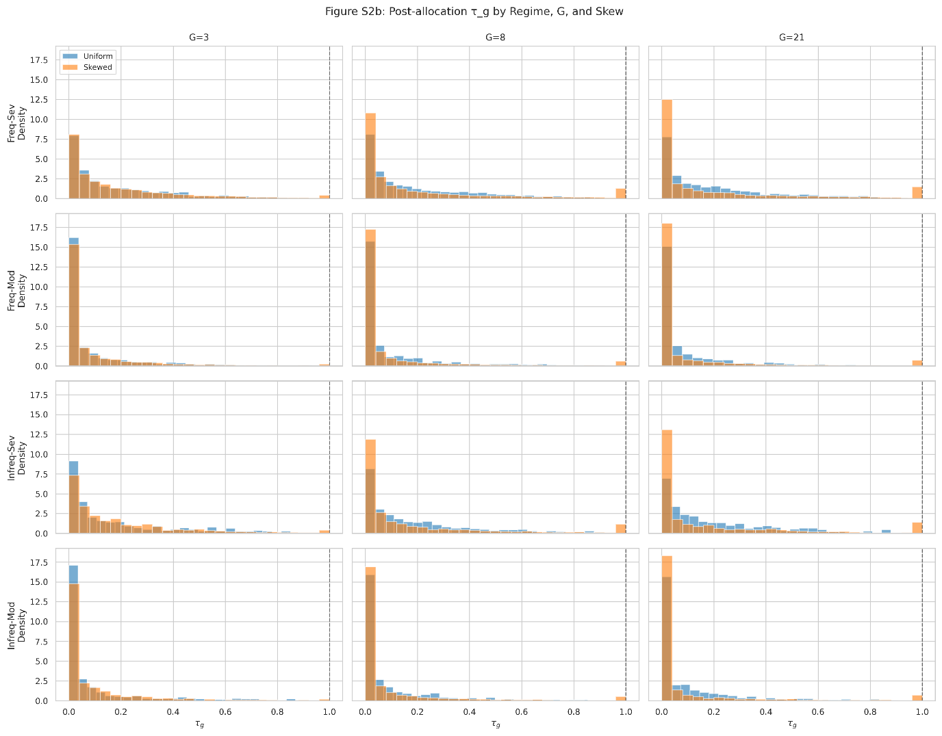Figure S2. Group-Level impact distributions for diversity (group number) 3,8 and 21 for all disruption regimes and combinations of disruption frequency and severity. Skewed distributions (orange) higher than8 and 21 show greater density of events that have T_{g} = 1 which would lead to groups payoff functions being completely changed having no correlation with pre disruption payoff function. Uniform disruptions (blue) do ever result in T_{g} = 1. This is indicative of the skewed impacts reducing performance in severe disruptions due to completely scrambling groups payoff functions.
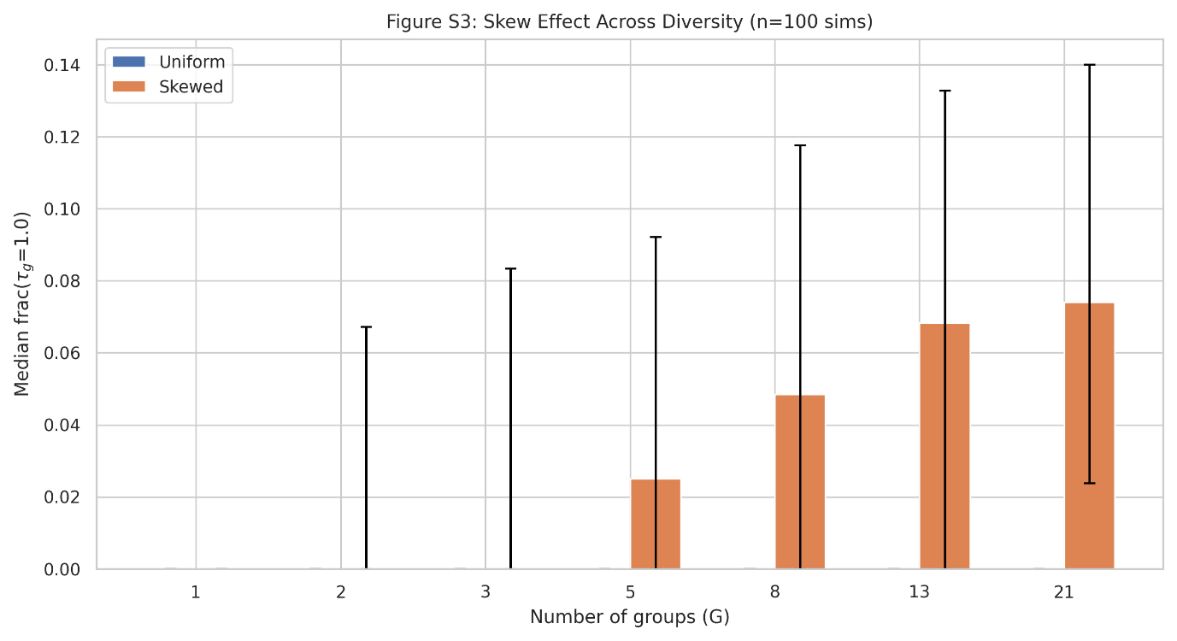Figure S3. Skew Effect Across number of groups (G) in Frequent-Severe regime for skewed and uniform disruptions. Only skewed disruptions show fraction of values above T_{g =} 1, with median fraction increasing monotonically with group size. This also indicates the skewed impact performance reductions (inequality impacts) are likely driven by extreme events that result in a subset of groups drawing completely new combination functions from uniform distribution, effectively removing the knowledge they had gained.

2. Disruption Regime Performance
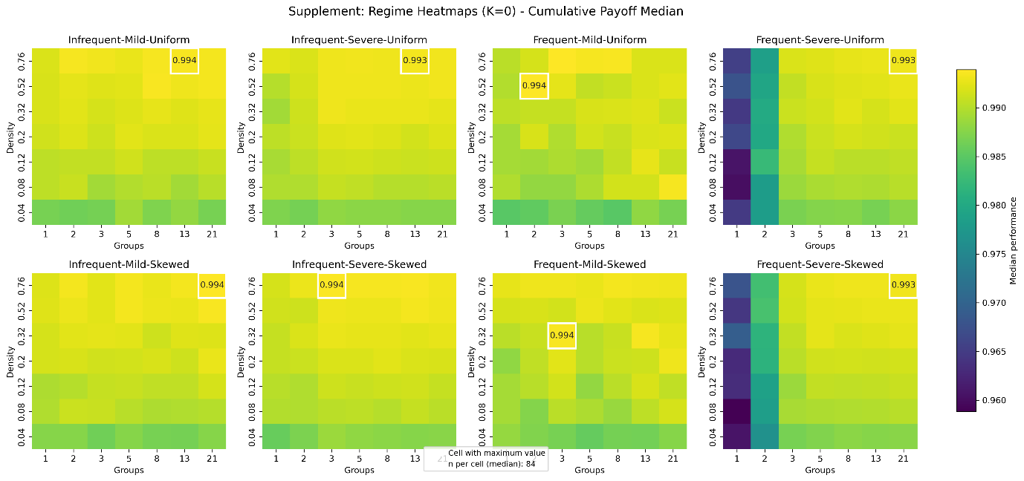Figure S4. Performance heatmaps across all disruption regimes in simple landscapes (K_{NK} = 0). Each panel shows cumulative performance as a function of network density (x-axis, d=0.04-0.76) and agent diversity (y-axis, G=1-21). Columns represent frequency-severity combinations; rows represent impact distribution (uniform vs. skewed). Note the minimal difference between uniform and skewed rows within each column, contrasting with progressive rightward shift of peaks across columns as disruption intensity increases.
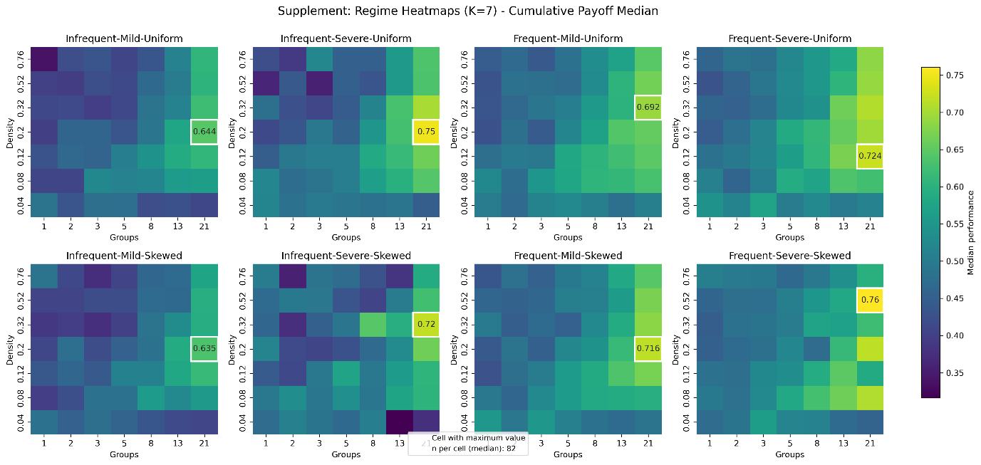Figure S5. Performance heatmaps across all disruption regimes in complex landscapes (K_{NK} = 7). Layout as in Supplementary Figure S3. Note the increasing divergence between uniform and skewed rows in severe conditions (columns 3-4), demonstrating that distributional equity matters in complex but not simple landscapes. All panels show performance gains relative to control conditions, with highest median performance under frequent-severe-skewed conditions (panel 8).

3. Disruption Regime Difference Analysis
Difference-in-difference analysis was employed to isolate the pure effect of disruption by comparing performance between control and disruption simulations with identical configuration parameters for each disruption regime. This approach enables precise quantification of disruption impacts across the configuration space.
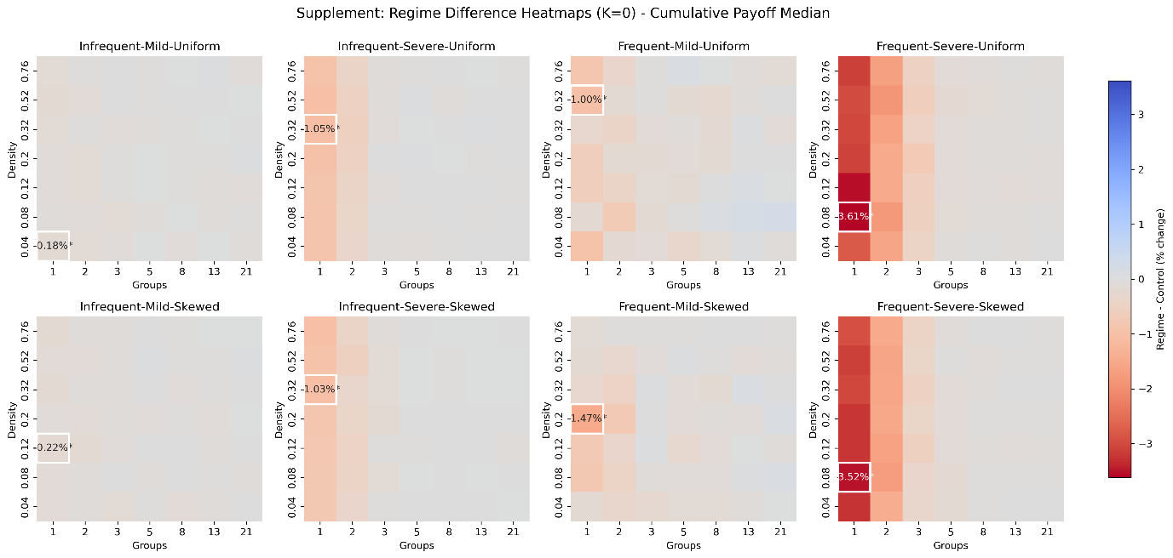
Figure S6. Performance difference from control heatmaps across all disruption regimes in simple landscapes (K_{NK} = 0). Each panel shows difference in cumulative performance of disruption regimes - control as a function of network density (x-axis, d=0.04-0.76) and agent diversity (y-axis, G=1-21). Columns represent frequency-severity combinations; rows represent impact distribution (uniform vs. skewed). Diversity (number of groups) has consistent impact up until G = 3 for severe impacts after which increases have minimal impact in protecting against performance loss.

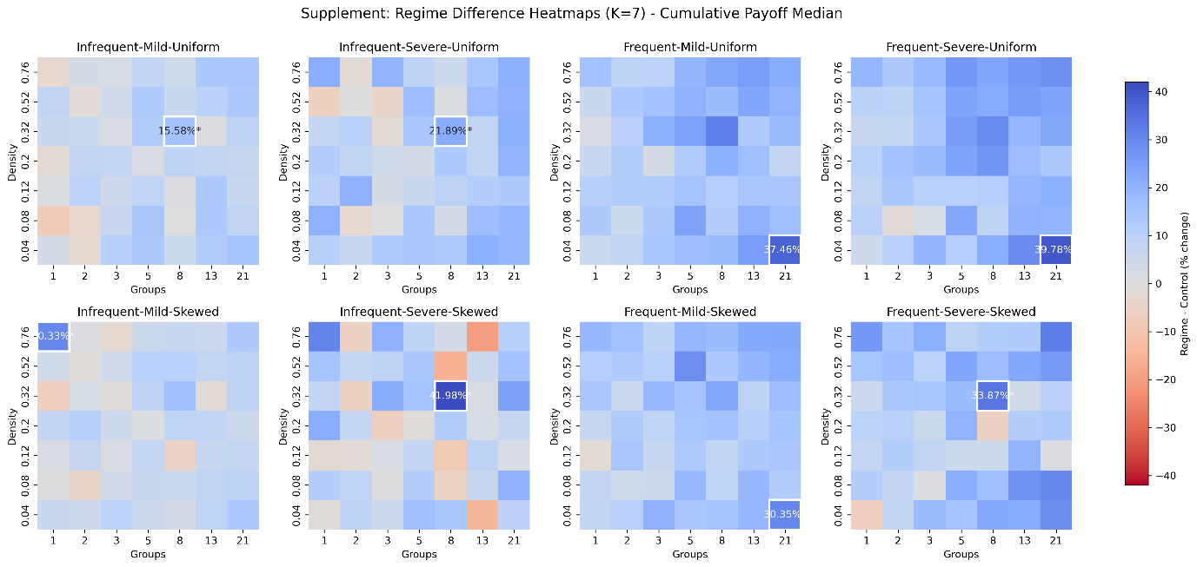Figure S7. Performance difference from control heatmaps across all disruption regimes in simple landscapes (K_{NK} = 7). Each panel shows difference in cumulative performance of disruption regimes - control as a function of network density (x-axis, d=0.04-0.76) and agent diversity (y-axis, G=1-21). Columns represent frequency-severity combinations; rows represent impact distribution (uniform vs. skewed). High diversity (number of groups) appears to broadly increase performance especially for severe impacts. Density has a less clear relationship with several conditions showing high density increases performance difference.

