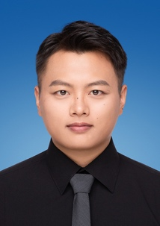
Cen Gu was born in Taizhou, China in 1998. His research focuses on public-key cryptography, information security, and artificial intelligence security, with several related publications to his name. He can be contacted at gc13852410048@163.com.
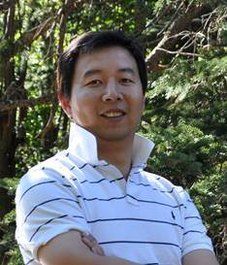
Hongjie Wu Professor ,Ph.D., Doctoral Supervisor. Currently serves as Dean of the School of Electronic and Information Engineering at Suzhou University of Science and Technology. Director of the Jiangsu Provincial Key Laboratory of Intelligent Energy Conservation in Buildings, Director of the Suzhou Key Laboratory of New Technologies and Interdisciplinary Applications in Artificial Intelligence, Director of the Suzhou Blockchain Data Privacy Protection Innovation Application Laboratory, Head of the Artificial Intelligence Program at our university, and Leader of the Artificial Intelligence and Interdisciplinary Applications Team. Selected for Jiangsu Province's “Six Major Talent Peaks” initiative and the Jiangsu “333” Key Teacher Cultivation Program. He has conducted research visits at the University of Michigan and the University of Colorado. He serves as a council member of the Suzhou Artificial Intelligence Society, a member of the Chinese Association for Artificial Intelligence and the Jiangsu Provincial Artificial Intelligence Society, and an executive committee member of the Bioinformatics Special Committee of the China Computer Federation. His long-term research focuses on artificial intelligence, bioinformatics, and health data computation and mining. He has published over 50 papers in prestigious domestic and international journals, including Science China: Information Sciences, Journal of Computer Science and Technology, and Knowledge Based Systems. He has led four National Natural Science Foundation projects. He has completed over 30 intelligent transformation software projects for government agencies, with achievements recognized by the Jiangsu Provincial Department of Construction and the Suzhou Science and Technology Progress Award. He has guided students in competitions including the Challenge Cup, Internet Plus, National Software Talent Design and Entrepreneurship Competition, National University Cloud Computing Application Innovation Competition, and Jiangsu Provincial College Student Programming Contest, earning over 20 awards. Graduates have secured positions at renowned enterprises such as Oracle (Suzhou) Co., Ltd., China Telecom, and China Unicom, or pursued advanced studies at prestigious domestic and international institutions.
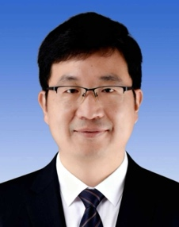
ChunLiang Wang Primary research areas include hospital information management, software development, project management, and data governance. Responsible for completing system construction projects such as integrated platforms and data centers, microservices-based unified electronic medical records, smart emergency platforms, internet hospitals, remote consultations, DRG, VTE, and SPD systems. Achieved Level 4A certification in interoperability standardization maturity assessment and Level 5 evaluation in electronic medical record application grading. Currently serves as: Member, Information Management Professional Committee, Chinese Hospital Association Member, Jiangsu Provincial Information Management Professional Committee Member, Jiangsu Provincial Health Big Data and Smart Healthcare Professional Committee Vice Chair, Information Management Professional Committee, Suzhou Hospital Association Member, Health Information Professional Committee, Suzhou Medical Association Recipient of the China Key Industry Technology Application Innovation Award, CNNC Information Technology Excellence Award, China Baoyuan and CNNC Healthcare Advanced Worker, Suzhou “Gusu Management Medical Star,” and China Baoyuan 2023 Management Innovation Achievement Award. Has led two municipal-level research projects and secured five software copyright registrations.
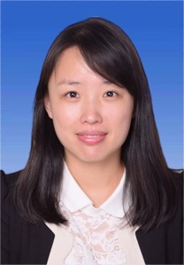
FanFan Kong With 18 years of experience in hospital information system development, I possess deep expertise in hospital IT infrastructure. My responsibilities include: - Building hospital data platforms and data centers - Conducting electronic medical record (EMR) level assessments - Evaluating smart service capabilities - Conducting interoperability evaluations - Managing data reporting to national, provincial, and municipal health commissions - Overseeing hospital information system construction, project management, and external collaboration - Understanding hospital IT requirements - Developing independent R&D capabilities I was honored with the “Yangtze River Delta Outstanding Engineer” title by the Health Information Technology Innovation Alliance.
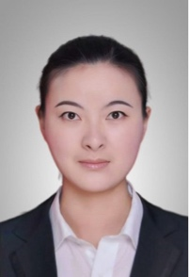
LuPing Wang Lecturer, School of Electronic and Information Engineering, Suzhou University of Science and Technology. Graduated in 2021 from the School of Computer Science at East China Normal University with a Ph.D. in Computer Software and Theory (Advisor: Researcher Chen Jie). Has been teaching in the Department of Computer Science at Suzhou University of Science and Technology since January 2022. Primarily engaged in research related to public-key cryptography, information security, and artificial intelligence security. He has led one project each from the Jiangsu Provincial Social Science Fund, the Jiangsu Provincial Higher Education Basic Science (Natural Science) Research Program, the Suzhou Municipal Key Social Science Project, the Ministry of Education's Supply-Demand Matching Employment Education Project, the National Key Laboratory of Blockchain and Data Security Open Project, and the Jiangsu Provincial Key Laboratory of Intelligent Elevator Safety Open Project. He has also participated in three National Natural Science Foundation of China (NSFC) General Projects. He has published over twenty papers in top-tier international conferences and journals on cryptography and cybersecurity, including ASIACRYPT, IEEE Transactions on Dependable and Secure Computing, and Theoretical Computer Science. In 2023, he was selected as a Jiangsu Provincial Science and Technology Deputy Director.

