Crawling towards complex interactions: the impact of 6PPD-quinone and increased temperatures on the freshwater snail Ampullaceana balthica
Núria de Castro-Català¹*, Catalina Lizama, Jordi Serra¹, Mira Čelić², Isabel Cadena², Mira Petrovic^{2,3}, Isabel Muñoz¹
¹ Department of Evolutionary Biology, Ecology and Environmental Sciences, Universitat de Barcelona, Av. Diagonal, 643, 08028 Barcelona, Spain.
² Catalan Institute for Water Research (ICRA- CERCA), Carrer Emili Grahit 101, Parc Científic I Tecnològic de la Universitat de Girona, 17003 Girona, Spain.
³ Catalan Institution for Research and Advanced Studies (ICREA); Barcelona, Spain.

Supplementary material
Figure S1. Chromatograms for 6PPD-Q. A: Calibration standard from Calibration Curve at two concentration levels (low and high); B: Stock solutions of 6PPD-quinone used in the experiment; C: Recovery chromatogram of sample 4, which did not contain any added contaminants.
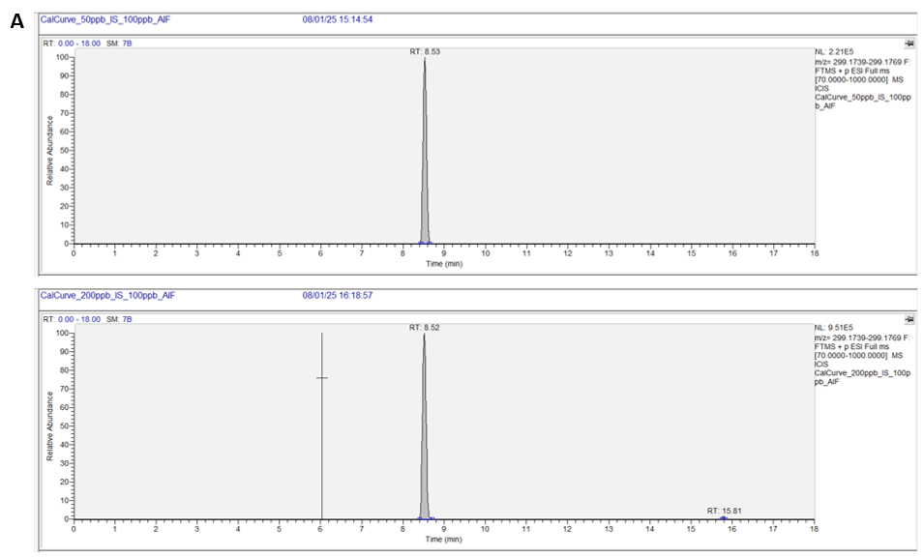
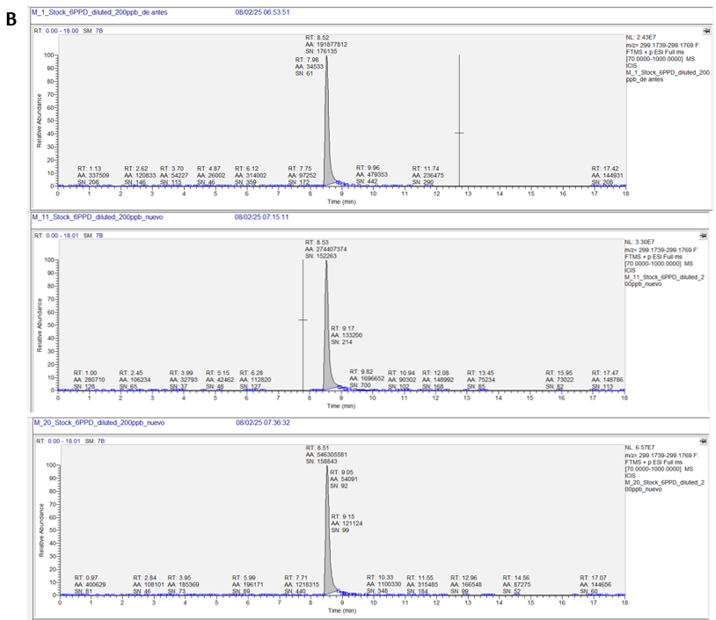
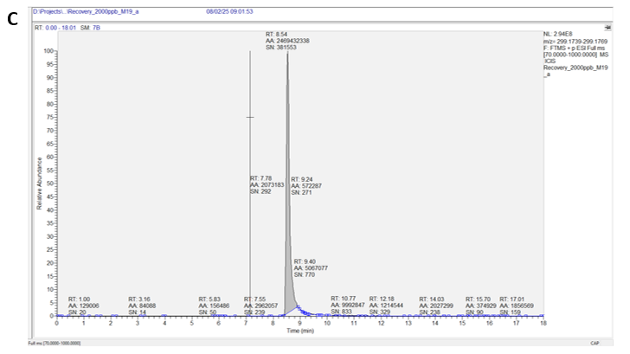

Figure S2. Temperature-dependent degradation of 6PPD-quinone over 48 hours
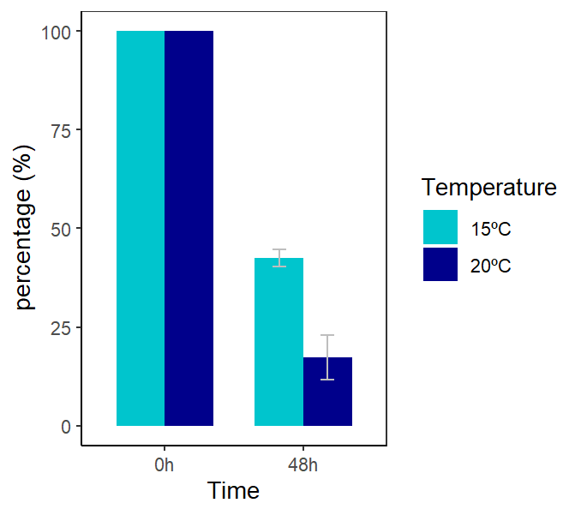

Text S1. Detailed R statistical results for regression model selection.
Daily mortality
> mod1 <- lm(logdailydead~ Treatment*Temperature*sampling , datos)
> mod2 <- lm(logdailydead~ Treatment*Temperature+sampling , datos)
> mod3 <- lm(logdailydead~ Treatment + Temperature + sampling, datos) #aquest
> mod4 <- lm(logdailydead~ Treatment*Temperature , datos)
> mod5 <- lm(logdailydead~ Treatment+Temperature , datos)
> mod6<-lm(logdailydead~Treatment*sampling,datos)
> mod7<-lm(logdailydead~Treatment+sampling,datos)
> summary(mod1)

Call:
lm(formula = logdailydead ~ Treatment * Temperature * sampling,
data = datos)

Residuals:
Min 1Q Median 3Q Max
-0.14976 -0.06272 -0.02333 0.05509 0.22399

Coefficients:
Estimate Std. Error t value Pr(>|t|)
(Intercept) 0.04255 0.07931 0.536 0.5947
Treatmentppdq -0.05484 0.11216 -0.489 0.6276
Temperaturehigh -0.06427 0.11387 -0.564 0.5757
sampling 0.01725 0.02896 0.596 0.5548
Treatmentppdq:Temperaturehigh 0.23561 0.15983 1.474 0.1485
Treatmentppdq:sampling 0.04940 0.04095 1.206 0.2350
Temperaturehigh:sampling 0.02781 0.04114 0.676 0.5031
Treatmentppdq:Temperaturehigh:sampling -0.10374 0.05805 -1.787 0.0817 .
---
Signif. codes: 0 ‘***’ 0.001 ‘**’ 0.01 ‘*’ 0.05 ‘.’ 0.1 ‘ ’ 1

Residual standard error: 0.1122 on 39 degrees of freedom
Multiple R-squared: 0.2237, Adjusted R-squared: 0.08438
F-statistic: 1.606 on 7 and 39 DF, p-value: 0.1627

> summary(mod2)#Adj R-squared 0.037

Call:
lm(formula = logdailydead ~ Treatment * Temperature + sampling,
data = datos)

Residuals:
Min 1Q Median 3Q Max
-0.18062 -0.07416 -0.02583 0.06881 0.27802

Coefficients:
Estimate Std. Error t value Pr(>|t|)
(Intercept) 0.011044 0.049145 0.225 0.8233
Treatmentppdq 0.068659 0.046276 1.484 0.1454
Temperaturehigh 0.005941 0.047321 0.126 0.9007
sampling 0.029850 0.014667 2.035 0.0482 *
Treatmentppdq:Temperaturehigh -0.024428 0.066187 -0.369 0.7139
---
Signif. codes: 0 ‘***’ 0.001 ‘**’ 0.01 ‘*’ 0.05 ‘.’ 0.1 ‘ ’ 1

Residual standard error: 0.1134 on 42 degrees of freedom
Multiple R-squared: 0.1461, Adjusted R-squared: 0.06474
F-statistic: 1.796 on 4 and 42 DF, p-value: 0.1476

> summary(mod3)#Adj R-squared 0.057

Call:
lm(formula = logdailydead ~ Treatment + Temperature + sampling,
data = datos)

Residuals:
Min 1Q Median 3Q Max
-0.18667 -0.06921 -0.03182 0.06884 0.28391

Coefficients:
Estimate Std. Error t value Pr(>|t|)
(Intercept) 0.016879 0.046064 0.366 0.7159
Treatmentppdq 0.056718 0.032751 1.732 0.0905 .
Temperaturehigh -0.006546 0.032751 -0.200 0.8425
sampling 0.029904 0.014518 2.060 0.0455 *
---
Signif. codes: 0 ‘***’ 0.001 ‘**’ 0.01 ‘*’ 0.05 ‘.’ 0.1 ‘ ’ 1

Residual standard error: 0.1122 on 43 degrees of freedom
Multiple R-squared: 0.1433, Adjusted R-squared: 0.08353
F-statistic: 2.397 on 3 and 43 DF, p-value: 0.08116

> summary(mod4)
Call:
lm(formula = logdailydead ~ Treatment * Temperature, data = datos)

Residuals:
Min 1Q Median 3Q Max
-0.15433 -0.08932 -0.01090 0.05389 0.32279

Coefficients:
Estimate Std. Error t value Pr(>|t|)
(Intercept) 0.085669 0.033896 2.527 0.0152 *
Treatmentppdq 0.068659 0.047937 1.432 0.1593
Temperaturehigh 0.007298 0.049014 0.149 0.8823
Treatmentppdq:Temperaturehigh -0.025785 0.068559 -0.376 0.7087
---
Signif. codes: 0 ‘***’ 0.001 ‘**’ 0.01 ‘*’ 0.05 ‘.’ 0.1 ‘ ’ 1

Residual standard error: 0.1174 on 43 degrees of freedom
Multiple R-squared: 0.06185, Adjusted R-squared: -0.003597
F-statistic: 0.945 on 3 and 43 DF, p-value: 0.4273

> summary(mod5)

Call:
lm(formula = logdailydead ~ Treatment + Temperature, data = datos)

Residuals:
Min 1Q Median 3Q Max
-0.14803 -0.09197 -0.01720 0.05634 0.32910

Coefficients:
Estimate Std. Error t value Pr(>|t|)
(Intercept) 0.091972 0.029175 3.152 0.00291 **
Treatmentppdq 0.056053 0.033935 1.652 0.10570
Temperaturehigh -0.005881 0.033935 -0.173 0.86320
---
Signif. codes: 0 ‘***’ 0.001 ‘**’ 0.01 ‘*’ 0.05 ‘.’ 0.1 ‘ ’ 1

Residual standard error: 0.1163 on 44 degrees of freedom
Multiple R-squared: 0.05877, Adjusted R-squared: 0.01599
F-statistic: 1.374 on 2 and 44 DF, p-value: 0.2638

> summary(mod6)
Call:
lm(formula = logdailydead ~ Treatment * sampling, data = datos)

Residuals:
Min 1Q Median 3Q Max
-0.18811 -0.06806 -0.03449 0.06823 0.28901

Coefficients:
Estimate Std. Error t value Pr(>|t|)
(Intercept) 0.010791 0.056940 0.190 0.851
Treatmentppdq 0.062580 0.079952 0.783 0.438
sampling 0.031077 0.020584 1.510 0.138
Treatmentppdq:sampling -0.002392 0.029047 -0.082 0.935

Residual standard error: 0.1123 on 43 degrees of freedom
Multiple R-squared: 0.1426, Adjusted R-squared: 0.08282
F-statistic: 2.385 on 3 and 43 DF, p-value: 0.08237

> summary(mod7)

Call:
lm(formula = logdailydead ~ Treatment + sampling, data = datos)

Residuals:
Min 1Q Median 3Q Max
-0.18990 -0.06927 -0.03508 0.06882 0.28722

Coefficients:
Estimate Std. Error t value Pr(>|t|)
(Intercept) 0.01382 0.04297 0.322 0.7493
Treatmentppdq 0.05657 0.03238 1.747 0.0876 .
sampling 0.02988 0.01436 2.081 0.0433 *
---
Signif. codes: 0 ‘***’ 0.001 ‘**’ 0.01 ‘*’ 0.05 ‘.’ 0.1 ‘ ’ 1

Residual standard error: 0.111 on 44 degrees of freedom
Multiple R-squared: 0.1425, Adjusted R-squared: 0.1035
F-statistic: 3.656 on 2 and 44 DF, p-value: 0.03397

> library(AICcmodavg)
> models <- list(mod1,mod2,mod3,mod4, mod5,mod6,mod7)
> aictab(cand.set = models)

Model selection based on AICc:

K AICc Delta_AICc AICcWt Cum.Wt LL
Mod7 4 -67.42 0.00 0.55 0.55 38.19
Mod3 5 -64.95 2.47 0.16 0.71 38.21
Mod6 5 -64.92 2.50 0.16 0.87 38.19
Mod5 4 -63.04 4.38 0.06 0.93 36.00
Mod2 6 -62.47 4.95 0.05 0.98 38.28
Mod4 5 -60.68 6.74 0.02 0.99 36.07
Mod1 9 -58.18 9.24 0.01 1.00 40.52

Warning message:
In aictab.AIClm(cand.set = models) :
Model names have been supplied automatically in the table

> summary(mod7)

Call:
lm(formula = logdailydead ~ Treatment + sampling, data = datos)

Residuals:
Min 1Q Median 3Q Max
-0.18990 -0.06927 -0.03508 0.06882 0.28722

Coefficients:
Estimate Std. Error t value Pr(>|t|)
(Intercept) 0.01382 0.04297 0.322 0.7493
Treatmentppdq 0.05657 0.03238 1.747 0.0876 .
sampling 0.02988 0.01436 2.081 0.0433 *
---
Signif. codes: 0 ‘***’ 0.001 ‘**’ 0.01 ‘*’ 0.05 ‘.’ 0.1 ‘ ’ 1

Residual standard error: 0.111 on 44 degrees of freedom
Multiple R-squared: 0.1425, Adjusted R-squared: 0.1035
F-statistic: 3.656 on 2 and 44 DF, p-value: 0.03397
> shapiro.test(residuals(mod7))

Shapiro-Wilk normality test

data: residuals(mod7)
W = 0.96253, p-value = 0.1355

> bp <- bptest(mod7)
> bp

studentized Breusch-Pagan test

data: mod7
BP = 5.5281, df = 2, p-value = 0.06304

> car::Anova(mod7, type= "III")
Anova Table (Type III tests)

Response: logdailydead
Sum Sq Df F value Pr(>F)
(Intercept) 0.00127 1 0.1034 0.74927
Treatment 0.03759 1 3.0519 0.08762 .
sampling 0.05332 1 4.3295 0.04331 *
Residuals 0.54190 44
---
Signif. codes: 0 ‘***’ 0.001 ‘**’ 0.01 ‘*’ 0.05 ‘.’ 0.1 ‘ ’ 1

Number of clutches
mod1 <- lm(logclutchsn ~ Temp*Tratamiento*Day , datos)
> summary(mod1)

Call:
lm(formula = logclutchsn ~ Temp * Tratamiento * Day, data = datos)

Residuals:
Min 1Q Median 3Q Max
-0.04362 -0.01563 -0.00073 0.01184 0.06687

Coefficients:
Estimate Std. Error t value Pr(>|t|)
(Intercept) 0.037839 0.026453 1.430 0.164
Temphigh 0.002652 0.037410 0.071 0.944
TratamientoPPD-Q -0.024375 0.037410 -0.652 0.520
Day -0.001608 0.003567 -0.451 0.656
Temphigh:TratamientoPPD-Q 0.043671 0.052906 0.825 0.416
Temphigh:Day 0.002055 0.005044 0.407 0.687
TratamientoPPD-Q:Day 0.002150 0.005044 0.426 0.673
Temphigh:TratamientoPPD-Q:Day -0.008616 0.007134 -1.208 0.237

Residual standard error: 0.02621 on 28 degrees of freedom
Multiple R-squared: 0.2446, Adjusted R-squared: 0.05581
F-statistic: 1.296 on 7 and 28 DF, p-value: 0.2887

> shapiro.test(resid(mod1))

Shapiro-Wilk normality test

data: resid(mod1)
W = 0.971, p-value = 0.4536

> mod2 <- lm(logclutchsn ~ Tratamiento *Temp +Day, datos)
> summary(mod2)

Call:
lm(formula = logclutchsn ~ Tratamiento * Temp + Day, data = datos)

Residuals:
Min 1Q Median 3Q Max
-0.048597 -0.013672 -0.004843 0.017206 0.060548

Coefficients:
Estimate Std. Error t value Pr(>|t|)
(Intercept) 0.038200 0.015046 2.539 0.0164 *
TratamientoPPD-Q -0.009324 0.012200 -0.764 0.4505
Temphigh 0.017035 0.012200 1.396 0.1726
Day -0.001659 0.001761 -0.942 0.3533
TratamientoPPD-Q:Temphigh -0.016639 0.017254 -0.964 0.3423
---
Signif. codes: 0 ‘***’ 0.001 ‘**’ 0.01 ‘*’ 0.05 ‘.’ 0.1 ‘ ’ 1

Residual standard error: 0.02588 on 31 degrees of freedom
Multiple R-squared: 0.1847, Adjusted R-squared: 0.07946
F-statistic: 1.755 on 4 and 31 DF, p-value: 0.1631

> shapiro.test(resid(mod2))

Shapiro-Wilk normality test

data: resid(mod2)
W = 0.96452, p-value = 0.2951

> mod3 <- lm(logclutchsn ~ Tratamiento+Temp*day , datos)
> summary(mod3)

Call:
lm(formula = logclutchsn ~ Tratamiento + Temp * day, data = datos)

Residuals:
Min 1Q Median 3Q Max
-0.053594 -0.011716 -0.007622 0.015938 0.055550

Coefficients:
Estimate Std. Error t value Pr(>|t|)
(Intercept) 0.030743 0.007463 4.119 0.000289 ***
TratamientoPPD-Q -0.017643 0.008617 -2.047 0.049771 *
Temphigh 0.008715 0.008617 1.011 0.320216
day.L -0.002261 0.010554 -0.214 0.831883
day.Q -0.009398 0.010554 -0.890 0.380532
Temphigh:day.L -0.009560 0.014926 -0.640 0.526891
Temphigh:day.Q 0.023551 0.014926 1.578 0.125437
---
Signif. codes: 0 ‘***’ 0.001 ‘**’ 0.01 ‘*’ 0.05 ‘.’ 0.1 ‘ ’ 1

Residual standard error: 0.02585 on 29 degrees of freedom
Multiple R-squared: 0.239, Adjusted R-squared: 0.08151
F-statistic: 1.518 on 6 and 29 DF, p-value: 0.2075

> shapiro.test(resid(mod3))

Shapiro-Wilk normality test

data: resid(mod3)
W = 0.96551, p-value = 0.3159

> mod3 <- lm(logclutchsn ~ Tratamiento+Temp*Day , datos)
> summary(mod3)

Call:
lm(formula = logclutchsn ~ Tratamiento + Temp * Day, data = datos)

Residuals:
Min 1Q Median 3Q Max
-0.04782 -0.01463 -0.01128 0.01344 0.06133

Coefficients:
Estimate Std. Error t value Pr(>|t|)
(Intercept) 0.0344732 0.0191250 1.803 0.0812 .
TratamientoPPD-Q -0.0176434 0.0086992 -2.028 0.0512 .
Temphigh 0.0244876 0.0263380 0.930 0.3597
Day -0.0005329 0.0025112 -0.212 0.8333
Temphigh:Day -0.0022532 0.0035514 -0.634 0.5304
---
Signif. codes: 0 ‘***’ 0.001 ‘**’ 0.01 ‘*’ 0.05 ‘.’ 0.1 ‘ ’ 1

Residual standard error: 0.0261 on 31 degrees of freedom
Multiple R-squared: 0.171, Adjusted R-squared: 0.064
F-statistic: 1.598 on 4 and 31 DF, p-value: 0.1996

> shapiro.test(resid(mod3))

Shapiro-Wilk normality test

data: resid(mod3)
W = 0.94669, p-value = 0.08224

> mod5 <- lm(logclutchsn ~ Tratamiento* Temp , datos)
> summary(mod5)

Call:
lm(formula = logclutchsn ~ Tratamiento * Temp, data = datos)

Residuals:
Min 1Q Median 3Q Max
-0.043618 -0.017260 -0.007124 0.016562 0.065526

Coefficients:
Estimate Std. Error t value Pr(>|t|)
(Intercept) 0.026583 0.008612 3.087 0.00416 **
TratamientoPPD-Q -0.009324 0.012179 -0.766 0.44955
Temphigh 0.017035 0.012179 1.399 0.17152
TratamientoPPD-Q:Temphigh -0.016639 0.017224 -0.966 0.34126
---
Signif. codes: 0 ‘***’ 0.001 ‘**’ 0.01 ‘*’ 0.05 ‘.’ 0.1 ‘ ’ 1

Residual standard error: 0.02584 on 32 degrees of freedom
Multiple R-squared: 0.1613, Adjusted R-squared: 0.08268
F-statistic: 2.052 on 3 and 32 DF, p-value: 0.1263

> shapiro.test(resid(mod5))

Shapiro-Wilk normality test

data: resid(mod5)
W = 0.93797, p-value = 0.04394

> mod6 <- lm(logclutchsn ~ Tratamiento+ Temp:Tratamiento , datos) #NO té sentit mirant p-valors
> summary(mod6)

Call:
lm(formula = logclutchsn ~ Tratamiento + Temp:Tratamiento, data = datos)

Residuals:
Min 1Q Median 3Q Max
-0.043618 -0.017260 -0.007124 0.016562 0.065526

Coefficients:
Estimate Std. Error t value Pr(>|t|)
(Intercept) 0.0265833 0.0086119 3.087 0.00416 **
TratamientoPPD-Q -0.0093238 0.0121791 -0.766 0.44955
TratamientoCNTL:Temphigh 0.0170347 0.0121791 1.399 0.17152
TratamientoPPD-Q:Temphigh 0.0003955 0.0121791 0.032 0.97429
---
Signif. codes: 0 ‘***’ 0.001 ‘**’ 0.01 ‘*’ 0.05 ‘.’ 0.1 ‘ ’ 1

Residual standard error: 0.02584 on 32 degrees of freedom
Multiple R-squared: 0.1613, Adjusted R-squared: 0.08268
F-statistic: 2.052 on 3 and 32 DF, p-value: 0.1263

> shapiro.test(resid(mod6))

Shapiro-Wilk normality test

data: resid(mod6)
W = 0.93797, p-value = 0.04394

> mod7 <- lm(logclutchsn ~ Temp+Day , datos) #AQUEST
> summary(mod7)

Call:
lm(formula = logclutchsn ~ Temp + Day, data = datos)

Residuals:
Min 1Q Median 3Q Max
-0.035615 -0.022856 -0.001926 0.014754 0.073529

Coefficients:
Estimate Std. Error t value Pr(>|t|)
(Intercept) 0.033538 0.014388 2.331 0.026 *
Temphigh 0.008715 0.009025 0.966 0.341
Day -0.001659 0.001842 -0.901 0.374
---
Signif. codes: 0 ‘***’ 0.001 ‘**’ 0.01 ‘*’ 0.05 ‘.’ 0.1 ‘ ’ 1

Residual standard error: 0.02707 on 33 degrees of freedom
Multiple R-squared: 0.0502, Adjusted R-squared: -0.007366
F-statistic: 0.872 on 2 and 33 DF, p-value: 0.4275

> shapiro.test(resid(mod7))

Shapiro-Wilk normality test

data: resid(mod7)
W = 0.94233, p-value = 0.06004

> mod8 <- lm(logclutchsn ~ Tratamiento+Day , datos) #AQUEST
> summary(mod8)

Call:
lm(formula = logclutchsn ~ Tratamiento + Day, data = datos)

Residuals:
Min 1Q Median 3Q Max
-0.04008 -0.01782 -0.01244 0.01731 0.06907

Coefficients:
Estimate Std. Error t value Pr(>|t|)
(Intercept) 0.046717 0.013743 3.399 0.00178 **
TratamientoPPD-Q -0.017643 0.008621 -2.047 0.04872 *
Day -0.001659 0.001760 -0.943 0.35250
---
Signif. codes: 0 ‘***’ 0.001 ‘**’ 0.01 ‘*’ 0.05 ‘.’ 0.1 ‘ ’ 1

Residual standard error: 0.02586 on 33 degrees of freedom
Multiple R-squared: 0.1334, Adjusted R-squared: 0.08084
F-statistic: 2.539 on 2 and 33 DF, p-value: 0.09426

> shapiro.test(resid(mod8))

Shapiro-Wilk normality test

data: resid(mod8)
W = 0.91995, p-value = 0.01254

> summary(modBIC)

Call:
lm(formula = logclutchsn ~ Tratamiento, data = datos)

Residuals:
Min 1Q Median 3Q Max
-0.03510 -0.01746 -0.01564 0.01731 0.07404

Coefficients:
Estimate Std. Error t value Pr(>|t|)
(Intercept) 0.035101 0.006086 5.768 1.73e-06 ***
TratamientoPPD-Q -0.017643 0.008607 -2.050 0.0481 *
---
Signif. codes: 0 ‘***’ 0.001 ‘**’ 0.01 ‘*’ 0.05 ‘.’ 0.1 ‘ ’ 1

Residual standard error: 0.02582 on 34 degrees of freedom
Multiple R-squared: 0.11, Adjusted R-squared: 0.08383
F-statistic: 4.203 on 1 and 34 DF, p-value: 0.04814

> mod4 <- lm(logclutchsn ~ Temp+ Tratamiento+sampling, datos)#AQUEST (stepwise+normality)
> summary(mod4)

Call:
lm(formula = logclutchsn ~ Temp + Tratamiento + sampling, data = datos)

Residuals:
Min 1Q Median 3Q Max
-0.045407 -0.017807 -0.009049 0.015384 0.063737

Coefficients:
Estimate Std. Error t value Pr(>|t|)
(Intercept) 0.036692 0.009773 3.754 0.00072 ***
Temphigh 0.008715 0.008742 0.997 0.32649
TratamientoPPD-Q -0.017643 0.008742 -2.018 0.05228 .
samplingsecond -0.007890 0.010706 -0.737 0.46669
samplingthird -0.009957 0.010706 -0.930 0.35955
---
Signif. codes: 0 ‘***’ 0.001 ‘**’ 0.01 ‘*’ 0.05 ‘.’ 0.1 ‘ ’ 1

Residual standard error: 0.02622 on 31 degrees of freedom
Multiple R-squared: 0.1629, Adjusted R-squared: 0.05485
F-statistic: 1.508 on 4 and 31 DF, p-value: 0.2241

> shapiro.test(resid(mod4))

Shapiro-Wilk normality test

data: resid(mod4)
W = 0.95058, p-value = 0.1091

> library(lmtest)
> bp <- bptest(mod4)
> bp

studentized Breusch-Pagan test

data: mod4
BP = 5.0856, df = 4, p-value = 0.2786

> mod5 <- lm(logclutchsn ~ Tratamiento* Temp , datos)
> summary(mod5)

Call:
lm(formula = logclutchsn ~ Tratamiento * Temp, data = datos)

Residuals:
Min 1Q Median 3Q Max
-0.043618 -0.017260 -0.007124 0.016562 0.065526

Coefficients:
Estimate Std. Error t value Pr(>|t|)
(Intercept) 0.026583 0.008612 3.087 0.00416 **
TratamientoPPD-Q -0.009324 0.012179 -0.766 0.44955
Temphigh 0.017035 0.012179 1.399 0.17152
TratamientoPPD-Q:Temphigh -0.016639 0.017224 -0.966 0.34126
---
Signif. codes: 0 ‘***’ 0.001 ‘**’ 0.01 ‘*’ 0.05 ‘.’ 0.1 ‘ ’ 1

Residual standard error: 0.02584 on 32 degrees of freedom
Multiple R-squared: 0.1613, Adjusted R-squared: 0.08268
F-statistic: 2.052 on 3 and 32 DF, p-value: 0.1263

> mod5 <- lm(logclutchsn ~ Tratamiento+ Temp , datos)
> summary(mod5)

Call:
lm(formula = logclutchsn ~ Tratamiento + Temp, data = datos)

Residuals:
Min 1Q Median 3Q Max
-0.03946 -0.01682 -0.01128 0.01609 0.06969

Coefficients:
Estimate Std. Error t value Pr(>|t|)
(Intercept) 0.030743 0.007451 4.126 0.000235 ***
TratamientoPPD-Q -0.017643 0.008603 -2.051 0.048297 *
Temphigh 0.008715 0.008603 1.013 0.318425
---
Signif. codes: 0 ‘***’ 0.001 ‘**’ 0.01 ‘*’ 0.05 ‘.’ 0.1 ‘ ’ 1

Residual standard error: 0.02581 on 33 degrees of freedom
Multiple R-squared: 0.1368, Adjusted R-squared: 0.08454
F-statistic: 2.616 on 2 and 33 DF, p-value: 0.08819

> shapiro.test(resid(mod5))

Shapiro-Wilk normality test

data: resid(mod5)
W = 0.93066, p-value = 0.0262

K AICc Delta_AICc AICcWt Cum.Wt LL
Mod4 5 -208.26 0.00 1 1 109.85
Mod8 4 -154.84 53.42 0 1 82.06
Mod5 5 -153.31 54.95 0 1 82.65
Mod6 5 -153.31 54.95 0 1 82.65
Mod7 4 -151.54 56.72 0 1 80.41
Mod2 6 -151.43 56.83 0 1 83.16
Mod3 6 -150.83 57.43 0 1 82.86
Mod1 9 -144.15 64.11 0 1 84.54

> mod4 <- lm(logclutchsn ~ Temp+ Tratamiento+Day, datos)
> summary(mod4)

Call:
lm(formula = logclutchsn ~ Temp + Tratamiento + Day, data = datos)

Residuals:
Min 1Q Median 3Q Max
-0.044437 -0.017072 -0.008079 0.014682 0.064708

Coefficients:
Estimate Std. Error t value Pr(>|t|)
(Intercept) 0.042359 0.014398 2.942 0.00602 **
Temphigh 0.008715 0.008618 1.011 0.31945
TratamientoPPD-Q -0.017643 0.008618 -2.047 0.04891 *
Day -0.001659 0.001759 -0.943 0.35255
---
Signif. codes: 0 ‘***’ 0.001 ‘**’ 0.01 ‘*’ 0.05 ‘.’ 0.1 ‘ ’ 1

Residual standard error: 0.02585 on 32 degrees of freedom
Multiple R-squared: 0.1602, Adjusted R-squared: 0.08147
F-statistic: 2.035 on 3 and 32 DF, p-value: 0.1287

> shapiro.test(resid(mod4))

Shapiro-Wilk normality test

data: resid(mod4)
W = 0.94994, p-value = 0.1041

> bp <- bptest(mod4)
> bp

studentized Breusch-Pagan test

data: mod4
BP = 5.1188, df = 3, p-value = 0.1633

Number of eggs per clutch
> mod1 <- lm(logeggscl~ Treatment*Temp*Day, datos)
> summary(mod1)

Call:
lm(formula = logeggscl ~ Treatment * Temp * Day, data = datos)

Residuals:
Min 1Q Median 3Q Max
-0.66311 -0.12484 0.01161 0.13266 0.46356

Coefficients:
Estimate Std. Error t value Pr(>|t|)
(Intercept) 1.0175510 0.2177653 4.673 2.61e-05 ***
Treatmentppdq -0.4716482 0.3264494 -1.445 0.155
Temphigh 0.0803449 0.2685537 0.299 0.766
Day 0.0110771 0.0306742 0.361 0.720
Treatmentppdq:Temphigh -0.1938910 0.4795756 -0.404 0.688
Treatmentppdq:Day 0.0624283 0.0450353 1.386 0.172
Temphigh:Day -0.0004941 0.0367906 -0.013 0.989
Treatmentppdq:Temphigh:Day 0.0480619 0.0769421 0.625 0.535
---
Signif. codes: 0 ‘***’ 0.001 ‘**’ 0.01 ‘*’ 0.05 ‘.’ 0.1 ‘ ’ 1

Residual standard error: 0.2423 on 46 degrees of freedom
Multiple R-squared: 0.2073, Adjusted R-squared: 0.08662
F-statistic: 1.718 on 7 and 46 DF, p-value: 0.1283

> mod2 <- lm(logeggscl~ Treatment*Temp+Day, datos)
> summary(mod2)

Call:
lm(formula = logeggscl ~ Treatment * Temp + Day, data = datos)

Residuals:
Min 1Q Median 3Q Max
-0.59999 -0.13771 0.04517 0.16712 0.45437

Coefficients:
Estimate Std. Error t value Pr(>|t|)
(Intercept) 0.89029 0.12019 7.407 1.56e-09 ***
Treatmentppdq -0.03839 0.10138 -0.379 0.7065
Temphigh 0.06765 0.08423 0.803 0.4257
Day 0.02979 0.01495 1.992 0.0519 .
Treatmentppdq:Temphigh -0.01938 0.14883 -0.130 0.8969
---
Signif. codes: 0 ‘***’ 0.001 ‘**’ 0.01 ‘*’ 0.05 ‘.’ 0.1 ‘ ’ 1

Residual standard error: 0.2482 on 49 degrees of freedom
Multiple R-squared: 0.1139, Adjusted R-squared: 0.04153
F-statistic: 1.574 on 4 and 49 DF, p-value: 0.196

> mod3 <- lm(logeggscl~ Treatment + Temp + Day + Treatment:Day, datos)
> summary(mod3)

Call:
lm(formula = logeggscl ~ Treatment + Temp + Day + Treatment:Day,
data = datos)

Residuals:
Min 1Q Median 3Q Max
-0.67320 -0.13033 0.02427 0.12680 0.44100

Coefficients:
Estimate Std. Error t value Pr(>|t|)
(Intercept) 1.01023 0.12656 7.982 2.04e-10 ***
Treatmentppdq -0.48909 0.21100 -2.318 0.0247 *
Temphigh 0.09898 0.06746 1.467 0.1487
Day 0.01028 0.01652 0.622 0.5366
Treatmentppdq:Day 0.06949 0.03131 2.219 0.0311 *
---
Signif. codes: 0 ‘***’ 0.001 ‘**’ 0.01 ‘*’ 0.05 ‘.’ 0.1 ‘ ’ 1

Residual standard error: 0.2366 on 49 degrees of freedom
Multiple R-squared: 0.1945, Adjusted R-squared: 0.1288
F-statistic: 2.958 on 4 and 49 DF, p-value: 0.02878

> mod4 <- lm(logeggscl~ Treatment*Day, datos)
> summary(mod4)

Call:
lm(formula = logeggscl ~ Treatment * Day, data = datos)

Residuals:
Min 1Q Median 3Q Max
-0.62569 -0.13864 0.00637 0.13429 0.47532

Coefficients:
Estimate Std. Error t value Pr(>|t|)
(Intercept) 1.05355 0.12448 8.464 3.22e-11 ***
Treatmentppdq -0.42962 0.20944 -2.051 0.0455 *
Day 0.01231 0.01665 0.740 0.4629
Treatmentppdq:Day 0.05792 0.03065 1.890 0.0646 .
---
Signif. codes: 0 ‘***’ 0.001 ‘**’ 0.01 ‘*’ 0.05 ‘.’ 0.1 ‘ ’ 1

Residual standard error: 0.2394 on 50 degrees of freedom
Multiple R-squared: 0.1591, Adjusted R-squared: 0.1087
F-statistic: 3.154 on 3 and 50 DF, p-value: 0.03278

> library(AICcmodavg)
Warning message:
package ‘AICcmodavg’ was built under R version 4.3.3
> models <- list(mod1,mod2,mod3,mod4)
> aictab(cand.set = models)

Model selection based on AICc:

K AICc Delta_AICc AICcWt Cum.Wt LL
Mod4 5 5.92 0.00 0.50 0.50 2.66
Mod3 6 6.14 0.22 0.45 0.95 3.82
Mod2 6 11.29 5.37 0.03 0.99 1.25
Mod1 9 13.58 7.66 0.01 1.00 4.25
> shapiro.test(residuals(mod3))

Shapiro-Wilk normality test

data: residuals(mod3)
W = 0.98288, p-value = 0.6306
> bp <- bptest(mod3)
> bp

studentized Breusch-Pagan test

data: modAIC
BP = 7.1289, df = 4, p-value = 0.1292

Total eggs per snail per day
> mod1 <- lm(toteggssnailaliveday~ Treatment*Temp*Day , datos)
> mod2 <- lm(toteggssnailaliveday~ Treatment*Temp , datos)
> mod3 <- lm(toteggssnailaliveday~ Treatment+Temp+Day , datos)
> mod4 <- lm(toteggssnailaliveday~ Treatment+Day , datos)
> mod5<- lm(toteggssnailaliveday~ Treatment , datos)

> models <- list(mod1,mod2,mod3,mod4,mod5)
> aictab(cand.set = models)

Model selection based on AICc:

K AICc Delta_AICc AICcWt Cum.Wt LL
Mod2 5 65.92 0.00 0.79 0.79 -26.19
Mod5 3 69.61 3.69 0.13 0.92 -31.17
Mod3 5 71.55 5.63 0.05 0.97 -29.01
Mod4 4 72.30 6.39 0.03 1.00 -31.04
Mod1 9 80.94 15.02 0.00 1.00 -24.55

> summary(mod2)

Call:
lm(formula = toteggssnailaliveday ~ Treatment * Temp, data = datos)

Residuals:
Min 1Q Median 3Q Max
-1.73345 -0.52953 -0.07711 0.40764 1.57104

Coefficients:
Estimate Std. Error t value Pr(>|t|)
(Intercept) 0.7993 0.2772 2.884 0.00951 **
Treatmentppdq 0.9396 0.5543 1.695 0.10642
Temphigh 1.3008 0.4190 3.104 0.00584 **
Treatmentppdq:Temphigh -1.8154 0.7609 -2.386 0.02760 *
---
Signif. codes: 0 ‘***’ 0.001 ‘**’ 0.01 ‘*’ 0.05 ‘.’ 0.1 ‘ ’ 1

Residual standard error: 0.8315 on 19 degrees of freedom
Multiple R-squared: 0.3523, Adjusted R-squared: 0.25
F-statistic: 3.445 on 3 and 19 DF, p-value: 0.03746

> shapiro.test(resid(mod2))

Shapiro-Wilk normality test

data: resid(mod2)
W = 0.95128, p-value = 0.311

W = 0.93597, p-value = 0.1472

> bp <- bptest(mod2)
> bp

studentized Breusch-Pagan test

data: mod2
BP = 2.7904, df = 3, p-value = 0.4251

Anova Table (Type III tests)

Response: toteggssnailaliveday
Sum Sq Df F value Pr(>F)
(Intercept) 5.7504 1 8.3169 0.009509 **
Treatment 1.9862 1 2.8727 0.106419
Temp 6.6624 1 9.6360 0.005840 **
Treatment:Temp 3.9359 1 5.6926 0.027601 *
Residuals 13.1367 19

Development

>m1 <- glm(nonhatch~ Temp*Treatment , data = datos,
+ family = poisson(link = "log")) #overdispersion
There were 29 warnings (use warnings() to see them)
> dispersiontest(m1)

Overdispersion test

data: m1
z = 3.9469, p-value = 3.959e-05
alternative hypothesis: true dispersion is greater than 1
sample estimates:
dispersion
16.16281

> m1 <- glm(nonhatch~ Temp*Treatment , data = datos,
+ family = quasipoisson(link = "log"))
> summary(m1)

Call:
glm(formula = X.nonhatch ~ Temp * Treatment, family = quasipoisson(link = "log"),
data = datos)

Coefficients:
Estimate Std. Error t value Pr(>|t|)
(Intercept) 2.3105 0.3400 6.795 1.38e-08 ***
Temphigh 1.8803 0.3590 5.238 3.40e-06 ***
Treatmentppdq 0.2499 0.5007 0.499 0.62
Temphigh:Treatmentppdq -0.5351 0.5549 -0.964 0.34
---
Signif. codes: 0 ‘***’ 0.001 ‘**’ 0.01 ‘*’ 0.05 ‘.’ 0.1 ‘ ’ 1

(Dispersion parameter for quasipoisson family taken to be 17.48223)

Null deviance: 2090.2 on 52 degrees of freedom
Residual deviance: 1066.3 on 49 degrees of freedom
AIC: NA

Number of Fisher Scoring iterations: 6

> m1 <- glm(nondevrate~ Temp*Treatment , data = datos,
+ family = poisson(link = "log")) #overdispersion
There were 16 warnings (use warnings() to see them)
> dispersiontest(m1)

Overdispersion test

data: m1
z = 3.3235, p-value = 0.0004445
alternative hypothesis: true dispersion is greater than 1
sample estimates:
dispersion
26.85266

> m1 <- glm(nondevrate~ Treatment*Temp , data = datos,
+ family = quasipoisson(link = "log")) #overdispersion
> summary(m1)

Call:
glm(formula = nondevrate ~ Treatment * Temp, family = quasipoisson(link = "log"),
data = datos)

Coefficients:
Estimate Std. Error t value Pr(>|t|)
(Intercept) 1.2224 0.7552 1.619 0.1120
Treatmentppdq 1.0704 0.9293 1.152 0.2550
Temphigh 1.6641 0.8070 2.062 0.0445 *
Treatmentppdq:Temphigh -0.8975 1.0559 -0.850 0.3995
---
Signif. codes: 0 ‘***’ 0.001 ‘**’ 0.01 ‘*’ 0.05 ‘.’ 0.1 ‘ ’ 1

(Dispersion parameter for quasipoisson family taken to be 29.04478)

Null deviance: 1532.8 on 52 degrees of freedom
Residual deviance: 1304.5 on 49 degrees of freedom
AIC: NA

Number of Fisher Scoring iterations: 6

Growth
> mod1 <- lm(logdPS ~ Tratamiento * Temperatura, datos)
> summary(mod1)
Call:
lm(formula = logdPS ~ Tratamiento * Temperatura, data = datos)

Residuals:
Min 1Q Median 3Q Max
-0.75821 -0.17958 0.02791 0.16706 0.44469

Coefficients:
Estimate Std. Error t value Pr(>|t|)
(Intercept) 0.70435 0.04278 16.465 < 2e-16 ***
Tratamientoppdq 0.05217 0.06627 0.787 0.43316
TemperaturaHIGH 0.21320 0.06297 3.386 0.00105 **
Tratamientoppdq:TemperaturaHIGH -0.29127 0.09307 -3.129 0.00235 **
---
Signif. codes: 0 ‘***’ 0.001 ‘**’ 0.01 ‘*’ 0.05 ‘.’ 0.1 ‘ ’ 1

Residual standard error: 0.2264 on 92 degrees of freedom
Multiple R-squared: 0.1515, Adjusted R-squared: 0.1238
F-statistic: 5.476 on 3 and 92 DF, p-value: 0.001656

> mod2<- lm(logdPS ~ Tratamiento + Temperatura, data = datos)
> summary(mod2)

Call:
lm(formula = logdPS ~ Tratamiento + Temperatura, data = datos)

Residuals:
Min 1Q Median 3Q Max
-0.81975 -0.13203 0.00645 0.17705 0.39566

Coefficients:
Estimate Std. Error t value Pr(>|t|)
(Intercept) 0.76589 0.03975 19.268 <2e-16 ***
Tratamientoppdq -0.09551 0.04868 -1.962 0.0528 .
TemperaturaHIGH 0.07987 0.04851 1.646 0.1031
---
Signif. codes: 0 ‘***’ 0.001 ‘**’ 0.01 ‘*’ 0.05 ‘.’ 0.1 ‘ ’ 1

Residual standard error: 0.2368 on 93 degrees of freedom
Multiple R-squared: 0.06119, Adjusted R-squared: 0.041
F-statistic: 3.031 on 2 and 93 DF, p-value: 0.05306

> mod3<- lm(logdPS ~ Tratamiento , data = datos)
> summary(mod3)

Call:
lm(formula = logdPS ~ Tratamiento, data = datos)

Residuals:
Min 1Q Median 3Q Max
-0.85661 -0.16445 0.02984 0.15685 0.40920

Coefficients:
Estimate Std. Error t value Pr(>|t|)
(Intercept) 0.80275 0.03314 24.223 <2e-16 ***
Tratamientoppdq -0.08881 0.04895 -1.814 0.0728 .
---
Signif. codes: 0 ‘***’ 0.001 ‘**’ 0.01 ‘*’ 0.05 ‘.’ 0.1 ‘ ’ 1

Residual standard error: 0.239 on 94 degrees of freedom
Multiple R-squared: 0.03383, Adjusted R-squared: 0.02355
F-statistic: 3.292 on 1 and 94 DF, p-value: 0.07283

> models <- list(mod1,mod2,mod3)
> aictab(cand.set = models)

Model selection based on AICc:

K AICc Delta_AICc AICcWt Cum.Wt LL
Mod1 5 -6.21 0.00 0.96 0.96 8.44
Mod2 4 1.27 7.48 0.02 0.98 3.58
Mod3 3 1.85 8.06 0.02 1.00 2.21

Warning message:
In aictab.AIClm(cand.set = models) :
Model names have been supplied automatically in the table
> shapiro.test(residuals(mod1))
Shapiro-Wilk normality test
data: residuals(mod1)
W = 0.9756, p-value = 0.07016
> bptest(mod1)
studentized Breusch-Pagan test
data: mod1
BP = 4.7982, df = 3, p-value = 0.1872

CN ratio

> mod1 <- lm(CN~ Treatment* Temp, datos)
> mod2<- lm(CN ~ Treatment, data = datos)

> models <- list(mod1,mod2)
> aictab(cand.set = models)

Model selection based on AICc:

K AICc Delta_AICc AICcWt Cum.Wt LL
Mod2 3 -106.55 0.00 0.82 0.82 56.41
Mod1 5 -103.58 2.97 0.18 1.00 57.14

> summary(mod2)

Call:
lm(formula = CN ~ Treatment, data = datos)

Residuals:
Min 1Q Median 3Q Max
-0.256401 -0.102835 0.008133 0.077854 0.309697

Coefficients:
Estimate Std. Error t value Pr(>|t|)
(Intercept) 4.38263 0.01886 232.364 <2e-16 ***
TreatmentPPDQ 0.05112 0.02774 1.843 0.0686 .
---
Signif. codes: 0 ‘***’ 0.001 ‘**’ 0.01 ‘*’ 0.05 ‘.’ 0.1 ‘ ’ 1

Residual standard error: 0.1334 on 91 degrees of freedom
Multiple R-squared: 0.03598, Adjusted R-squared: 0.02538
F-statistic: 3.396 on 1 and 91 DF, p-value: 0.0686

> shapiro.test(resid(mod2))

Shapiro-Wilk normality test

data: resid(mod2)
W = 0.97934, p-value = 0.1476

> bp <- bptest(mod2)
> bp

studentized Breusch-Pagan test

data: mod2
BP = 1.5761, df = 1, p-value = 0.2093

> car::Anova(mod2, type= "III")
Anova Table (Type III tests)

Response: CN
Sum Sq Df F value Pr(>F)
(Intercept) 960.37 1 53993.0534 <2e-16 ***
Treatment 0.06 1 3.3962 0.0686 .
Residuals 1.62 91
---
Signif. codes: 0 ‘***’ 0.001 ‘**’ 0.01 ‘*’ 0.05 ‘.’ 0.1 ‘ ’ 1

Motility

> summary(mod1)

Call:
lm(formula = Velocity ~ Treatment * Temp, data = datos)

Residuals:
Min 1Q Median 3Q Max
-0.34489 -0.06280 -0.01506 0.06315 0.40333

Coefficients:
Estimate Std. Error t value Pr(>|t|)
(Intercept) 1.1090 0.1417 7.825 5.12e-05 ***
TreatmentPPDQ -0.5146 0.2004 -2.567 0.0333 *
Temphigh -0.4727 0.2004 -2.358 0.0461 *
TreatmentPPDQ:Temphigh 0.4525 0.2835 1.596 0.1491
---
Signif. codes: 0 ‘***’ 0.001 ‘**’ 0.01 ‘*’ 0.05 ‘.’ 0.1 ‘ ’ 1

Residual standard error: 0.2455 on 8 degrees of freedom
Multiple R-squared: 0.5483, Adjusted R-squared: 0.3789
F-statistic: 3.237 on 3 and 8 DF, p-value: 0.08175

> mod2<- lm(Velocity ~ Treatment+Temp, data = datos)
> summary(mod2)

Call:
lm(formula = Velocity ~ Treatment + Temp, data = datos)

Residuals:
Min 1Q Median 3Q Max
-0.41508 -0.14109 0.01472 0.11326 0.51645

Coefficients:
Estimate Std. Error t value Pr(>|t|)
(Intercept) 0.9959 0.1329 7.495 3.71e-05 ***
TreatmentPPDQ -0.2883 0.1534 -1.879 0.0929 .
Temphigh -0.2465 0.1534 -1.606 0.1427
---
Signif. codes: 0 ‘***’ 0.001 ‘**’ 0.01 ‘*’ 0.05 ‘.’ 0.1 ‘ ’ 1

Residual standard error: 0.2658 on 9 degrees of freedom
Multiple R-squared: 0.4044, Adjusted R-squared: 0.2721
F-statistic: 3.056 on 2 and 9 DF, p-value: 0.09709

> models <- list(mod1,mod2)
> aictab(cand.set = models)

Model selection based on AICc:

K AICc Delta_AICc AICcWt Cum.Wt LL
Mod2 4 12.51 0.00 0.82 0.82 0.60
Mod1 5 15.48 2.97 0.18 1.00 2.26

Warning message:
In aictab.AIClm(cand.set = models) :
Model names have been supplied automatically in the table

> shapiro.test(residuals(mod1))

Shapiro-Wilk normality test

data: residuals(mod1)
W = 0.92827, p-value = 0.3621

> shapiro.test(residuals(mod2))

Shapiro-Wilk normality test

data: residuals(mod2)
W = 0.97162, p-value = 0.927

> bptest(mod1)

studentized Breusch-Pagan test

data: mod1
BP = 5.9247, df = 3, p-value = 0.1153

> bptest(mod2)

studentized Breusch-Pagan test
data: mod2
BP = 2.8721, df = 2, p-value = 0.2379

Table S1: Quasi-Poisson Regression Results for non-hatched eggs
Predictor | Coefficient (β) | Standard Error (SE) | t value | p-value
Temperature | 1.88 | 0.36 | 5.24 | <0.001
Treatment (6PPDQ) | 0.25 | 0.5 | 0.5 | 0.62
Temperature:Treatment | -0.54 | 0.55 | -0.97 | 0.34
Dispersion (φ) | 16.16
Residual deviance | 1066.3
d.f. | 49
Table S2: Quasi-Poisson Regression Results for non-developed embryos
Predictor | Coefficient (β) | Standard Error (SE) | t value | p-value
Temperature | 1.66 | 0.81 | 2.06 | 0.045
Treatment (6PPDQ) | 1.07 | 0.93 | 1.15 | 0.26
Temperature:Treatment | -0.9 | 1.06 | -0.85 | 0.4
Dispersion (φ) | 26.85
Residual deviance | 1304.5
d.f. | 49

