Supplementary information for

Control of pore geometry on the strength, elastic anisotropy and acoustic emission output of vesicular lavas from Nevados de Chillán, Chile
Fernanda Merchánª, John Browning^{a,b*}, Gloria Arancibiaª, David Healy^{c}, Valentina Muraª, Camila Pineda^{d}, Michael J. Heap^{e, f}, Patrick Baud^{e}, Jorge E. Romero^{g}, Matias Clunes^{h,i}, Luis Felipe Orellana^{h,i}, Diego Morata^{j}
a) Department of Structural and Geotechnical Engineering, Pontificia Universidad Católica de Chile, Chile
b) Department of Earth Sciences, University College London
c) Geosolutions Leeds, University of Leeds
d) Department of Earth Sciences, Universidad Mayor, Santiago, Chile
e) Université de Strasbourg, CNRS, Institut Terre et Environnement de Strasbourg, UMR 7063, 5 rue Descartes, Strasbourg F-67084, France
f) Institut Universitaire de France (IUF), Paris, France
g) Instituto de Ciencias de la Ingeniería, Universidad O’Higgins. Lib. Gral. Bernardo O’Higgins 611, Rancagua, Chile.
h) Department of Mining Engineering, FCFM - Universidad de Chile, Santiago, Chile
i) Advanced Mining Technology Center (AMTC), FCFM - Universidad de Chile, Santiago, Chile
j) Department of Earth Sciences, Universidad de Chile, Santiago, Chile
* j.browning@ucl.ac.uk

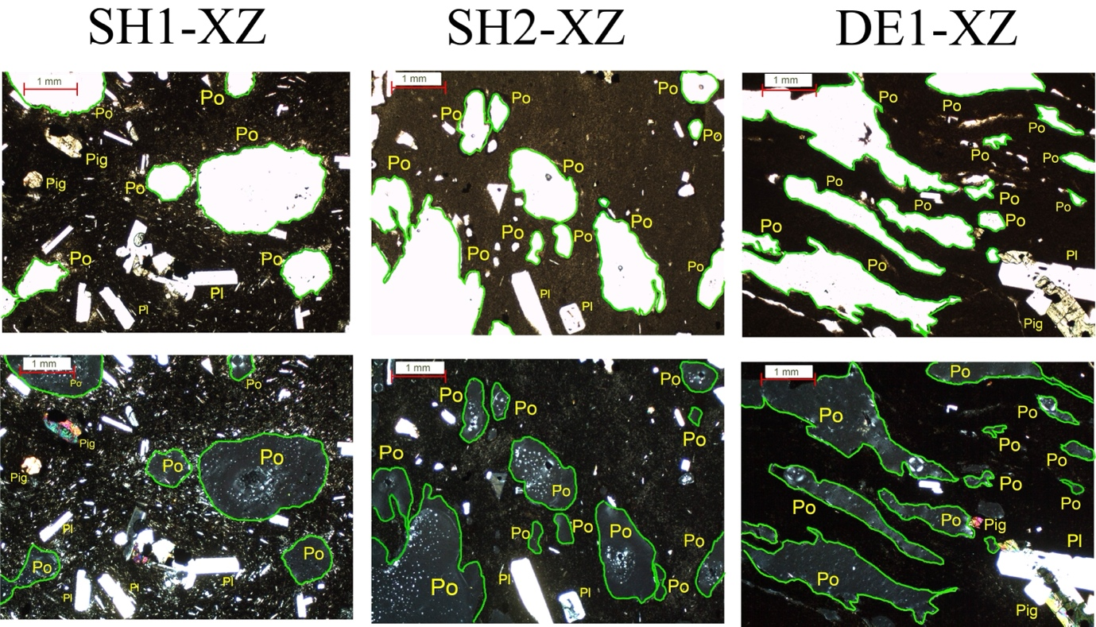
S1: Thin section images of representative samples SH1, SH2 and DE1 cored in the XZ direction.

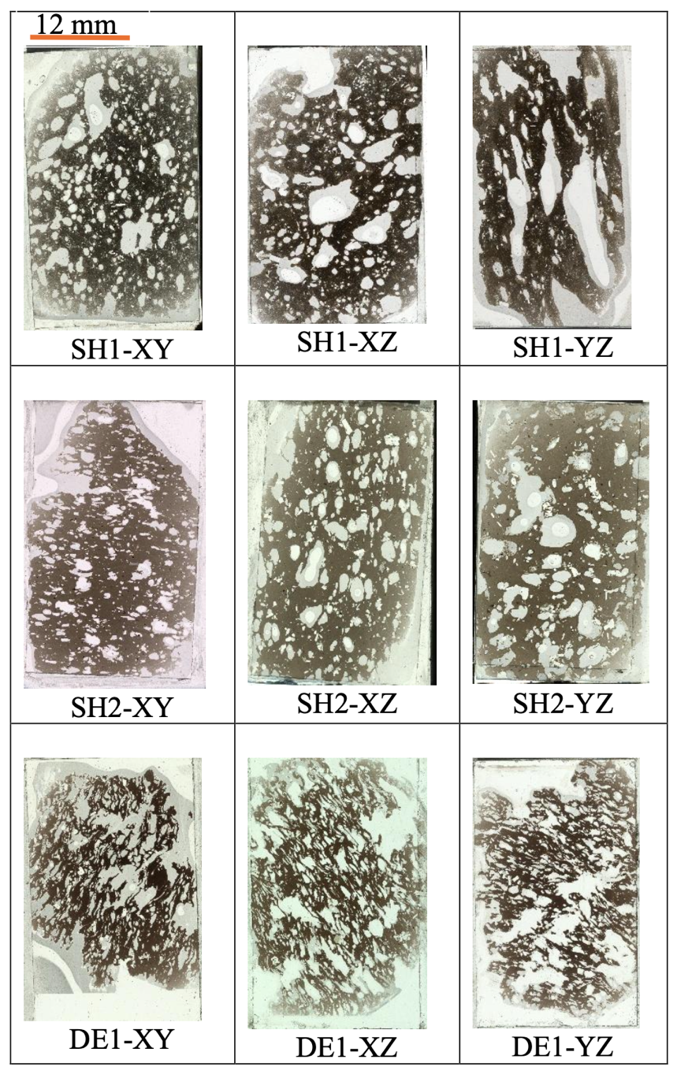
S2: Thin sections of representative samples SH1, SH2 and DE1 cored in the XZ, XY and YZ directions.
S3: Pore length characteristics from sample surface analysis for sample SH1 cored in the XZ, Y and X directions.

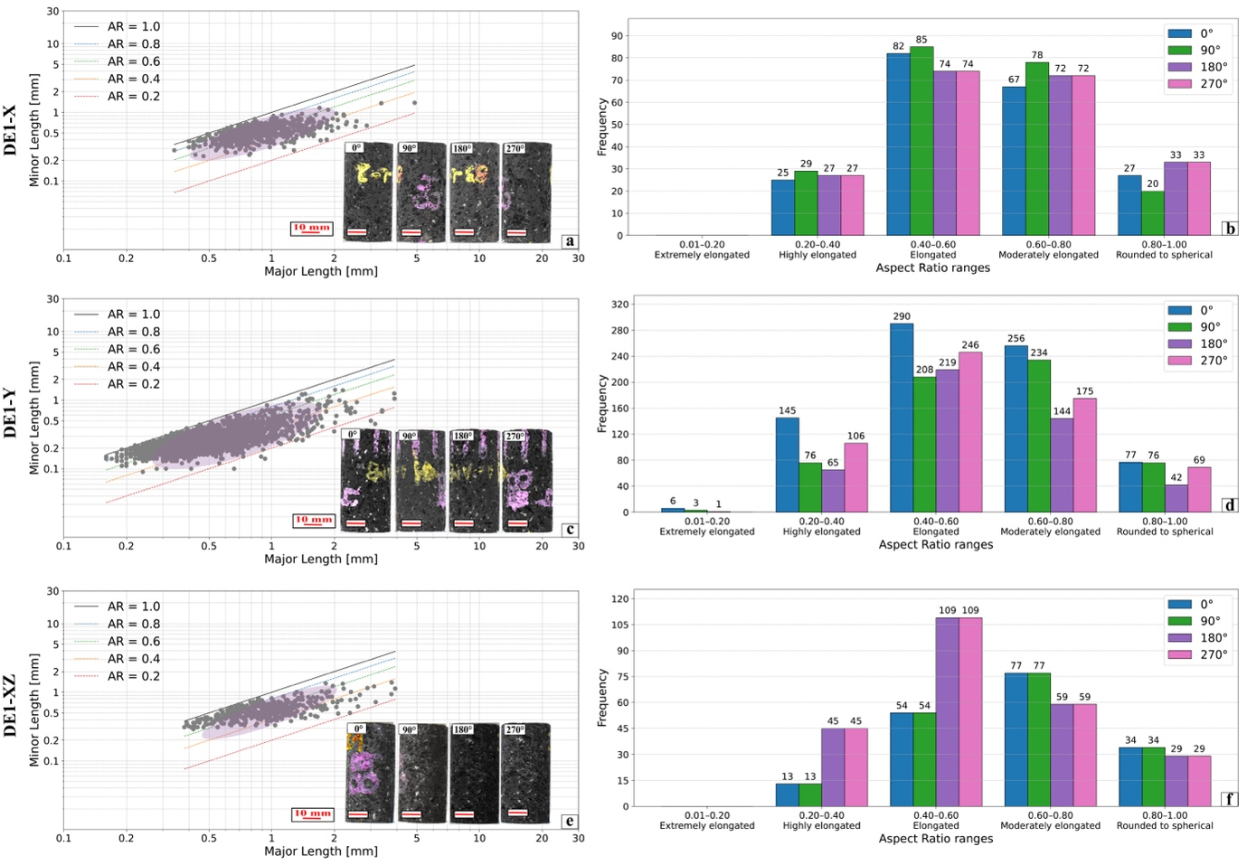
S4: Pore length characteristics from sample surface analysis for sample DE1 cored in the XZ, Y and X directions.
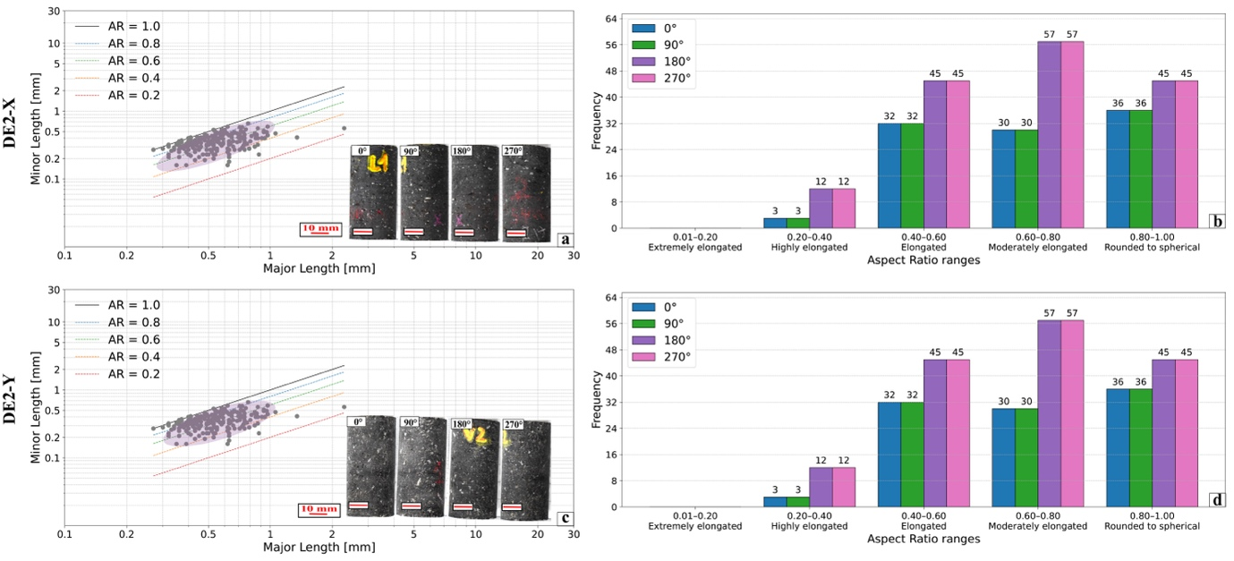
S5: Pore length characteristics from sample surface analysis for sample DE2 cored in the XZ, Y and X directions.

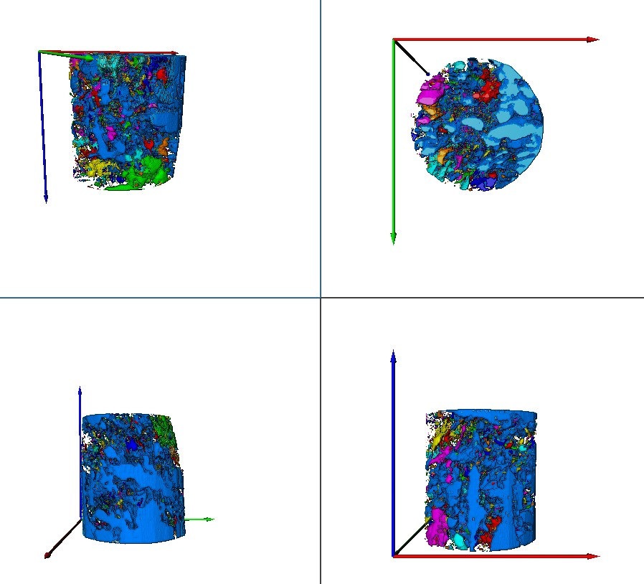
S6: Micro CT analysis of sample SH2.

T1:

