Supplementary Information for

Sea ice-air interactions amplify multidecadal variability in the North Atlantic and Arctic region

Jiechun Deng and Aiguo Dai

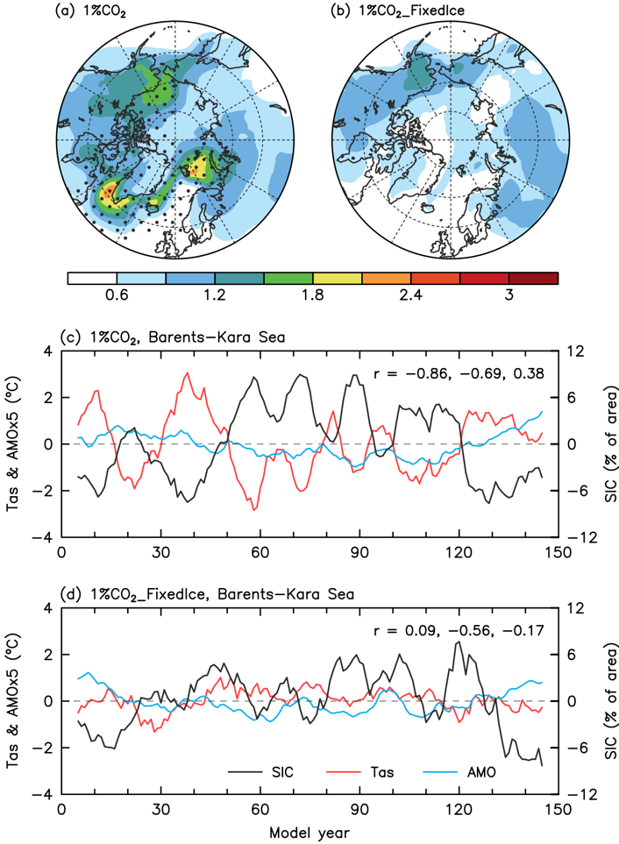
Figure S1. Same as Fig. 2, but for the CESM1 (a, c) 1%CO₂ and (b, d) 1%CO₂_FixedIce runs.
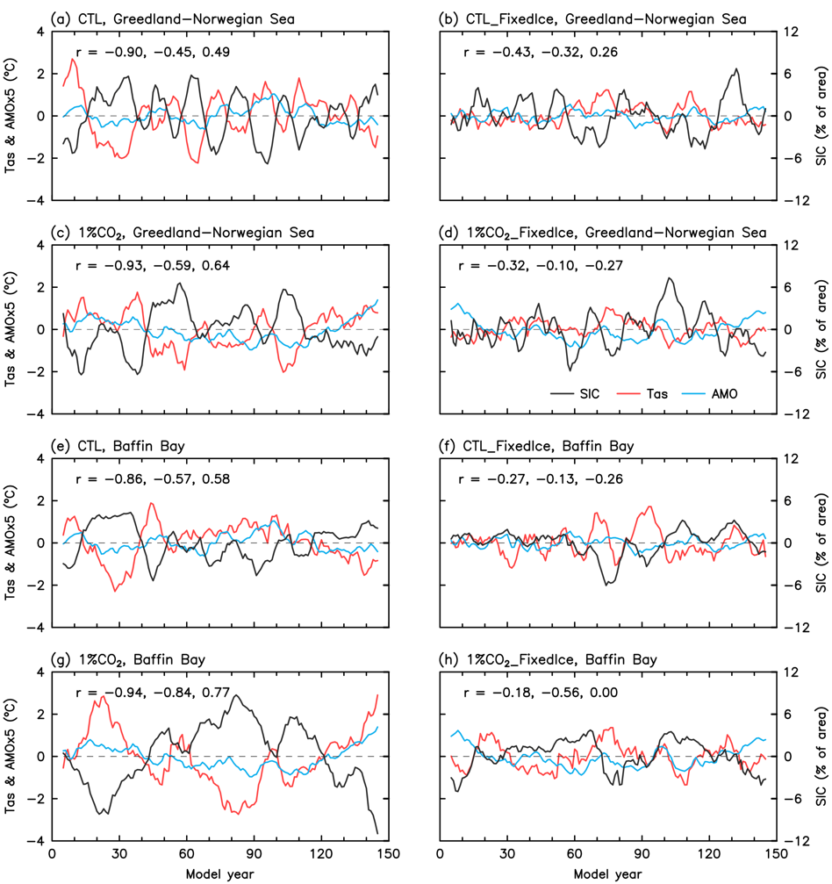
Figure S2. (a–d) Nine-year smoothed time series of the linearly detrended DJF-mean anomalies of SIC (black line; in % of area, right y-axis) and Tas (red line; in ºC, left y-axis) averaged over the Greenland-Norwegian Seas defined in Fig. 1d and the AMO index (blue line; in ºC, multiplied by 5 in order to use the same left y-axis) from the CESM1 (a) CTL, (b) CTL_FixedIce, (c) 1%CO₂, and (d) 1%CO₂_FixedIce runs from years 1–150. The correlation coefficients (r) are, from left to right, between SIC and Tas, SIC and AMO, and Tas and AMO. (e–h) Same as a–d, respectively, but for the Baffin Bay defined in Fig. 1d.

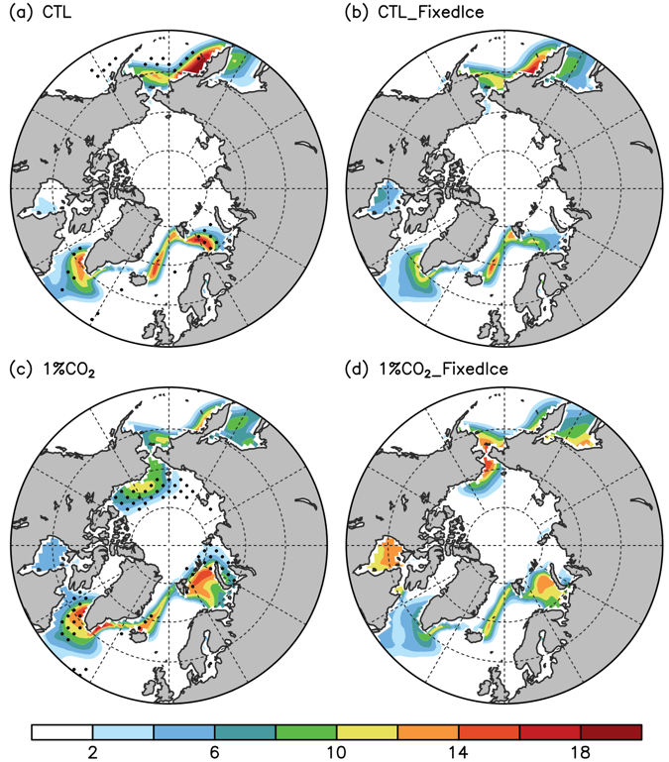
Figure S3. Spatial distributions of the standard deviation of the linearly detrended and nine-year smoothed DJF-mean SIC anomalies (in % of area) over 50°–90°N from the CESM1 (a) CTL, (b) CTL_FixedIce, (c) 1%CO₂, and (d) 1%CO₂_FixedIce runs during years 1–150. The stippling in a (c) indicates the difference between a and b (c and d) is statistically significant at the 5% level on the basis of a F-test.

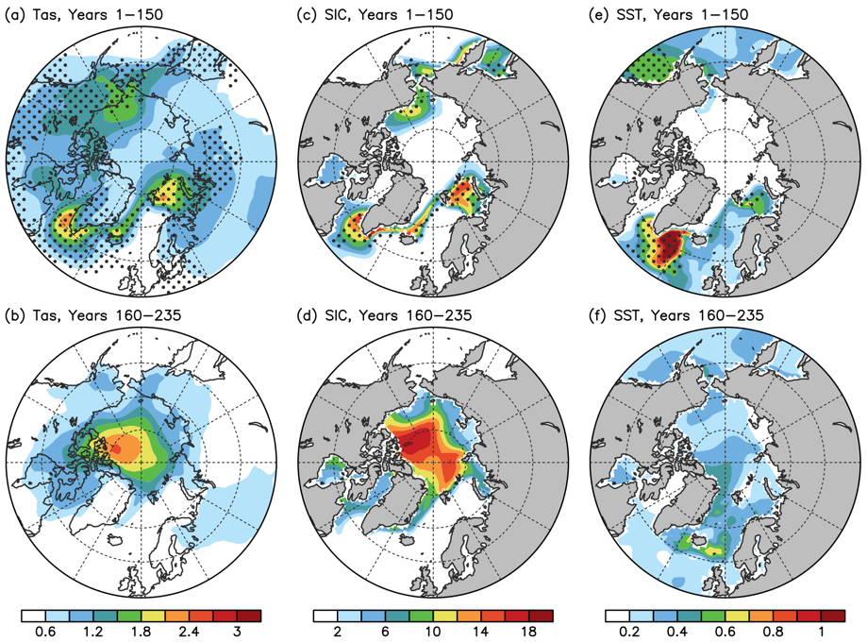
Figure S4. Spatial distributions of the standard deviation of the linearly detrended and nine-year smoothed DJF-mean anomalies of (a, b) Tas (in ºC), (c, d) SIC (in % of area), and (e, f) SST (in ºC) over 50°–90°N from the CESM1 1%CO₂ run during (a, c, e) years 1–150 and (b, d, f) years 160–235. The stippling in a, c, e indicates the difference between the two periods is statistically significant at the 5% level on the basis of a F-test.

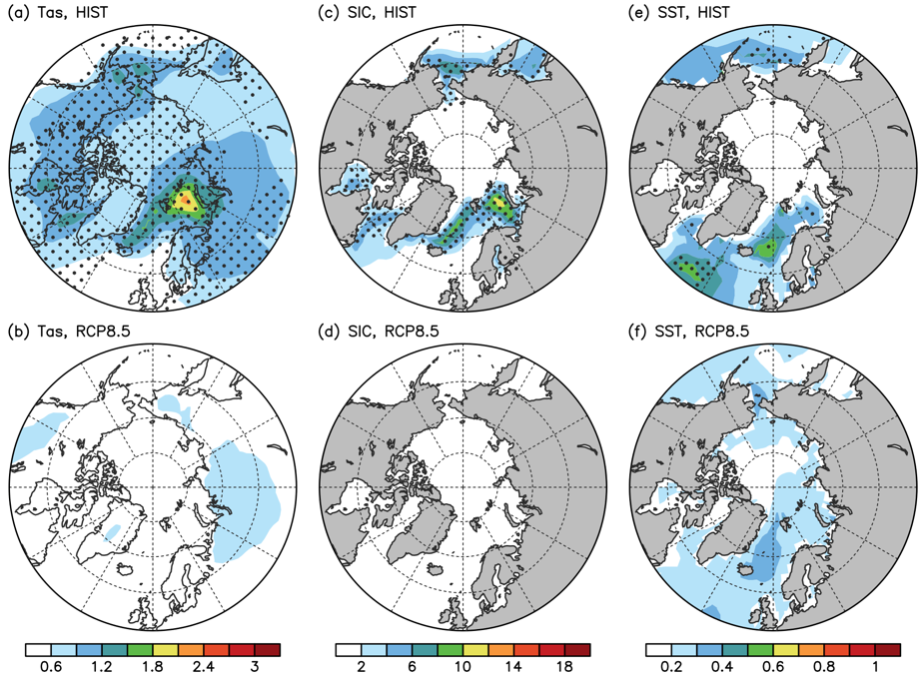
Figure S5. Spatial distributions of the standard deviation of the linearly detrended and nine-year smoothed DJF-mean anomalies of (a, b) Tas (in ºC), (c, d) SIC (in % of area), and (e, f) SST (in ºC) over 50°–90°N averaged over twelve CMIP5 and CMIP6 models during (a, c, e) 1920–2019 and (b, d, f) 2200–2299. The stippling in a, c, e indicates the difference between the two periods is statistically significant at the 5% level on the basis of a F-test.

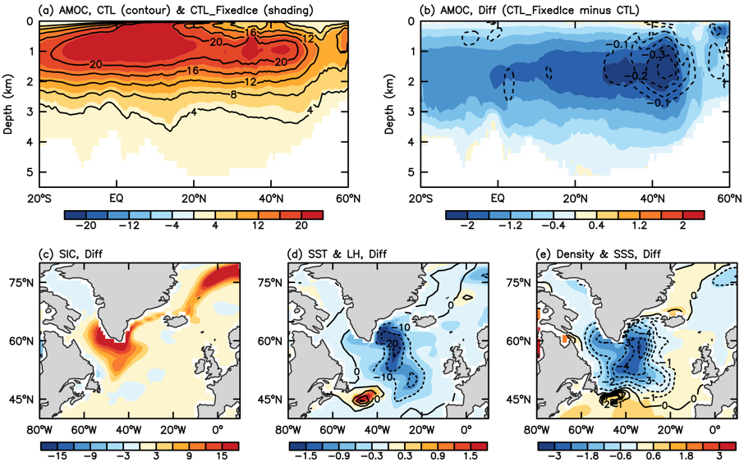
Figure S6. (a, b) CESM1-simulated climatological DJF-mean stream-function (in Sv) for the Atlantic meridional overturning circulation (AMOC) from the (a) CTL_FixedIce (color shading) and CTL (contours) runs and (b) their difference (i.e., CTL_FixedIce minus CTL) averaged over years 1–150. The contours in b are the CTL_FixedIce-minus-CTL difference of the standard deviation of the nine-year smoothed DJF-mean stream-function anomalies (in Sv). (c–e) The CTL_FixedIce-minus-CTL difference in the climatological DJF-mean (c) SIC (in % of area), (d) SST (color shading, in ºC) and surface latent heat flux (contours, positive upward, in W m⁻²), and (e) upper-5m ocean density (color shading, in 10⁻⁴ kg m⁻³) and salinity (contours, in 10⁻⁴ g kg⁻¹).

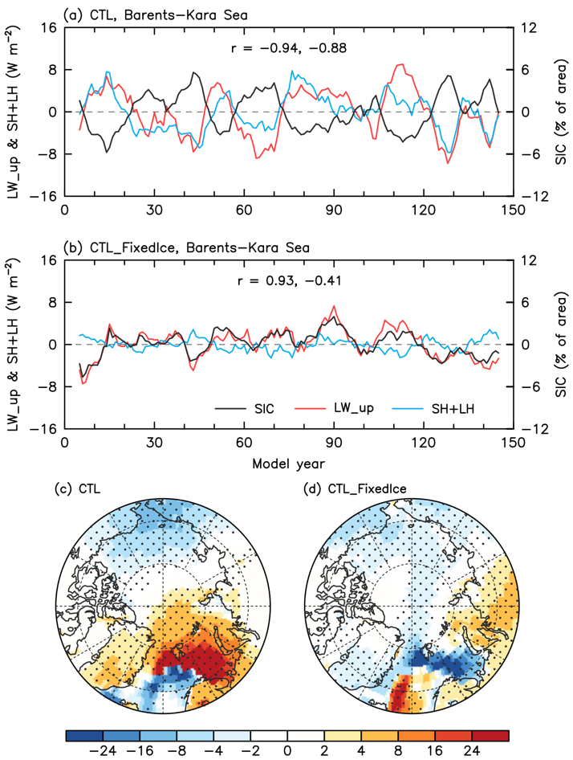
Figure S7. (a, b) Nine-year smoothed time series of the linearly detrended DJF-mean anomalies of SIC (black line; in % of area, right y-axis), surface upward longwave radiation (LW_up, red line; in W m⁻², left y-axis), and surface sensible plus latent heat flux (SH+LH, blue line; in W m⁻², left y-axis) averaged over the Barents-Kara Seas defined in Fig. 1d from the CESM1 (a) CTL and (b) CTL_FixedIce runs from years 1–150. The correlation coefficients (r) are, from left to right, between SIC and LW_up, and SIC and SH+LH. (c, d) Composite differences of DJF-mean LW_up + SH + LH anomalies (color shading, in W m⁻²; upward positive) over 55°–90°N between years with lower (≤ –1 SD) and higher (≥ +1 SD) BKS SIC anomalies (i.e., low SIC years minus high SIC years) from the CESM1 (c) CTL and (d) CTL_FixedIce runs from years 1–150. The stippling in c and d indicates the difference is statistically significant at the 5% level on the basis of a Student’s t-test.

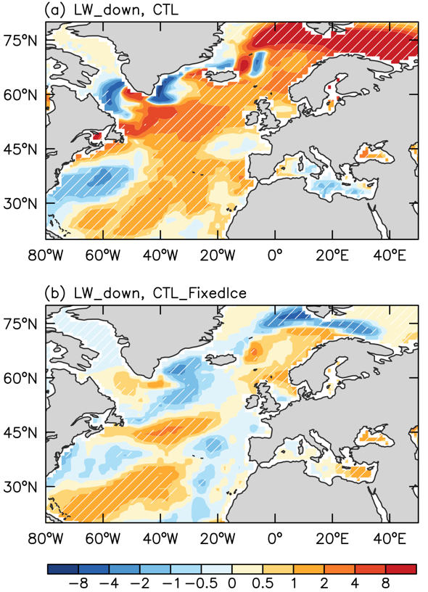
Figure S8. Composite differences of DJF-mean anomalies of surface downward longwave radiation (color shading, in W m⁻²) between years with warm (≥ +1 SD) and cold (≤ –1 SD) BKS Tas anomalies (i.e., warm Tas years minus cold Tas years) from the CESM1 (a) CTL and (b) CTL_FixedIce runs during years 1–150. The hatching indicates the difference is statistically significant at the 5% level on the basis of a Student’s t-test.

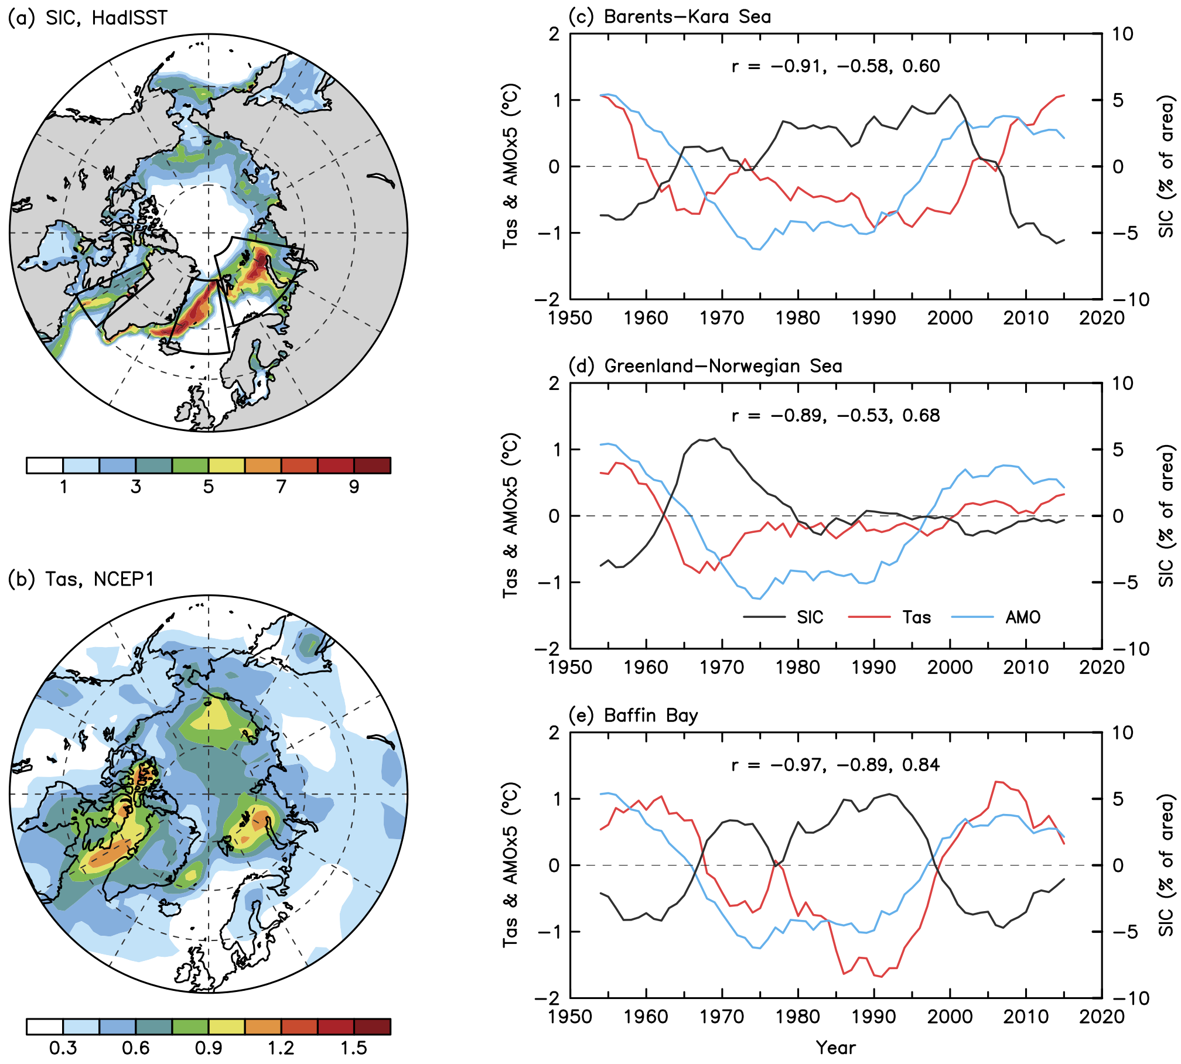
Figure S9. Same as Fig.1, but for the annual mean that shows results similar to DJF except for smaller magnitudes.

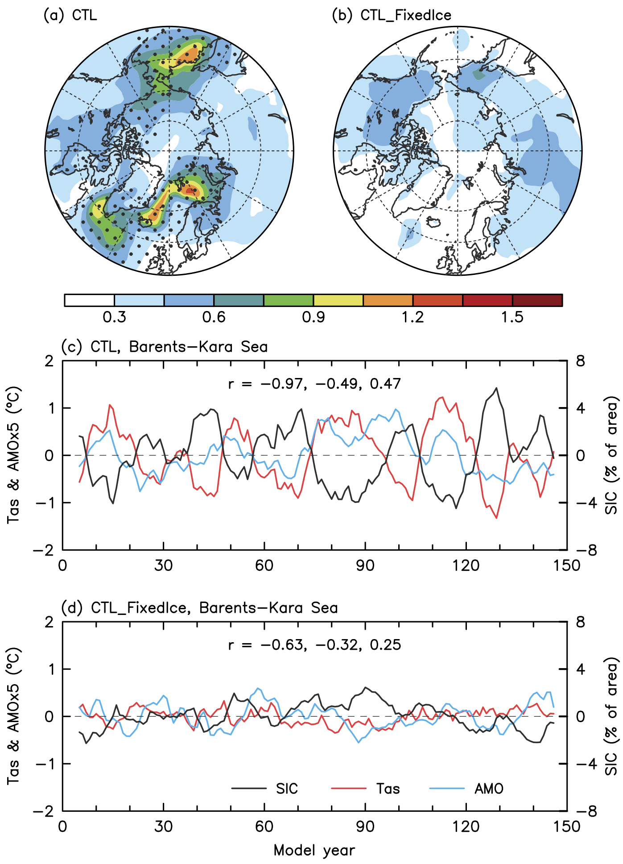
Figure S10. Same as Fig. 2, but for the annual mean.

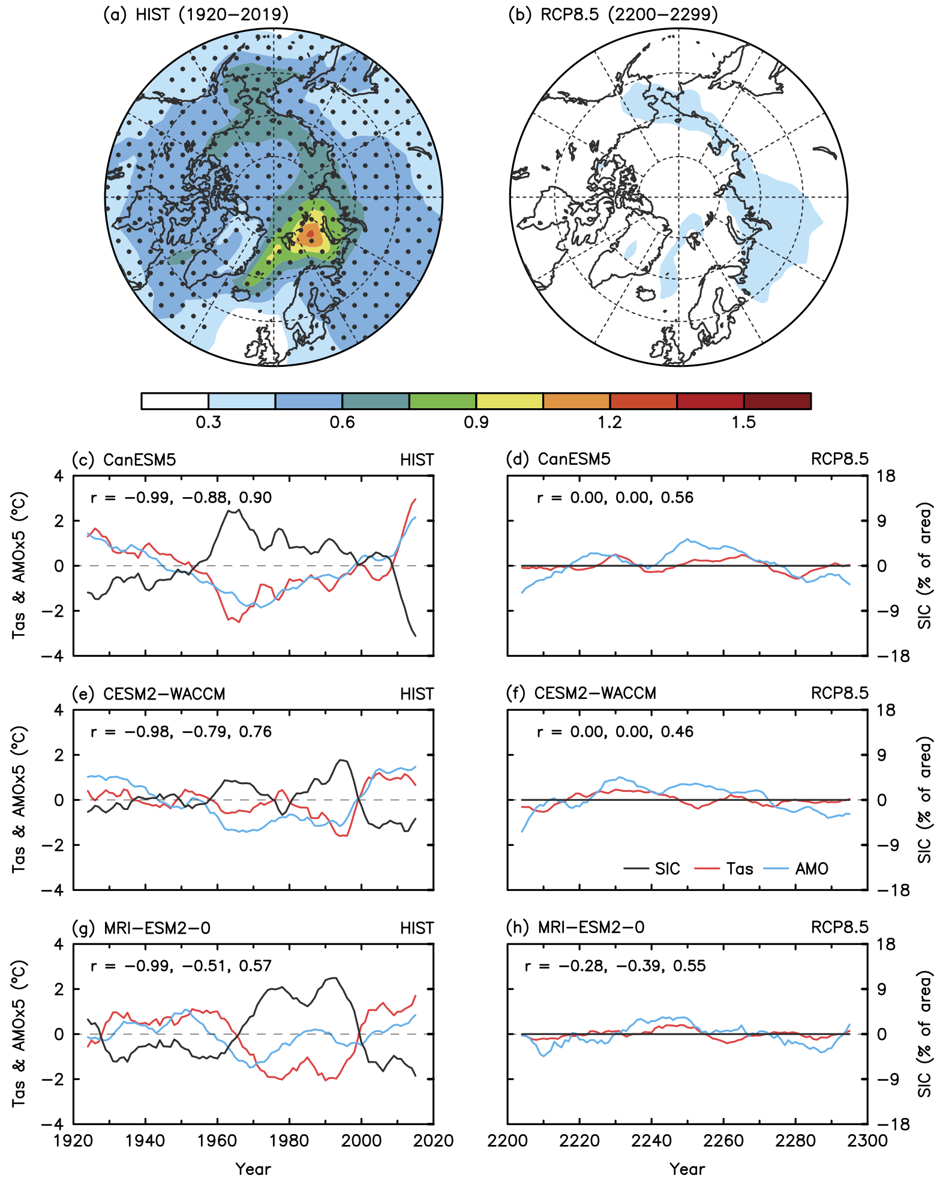
Figure S11. Same as Fig. 3, but for the annual mean.

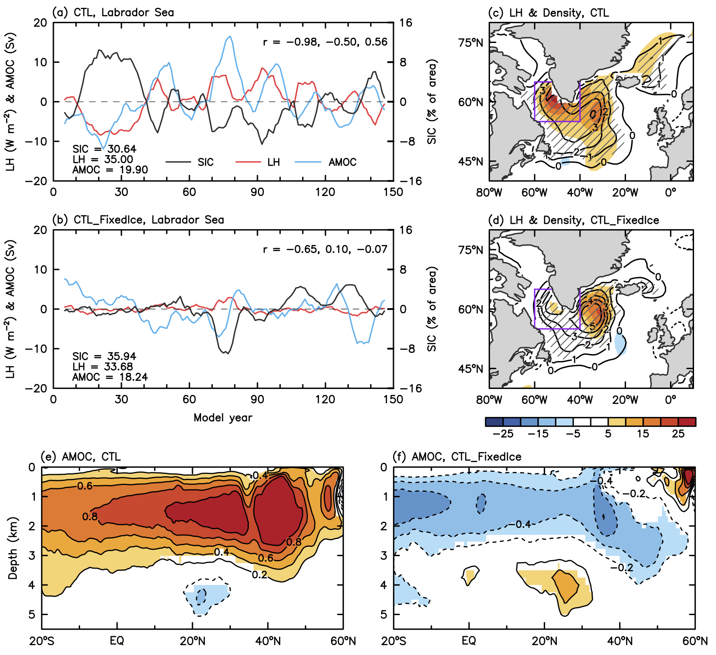
Figure S12. Same as Fig. 4, but for the annual mean.

