Supplementary Materials
Scenarios for long term conservation of Swedish semi-natural grasslands with limited climate impact
J.O. Karlsson, K. von Greyerz, A. Hessle, M. Lindberg, A. Glimskär, P. Tidåker, J. Bengtsson and E. Röös

Table S1. Assumed annual gross biomass growth in semi-natural grasslands before correction for climatic variations based on data presented in Spörndly and Glimskär (2018) normalised to 9.5 MJ ME / kg dry matter.
Annual gross biomass growth | (kg dry matter/ha)
Semi-natural grasslands, open areas, moist soil (SMI > 110) | 3980
Semi-natural grasslands, open areas, mesic soil (40 < SMI < 110) | 3060
Semi-natural grasslands, open areas, dry soil (SMI < 40) | 1800
Semi-natural grasslands, shaded areas | 1330
Semi-natural grasslands, thin soils | 1000
Pastures on arable land | Estimated from national statistics for mowed leys

Table S2. Assumed pasture utilisation rates for different types of pasture.
Pasture utilisation rate | (%)
Semi-natural pastures | 45
Semi-natural pastures, thin soils | 30
Semi-natural pastures, wooded (>60% tree cover) | 30
Pastures on arable land | 62.5

Table S3. Assumptions on maximum share of grazed biomass (dry matter) from semi-natural grasslands (after applying the -30% correction factor) for different grazing livestock categories. Figures are shown for the baseline as well as for the scenarios where this parameter changes. Numbers in brackets show the original figure reported in the cited literature.
Animal category | Maximum share of grazed dry matter from semi-natural grasslands | Source
Dairy cows | Baseline: 20% (28%)  CulCows: 37%  DryCows: 40%  All: 48% | Hessle and Danielsson (2023)
Suckler cows and their calves | 70% (100%) | Ahlgren et al. (2022)
Slaughter bulls after weaning and dairy calves before weaning | No grazing assumed
Other cattle | 56% (80%) | Ahlgren et al. (2022)
Lambs in autumn lamb production | 48% (69%) | Ahlgren et al. (2022)
Other sheep in autumn lamb production | 46% (66%) | Ahlgren et al. (2022)
Other sheep and lambs | 70% (100%) | Ahlgren et al. (2022)
Horses | Baseline: 10% (15%)  RecHorses: 70% for ponies, cold-blooded horses and horses in breeding | Cederberg and Henriksson (2020)
Horses for nature conservation | 70%

Table S4. Sensitivity analysis for the MaxCur and All scenarios. Values show the maximum semi-natural grassland area (including wooded pastures) in million hectares for the original scenarios (bold) and for the seven sensitivity analyses (S) with the percentage difference from the original scenario in brackets.
Scenario | Description | Cap on enteric methane emissions
Scenario | Description | -30% CH₄ | ±0% CH₄ | +10% CH₄
MaxCur | Original scenario | 0.49 | 0.73 | 0.81
S1 | Fixed regional distribution of animals |  | 0.69 (-6%)
All | Original scenario | 0.73 | 1.02 | 1.10
S2 | Higher share semi-natural grasslands in grazing by removing the 30% correction factor (see section 2.4.1 in main text) | 1.03 (+42%) | 1.20 (+18%) | 1.20 (+9%)
S3 | -25% Semi-natural grassland productivity | 0.96 (+33%) | 1.18 (+16%) | 1.18 (+7%)
S4 | ×10 Wooded pastures | 0.84 (+16%) | 1.19 (+17%) | 1.30 (+18%)
S5 | +25% Potential semi-natural grassland areas | 0.75 (+3%) | 1.04 (+2%) | 1.13 (+3%)
S6 | +25% Maximum cropland area | 0.73 (+0%) | 1.02 (+0%) | 1.10 (+0%)
S7 | Alternative objective function: Maximise semi-natural grassland area instead of grazed biomass | 0.75 (+3%) | 1.03 (+2%) | 1.11 (+1%)

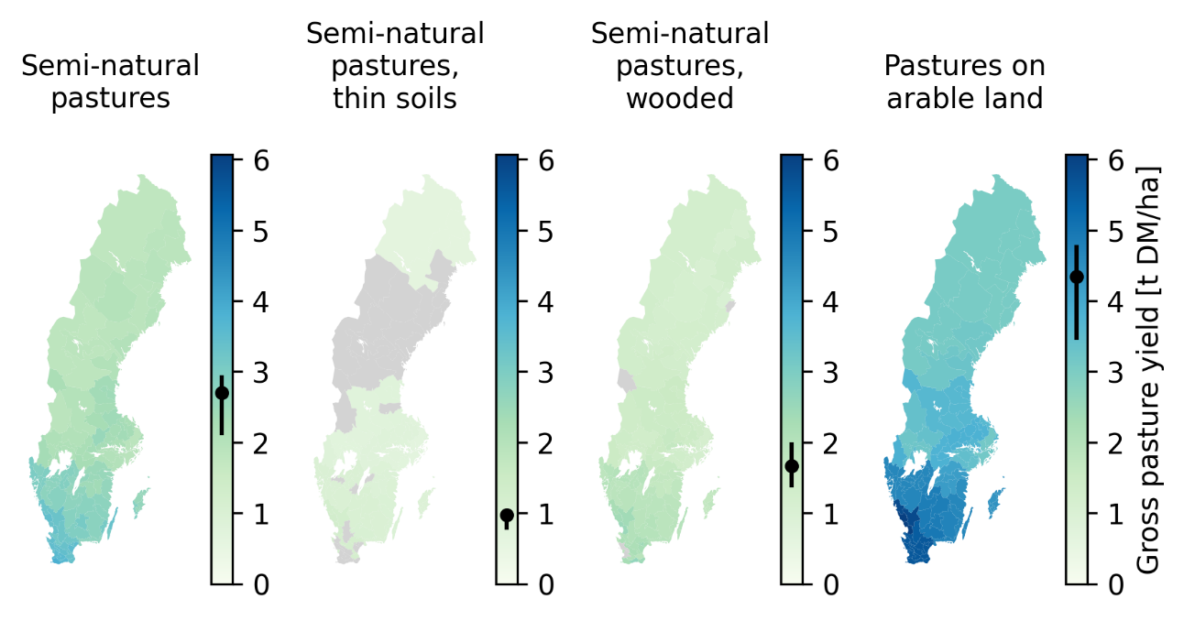
Figure S1. Estimated gross herbage yields for the three types of semi-natural pastures and for pastures on arable land. The ranges of the colour bars are the same across all maps, which explains the low contrast for the pasture types with low yields. The points on the colour bars show the national average yield in the baseline and the whiskers the interquartile range across regions. Grey areas represent regions where that pasture type is absent.
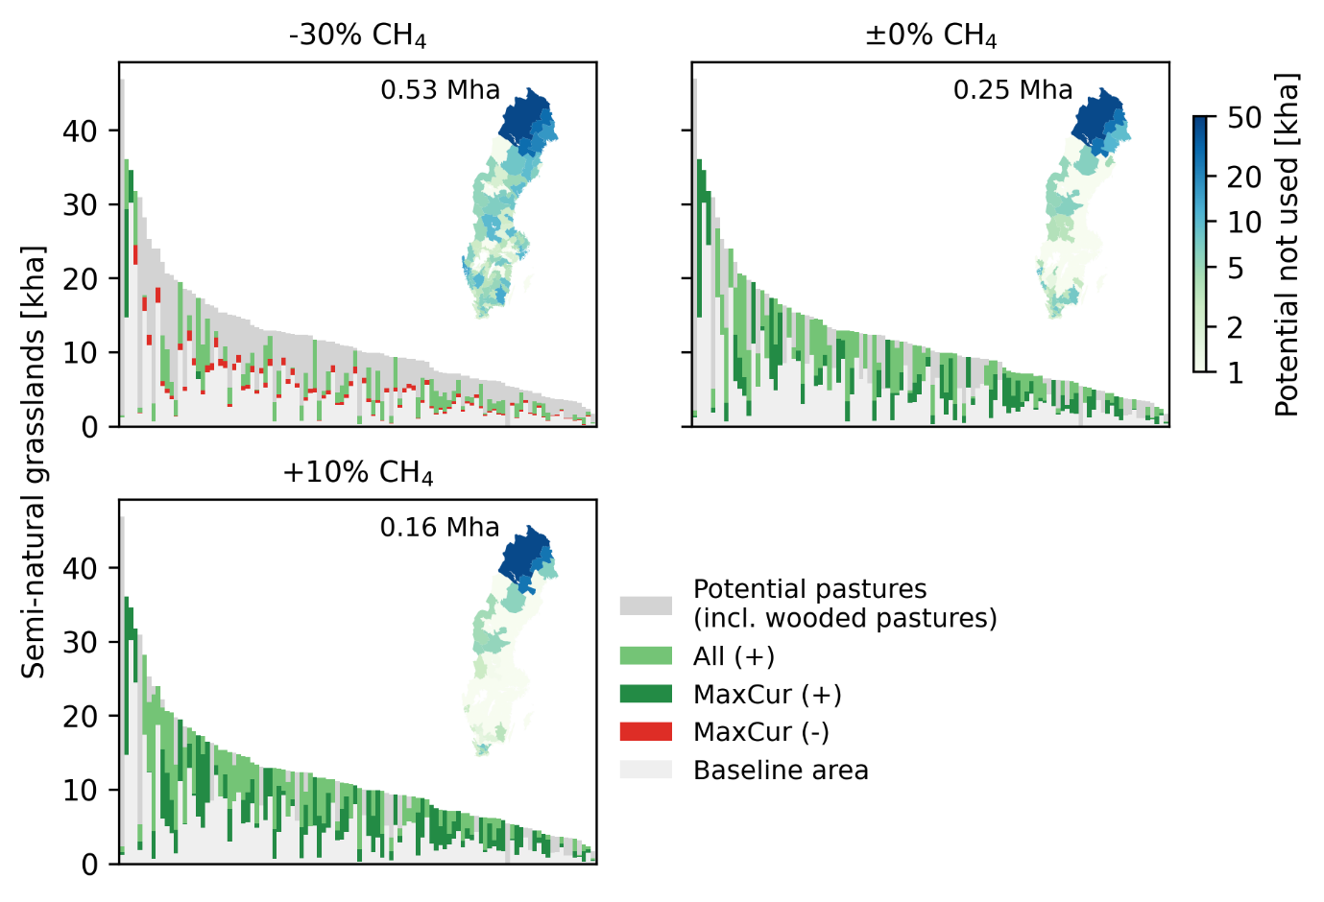
Figure S2. Semi-natural grassland area (incl. wooded pastures) across regions ordered along the x-axis based on the area of potential pastures. Light grey bars at the bottom show baseline areas and red or dark green bars show reduced or increased area from the baseline under the ‘MaxCur’ scenario. Light green bars show the additional increases in area under when all interventions (excl. ‘NatHorses’ scenario) are introduced (‘All’ scenario) and dark grey bars show the unutilised area of potential pastures in each region. The maps show the area of potential pastures in each region that remains unutilised in the ‘All’ scenario. Results are presented for the three different caps on methane emissions form enteric fermentation.

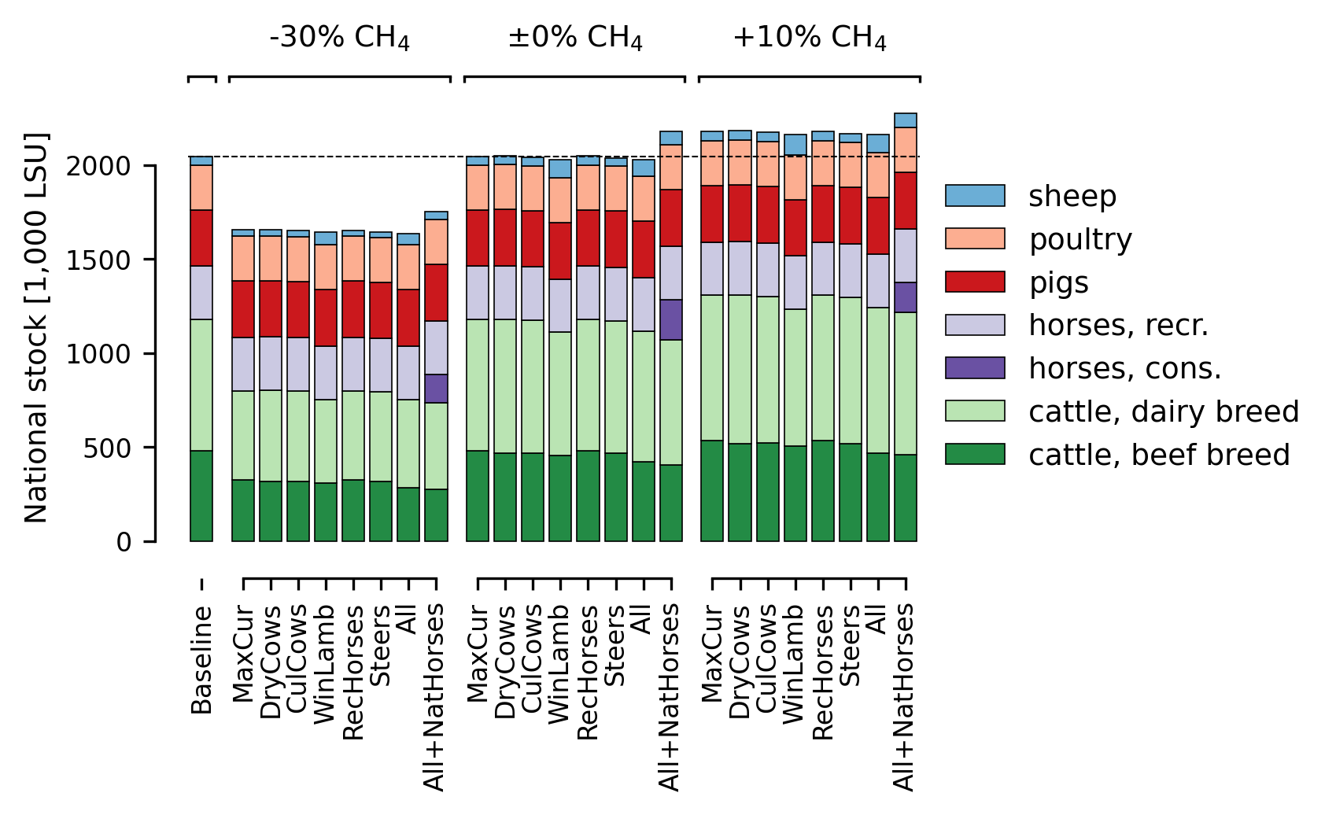
Figure S3. Total national livestock in terms of livestock units (LSU) in the different scenarios.

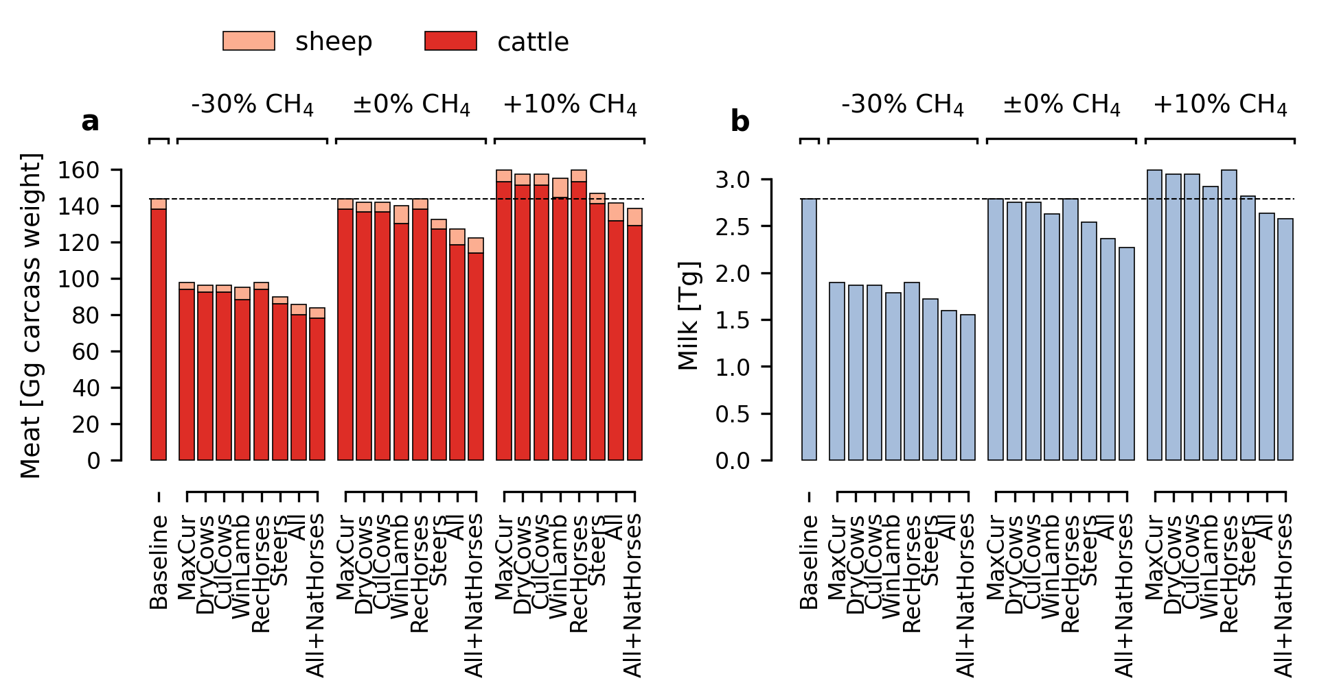
Figure S4. Production of meat and milk in the different scenarios.

References
Ahlgren, S., Behaderovic, D., Wirsenius, S., Carlsson, A., Hessle, A., Toräng, P., Seeman, A., den Braver, T. & Kvarnbäck, O. (2022). Miljöpåverkan av svensk nöt-och lammköttsproduktion. https://www.diva-portal.org/smash/record.jsf?pid=diva2%3A1718732 [2025-11-14]
Cederberg, C. & Henriksson, M. (2020). Gräsmarkernas användning i Sverige. CHALMERS TEKNISKA HÖGSKOLA. https://research.chalmers.se/publication/517805 [2025-11-14]
Hessle, A. & Danielsson, R. (2023). Number of cattle required to obtain good ecological status in Swedish grasslands and livestock’s methane emissions. (Report 60). Swedish University of Agricultural Sciences, Skara, Sweden. https://res.slu.se/id/publ/123395 [2025-11-14]
Spörndly, E. & Glimskär, A. (2018). Betesdjur och betestryck i naturbetesmarker. (Rapport 297). Uppsala: Sveriges lantbruksuniversitet. https://pub.epsilon.slu.se/15649/ [2025-11-14]

