Supplementary Materials

Title
Shallow segment rupture associated with the 2025 Kamchatka earthquake inferred from ALOS-2/PALSAR-2 InSAR

Author Information
Yuji Himematsu
Geospatial Information Authority of Japan, 1 Kitasato, Tsukuba, Ibaraki 3050811, Japan.
E-mail: himematsu-y96da@mlit.go.jp
Hiroshi Munekane
Geospatial Information Authority of Japan, 1 Kitasato, Tsukuba, Ibaraki 3050811, Japan.

Summary
Table S1 – S3, Figure S1 – S6

Table S1. Details of ALOS-2/PALSAR-2.
Path | Orbit | Obs. Date (UTC)
010 | Descending | Sep. 14, 2024  Aug. 2, 2025
113 | Ascending | Sep. 13, 2023  Jul. 30, 2025

Table S2. Root-mean-square error between the observation and the synthetic deformation derived from the best-fit model.
Path | Kamchatka [m] | Kuril [m]
010 | 0.047 | 0.066
113 | 0.030 | 0.058

Table S3. Offset of LOS change on the Kuril Islands.

Path | Best-fit delta LOS (std.) [m]
010 | -0.410 (0.126)
113 | 0.251 (0.100)
Values in parentheses are the standard deviations of the LOS change offset (see Methods).

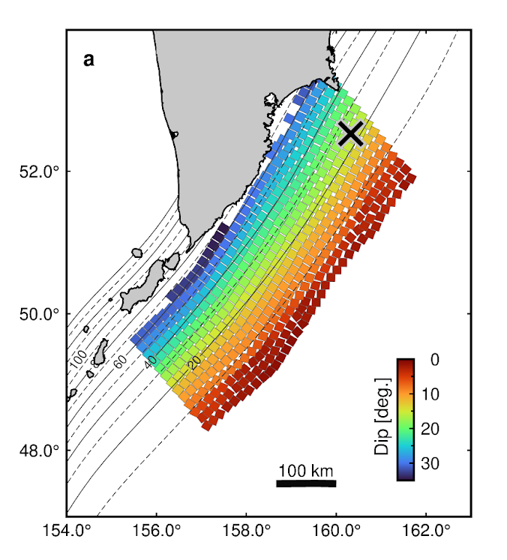
Fig. S1. Dip angle of each subfault patch derived from the plate model (Iwasaki et al. 2015).

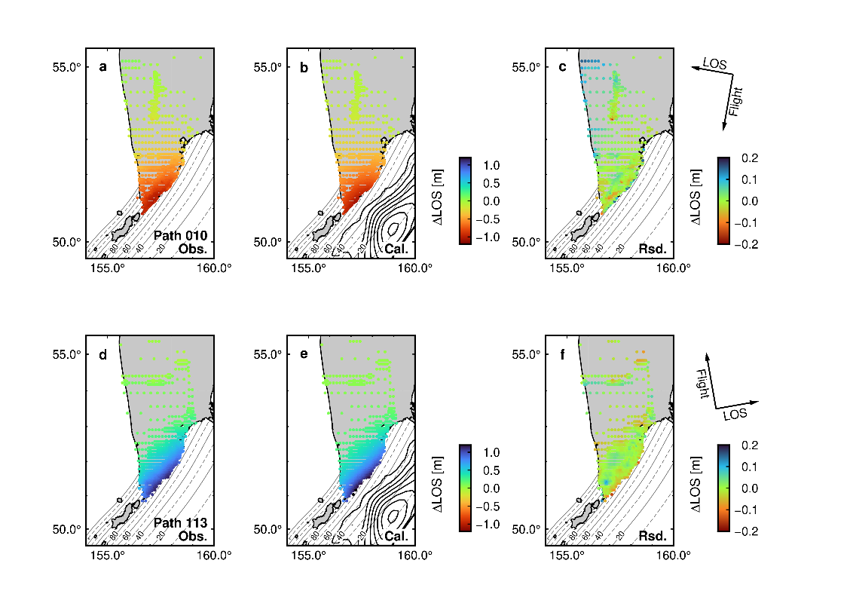
Fig. S2. Comparison of the modeling result: Kamchatka Peninsula. (Left) Observation; (Center) Calculation; (Right) Residuals. Positive line-of-sight changes (ΔLOS) indicate distance change moving away from the satellite (increase in distance).

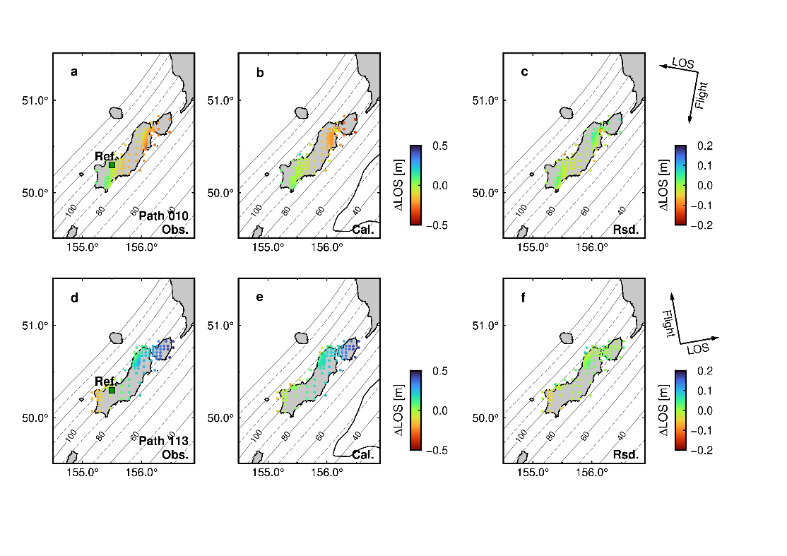
Fig. S3. Comparison of the modeling result: Paramushir and Shumshu Islands. (Left) Observation; (center) Calculation; (right) Residuals. Positive line-of-sight changes (ΔLOS) indicate a distance change moving away from the satellite (increase in distance).

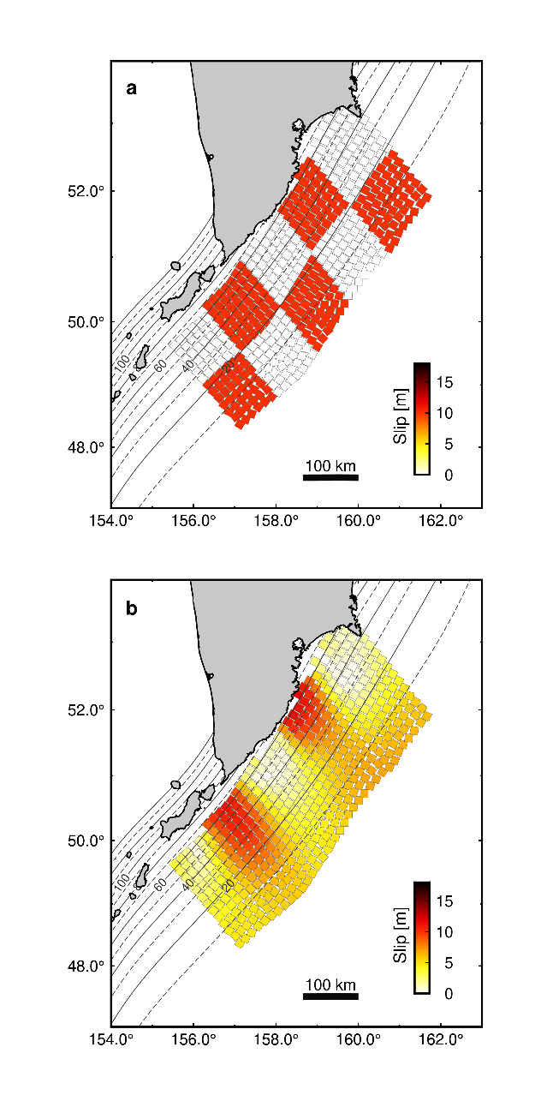
Fig. S4. Resolution (checkerboard) test. (a) Predefined synthetic slip pattern. (b) Reproduced slip distribution.

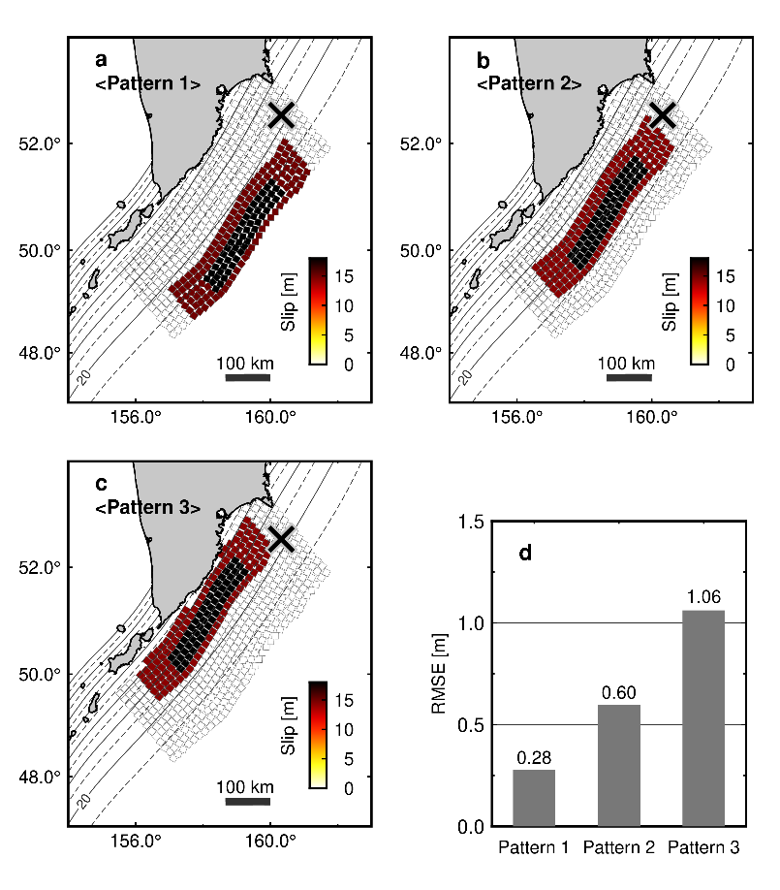
Fig. S5. Comparison with predefined slip distribution for evaluating misfits with the observations. (a–c) Three patterns of predefined slip distributions with depth variations. All the released moments were set to 8.85, which is the same as that of the best-fit model in this study. (d) Root-mean-square of error (RMSE) between the observations and the synthetic deformations computed from the predefined slip distributions.

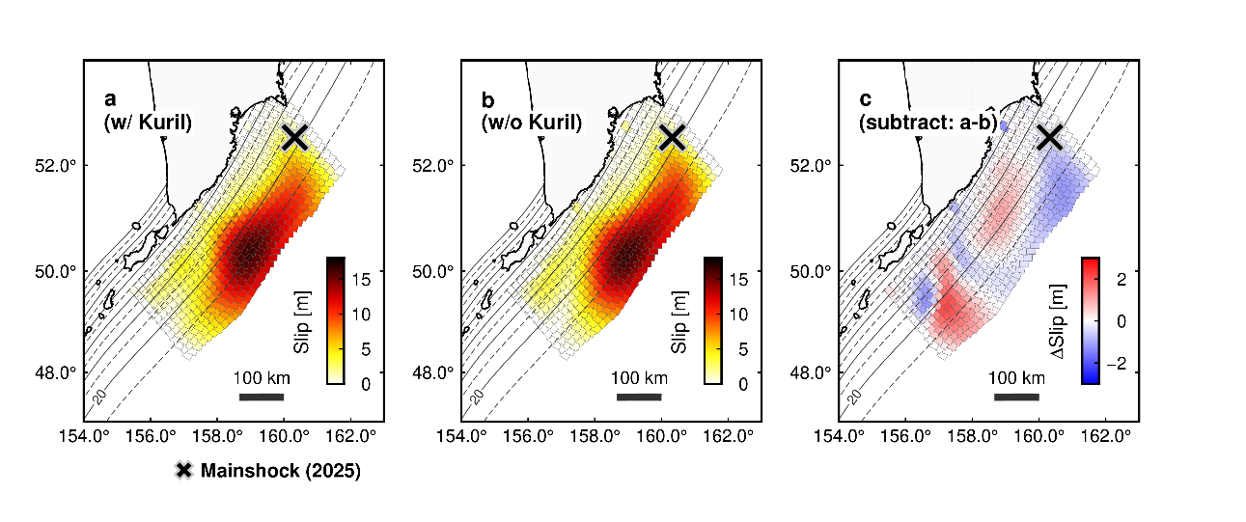
Fig. S6. Effect of data on the Kuril Islands. (a) Slip distribution using only the Kamchatka Peninsula data; (b) slip distribution including the Kuril Islands data; (c) difference of (a) and (b).

