Supplementary Information

Title: Burden of respiratory syncytial virus infection attributable to cold and heat ambient temperature in Japan: a nationwide time-stratified case-crossover analysis

Authors:
Keita Wagatsuma^{1,2}

Affiliations:
¹ Division of International Health (Public Health), Graduate School of Medical and Dental Sciences, Niigata University, Niigata, Japan
² Institute for Research Administration, Niigata University, Niigata, Japan

Corresponding author:
Keita Wagatsuma, PhD
Division of International Health (Public Health)
Graduate School of Medical and Dental Sciences, Niigata University
1-757 Asahimachi dori, Chuo-ku, Niigata City, Niigata 951-8510, Japan
Tel: +81-25-227-2129; Fax +81-25-227-0765
E-mail address: waga@med.niigata-u.ac.jp

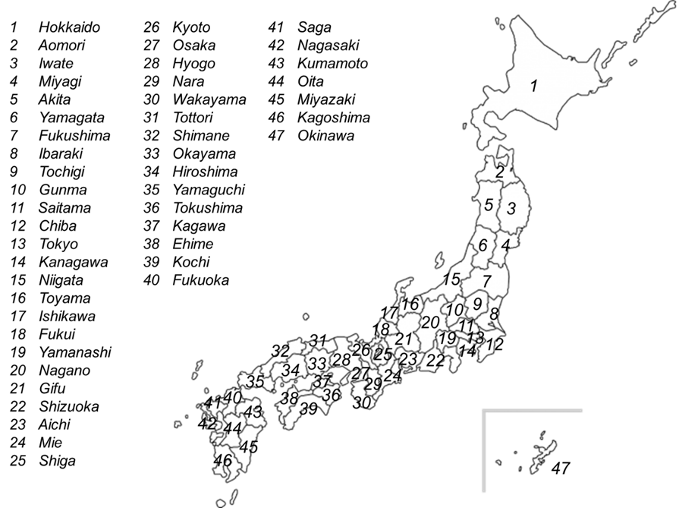
Figure S1. Geographic distribution and locations of the 47 prefectures in Japan. Japan is located at approximately 26°N to 43°N and approximately 127°E to 141°E in the western Pacific region and comprises a total of 47 Japanese prefectures covering the whole country.

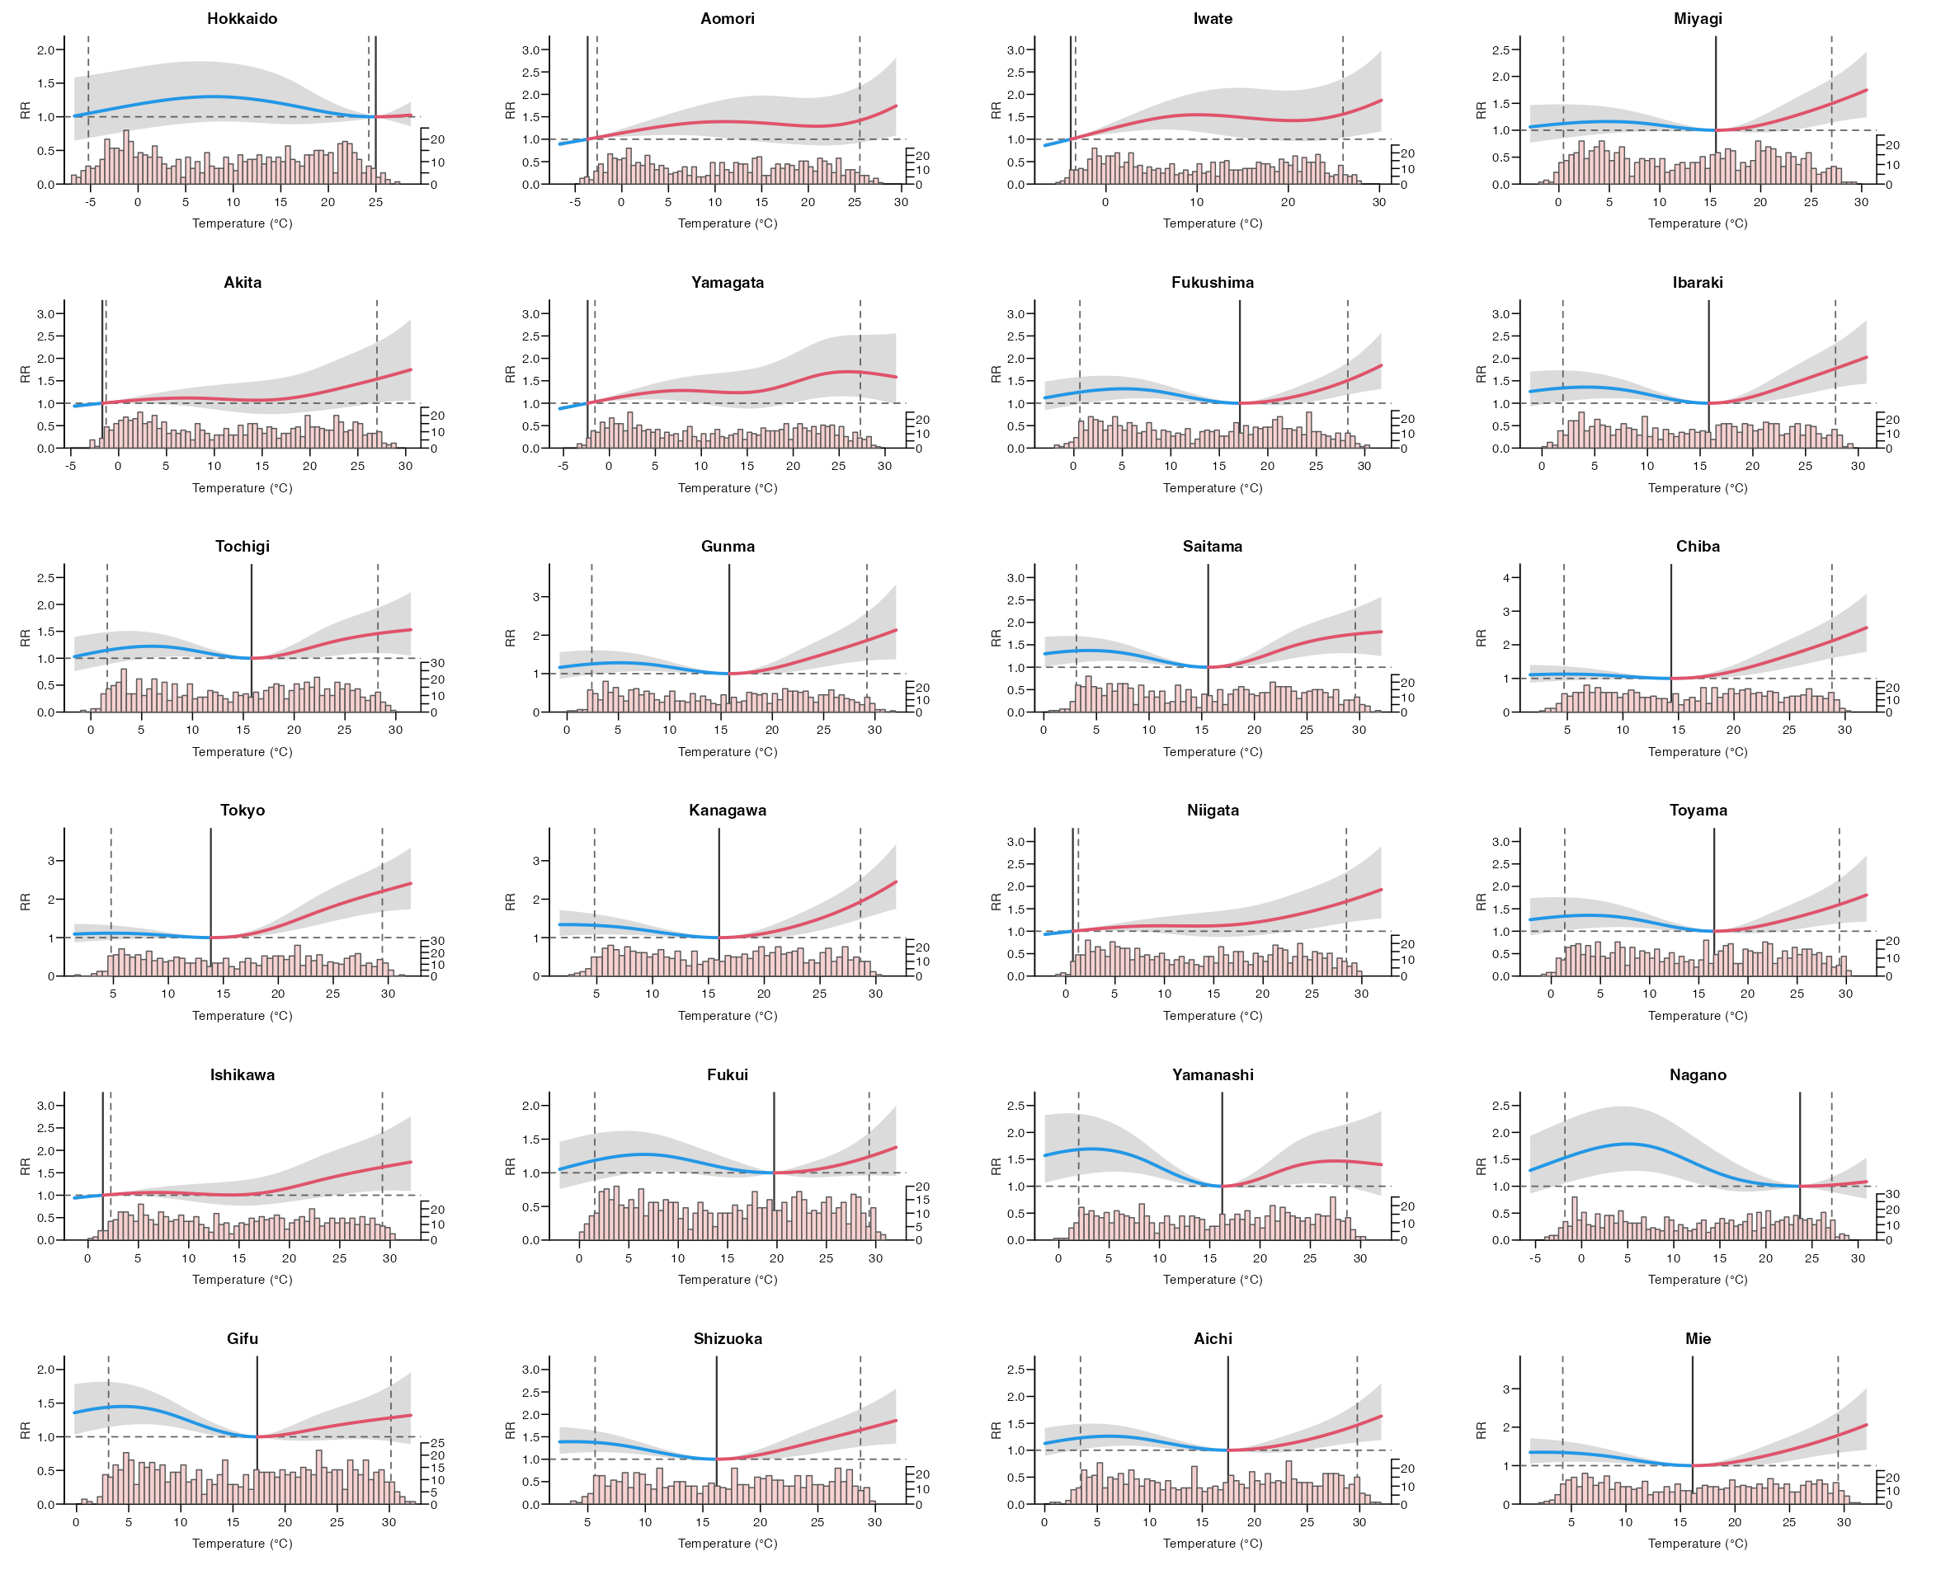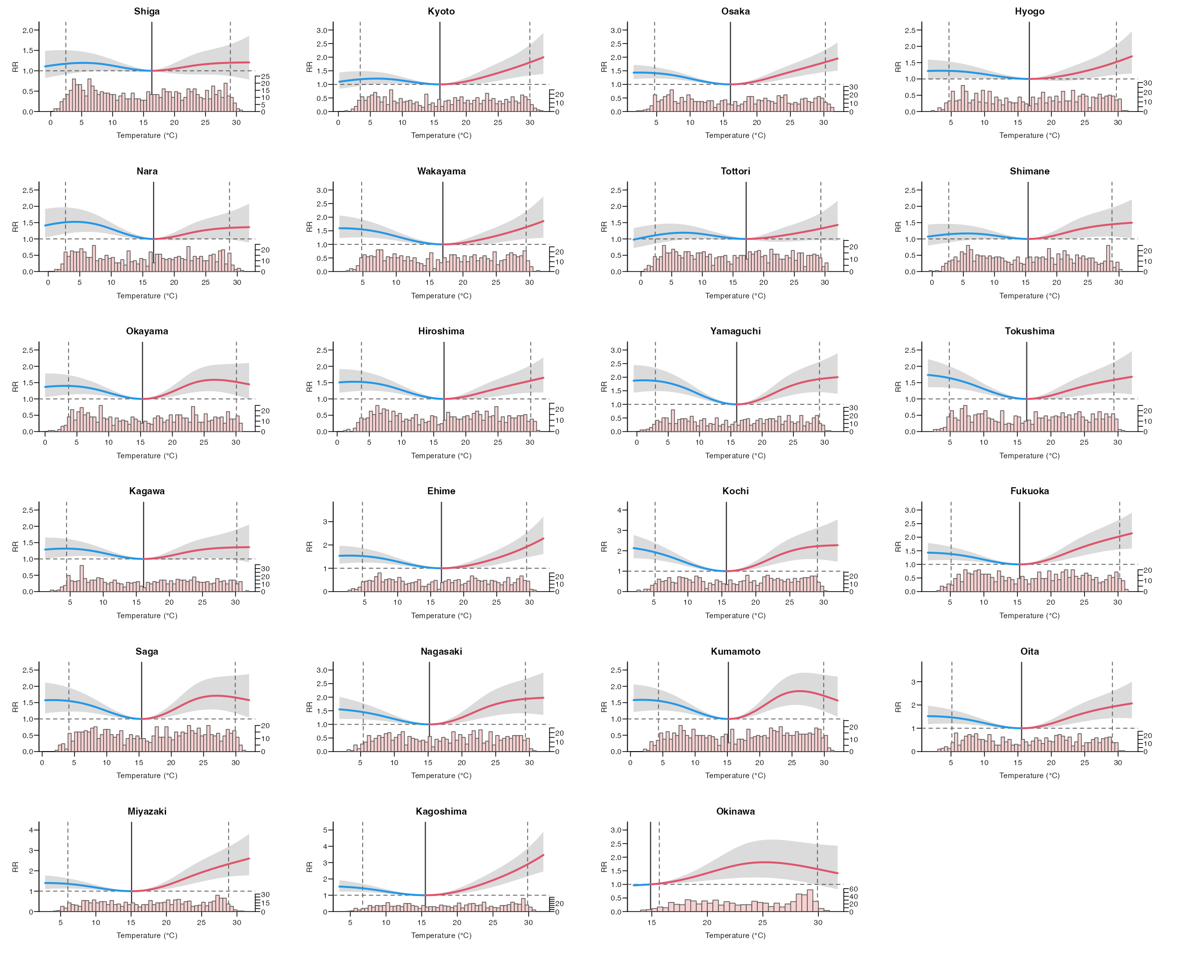
Figure S2. Location-specific overall cumulative exposure-response relationship. Notes: Exposure-response relationships computed as BLUP, with their 95% CIs added as a grey area. The MMT is added as a line, and the 2.5th and 97.5th percentiles are added as dashed lines. Abbreviations: BLUP, best linear unbiased prediction; CI, confidence interval; MMT, minimum morbidity temperature.

Table S1. Location-specific relative risks of respiratory syncytial virus incidence by cold and heat temperatures
Prefecture | MMTP (%) | MMT (°C) | RR (95% CI) due to cold compared with MMT | RR (95% CI) due to heat compared with MMT
Hokkaido | 99 | 24.95 | 1.24 (0.87, 1.78) | NA
Aomori | 1 | −3.67 | NA | 2.34 (1.29, 4.24)
Iwate | 1 | −3.86 | NA | 2.15 (1.25, 3.69)
Miyagi | 56 | 15.52 | 1.09 (0.76, 1.56) | 1.84 (1.30, 2.62)
Akita | 1 | −1.71 | NA | 1.95 (1.01, 3.73)
Yamagata | 1 | −2.37 | NA | 1.57 (0.83, 2.98)
Fukushima | 59 | 17.09 | 1.15 (0.86, 1.55) | 1.71 (1.29, 2.27)
Ibaraki | 53 | 15.82 | 1.06 (1.02, 1.11) | 2.42 (1.37, 4.26)
Tochigi | 52 | 15.83 | 1.04 (1.00, 1.09) | 1.82 (1.08, 3.07)
Gunma | 50 | 15.84 | 1.04 (1.00, 1.07) | 2.61 (1.45, 4.69)
Saitama | 49 | 15.62 | 1.07 (0.80, 1.43) | 1.79 (1.34, 2.40)
Chiba | 42 | 14.37 | 1.01 (0.97, 1.07) | 2.69 (1.63, 4.45)
Tokyo | 40 | 13.84 | 1.04 (0.98, 1.11) | 2.83 (1.80, 4.47)
Kanagawa | 47 | 15.98 | 1.35 (0.95, 1.90) | 2.29 (1.68, 3.11)
Niigata | 1 | 0.73 | NA | 2.39 (1.53, 3.73)
Toyama | 54 | 16.54 | 1.31 (0.85, 2.03) | 1.79 (1.14, 2.80)
Ishikawa | 1 | 1.47 | NA | 2.49 (1.27, 4.85)
Fukui | 64 | 19.68 | 1.20 (0.70, 2.04) | 1.36 (0.96, 1.92)
Yamanashi | 51 | 16.2 | 1.60 (0.96, 2.67) | 1.07 (0.58, 1.99)
Nagano | 86 | 23.75 | 2.09 (1.09, 3.98) | 1.01 (0.95, 1.08)
Gifu | 51 | 17.31 | 1.32 (0.89, 1.94) | 1.11 (0.79, 1.56)
Shizuoka | 45 | 16.18 | 1.23 (0.91, 1.67) | 1.66 (1.20, 2.28)
Aichi | 51 | 17.48 | 1.05 (1.01, 1.09) | 1.61 (1.10, 2.36)
Mie | 48 | 16.13 | 1.30 (0.95, 1.77) | 1.95 (1.38, 2.76)
Shiga | 53 | 16.36 | 1.14 (0.60, 2.18) | 1.03 (0.97, 1.08)
Kyoto | 48 | 15.9 | 1.05 (1.00, 1.10) | 2.55 (1.50, 4.33)
Osaka | 46 | 16.01 | 1.31 (1.06, 1.62) | 1.83 (1.48, 2.27)
Hyogo | 47 | 16.71 | 1.21 (0.92, 1.60) | 1.51 (1.11, 2.05)
Nara | 53 | 16.7 | 1.17 (0.80, 1.71) | 1.23 (0.84, 1.80)
Wakayama | 48 | 16.95 | 1.82 (1.23, 2.69) | 1.61 (1.10, 2.36)
Tottori | 55 | 17.11 | 1.10 (1.03, 1.18) | 2.18 (1.10, 4.30)
Shimane | 49 | 15.35 | 1.03 (0.97, 1.09) | 1.51 (0.82, 2.78)
Okayama | 46 | 15.27 | 1.31 (0.94, 1.83) | 1.29 (0.87, 1.91)
Hiroshima | 48 | 16.58 | 1.49 (1.10, 2.02) | 1.50 (1.11, 2.03)
Yamaguchi | 48 | 15.91 | 1.91 (1.43, 2.56) | 1.97 (1.44, 2.69)
Tokushima | 47 | 16.44 | 2.09 (1.48, 2.94) | 1.38 (0.95, 2.00)
Kagawa | 47 | 16.08 | 1.11 (0.78, 1.60) | 1.10 (0.71, 1.70)
Ehime | 47 | 16.67 | 1.53 (1.07, 2.17) | 2.09 (1.50, 2.90)
Kochi | 42 | 15.61 | 2.85 (1.93, 4.20) | 2.22 (1.35, 3.66)
Fukuoka | 41 | 15.28 | 1.35 (1.00, 1.82) | 2.16 (1.64, 2.83)
Saga | 43 | 15.38 | 1.60 (1.02, 2.51) | 1.48 (0.96, 2.29)
Nagasaki | 41 | 15.20 | 1.82 (1.23, 2.69) | 2.17 (1.46, 3.22)
Kumamoto | 41 | 15.09 | 1.51 (1.09, 2.09) | 1.51 (1.06, 2.15)
Oita | 44 | 15.59 | 1.55 (1.05, 2.30) | 2.07 (1.43, 3.00)
Miyazaki | 39 | 15.01 | 1.22 (0.84, 1.79) | 2.74 (1.84, 4.08)
Kagoshima | 37 | 15.49 | 1.47 (1.05, 2.07) | 3.37 (2.47, 4.59)
Okinawa | 1 | 14.89 | NA | 2.21 (1.10, 4.46)
Notes: The relative risks of cold (2.5th percentile of temperature) and heat (97.5th percentile of temperature) compared with corresponding MMT. Abbreviations: CI, confidence interval; MMT, minimum morbidity temperature; MMTP, minimum morbidity temperature percentile; NA, not applicable; RR, relative risk.

Table S2. Random-effects meta-regression models in the second-stage analysis
Model | Predictor | Test for predictor (p-value) ª | Cochran’s Q-test for heterogeneity (p-value) ^{b} | I² statistic (%)
Intercept-only |  |  | <0.001 | 60.7%
Single predictor | Temperature | <0.001 | <0.001 | 55.9%
Single predictor | Temperature range | 0.025 | <0.001 | 60.3%
Full model | Temperature | <0.001 | <0.001 | 55.1%
Full model | Temperature range | 0.010 | <0.001 | 55.1%
ª p-value for the multivariate Wald test for the significance of the meta-predictors.
^{b} p-value for the multivariate Cochran Q-test.
Table S3. Fraction of respiratory syncytial virus incidence attributable to moderate and extreme cold and heat temperatures
Prefecture | Extreme cold-related AF  (%, 95% eCI) | Moderate cold-related AF  (%, 95% eCI) | Moderate heat-related AF  (%, 95% eCI) | Extreme heat-related AF  (%, 95% eCI)
Hokkaido | 3.17 (−11.82, 13.13) | 9.03 (−11.02, 23.39) | 0.00 (0.00, 0.00) | 0.00 (0.00, 0.00)
Aomori | 0.00 (0.00, 0.00) | 0.00 (0.00, 0.00) | 27.44 (5.35, 43.06) | 0.00 (0.00, 0.00)
Iwate | 0.00 (0.00, 0.00) | 0.00 (0.00, 0.00) | 31.76 (12.76, 46.23) | 0.00 (0.00, 0.00)
Miyagi | 0.04 (−0.91, 0.76) | 4.08 (−5.30, 11.57) | 8.45 (1.59, 14.41) | 0.00 (0.00, 0.00)
Akita | 0.00 (0.00, 0.00) | 0.00 (0.00, 0.00) | 18.11 (−3.45, 33.51) | 0.00 (0.00, 0.00)
Yamagata | 0.00 (0.00, 0.00) | 0.00 (0.00, 0.00) | 33.77 (11.96, 48.89) | 0.00 (0.00, 0.00)
Fukushima | 0.22 (−1.10, 1.22) | 9.66 (1.00, 17.07) | 5.47 (1.27, 9.11) | 0.43 (0.23, 0.58)
Ibaraki | 0.01 (−0.09, 0.07) | 8.31 (−0.13, 15.06) | 12.75 (5.85, 18.13) | 0.00 (0.00, 0.00)
Tochigi | −0.04 (−0.14, 0.03) | 5.45 (−4.71, 13.76) | 7.13 (0.72, 12.05) | 0.27 (0.03, 0.44)
Gunma | −0.01 (−0.08, 0.03) | 7.61 (−1.42, 14.95) | 9.87 (3.78, 14.89) | 0.73 (0.38, 0.98)
Saitama | 0.00 (–0.06, 0.04) | 8.28 (1.94, 13.35) | 12.69 (6.27, 17.99) | 1.18 (0.56, 1.64)
Chiba | 0.00 (0.00, 0.00) | 1.68 (−3.85, 6.11) | 19.79 (11.86, 26.21) | 1.59 (1.14, 1.91)
Tokyo | 0.00 (0.00, 0.00) | 1.23 (−2.63, 4.38) | 22.25 (14.09, 28.93) | 2.36 (1.67, 2.86)
Kanagawa | 0.00 (0.00, 0.00) | 6.49 (0.70, 11.11) | 16.55 (8.84, 22.83) | 1.54 (1.09, 1.87)
Niigata | 0.00 (0.00, 0.00) | 0.00 (0.00, 0.00) | 28.43 (9.47, 42.96) | 0.67 (0.37, 0.86)
Toyama | 0.14 (−0.25, 0.43) | 9.02 (0.38, 15.76) | 7.38 (0.82, 12.36) | 1.07 (0.41, 1.51)
Ishikawa | 0.00 (0.00, 0.00) | 0.00 (0.00, 0.00) | 25.33 (2.23, 41.12) | 1.40 (0.55, 1.93)
Fukui | −0.06 (−0.32, 0.13) | 7.52 (−4.43, 16.62) | 2.80 (−1.27, 6.23) | 0.82 (−0.14, 1.48)
Yamanashi | 0.08 (−0.10, 0.20) | 16.74 (5.27, 25.16) | 8.93 (−0.32, 15.79) | 0.16 (−0.12, 0.32)
Nagano | 6.30 (0.07, 10.64) | 24.84 (8.75, 36.59) | 0.23 (−0.53, 0.83) | 0.00 (0.00, 0.00)
Gifu | 0.02 (–0.08, 0.09) | 12.91 (4.56, 19.73) | 3.94 (−1.70, 8.68) | 0.68 (−0.34, 1.40)
Shizuoka | 0.00 (0.00, 0.00) | 9.68 (2.90, 15.36) | 10.08 (4.12, 15.00) | 1.12 (0.60, 1.51)
Aichi | 0.00 (0.00, 0.00) | 7.47 (−0.89, 14.35) | 4.99 (0.66, 8.73) | 1.15 (0.46, 1.67)
Mie | 0.00 (0.00, 0.00) | 9.96 (2.13, 16.36) | 8.66 (3.20, 13.18) | 1.68 (0.90, 2.24)
Shiga | −0.02 (−0.14, 0.07) | 6.62 (−6.45, 16.72) | 2.64 (−2.65, 6.90) | 0.13 (−0.23, 0.37)
Kyoto | 0.00 (0.00, 0.00) | 4.02 (−3.67, 10.14) | 9.66 (3.45, 14.71) | 3.20 (1.74, 4.28)
Osaka | 0.00 (0.00, 0.00) | 10.22 (5.38, 14.34) | 9.56 (5.44, 13.13) | 3.31 (2.21, 4.18)
Hyogo | 0.00 (0.00, 0.00) | 8.04 (−1.06, 15.35) | 5.80 (0.28, 10.30) | 1.58 (0.53, 2.34)
Nara | 0.00 (0.00, 0.00) | 13.87 (4.04, 21.44) | 6.07 (−1.47, 11.82) | 0.51 (−0.23, 1.02)
Wakayama | 0.00 (0.00, 0.00) | 16.95 (8.66, 23.92) | 6.14 (1.39, 10.00) | 2.06 (0.84, 2.96)
Tottori | 0.00 (0.00, 0.00) | 4.29 (−7.18, 13.41) | 3.57 (−2.09, 8.10) | 0.55 (−0.11, 1.00)
Shimane | 0.00 (−0.02, 0.01) | 3.99 (−4.87, 11.19) | 7.95 (0.32, 14.12) | 0.70 (0.02, 1.17)
Okayama | 0.01 (−0.02, 0.03) | 9.88 (2.94, 15.58) | 10.40 (4.42, 15.43) | 1.28 (0.05, 2.14)
Hiroshima | 0.00 (0.00, 0.00) | 13.28 (6.85, 18.71) | 7.35 (2.02, 11.73) | 1.78 (0.71, 2.58)
Yamaguchi | 0.03 (0.01, 0.05) | 20.80 (13.57, 26.74) | 11.79 (6.74, 15.96) | 1.31 (0.73, 1.73)
Tokushima | 0.00 (0.00, 0.00) | 17.43 (10.22, 23.08) | 8.27 (2.09, 13.05) | 1.14 (0.35, 1.71)
Kagawa | 0.00 (0.00, 0.00) | 8.94 (0.84, 15.59) | 5.35 (−0.70, 10.37) | 1.00 (−0.30, 1.92)
Ehime | 0.00 (0.00, 0.00) | 12.98 (5.80, 18.46) | 11.56 (6.08, 16.20) | 2.57 (1.71, 3.20)
Kochi | 0.00 (0.00, 0.00) | 23.21 (16.13, 28.61) | 14.94 (8.88, 19.49) | 0.56 (0.30, 0.74)
Fukuoka | 0.00 (0.00, 0.00) | 7.43 (2.75, 11.22) | 15.35 (9.15, 20.67) | 5.14 (3.44, 6.45)
Saga | 0.00 (0.00, 0.00) | 11.01 (4.23, 16.14) | 14.20 (6.00, 20.54) | 2.17 (0.33, 3.42)
Nagasaki | 0.00 (0.00, 0.00) | 8.89 (3.70, 13.24) | 18.25 (9.54, 25.26) | 3.63 (1.86, 4.87)
Kumamoto | 0.00 (0.00, 0.00) | 11.12 (5.13, 16.08) | 16.21 (8.93, 21.97) | 1.83 (0.37, 2.83)
Oita | 0.00 (0.00, 0.00) | 11.18 (4.24, 16.57) | 15.12 (7.42, 20.92) | 1.21 (0.68, 1.59)
Miyazaki | 0.00 (0.00, 0.00) | 6.04 (0.93, 10.38) | 24.14 (15.39, 31.00) | 0.64 (0.43, 0.77)
Kagoshima | 0.00 (0.00, 0.00) | 6.89 (2.88, 10.09) | 24.47 (17.47, 29.83) | 7.81 (6.39, 8.90)
Okinawa | 0.00 (0.00, 0.00) | 0.00 (0.00, 0.00) | 29.19 (−2.05, 49.70) | 2.88 (−1.89, 5.56)
Overall | 0.32 (−0.69, 1.00) | 8.25 (1.26, 13.81) | 12.60 (5.31, 18.33) | 1.76 (0.96, 2.34)
Notes: The fraction is presented as a component attributable to moderate and extreme cold and heat temperatures, with 95% eCIs included. Abbreviations: AF, attributable fraction; eCI, empirical confidence interval.

Table S4. Sensitivity analysis using the fraction attributable to temperature (total, high, and low temperature components) by varying the modeling choices and controlling for placements of knots, lag periods, autocorrelation, and confounders
 | Non-optimal AF  (%, 95% eCI) | Cold-related AF  (%, 95% eCI) | Heat-related AF  (%, 95% eCI)
Modeling choices (47 prefectures)
Main model | 23.02 (10.65, 32.49) | 8.25 (0.65, 14.19) | 14.77 (6.64, 21.08)
Placements of knots: 10th, 50th, and 90th percentiles | 22.99 (11.67, 31.74) | 7.44 (2.01, 11.87) | 15.55 (6.30, 22.60)
Placements of knots: 10th, 75th, and 90th percentiles | 23.86 (13.34, 31.97) | 8.47 (2.21, 13.59) | 15.39 (7.86, 21.17)
Lag periods: 5 weeks | 25.59 (11.69, 35.98) | 11.18 (2.31, 17.90) | 14.42 (6.23, 20.69)
Control for autocorrelation (47 prefectures)
With autocorrelation (main model) | 23.02 (10.65, 32.49) | 8.25 (0.65, 14.19) | 14.77 (6.64, 21.08)
Without autocorrelation | 32.34 (17.74, 42.54) | 14.23 (4.68, 21.06) | 18.11 (9.37, 24.39)
Control for confounders (47 prefectures)
With relative humidity, windspeed, and sunshine duration (main model) | 23.02 (10.65, 32.49) | 8.25 (0.65, 14.19) | 14.77 (6.64, 21.08)
Without relative humidity, windspeed, and sunshine duration | 22.27 (10.06, 31.69) | 7.92 (0.07, 14.02) | 14.35 (6.60, 20.36)
Abbreviations: AF, attributable fraction; eCI, empirical confidence interval.

