Characterizing the epidemiology and natural history of colorectal cancer using fecal immunochemical test data from screening programs: a modelling study

Supplementary appendix

The Hong Kong Colorectal Cancer Screening Programme 2
Model details 8
Model Summary 8
The natural history model 8
FIT screening 12
Inference and likelihood 18
The posterior estimates of natural history parameters. 26
The posterior estimates of the two-sample FIT distribution 28
Estimated underlying FIT values and its variation 31
Age-specific prevalence of colorectal neoplasms 32
Age-specific proportions of CRC in colorectal neoplasms 33
Empirical PPV of two-sample FIT screening 34
Estimated test performance of two-sample FIT screening 35
Estimated absolute risk for FIT-negative 38
References 39

The Hong Kong Colorectal Cancer Screening Programme
The Hong Kong government launched the pilot phase of the Colorectal Cancer Screening Programme (HKCRCSP) in September 2016, targeting individuals aged 62 to 71 years based on a quantitative fecal immunochemical test (FIT).¹ The program was regularized upon completion of the pilot phase in August 2018. The targeted screening age range has since expanded in phases. Under the latest recommendations, the HKCRCSP subsidizes colorectal cancer (CRC) screening services in the private healthcare sector for Hong Kong residents aged 50 to 75 years. Screenees participating in the screening program were required to submit two fecal samples collected within five days of each other. The hemoglobin concentration (FIT values) in these samples was analyzed. A screenee was classified as FIT-positive if one or both FIT samples had a value of 100 ng/mL or above; otherwise, the screenee was classified as FIT-negative. Only FIT-positive individuals were referred to colonoscopy. Throughout the data collection period, two laboratories were involved in analyzing the fecal samples, each using different machines. Laboratory A used the NS Prime by Alfresa Pharma Co., Ltd, from September 2016 to August 2019, while laboratory B used the OC-Sensor by Eiken Chemical Co., Ltd, from September 2019 afterwards.

Our study only included data from first-time screenees in both the pilot and routine phases. The dataset comprised a total of 108,493 (44%) males and 140,199 (56%) females who had at least one valid FIT sample collected between September 2016 and September 2021. Figure S1 describes the monthly number of screenees stratified by gender. The participants were aged 49-77 years when they first entered the program. Among all screenees, 107,047 (99%) males and 138,524 (99%) females were in the targeted age range (50-75 years) of the CRC screening program. Within the recommended screening age range (50-75 years), 16% of male screenees and 11% of female screenees were FIT-positive (Table S1). Figure S2 presents the FIT-positivity proportion by the age of screenees. Figure S3 shows the pattern of the two-sample FIT values by colonoscopy outcomes stratified by gender and processing laboratory.

The HKCRCSP may include participants who were not ethnic Chinese. The proportion of non-ethnic Chinese in the HKCRCSP data was currently not available because the respective data was not linked with screenees’ electronic health records. According to the 2021 census data, the ethnic Chinese population accounted for over 95% of the general population aged 50-74 years in Hong Kong.² The overall participation rate among screenees in the targeted age range was 8.5% among males and 9.7% among females (Table S2).² The participation rates were the highest in the age group 65-69 years (16% in males and 18% in females, based on the overall population in each gender.

 | Male |  |  |  |  |  |  |  |  | Female
 | N | HP | NA | SL | AA | CRC | Unk ¹ | FIT-positive rate ² | Overall ³ | N | HP | NA | SL | AA | CRC | Unk ¹ | FIT-positive rate ² | Overall ³
Overall | 1,843 (1.7%) | 1,573 (1.4%) | 7,594 (7.0%) | 685 (0.6%) | 2,107 (1.9%) | 1,068 (1.0%) | 93,623 (86.3%) | 17,717 (16.3%) | 108,493 | 2,893 (2.1%) | 1,911 (1.4%) | 5,231 (3.7%) | 659 (0.5%) | 1,282 (0.9%) | 678 (0.5%) | 127,545 (91.0%) | 14,868 (10.6%) | 140,199
45-49 | 6  (1.5%) | 10  (2.5%) | 10  (2.5%) | 1  (0.3%) | 10  (2.5%) | 2  (0.5%) | 356  (90.1%) | 50 (12.7%) | 395  (0.4%) | 24  (3.7%) | 13  (2.0%) | 6 (0.9%) | 3  (0.5%) | 2  (0.3%) | 0  (0.0%) | 594  (92.5%) | 62  (9.7%) | 642  (0.5%)
50-54 | 212 (2.5%) | 151 (1.8%) | 379  (4.4%) | 36  (0.4%) | 122 (1.4%) | 23  (0.3%) | 7,664 (89.3%) | 1,142 (13.3%) | 8,587  (7.9%) | 402 (3.0%) | 196  (1.5%) | 270 (2.0%) | 51  (0.4%) | 73  (0.5%) | 23  (0.2%) | 12,285 (92.4%) | 1,297 (9.8%) | 13,300  (9.5%)
55-59 | 321  (2.1%) | 264 (1.7%) | 811 (5.2%) | 122  (0.8%) | 233 (1.5%) | 96  (0.6%) | 13,605 (88.0%) | 2,226 (14.4%) | 15,452  (14.2%) | 533  (2.3%) | 368  (1.6%) | 595 (2.5%) | 107  (0.5%) | 163  (0.7%) | 72  (0.3%) | 21,767 (92.2%) | 2,157 (9.1%) | 23,605  (16.8%)
60-64 | 478 (1.6%) | 405 (1.4%) | 1,952 (6.6%) | 192  (0.6%) | 561  (1.9%) | 256 (0.9%) | 25,805 (87.0%) | 4,474 (15.1%) | 29,649  (27.3%) | 753 (1.9%) | 487 (1.2%) | 1,456 (3.6%) | 183  (0.5%) | 353  (0.9%) | 199  (0.5%) | 36,786 (91.5%) | 3,918 (9.7%) | 40,217  (28.7%)
65-69 | 540 (1.4%) | 486 (1.3%) | 3070 (8.2%) | 218  (0.6%) | 769 (2.1%) | 435  (1.2%) | 31,750 (85.2%) | 6,447 (17.3%) | 37,268  (34.4%) | 830 (1.9%) | 562  (1.3%) | 1,903 (4.3%) | 186  (0.4%) | 445 (1.0%) | 251  (0.6%) | 40,154 (90.6%) | 4,872 (11.0%) | 44,331  (31.6%)
70-74 | 242  (1.7%) | 211 (1.5%) | 1150 (8.1%) | 94  (0.7%) | 347  (2.4%) | 204  (1.4%) | 11,952 (84.2%) | 2,790 (19.6%) | 14,200  (13.1%) | 304  (2.0%) | 232  (1.5%) | 820 (5.4%) | 104 (0.7%) | 189  (1.2%) | 109  (0.7%) | 13,459 (88.4%) | 2,101 (13.8%) | 15,217  (10.9%)
75+ | 44  (1.5%) | 46  (1.6%) | 222  (7.5%) | 22  (0.7%) | 65  (2.2%) | 52  (1.8%) | 2,491 (84.7%) | 588 (20.0%) | 2,942  (2.7%) | 47  (1.6%) | 53 (1.8%) | 181 (6.3%) | 25  (0.9%) | 57  (2.0%) | 24 (0.8%) | 2,500 (86.6%) | 461 (16.0%) | 2,887  (2.1%)
Table S1. Summary of colonoscopy outcomes in the dataset. The dataset comprised 108,493 (44%) male and 140,199 (56%) female first-time screenees who had at least one valid FIT sample from HKCRCSP (both the pilot and routine phases) by 27 September 2021. ¹ The ‘Unk’ stage comprises screenees who (i) were FIT-negative or (ii) were FIT-positive but whose colonoscopy examinations were not yet performed or were invalid. ² Screenees were termed FIT-positive if one or both of their two-sample FIT values were 100 ng/mL or above, and FIT-negative otherwise. ³ Percentages presented in this column indicate the proportion of screenees by age group, while the remaining percentages presented in other column correspond to the stage-specific distribution within each age group. Abbreviations: AA, advanced adenoma; CRC, colorectal cancer; FIT, fecal immunochemical test; HKCRCSP, Hong Kong Colorectal Cancer Screening Programme; HP, hyperplastic polyps; N, Normal; NA, non-advanced adenoma; SL, serrated lesions; Unk, unknown disease stage.

Age range (years) | Male screenees, n (%) | Female screenees, n (%) | Overall, n (%)
50-75 | 107,047 (8.5%) | 138,524 (9.7%) | 245,571 (9.1%)
50-54 | 8,587 (3.6%) | 13,300 (4.2%) | 21,887 (3.9%)
55-59 | 15,452 (5.5%) | 23,605 (6.9%) | 39,057 (6.3%)
60-64 | 29,649 (9.9%) | 40,217 (12.9%) | 69,866 (11.5%)
65-69 | 37,268 (15.6%) | 44,331 (17.7%) | 81,599 (16.7%)
70-74 | 14,200 (7.8%) | 15,217 (8.1%) | 29,417 (8.0%)
75 | 1,891 (7.7%) | 1,854 (7.1%) | 3,745 (7.4%)
Table S2. Participation rate of the CRC screening program according to the 2021 population. Hong Kong residents aged 50-75 years were eligible for the CRC screening program. In the cell, cases (n) represent participants in each age and gender group from the HKCRCSP; percentages in parentheses indicate their proportion within the corresponding age and gender group of Hong Kong residents. We referred to the population of ‘Hong Kong residents’ as the number of people whose duration of residence in Hong Kong was 7 years or above, based on the Population Census 2021. Abbreviations: CRC, colorectal cancer; HKCRCSP, Hong Kong Colorectal Cancer Screening Programme.

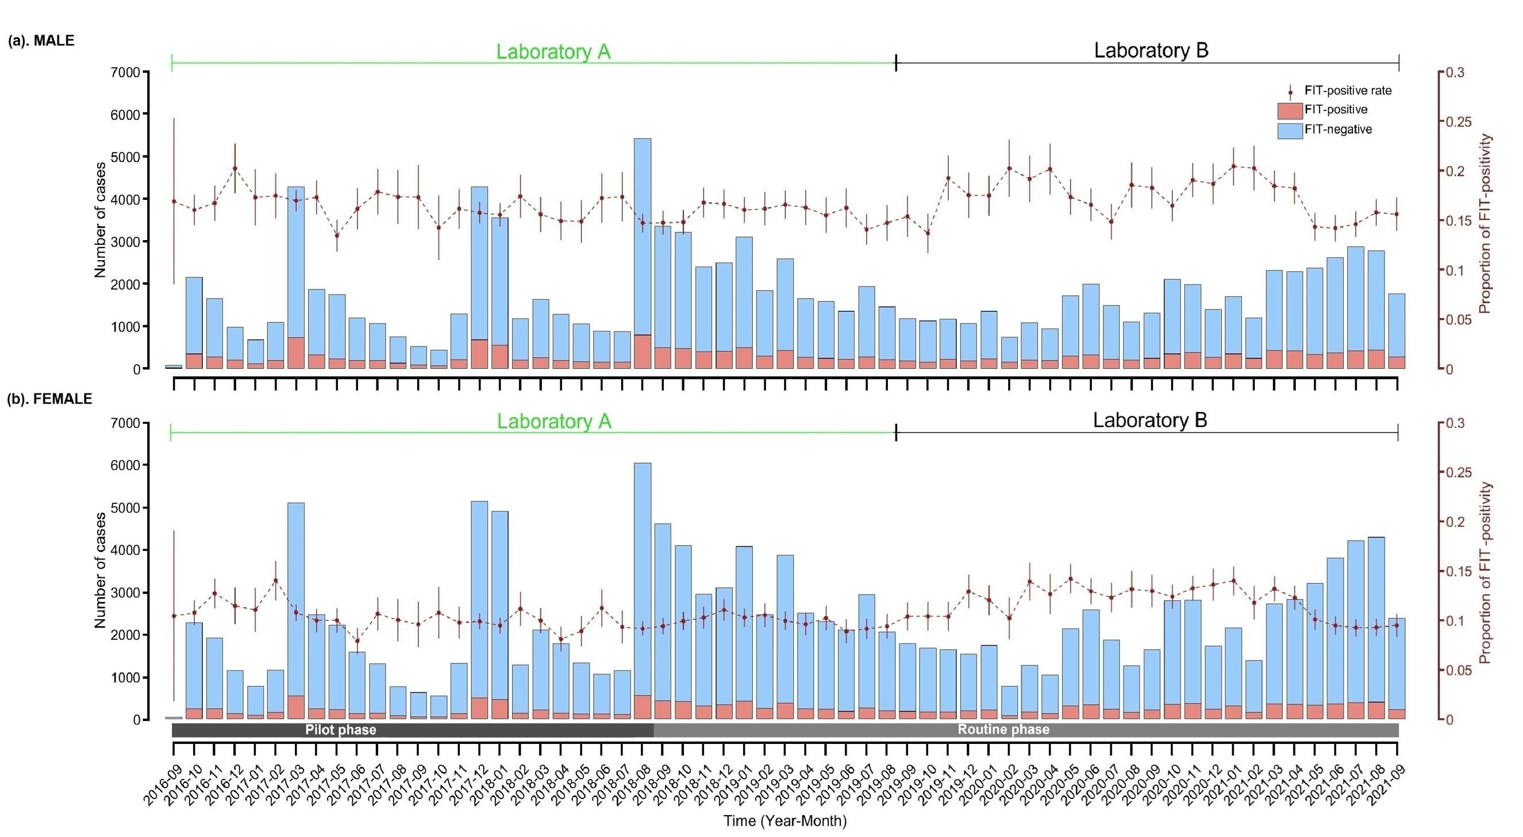
Figure S1. Number of participants by year-month. Participants who enrolled in the HKCRCSP from September 2016 to September 2021 were included. Throughout the data collection period, two laboratories were involved in analyzing fecal samples. Laboratory B began analysis in September 2019. Screenees were termed FIT-positive if one or both of their two-sample FIT values were 100 ng/mL or above, and FIT-negative otherwise. Circles and vertical bars, connected with dashed lines, indicate the empirical FIT-positive rates and their 95% confidence intervals based on the binomial distribution, respectively. Abbreviations: FIT, fecal immunochemical test; HKCRCSP, Hong Kong Colorectal Cancer Screening Programme.

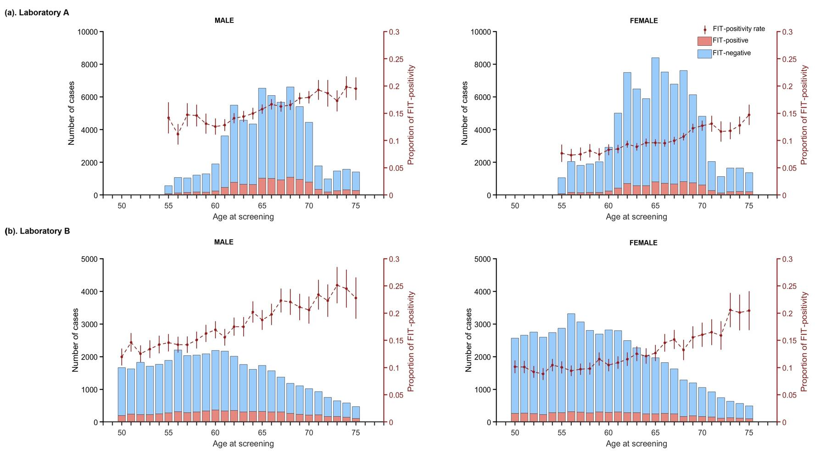
Figure S2. Age distribution of male and female screenees in the dataset by laboratory. Only screenees aged 50-75 years, the recommended screening age in HKCRCSP, are shown in the figure. Screenees were termed FIT-positive if one or both of their two-sample FIT values were 100 ng/mL or above, and FIT-negative otherwise. Circles and vertical bars indicate the empirical FIT-positive and their 95% confidence intervals based on the binomial distribution, respectively. Abbreviations: FIT, fecal immunochemical test; HKCRCSP, Hong Kong Colorectal Cancer Screening Programme.

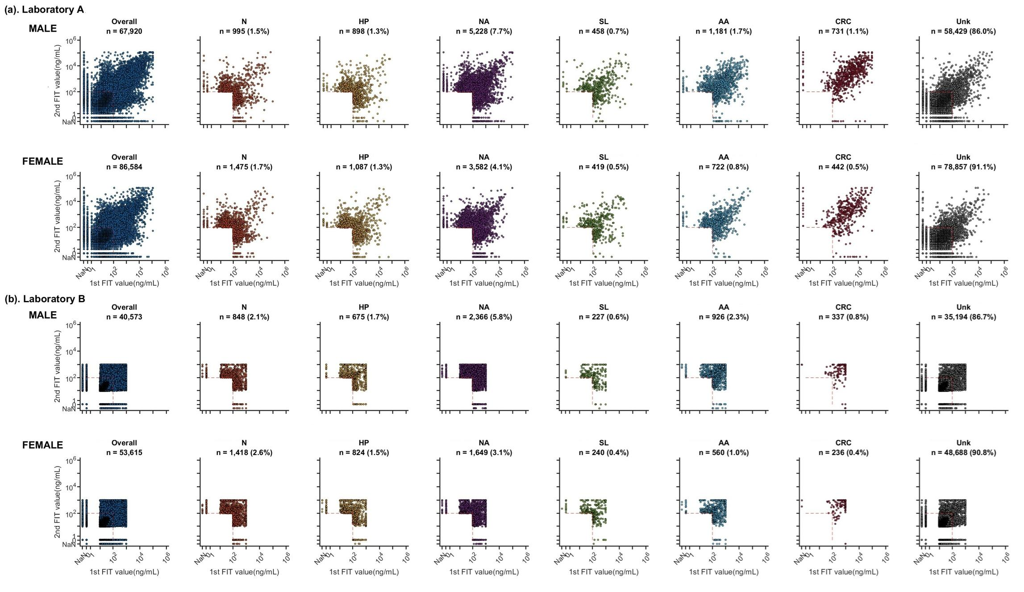
Figure S3. Two-sample FIT values in the dataset stratified by colonoscopy outcome and processing laboratory. There were three possible outcomes for each sample: invalid results (e.g., Not a number), a FIT value of 0, and a positive FIT value. For positive FIT values, the laboratories applied different censoring thresholds: Laboratory A did not apply left-censoring, but the right-censoring threshold was 120,000 ng/mL. In contrast, laboratory B applied a left-censoring threshold at 9 ng/mL and a right-censoring threshold at 1,000 ng/mL. The red dashed lines indicate the positivity threshold of 100 ng/ mL. The ‘Unk’ stage (grey dots; the rightmost column) comprises screenees who (i) were FIT-negative or (ii) were FIT-positive but whose colonoscopy examinations were not yet performed or were invalid. Abbreviations: AA, advanced adenoma; CRC, colorectal cancer; FIT, fecal immunochemical test; HKCRCSP, Hong Kong Colorectal Cancer Screening Programme; HP, hyperplastic polyps; N, normal; NA, non-advanced adenoma; NaN, not a number; SL, serrated lesions; Unk, unknown disease stage.

Model details
Here we provide more details on model description, model parameterization, as well as the construction of the likelihood function.

Model Summary
We estimated 151 parameters that describe the epidemiology of CRC and the distribution of FIT data from the HKCRCSP. We use $θ$ to denote the set of model parameters subject to statistical inference. Our data-driven model comprises two components: (1) a natural history model that simulates CRC development over the lifetime of each gender through both conventional and serrated pathways, and (2) a statistical model that characterizes the distribution of FIT values across disease stages.

The natural history model
We developed a gender-specific natural history model for CRC. Figure 1b of the main text presents the schematic of the natural history model. Without loss of generality, we suppressed the gender dependence of the model in what follows. We assumed that CRC cases developed via either the conventional adenoma or the serrated pathway. The health states of the screenees with colonoscopy records were defined according to their colonoscopy diagnosis: (i) normal (N); (ii) hyperplastic polyps (HP); (iii) non-advanced adenoma (NA); (iv) serrated lesions (SL); (v) advanced adenoma (AA); (vi) colorectal cancer (CRC); and (vii) unknown disease stage (Unk) which comprised all the FIT-negative screenees or those FIT-positive screenees who had no colonoscopy diagnosis records. See Figure S4 for the definition of colonoscopy diagnosis.
The two development pathways are as follows:
1. The conventional adenoma pathway: N → NA → AA → pCRC → dCRC
2. The serrated pathway: N → HP → SL → pCRC → dCRC
where pCRC and dCRC are referred to as preclinical (undiagnosed) and diagnosed CRC, respectively. Based on previous studies, we assumed that the serrated pathway accounts for 10-30% of all CRC cases and inferred the corresponding proportion through model calibration.³⁻⁵ Furthermore, following the American Joint Committee on Cancer (AJCC) staging system,⁶ CRC cases were classified into stages 1, 2, 3, and 4. In the model, an individual who has just developed CRC would be classified as preclinical CRC stage 1 (pCRC₁). In the absence of screening, a pCRC case might be diagnosed due to manifestations of symptoms (e.g., pCRC_{i} → dCRC_{i} for i = 1, 2, 3, and 4) or remain undiagnosed and progress to more advanced stages (i.e., pCRC_{i} → pCRC_{i+1} for i = 1, 2, and 3).

We used the following mathematical model to simulate the epidemiology of colorectal neoplasms in a cohort, starting at age 20 until death or age 100 (whichever happened sooner), in the absence of screening. Without loss of generality, we assumed that the initial cohort size (at age 20) was 1. Let $x_{s}(a)$ be the proportion of individuals in the cohort in disease stage $s$ at age $a$, and $γ_{s,s^{'}}(a)$ be the progression rate from disease stage $s$ to another stage $s'$ at age $a$. We included $x_{s}(a)$ and $γ_{s,s^{'}}(a)$ in $θ$ for statistical inference. The natural history model comprised the following differential equations:
$$\frac{dx_{N}(a)}{da}=-\left(γ_{N,NA}\left(a\right)+γ_{N,HP}\left(a\right)+μ\left(a\right)\right)x_{N}(a) \\ \frac{dx_{NA}(a)}{da}=γ_{N,NA}\left(a\right)x_{N}(a)-γ_{NA,AA}\left(a\right)x_{NA}(a)-μ(a)x_{NA}(a)$$
$$\frac{dx_{HP}(a)}{da}=γ_{N,HP}{\left(a\right)x}_{N}(a)-γ_{HP,SL}\left(a\right)x_{HP}(a)-μ(a)x_{HP}(a) \\ \frac{dx_{AA}(a)}{da}=γ_{NA,AA}{\left(a\right)x}_{NA}(a)-γ_{AA,{pCRC}_{1}}{\left(a\right)x}_{AA}(a)-μ(a)x_{AA}(a) \\ \frac{dx_{SL}(a)}{da}=γ_{HP,SL}\left(a\right)x_{HP}(a)-γ_{SL,{pCRC}_{1}}{\left(a\right)x}_{SL}(a)-μ(a)x_{SL}(a) \\ \frac{dx_{{pCRC}_{1}}(a)}{da}=γ_{AA,{pCRC}_{1}}{\left(a\right)x}_{AA}\left(a\right)+γ_{SL,{pCRC}_{1}}{\left(a\right)x}_{SL}\left(a\right)-γ_{{pCRC}_{1},{dCRC}_{1}}{\left(a\right)x}_{{pCRC}_{1}}\left(a\right)-γ_{{pCRC}_{1},{pCRC}_{2}}{\left(a\right)x}_{{pCRC}_{1}}\left(a\right)-μ(a)x_{{pCRC}_{1}}(a)$$
$$\frac{dx_{{pCRC}_{2}}\left(a\right)}{da}=γ_{{pCRC}_{1},{pCRC}_{2}}{\left(a\right)x}_{{pCRC}_{1}}\left(a\right)-γ_{{pCRC}_{2},{dCRC}_{2}}{\left(a\right)x}_{{pCRC}_{2}}\left(a\right)-γ_{{pCRC}_{2},{pCRC}_{3}}\left(a\right)x_{{pCRC}_{2}}\left(a\right)-μ\left(a\right)x_{{pCRC}_{2}}\left(a\right)$$
$$\frac{dx_{{pCRC}_{3}}\left(a\right)}{da}=γ_{{pCRC}_{2},{pCRC}_{3}}\left(a\right)x_{{pCRC}_{2}}\left(a\right)-γ_{{pCRC}_{3},{dCRC}_{3}}{\left(a\right)x}_{{pCRC}_{3}}\left(a\right)-γ_{{pCRC}_{3}{pCRC}_{4}}(a)x_{{pCRC}_{3}}\left(a\right)-μ\left(a\right)x_{{pCRC}_{3}}\left(a\right)$$
$$\frac{dx_{{pCRC}_{4}}\left(a\right)}{da}=γ_{{pCRC}_{3},{pCRC}_{4}}(a)x_{{pCRC}_{3}}\left(a\right)-γ_{{pCRC}_{4},{dCRC}_{4}}{\left(a\right)x}_{{pCRC}_{4}}\left(a\right)-μ\left(a\right)x_{{pCRC}_{4}}\left(a\right)$$
$$\frac{dx_{{dCRC}_{i}}(a)}{da}=γ_{{pCRC}_{i},{dCRC}_{i}}\left(a\right)x_{{pCRC}_{i}}\left(a\right)-γ_{{dCRC}_{i},Death}x_{{dCRC}_{i}}\left(a\right)-μ\left(a\right)x_{{dCRC}_{i}}\left(a\right), i=1, 2, 3, 4$$
where ${pCRC}_{i}$ and ${dCRC}_{i}$ represent the preclinical and diagnosed CRC of stage $i$ ($i=1, 2, 3, 4$), respectively. $μ(a)$ represents the gender-specific non-CRC mortality rate at age $a$, based on data from the Hong Kong Census and Statistics Department for 2012-2016.² We assumed that the disease transition rates $γ_{s,s^{'}}(a)$ were age-specific (except for the CRC stage-specific mortality rates $γ_{{dCRC}_{i},Death}$). We assumed that the incidence rate of developing NA and HP (i.e., $γ_{N,NA}$, and $γ_{N,HP}$, respectively), were age-specific from age 20 to 70 and remained constant after age 70. The disease progression rates from disease stages (HP, NA, SL, AA, and CRC) were assumed to be constant before age 50 and age-specific between ages 50 and 100. We modelled both age-specific incidence and progression rates using piecewise cubic Hermite interpolating polynomial (PCHIP) function with 3 knots: (i) at age 20, 45 and 70 for incidence rates; and (ii) at age 50, 75 and 100 for disease progression rates.⁷ For CRC mortality, we assumed that an individual with dCRC would experience an age-independent, stage-specific CRC mortality rate ($γ_{{dCRC}_{i},Death}, i=1, 2, 3, 4)$. We considered the stage-specific relative survival rates (CRC Stage 1, 96%; CRC Stage 2, 87%; CRC Stage 3, 69%; CRC Stage 4, 9.3%) that were reported by Hong Kong Cancer Registry (HKCaR),⁸ a population-based cancer registry that collects cancer data from both public and private sectors, to project age- and stage-specific CRC mortality in the simulation.

Moreover, we assumed that the conventional adenoma and serrated pathways are mutually exclusive based on the histology results in the current CRC screening program and evidence in the literature.⁹⁻¹² We did not include the development via other pathways (e.g., the microsatellite instability and inflammatory pathways) because they represented only a small proportion of CRC cases.^{4,13,14} We also assumed that disease development is irreversible; an individual in a more advanced stage would not regress to less advanced stages in the absence of appropriate treatment.

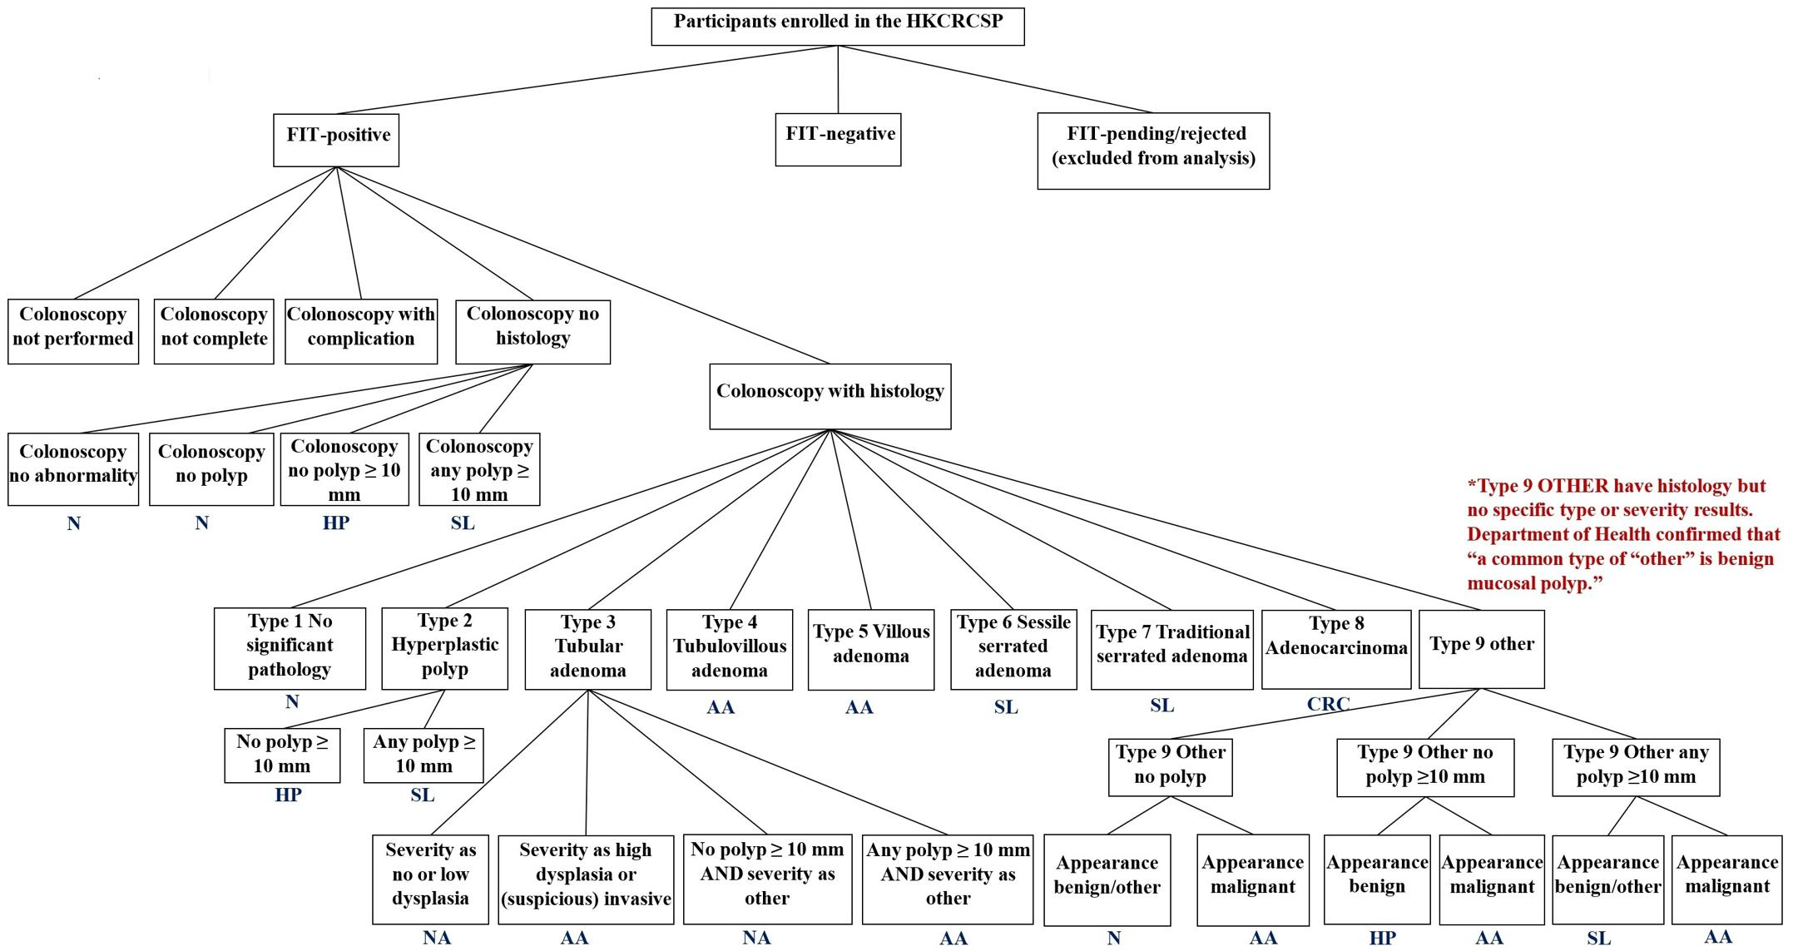
Figure S4. Schematic of the definition of colonoscopy diagnosis. The health states of the screenees were based on their colonoscopy diagnosis. The health states of FIT-positive screenees were classified as ‘Unknown’ if they had not undergone colonoscopy examinations or their colonoscopy examinations were invalid. The notations in navy blue below the boxes represent the classification of the health states based on colonoscopy examinations. Abbreviations: AA, advanced adenoma; CRC, colorectal cancer; FIT, fecal immunochemical test; HKCRCSP, Hong Kong Colorectal Cancer Screening Programme; HP, hyperplastic polyps; N, normal; NA, non-advanced adenoma; SL, serrated lesions.

FIT screening
Two laboratories analyzed fecal samples during the data collection period from September 2016 to September 2021. The first laboratory (laboratory A) processed samples before September 2019, after which the second laboratory (laboratory B) took over (Figure S1). There were three possible outcomes for each sample: invalid results (e.g., Not a number, NaN), a FIT value of 0, and a positive FIT value. For positive FIT values, the laboratories applied different censoring thresholds: Laboratory A did not apply left-censoring, but the right-censoring threshold was 120,000 ng/mL. In contrast, laboratory B applied a left-censoring threshold at 9 ng/mL and a right-censoring threshold at 1,000 ng/mL (Figure S3). Based on this empirical data, we constructed a statistical model to characterize the FIT distributions from two samples:

Let $a_{i}$ and $s_{i}$ be the age and disease stage of individual $i$, and $V_{ij}$ be the FIT value in his/her j^{th} sample. We assumed that given $s_{i}$ and $V_{ij}$ was independent of $a_{i}$; this assumption was consistent with the empirical FIT value distribution observed among the samples of screenees with colonoscopy diagnosis (Figure S5). Furthermore, we made the following assumptions:
- Each screenee $i$ had an underlying FIT value $U_{i}$ such that:
  - $V_{ij}=0$ for all j if $U_{i}=0$;
  - $\ln\left(1+V_{ij}\right)=\ln\left(1+U_{i}\right)+ε_{ij}$ if $U_{i}>0$, where $ε_{ij}$ were independent normal random variables with mean 0 and standard deviation $ω(U_{i})$, i.e., $ε_{ij} \sim \text{N}(0,ω(U_{i}))$.
The above assumptions implied that $∆_{i}=\text{ln}\left(\text{1+}{\text{V}}_{\text{i1}}\right)\text{–}\text{ln}\left(\text{1+}{\text{V}}_{\text{i2}}\right)\text{=}{\text{ε}}_{\text{i1}}\text{ – }{\text{ε}}_{\text{i2}}\text{ \sim }\text{N}\text{(0,}\sqrt{\text{2}}\text{ω}\text{(}{\text{U}}_{\text{i}}\text{))}$ if $U_{i}>0$. Figure S6 suggests that the empirical distribution of $∆_{i}$ supports our assumption. To be specific, we modeled $ω(U)$ as follows:
- We set $ω\left(U\right)=ω(10)$ for $U<10$ ng/mL and $ω\left(U\right)=ω(1000)$ for $U>1000$ ng/mL.
- We assumed $ω(U)$ followed a PCHIP function of $\ln\left(1+U\right)$ over the range $10≤U≤1000$ng/mL. The values of $ω(U)$ were specified at $U=10, 31.62, 100, 316.23, 1000$ng/mL, which were equally separated in the natural logarithmic scale. These corresponding values were included in $θ$ for statistical inference.
- If $U_{i}>0$, we assumed $\ln\left(1+U_{i}\right)$ followed a lognormal distribution with stage-specific parameters: mean $μ_{s}$​ and standard deviation $σ_{s}$, shared across individuals in the same stage $s$. We inferred the value of $μ_{s}$ and $σ_{s}$ for each $s∈\{N,HP, NA,SL,AA,CRC\}$ from the data by including them in $θ$ for statistical inference. We used lognormal distribution in the model because the Akaike information criterion (AIC) for the lognormal distribution model was lower than that for the gamma and Weibull distribution models.
- For individual $i$ at stage $s_{i}$, we assumed that$U_{i}=0$ with probability $r_{s_{i}}$, where $r_{s}$​ was stage-specific (i.e., individuals with the same disease stage shared the same value of $r_{s}$​). We inferred the values of $r_{s}$, $s∈\{N,HP, NA,SL,AA,CRC\}$, from the data by including them in $θ$ for statistical inference.
- With probability $q_{NaN}$, each sample would experience a FIT-invalid event which rendered $V_{ij}‍=‍NaN$ regardless of $U_{i}$. The empirical distribution of the two-sample FIT values suggested that $q_{NaN}$ had a very weak (if any) dependence on disease stage or $U_{i}$ (Figure S7 showed the empirical evidence). As such, for model parsimony, we assumed that $q_{NaN}$ was constant and inferred its value from the data by including it in $θ$ for statistical inference.
- With probability $q_{0}$, each sample would experience a FIT-zero event which rendered $V_{ij}=0$ regardless of $U_{i}$. The empirical distribution of the two-sample FIT values suggested that the dependence of $q_{0}$ on disease stage and $U_{i}$ was weak except perhaps when $U_{i}$ was lower than 10 ng/mL. Figure S8 illustrates how empirical data supports our assumption. For simplicity, we assumed that $q_{0}$ was a constant and inferred its value from the data by including it in $θ$ for statistical inference.

To account for the potential variation between laboratories, we estimated the following parameters specific to each laboratory: (a) the mean $μ_{s}$ and standard deviation $σ_{s}$, for $s∈\left\{N,HP, NA,SL,AA,CRC\right\}$, (b) and $r_{s}$ for the probability of $U_{s}=0$, for $s∈\left\{N,HP, NA,SL,AA,CRC\right\}$, (c) $q_{NaN}$ and $q_{0}$, which were assumed constant by disease stage, for the probability that one sample experienced a FIT-invalid event and a FIT-zero event, respectively. In contrast, $ω(U)$ denotes the standard deviation of the difference between the transformed values of a rendered FIT value $V_{j}$ and an underlying FIT value $U$ (i.e., $\ln\left(1+V_{j}\right)-\ln\left(1+U\right)$). We assumed a shared $ω(U)$ across laboratories, because allowing lab-specific $ω(U)$ yielded highly similar inferred estimates, except at the last knot. All parameters were also estimated separately by gender, except for $ω(U)$. We proposed that the function $ω(U)$ is agnostic to gender, as the empirical distribution of $∆_{i}$ exhibits a similar pattern across both genders, as shown in Figure S6 (e) and (f). In summary, $ω(U)$ was treated as a global function that does not vary by laboratory or gender, based on both empirical and modeling evidence. Furthermore, we assumed that the FIT-related parameters specific to disease stages were shared across all cancer stages, in both preclinical and clinical states. That is, $μ_{CRC}$, $σ_{CRC}$ and $r_{CRC}$would be the same for health states pCRC_{i} and dCRC_{i}, i = 1, 2, 3, and 4.

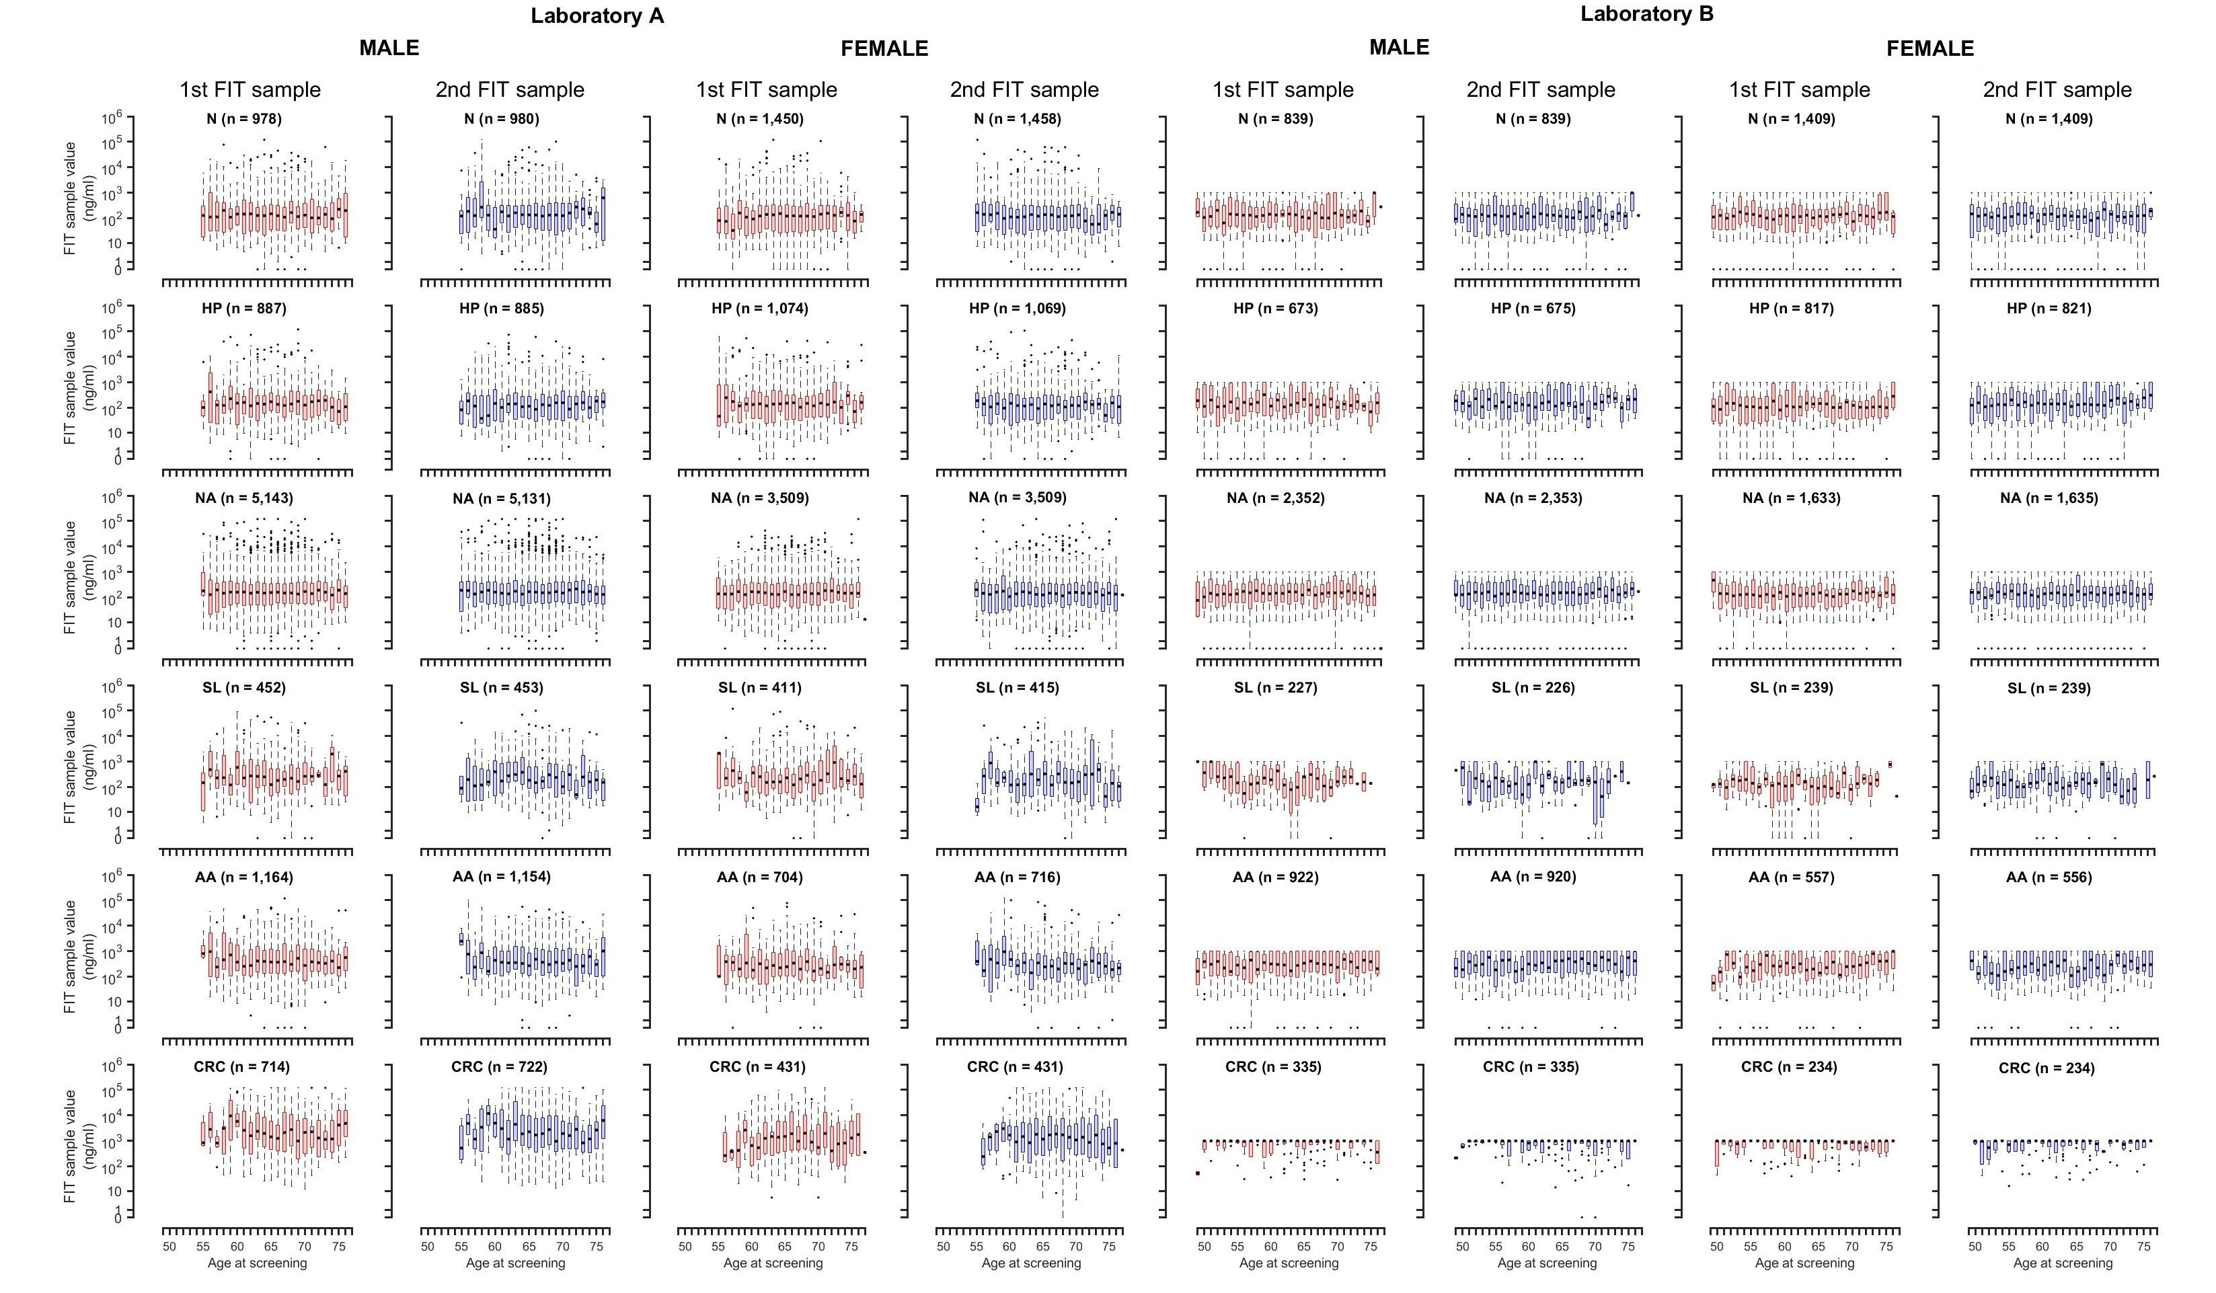
Figure S5. Distributions of FIT values stratified by age and colonoscopy outcomes. There were three possible outcomes for each sample: invalid results, a FIT value of 0, and a positive FIT value. For positive FIT values, the laboratories applied different censoring thresholds: Laboratory A did not apply left-censoring, but the right-censoring threshold was 120,000 ng/mL. In contrast, laboratory B applied a left-censoring threshold at 9 ng/mL and a right-censoring threshold at 1,000 ng/mL. Notably, the outliers below 9 ng/mL in laboratory B were driven by FIT values of 0. The box plot suggested that, given the disease stage, the FIT values did not depend on the age or the order of the samples in the two-sample FIT (p > 0.05 Kruskal-Wallis rank sum test with adjustments for multiple testing). Abbreviations: AA, advanced adenoma; CRC, colorectal cancer; FIT, fecal immunochemical test; HP, hyperplastic polyps; N, normal; NA, non-advanced adenoma; SL, serrated lesions.

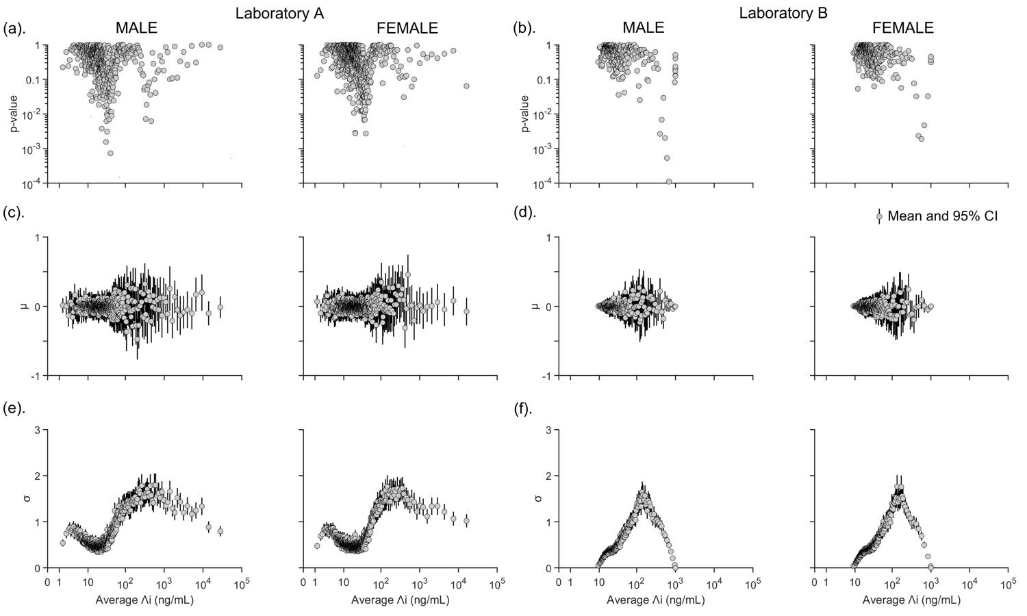
Figure S6. Justification for model Assumption 1. Assumption 1 stated that the two samples of FIT values were independent and identically distributed. In our dataset, 91% of male and 89% female screenees had both of their two-sample FIT values positive (i.e., both >0) for FIT data from laboratory A. The corresponding proportions were 71% and 67% for data from laboratory B. Given that $V_{ij}$ was the FIT value in the jth sample from individual i, let $Λ_{i}=\sqrt{V_{i1}V_{i2}}$ (i.e. the geometric mean of the two-sample FIT values) and $Δ_{i}=\ln\left(1+V_{i1}\right)-ln\left(1+V_{i2}\right)$ (i.e. the between-sample log-FIT differential, where $∆_{i}\text{ \sim }\text{N}\text{(0,}\sqrt{\text{2}}\text{ω}\text{(}{\text{U}}_{\text{i}}\text{))}$. Assumption 1 states that $Δ_{i}/\sqrt{2}$ can be modelled as independent and identically distributed normal random variables with mean 0 and standard deviation $\text{ω}\text{(}{\text{U}}_{\text{i}}\text{)}$ that varied with the underlying FIT value $U_{i}$. To test this hypothesis, we stratified the screenees within each gender into groups of 100 in ascending order of their $Λ_{i}$ values (which served as empirical estimates for the underlying FIT values) and examined the statistical distribution of $Δ_{i}$ within each stratum. FIT values are in principle continuous numbers, but FIT values in our dataset were integers. To circumvent the unnecessary complications of discrete mathematics, we converted the discrete FIT values in our dataset into continuous numbers by adding a uniform random variable ranging between −0.5 and 0.5 to each FIT value. We repeated this procedure 10 times to generate 10 different sets of augmented datasets. This augmentation procedure was performed only here and not in our main analysis. We obtained the same overall conclusion with all 10 augmented datasets, so we present the results from only one of them here. (a/b). We used the Kolmogorov-Smirnov test to calculate the p-value for the null hypothesis that the standardized $Δ_{i}$ values within each stratum followed a standard normal distribution. The p-value was greater than 0.05 in more than 92% and 94% of the stratum for both genders for laboratories A and B, respectively. The sample mean of $Λ_{i}$ in each stratum was used as the abscissa for each data point. (c/d) and (e/f). The mean $μ$ and standard deviation $σ$ of the fitted normal distribution in each stratum. Taken together, (a-f) suggested that it was reasonable to adopt Assumption 1 for model parsimony for FIT data from both laboratories. Abbreviations: CI, confidence intervals; FIT, fecal immunochemical test.
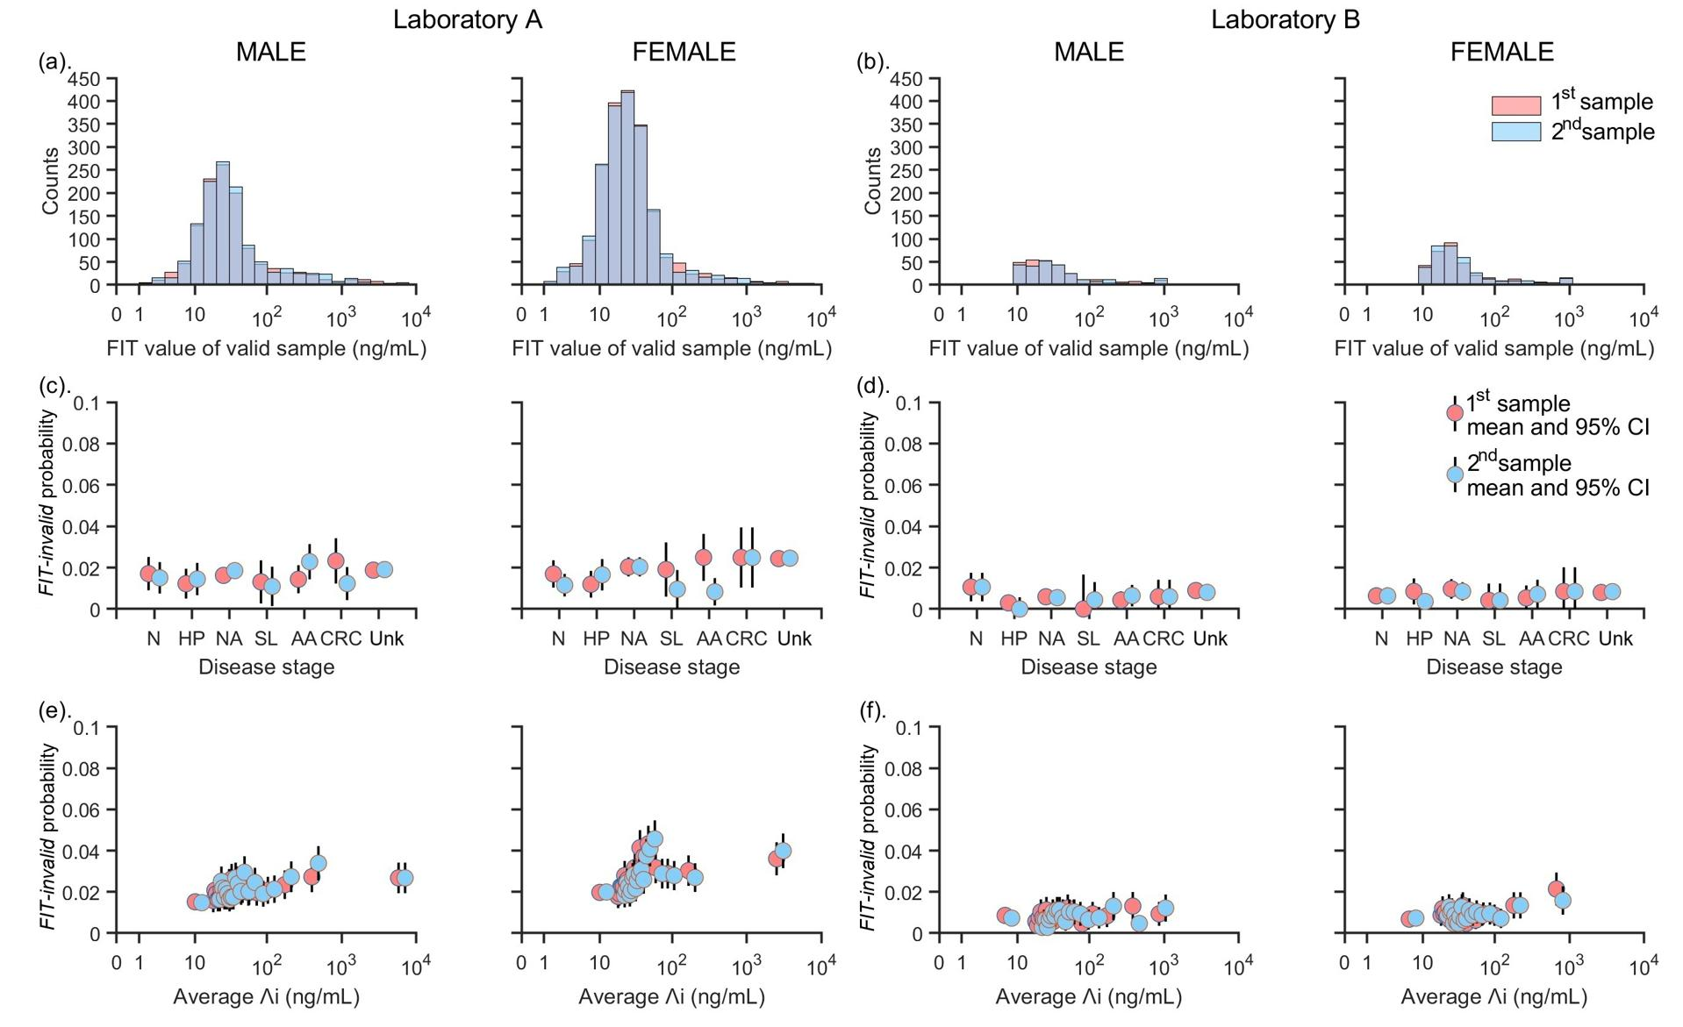
Figure S7. Justification for model Assumption 4. In this figure, we examined the probability of FIT-invalid events (i.e., $q_{NaN}$). In our dataset, 3.7% of male and 4.8% of female samples were at least one sample of invalid for data from laboratory A. The corresponding proportions were 1.6% for both genders for data from laboratory B. The percentages of invalid samples did not depend on the order of the samples in the two-sample FIT. (a/b). The ‘Unk’ stage comprises screenees who (i) were FIT-negative or (ii) were FIT-positive but whose colonoscopy examinations were not yet performed or were invalid. Comparing screenees from whom the first sample was invalid (red) with screenees from whom the second sample was invalid (blue), the FIT-value distributions of their valid samples had no statistically significant difference (p > 0.64 for both genders, Kolmogorov-Smirnov test). (c/d). The probability of FIT-invalid events was largely independent of the disease stage of the screenees. (e/f). The screenees were stratified within each gender in ascending order of their $Λ_{i}$ values (as defined in Figure S6). The first stratum comprised screenees with $Λ_{i}$ below 20 ng/mL. All subsequent strata were equal in size with 5% screenees in each stratum. The sample mean of $Λ_{i}$ in each stratum was used as the abscissa for each data point. In such, the probability of FIT-invalid events was largely independent of the underlying FIT value of the screenees. Taken together, the results in (a-f) suggested that it was reasonable to adopt Assumption 4 for model parsimony for FIT data from both laboratories. Abbreviations: AA, advanced adenoma; CI, confidence intervals; CRC, colorectal cancer; FIT, fecal immunochemical test; HP, hyperplastic polyps; N, normal; NA, non-advanced adenoma; SL, serrated lesions; Unk, unknown disease stage.
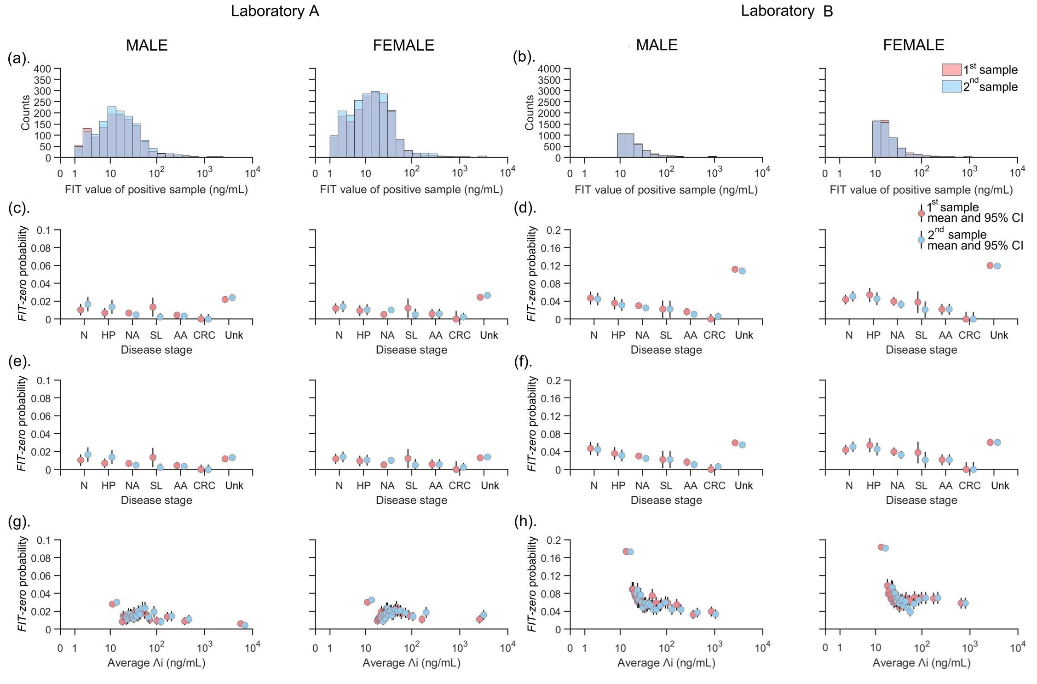
Figure S8. Justification for model Assumption 5. To examine the probability of FIT-zero events (i.e., $q_{0}$), we considered only screenees who had no invalid samples and at least one sample with a positive FIT value (which corresponded to 95% and 93% of male and female screenees for data from laboratory A, respectively, and to 88% and 86% of male and female screenees for data from laboratory B, respectively). The stochastic effect described in Assumption 1 would only account for a small proportion of FIT-zero samples. (a/b). The ‘Unk’ stage comprises screenees who (i) were FIT-negative or (ii) were FIT-positive but whose colonoscopy examinations were not yet performed or were invalid. Comparing individuals from whom the first sample was FIT-zero (red) with individuals from whom the second sample was FIT-zero (blue), the FIT-value distributions of their other samples had no statistically significant difference (p > 0.43 for both genders, Kolmogorov-Smirnov test). (c/d) and (g/h). The probability of FIT-zero events appeared to decrease slightly with more advanced disease stages and higher underlying FIT values. This was partially caused by the stochastic effects described in Assumption 1 (such effects rendered screenees with lower underlying FIT values and hence milder disease stages more likely to have FIT-zero samples). (e/f). We constrained the dataset to include at least one sample with FIT value > 20 ng/mL, the FIT-zero probability in Unk stage decreased, becoming comparable to the FIT-zero probabilities in the disease stage N, HP and NA, which supported Assumption 1. (g/h). Screenees were stratified in ascending order of their $Λ_{i}$ values as in Figure S6. Taking together, the results in (a-h) suggested that it was reasonable to adopt Assumption 5 for model parsimony. Abbreviations: AA, advanced adenoma; CI, confidence intervals; CRC, colorectal cancer; FIT, fecal immunochemical test; HP, hyperplastic polyps; N, normal; NA, non-advanced adenoma; SL, serrated lesions; Unk, unknown disease stage.

Inference and likelihood
CRC incidence

We utilized data from the HKCaR covering the years 2012 to 2016, which reported CRC incidence in 5-year age groups.⁸ Notably, around 20% of CRC cases were classified as “unstaged”. We assumed that, in the absence of screening, the incidence rate of CRC diagnosis among our study participants would mirror that of the general population. We assumed that for CRC cases of underlying stage $x$, $g_{x}(a)$of them were staged (rendered as ascertainment ratio), while $1-g_{x}(a)$ of the cases were not staged. For simplicity, we assumed that $g_{3}\left(a\right)= g_{4}(a)$. We assumed that $g_{x}(a)$ was (i) constant before age $a_{x}$; and (ii) a PCHIP function between age $a_{x}$ and 100. In the cohort simulation, we estimated the observed incidence of CRC at age $a$ ($λ_{x,a}$ and $λ_{unstaged,a}$ for stage $x$ and unstaged, respectively; as reported by HKCaR):
$$λ_{x,a}={\tilde{λ}}_{x,a}∙g_{x}(a) , x=1, 2, 3, 4$$
$$λ_{unstaged,a}=\sum_{x}{\left[{\tilde{λ}}_{x,a} ×(1-g_{x}(a))\right]}$$
where ${\tilde{λ}}_{x,a}$ was the underlying incidence of CRC stage $x$ at age $a$ based on the model simulation. We included $a_{x}$, and the stage-specific ascertainment ratios $g_{x}(a)$ at ages $a_{x}$ and 100 in 𝜃 for statistical inference.

Model Inference

For the natural history, we inferred the prevalence of each disease stage $s$ for $s∈\left\{N,HP, NA,SL,AA,CRC\right\}$ at age 20 ($x_{s}(20)$), and the disease transition rates $γ_{s,s^{'}}(a)$ from stage $s$ to $s^{'}$ from the screening data for each gender. Specifically, (a) we inferred the incidence rates (from $N$ to $NA$, or from $N$ to $HP$) at specific ages at 20, 45 (midpoint age between 20 to 70) and 70; and (b) for the progression rate, we inferred the relative changes (compared to the baseline progression rates before age 50) at the ages of 75 (the midpoint age between 50 to 100) and 100. We incorporated these into $θ$ for statistical inference. For two-sample FIT distribution, we inferred the following parameters specific to each gender and laboratory: (a) the mean $μ_{s}$ and standard deviation $σ_{s}$, and $r_{s}$ for the probability of $U_{s}=0$, for disease stage $s$; and (b) $q_{NaN}$ and $q_{0}$, which were assumed constant by disease stage, for the probability that one sample experienced a FIT-invalid event and a FIT-zero event, respectively. In contrast, $ω(U)$ was treated as a global function that does not vary by laboratory or gender, based on both empirical and modeling evidence. Furthermore, we assumed that the FIT-related parameters that were specific to disease stages were the same for all cancer stages in both preclinical and clinical cases. That is, $μ_{CRC}$, $σ_{CRC}$ and $r_{CRC}$would be the same for health states pCRC_{i} and dCRC_{i}, i = 1, 2, 3, and 4.

Likelihood function

The prevalence of disease stage $s$ at age $a$ among individuals who had never been diagnosed with CRC was $p(s|a,θ)=\frac{x_{s}(a)}{\sum_{s∈W}{x_{s}(a)}}$ where $W=\{N,HP,NA,SL,AA,CRC\}$ through cohort simulation. Because HKCaR reported cancer data with 5-year age bands, we tallied cancer incidence for the same age groups in our cohort simulation when formulating the likelihood function. Let $λ_{xj}^{HKCaR}$ be the observed number of incident CRC cases of cancer stage $x$ ($x$ = 1, 2, 3, 4, and “unstaged”) in the j^{th} age group during 2012-2016 based on the age- and stage-specific number of incidence CRC cases recorded by the HKCaR, and $λ_{xj}^{model}$ be the expected number of individuals diagnosed with CRC of stage $x$ in the j^{th} age group in the cohort simulation. For mortality data, let $z_{j}^{HKCaR}$ be the observed number of CRC death cases in the j^{th} age group during 2012-2016 based on the age-specific mortality recorded by the HKCaR, and $z_{j}^{model}$ be the expected number of individuals that would die with CRC in the j^{th} age group in the cohort simulation. We assumed that CRC incidence and mortality rates followed a Poisson distribution.

Let $f\left(v_{1},v_{2} | s,l,θ\right)$ be the probability density function of the two-sample FIT values ($v_{1},v_{2})$ for individuals with disease stage $s$ and processed by laboratory $l$. Let $C^{+}$ be the group of FIT-positive screenees who had received their colonoscopy diagnosis and $C^{-}$ be the remaining screenees (who were either FIT-negative or FIT-positive but had not yet received their colonoscopy diagnosis). The likelihood function was based on the components regarding the natural history model and the two-sample FIT characteristics. The parameters for both components were inferred simultaneously. The likelihood function was:

$${L\left(θ\right)=L}_{C^{+}}\left(θ\right)×L_{C^{-}}\left(θ\right)×\underset{\text{CRC incidence} }{\underbrace{\prod_{x}{\prod_{j}{Poisson(λ_{xj}^{HKCaR},λ_{xj}^{model})}}}}×\underset{\text{CRC mortality} }{\underbrace{\prod_{j}{Poisson(z_{j}^{HKCaR} ,z_{j}^{model})}}}$$
where
$$L_{C^{+}}\left(θ\right)=\prod_{i∈C^{+}}{p(s_{i}|a_{i},θ)f(v_{i1},v_{i2}|s_{i},l_{i},θ)}$$
corresponded to screenees in group $C^{+}$ and
$$L_{C^{-}}\left(θ\right)=\prod_{i∈C^{-}}{\sum_{s∈\{N,HP,NA,SL,AA,CRC\}}{p(s|a_{i},θ)f(v_{i1},v_{i2}|s,l_{i},θ)}}$$
corresponded to screenees in group $C^{-}$. Note that although screenees in group $C^{-}$ (primarily FIT-negative and also FIT-positive with no colonoscopy completed) did not have colonoscopy outcomes, their two-sample FIT values contained information on the likelihood of their disease stages. The likelihood component $L_{C^{-}}\left(θ\right)$ encapsulated such information where $s$ is a dummy variable denoting the possible disease stages.
Furthermore, regarding the two-sample FIT distribution function:
- $v_{i1}$, $v_{i2}$, $s_{i}$, and $a_{i}$ are the two-sample FIT values from laboratory $l_{i}$, disease stage, and age of individual $i$ in the screening, respectively.
- $f(v_{i}|s_{i},l_{i},θ)$ was the probability of two-sample FIT values from laboratory $l_{i}$ for screenee $i$ whose disease stage was $s_{i}$ and FIT values of the two samples were $v_{i}={(v}_{i1}, v_{i2})$. In the study, we inferred FIT-pattern parameters that were specific to each laboratory expect for the $ω({U_{s}}_{i})$, which was the standard deviation of the difference between a rendered FIT value $v_{i}$ and an underlying FIT value ${U_{s}}_{i}$:
$$f\left(v_{i1},v_{i2} | s_{i},l_{i},θ\right)=\left\{\begin{aligned}\begin{aligned}\begin{matrix}q_{NaN}y_{1}\left(v_{i1} | s_{i},l_{i},θ\right) & \text{if }v_{i1}≠NaN\text{ and }v_{i2}=NaN; \\ & \\ q_{NaN}y_{1}\left(v_{i2} | s_{i},l_{i},θ\right) & \text{if }v_{i1}=NaN\text{ and }v_{i2}≠NaN;\end{matrix} \\ \end{aligned} \\ \begin{matrix}{\left(1-q_{NaN}\right)}^{}y_{2}\left(v_{i1},v_{i2} | { s}_{i},l_{i},θ\right) & \text{if }v_{i1}≠NaN\text{ and }v_{i2}≠NaN. \end{matrix}\end{aligned}\right.$$

$$y_{1}\left(v_{i} | s_{i},l_{i},θ\right)=\left\{\begin{matrix}r_{s_{i}}+\left(1-r_{s_{i}}\right)q_{0+}^{} & \text{if }v_{i}=0; \\ & \\ \left(1-r_{s_{i}}\right)\left(1-q_{0}\right)∙E_{U_{s_{i}}}\left[\left.φ\left(\frac{\ln\left(1+v\right)-\ln\left(1+U_{s_{i}}\right)}{ω\left(U_{s_{i}}\right)}\right)\right|U_{s_{i}}>0\right] & \text{if }v_{i}≠0,\end{matrix}\right.$$
and
$$y_{2}\left(v_{i1},v_{i2} | s_{i},l_{i},θ\right)=\left\{\begin{aligned}\begin{aligned}\begin{aligned}\begin{aligned}\begin{matrix}r_{s_{i}}+\left(1-r_{s_{i}}\right)q_{0+}^{2} & \text{if }v_{i1}=0\text{ and }v_{i2}=0; \end{matrix} \\ \end{aligned} \\ \begin{matrix}\left(1-r_{s_{i}}\right)q_{0+}^{}\left(1-q_{0}\right)∙E_{U_{s_{i}}}\left[\left.φ\left(\frac{\ln\left(1+v_{i1}\right)-\ln\left(1+{U_{s}}_{i}\right)}{ω\left(U_{s_{i}}\right)}\right)\right|U_{s_{i}}>0\right] & \text{if }v_{i1}>0\text{ and }v_{i2}=0;\end{matrix}\end{aligned} \\ \end{aligned} \\ \begin{matrix}\left(1-r_{s_{i}}\right)q_{0+}^{}\left(1-q_{0}\right)∙E_{U_{s_{i}}}\left[\left.φ\left(\frac{\ln\left(1+v_{i2}\right)-\ln\left(1+{U_{s}}_{i}\right)}{ω\left(U_{s_{i}}\right)}\right)\right|U_{s_{i}}>0\right] & \text{if }v_{i1}=0\text{ and }v_{i2}>0;\end{matrix} \\ \\ \begin{matrix}\left(1-r_{s_{i}}\right){\left(1-q_{0}\right)}^{2}∙E_{U_{s_{i}}}\left[\left.\prod_{j=1}^{2}{φ\left(\frac{\ln\left(1+v_{ij}\right)-\ln\left(1+{U_{s}}_{i}\right)}{ω\left(U_{s_{i}}\right)}\right)}\right|U_{s_{i}}>0\right] & \text{if }v_{i1}>0\text{ and }v_{i2}>0,\end{matrix}\end{aligned}\right.$$
where $q_{0+}^{}=q_{0}+\left(1-q_{0}\right)∙E_{U_{S_{i}}}\left[\left.φ\left(\frac{\ln\left(1+0\right)-\ln\left(1+{U_{s}}_{i}\right)}{ω\left(U_{s_{i}}\right)}\right)\right|U_{s_{i}}>0\right]$.
For an observed FIT with the left-censoring value (e.g., $L$), cumulative values $v_{i}≤L$ will be used rather than a single $v_{i}$’s in the $φ(.)$ function calculation (e.g., $\int_{o}^{L}{φ(v_{i})}$). Instead, for an observed FIT with the right-censoring value (e.g., $R$), cumulative values $v_{i}≥R$ will be used in the $φ\left(.\right)$ function calculation (e.g., $\int_{R}^{∞}{φ(v_{i}))}$.

We also considered the information that 10% to 30% of CRC cases were developed via the serrated lesions pathway of all CRC cases and inferred the corresponding proportion through model calibration.⁵ Let $ξ_{j}$ be the proportion of diagnosed CRC cases developed via the serrated lesion pathway for each age group $j$ in the cohort simulation. We considered a prior function if $ξ_{j}$ follows a beta distribution$beta(α,β)$. The $α$ and $β$ parameters of the beta distribution were set to 18.67 and 80.56, respectively, so that there would be a 99% chance for $ξ_{j}$ to fall in the range 10% to 30%. Additionally, for underlying FIT value where $U<10$ng/mL, we introduced a beta distribution$beta(2,2)$ prior on $ω(10)$ to constrain it within a plausible range of 0 to 1. This corresponds to the empirical data of laboratory A and reduces the impact of potential over-dispersion. We combined both the likelihood and the prior function to infer parameters using the Markov chain Monte Carlo (MCMC) method. The fitted model was congruent with the data on stage-specific FIT distribution, and CRC incidence and mortality (Figure S10).
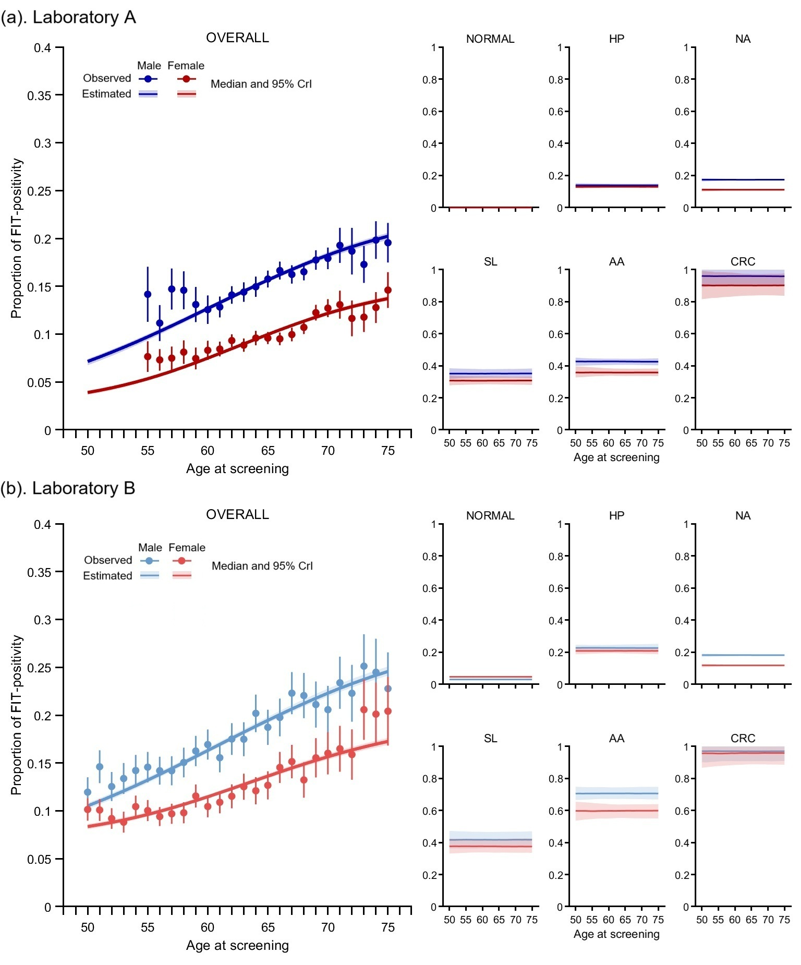
Figure S9. Estimated two-sample FIT positive rates across ages and stages with a FIT-positivity threshold of 100 ng/mL. The overall observed and estimated FIT-positive rate curves are on the left, while the stage-specific estimated FIT-positive rates are on the right. The FIT-positive rates increased with age; however, when considering specific stages, the FIT-positive rates were independent of age. Abbreviations: AA, advanced adenoma; CRC, colorectal cancer; CrI, credible interval; FIT, fecal immunochemical test; HP, hyperplastic polyps; NA, non-advanced adenoma; SL, serrated lesions.
Figure S10. Goodness-of-fit of the fitted model. (a). Cumulative distribution function (CDF) of 2-FIT-max stratified by colonoscopy outcomes, gender, and processing laboratory. FIT values from laboratory A were right-censored at 120,000 ng/mL. FIT values from laboratory B were left-censored at 9 ng/mL and right-censored at 1,000 ng/mL. The black vertical dashed lines indicate the right-censored (1,000 ng/mL) FIT values in laboratory B. (b). Age-specific CRC incidence (stratified by stage at diagnosis) and mortality rate. Abbreviations: AA, advanced adenoma; CRC, colorectal cancer; CrI, credible interval; FIT, fecal immunochemical test; HP, hyperplastic polyps; N, normal; NA, non-advanced adenoma; SL, serrated lesions; Unk, unknown disease stage; 2-FIT-max, maximum two-sample FIT values.
Assessing model capacity to infer true prevalence
Our model integrates quantitative FIT results with local epidemiological data to infer the gender- and age-specific prevalence of colorectal neoplasms in the overall population, based on disease stage information among FIT-positive cases with colonoscopy outcomes available. Despite the absence of colonoscopy outcomes for FIT-negative screenees and for FIT-positive screenees whose colonoscopies were incomplete or invalid, their FIT concentration distributions still provide valuable information on the likelihood of disease stages in our framework. Based on this rationale, we evaluated the feasibility of inferring the underlying disease prevalence using only FIT-positive colonoscopy data. Specifically, we generated a hypothetical population of 100,000 individuals (50% males) based on a set of 151 randomly specified parameters. These parameters were randomly assigned rather than calibrated from real data, ensuring that the simulation was entirely independent of empirical observations. Under this design, the true disease stages of all individuals were fully known, allowing direct comparison between the model-estimated prevalence and the predefined “true” values. The prevalence estimates derived from FIT-positive data closely approximated the true values (Figure S11).
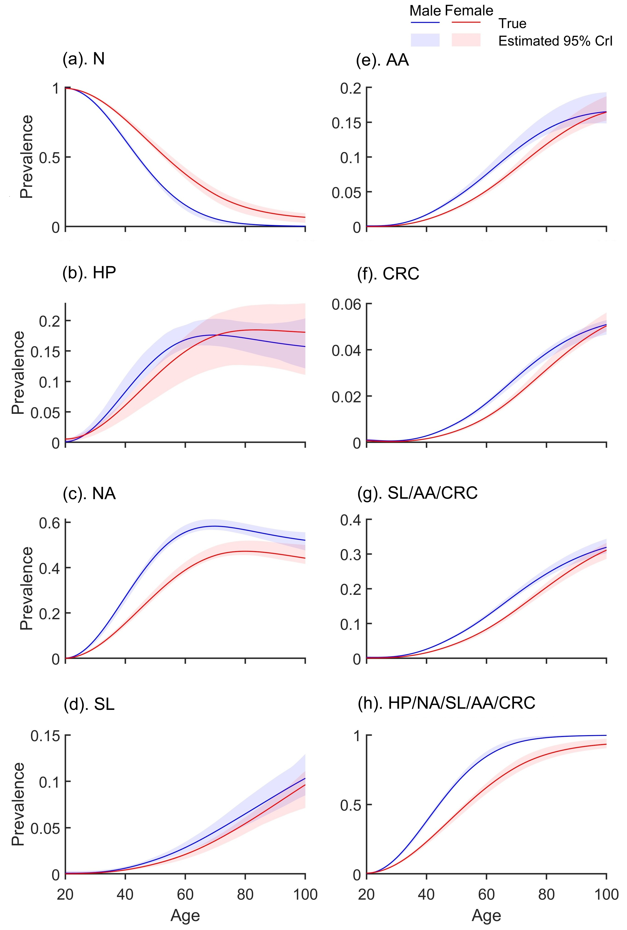
Figure S11. Assessing the feasibility of capturing the underlying disease prevalence. We used a set of 151 randomly specified parameters to simulate a population of 100,000 individuals (50% males) and obtained the “true” age-specific prevalence of disease stages in the overall population. Using a FIT cut-off of 100 ng/mL (corresponding to a simulated positivity rate of 30%), we applied our framework to perform statistical inference and obtained the corresponding 95% CrI for the estimates. As shown in the figure, our results captured the “true” disease distribution in the population. Abbreviations: AA, advanced adenoma; CrI, credible interval; CRC, colorectal cancer; FIT, fecal immunochemical test; HP, hyperplastic polyps; N, normal; NA, non-advanced adenoma; SL, serrated lesions.

The posterior estimates of natural history parameters.
 | Posterior median (95% CrI)
Parameters | Male | Female
Prevalence at age 20 years (per 100,000 individuals)
HP, x_{HP}(20) | 79 (10, 331) | 21 (0.3, 209)
NA, x_{NA}(20) | 54 (10, 383) | 4 (0.04, 90)
SL, x_{SL}(20) | 15 (6, 29) | 0.4 (0.004, 8)
AA, x_{AA}(20) | 28 (14, 52) | 0.4 (0.001, 10)
pCRC, x_{pCRC}(20) | 9 (2, 17) | 0.1 (0.0002, 2)
Incidence rate of the conventional adenoma pathway (γ_{N, NA}; per 100,000 individuals, yr⁻¹)
At age 20 years | 335 (230, 433) | 622 (512, 714)
At age 45 years | 1978 (1830, 2188) | 720 (630, 864)
At age 70 years | 12486 (11390, 13663) | 14657 (13636, 15931)
Incidence rate of the serrated pathway (γ_{N, SL}; per 100,000 individuals, yr⁻¹)
At age 20 years | 22 (0.9, 72) | 255 (205, 363)
At age 45 years | 636 (582, 690) | 461 (378, 545)
At age 70 years | 1208 (934, 1601) | 1870 (1434, 2451)
Disease progression rates at age 50 years or below (yr⁻¹)
NA to AA, γ_{NA,AA} | 0.0082 (0.0078, 0.0088) | 0.0060 (0.0055, 0.0064)
AA to pCRC, γ_{AA, pCRC} | 0.042 (0.039, 0.046) | 0.042 (0.037, 0.047)
HP to SL, γ_{HP, SL} | 0.011 (0.010, 0.013) | 0.0091 (0.0079, 0.010)
SL to pCRC, γ_{SL, pCRC} | 0.018 (0.016, 0.020) | 0.012 (0.011, 0.014)
Relative disease progression rates at age 75 and 100 compared to age 50
Relative rate at age 75 | 1.22 (1.14, 1.29) | 1.16 (1.09, 1.24)
Relative rate at age 100 | 2.86 (2.66, 3.07) | 2.99 (2.79, 3.26)
Mean duration of cancer stages at age 50 years (yr)
Stage 1 | 1.16 (1.02, 1.32) | 1.43 (1.17, 1.78)
Stage 2 | 1.87 (1.66, 2.08) | 1.33 (1.10, 1.60)
Stage 3 | 4.78 (4.18, 5.37) | 4.45 (3.92, 5.14)
Stage 4 | 3.64 (2.89, 4.70) | 3.28 (2.51, 4.17)
Mean duration of cancer stages at age 75 years (yr)
Stage 1 | 0.96 (0.84, 1.10) | 1.22 (1.02, 1.48)
Stage 2 | 1.53 (1.36, 1.71) | 1.13 (0.95, 1.36)
Stage 3 | 3.93 (3.47, 4.40) | 3.82 (3.30, 4.39)
Stage 4 | 2.96 (2.44, 3.88) | 2.82 (2.18, 3.52)
Table S3. The posterior estimates of the CRC natural history model parameters. Abbreviations: AA, advanced adenoma; CrI, credible interval; HP, hyperplastic polyps; N, normal; NA, non-advanced adenoma; pCRC, preclinical colorectal cancer; SL, serrated lesions.

The posterior estimates of the two-sample FIT distribution
 | Posterior median (95% CrI)
 | Laboratory A |  | Laboratory B
Parameters | Male | Female | Male | Female
Probability that U = 0
N, r_{N} | 0.032 (0.030, 0.034) | 0.026 (0.024, 0.029) | 0.058 (0.050, 0.070) | 0.072 (0.067, 0.082)
HP, r_{HP} | 0.013 (0.007, 0.019) | 0.0065 (0.0026, 0.011) | 0.045 (0.017, 0.058) | 0.058 (0.029, 0.076)
NA, r_{NA} | 0.014 (0.013, 0.016) | 0.020 (0.019, 0.022) | 0.049 (0.042, 0.055) | 0.047 (0.036, 0.054)
SL, r_{SL} | 0.0035 (0.0005, 0.010) | 0.0016 (0.0002, 0.0059) | 0.021 (0.0051, 0.048) | 0.027 (0.0040, 0.062)
AA, r_{AA} | 0.0022 (0.0004, 0.0051) | 0.0029 (0.0004, 0.0093) | 0.013 (0.0013, 0.038) | 0.019 (0.0028, 0.042)
CRC, r_{CRC} | 0.0007 (0, 0.0033) | 0.0006 (0, 0.0028) | 0.0042 (0, 0.022) | 0.0052 (0.0002, 0.024)
Mean of log(1+U) if U > 0
N, µ_{N} | 2.67 (2.65, 2.68) | 2.64 (2.63, 2.65) | 2.89 (2.86, 2.92) | 2.97 (2.95, 2.99)
HP, µ_{HP} | 3.34 (3.30, 3.39) | 3.29 (3.26, 3.32) | 3.64 (3.60, 3.71) | 3.59 (3.51, 3.65)
NA, µ_{NA} | 3.44 (3.42, 3.46) | 3.29 (3.28, 3.30) | 3.42 (3.42, 3.43) | 3.17 (3.15, 3.17)
SL, µ_{SL} | 3.99 (3.82, 4.10) | 3.82 (3.76, 3.92) | 4.19 (3.99, 4.32) | 4.07 (3.96, 4.20)
AA, µ_{AA} | 4.30 (4.23, 4.35) | 4.02 (3.91, 4.13) | 5.28 (5.13, 5.43) | 4.87 (4.68, 5.06)
CRC, µ_{CRC} | 7.51 (7.36, 7.66) | 6.85 (6.53, 7.08) | 8.00 (7.67, 8.37) | 8.10 (7.75, 8.49)
Standard deviation of log(1+U) if U > 0
N, σ_{N} | 0.25 (0.24, 0.26) | 0.27 (0.26, 0.28) | 0.56 (0.55, 0.58) | 0.62 (0.60, 0.64)
HP, σ_{HP} | 0.75 (0.72, 0.81) | 0.77 (0.75, 0.78) | 0.84 (0.83, 0.84) | 0.84 (0.83, 0.84)
NA, σ_{NA} | 0.82 (0.81, 0.83) | 0.68 (0.67, 0.68) | 0.95 (0.94, 0.95) | 0.86 (0.85, 0.86)
SL, σ_{SL} | 1.26 (1.17, 1.37) | 1.17 (1.12, 1.25) | 0.86 (0.82, 0.96) | 0.84 (0.83, 0.88)
AA, σ_{AA} | 1.58 (1.50, 1.64) | 1.33 (1.25, 1.41) | 1.37 (1.25, 1.48) | 1.35 (1.21, 1.52)
CRC, σ_{CRC} | 1.75 (1.62, 1.89) | 1.86 (1.67, 2.12) | 1.88 (1.41, 2.44) | 2.22 (1.70, 2.65)
Probability of FIT-invalid event per sample, q_{NaN} | 0.048 (0.047, 0.049) | 0.048 (0.047, 0.049) | 0.016 (0.015, 0.018) | 0.016 (0.015, 0.018)
Probability of FIT-zero event per sample, q₀ | 0.019 (0.018, 0.020) | 0.022 (0.022, 0.023) | 0.013 (0.010, 0.016) | 0.019 (0.017, 0.022)
Standard deviation of FIT values between sister samples as a function of U if U>0, ω(U) in both laboratories
At U = 10 ng/mL | 0.74 (0.74,0.75)
At U = 31.62 ng/mL | 0.30 (0.30,0.31)
At U = 100 ng/mL | 1.71 (1.70,1.72)
At U = 316.23 ng/mL | 1.90 (1.86,1.93)
At U = 1000 ng/mL | 0.95 (0.90,1.00)
Table S4. Posterior estimates of the two-sample FIT distribution in two laboratories (summary statistics). Abbreviations: AA, advanced adenoma; CRC, colorectal cancer; CrI, credible interval; FIT, fecal immunochemical test; HP, hyperplastic polyps; N, normal; NA, non-advanced adenoma; SL, serrated lesions.

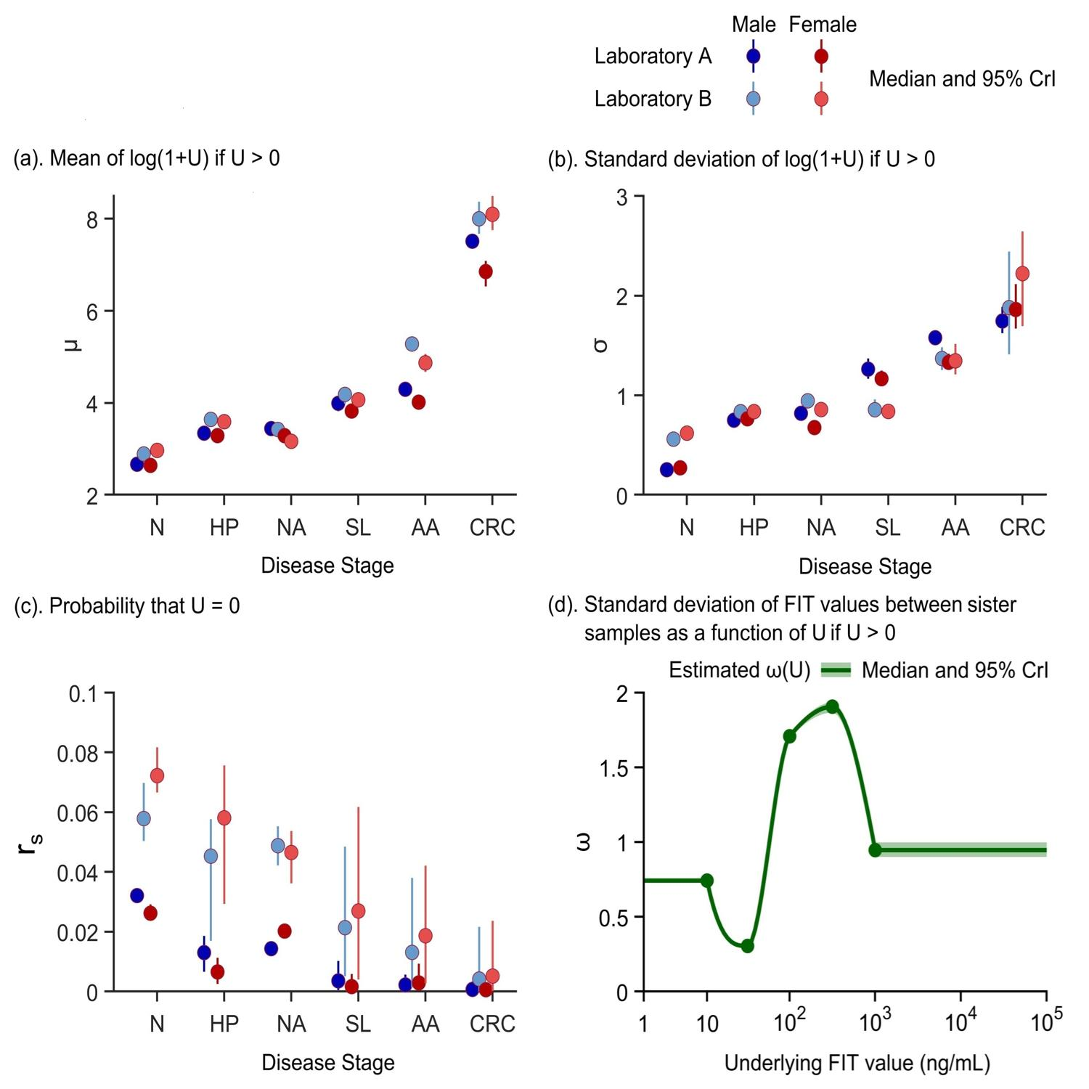
Figure S12. Posterior estimates of the two-sample FIT distribution in two laboratories (graphical representation). $U$represents the underlying FIT value. The green line and dots represent the estimate $ω(U)$ by the PCHIP function and corresponding predefined knots at $U$ =10, 31.62, 100, 316.23, 1000 ng/mL, which were equally separated in the natural logarithmic scale. Abbreviations: AA, advanced adenoma; CRC, colorectal cancer; CrI, credible interval; FIT, fecal immunochemical test; HP, hyperplastic polyps; N, normal; NA, non-advanced adenoma; PCHIP, piecewise cubic Hermite interpolating polynomial; SL, serrated lesions.

Estimated underlying FIT values and its variation
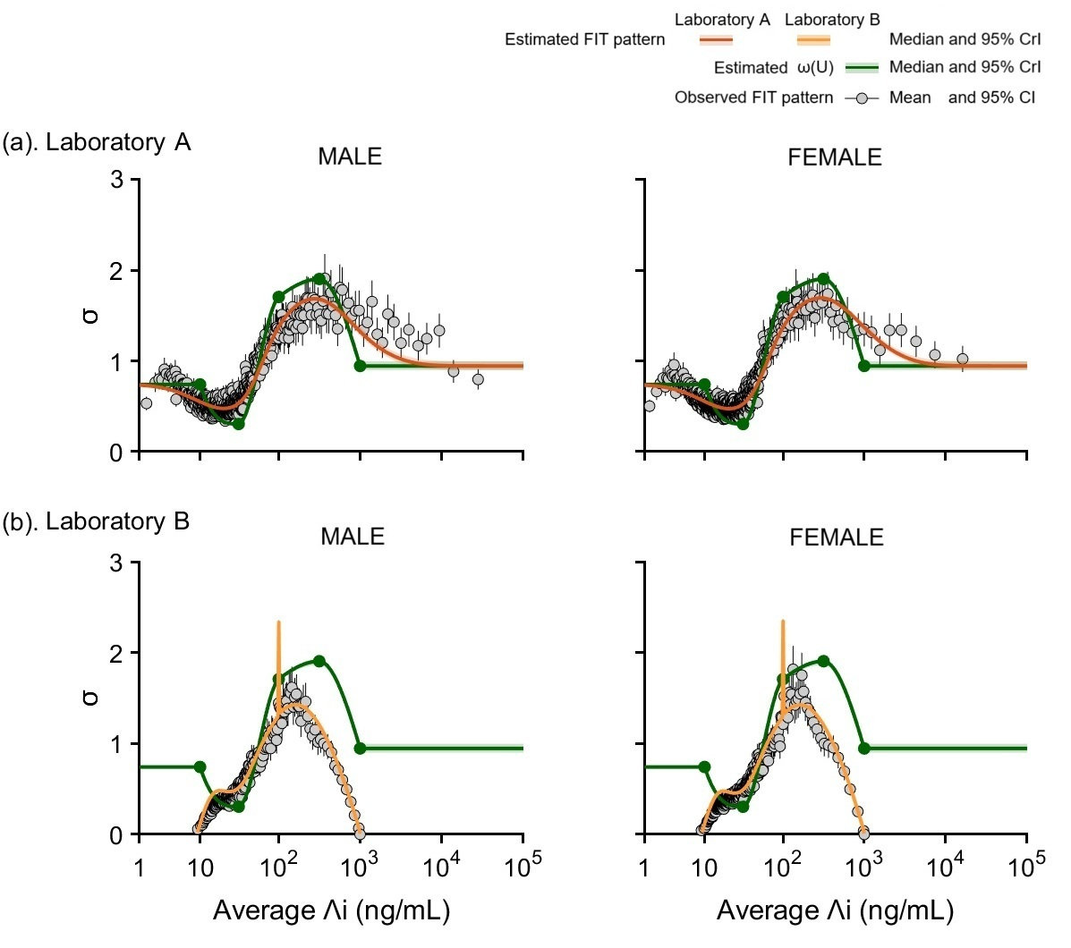
Figure S13. Estimated underlying FIT values and its variation based on the inferred parameters. The black dots show the relationship between the average geometric two-sample FIT mean $Λ_{i}$ and $ω(U_{i})$ from empirical data which as described in assumption 1 (Figure S6). The green line and dots represent the estimated $ω(U)$ by the PCHIP function and predefined knots at $U$ =10, 31.62, 100, 316.23, 1000 ng/mL, which were equally separated in the natural logarithmic scale. The analytical curves (orange line) were calculated by following probabilistic analysis: For any given specific stage, let $V_{j}$ be the FIT value in the jth sample, let $H=\frac{\ln{(1+V_{1}})+\ln{(1+V_{2}})}{2}$ (i.e., the geometric mean $\sqrt{V_{1}V_{2}}$ in the natural logarithmic scale) and the difference $∆=\ln\left(1+V_{1}\right)-ln\left(1+V_{2}\right) , where ∆\sim N(0,\sqrt{2}ω(U)).$In such, the variance of $∆$ given $H=h$ was $var(∆ \left| H=h\right)$=$4\left(E\left[{\left(ln⁡(1+V_{1})\right)}^{2}\left|H=h\right.\right]-{E\left[\ln\left(1+V_{1}\right)\left|H=h\right.\right]}^{2}\right)$. For each specific laboratory $l$, let left-censored was $V_{L,l}$ and right-censored was $V_{R,l},$according to the conditional expectation, $E\left[\ln\left(1+V_{1}\right)\left|H=h\right.\right]$ was calculated by $\int_{ln⁡(1+V_{L,l})}^{ln⁡(1+V_{R,l})}{\ln\left(1+u\right)P\left(\ln\left(1+V_{1}\right)=u|H=h\right)du}$, with P represented the probabilistic density function. Thus, the overall variance of $∆$ was calculated as a weighted average based on disease prevalence. The estimated relationship between the underlying FIT value $U$ and its variation $ω(U)$ showed a great fit with empirical data. Abbreviations: CI, confidence intervals; CrI, credible interval; FIT, fecal immunochemical test; PCHIP, piecewise cubic Hermite interpolating polynomial.

Age-specific prevalence of colorectal neoplasms
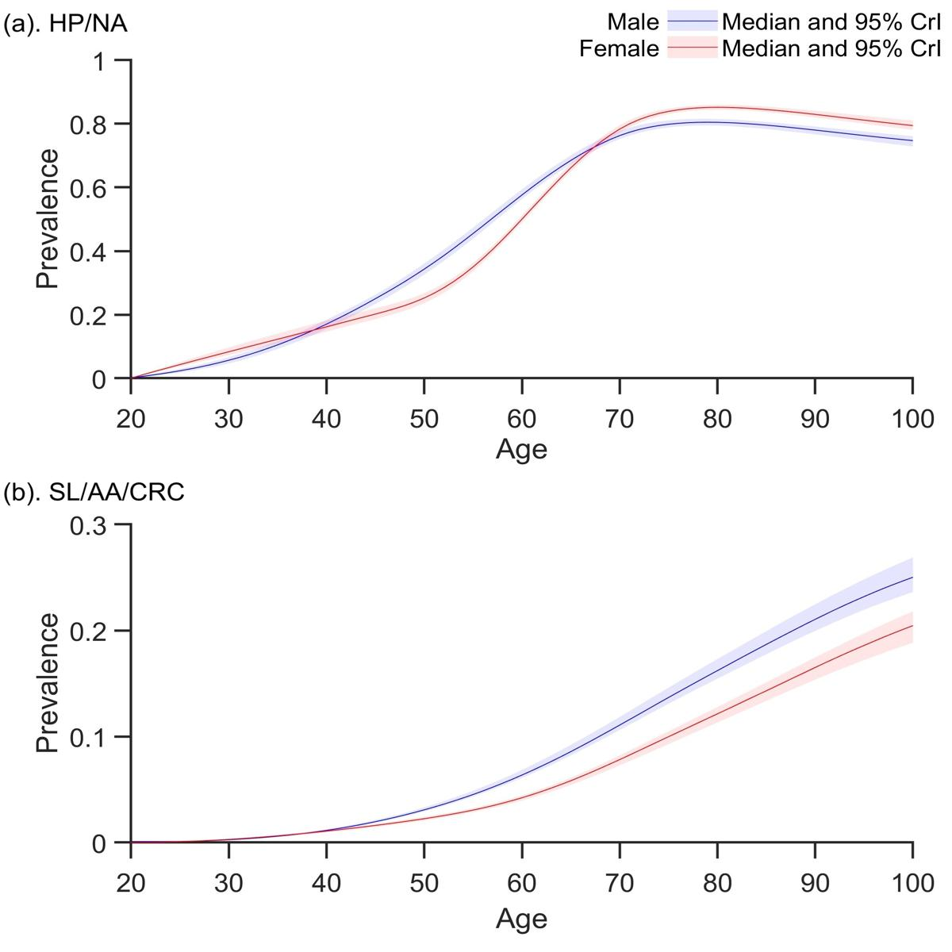
Figure S14. Estimated age-specific prevalence of colorectal neoplasms in the fitted natural history model. Abbreviations: AA, advanced adenoma; CRC, colorectal cancer; CrI, credible interval; HP, hyperplastic polyps; NA, non-advanced adenoma; SL, serrated lesions.

Age-specific proportions of CRC in colorectal neoplasms
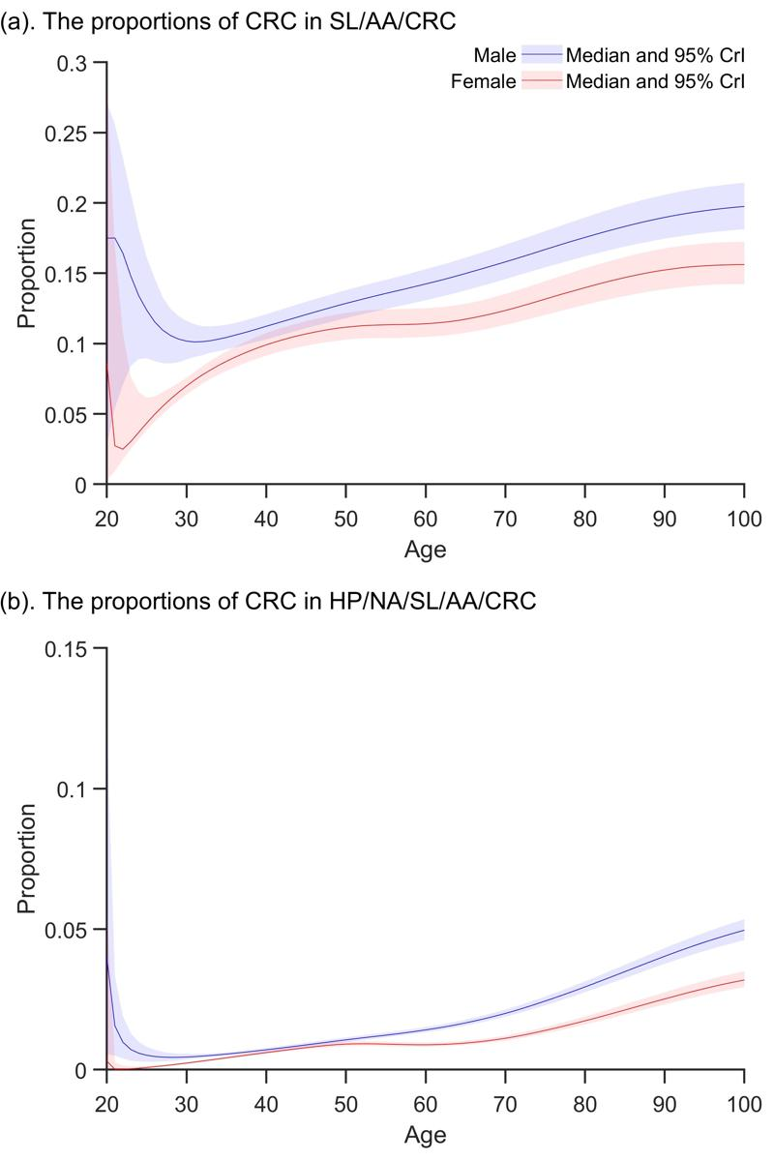
Figure S15. Estimated age-specific proportions of CRC in colorectal neoplasms in the fitted natural history model. Abbreviations: AA, advanced adenoma; CRC, colorectal cancer; CrI, credible interval; HP, hyperplastic polyps; NA, non-advanced adenoma; SL, serrated lesions.

Empirical PPV of two-sample FIT screening
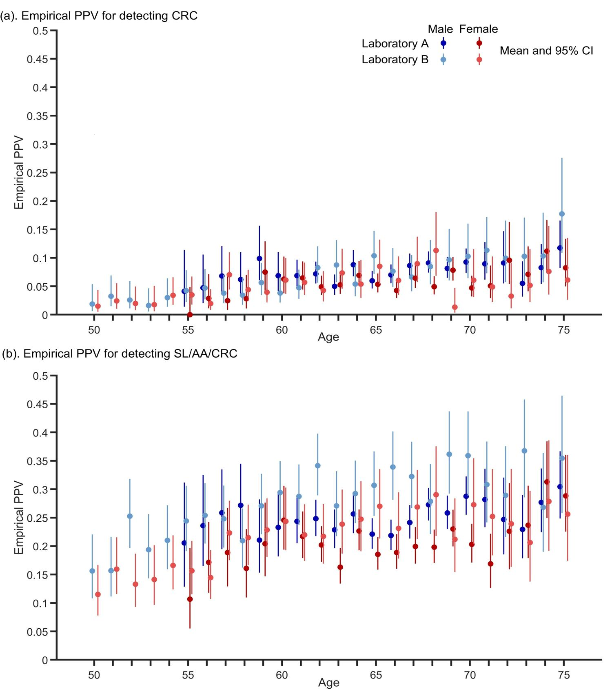
Figure S16. Empirical PPV of two-sample FIT screening for detecting CRC and advanced colorectal neoplasms (SL, AA, or CRC) across ages with a FIT-positivity threshold of 100 ng/mL. The test performance was based on the FIT-positivity threshold of 100 ng/mL. Given the age-dependent prevalence of health states, the empirical PPV of two-sample FIT was increased by age. Abbreviations: AA, advanced adenoma; CI, confidence interval; CRC, colorectal cancer; FIT, fecal immunochemical test; PPV, positive predictive value; SL, serrated lesions.

Estimated test performance of two-sample FIT screening
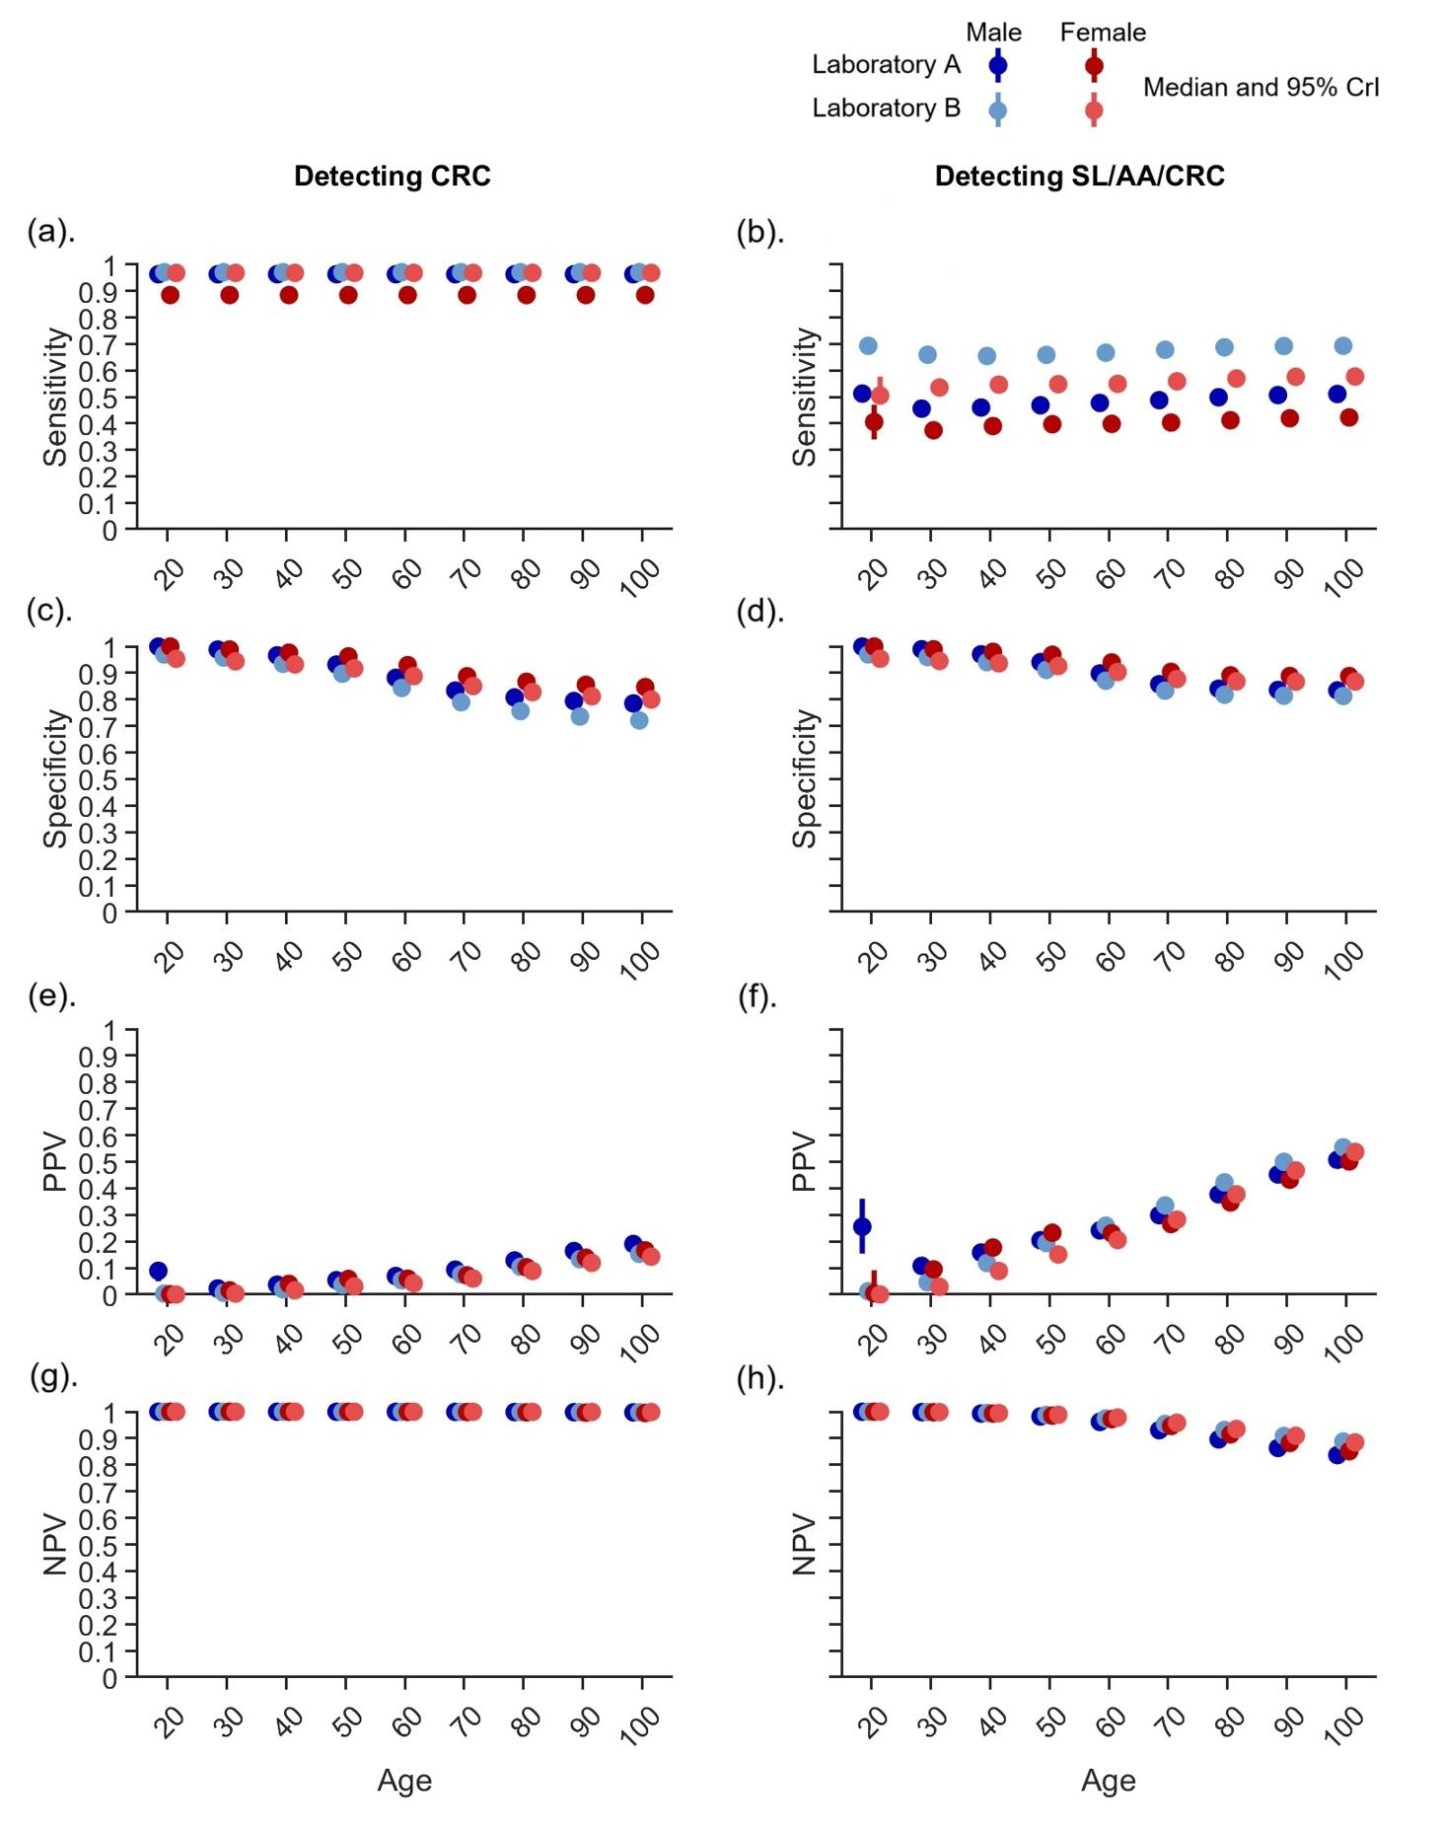
Figure S17. Estimated test performance of two-sample FIT screening for detecting CRC and advanced colorectal neoplasms (SL, AA, or CRC) across ages with a FIT-positivity threshold of 100 ng/mL. The test performance was based on the FIT-positivity threshold of 100 ng/mL. Given the age-dependent prevalence of health states, the test performance of FIT varied by age. Abbreviations: AA, advanced adenoma; CRC, colorectal cancer; CrI, credible interval; FIT, fecal immunochemical test; NPV, negative predictive value; PPV, positive predictive value; SL, serrated lesions.

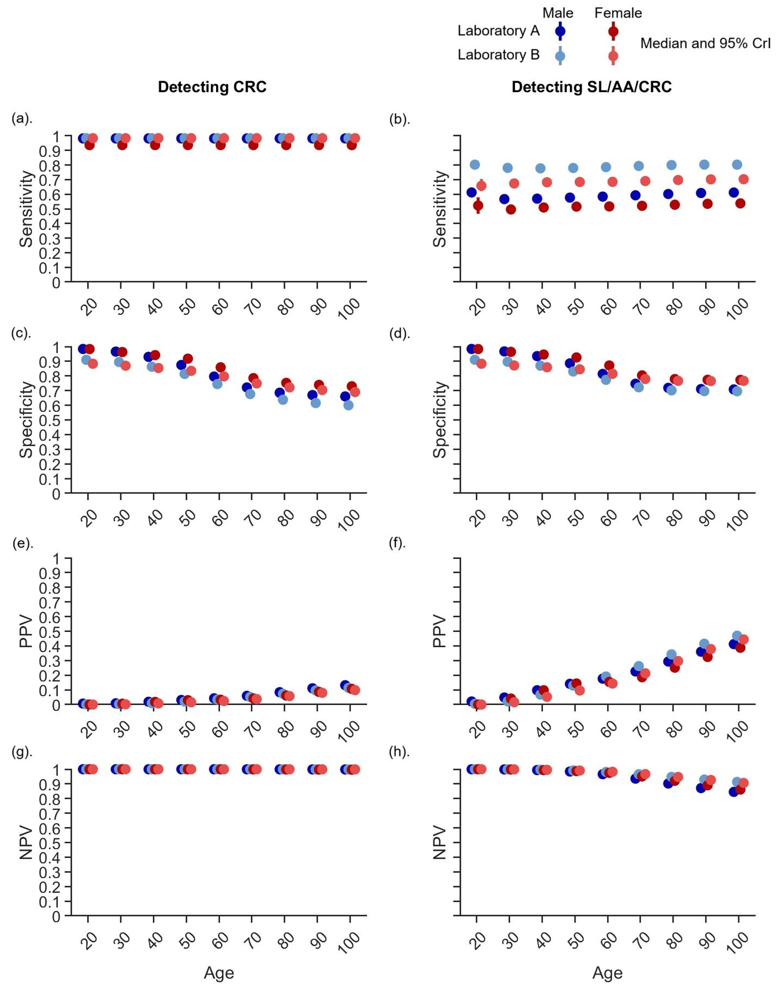
Figure S18. Estimated test performance of two-sample FIT screening for detecting CRC and advanced colorectal neoplasms (SL, AA, or CRC) across ages with a FIT-positivity threshold of 50 ng/mL. The test performance was based on the FIT-positivity threshold of 50 ng/mL. Given the age-dependent prevalence of health states, the test performance of FIT varied by age. Abbreviations: AA, advanced adenoma; CRC, colorectal cancer; CrI, credible interval; FIT, fecal immunochemical test; NPV, negative predictive value; PPV, positive predictive value; SL, serrated lesions.
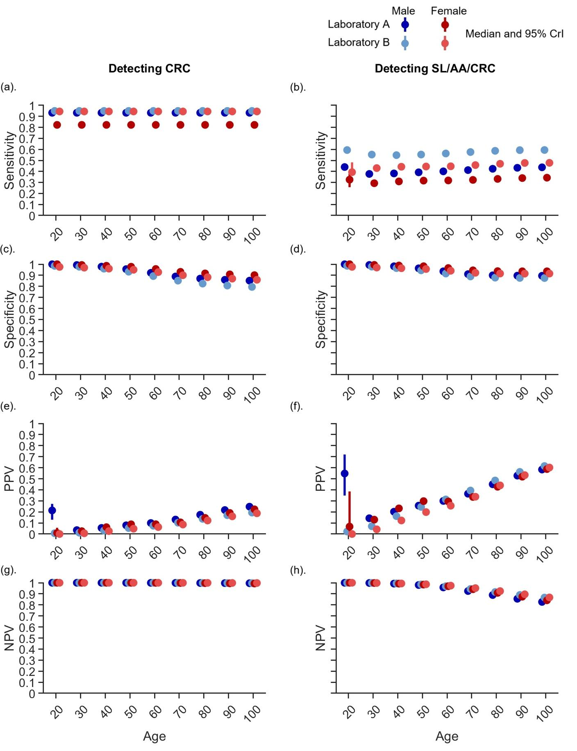
Figure S19. Estimated test performance of two-sample FIT screening for detecting CRC and advanced colorectal neoplasms (SL, AA, or CRC) across ages with a FIT-positivity threshold of 200 ng/mL. The test performance was based on the FIT-positivity threshold of 200 ng/mL. Given the age-dependent prevalence of health states, the test performance of FIT varied by age. Abbreviations: AA, advanced adenoma; CRC, colorectal cancer; CrI, credible interval; FIT, fecal immunochemical test; NPV, negative predictive value; PPV, positive predictive value; SL, serrated lesions.

Estimated absolute risk for FIT-negative
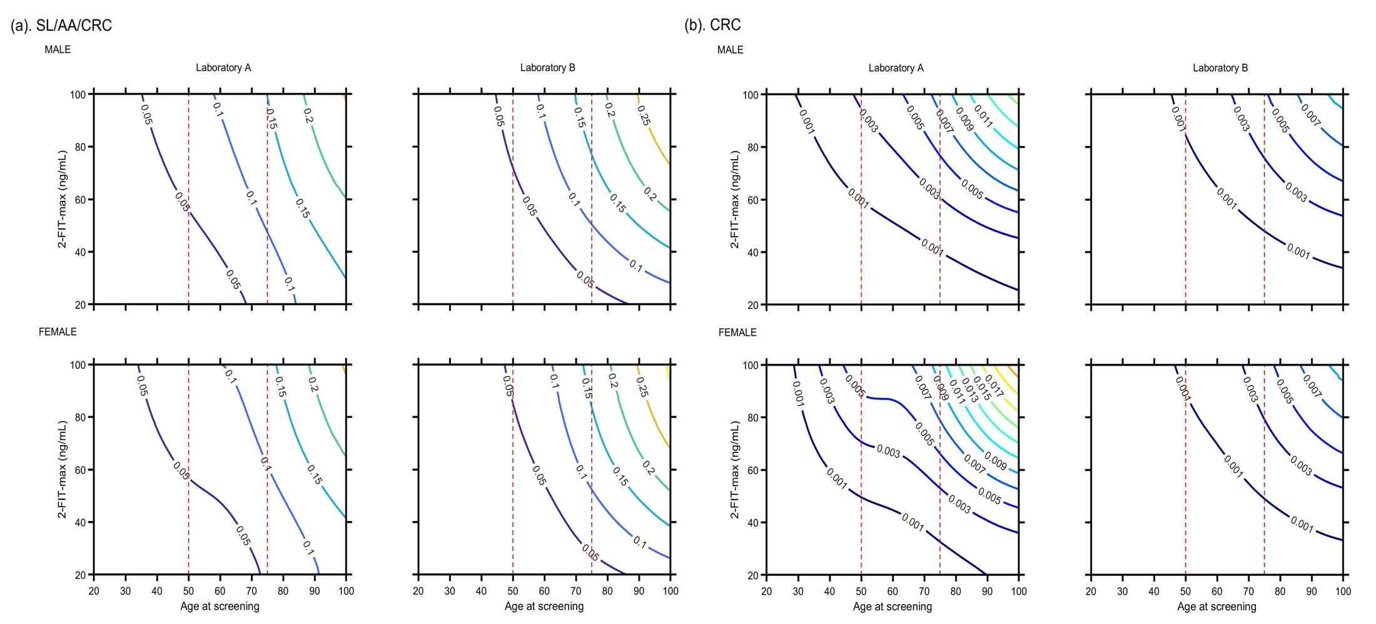Figure S20. Estimated FIT-negative absolute risk contour map under a 100 ng/mL threshold based on the inferred parameters. We calculated the probability of advanced colorectal neoplasms (SL, AA, or CRC) or CRC given the 2-FIT-max value and age: (a). shows the absolute risk of advanced colorectal neoplasms when the 2-FIT-max value was under 100 ng/mL. (b). shows the absolute risk of CRC when the 2-FIT-max was under 100 ng/mL. Although the values were below the threshold, there was still an increased risk in the population with a high FIT-negative result. For example, within the current screening age range (e.g., 50-75 years, between red dash lines), approximately 5-15% of the population was found to have an advanced colorectal neoplasm when the 2-FIT-max falls between 50 and 100 ng/mL. Abbreviations: AA, advanced adenoma; CRC, colorectal cancer; FIT, fecal immunochemical test; SL, serrated lesions; 2-FIT-max, maximum two-sample FIT value.

References
1 Hong Kong Colorectal Cancer Screening Program. <https://www.colonscreen.gov.hk/en/public/index.html> (
2 Hong Kong Census and Statistics Department. <https://www.censtatd.gov.hk/home/index.jsp> (
3 Szylberg, L., Janiczek, M., Popiel, A. & Marszalek, A. Serrated polyps and their alternative pathway to the colorectal cancer: a systematic review. Gastroenterol Res Pract 2015, 573814 (2015). https://doi.org/10.1155/2015/573814
4 East, J. E., Vieth, M. & Rex, D. K. Serrated lesions in colorectal cancer screening: detection, resection, pathology and surveillance. Gut 64, 991-1000 (2015). https://doi.org/10.1136/gutjnl-2014-309041
5 East, J. E. et al. British Society of Gastroenterology position statement on serrated polyps in the colon and rectum. Gut 66, 1181-1196 (2017). https://doi.org/10.1136/gutjnl-2017-314005
6 Amin, M. B. et al. AJCC cancer staging manual. Vol. 1024 (Springer, 2017).
7 Fritsch, F. N. & Carlson, R. E. Monotone Piecewise Cubic Interpolation. SIAM Journal on Numerical Analysis 1980 17 (2), 238-246
8 Hong Kong Cancer Registry. <https://www3.ha.org.hk/cancereg/hkcar.html> (
9 Ogino, S., Kawasaki, T., Kirkner, G. J., Ohnishi, M. & Fuchs, C. S. 18q loss of heterozygosity in microsatellite stable colorectal cancer is correlated with CpG island methylator phenotype-negative (CIMP-0) and inversely with CIMP-low and CIMP-high. BMC Cancer 7, 72 (2007). https://doi.org/10.1186/1471-2407-7-72
10 Ogino, S. et al. Molecular correlates with MGMT promoter methylation and silencing support CpG island methylator phenotype-low (CIMP-low) in colorectal cancer. Gut 56, 1564-1571 (2007). https://doi.org/10.1136/gut.2007.119750
11 Goel, A. et al. Characterization of sporadic colon cancer by patterns of genomic instability. Cancer Res 63, 1608-1614 (2003).
12 Bond, C. E. et al. Chromosomal instability in BRAF mutant, microsatellite stable colorectal cancers. PLoS One 7, e47483 (2012). https://doi.org/10.1371/journal.pone.0047483
13 Worthley, D. L. & Leggett, B. A. Colorectal cancer: molecular features and clinical opportunities. Clin Biochem Rev 31, 31-38 (2010).
14 Keum, N. & Giovannucci, E. Global burden of colorectal cancer: emerging trends, risk factors and prevention strategies. Nat Rev Gastroenterol Hepatol 16, 713-732 (2019). https://doi.org/10.1038/s41575-019-0189-8

