Supplementary material
Table S1. List of butterfly species recorded during the sampling period in the Kihansi gorge forest. Zero and one indicate absence and presence of species, respectively in the named habitat.
 |  |  | Habitat type
Scientific Name |  | Family | Woodland | Montane forest | Wooded grassland
Celaenorrhinus sanjeensis (Kielland, 1990) |  | Hesperiidae | 1 | 1 | 1
Eretis lugens (Rogenhofer, 1891) |  | Hesperiidae | 0 | 1 | 1
Leptotes pirithous (Linnaeus, 1767) |  | Lycaenidae | 0 | 1 | 1
Zizeeria knysna (Trimen, 1862) |  | Lycaenidae | 1 | 0 | 1
Anthene lunulata (Trimen, 1894) |  | Lycaenidae | 0 | 1 | 1
Euchrysops osiris (Hopffer, 1855) |  | Lycaenidae | 0 | 0 | 1
Acraea anemosa (Hewitson, 1865) |  | Nymphalidae | 0 | 0 | 1
Acraea cabira (Hopffer, 1855) |  | Nymphalidae | 1 | 0 | 1
Acraea insignis (Distant, 1880) |  | Nymphalidae | 0 | 1 | 1
Acraea spp |  | Nymphalidae | 1 | 0 | 0
Amauris niavius (Linnaeus, 1758) |  | Nymphalidae | 1 | 1 | 0
Bebearia orientis (Karsch, 1895) |  | Nymphalidae | 0 | 1 | 0
Bicyclus ena (Hewitson, 1877) |  | Nymphalidae | 1 | 1 | 1
Bicyclus spp |  | Nymphalidae | 1 | 0 | 1
Catuna sikorana (Rogenhofer, 1889) |  | Nymphalidae | 0 | 1 | 0
Charaxes acuminatus (Thurau, 1903) |  | Nymphalidae | 1 | 0 | 0
Charaxes brutus (Cramer, 1779) |  | Nymphalidae | 1 | 1 | 0
Charaxes candiope (Godart, 1824) |  | Nymphalidae | 1 | 1 | 0
Charaxes castor (Cramer, 1775) |  | Nymphalidae | 1 | 0 | 0
Charaxes cithaeron (C. & R. Felder, 1859) |  | Nymphalidae | 1 | 1 | 1
Charaxes congdoni (Collins, 1989) |  | Nymphalidae | 1 | 0 | 0
Charaxes druceanus (Butler, 1869) |  | Nymphalidae | 1 | 0 | 0
Charaxes lucyae (van Someren, 1975) |  | Nymphalidae | 1 | 0 | 0
Charaxes macclounii (Butler, 1895) |  | Nymphalidae | 0 | 1 | 0
Charaxes pollux geminus (Rothschild, 1900) |  | Nymphalidae | 1 | 0 | 0
Charaxes protoclea azota (Hewitson, 1877) |  | Nymphalidae | 1 | 1 | 0
Charaxes sp |  | Nymphalidae | 0 | 1 | 0
Charaxes varanes (Cramer, 1764) |  | Nymphalidae | 1 | 1 | 1
Charaxes zoolina (Westwood,1850) |  | Nymphalidae | 1 | 0 | 0
Danaus chrysippus (Linnaeus, 1758) |  | Nymphalidae | 0 | 1 | 1
Euphaedra neophron (Hopffer, 1855) |  | Nymphalidae | 1 | 1 | 1
Euphaedra zaddachii (Dewitz, 1879) |  | Nymphalidae | 0 | 1 | 1
Euptera kinugnana |  | Nymphalidae | 0 | 0 | 1
Euptera spp |  | Nymphalidae | 0 | 0 | 1
Eurytela dryope (Cramer, 1775) |  | Nymphalidae | 1 | 1 | 1
Eurytela hiarbas (Drury, 1770) |  | Nymphalidae | 0 | 1 | 0
Euxanthe tiberius (Grose-Smith, 1889) |  | Nymphalidae | 0 | 1 | 0
Gnophodes betsimena (Boisduval, 1833) |  | Nymphalidae | 1 | 1 | 1
Gnophodes spp |  | Nymphalidae | 0 | 0 | 1
Heteropsis perspicua (Trimen, 1873) |  | Nymphalidae | 1 | 0 | 1
Hypolimnas misippus (Linnaeus, 1764) |  | Nymphalidae | 0 | 0 | 1
Junonia orithya (Linnaeus, 1758) |  | Nymphalidae | 0 | 0 | 1
Junonia natalica (C. & R. Felder) |  | Nymphalidae | 0 | 0 | 1
Junonia terea (Druce, 1773) |  | Nymphalidae | 1 | 1 | 1
Melanitis leda (Linnaeus, 1758) |  | Nymphalidae | 1 | 1 | 1
Melanitis libya (Distant, 1882) |  | Nymphalidae | 1 | 1 | 1
Neptis laeta (Overlaet, 1955) |  | Nymphalidae | 1 | 1 | 1
Phalanta phalanta (Drury, 1773) |  | Nymphalidae | 0 | 1 | 1
Physcaeneura jacksoni (Carcasson, 1961) |  | Nymphalidae | 1 | 1 | 1
Protogoniomorpha anacardii (Linnaeus, 1758) |  | Nymphalidae | 0 | 1 | 0
Protogoniomorpha parhassus (Drury, 1782) |  | Nymphalidae | 0 | 1 | 0
Pseudacraea boisduvali (Doubleday, 1845) |  | Nymphalidae | 0 | 0 | 1
Pseudacraea spp |  | Nymphalidae | 0 | 1 | 0
Graphium angolanus (Goeze, 1779) |  | Papilionidae | 1 | 1 | 1
Graphium colonna (Ward, 1873) |  | Papilionidae | 0 | 1 | 0
Graphium policenes (Cramer, 1775) |  | Papilionidae | 0 | 1 | 0
Graphium spp |  | Papilionidae | 0 | 1 | 1
Papilio ophidicephalus(Oberthur) |  | Papilionidae | 0 | 1 | 0
Papilio dardanus (Brown, 1776) |  | Papilionidae | 1 | 1 | 1
Papilio echerioides (Trimen, 1868) |  | Papilionidae | 1 | 1 | 0
Papilio demodocus(Esper, ) |  | Papilionidae | 0 | 1 | 0
Papilio nireus lyaeus (Doubleday, 1845) |  | Papilionidae | 0 | 1 | 0
Papilio spp |  | Papilionidae | 1 | 1 | 1
Catopsilia florella (Fabricius, 1775) |  | Pieridae | 1 | 0 | 0
Colotis spp |  | Pieridae | 0 | 1 | 0
Eurema brigitta (Cramer, 1780) |  | Pieridae | 1 | 1 | 1
Eurema desjardinsii (Boisduval, 1833) |  | Pieridae | 1 | 1 | 1
Eurema hapale (Mabille, 1882) |  | Pieridae | 0 | 1 | 1
Leptosia alcesta (Stoll, 1782) |  | Pieridae | 0 | 1 | 1
Leptosia alcesta inalcesta (Bernardi, 1959) |  | Pieridae | 0 | 1 | 0
Mylothris agathina (Cramer, 1779) |  | Pieridae | 0 | 1 | 0
Belenois thysa (Hopffer, 1855) |  | Pieridae | 0 | 1 | 0

Supplementary Figures

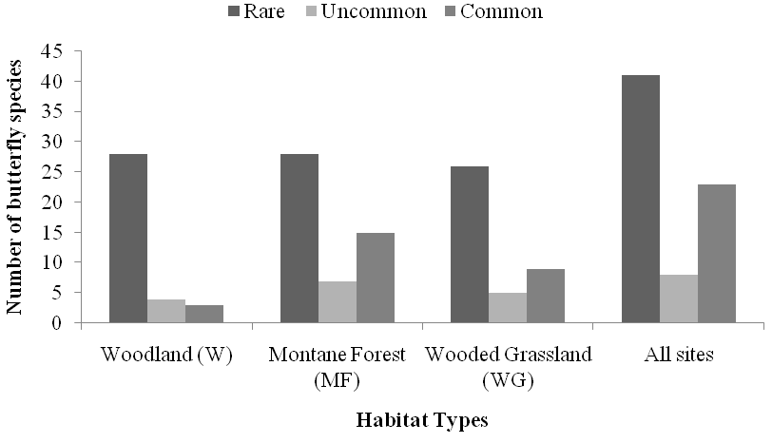
Fig S1. Rarity status of butterfly species recorded in different habitats in the Kihansi gorge ecosystem

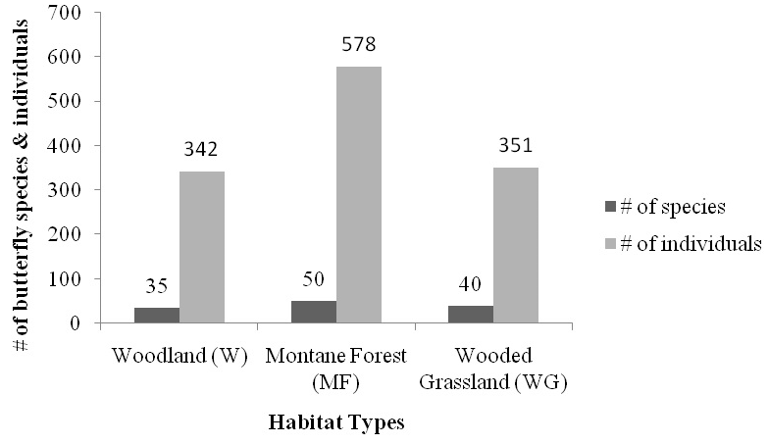
Fig S2. Number of butterfly species and individuals recorded during the sampling period across different habitat types in Kihansi gorge forest

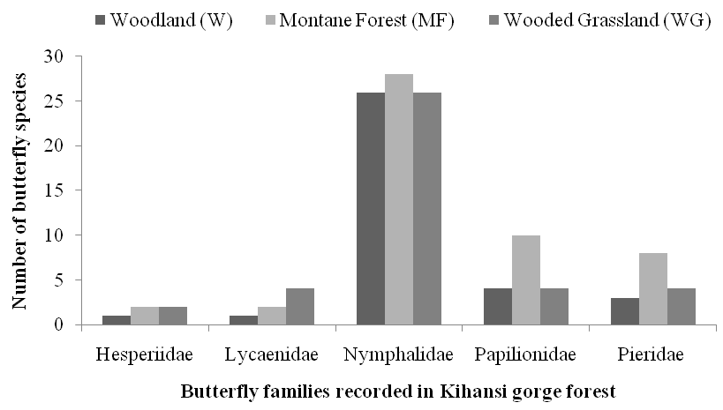
Fig S3. Number of butterfly species recorded in various families across three habitat types.

