Supplementary Material: Page et al Insights from multispecies coral seeding deployments on turbid nearshore reefs
Table S1. Spawning and mass settlement details for the three Acroporidae species, Acropora millepora, Acropora muricata and Montipora aequituberculata, used to seed aragonite plugs and concrete tabs. DAFM=days after full moon.
Species | Spawning date (DAFM) and time | No. colonies contributing to culture | Settlement date/s  (larval age) | Settlement stocking densities
Acropora millepora | 27/11/2021 (8 DAFM)  7:37pm | 6 | 6/12/2021-7/12/2021  (9-10 days) | 6/12/2021: 4000 larvae per tank  7/12/2021: + 4000 larvae per tank
Acropora muricata | 29/11/2021 (10 DAFM)  9:20-9:39pm | 6 | 6/12/2021-9/12/2021  (7-10 days) | 6/12/2021: 4000 larvae per tank  7/12/2021: + 4000 larvae per tank  9/12/2021: + 4000 larvae per tank (concrete tiles only)
Montipora aequituberculata | 26/11/2021 (7 DAFM) + 27/11/2021 (8 DAFM)  7:40 – 8:20pm | 5 | 2/12/2021  (5-6 days) | 2/12/2021: 1700 larvae per tank  4/12/2021: + 1700 larvae per tank

Table S2. Device deployment sites, latitude and longitude, date of device deployment and collection.
Site name | Latitude | Longitude | Date of deployment | Date of collection
Clam Bay, Great Keppel Island | 23°11'11.20"S | 150°58'26.69"E | 8/01/2022 | 13/02/2023
Halfway Island | 23°12'7.10"S | 150°58'16.27"E | 9/01/2022 | 12/02/2023
Home Reef, North Keppel Island | 23° 4'58.06"S | 150°53'4.70"E | 10/01/2022 | 15/02/2023
Humpy Island | 23°12'40.66"S | 150°57'58.23"E | 8/01/2022 | 13/02/2023
Mazie Bay, North Keppel Island | 23° 5'7.99"S | 150°54'11.43"E | 9/01/2022 | 15/02/2023
Shelving Bay, Great Keppel Island | 23°11'20.46"S | 150°56'1.68"E | 10/01/2022 | 14/02/2023

Table S3: Codes and descriptions for benthic cover categories used for photoquadrat ReefCloud scoring.
Code | Description
ACBX | Branching Acropora spp.
CCA | Crustose coralline algae
Colpomenia | Colpomenia macroalgae
Fungiidae | Fungiidae spp.
Lobophora | Lobophora spp. macroalgae
Montipora | Montipora spp.
Pocillopora | Pocillopora spp.
Porites | Porites spp.
RedAlgae | Red algae spp.
Sargassum | Sargassum spp. macroalgae
Sediment | Sand/silt etc
TurfAlgae | Turfing algae

Table S4: Generalized linear mixed model summary statistics for fixed triangle devices predicting the probability of: 1) pre-deployment spat counts based on deployment orientation (side- or down-facing) and species (Acropora muricata, Acropora millepora or Montipora aequituberculata): 2) a surviving spat on each plug ~13 months after deployment, based on deployment orientation and species, 3) a surviving A. muricata spat on each plug based on deployment orientation, pre-deployment spat counts (PreDeploymentNo) and site (Clam, Humpy, Home, Halfway, Mazie); 4) a surviving A. millepora spat on each plug based on deployment orientation, pre-deployment spat counts and site (Clam, Humpy, Home, Halfway, Mazie, Shelving); 5) a surviving M. aequituberculata spat on each plug based on deployment orientation, pre-deployment spat counts and site (Clam, Humpy, Home, Halfway, Mazie, Shelving); 6) Yield based on site; 7) Maximum linear length (mm) of spat based on species and deployment orientation. p values in bold indicate statistical significance at p < 0.05.
Model | Effect | Estimate | SE | Z value | p value
- PreDeploymentNo ~ Orientation + Species +  (1 | Site/DevNo) | Intercept | 2.999 | 0.053 | 56.986 | 0.000
 | OrientationUpward | -0.024 | 0.028 | -0.857 | 0.391
 | SpeciesAmuricata | -0.259 | 0.030 | -8.748 | <0.001
 | SpeciesMaequituberculata | -1.741 | 0.051 | -33.862 | <0.001
- Survival ~ Orientation + Species + (1 | Site/DevNo) | Intercept | -0.416 | 0.227 | -1.830 | 0.067
 | OrientationUpward | -0.814 | 0.195 | -4.169 | <0.001
 | SpeciesAmuricata | -1.607 | 0.289 | -5.564 | <0.001
 | SpeciesMaequituberculata | 0.611 | 0.210 | 2.907 | 0.004
- A. muricata: Survival ~ Orientation + Site  + PreDeploymentNo | Intercept | -2.772 | 0.896 | -3.092 | 0.002
 | OrientationUpward | 0.083 | 0.504 | 0.165 | 0.869
 | SiteHalfway | -0.692 | 0.731 | -0.947 | 0.344
 | SiteHome | -1.088 | 0.890 | -1.223 | 0.221
 | SiteHumpy | 0.737 | 0.720 | 1.024 | 0.306
 | SiteMazie | -1.634 | 1.138 | -1.436 | 0.151
 | SiteShelving | -23.098 | 50596.687 | 0.000 | 1.000
 | PreDeploymentNo | 0.056 | 0.034 | 1.637 | 0.102
- A.millepora: Survival ~ Orientation + Site  + PreDeploymentNo | Intercept | -0.001 | 0.767 | -0.001 | 0.999
 | OrientationUpward | -0.941 | 0.323 | -2.916 | 0.004
 | SiteHalfway | 1.092 | 0.535 | 2.040 | 0.041
 | SiteHome | -0.990 | 0.644 | -1.538 | 0.124
 | SiteHumpy | -0.211 | 0.592 | -0.356 | 0.722
 | SiteMazie | 0.891 | 0.554 | 1.608 | 0.108
 | SiteShelving | 0.104 | 0.573 | 0.182 | 0.856
 | PreDeploymentNo | -0.029 | 0.030 | -0.945 | 0.345
- M. aequituberculata: Survival ~ Orientation  + Site  + PreDeploymentNo | Intercept | -0.561 | 0.468 | -1.200 | 0.230
 | OrientationUpward | -1.148 | 0.308 | -3.732 | <0.001
 | SiteHalfway | 0.153 | 0.532 | 0.288 | 0.773
 | SiteHome | -0.447 | 0.551 | -0.812 | 0.417
 | SiteHumpy | 0.888 | 0.564 | 1.575 | 0.115
 | SiteMazie | 0.858 | 0.557 | 1.541 | 0.123
 | SiteShelving | 0.375 | 0.548 | 0.685 | 0.494
 | PreDeploymentNo | 0.203 | 0.069 | 2.950 | 0.003
- Yield ~ Site | Intercept | 1.872 | 0.760 | 2.464 | 0.014
 | SiteHalfway | -0.137 | 0.984 | -0.139 | 0.889
 | SiteHome | -1.253 | 0.893 | -1.404 | 0.160
 | SiteHumpy | -0.331 | 0.991 | -0.334 | 0.738
 | SiteMazie | 0.143 | 1.069 | 0.134 | 0.894
 | SiteShelving | -0.996 | 0.928 | -1.074 | 0.283
- Maximum linear length ~ Species + Orientation  + (1 |Site/DevNo) | Intercept | 16.330 | 1.424 | 11.468 | 0.000
 | SpeciesAmuricata | -5.954 | 1.709 | -3.484 | <0.001
 | SpeciesMaequituberculata | -1.514 | 1.038 | -1.459 | 0.145
 | OrientationUpward | -1.384 | 1.005 | -1.377 | 0.168

Table S5: Generalized linear mixed model summary statistics for tethered star devices predicting the probability of: 1) pre-deployment spat counts based on species (Acropora muricata, Acropora millepora or Montipora aequituberculata): 2) a surviving spat on each tab ~13 months after deployment, based on species, 3) a surviving A. muricata spat on each tab based on pre-deployment spat counts (PreDeploymentNo) and site (Clam, Humpy, Home, Halfway, Mazie, Shelving); 4) a surviving A. millepora spat on each tab based on pre-deployment spat counts and site (Clam, Humpy, Home, Halfway, Mazie, Shelving); 5) a surviving M. aequituberculata spat on each tab based on pre-deployment spat counts and site (Clam, Humpy, Home, Halfway, Mazie, Shelving); 6) Yield based on site; 7) Maximum linear length (mm) of spat based on species. p values in bold indicate statistical significance at p < 0.05. * denotes a significant site effect from the model, though post hoc Tukey tests showed no significant pairwise differences.
Model | Effect | Estimate | SE | Z value | p value
1.PreDeploymentNo ~ Species + (1 |Site/DevNo) | Intercept | 2.228 | 0.056 | 39.826 | <0.001
 | SpeciesAmuricata | -0.452 | 0.049 | -9.160 | <0.001
 | SpeciesMaequituberculata | -1.539 | 0.073 | -21.003 | <0.001
2.Survival ~ Species + (1 |Site/DevNo) | Intercept | -2.757 | 0.418 | -6.596 | 0.000
 | SpeciesAmuricata | -0.346 | 0.602 | -0.574 | 0.566
 | SpeciesMaequituberculata | 2.148 | 0.441 | 4.874 | <0.001
3.M. aequituberculata: Survival ~ Site  + PreDeploymentNo | Intercept | -1.377 | 0.639 | -2.156 | 0.031
 | PreDeploymentNo | 0.031 | 0.167 | 0.184 | 0.854
 | SiteHalfway | 0.775 | 0.738 | 1.050 | 0.294
 | SiteHome | 0.000 | 0.796 | 0.000 | 1.000
 | SiteHumpy | 0.994 | 0.732 | 1.358 | 0.174
 | SiteMazie | 1.319 | 0.719 | 1.834 | 0.067
 | SiteShelving | 0.787 | 0.774 | 1.017 | 0.309
4.A. millepora:  Survival ~ Site  + PreDeploymentNo | Intercept | -2.083 | 1.533 | -1.358 | 0.174
 | PreDeploymentNo | -0.093 | 0.130 | -0.721 | 0.471
 | SiteHalfway | 0.912 | 1.282 | 0.711 | 0.477
 | SiteHumpy | -0.123 | 1.471 | -0.084 | 0.933
 | SiteMazie | 0.812 | 1.276 | 0.637 | 0.524
 | SiteShelving | 0.125 | 1.465 | 0.086 | 0.932
5.A. muricata:  Survival ~Site  + PreDeploymentNo | Intercept | -5.620 | 1.850 | -3.038 | 0.002
 | PreDeploymentNo | 0.377 | 0.176 | 2.144 | 0.032
 | SiteHalfway | -23.185 | 63492.296 | 0.000 | 1.000
 | SiteHome | 0.567 | 1.554 | 0.365 | 0.715
 | SiteHumpy | -21.893 | 63720.758 | 0.000 | 1.000
 | SiteMazie | 1.369 | 1.299 | 1.054 | 0.292
 | SiteShelving | -22.275 | 71621.563 | 0.000 | 1.000
6.Yield ~ Site | Intercept | -0.847 | 0.488 | -1.736 | 0.082
 | SiteHalfway | 0.308 | 0.681 | 0.452 | 0.651
 | SiteHome | -0.251 | 0.710 | -0.354 | 0.724
 | SiteHumpy | 0.742 | 0.670 | 1.107 | 0.268
 | SiteMazie | 1.466 | 0.677 | 2.167 | 0.030*
 | SiteShelving | 0.336 | 0.710 | 0.474 | 0.636
7.MaxLinearLength ~ Species + (1 | Site/DevNo) | Intercept | 7.6651 | 1.3051 | 5.873 | 4.28E-09
 | SpeciesAmuricata | -3.0375 | 1.98 | -1.534 | 0.125
 | SpeciesMaequituberculata | 0.2805 | 1.2808 | 0.219 | 0.827

Table S6: Generalized linear model summary statistics for tethered star devices predicting the site level average probability of a surviving spat on a device after a ~13 month deployment, based the the biomass of algae, cover of benthic categories, sedimentation measured via sediment traps turf pods and sed pods, and water tempertature and flow metrics. p values in bold indicate statistical significance at p < 0.05.
Species | Effect | Estimate | SE | Z value | p value
M. aequituberculata | Intercept | 0.439 | 0.045 | 9.656 | 0.000
 | Sargassum biomass | -0.002 | 0.001 | -2.783 | 0.020
 | Month October | -0.031 | 0.051 | -0.612 | 0.555
 | Intercept | 0.392 | 0.040 | 9.830 | 0.000
 | Peyssonnelia biomass | -0.097 | 0.041 | -2.393 | 0.040
 | Month October | 0.006 | 0.053 | 0.107 | 0.910
 | Intercept | 0.391 | 0.038 | 10.303 | 0.000
 | Red Algae biomass | -0.023 | 0.009 | -2.638 | 0.030
 | Month October | 0.001 | 0.051 | 0.010 | 0.990
 | Intercept | -3.690 | 1.090 | -3.385 | 0.007
 | Maximum daily water temperature | 0.149 | 0.040 | 3.714 | 0.004
 | Intercept | 0.189 | 0.050 | 3.800 | 0.010
 | Turf algae cover | 0.011 | 0.003 | 3.833 | 0.020
A. millepora | Intercept | 0.093 | 0.014 | 6.662 | 0.000
 | Sargassum biomass | -0.001 | 0.000 | -3.475 | 0.007
 | Month October | -0.012 | 0.016 | -0.765 | 0.464
 | Intercept | 0.090 | 0.013 | 6.673 | 0.003
 | Sargassum cover | -0.001 | 0.000 | -2.972 | 0.041
 | Intercept | 0.117 | 0.015 | 8.032 | 0.000
 | Trap total sedimentation | -0.069 | 0.016 | -4.236 | 0.002
 | Intercept | 0.104 | 0.018 | 5.665 | 0.000
 | SedPod Total sedimentation | -0.391 | 0.152 | -2.562 | 0.030
 | Intercept | 0.107 | 0.014 | 7.925 | 0.000
 | TurfPod Total sedimentation | -0.092 | 0.024 | -3.885 | 0.003
 | Intercept | 0.109 | 0.013 | 8.084 | 0.000
 | Trap Inorganic sedimentation | -0.077 | 0.019 | -4.014 | 0.003
 | Intercept | 0.098 | 0.015 | 6.485 | 0.000
 | SedPod Inorganic sedimentation | -0.469 | 0.167 | -2.814 | 0.020
 | Intercept | 0.097 | 0.011 | 8.896 | 0.000
 | TurfPod Inorganic sedimentation | -0.110 | 0.027 | -4.087 | 0.002
 | Intercept | 0.172 | 0.021 | 8.041 | 0.000
 | Trap Organic sedimentation | -0.535 | 0.101 | -5.319 | 0.000
 | Intercept | 0.147 | 0.032 | 4.539 | 0.001
 | TurfPod Organic sedimentation | -0.493 | 0.182 | -2.705 | 0.020
 | Intercept | 0.154 | 0.031 | 4.898 | 0.001
 | Mean daily water speed | -1.454 | 0.482 | -3.015 | 0.010
 | Intercept | 0.136 | 0.028 | 4.826 | 0.001
 | Median daily water speed | -1.238 | 0.452 | -2.739 | 0.020
A. muricata | Intercept | 0.114 | 0.023 | 4.945 | 0.001
 | Maximum daily water speed | -0.105 | 0.029 | -3.572 | 0.010

Table S7: Generalized linear model summary statistics for tethered star devices predicting the site level average probability of a surviving spat on a device after a ~13 month deployment, based the the biomass of algae, cover of benthic categories, sedimentation, and water tempertature and flow metrics. p values in bold indicate statistical significance at p < 0.05.
Species | Effect | Estimate | SE | Z value | p value
M. aequituberculata | Intercept | 12.525 | 0.455 | -27.515 | 0.000
 | Padina biomass | 0.165 | 0.046 | -3.566 | 0.024
 | Intercept | 14.565 | 0.996 | 14.630 | 0.000
 | Trap total sedimentation | -3.431 | 1.103 | -3.110 | 0.036
 | Intercept | 14.228 | 0.778 | 18.286 | 0.000
 | Turf total sedimentation | -4.933 | 1.356 | -3.639 | 0.022
 | Intercept | 14.153 | 0.900 | 15.723 | 0.000
 | Trap inorganic sedimentation | -3.917 | 1.291 | -3.034 | 0.039
 | Intercept | 16.885 | 1.726 | 9.783 | 0.001
 | Trap organic sedimentation | -24.791 | 8.119 | -3.053 | 0.038
 | Intercept | 14.565 | 0.996 | 14.630 | 0.000
 | Trap total sedimentation | -3.431 | 1.103 | -3.110 | 0.036
 | Intercept | 13.710 | 0.584 | 23.497 | 0.000
 | Turf inorganic sedimentation | -5.951 | 1.430 | -4.161 | 0.014
A. millepora | Intercept | 6.410 | 1.460 | 4.389 | 0.012
 | Lobophora cover | 0.252 | 0.043 | 5.822 | 0.004
 | Intercept | 18.998 | 1.332 | 14.262 | 0.000
 | Sediment cover | -26.346 | 5.855 | -4.499 | 0.011
 | Intercept | 17.052 | 1.500 | 11.369 | 0.000
 | Sargassum cover | -0.092 | 0.032 | -2.854 | 0.046

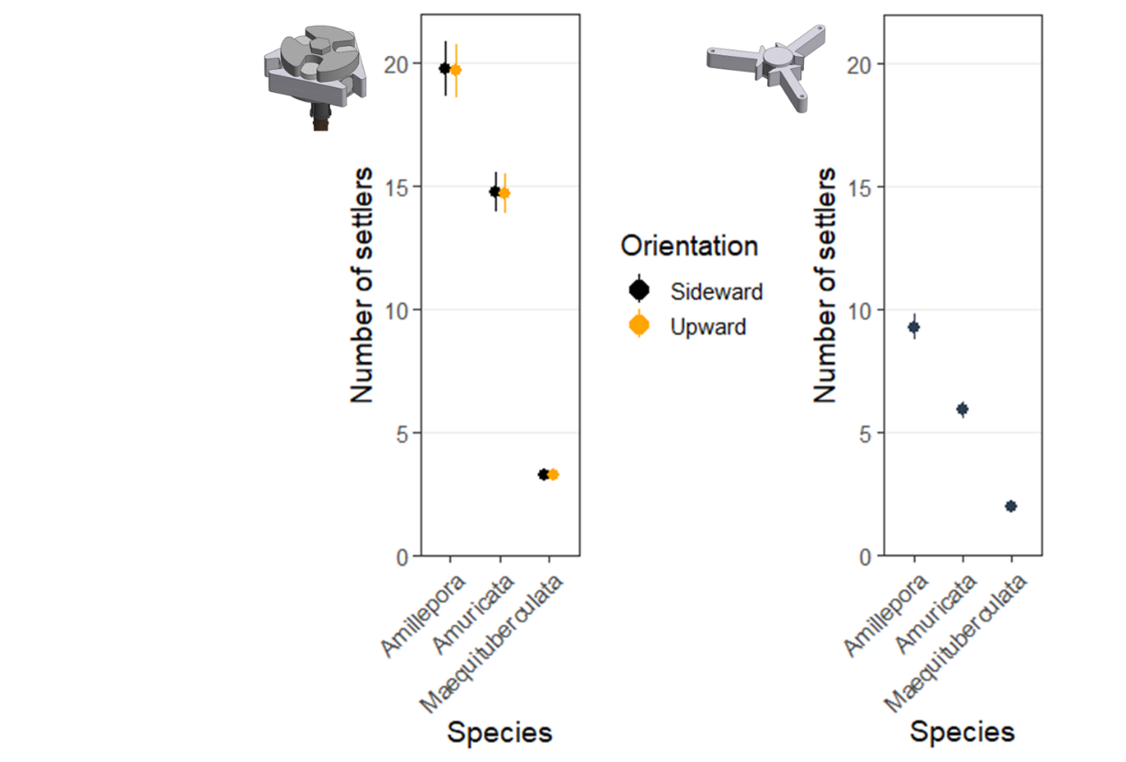
Figure S1. Number of settlers per plug or tab per coral species (Acropora millepora, Acropora muricata and M. aequituberculata) for triangle fixed devices, and star tethered devices.

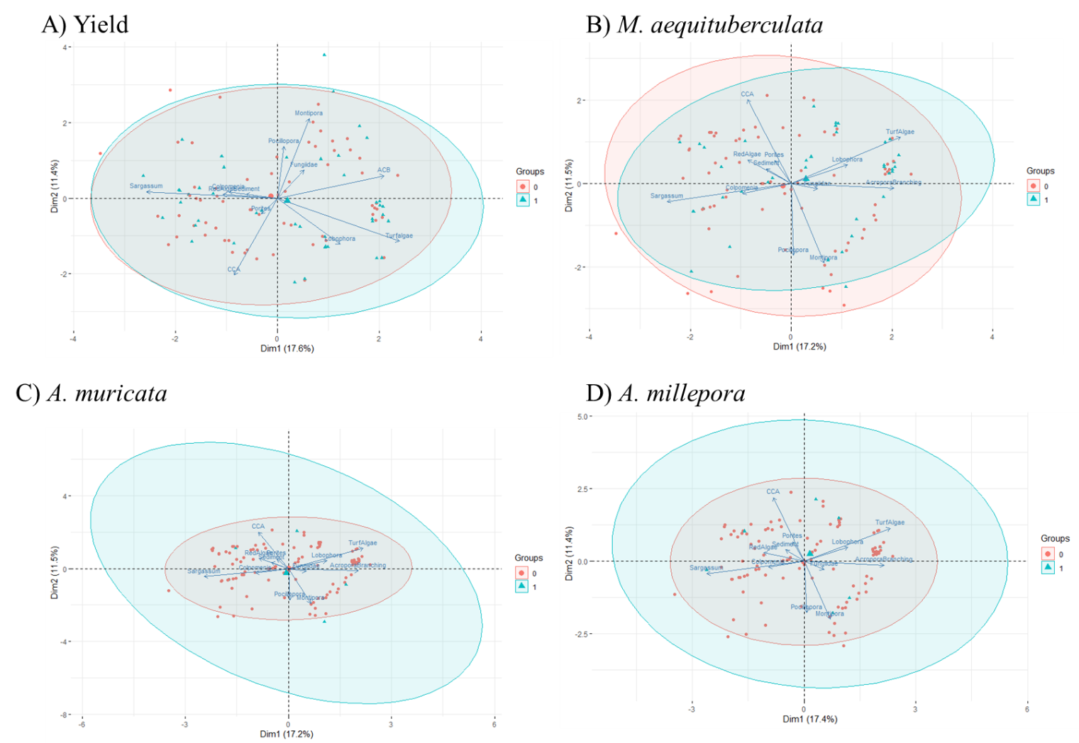

Figure S2. Principal component analysis with benthic group vectors for benthic community composition among (A) tethered star devices with positive yield (device level survival) (1) or not (0), and on which corals survived (1) and died (0) for (B) Montipora aequituberculata, (C) Acropora millepora, and (D) A. muricata. Ellipses represent 95% confidence intervals.

