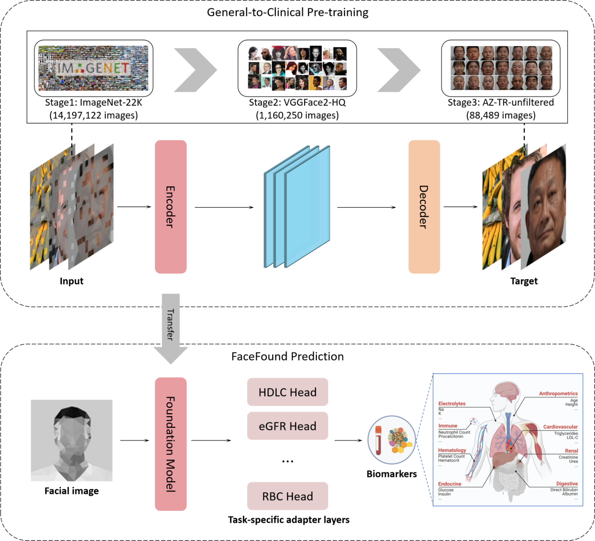
Extended Data Fig. 1 | Overview of the FaceFound training and prediction framework. The model was developed using a hierarchical general-to-clinical pre-training strategy. Stage 1: initialization with large-scale natural image data (14,197,122 photos, ImageNet-22K); Stage 2: adaptation to high-quality facial image datasets (1,160,250 photos VGGFace2-HQ); and Stage 3: refinement with clinical facial cohorts (88,489 facial images on AZ-TR). Pre-training employed an encoder–decoder masked autoencoding scheme to learn transferable facial representations. After pre-training, the model was transferred for biomarker prediction (bottom). Given a single facial image, the FaceFound foundation model generates multiple prediction heads corresponding to specific biomarkers (for example, HDL-C, eGFR(CKD-EPI), RBC, etc.), covering 62 biomarkers across eight physiological domains, including anthropometrics, hematology, cardiovascular, renal, endocrine, digestive, immune, and electrolyte systems.

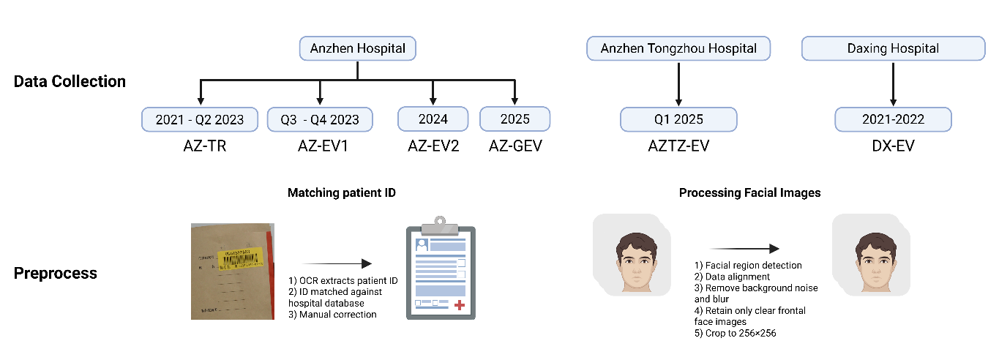
Extended Data Fig. 2 | Overview of data collection and preprocessing. The figure summarizes the timeline and sources of data collection across multiple hospitals, including Anzhen Hospital (training cohort AZ-TR and external validation cohorts AZ-EV1, AZ-EV2, and AZ-GEV), Anzhen Tongzhou Hospital (AZTZ-EV), and Daxing Hospital (DX-EV). Data preprocessing included patient ID extraction using optical character recognition (OCR), database matching, and manual correction, followed by standardized image processing steps: facial region detection, data alignment, removal of background noise and blur, retention of clear frontal face images, and cropping to 256 × 256 pixels.

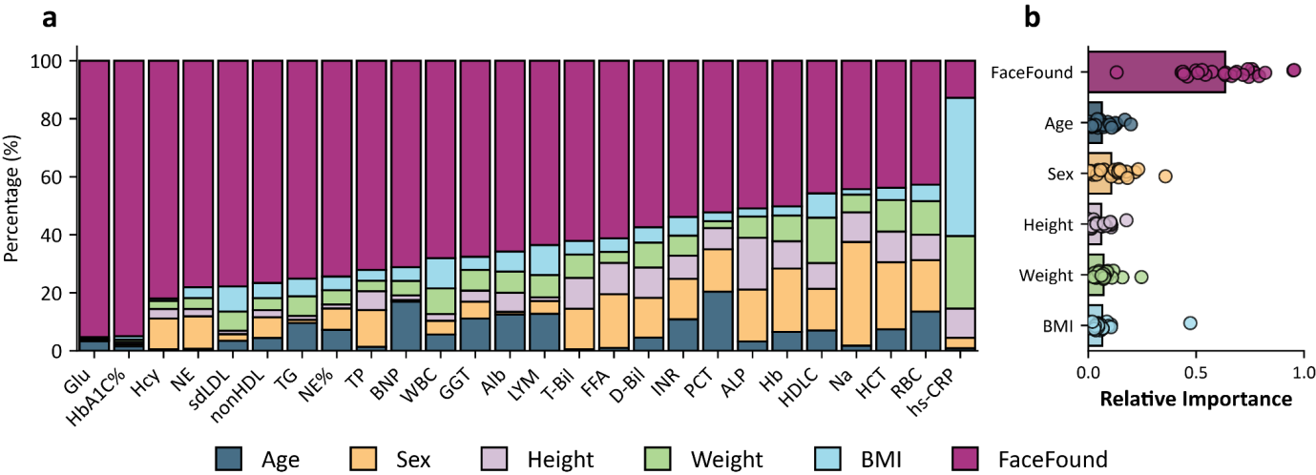
Extended Data Fig. 3 | Contribution of face components and demographic factors to biomarker prediction. a, Stacked bar plots showing the Variance explained of facial features, age, sex, height, weight, and BMI to the prediction of 26 biomarkers independent of face, evaluated in the AZ-EV1 cohort (n = 1,498). Each bar represents one biomarker, and the stacked colors denote the percentage contribution of each factor. b, Average Variance explained across all 26 biomarkers. Each dot represents a single biomarker, and the horizontal bars denote the mean contribution of each factor. Relative importance was quantified using the LMG method, which partitions R² by averaging contributions across all possible predictor orderings.

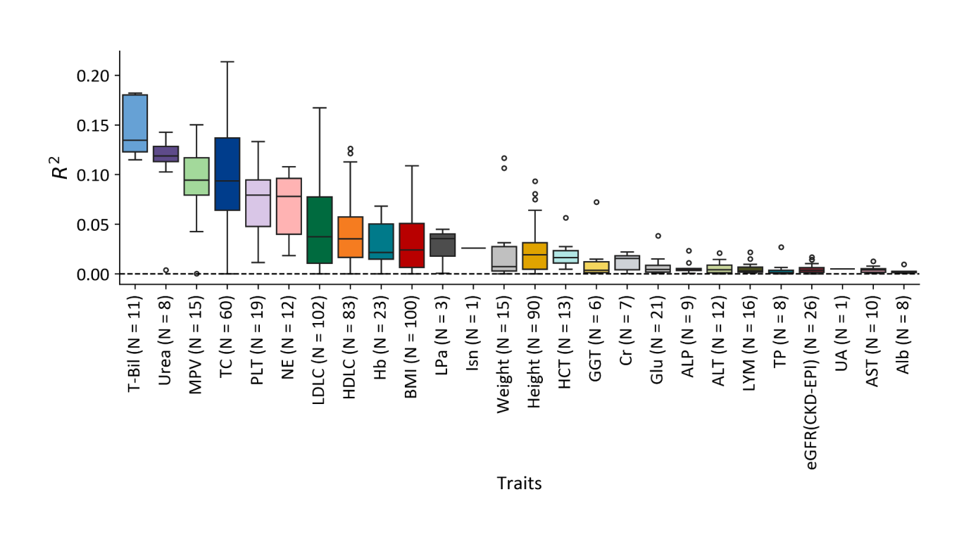Extended Data Fig. 4 | R² of 679 PRS for 26 biomarkers in AZ-GEV cohort. Boxplots showing the distribution of R² values for 679 polygenic risk scores (PRS) derived from the PGS Catalog, from 26 biomarkers in the AZ-GEV cohort (n = 111). R² was calculated by regressing measured biomarker values on PRS. Each box represents the interquartile range (IQR), with the horizontal line indicating the median R², and whiskers denoting 1.5 × IQR. PRS were constructed by summing the variant effect size of genetic variants (obtained from PGS Catalog) for each individual with the corresponding genotypes.

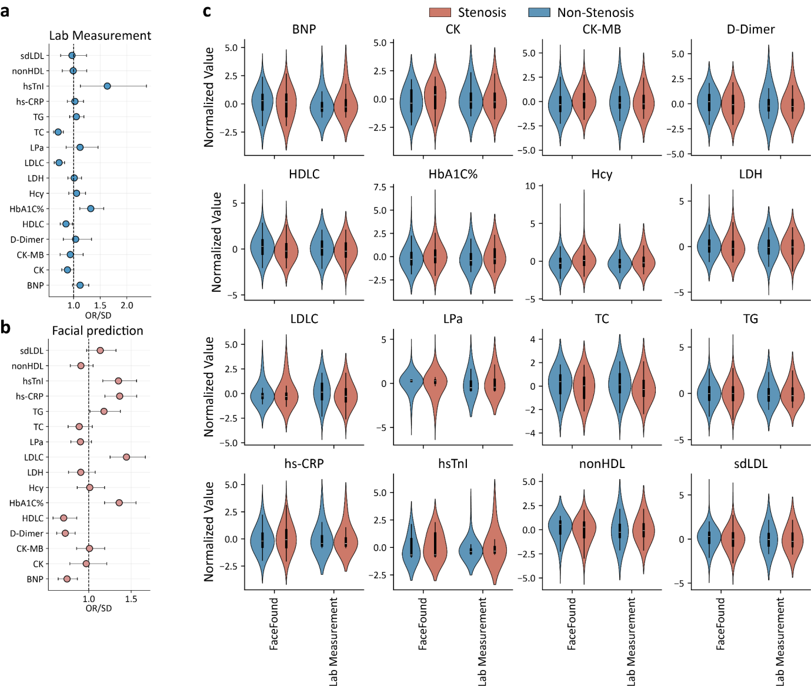
Extended Data Fig. 5 | Associations and distributions of cardiovascular-related biomarkers with coronary stenosis severity.
a,b, Forest plots showing odds ratios per SD (OR/SD) and 95% confidence intervals for 16 cardiovascular-related biomarkers in relation to coronary stenosis severity (<50% vs ≥50%) in the AZ-EV1 and DX-EV cohorts. top, OR/SDs derived from laboratory measurements; bottom, OR/SD derived from facially predicted biomarker values. Each point represents the estimated OR/SD, with horizontal lines denoting 95% confidence intervals; the vertical dashed line indicates the null (OR/SD = 1). c, Violin plots showing normalized values of 16 cardiovascular-related biomarkers stratified by facial predictions and laboratory measurements across stenosis groups (<50% vs ≥50%). The width of each violin reflects data density; central black bars indicate interquartile ranges and white dots denote medians. Biomarkers include sdLDL, nonHDL, hsTnI, hs-CRP, TG, TC, Lp(a), LDLC, LDH, Hcy, HbA1c, HDLC, D-Dimer, CK-MB, CK, and BNP.

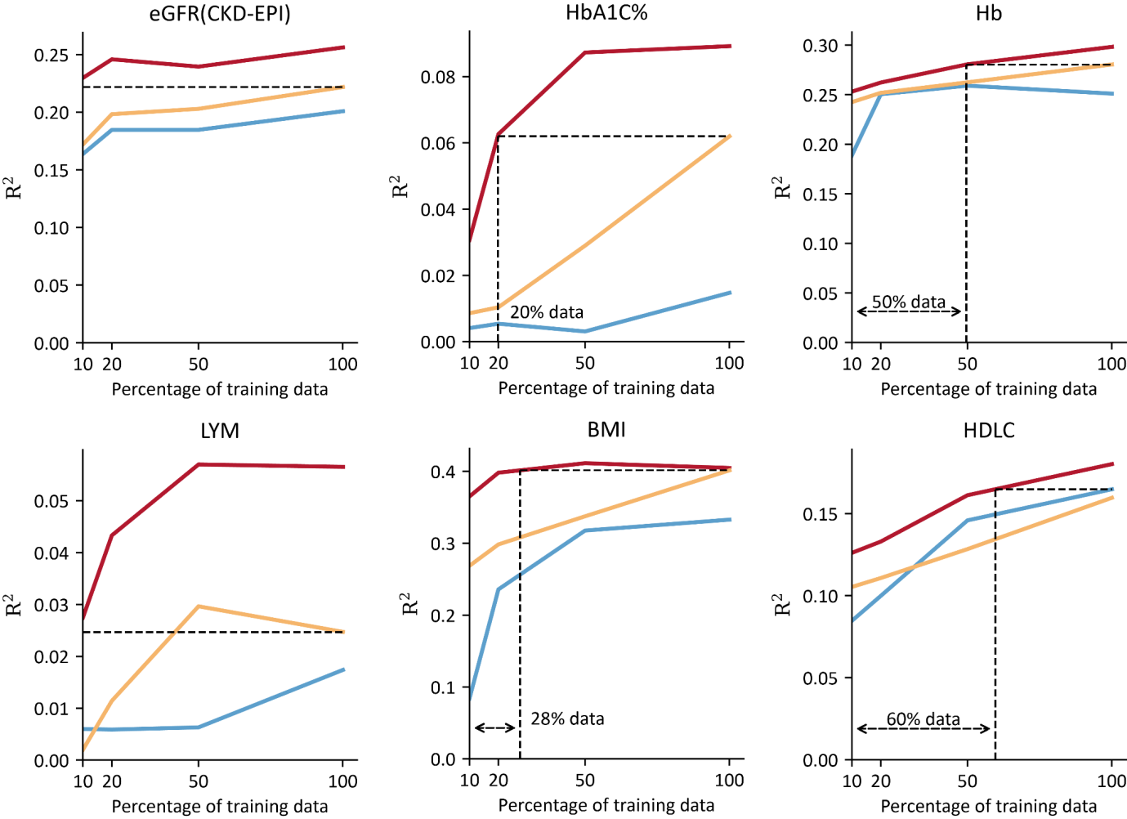
Extended Data Fig. 6 | Label efficiency of FaceFound in biomarker prediction. We evaluated label efficiency by varying the fraction of labelled training data used for model development and measuring the performance achieved at each level. In six exemplary biomarkers (eGFR (CKD-EPI), HbA1c, Hb, LYM, BMI, and HDL-C), FaceFound showed consistently higher efficiency than Swin-Large and ResNet18, particularly when only small amounts of data were available. The dashed black lines mark the percentage of data required for FaceFound to match the performance of the of SwinLarge or ResNet18 baseline model—10% for eGFR (CKD-EPI) and LYM, 20% for HbA1c, 28% for BMI, 50% for Hb, and 60% for HDL-C. Collectively, these results highlight the ability of FaceFound to achieve benchmark or superior performance with substantially fewer labelled samples. Points and lines represent the median R² across four external cohorts (AZ-EV1, AZ-EV2, AZTZ-EV, and DX-EV).

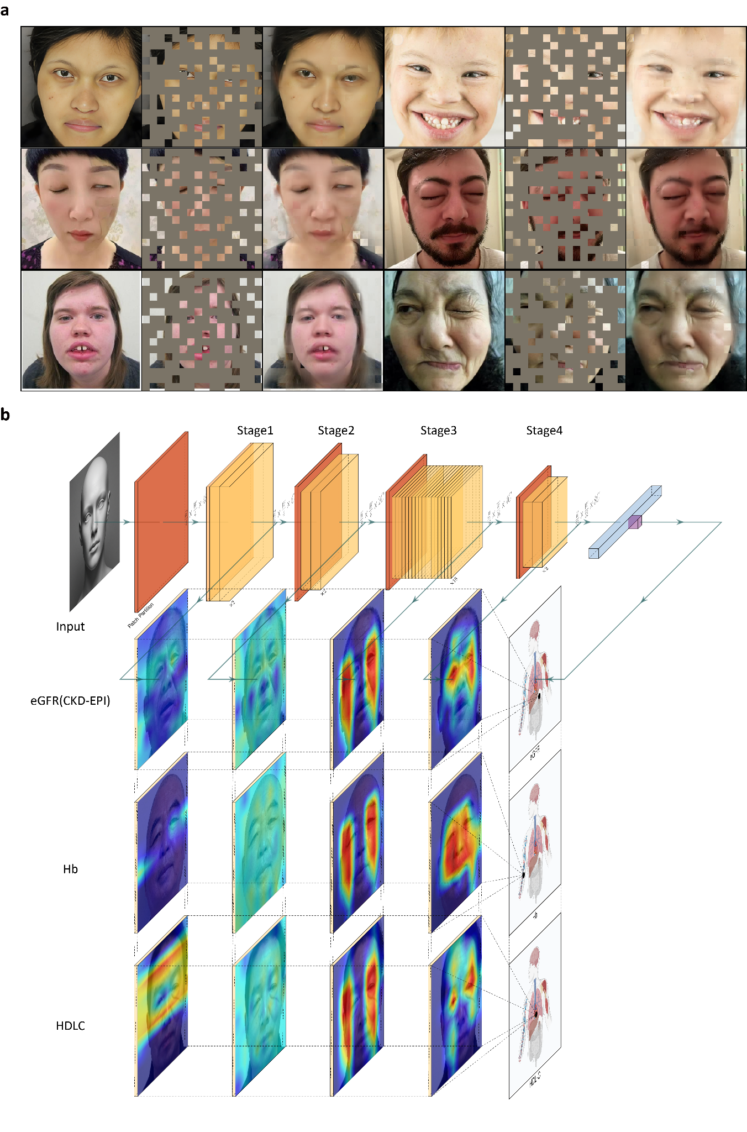
Extended Data Fig. 7 | Qualitative results of FaceFound. a, Reconstructed facial images from highly masked images in a pretext task. Even with limited visible patches, FaceFound successfully recovered salient facial abnormalities, such as periorbital swelling, dental malocclusion, and macular lesions, indicating that the model has learned to capture disease-related facial patterns. Note: these facial images were not included in our FaceFound pre-training process. b, Stage-specific representations of FaceFound for biomarker prediction. Grad-CAM heatmaps highlight the regions contributing to model decisions at different stages of the Swin-based architecture. Distinct patterns of feature utilization were observed across biomarkers: for eGFR prediction, early stages captured global facial context, intermediate stages emphasized the eyes and cheeks, and the final stage focused on the periocular region; for Hb prediction, later stages integrated signals from the entire face; for HDL-C, salient features were largely distributed around the eyes.

