Supporting Information for
Identifying cycling current-dependent degradation pathways in high-voltage layered sodium–ion cathodes
Yongchun Li^{1,3,9}, Qiao Zhang^{2,9}, Katherine A. Mazzio^{3,4,5,6}, Yanan Sun⁴, Changjiang Bai³, Deniz Wong⁴, Götz Schuck⁴, Wenguang Zhao⁸, Haiyun Zhu², Mingman Yuan¹, Jun Wang², Philipp Adelhelm^{3,4} and Haidong Liu^{1,8}
¹ Department of Chemistry - Ångström Laboratory, Uppsala University, 75121 Uppsala, Sweden
² Department of Materials Science and Engineering, School of Innovation and Entrepreneurship, Southern University of Science and Technology, 518055 Shenzhen, China
³ Institut für Chemie, Humboldt-Universität zu Berlin, Brook-Taylor-Str. 2, 12489 Berlin, Germany
⁴ Helmholtz-Zentrum-Berlin für Materialien und Energie GmbH, Hahn-Meitner-Platz 1, 14109, Berlin, Germany
⁵ Institute of Chemical Technologies and Analytics, TU Wien, Getreidemarkt 9, 1060 Vienna, Austria
⁶ X-Ray Center, TU Wien, Lehargasse 4, 1060 Vienna, Austria
⁷ Department of Technical Physics, University of Eastern Finland, 70210 Kuopio, Finland
⁸ School of Advanced Materials, Peking University, Shenzhen Graduate School, 518055 Shenzhen, China
⁹ These authors contributed equally: Yongchun Li, Qiao Zhang
E-mail: haidong.liu@kemi.uu.se, philipp.adelhelm@hu-berlin.de, wangj9@sustech.edu.cn, and yongchun.li@kemi.uu.se

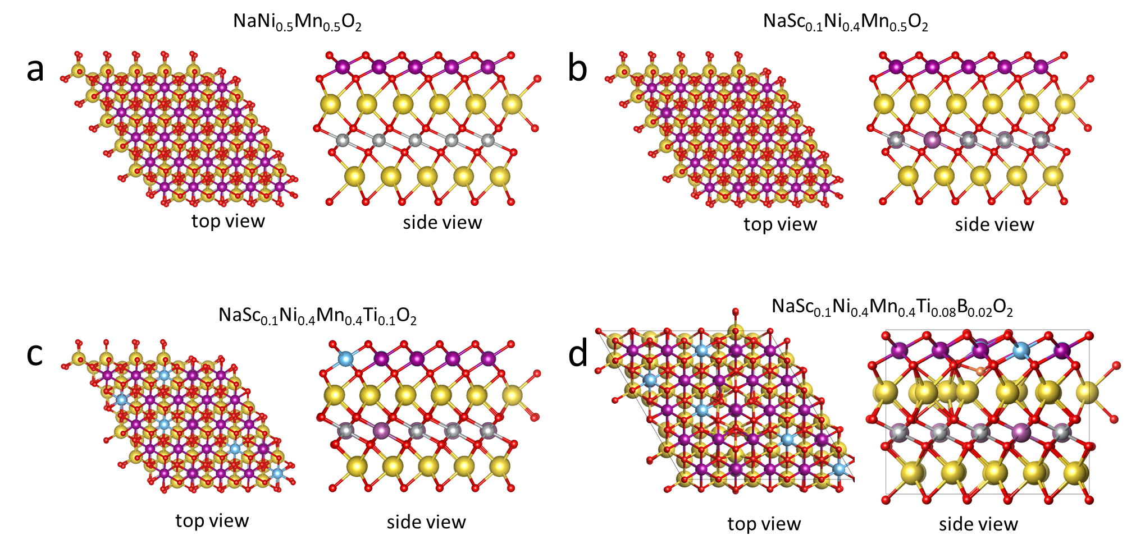
Figure S1 Crystal structures (top and side views) of different cathodes after density functional theory (DFT) structural optimization: (a) O3–NaNi_{0.5}Mn_{0.5}O₂ (O3–undoped), (b) O3–NaSc_{0.1}Ni_{0.4}Mn_{0.5}O₂ (O3–Sc doping), (c) O3–NaSc_{0.1}Ni_{0.4}Mn_{0.4}Ti_{0.1}O₂ (O3–ScTi doping) and (d) O3–NaSc_{0.1}Ni_{0.4}Mn_{0.4}Ti_{0.08}B_{0.02}O₂ (O3–ScTiB doping). Sc and Ti dopants occupy the transition metal (TM) layer, whereas B resides in the tetrahedral interstitial sites.¹
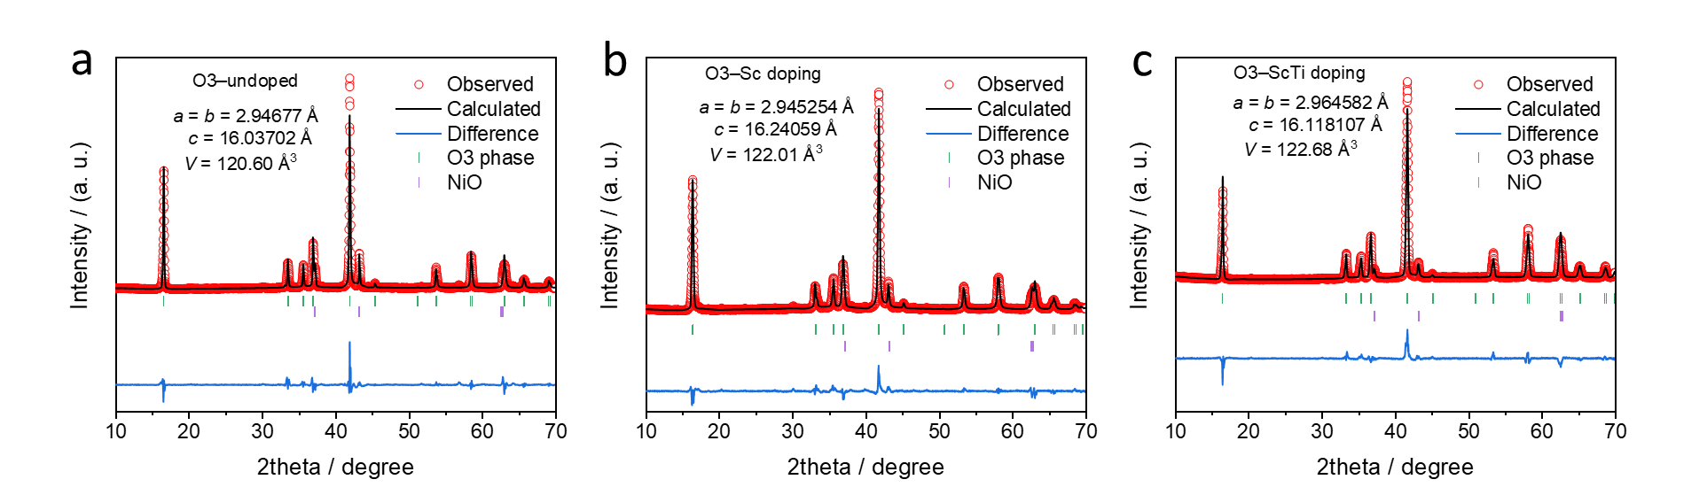
Figure S2 X-ray diffraction (XRD) Rietveld refinement patterns of (a) O3–undoped, (b) O3–Sc doping and (c) O3–ScTi doping.

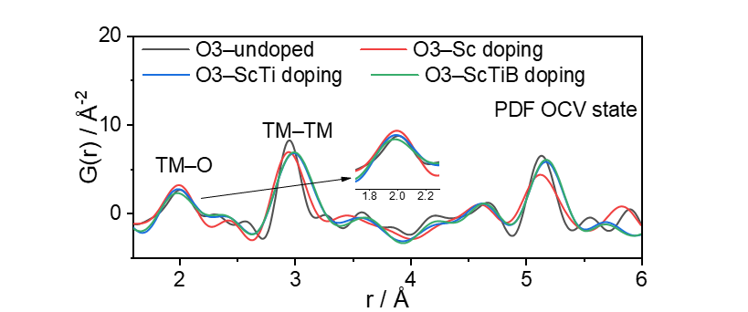
Figure S3 Pair distribution function (PDF) patterns of O3–undoped, O3–Sc doping, O3-ScTi doping and O3–ScTiB doping.

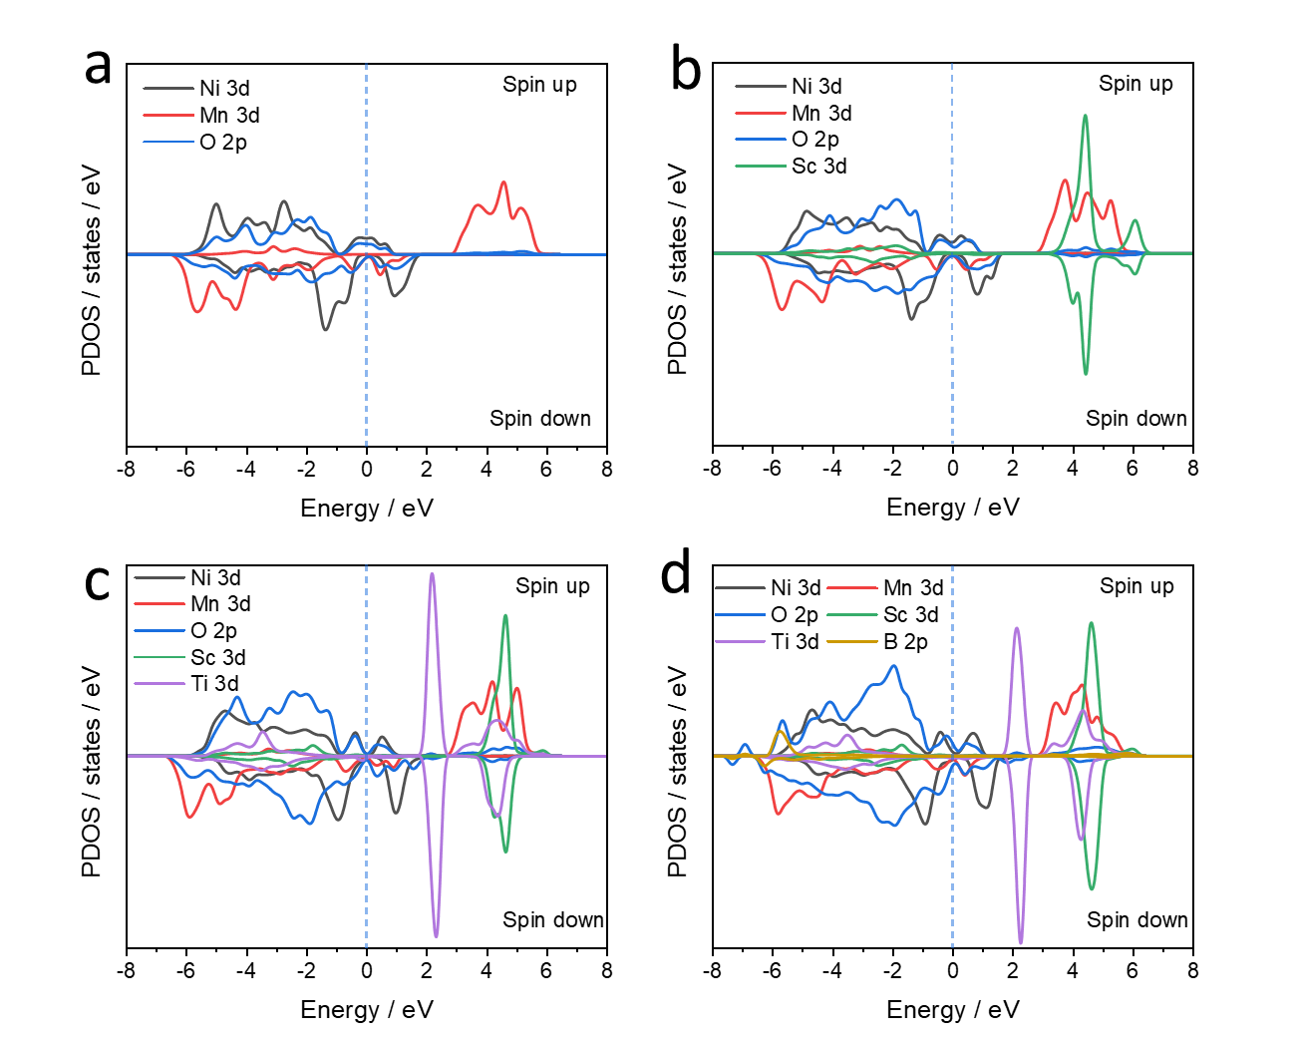
Figure S4 Projected density of states (pDOS) of different samples: (a) O3–undoped, (b) O3–Sc doping, (c) O3–ScTi doping and (d) O3–ScTiB doping.
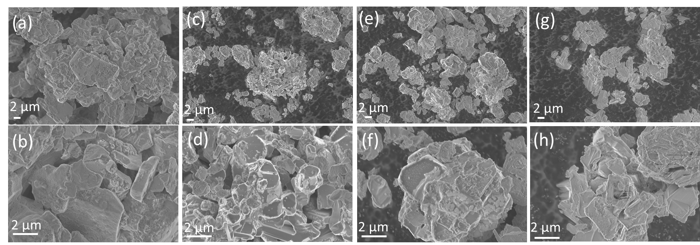
Figure S5 Scanning electron microscopy (SEM) images of (a, b) O3–undoped, (c, d) O3–Sc doping, (e, f) O3–ScTi doping and (g, h) O3–ScTiB doping.

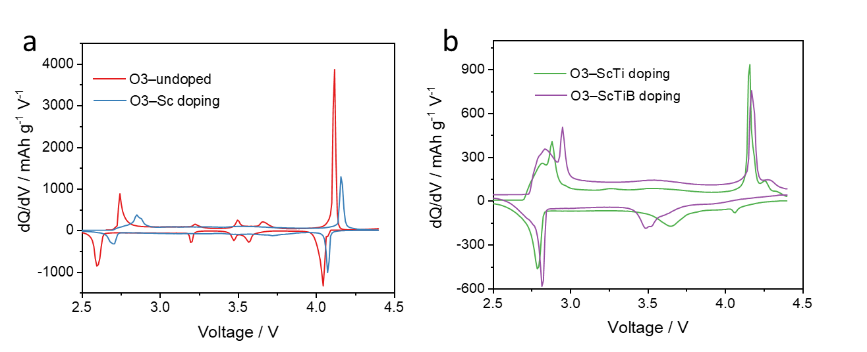
Figure S6 Initial dQ/dV curves of (a) O3–undoped and O3–Sc doping (b) O3–ScTi doping and O3–ScTiB doping.

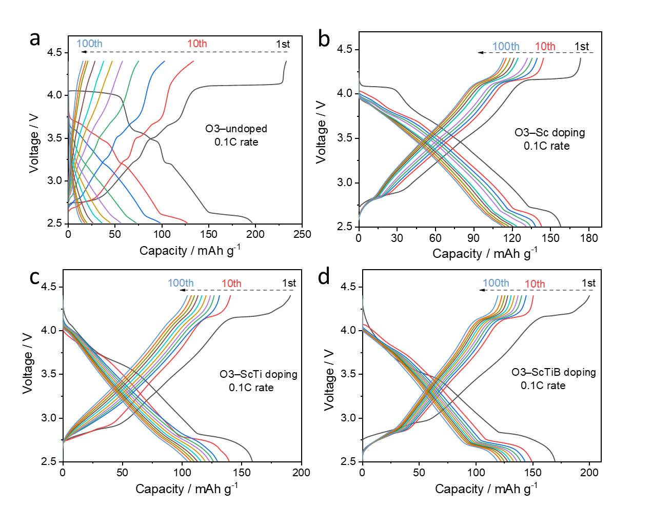
Figure S7 Charge/discharge curves of (a) O3–undoped, (b) O3–Sc doping, (c) O3–ScTi doping, and (d) O3–ScTiB doping at 1st, 10th, 20th, …100th cycles.

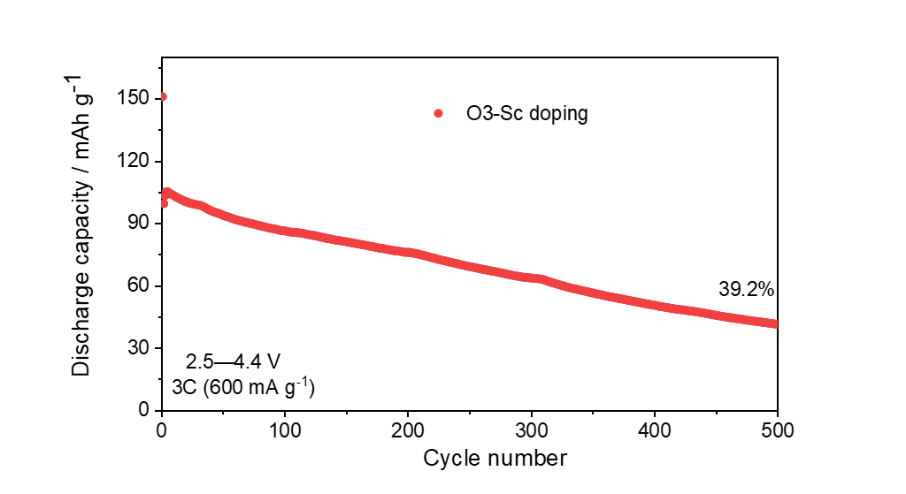
Figure S8 Long-term cycling performance of O3–Sc doping at 3C rate.

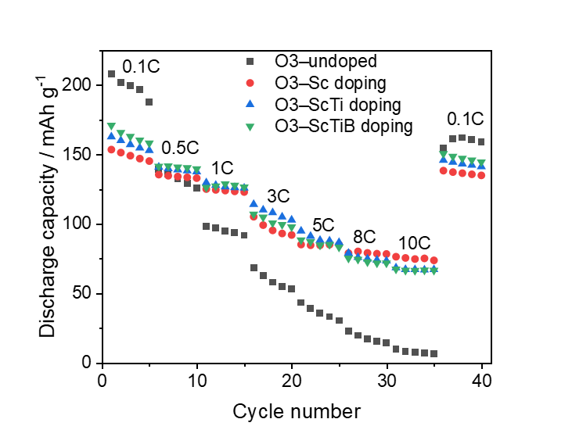
Figure S9 Rate capabilities of O3–undoped, O3–Sc doping, O3–ScTi doping, and O3–ScTiB doping at 0.1, 0.5, 1, 3, 5, 8, and 10C within a voltage range of 2.5–4.4 V. After cycling at 10C, all materials were returned to 0.1C to evaluate their reversibility.

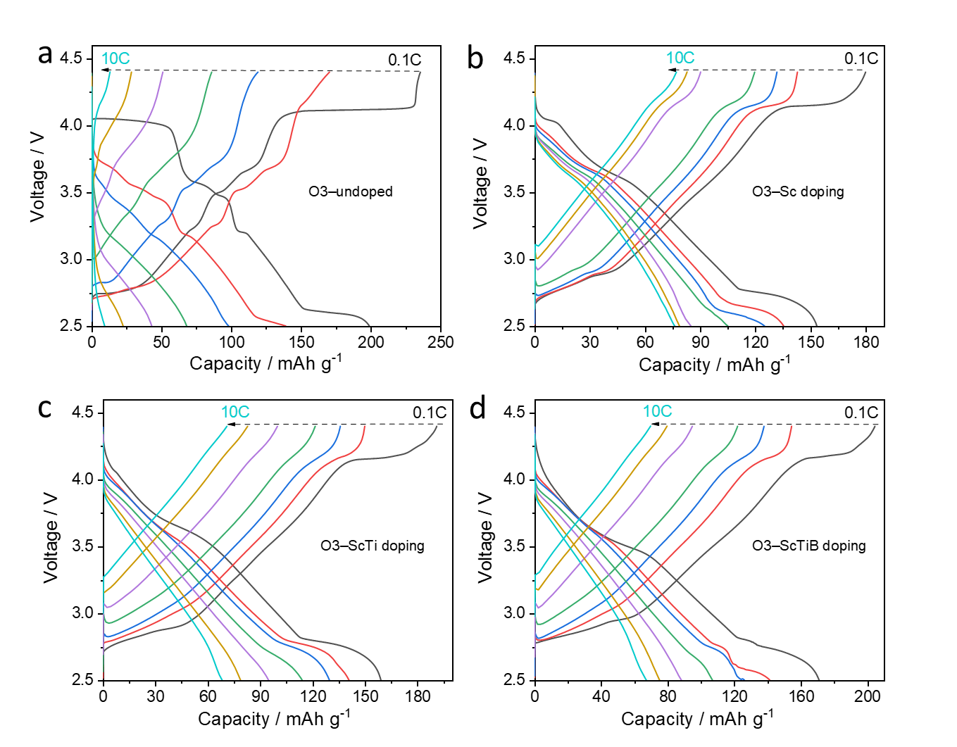
Figure S10 Charge/discharge curves of (a) O3–undoped, (b) O3–Sc doping, (c) O3–ScTi doping, and (d) O3–ScTiB doping at 0.1, 0.5, 1, 3, 5, 8, and 10C within a voltage range of 2.5–4.4 V. The doped materials exhibit superior rate performance compared to the undoped sample, particularly at high cycling rates. Among the doped samples, the Sc–Ti–B co-doped material delivers a higher discharge capacity at lower rates, whereas the Sc-doped material alone shows better performance at higher rates.

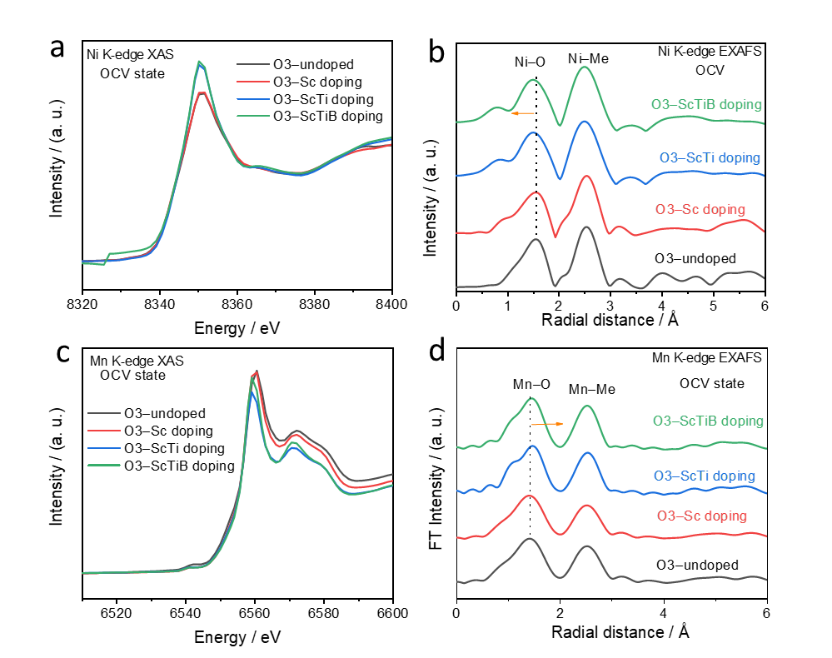
Figure S11 X-ray absorption near edge structure (XANES) and extended X-ray absorption fine structure EXAFS spectra of O3–undoped, O3–Sc doping, O3–ScTi doping, O3–ScTiB doping, measured at (a, b) the Ni K-edge and (c, d) the Mn K-edge. All samples exhibit similar absorption edge energies at both the Ni and Mn K-edge XANES spectra, indicating comparable oxidation states of Ni and Mn across the different materials at the open-circuit voltage (OCV) state. In the extended region, the undoped and Sc-doped samples display similar radial distances. In contrast, the Sc–Ti and Sc–Ti–B co-doped materials exhibit shorter radial distances in the Ni–O shell and longer radial distances in the Mn–O shell. These observations are consistent with DFT, which suggest that Ti doping and B doping have a more pronounced effect on the Ni 3d states than on the Mn 3d states.

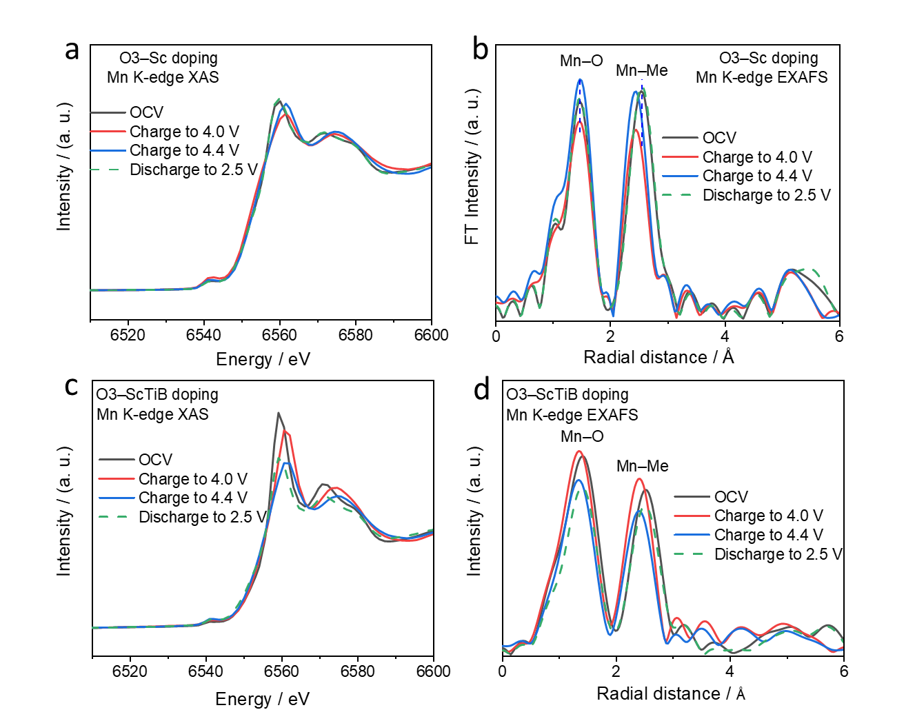
Figure S12 XANES and EXAFS spectra at the Ni K-edge for (a, b) O3–Sc doping and (c, d) O3–ScTiB doping. Both materials exhibit slight shifts toward higher energy at the Mn K-edge XANES, indicating that Mn redox contributes only modestly to the electrochemical process. In the extended region, Sc doping alone induces changes similar to those observed in the undoped material for both the Mn–O and Mn–Me (Ni, Mn, Sc, Ti and B) shells. Specifically, it mainly alters the coordination environment in the Mn–O shell, whereas the Mn–Me shell undergoes more pronounced changes in both radial distance and the height of the shell, attributable to the electrochemical activity of Ni. For the Sc, Ti, and B co-doped material, the Mn–O and Mn–Me radial distances decrease markedly when charged from the OCV state to 4.0 V. However, upon further charging to 4.4 V, the material exhibits decrease only in the heights of the two shells, without additional shortening of radial distances. These results indicate that the contribution from Mn redox is primarily confined to potentials below 4.0 V.
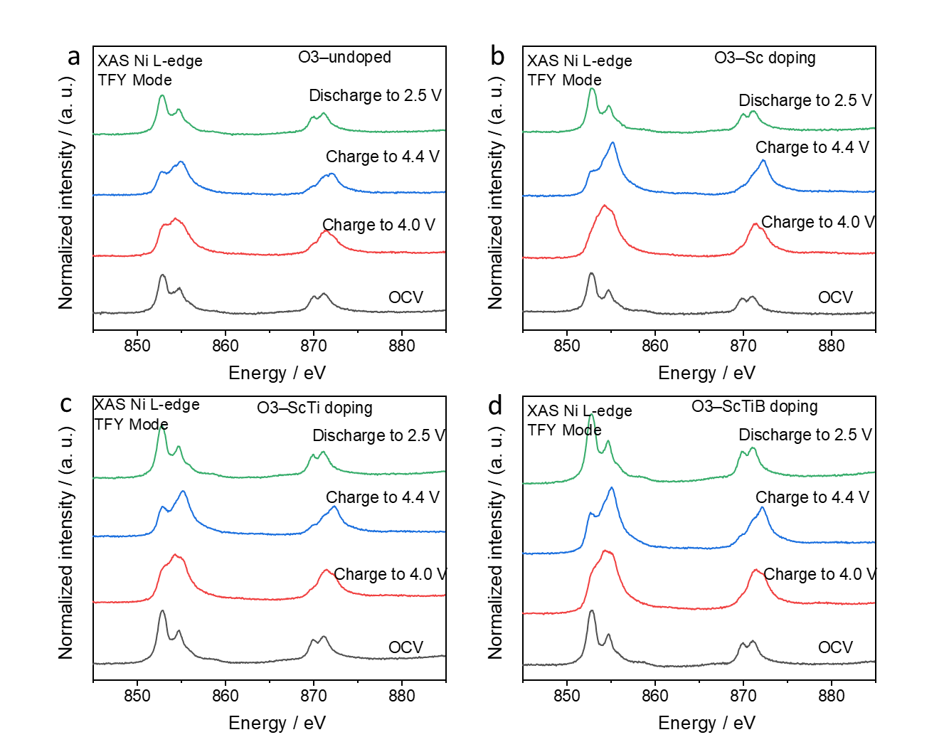
Figure S13 Soft Ni L-edge spectra of (a) O3–undoped, (b) O3–Sc doping, (c) O3–ScTi doping, and (d) O3–ScTiB doping at the OCV, charged to 4.0 V, charged to 4.4 V, and discharged to 2.5 V states. All materials display pronounced changes at the L₃ edge (~ 852 eV), particularly at the charge to 4.4 V state, confirming the electrochemical activity of Ni.

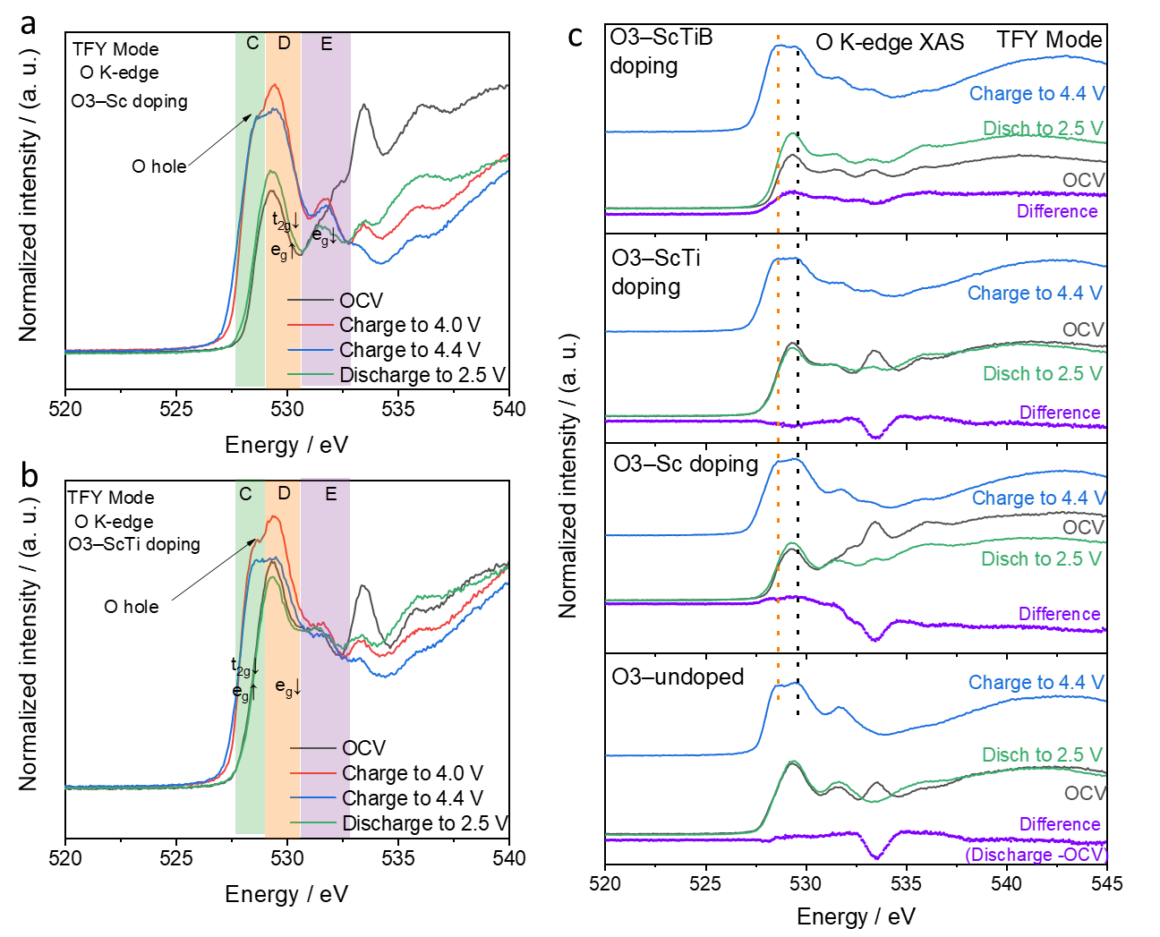
Figure S14 O K-edge spectra of (a) O3–Sc doping and (b) O3–ScTi doping at the OCV, charged to 4.0 V, charged to 4.4 V, and discharged to 2.5 V states. (c) Comparison of O K-edge spectra for O3–undoped, O3–Sc doping, O3–ScTi doping, and O3–ScTiB doping. The O3–Sc and O3–ScTi samples exhibit changes similar to those of O3–undoped and O3–ScTiB across the charge/discharge states, with clear O-hole features appearing at both 4.0 V and 4.4 V. This indicates that dopants (Sc, Ti, and B) do not alter the nature of the oxygen redox species. To further compare differences, spectra at the fully charged, OCV, and discharged (2.5 V) states are plotted together in Figure S9c. The O-hole intensity (orange dotted line) increases progressively from the undoped material to the ScTiB-doped material, suggesting varying degrees of oxygen redox contribution among these samples. At the discharged state, the O-hole feature disappears for all materials, and only slight differences remain between the OCV and discharged states (see violet scatter), particularly in the Sc–Ti–B doped sample. These results demonstrate the reversible nature of oxygen redox.
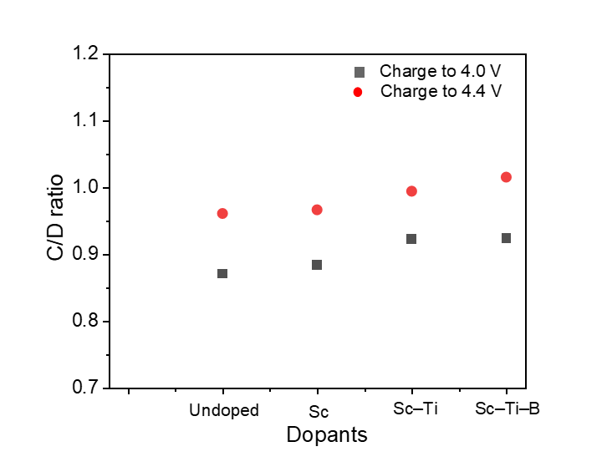
Figure S15 Quantification of the O-hole feature, given by the C/D ratio, for O3–undoped, O3–Sc doping, O3–ScTi doping, and O3–ScTiB doping at 4.0 V and 4.4 V charge states. Herein, C and D denote the peak intensities at 528.6 eV and 529.4 eV, respectively, in the O K-edge XAS spectra

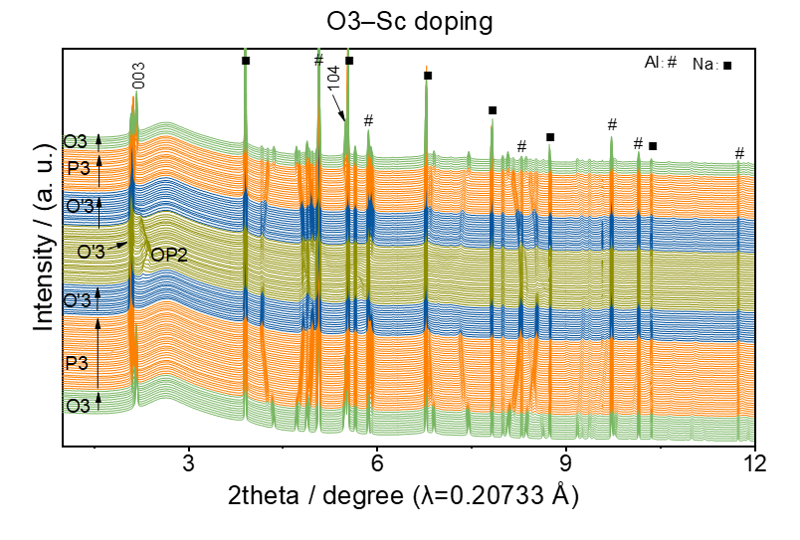
Figure S16 Operando XRD patterns and corresponding phase transitions during the first cycle for O3–Sc doping. The results reveal a sequence of phase transitions during charging: O3 → P3 → O′3 → O′3 and OP2, with partial reversibility observed during discharging.

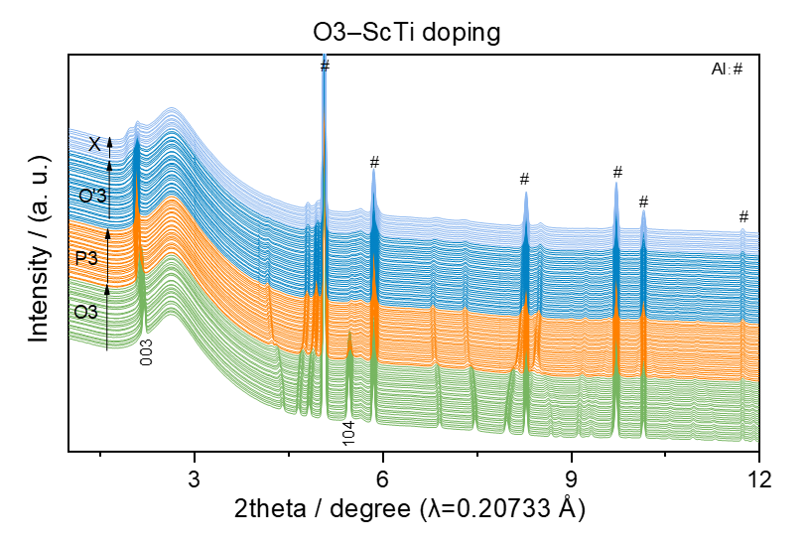
Figure S17 Operando XRD patterns and corresponding phase transitions during the first cycle for O3–ScTi doping. A 1 mm diameter hole was created at the Na site (anode) to eliminate signals from Na during operando testing, as no Na reflections were detected. Similar to the Sc-doped case, the material undergoes phase transitions from O3 to P3 below 4.0 V, and further transforms into the O′3 phase at higher voltages. However, at the fully charged state, an unknown phase was observed, indicated by a main reflection appearing at a lower angle.

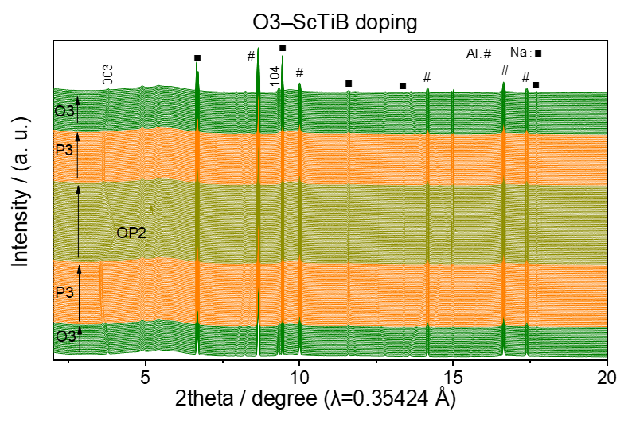
Figure S18 Operando XRD patterns and corresponding phase transitions during the first cycle for O3–ScTiB doping. With B incorporation, the material exhibits a more distinct phase transition boundary and improved reversibility. At the fully charged state, it displays a pure OP2 phase, which is well retained during discharge, indicating good structural reversibility.

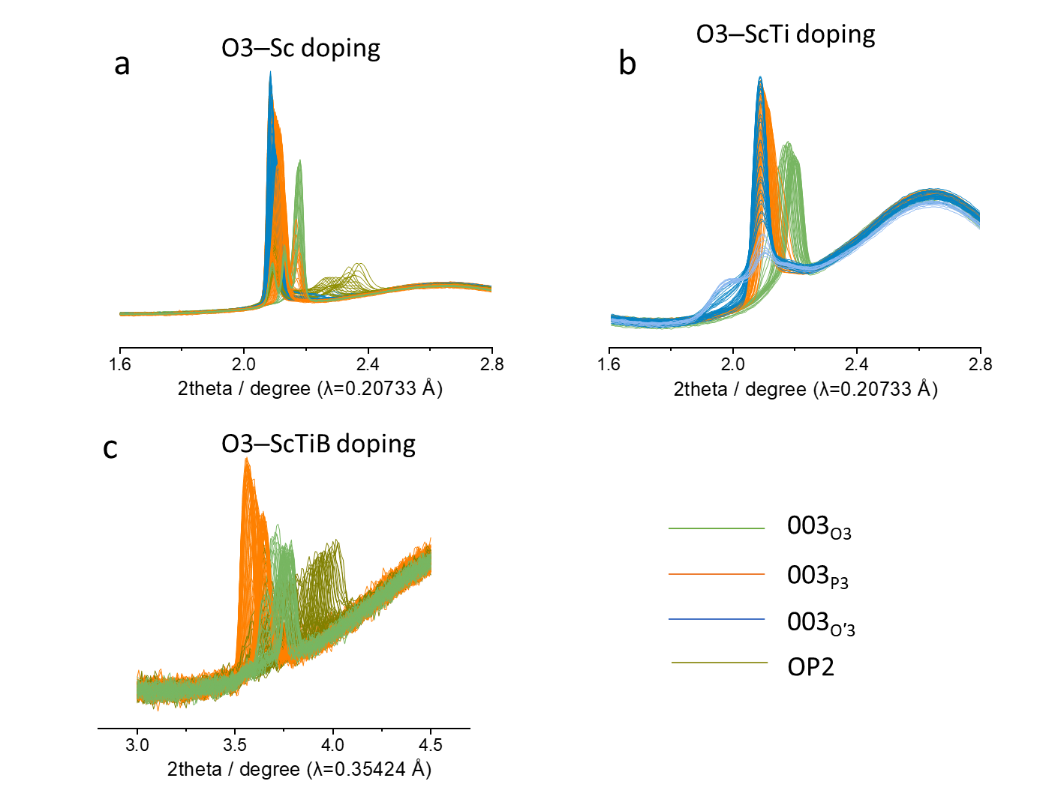
Figure S19 Evolution of the 003 reflection for (a) O3–Sc, (b) O3–ScTi, and (c) O3–ScTiB doping, with different colors representing distinct phases. All diffraction patterns were obtained from operando XRD measurements during the first charge at a 0.1C rate

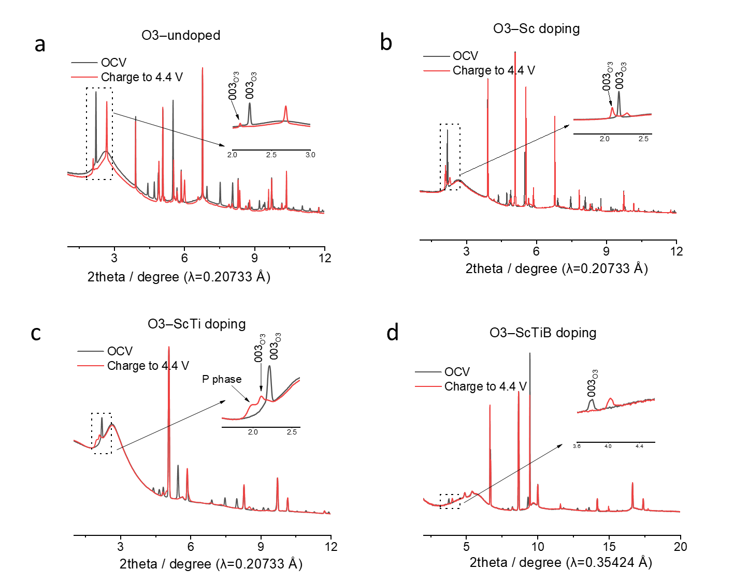
Figure S20 XRD patterns of (a) O3–undoped, (b) O3–Sc doping, (c) O3–ScTi doping, and (d) O3–ScTiB doping at OCV and at a charged state of 4.4 V. Insets highlight the differences in the 003 reflections. The undoped material exhibits a mixture of O3 and O′3 phases, indicating a fully octahedral (100%) stacking structure. In contrast, the Sc–Ti–B doped sample displays a single OP2 phase, corresponding to a 50% octahedral stacking arrangement. For the Sc and Sc–Ti doped samples, both are predominantly composed of the O′3 phase. The Sc-doped sample contains a minor fraction of the OP2 phase, while the Sc–Ti doped sample also shows the emergence of an unidentified X phase. This X phase closely resembles the prismatic stacking observed in the desodiated NaNi_{1/3}Mn_{1/3}Co_{1/3}O₂ structure². By integrating the main reflection peak, it is estimated that approximately 41% of the structure adopts prismatic stacking. For the Sc doped sample, integration of the two relevant reflections indicates that the OP2 phase comprises about 28% of the material. This suggests that only around 14% of the sodium ions occupy prismatic sites.

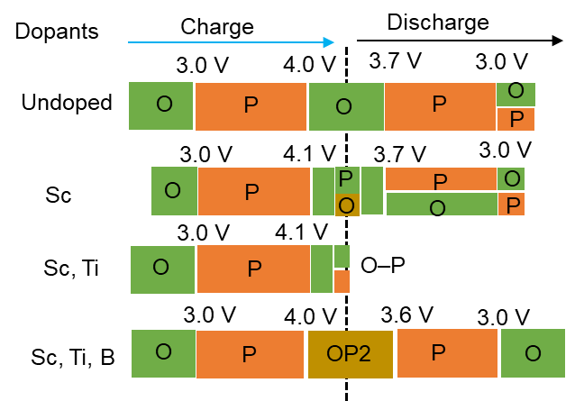
Figure S21 Comparison of the phase transition process and the corresponding potential for O3–undoped, O3–Sc doping, O3–ScTi doping, and O3–ScTiB doping during the first cycle. ‘O’ (green) represents octahedral stacking, while ‘P’ (yellow) denotes prismatic stacking. Clearly, 3.0 V and 4.0 V serve as distinct boundaries separating the P–type and O–type stacking phases. In the high-voltage region, P–type stacking typically induces smaller changes in the lattice parameters, resulting in a more structurally stable framework compared to O–type stacking³. During discharge, the transition from O–type to P–type stacking exhibits a noticeable delay, likely due to sluggish kinetics associated with oxygen redox processes and the slow reversibility of the phase transition.

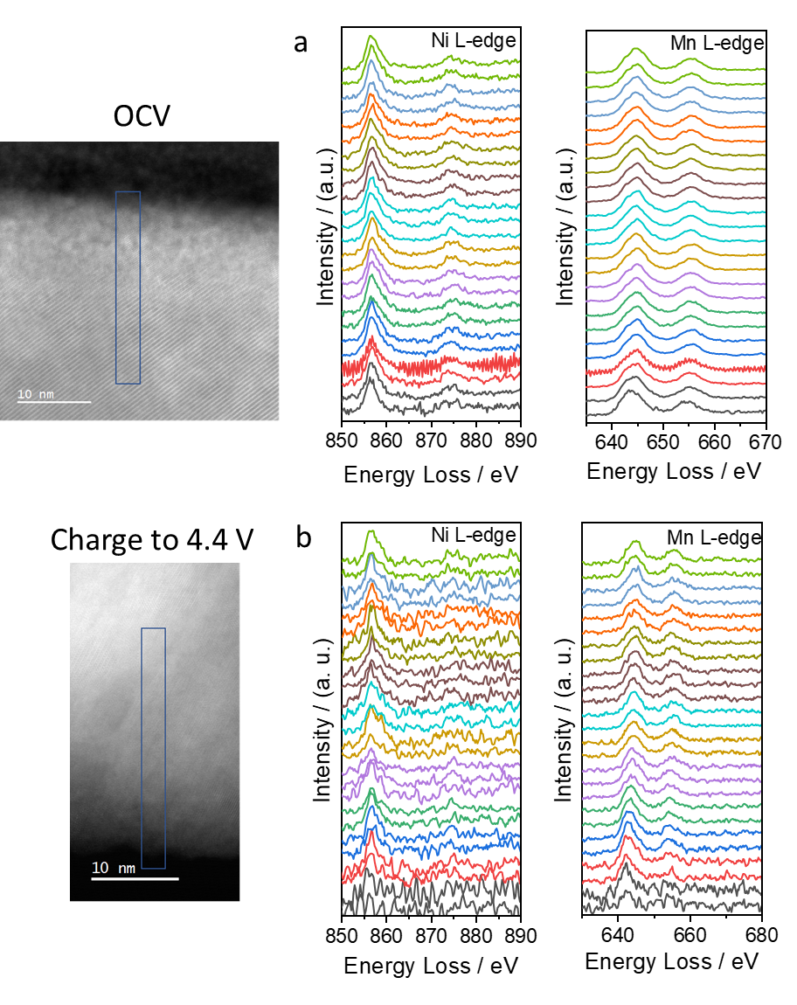
Figure S22 Electron energy loss spectroscopy (EELS) spectra of O3–undoped at the Ni and Mn L-edges in the (a) OCV state and (b) charged to 4.4 V state.

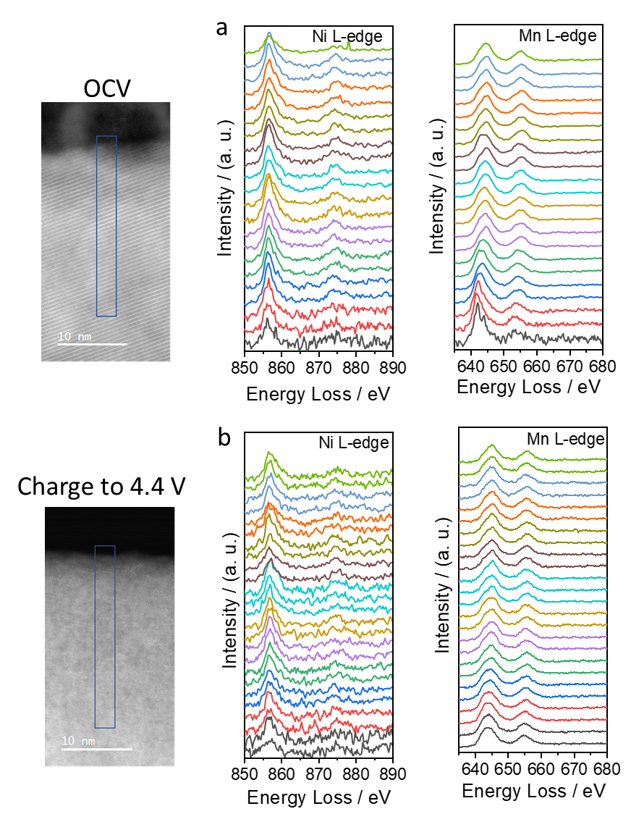
Figure S23 EELS spectra of O3–ScTiB doping at the Ni and Mn L-edges in the (a) OCV state and (b) charged state at 4.4 V. At full charge, both states exhibit weakened signals at all edges, indicative of structural changes. Although the Ni and Mn L-edge signals are relatively weak, distinct Ni/Mn L-edge peaks can still be identified. In contrast, the O K-edge signal disappears and reappears deeper in the bulk, particularly for the O3–undoped sample in the fully charged state. These observations indicate that oxygen loss occurs upon charging and extends beyond the surface region. Doping is thus effective in suppressing oxygen loss and enhancing structural stability.

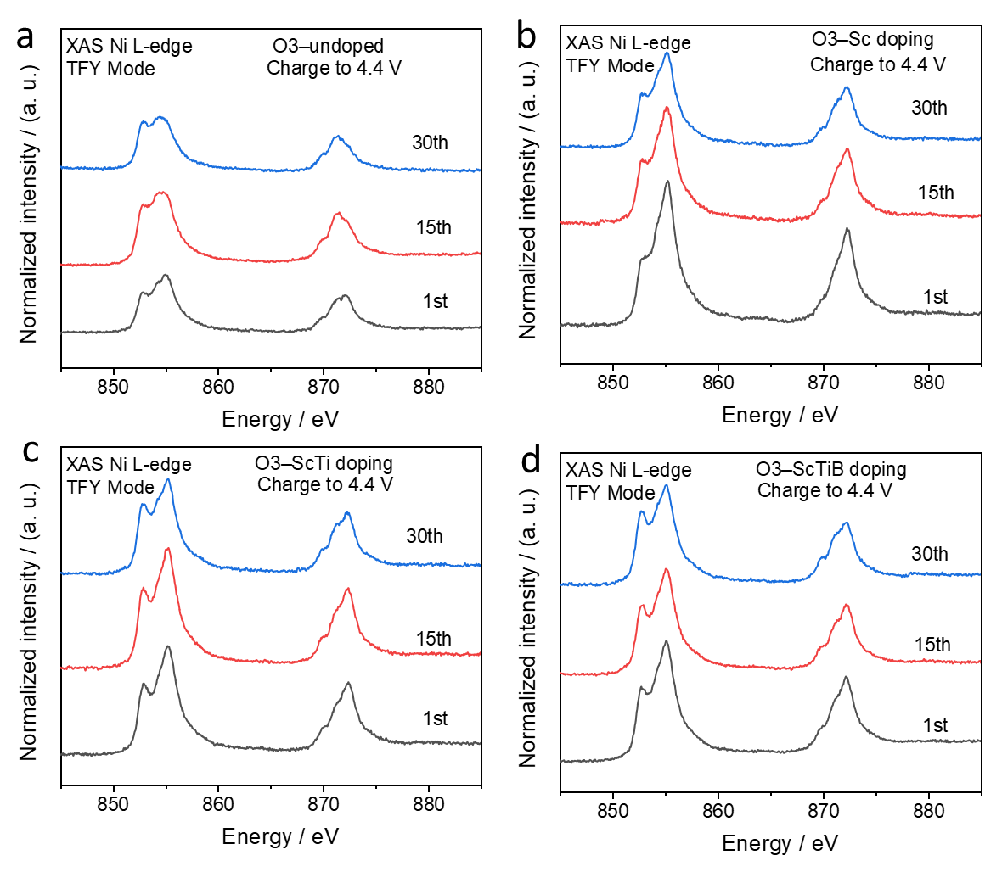
Figure S24 Soft Ni L-edge spectra of (a) O3–undoped, (b) O3–Sc doping, (c) O3–ScTi doping, and (d) O3–ScTiB doping at the 1st, 15th, and 30th fully charged states.

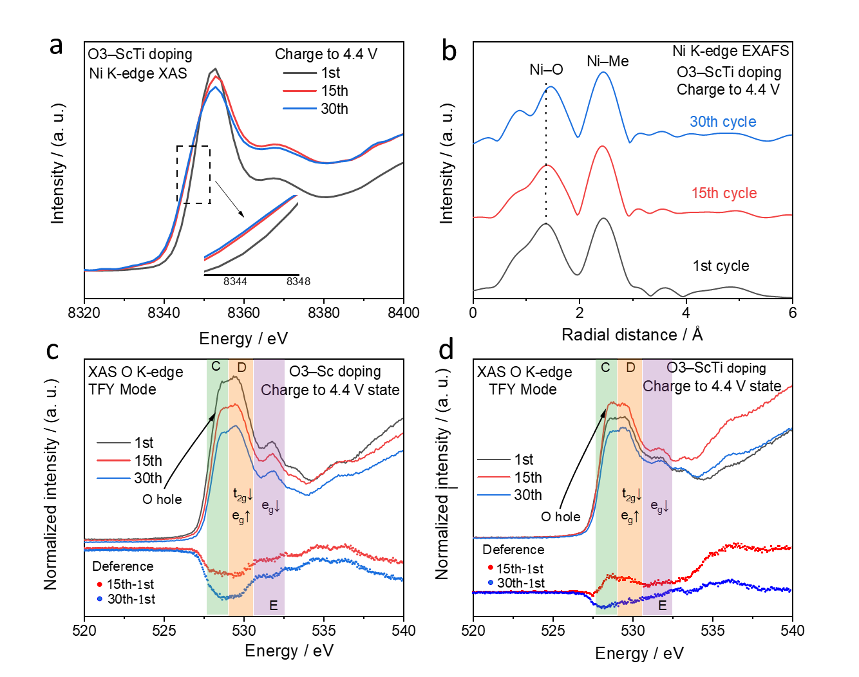
Figure S25 (a) Ni K-edge XAS of O3–ScTi doping at the 1st, 15th, and 30th cycles under the fully charged state. (b) Corresponding EXAFS spectra at the Ni K-edge. O K-edge spectra of (c) O3–Sc doping and (d) O3–ScTi doping at different cycles. For the Ni K-edge XAS, the Sc–Ti co-doped material shows a gradual decrease in edge energy with cycling, accompanied by an increase in the Ni–O radial distance, indicating an increasingly unstable local environment. At the O K-edge, although the changes upon cycling are smaller than in the undoped case, the O-hole peak intensity still weakens progressively. Moreover, the differences observed between the 15th/30th and 1st cycles further suggest that Sc–Ti–B doping helps stabilize the oxygen environment. Taken together, these results highlight that maintaining oxygen stability is critical for sustaining cycling performance at low-current cycling.

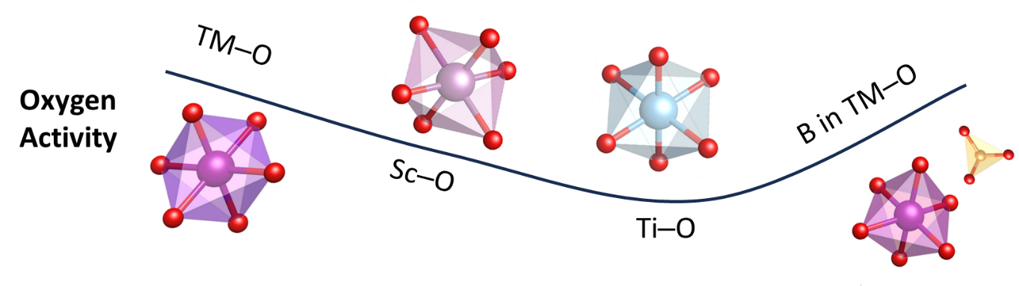
Figure S26. Schematic illustration of the evolution of oxygen properties—structural stability and target reaction activity—regulated by different metal–oxygen (M–O) bonds (TM–O, Sc–O, Ti–O) and B doping within the TM–O environment, as inferred from partial density of states (PDOS) analysis. The curve reveals a progressive trend: oxygen’s non-target reaction activity decreases while structural stability improves across the sequence undoped → Sc doping → Sc–Ti co-doping, driven by enhanced overlap of O 2p–Ni 3d t_{2g} / Sc 3d / Ti 3d bonding orbitals that stabilize electrons in low-energy states. In the subsequent Sc–Ti co-doped → Sc–Ti–B co-doped transition, B (through 2p–O 2p hybridization) preserves the Sc–O/Ti–O-derived bonding stability (ensuring optimal structural stability) while simultaneously boosting target reaction activity by modulating O 2p state density near the Fermi level and enhancing O 2p–Ni 3d e_{g} overlap. Coordination polyhedral are also depicted to intuitively illustrate the structural characteristics of different M–O configurations.

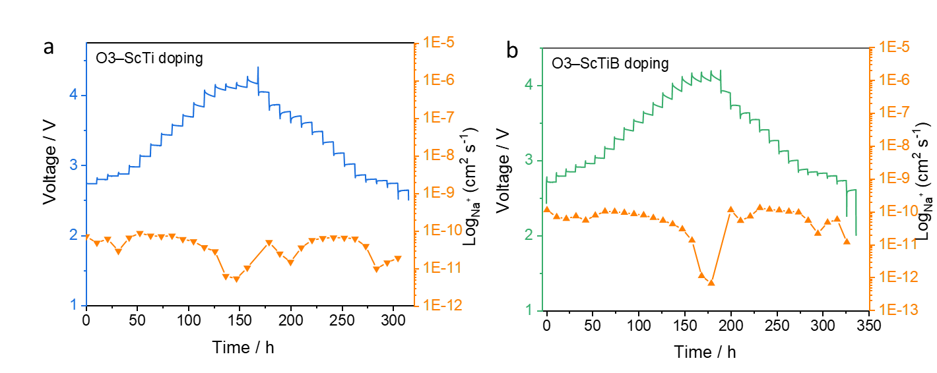
Figure S27 Galvanostatic intermittent titration technique (GITT) measurements and the calculated Na⁺ diffusion coefficients for (a) O3–ScTi and (b) O3–ScTiB during the first cycle. The Na⁺ diffusion coefficients of the two materials fall within the same order of magnitude. However, a pronounced decrease in diffusivity is observed in the high-voltage region, which can be attributed to the sluggish kinetics associated with oxygen redox processes.
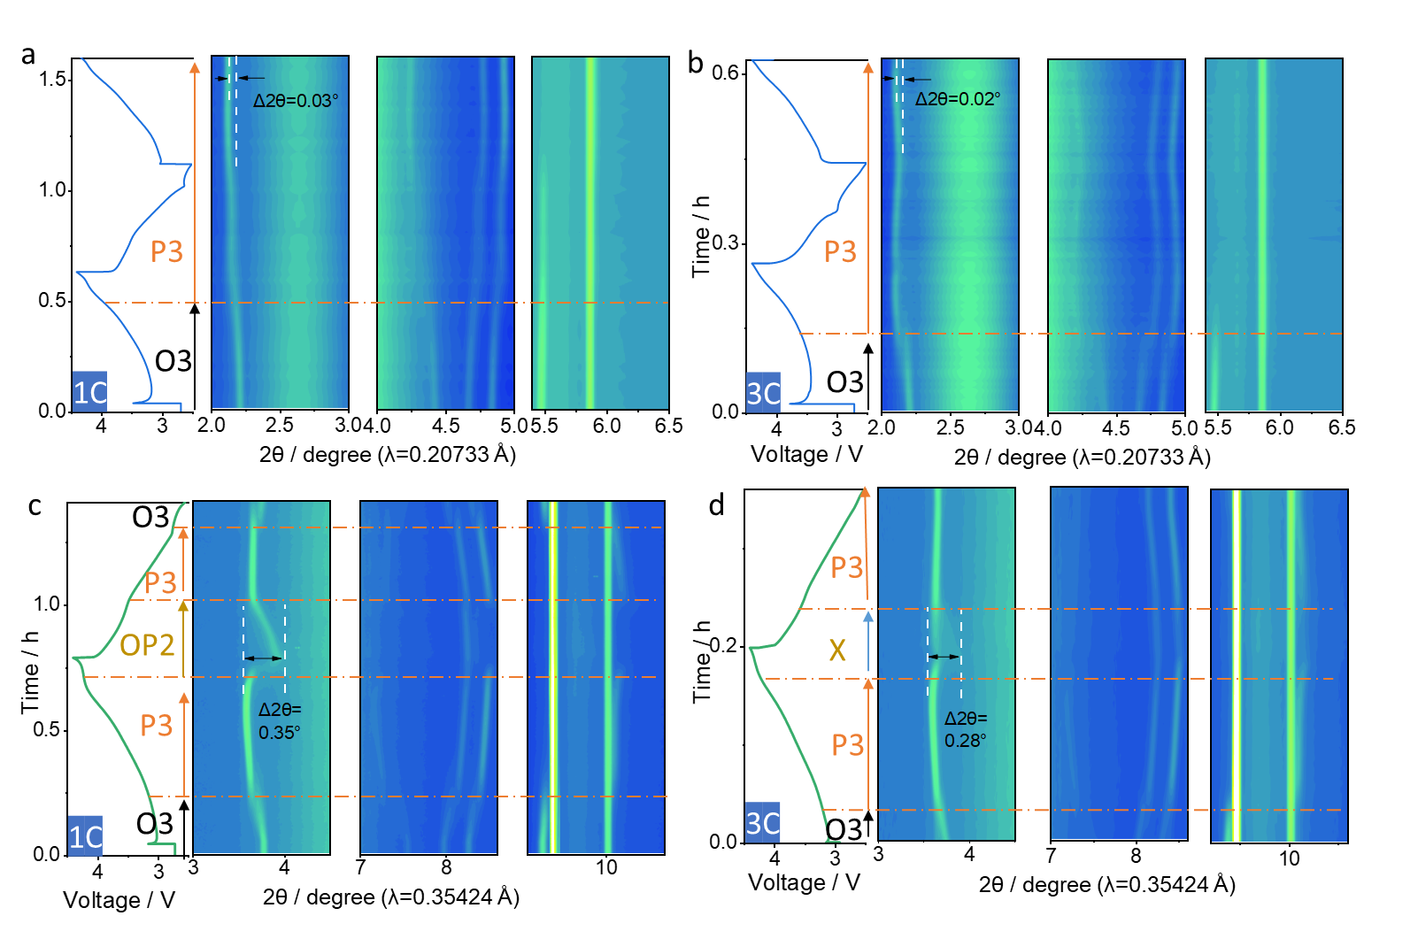
Figure S28 Contour plots of synchrotron-based operando XRD patterns: O3–ScTi doping at (a) 1C and (b) 3C rates (λ = 0.20733 Å), and O3–ScTiB doping at (c) 1C and (d) 3C rates (λ = 0.35424 Å). All cells were initially tested at 0.1C, followed by operando XRD measurements at 1C or 3C. As shown in the figures, all materials exhibit a similar O3 → P3 phase transition below 4.0 V, consistent with the 0.1C test. For the Sc and Ti co-doped sample, a single P3 phase is observed at high voltage and maintained during subsequent cycles at both 1C and 3C, indicating a direct single-phase P3 reaction under high-rate cycling. With the introduction of B, the phase transition behavior becomes more complex compared with the O3–ScTi sample. At 1C, the O3–ScTiB material undergoes sequential O3→P3→OP2 transitions during charging, while showing good reversibility upon discharge. At 3C, however, the material follows an O3→P3→X phase pathway during charging, but stabilizes in a single P3 phase during discharge. Compared with O3–ScTi, the O3–ScTiB sample shows more pronounced changes in 2θ, which can be attributed to reduced oxygen loss enabled by B doping. Overall, these results suggest that a single P3 pathway dominates in high-voltage layered oxides under fast de/intercalation processes, with B doping providing enhanced structural stability and distinct phase evolution.

Table S1 Lattice parameters deduced from the XRD Rietveld refinement for NaNi_{0.5}Mn_{0.5}O₂ (O3–undoped).
NaNi_{0.5}Mn_{0.5}O₂
Space Group: R3̅m
a = b = 2.94677 Å, c = 16.03702 Å, V = 120.60 Å³
χ² = 12.7, Bragg R-factor = 4.924 %
Atom | Site | x/a | y/b | z/c | Occupancy
Na | 3a | 0 | 0 | 0 | 0.08333
Ni | 3b | 0 | 0 | 0.5 | 0.04167
Mn | 3b | 0 | 0 | 0.5 | 0.04167
O | 6c | 0 | 0 | 0.2325 | 0.16667

Table S2 Lattice parameters deduced from the XRD Rietveld refinement for NaSc_{0.1}Ni_{0.4}Mn_{0.5}O₂ (O3–Sc doping).
NaSc_{0.1}Ni_{0.4}Mn_{0.5}O₂
Space Group: R3̅m
a = b = 2.945254 Å, c = 16.24059 Å, V = 122.01 Å³
χ² = 6.63, Bragg R-factor = 5.525 %
Atom | Site | x/a | y/b | z/c | Occupancy
Na | 3a | 0 | 0 | 0 | 0.08333
Ni | 3b | 0 | 0 | 0.5 | 0.03333
Sc | 3b | 0 | 0 | 0.5 | 0.00833
Mn | 3b | 0 | 0 | 0.5 | 0.04167
O | 6c | 0 | 0 | 0.2325 | 0.16667

Table S3 Lattice parameters deduced from the XRD Rietveld refinement for NaSc_{0.1}Ni_{0.4}Mn_{0.4}Ti_{0.1}O₂ (O3–ScTi doping).
NaSc_{0.1}Ni_{0.4}Mn_{0.4}Ti_{0.1}O₂
Space Group: R3̅m
a = b = 2.964582 Å, c = 16.118107 Å, V = 122.68 Å³
χ² = 7.98, Bragg R-factor = 8.971 %
Atom | Site | x/a | y/b | z/c | Occupancy
Na | 3a | 0 | 0 | 0 | 0.08333
Ni | 3b | 0 | 0 | 0.5 | 0.03333
Sc | 3b | 0 | 0 | 0.5 | 0.00833
Mn | 3b | 0 | 0 | 0.5 | 0.03333
Ti | 3b | 0 | 0 | 0.5 | 0.00833
O | 6c | 0 | 0 | 0.2325 | 0.16667

Table S4 Lattice parameters deduced from the XRD Rietveld refinement for NaSc_{0.1}Ni_{0.4}Mn_{0.4}Ti_{0.08}B_{0.02}O₂ (O3–ScTiB doping).
NaSc_{0.1}Ni_{0.4}Mn_{0.4}Ti_{0.08}B_{0.02}O₂
Space Group: R3̅m
a =b = 2.984512Å, c =16.070471 Å, V = 123.97 Å³
χ² = 8.67, Bragg R-factor = 6.99%
Atom | Site | x/a | y/b | z/c | Occupancy
Na | 3a | 0 | 0 | 0 | 0.08333
Ni | 3b | 0 | 0 | 0.5 | 0.03333
Sc | 3b | 0 | 0 | 0.5 | 0.00833
Mn | 3b | 0 | 0 | 0.5 | 0.03333
Ti | 3b | 0 | 0 | 0.5 | 0.00666
O | 6c | 0 | 0 | 0.2325 | 0.16667

Reference
1 Guo, Y. J. et al. Boron-doped sodium layered oxide for reversible oxygen redox reaction in Na-ion battery cathodes. Nat. Commun. 12, 5267 (2021).
2 Sathiya, M., Hemalatha, K., Ramesha, K., Tarascon, J. M. & Prakash, A. S. Synthesis, Structure, and Electrochemical Properties of the Layered Sodium Insertion Cathode Material: NaNi1/3Mn1/3Co1/3O2. Chem. Mater. 24, 1846-1853(2012).
3 Wang, Q. et al. Fast-charge high-voltage layered cathodes for sodium-ion batteries. Nat. Sustain. 7, 338-347 (2024).

