Large Fisheries Declines Linked to Compound and Extreme Climate Events

Authors
William W. L. Cheung^{1*}, Thomas L. Frölicher^{2, 3}, Isabella Morgante¹, Juliano Palacios-Abrantes¹

Affiliations
- Institute for the Oceans and Fisheries, The University of British Columbia
- Climate and Environmental Physics, Physics Institute, University of Bern, Bern, Switzerland
- Oeschger Centre for Climate Change Research, University of Bern, Bern, Switzerland

*Corresponding author: email: w.cheung@oceans.ubc.ca Tel: +1 604 827 3756

Supplementary Information

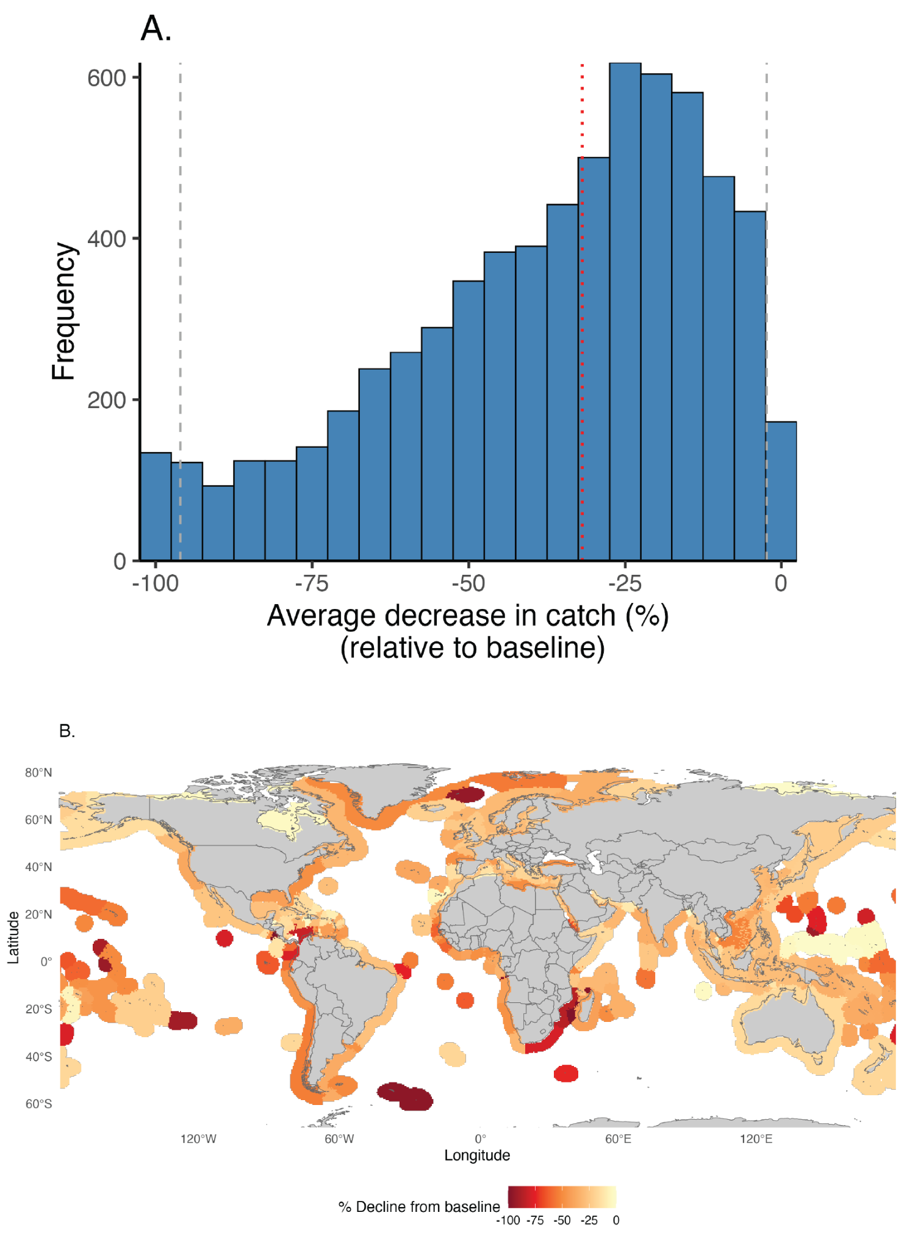
Supplementary Figure 1. Average historical extreme declines in catch from 1993 to 2022. (A) Histogram showing the distribution of the average percent decrease in catch across exclusive economic zone-species combinations during extreme events, relative to the mean non-extreme levels during the period. The vertical red dotted line indicates the median decline, while grey dashed lines represent the 2.5th and 97.5th percentiles (95% confidence interval). (B) Spatial distribution of average percent decline in catch, aggregated by EEZ. Warmer colors indicate greater reductions in catch during extreme events, with dark red representing declines approaching 100%. Grey areas indicate land and white regions indicate areas with no data.
Supplementary Figure 2. Linking species-specific environmental exposure with extreme low-catch events. Example illustrating the analytical framework for detecting compound environmental extremes and their correspondence with fishery outcomes. (Top panels) Species distribution within Exclusive Economic Zones (EEZs) is used to define spatial presence grids (left), overlaid on sea-surface temperature (SST; middle) and net primary production (NPP; right) fields. (Bottom panels) Time-series of catch, SST, and NPP averaged over the species–EEZ presence area are analysed to identify extreme temperature (TempX) and productivity (NPPX) anomalies. Coloured vertical bands indicate years of individual (TempX = red; NPPX = green) and compound (TempX + NPPX = orange) exposure events, which are subsequently compared with years of extreme low catch (CatchX = dashed lines) to quantify the association between environmental extremes and fishery performance.

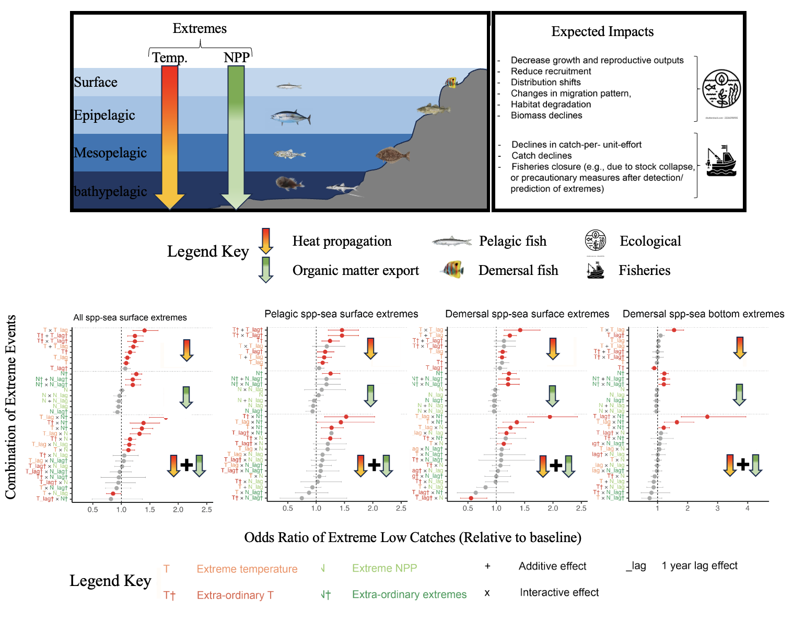
Supplementary Figure 3. Pathways and effects of high temperature and low net primary production (NPP) extremes on fish catches across ocean depths and functional groups. Top panel: Conceptual diagram illustrating how extreme temperature and NPP events propagate vertically through the ocean column, from surface to bathypelagic zones, and impact pelagic and demersal fishes via heat and organic matter fluxes. Resulting ecological responses include reduced growth and reproduction, biomass decline, habitat degradation, and altered migration and distribution. These processes translate into fishery-level impacts such as reduced catch, increased variability, and potential closures. Bottom panels: Odds ratios of extreme low catch events relative to baseline across different combinations of extreme events. Panels represent (from left to right): all species under surface extremes, pelagic species under surface extremes, demersal species under surface extremes, and demersal species under bottom extremes. Points show estimated odds ratios, with red indicating significant effects. Arrows and symbols denote whether effects stem from temperature (orange), NPP (green), or their combination (interactive: ×; additive: +). Extra-ordinary extremes (†) and lagged effects (_lag) are also indicated.

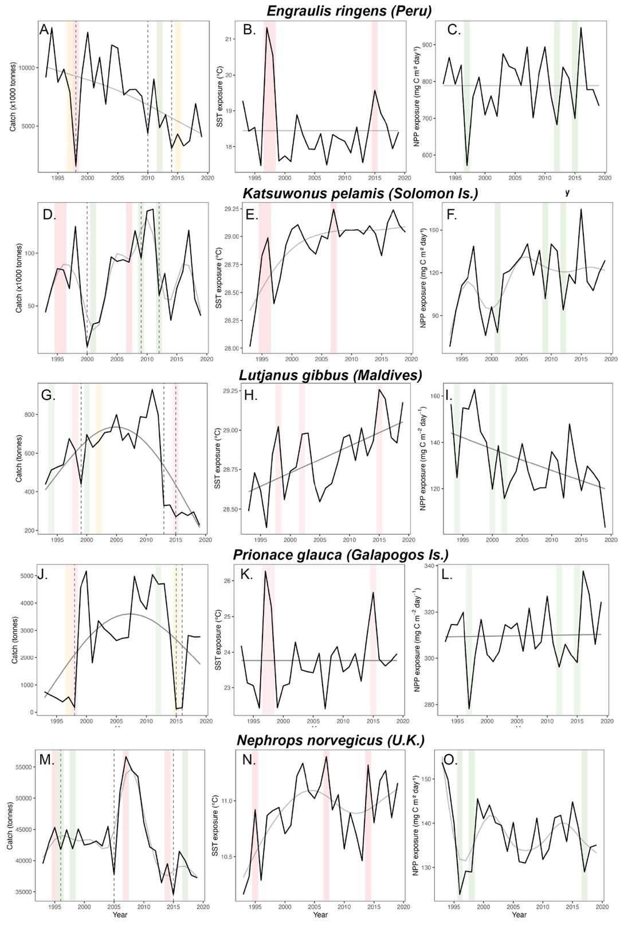
Supplementary Figure 4. Environmental exposures and extreme low-catch events across representative fisheries. Annual time-series of catch (left), sea-surface temperature (SST; middle), and net primary production (NPP; right) for (A–C) Engraulis ringens (Peru), (D–F) Katsuwonus pelamis (Solomon Islands), (G–I) Lutjanus gibbus (Maldives), (J–L) Prionace glauca (Galápagos Islands), and (M–O) Nephrops norvegicus (U.K.). Red, green, and yellow shaded bars indicate temperature (TempX), productivity (NPPX), and compound (TempX + NPPX) extreme years, respectively. Dashed lines denote extreme low-catch (CatchX) years. These species represent key fisheries within the functional groups and EEZs shown in Fig. 3.

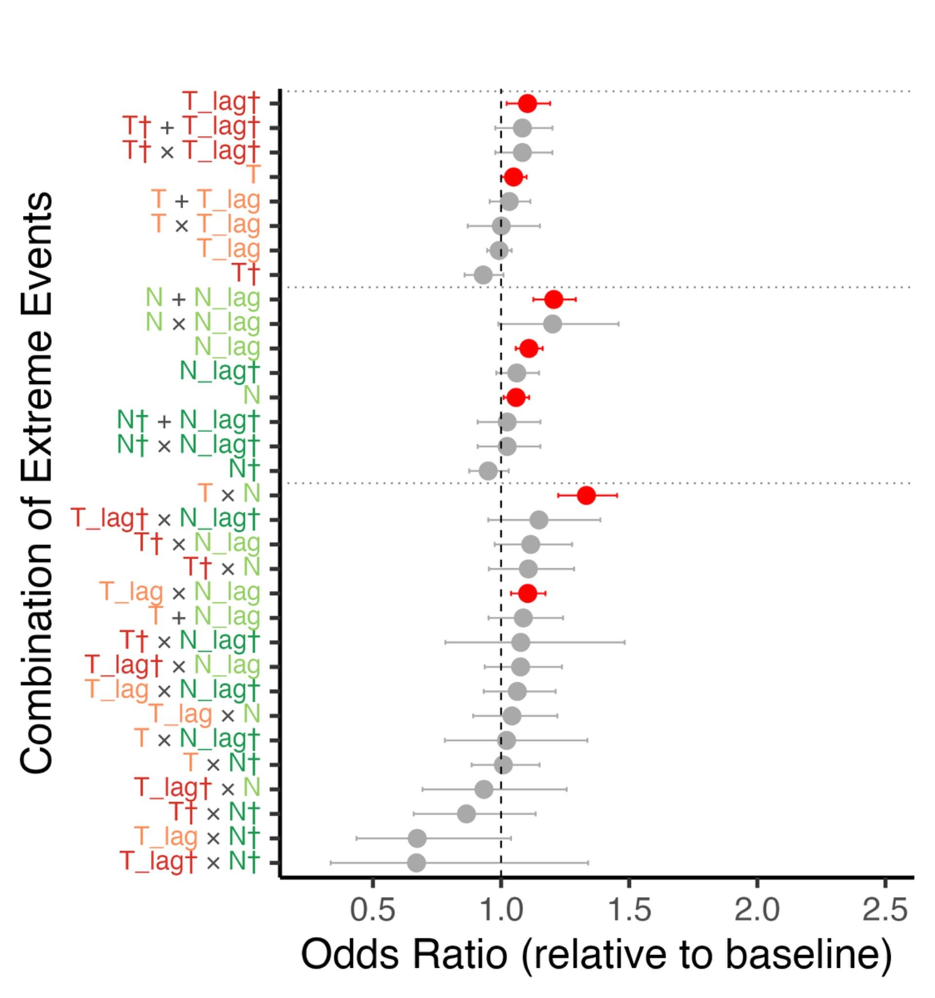
Supplementary Figure 5. Estimated weighted Odds Ratios (OR) for the occurrence of extreme high catch events in relation to extreme low temperature (Tt), extreme high net primary production (N), and their 1-year lagged effects (T_lag and N_lag) across all exclusive economic zones (EEZs) and exploited fishes and invertebrates. Variables marked with an asterisk (†) and in darker red and green colour represent extra-ordinary extreme temperature or NPP events (1 percentile outliers) while the lighter red and green colours represent ordinary extreme events (10 percentile outliers) occurring within the time series.

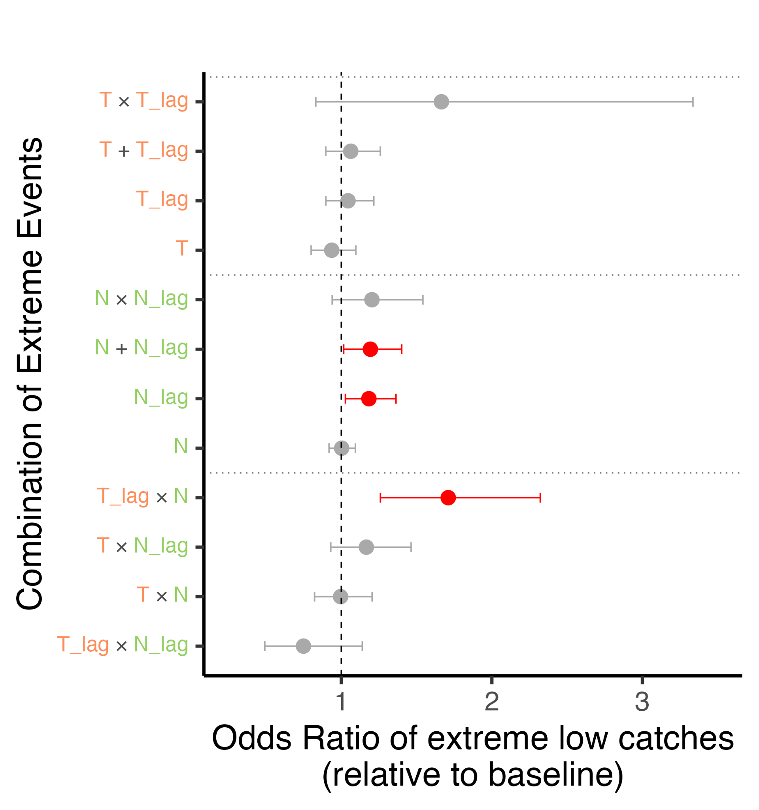

Supplementary Figure 6. Odds ratios of extreme low catches for demersal fish stocks in EEZs analyzed by Fredston et al. under different combinations of environmental extremes. Each point represents the estimated odds ratio (OR) for a specific combination of temperature (T) and net primary production (NPP) extremes, with horizontal lines indicating the 95% confidence intervals. Gray points are not statistically significant; red points indicate combinations where the OR is significantly greater than 1 (p < 0.05). While extreme temperature events alone (T, T_lag, T × T_lag) show weak or variable effects, low NPP events (N_lag, N + N_lag) and their compound interactions with temperature extremes (e.g., T_lag × N) consistently increase the likelihood of extreme low catch events. This highlights the greater predictive power of productivity-related stressors and lagged compound extremes in explaining fisheries collapse events.

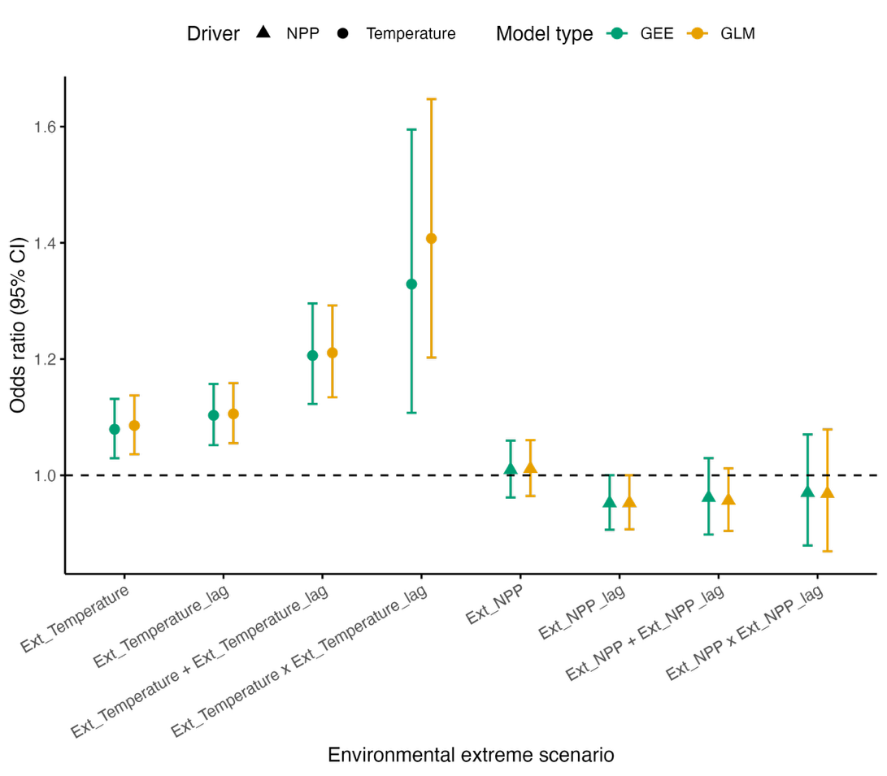

Supplementary Figure 7. Comparison of model-averaged odds ratios from generalized linear models (GLMs) and generalized estimating equations (GEEs). Odds ratios (±95% confidence intervals) represent the change in likelihood of extreme low catch events associated with environmental extremes in temperature (Ext_Temp, circles) and net primary productivity (Ext_NPP, triangles), and their lags, across single and compound scenarios. The dashed line denotes the baseline (OR = 1), corresponding to no effect of extremes.

Supplementary Table 1. Plausible drivers of extreme low-catch events for representative fisheries species. Summary of plausible explanations for identified extreme low-catch years for Engraulis ringens (Peruvian anchovy, Peru), Katsuwonus pelamis (skipjack tuna, Solomon Islands), Lutjanus gibbus (humpback red snapper, Maldives), Prionace glauca (blue shark, Galápagos Islands, Ecuador), and Nephrops norvegicus (Norway lobster, United Kingdom waters). These species represent key fisheries within the functional groups and EEZs shown in Fig. 3. Ext = extreme environmental conditions; Ent = non-extreme environmental variability; Mngt = management or policy actions; Othr = other socio-economic or operational factors.
Extreme low catch year | Mechanisms and Evidence | Plausible dominant driver(s)
Peruvian anchovy (Engraulis ringens) in Peru
1998 | During the strong 1997–98 El Niño, pronounced surface warming and weakened coastal upwelling sharply reduced primary productivity^{1,2}. The decline in plankton availability impaired growth and survival of juvenile anchoveta and altered stock distribution, with schools moving deeper and closer to shore³. These disruptions led to major reductions in biomass and landings of the Peruvian anchoveta fishery. | Ext
2010 | A moderate, short-lived El Niño affected coastal waters. The first full year of Individual Vessel Quota (IVQ) implementation coincided with low adult biomass and a high proportion of juveniles in catches. The main fishing season was closed early to protect recruitment. Fleet consolidation and precautionary IVQ enforcement contributed to lower landings, with recovery in 2011⁴. | Ent + Mngt
2014 | Acoustic surveys indicated inadequate adult biomass and high juvenile abundance in the North–Central anchoveta stock. In the context of warming sea-surface temperatures building toward the 2015 El Eiño, the main fishing season was cancelled as a precautionary measure, reflecting adaptive management in response to both environmental stress and stock composition indicators⁵. | Ent + Mngt
Skipjack tuna (Katsuwonus pelamis) in the Solomon Islands
2000 | National political unrest following the June 2000 coup disrupted domestic fishing, processing, and port operations in the Solomon Islands. Foreign fleets reduced effort within Solomon EEZ, and reporting coverage declined⁶. | Othr
2010 | The onset of El Niño conditions led to weakened upwelling and reduced NPP in the western equatorial Pacific, including Solomon Islands waters⁷. El Niño conditions and lower productivity in Western Pacific generally leads to an eastward shift of skipjack habitat that would have reduced catch within the Solomon Islands EEZ⁸. | Ext
2012 | No direct published explanation was found for the low skipjack catch in Solomon Islands waters. However, the event coincided with reduced net primary production in the western equatorial Pacific, consistent with expectations from ecosystem and biogeochemical models ⁸. | Ext
Humpback red snapper (Lutjanus gibbus) in the Maldives
1999 | Severe coral bleaching during the 1997–98 El Niño caused widespread reef mortality in the Maldives, leading to habitat loss⁹. The resulting collapse of reef structural complexity reduced habitat and recruitment success for reef-associated fishes including L. gibbus. Although the bleaching event occurred in 1998, reef-fishery impacts were most evident in 1999, reflecting a lagged ecological response as juvenile cohorts failed to replenish adult populations. Similar lag effects following the 1998 bleaching have been documented in the western Indian Ocean¹⁰. | Ext
2009 | No direct published explanation was found for the sharp decline in L. gibbus catch in the Maldives. | Othr
2015 | The 2014–2016 El Niño produced record sea-surface temperatures across the Indian Ocean. The strong El Niño, compounded by a positive Indian Ocean Dipole, triggered widespread coral bleaching and large losses of live coral, comparable in severity to the 1998 event. The coral mortality and thermal stress likely degraded reef habitat and prey availability for reef-associated species, and expected to have contributed to the observed low catch of L. gibbus in 2015^{10,11} ^{10,11}. | Ext
Blue shark (Prionace glauca) in the Galapagos Islands (Ecuador)
1998 | The 1997-1998 El Niño was associated with high sea surface temperature, deeper thermocline and lower primary production in the eastern tropical Pacific region, and blue shark, a subtropical to temperate species, would shift to deeper water as suggested in the California Current upwelling system that would have led to lower catchability and catch¹². In the late 1990s, after the collapse of the sea cucumber fishery, many newly immigrated Galapagos fishers turned to fishing for sharks, which could explain the immediate increase in catches¹³. In 1998, the Galapagos Marine Park was established, but illegal fishing continues to happen until the early 2010s. | Ext + Othr
2015-16 | The 2014-2016 El Niño was associated with high sea surface temperature, deeper thermocline and lower primary production¹⁴ and would have contributed to lower blue shark catches as in 1998. Between 2009 and 2011, the Galápagos National Park Directorate implemented satellite-based Vessel Monitoring Systems (VMS) and the Automatic Identification System (AIS) to enhance maritime surveillance. Additionally, anecdotal evidence suggests that by 2012, shark finning had lost much of its economic attractiveness in the region. These events could explain the drop in catches in the region¹⁵. | Ext+Othr
Norway lobster (Nephrops norvegicus) in the United Kingdom Waters
1996 | The lower Nephrops catches in UK waters in 1996 were likely caused by environmentally driven reductions in catchability, reduced fishing effort and technical constraints¹⁶. | Ent + Othr
2005 | During 2003–2005, the European Council applied zero total allowable catch (TAC) and quota regulations EU-wide, including the UK’s share of TACs in its ICES divisions VIa (West of Scotland) and VIIj–k (SW of Ireland) ¹⁷. | Othr
2015 | The decline in UK landings in 2015 appears to reflect a combination of reduced catchability and availability, likely related to localized stock and environmental conditions, and operational or management constraints such as mixed-fishery interactions, days-at-sea limits, and restricted access to fishing grounds ^{18–20}. | Ent + Othr

References
1. Ñiquen, M. & Bouchon, M. Impact of El Niño events on pelagic fisheries in Peruvian waters. Deep Sea Res. Part II Top. Stud. Oceanogr. 51, 563–574 (2004).
2. Sanchez, G., Calienes, R. & Zuta, S. The 1997-98 El Niño and its effects on the coastal marine ecosystem off Peru. Rep. Calif. Coop. Ocean. Fish. Investig. 41, 62–86 (2000).
3. Bouchon, M., Diaz, E., Cahuín, S. & Ochoa, M. Effects of" El Niño" 1997-98 on the Schooling Behaviour of the Peruvian Anchovy (Engraulis ringens). Investig. Mar. 30, 182–183 (2002).
4. Kroetz, K. et al. Examination of the Peruvian anchovy individual vessel quota (IVQ) system. Mar. Policy 101, 15–24 (2019).
5. IMARPE – PRODUCE. Peru’s Annual Report, Part II: National Report on the Situation of the Peruvian Stock of Jack Mackerel (Far-North Stock) and the Peruvian Fishery in National Jurisdictional Waters. https://www.sprfmo.int/assets/Meetings/02-SC/2018-SC6/Meeting-Documents/SC6-Doc20-Peru-Annual-Report-part-2.pdf (2018).
6. Tukuta, L. Sustainable Management and Development of Solomon Islands Fishery Resources: New Directions in Fisheries Policy.
7. Lee, T. et al. Record warming in the South Pacific and western Antarctica associated with the strong central-Pacific El Niño in 2009–10. Geophys. Res. Lett. 37, (2010).
8. Lehodey, P. et al. Predicting skipjack tuna forage distributions in the equatorial Pacific using a coupled dynamical bio‐geochemical model. Fish. Oceanogr. 7, 317–325 (1998).
9. Schuhmacher, H., Loch, K., Loch, W. & See, W. R. The aftermath of coral bleaching on a Maldivian reef—a quantitative study. Facies 51, 80–92 (2005).
10. Graham, N. A. et al. Lag effects in the impacts of mass coral bleaching on coral reef fish, fisheries, and ecosystems. Conserv. Biol. 21, 1291–1300 (2007).
11. Zubair, L. & Nijamdeen, A. The Maldives: The 2014–2016 El Niño in the Maldives: Climate, Impacts, and Response. in El Niño Ready Nations and Disaster Risk Reduction: 19 Countries in Perspective 45–62 (Springer, 2022).
12. Godínez-Padilla, C. J., Castillo-Géniz, J. L., Hernandez de la Torre, B., González-Ania, L. V. & Román-Verdesoto, M. H. Marine-climate interactions with the blue shark (Prionace glauca) catches in the western coast of Baja California Peninsula, Mexico. Fish. Oceanogr. 31, 291–318 (2022).
13. Jacquet, J., Alava, J. J., Pramod, G., Henderson, S. & Zeller, D. In hot soup: sharks captured in Ecuador’s waters. Environ. Sci. 5, 269–283 (2008).
14. Jarrin, J. R. M. & Salinas-de-León, P. Effects of the 2016 El Niño on the Galapagos Artisanal Coastal Fin-Fish Fishery. (2018).
15. Hockings, M. et al. Galapagos Marine Reserve management effectiveness assessment. Galapagos National Park Service. World Wildl. Fund Galapagos Ecuad. (2012).
16. ICES. Report of the Working Group on Nephrops Stocks. ICES CM 1997/Assess:13. https://ices-library.figshare.com/articles/report/Report_of_the_Working_Group_on_Nephrops_Stocks_-_Part_1_of_2/19262930?file=41343927 (1997).
17. Council of the European Union. Council Regulation (EC) No. 27/2005 of 22 December 2004 fixing for 2005 the fishing opportunities and associated conditions for certain fish stocks and groups of fish stocks, applicable in Community waters and, for Community vessels, in waters where catch limitations are required. Off. J. Eur. Union L 12, 1–123.
18. Russell, J. & Mardle, S. Analysis of Nephrops Industry in Scotland. https://www.gov.scot/binaries/content/documents/govscot/publications/foi-eir-release/2018/02-a/foi-17-02544/documents/foi-17-02544-nephrops-final-report-171017-issued-pdf/foi-17-02544-nephrops-final-report-171017-issued-pdf/govscot%3Adocument/FOI-17-02544%2B-%2BAS%2Bnephrops%2BFINAL%2Breport%2B171017%2BISSUED.pdf (2017).
19. North Sea Regional Advisory Council. Long-Term Management Plan for Nephrops in the North Sea. Document 2-1415-2015-02-16.
20. Scottish Government. Provisional Scottish Sea Fisheries Statistics 2015. Edinburgh: Marine Scotland Science. (2016).

