Supplementary Table S1. Study population and criteria (descriptive; not used for analyses)
Category | Details
Study design | Retrospective cohort study
Study location | King Abdulaziz Cardiac Center, Riyadh
Study period | 2010-2015
Sample size | 237 patients
Inclusion criteria | Adults with ICD implantation
Exclusion criteria | Incomplete ECG data, lost to follow-up

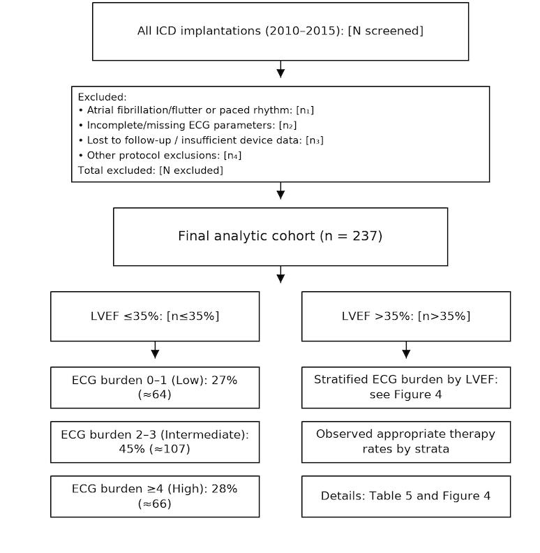

Supplementary Figure S1. The final analytic cohort (n=237) includes ICDs for both primary and secondary prevention. LVEF was summarized descriptively; binary LVEF analyses excluded patients with EF ranges spanning 35%.

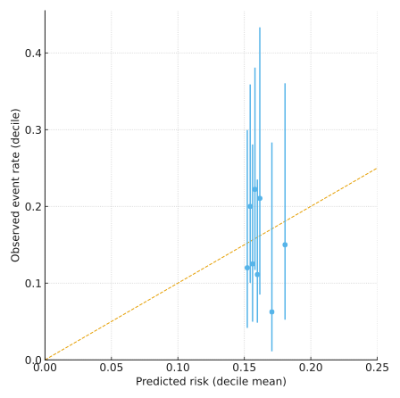
Supplementary Figure S2. Calibration of the combined model (LVEF≤35% + ECG burden). Points represent observed versus predicted event rates by decile (means with 95% binomial confidence intervals); the dashed line indicates perfect calibration.

