Supplemental Table 1: List of 256 variables included in the mobility predictor analysis
Predictors
Age in years
Beer consumed on weekdays (number of drinks)
Beer consumed on weekends (number of drinks)
Binge drinking female
Frequency alcohol consumption past 12 months
Alcohol consumption compared to heaviest drinking period
Liquors consumed on weekdays (number of drinks)
Liquors consumed on weekends (number of drinks)
Binge drinking male
Another kind of alcohol consumed on weekdays (number of drinks)
Another kind of alcohol consumed on weekends (number of drinks)
Red wine consumed on weekdays (number of drinks)
Red wine consumed on weekends (number of drinks)
White wine consumed on weekdays (number of drinks)
White wine consumed on weekends (number of drinks)
Albumin
Estimated Glomerular Filtration Rate
Ferritin
Granulocytes (absolute number)
Hemoglobin A1c
High-Density Lipoprotein
Hemoglobin
High Sensitivity C-Reactive Protein
Low-Density Lipoprotein, calculated
Lymphocytes (absolute number)
Mean corpuscular hemoglobin
Mean corpuscular volume
Monocytes (absolute number)
Platelets
Red blood cells
Red blood cell distribution width
Triglycerides
Thyroid-Stimulating Hormone
25-hydroxyvitamin D
White blood cells
Average Diastolic Blood Pressure (All measurements)
Average Pulse (All measurements)
Average Systolic Blood Pressure (All measurements)
Relationship of the Main Care Recipient
Comorbidity: Cancer domain
Comorbidity: Cardiovascular domain
Comorbidity: Endocrine domain
Comorbidity: Genitourinary domain
Comorbidity: Gastrointestinal domain
Comorbidity: Musculoskeletal domain
Comorbidity: Neurological domain
Comorbidity: Opthalmalogic domain
Comorbidity: Renal domain
Comorbidity: Respiratory domain
Comorbidity: Total count
Animal fluency test: score 1
Animal fluency test: score 2
Mental alternation test score
Rey I: Auditory Verbal Learning Test
Rey II: Auditory Verbal Learning Test
Relationship of Main Caregiver
Flag for Receiving Formal or Informal Home Care (Last 12 Months)
Mean Reaction Time (in ms)
Died since bl visit
Center for Epidemiological Studies Short Depression Scale (CES-D 10) score
CES-D 10: count of missing items
Body Composition Index
Pure lean mass (without bone) in limbs
Pure lean mass (without bone) in head
Pure lean mass (without bone) in left leg
Pure lean mass (without bone) in left arm
Pure lean mass (without bone) in right leg
Pure lean mass (without bone) in right arm
Total pure lean mass (without bone) excluding head region
Pure lean mass (without bone) in trunk
Length of Left Hip Axis in cm
Femur Shaft Average Cortical Thickness (cm) - left hip
Femur Shaft Buckling Ratio (dimensionless) - left hip
Femur Shaft Center of Mass Position (dimensionless) - left hip
Femur Shaft Cross Sectional Area (cm2) - left hip
Femur Shaft Cross Sectional Moment of Inertia (cm4) - left hip
Femur Shaft Endocortical Diameter (cm) - left hip
Femur Shaft Profile Center Distance (cm) - left hip
Femur Shaft Section Modulus (cm3) - left hip
Femur Shaft Subperiosteal Width (cm) - left hip
Intertrochanter Average Cortical Thickness (cm) - left hip
Intertrochanter Buckling Ratio (dimensionless) - left hip
Intertrochanter Center of Mass Position (dimensionless) - left hip
Intertrochanter Cross Sectional Area (cm2) - left hip
Intertrochanter Cross Sectional Moment of Inertia (cm4) - left hip
Intertrochanter Endocortical Diameter (cm) - left hip
Intertrochanter Profile Center Distance (cm) - left hip
Intertrochanter Section Modulus (cm3) - left hip
Intertrochanter Subperiosteal Width (cm) - left hip
T-score for Neck Bone analysis - left hip
Narrow Neck Average Cortical Thickness (cm) - left hip
Narrow Neck Bone Mineral Density (g/cm2) -Left hip
Narrow Neck Buckling Ratio (dimensionless) - left hip
Narrow Neck Center of Mass Position (dimensionless) - left hip
Narrow Neck Cross Sectional Area (cm2) - left hip
Narrow Neck Cross Sectional Moment of Inertia (cm4) - left hip
Narrow Neck Endocortical Diameter (cm) - left hip
Narrow Neck Profile Center Distance (cm) - left hip
Narrow Neck Section Modulus (cm3) - left hip
Narrow Neck Subperiosteal Width (cm) - left hip
DXA total fat mass
Total BMD
P Duration
P Offset
P Onset
PP Interval
PQ Interval
Q Offset
Q Onset
QRS Duration
QRS Number
QT Interval
QTC Interval
RR Interval
T Offset
Ventricular Rate
Highest Level of Education - Respondent, 4 Levels
Highest Level of Education - Respondent, 11 Levels
Fall Status - 12 months
FAS test: __ score
10 year probability (x 100) of hip fracture, without knowing BMD
10 year probability (x 100) of osteoporotic fracture, without knowing BMD
Baseline gate speed (m/s)
Play games cards etc
Perceived Health
Perceived Mental Health
Self-rated general health
Self-rated mental health
Play musical instrument or sing
Self-rated healthy aging
Average grip strength for all trials
Average height in m
Hearing rating
Body Mass Index
Highest source of household income
Highest source of personal income
Second highest source of personal income
Total personal income
Second highest source of household income
Total household income
Number of times injured (past 12 months)
Frequency been to places outside town
Frequency been to places in the neighbourhood
Frequency been to outside area of home
Frequency been to places outside neighbourhood but within town
Frequency of consumption (times per day) of whole wheat breads, bran breads, multigrain breads, ryebreads
Frequency of consumption (times per day) of butter or regular margarine
Frequency of consumption (times per day) of other calcium-fortified beverages
Frequency of consumption (times per day) of Calcium-fortified juices
Frequency of consumption (times per day) of calcium-fortified foods
Frequency of consumption (times per day) of calcium-fortified milk (35% more calcium)
Frequency of consumption (times per day) of chicken, turkey
Frequency of consumption (times per day) of chocolate bars
Frequency of consumption (times per day) of all regular cheeses
Frequency of consumption (times per day) of carrots
Frequency of consumption (times per day) of milk-based desserts
Frequency of consumption (times per day) of regular vinaigrettes, dressings, and dips
Frequency of consumption (times per day) of pasteries
Frequency of consumption (times per day) of all egg dishes except omega 3 eggs
Frequency of consumption (times per day) of high fibre breakfast cereals
Frequency of consumption (times per day) of fish
Frequency of consumption (times per day) of french fries or pan-fried potatoes, poutine
Frequency of consumption (times per day) of fruit
Frequency of consumption (times per day) of green salad
Frequency of consumption (times per day) of legumes: beans, peas, lentils
Frequency of consumption (times per day) of 2%, 1%, skim milk
Frequency of consumption (times per day) of all low-fat cheeses
Frequency of consumption (times per day) of yogurt (low-fat)
Frequency of consumption (times per day) of beef, pork
Frequency of consumption (times per day) of other meats (veal, lamb, game)
Frequency of consumption (times per day) of nuts, seeds and peanut butter
Frequency of consumption (times per day) of omega-3 eggs
Frequency of consumption (times per day) of patÃ©s, cretons, terrines
Frequency of consumption (times per day) of potatoes
Frequency of consumption (times per day) of 100% pure fruit juices
Frequency of consumption (times per day) of salty snacks
Frequency of consumption (times per day) of sausages, hot dogs, ham, smoked meat, bacon
Frequency of consumption (times per day) of sauces and gravies
Frequency of consumption (times per day) of other vegetables (except carrots, potatoes or salad)
Frequency of consumption (times per day) of whole milk 3.25% m.f
Frequency of consumption (times per day) of yogurt (regular)
Dwelling type
Dwelling ownership/ rent status
Accuracy of Response
Intention to perform
Need of Reminders
Primary Care Posttraumatic Stress Disorder (PC-PTSD) score
Number of missing items on PC-PTSD
Subjective retirement status
Aboriginal identity
Cultural / Racial Background
First Official Language Learned and Still Understood
Language(s) in Which Respondent Can Converse
Immigration Flag
Country of Birth - grouped
Marital/partner status
Sexual orientation
Religion
Urban/ rural classification
Biological sex
Required more than 30 min to fall asleep
Number of sleep hours during past month
Frequency waking up and having difficulty falling asleep again
Satisfaction with current sleep pattern
Frequency finding difficulty to stay awake during normal hours
Satisfaction with Life Scale (SWLS) - Classification
SWLS: The conditions of my life are excellent - Grouped
SWLS: I have gotten the important things I want in life - Grouped
SWLS: Life is close to my ideal - Grouped
SWLS: If I could live my life over, I would change almost nothing - Grouped
SWLS: I am satisfied with my life - Grouped
Satisfaction with Life Scale (SWLS) - Score
Type of Smoker
Number of cigarette packs per year
Number of living children
Number of Persons in Household Greater Than or Equal to 65 Years of Age
Number of Persons in Household Between 16 and 64 Years of Age
Living/Family Arrangement of Participant (generational households)
Number of Persons in Household Less Than 16 Years of Age
Number of close friends
Number of people living in household (excluding the participant)
Number of Children Living in Household
Number of neighbours
Number of people known through other activities
Number of people known through community involvement
Number of people known through work or school
Number of living relatives
Last get together with children outside of household
Last get together with close friends outside of household
Last get together with neighbours
Last get together with relatives outside of household
Last get together with siblings outside of household
Number of living siblings
Frequency of Community-Related Activity Participation (past 12 months)
Max forced expiratory volume
Max forced vital capacity
Affection - MOS Subscale
Emotional and Informational Support - MOS Subscale
Positive Social Interaction - MOS Subscale
Tangible Social Support - MOS Subscale
Language used at start of interview
Stroop test score
Accuracy of Response
Intention to perform
Need of Reminders
Intaocular pressure - left eye
Intaocular pressure - right eye
Visual acuity test result for both eyes
Visual acuity test result for left eye
Visual acuity test result for right eye
Eyesight rating
Average weight in kg
Waist to hip ratio
Ever used hormone replacement therapy
Occurrence of menopause
Age of menopause onset

Supplemental Figure 1: R packages used in the analysis
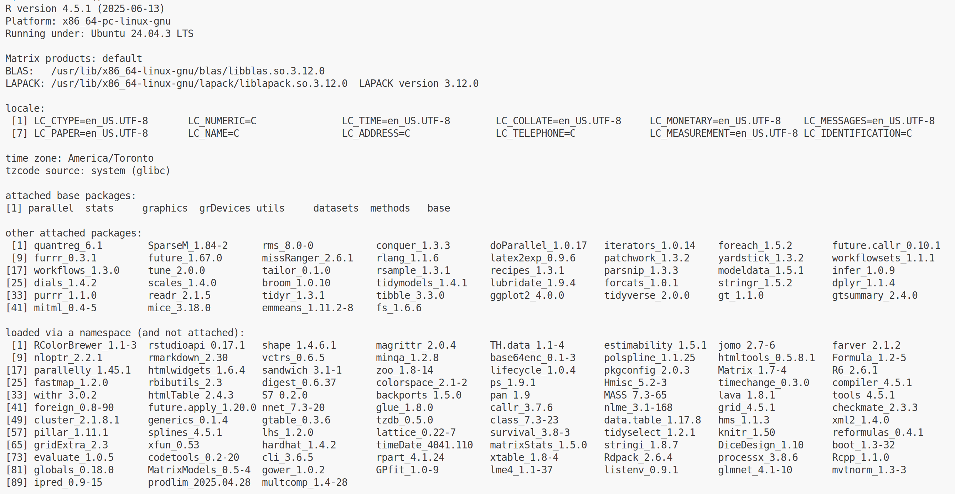

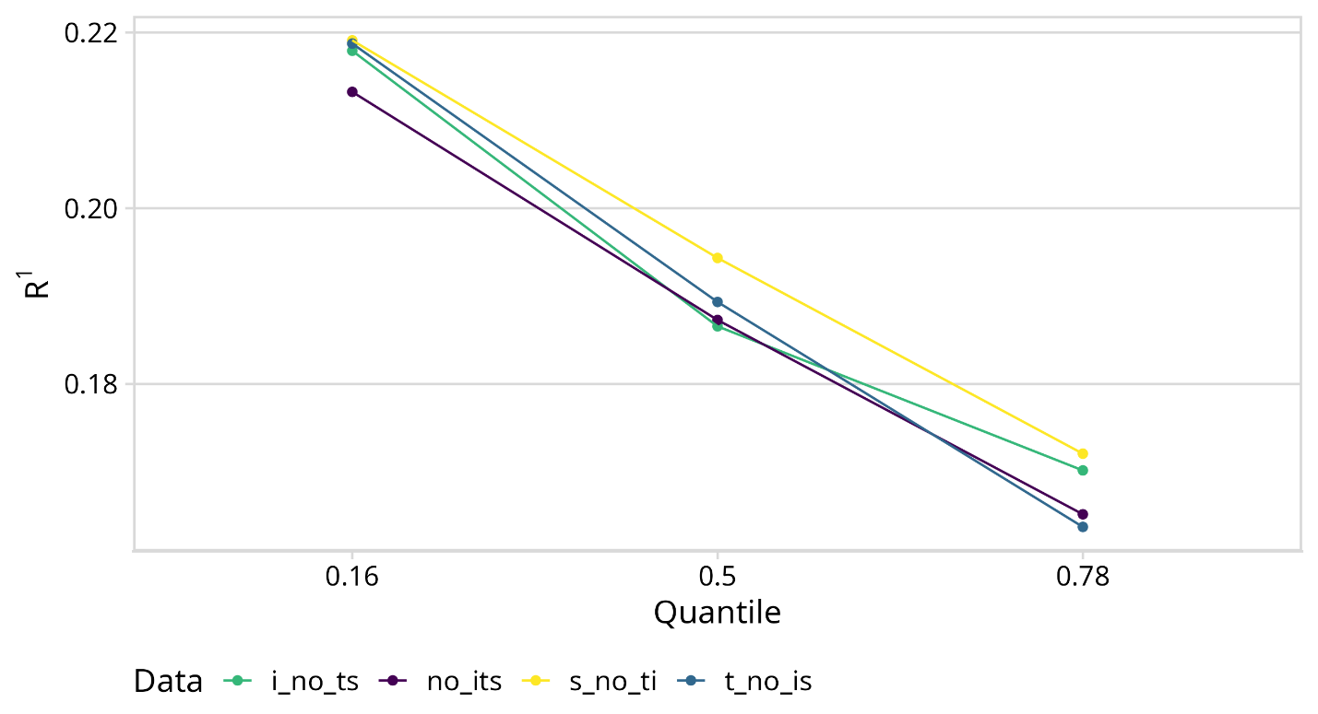
Supplemental Figure 2: Predictive performance of quantile regression models on the test set across four feature engineering strategies. Across the quantiles, the strategy using splines and no transformations or interactions (s_no_ti or yellow), generalized best.

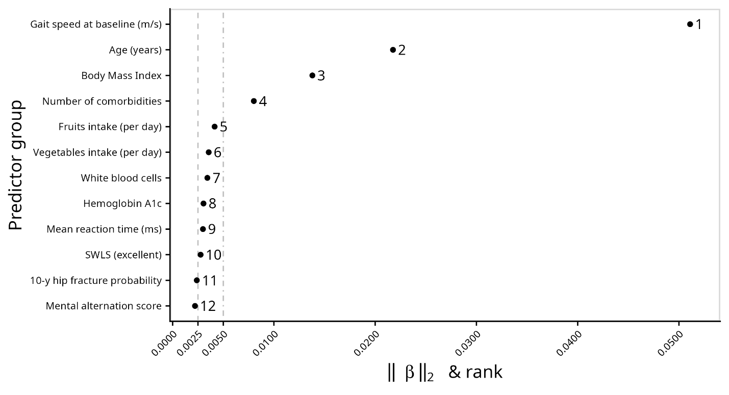
Supplemental Figure 3: Coefficient L² norms at the 78th quantile, based on training set results using the λ selected via 10fCV. Four predictors stand out due to their large coefficient L² norms: baseline gait speed, age, BMI, and comorbidity count. Predictors with ranks five through twelve exhibits substantially smaller L² norms, suggesting their associations with follow-up gait speed may be less stable.

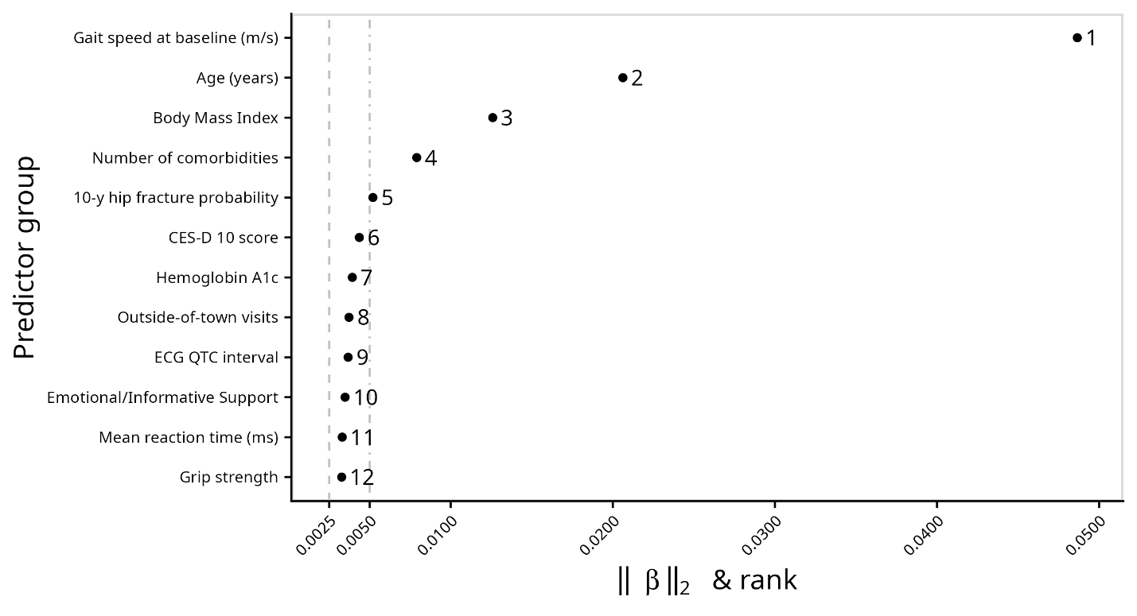 Supplemental Figure 4: Coefficient L² norms at the 16th quantile, based on training set results using the λ selected via 10fCV.

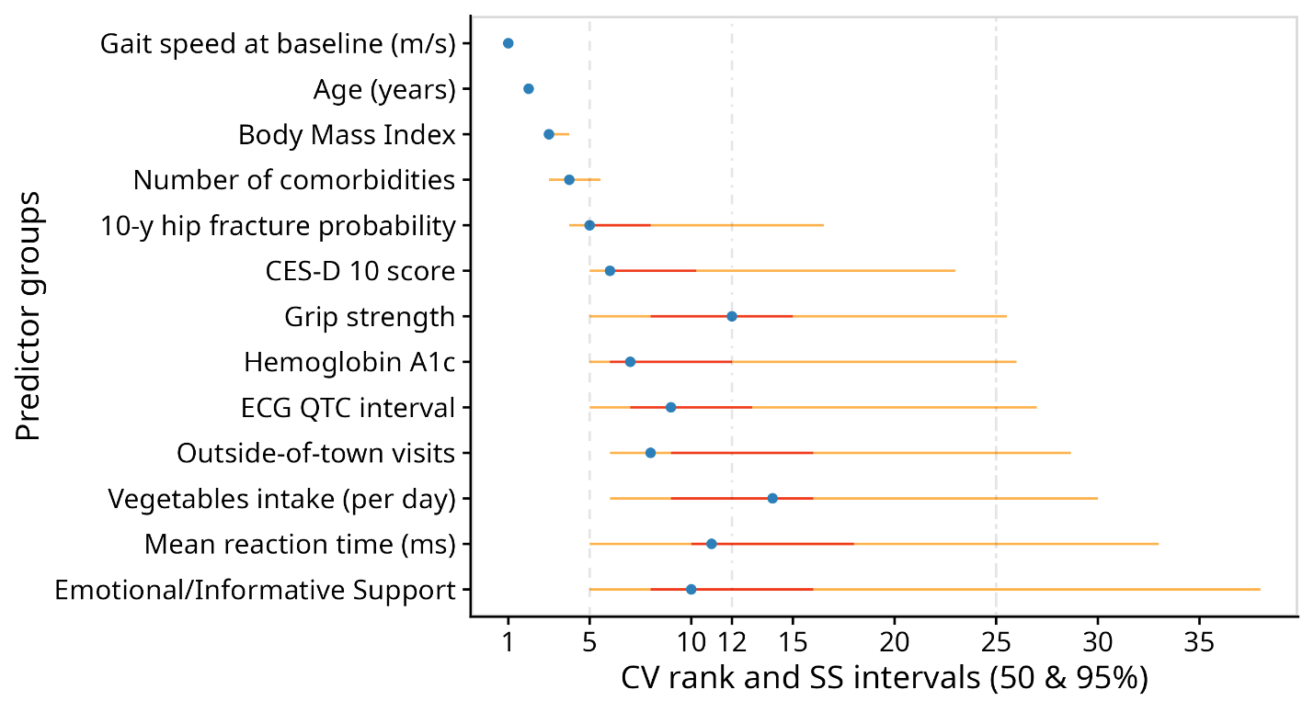 Supplemental Figure 5: Stability results for the 16th quantile: blue dots show ranks from the 10fCV, red lines indicate 50% percentile rank intervals, and yellow lines represent 95% intervals.

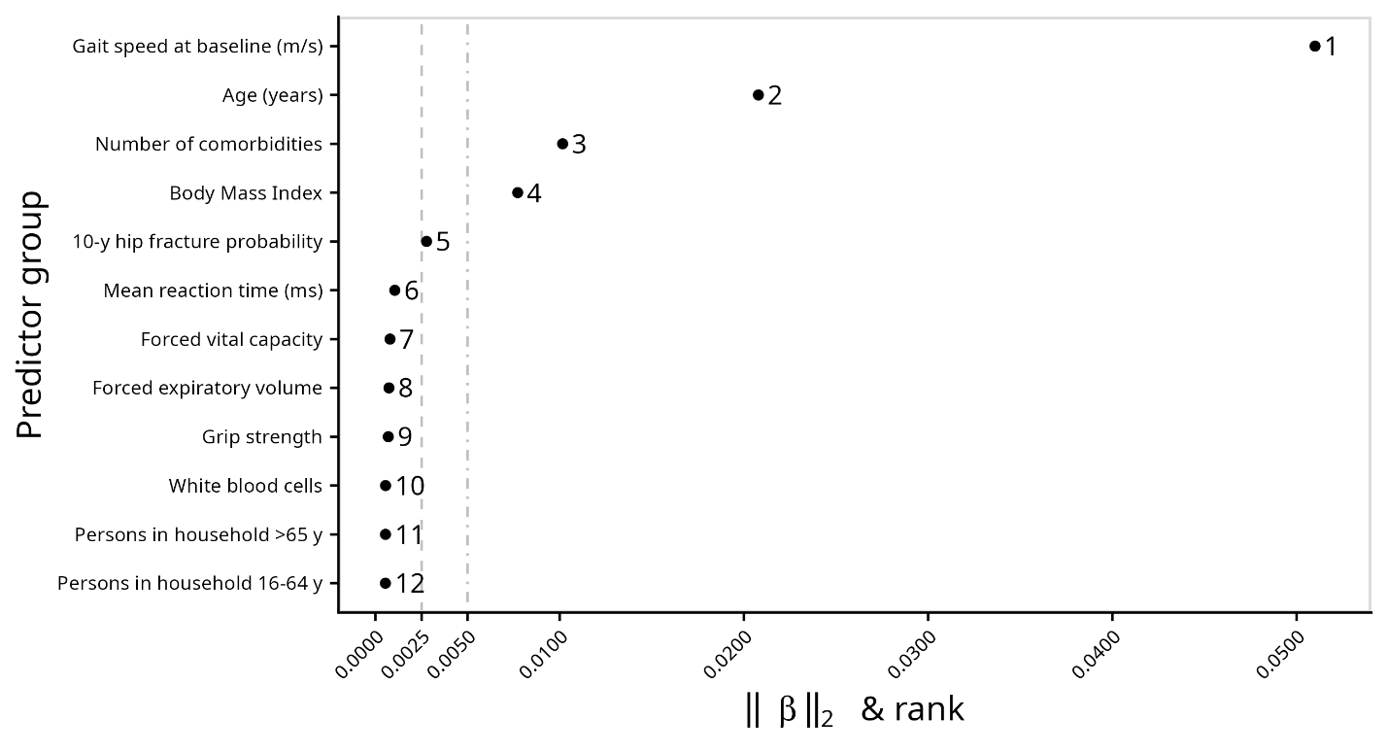 Supplemental Figure 6: Coefficient L² norms at the 50th quantile, based on training set results using the λ selected via 10fCV.

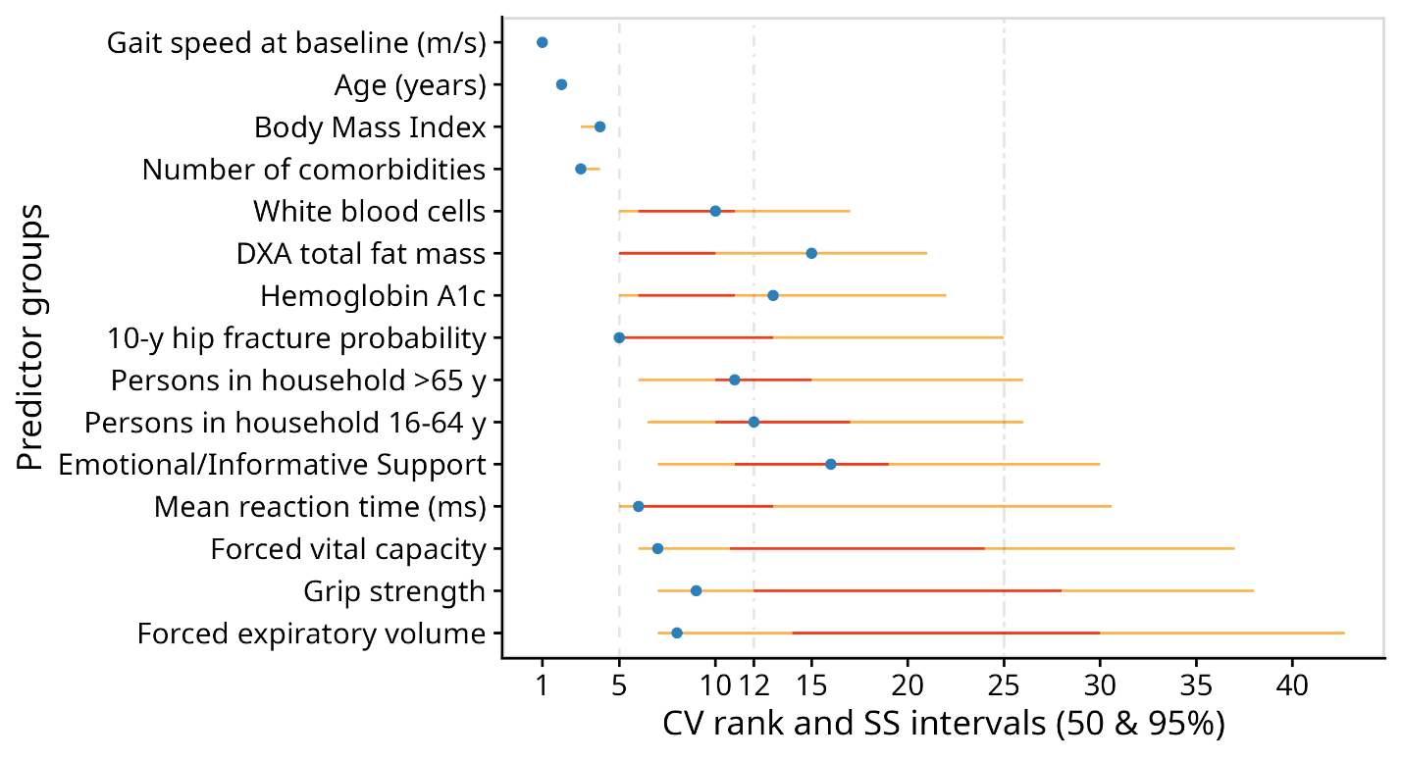 Supplemental Figure 7: Stability results for the 50th quantile: blue dots show ranks from the 10fCV, red lines indicate 50% percentile rank intervals, and yellow lines represent 95% intervals.

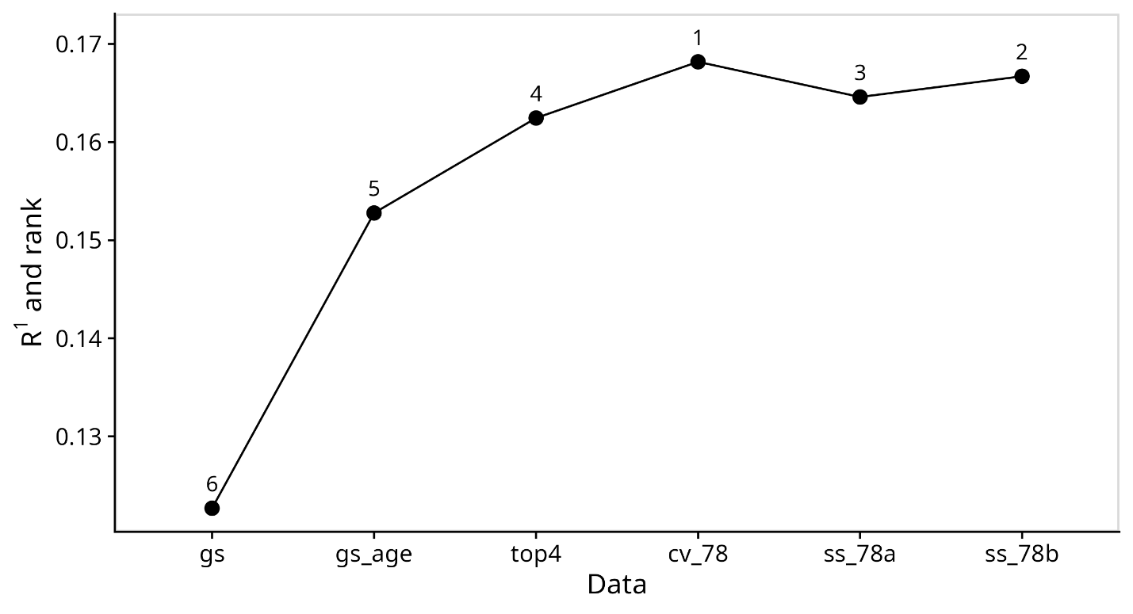 Supplemental Figure 8: Data splitting results at the 78th quantile. The model using predictors with an upper 95th percentile ranks ≤ 25 (ss_78b) has fewer predictors than the one from 10fCV (cv_78) and generalizes to new data equally well based on a region of practical equivalence of 0.005. The cv_78 model and the model with predictors having an upper 95th percentile ranks ≤ 20 (ss_78a) fell just below the equivalence threshold of 0.95. All comparisons showed equivalence when the ROPE was widened to 0.01.

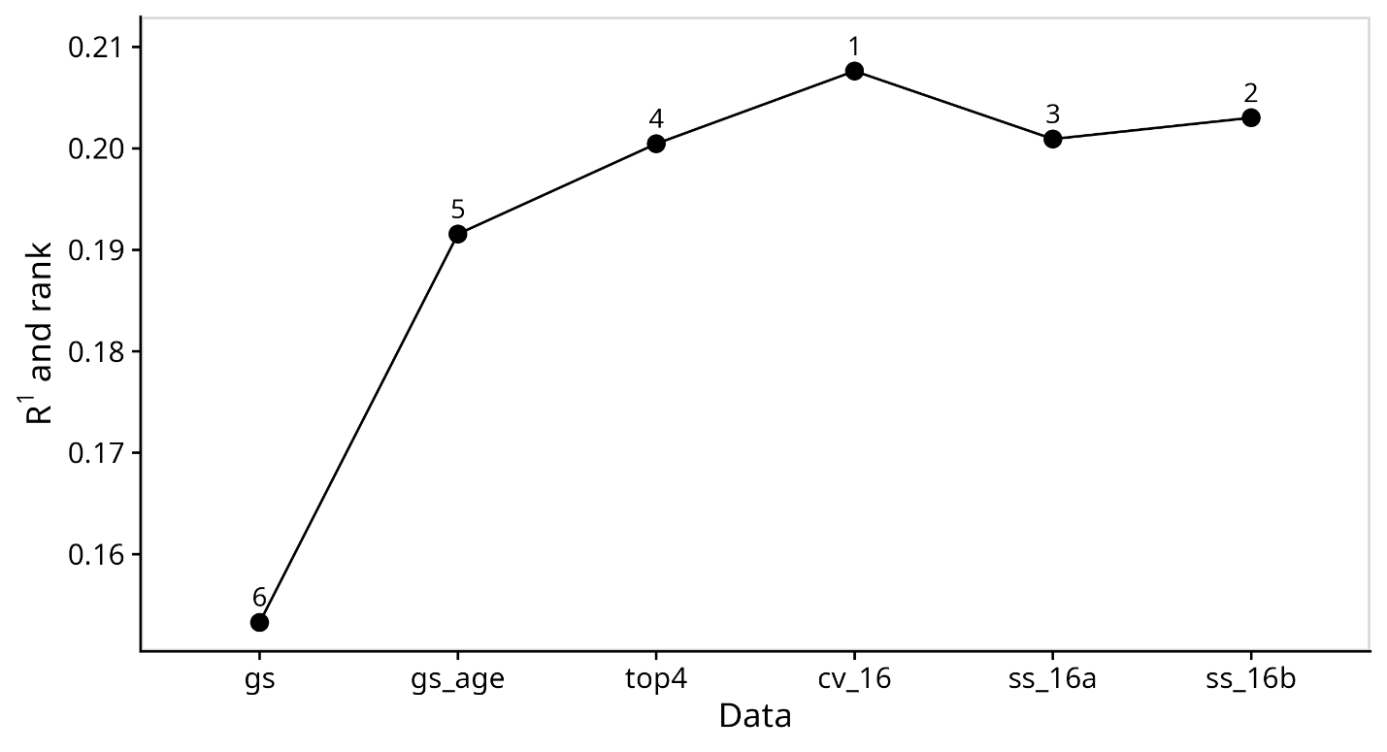 Supplemental Figure 9: Data splitting results at the 16th quantile. The model using the top ten predictors from 10fCV (cv_16) generalizes to new data best and is superior to the other models using a region of practical equivalence of 0.005 and 0.01.

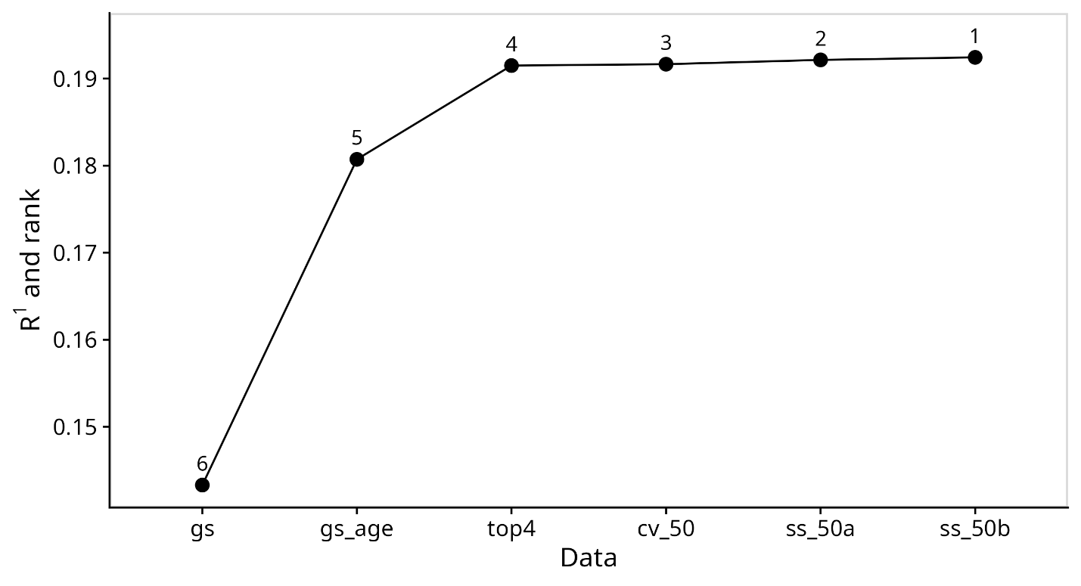
Supplemental Figure 10: Data splitting results at the 50th quantile. There is little improvement in the model's predictive performance when adding predictors beyond the top four (top4): baseline gait speed, number of comorbidities, age and BMI. Models with ranks 1 through 4 are equivalent using a region of practical equivalence of 0.005.

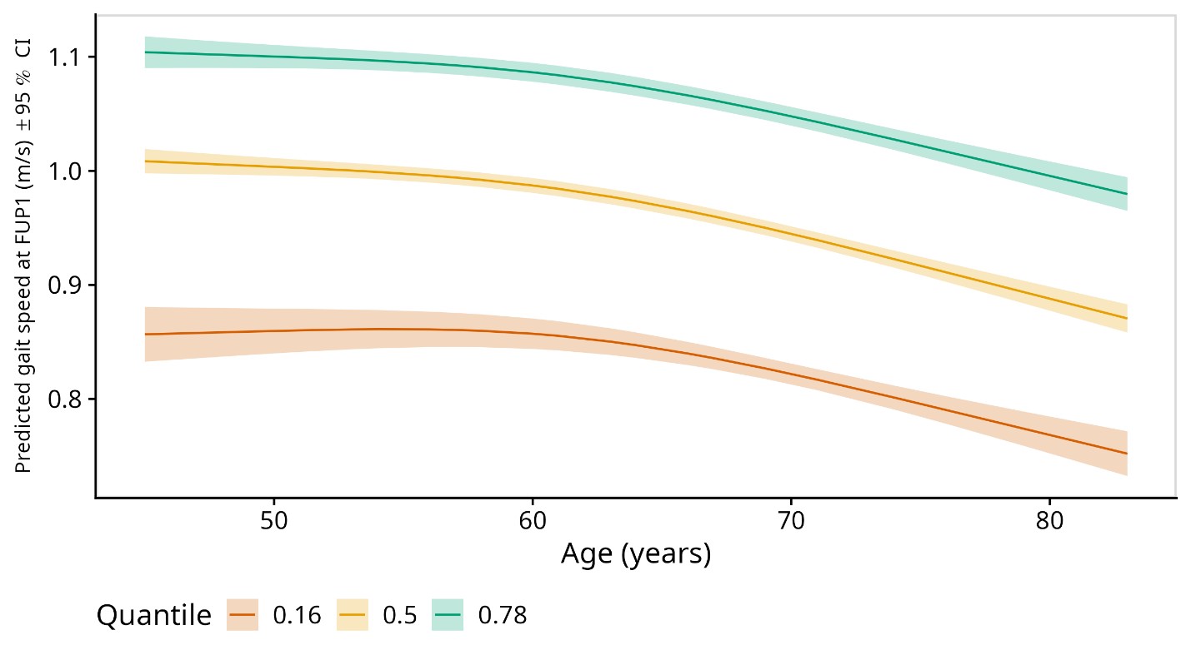
Supplemental Figure 11: Illustrates how chronological age affects gait speed at follow-up 1 across the three quantiles. As the quantiles increase, participants less than 60 years old have a sharper decline in gait speed. The 95% CIs are point-wise confidence intervals.

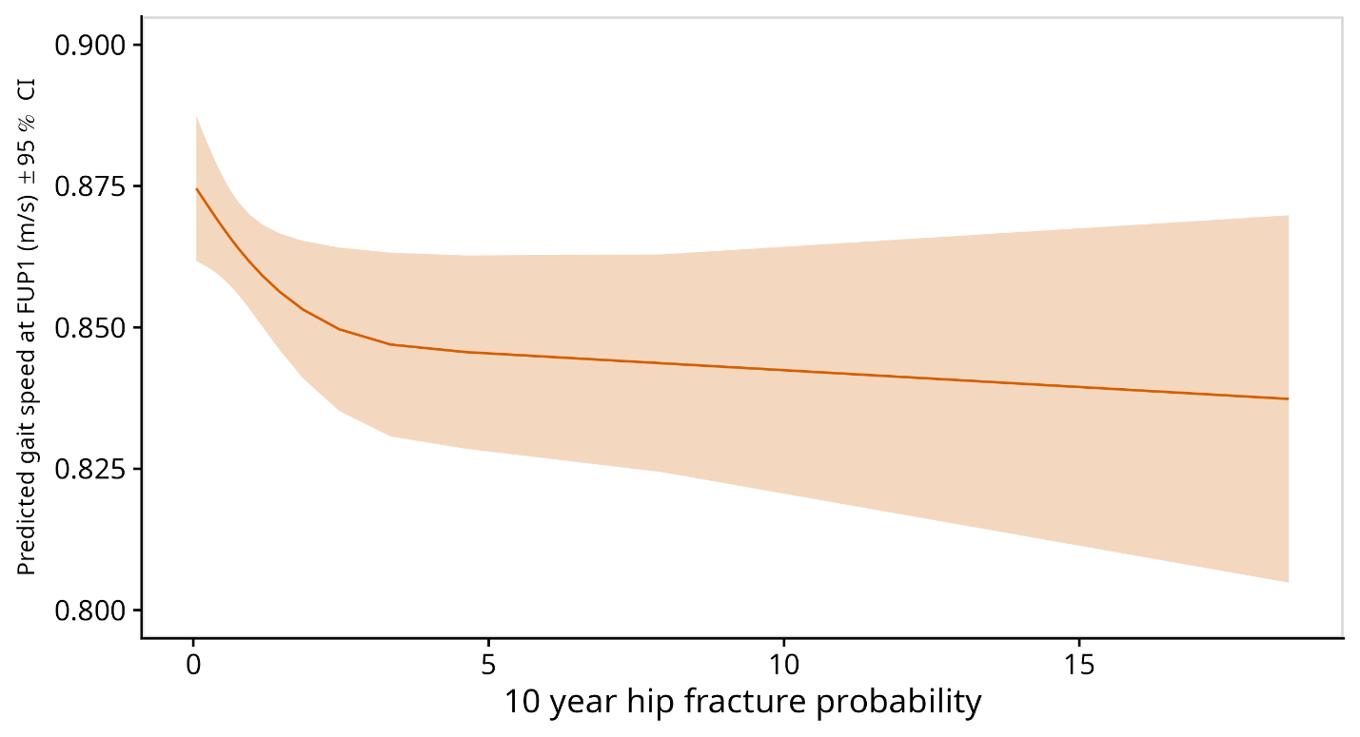 Supplemental Figure 12: Depicts how 10-year probability of hip fracture affects the 16th quantile of gait speed at 3 years. There is a rapid decline in the 16th quantile, which slows as the probability approaches 5%. The 95% CIs are point-wise confidence intervals.

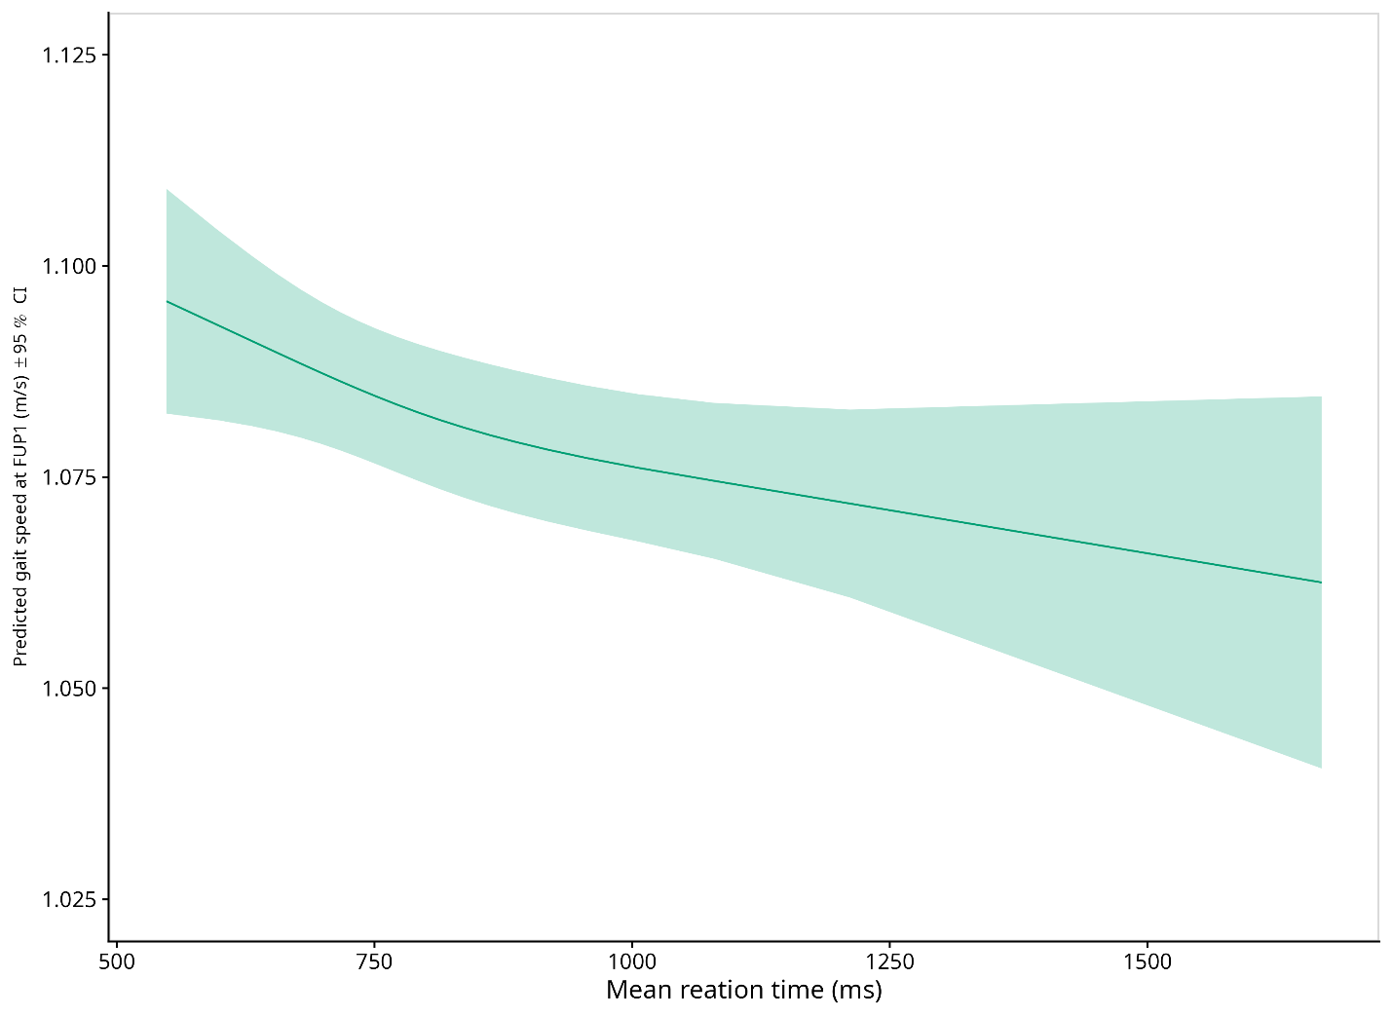 Supplemental Figure 13: Depicts how mean reaction time affects the 78th quantile of gait speed at 3 years. There is a slope change approaching 1000ms, attenuating the decline in the 78th quantile. The 95% CIs are point-wise confidence intervals.

