Table of Contents
1. Supplementary Table Descriptions 2
2. Supplementary Methods 3
2.1 Canadian Longitudinal Study on Aging 3
2.1.1. Quality Control for Non-imputed Genotype Data (for GCTA-GREML) 3
2.1.2. Quality Control for Imputed Genotype Data (for GWAS Analyses) 4
2.1.3. Phenotype Selection and Data Cleaning for Bivariate-GREML 5
2.2. Wisconsin Longitudinal Study 6
2.3. Trøndelag Health Study 7
3. Supplementary Figures 9
4. References 32

Supplementary Table Descriptions
Supplementary Table 1. LDSC genetic correlations and source GWAS data
Linkage disequilibrium score regression (LDSC) estimated heritability and genetic correlations of the GWAS of active music engagement frequency with aging-related health phenotypes, estimated using LDSC software ¹. Note. Active music engagement frequency is trait 1, and trait 2 is the study listed with its heritability and N.
Supplementary Table 2. Bivariate-GREML genetic correlation results
GCTA-GREML estimated the heritability of aging-related health traits in CLSA and their genetic correlation (rg) with active music engagement frequency. Note. Trait 1 is active music engagement frequency, and trait 2 is the health phenotype described.
Supplementary Table 3. Genomic risk loci as defined by independent lead SNPs and maximum distance between their LD block (GenomicRiskLoci.txt as outputted from FUMA).
Supplementary Table 4. Lead SNPs table as defined by r² of 0.1 (leadSNPs.txt as output from FUMA).
Supplementary Table 5. Independent Significant SNPs table as defined by r² of 0.6 (IndSigSNPs.txt as outputted from FUMA)
Supplementary Table 6. Complete results of ANNOVAR analyses (annov.txt as outputted from FUMA)
Supplementary Table 7. List of eQTL mapped genes (genes.txt as outputted from FUMA)
Supplementary Table 8. List of all SNP to eQTL mappings (eqtl.txt as outputted from FUMA)
Supplementary Table 9. LDSC partitioned heritability analysis results for enrichment/depletion in eight brain cell-type specific regulatory annotations. qFDR column shows FDR corrected (n=8) Enrichment p-values.
Supplementary Table 10. Sensitivity Leave-one-out Results for all Two-sample MR Analyses
Supplementary File 1. FUMA parameters (params.config as outputted from FUMA)
Supplementary Tables and Files are attached in Henechowicz_Tara_L_202506_AppendixA_tables.xlsx

2. Supplementary Methods

2.1 Canadian Longitudinal Study on Aging
The Canadian Longitudinal Study on Aging is a cohort study of n=26,622 individuals with genotyped data available in release 3.0. Active music engagement was measured using the GEN_MUSC_COM variable from the Canadian Longitudinal Study on Aging’s General Health questionnaire from the Comprehensive Baseline Assessment version 7.0 (Canadian Longitudinal Study on Aging, 2018). In the set of questions on mental exercise, participants were asked: “About how much time do you spend doing each of the following activities, taking into account both work and leisure time?” for “Playing a musical instrument or singing in a choir” with the response options of “Every day...1”, “Several times a week...2”, “Several times a month...3”, Several times a year...4”, “Once a year or less...5.” Participants who did not know, did not answer, or refused to answer were excluded from the analyses.

2.1.1. Quality Control for Non-imputed Genotype Data (for GCTA-GREML)
Participants were genotyped using Affymetrix Axiom array genotypes for 794,409 genetic variants, of which 95% are high quality ^{2,3}. For the GCTA-GREML analyses, we implemented our customized quality control protocol on non-imputed CLSA data in genome assembly GRCh37.
First, variants were removed if they failed CLSA’s marker-based quality control (see section 3 of CLSA data release 3.0 section 4), including if the variants were determined to be an insertion and deletion and had greater than zero batches that failed the frequency discordance test, Hardy Weinberg Equilibrium test, control genotype discordance test, or the sex genotype frequency test. Additional variant-level quality control was conducted using PLINK v1.90 beta ⁴ to remove variants with the cut-offs of variant missingness > 0.05 and minor allele frequency <0.05. Next, samples were removed with missingness >0.01. The data was then LD-pruned (window: 50, step size: 5, R2: 0.5) to (a) check heterozygosity and remove samples with F>0.2 or <-0.2 and (b) remove samples with mismatched imputed and expected sex after pruning the pseudoautosomal region. Samples that failed heterozygosity and sex checks were removed from the non-LD-pruned data. Identity-by-descent was estimated using PRIMUS ⁵, and we obtained the maximal unrelated set of individuals of 3rd-degree relatives (Kinship <0.125). Next, variant identifiers (rsid) were updated to P using the rsIDs corresponding with the Affymetrix array identifiers and variants were filtered out for Hardy Weinberg Equilibrium < ${{1×10}^{-8}}^{}$.
Genetic ancestry principal components were calculated on autosomal genotyped data using PRIMUS ⁵ to extract 20 principal components. The European ancestry sample retained participants overlapping with CEU and TSI HapMap3 ancestries. The final unrelated European sample of non-imputed genotyped data had 369,558 variants and 20,989 individuals passing quality control thresholds. For GCTA-GREML analyses, 195,22 individuals were included because they had no missing values for the music engagement phenotype, age, and sex.

2.1.2. Quality Control for Imputed Genotype Data (for GWAS Analyses)
For GWAS analyses, we accessed the TOPMed r2 reference panel imputed data from CLSA version 3.0 for 26,222 participants who passed the CLSA quality control protocol (see CLSA data release 3.0 section 4). The CLSA cohort conducted pre-imputation genetic quality control on the data of 26,622 individuals who were genotyped using UK Biobank Axiom array for 794,409 SNPs. The CLSA followed standardized quality filtering procedures similar to the UK Biobank (see CLSA version 3.0, section 1.4.3(1)). For post-imputation quality control, multi-allelic variants were excluded, and variants with imputation information score > 0.8 were included. As per CLSA’s quality control protocol, samples were removed if they were determined to be outliers for heterozygosity or genotype missingness and had mismatches between self-reported and chromosomal sex ⁶. Next, variants were remapped from chromosome:base pair coordinates to rsIDs using dbSNP155 mappings for genome assembly GRCh38 (downloaded from https://hgdownload.soe.ucsc.edu/gbdb/hg38/snp/dbSnp155.bb on March, 13, 2024).. Lastly, before GWAS analysis, we removed variants with minor allele frequency < 0.01 using PLINK2.0 ⁷.
The European subset (cluster four matching with populations of European ancestry) was extracted from CLSA’s sample quality control metrics file, resulting in N=24,601 Europeans with 8,321,411 variants. For GWAS analyses, N=23,782 were included because they had complete data for active music engagement frequency, sex, and age. Additionally, the first seven principal components were selected from CLSA’s sample quality control metrics file as genetic ancestry covariates to control for population substructure (see CLSA data release 3.0 sections 4.4 and 4.5). For all analyses in LDSC and Two-sample Mendelian Randomization, we used pyliftover and summary-gwas-imputation (https://github.com/hakyimlab/summary-gwas-imputation) to remap the GWAS summary statistics from hg38 to hg19.

2.1.3. Phenotype Selection and Data Cleaning for Bivariate-GREML
We selected individuals who had complete data for sex and age and met all quality control standards as described in supplementary methods 1.1. For health traits, we scanned all available variables in the CLSA comprehensive baseline assessment v7.0. including psychiatric and mental health, cognitive, physical activity, mobility, social participation, alcohol use, and smoking variables. The complete list of variables included with their naming convention in CLSA, and their cleaning and recoding is available in Supplementary Table 2. For psychiatric diagnoses, we included diagnoses for anxiety (N=1756 cases for “CCC_ANXI_COM”), mood disorder (N=3484 cases for “CCC_MOOD_COM”), and (N=3,301 cases for “DPR_CLINDEP_COM”). However, we did not include Alzheimer’s disease diagnosis in bivariate-GREML genetic correlations due to the low case count (N=68 cases for “CC_ALZH_COM”). For mental health traits, we did not include the PC-PTSD scale because of the low case count for positively screened PTSD cases (N=1,502). For cognitive variables, we excluded “TMT” and “PMT” variables due to their low variability in responses. We included the following seven cognitive variables for analysis. For the Stroop task, we included the time to complete the third Stroop task (“STP_COLTIME_SS_COM”) and log-transformed the values. For the reaction time task, we included the log-transformed speed (mean reaction time without outliers in ms, “CRT_MRTWOUT_CORRANS_COM”). We created averaged scores for the number of animal words recited in 60 seconds (“ COG_AFT_SCORE_1_COM” and “COG_AFT_SCORE_2_COM”) and for the number of “F”, “A”, “S” words recited in 60 seconds (“FAS_F_SCORE_COM,” “FAS_A_SCORE_COM,” and “FAS_S_SCORE_COM”). We included the number of words recalled in 90 seconds for the immediate and delayed recall of the Rey Auditory Verbal Learning Test (“COG_REYI_SCORE_COM” and “COG_REYII_SCORE_COM”). Lastly, we included the “Number of correct consecutive numeric and alphabetical alternations in 30 seconds” (“COG_MAT_SCORE_COM”). We performed a principal component analysis of the aforementioned cognitive variables. However, results revealed limited dimension reduction as the five principal components explained 83% of the variance. For physical activity, we created a sum score of five physical activity frequency variables from the PASE scale, which were coded as 1=Never, 2=Seldom (1 to 2 days), 3=Sometimes (3 to 4 days), 4=Often (5 to 7 days) ("PA2_WALK_MCQ", "PA2_LSPRT_MCQ", "PA2_MSPRT_MCQ", "PA2_SSPRT_MCQ", and "PA2_EXER_MCQ"). We removed any participants who had NA for one of the variables, and we then log-transformed the sum score before analyses to approximate a normal distribution.

2.2. Wisconsin Longitudinal Study
WLS is a longitudinal study of men and women who graduated from Wisconsin high schools in 1957 and one of their randomly selected siblings with data spanning over 60 years that allows researchers to link recently collected genetic data to social, health, and demographic characteristics ⁸. We extracted phenotype data from release 13.07 of WLS data, specifically the “2003–2005” and “2011” waves of data collection for graduates and spouses, which were collected via the Social and Civic participation module of the mail-in survey. The active music engagement measure was: “During the past year, how many hours per month did you play a musical instrument?” (q7spd_1). Due to a largely skewed distribution, we binarized the phenotype to those who practice >0 hours per month (cases) and those who practice 0 hours per month (controls).

For genetic data, we pulled publicly available Haplotype Reference Consortium (HRC) imputed data from Lee et al.’s (2018) GWAS of educational attainment ⁹. In summary, Lee et al. (2018) extracted genotype data from the Illumina Human Omni Express Bead Chip, which was available for 9109 individuals and 713,014 variants. Prior to imputation, 373 non-European individuals were identified and removed by plotting principal components of individuals’ genotype data together with 1000 Genomes populations. Second, individuals were excluded for genotype missingness <0.05, no mismatch between genetic and surveyed sex, no mismatch between surveyed relationship data and genetic relatedness, and extreme homozygosity/heterozygosity values (Fhet > |0.03|). SNPs were removed if they had a call rate <0.05, HWE p-value <10⁻⁵, and MAF<0.01. SNPs were also removed if: (i) A/T or G/C alleles and a minor allele frequency greater than 0.4, (ii) alleles that do not match the HRC data, (iii) minor allele frequency discrepancy with the HRC data >0.2, (iv) not available in the HRC data. The final dataset used for imputation had 8,527 individuals with 604,710 SNPs autosomal SNPs, which were imputed to the Haplotype Reference Consortium (HRC) v1.1 European reference panel using the Michigan Imputation Server. For post-imputation quality control, we removed variants with r²<0.7 and MAF<0.01 and duplicate variants using PLINK 1.9⁴. Before PGS analyses, we removed participants determined to be 3rd-degree related by Herd et al.’s (2016) QC report (see Wisconsin longitudinal study data availability). Herd et al. (2016) estimated IBD coefficients using 94,261 autosomal SNPs and the KING-robust procedure implemented in the R package SNPRelate^{8,10}. The final dataset of N=7,554,744 deduplicated genetic variants for unrelated individuals yielded N=6,189 unrelated individuals. Those who had complete data for age, sex, and active music engagement phenotypes were included in the statistical analyses.

We used the genetic ancestry principal components provided by WLS from Lee et al.’s (2018) study to control for population stratification. In Lee et al.’s (2018) study, principal components were calculated in PLINK v1.97 using SNPs with a call rate>0.99, MAF>0.01, and r²>0.6. Prior to calculating the principal components, long-range LD regions on chromosomes 5 (44-51.5 Mb), 6 (25-33.5 Mb), 8 (8-12 Mb) and 11 (45-57 Mb) were excluded, and the remaining SNPs were LD-pruned (R2<0.1 on a 1000kb window).

2.3. Trøndelag Health Study
The Trøndelag Health Study is a population-based cohort study that has collected a broad range of data on health-related topics from adults in Trøndelag county since 1984. In 2019, the study was expanded to included adults from Nord-Trøndelag and Sør-Trøndelag, children, and immigrant populations^{11–13}. The genotyping in Trøndelag Health Study and work presented in here was approved by the Regional Committee for Ethics in Medical Research, Central Norway. All participants signed informed consent for participation and the use of data in research.
Performing arts engagement (i.e., music, singing, or theatre engagement) was measured in HUNT3, HUNT4, HUNT4 immigrants, and HUNT 4 Sør Trøndelag questionnairesusing an item asking “How many times in the last 6 months have you participated in music, singing, or theatre?” with responses of “More than once a week”, “Once a week”, “1-3 times/month”, “1-5 times the last 6 months”, and “Never”. For analyses, we coded data on an ordinal scale of 1 to 5 with the highest frequency response being 5 and the lowest being 1. If participants answered in both HUNT3 and HUNT4, the answer reflecting most musical engagement and the associated participation age was used. For 498 individuals missing an answer in HUNT3 or HUNT4, the answer from the sub-cohort of HUNT4 focused on immigrants or residents of Sør Trøndelag was used.
Participants have been genotyped using one of four Illumina HumanCoreExome arrays: 12 v.1.0, 12 v.1.1, UM HUNT Biobank v1.0 and UM HUNT Biobank v2.0.39 Genotype calling was performed with GenTrain v.2.0 in GenomeStudio v.2011.1 (Illumina)(PMID: 36777998). Samples were excluded if they had call rate < 99%, large chromosomal copy number variants, contamination > 2.5% as estimated with BAF Regress,64 or a discrepancy between genetically inferred sex and reported gender. Genetic variants were excluded if they deviated from Hardy-Weinberg Equilibrium (p-value < 10-4). Samples were phased with Eagle2 v.2.0.5 (https://alkesgroup.broadinstitute.org/Eagle/). All variants were imputed from the Haplotype Reference Consortium (HRC) v1.1 reference panel with the positional Burrows-Wheeler transform (PBWT) v3.1 (https://github.com/richarddurbin/pbwt)(PMID: 24413527).
Ancestry of all samples was inferred using an online singular value decomposition and shrinkage adjustment algorithm (FRAPOSA), (PMID: 32196066) and the Human Genome Diversity Project (HGDP) reference panel (938 unrelated individuals; downloaded from http://csg.sph.umich.edu/chaolong/LASER/) (PMID 15803201). Individuals identified as having genetic ancestry similar to the European reference population were included in this analysis. Principal components were estimated using PLINK.

3. Supplementary Figures
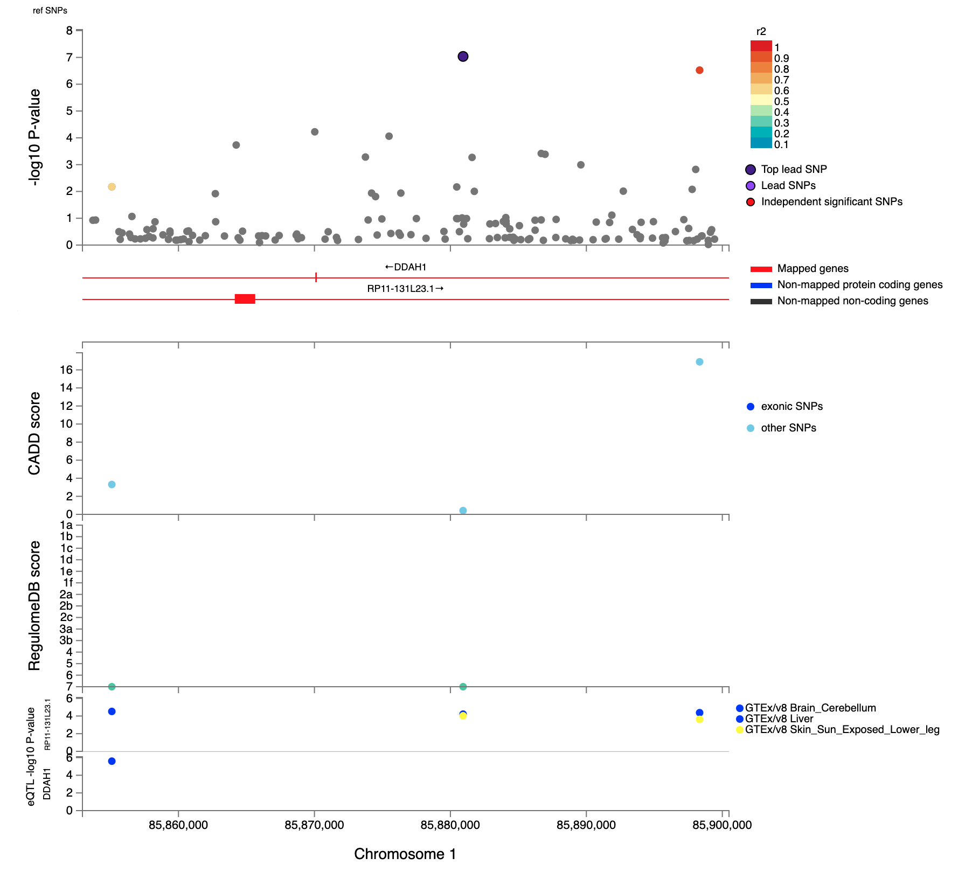
Supplementary Fig 1. Regional plot of genomic locus 1 around the lead variant rs7553699 identified in the Active Music Engagement Frequency (AME) GWAS (N=23,782). Top. Top panel presents the -log10(p-values) of the association between variants and AME and linkage disequilibrium (LD) r² information for the variants in the locus (variants are colored by LD r²) and any eQTL-mapped genes are in red below. Middle. The middle panel presents the CADD (combined annotation dependent depletion) scores and RegulomeDB scores (top and bottom tracks, respectively). Bottom. The bottom panel has the -log10(p-values) of the associations between variants and expression of the gene (on the y-axis), with the colour legend representing the eQTL database.
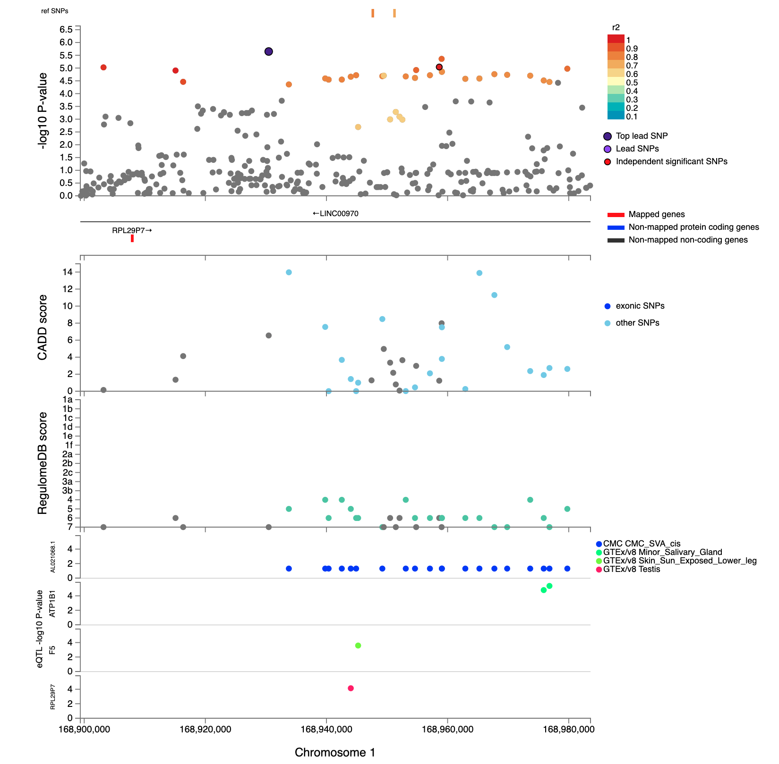
Supplementary Fig 2. Regional plot of genomic locus 2 around the lead variant rs12729624 identified in the Active Music Engagement Frequency (AME) GWAS (N=23,782). Top. Top panel presents the -log10(p-values) of the association between variants and AME and linkage LD r² information for the variants in the locus (variants are colored by LD r²) and any eQTL-mapped genes are in red below. Middle. The middle panel presents the CADD scores and RegulomeDB scores (top and bottom tracks, respectively). Bottom. The bottom panel has the -log10(p-values) of the associations between variants and expression of the gene (on the y-axis), with the colour legend representing the eQTL database.
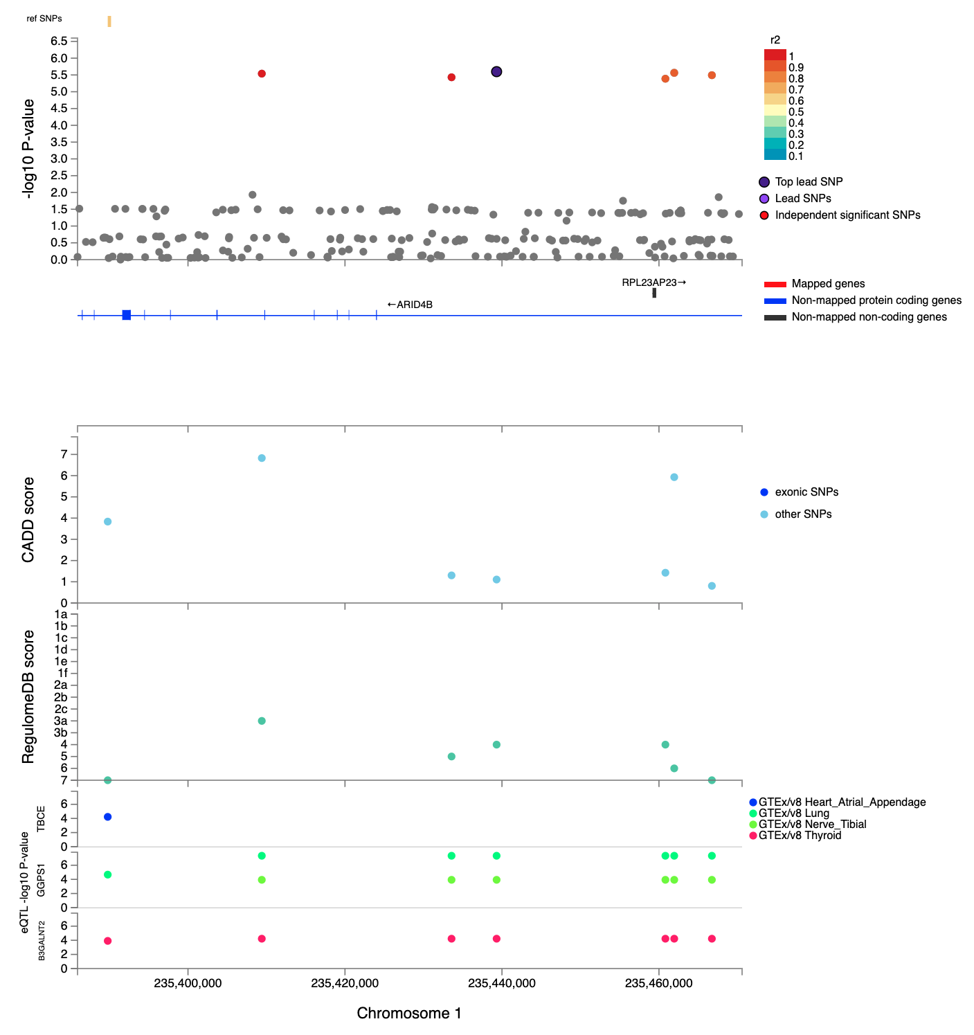
Supplementary Fig 3. Regional plot of genomic locus 3 around the lead variant rs114029967 identified in the Active Music Engagement Frequency (AME) GWAS (N=23,782). Top. Top panel presents the -log10(p-values) of the association between variants and AME and linkage LD r² information for the variants in the locus (variants are colored by LD r²) and any eQTL-mapped genes are in red below. Middle. The middle panel presents the CADD scores and RegulomeDB scores (top and bottom tracks, respectively). Bottom. The bottom panel has the -log10(p-values) of the associations between variants and expression of the gene (on the y-axis), with the colour legend representing the eQTL database.
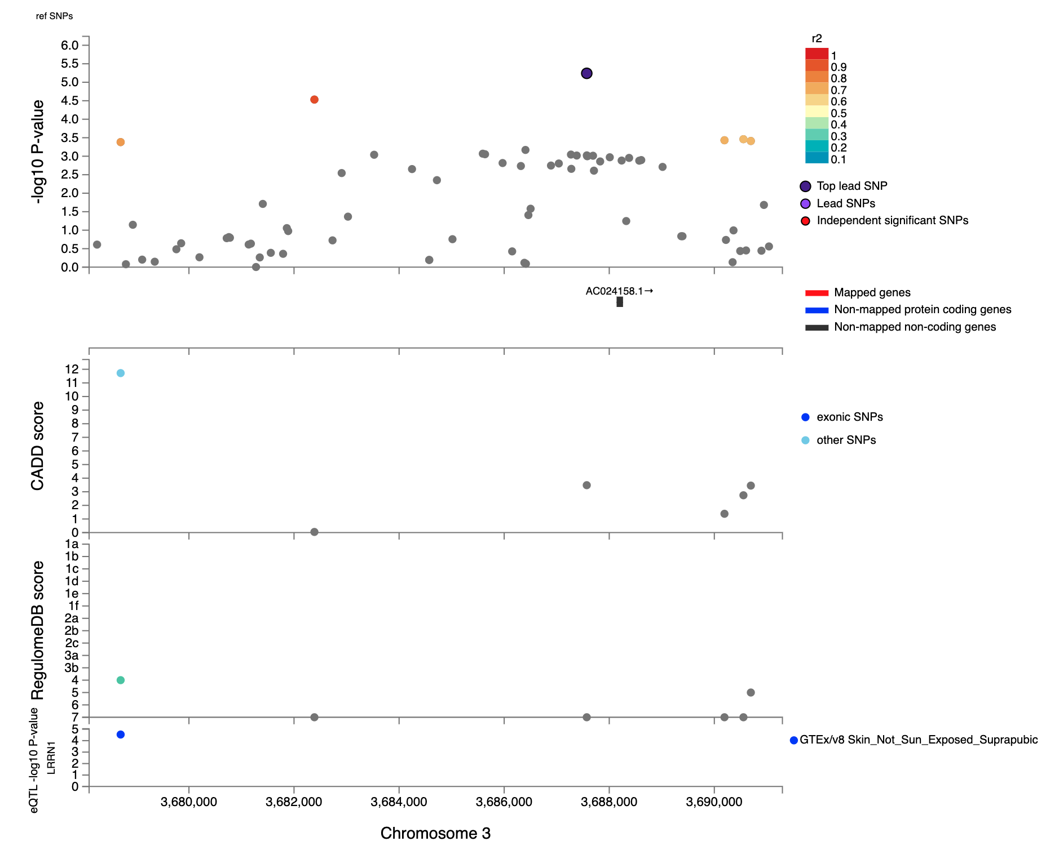
Supplementary Fig 4. Regional plot of genomic locus 4 around the lead variant rs116481454 identified in the Active Music Engagement Frequency (AME) GWAS (N=23,782). Top. Top panel presents the -log10(p-values) of the association between variants and AME and linkage LD r² information for the variants in the locus (variants are colored by LD r²) and any eQTL-mapped genes are in red below. Middle. The middle panel presents the CADD scores and RegulomeDB scores (top and bottom tracks, respectively). Bottom. The bottom panel has the -log10(p-values) of the associations between variants and expression of the gene (on the y-axis), with the colour legend representing the eQTL database.
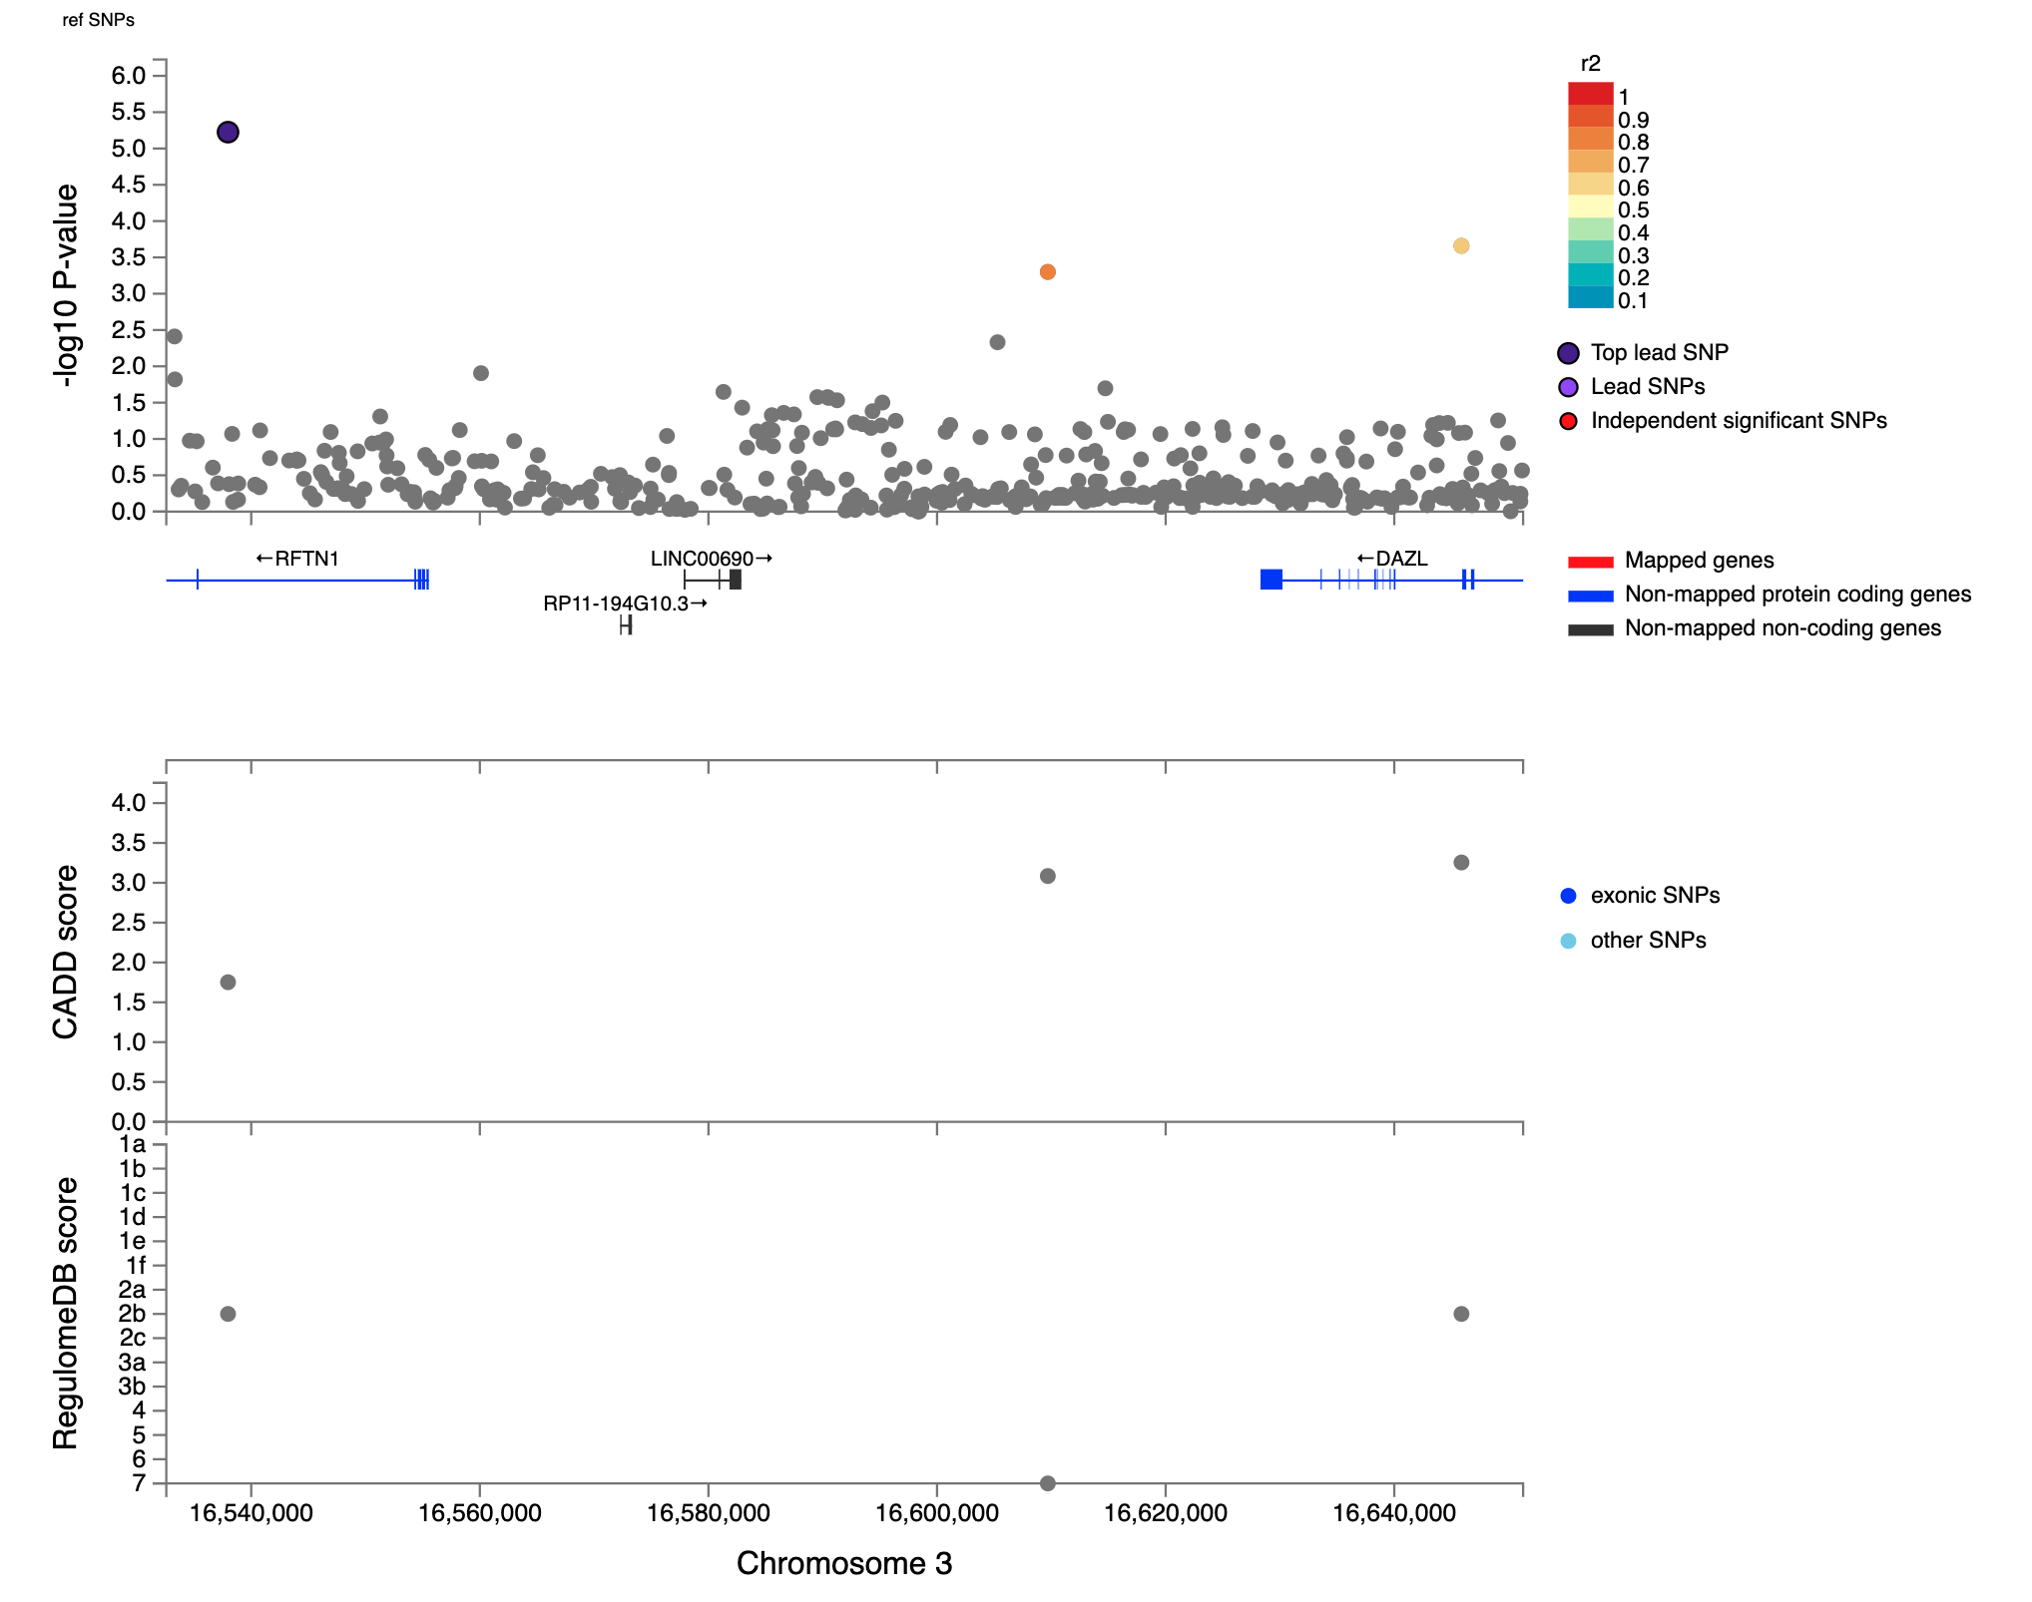
Supplementary Fig 5. Regional plot of genomic locus 5 around the lead variant rs115067899 identified in the Active Music Engagement Frequency (AME) GWAS (N=23,782). Top. Top panel presents the -log10(p-values) of the association between variants and AME and linkage LD r² information for the variants in the locus (variants are colored by LD r²) and any eQTL-mapped genes are in red below. Bottom. The bottom panel presents the CADD scores and RegulomeDB scores (top and bottom tracks, respectively).
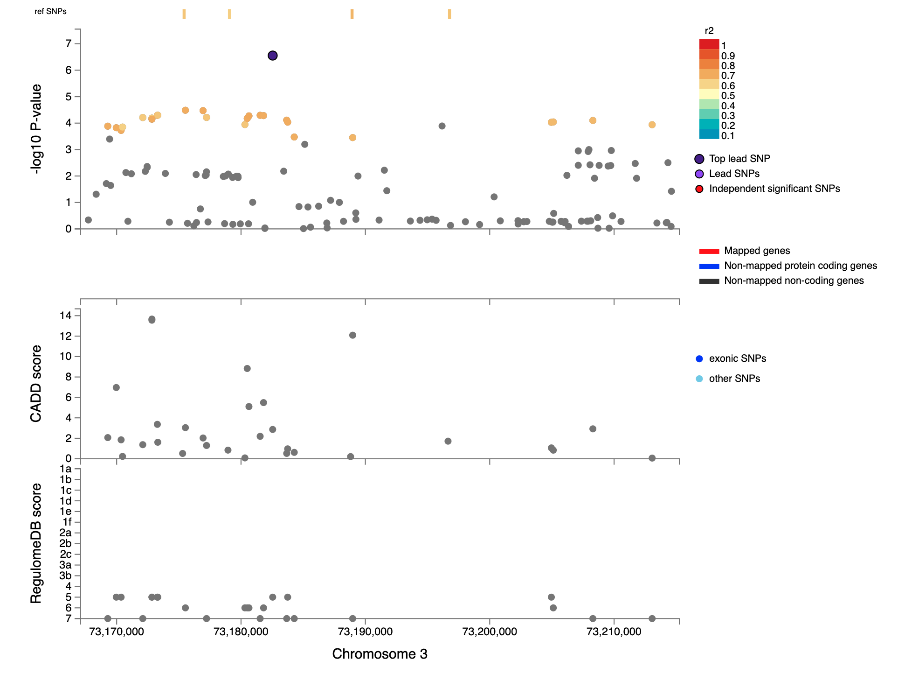
Supplementary Fig 6. Regional plot of genomic locus 6 around the lead variant rs9647401 identified in the Active Music Engagement Frequency (AME) GWAS (N=23,782). Top. Top panel presents the -log10(p-values) of the association between variants and AME and linkage LD r² information for the variants in the locus (variants are colored by LD r²) and any eQTL-mapped genes are in red below. Bottom. The bottom panel presents the CADD scores and RegulomeDB scores (top and bottom tracks, respectively).
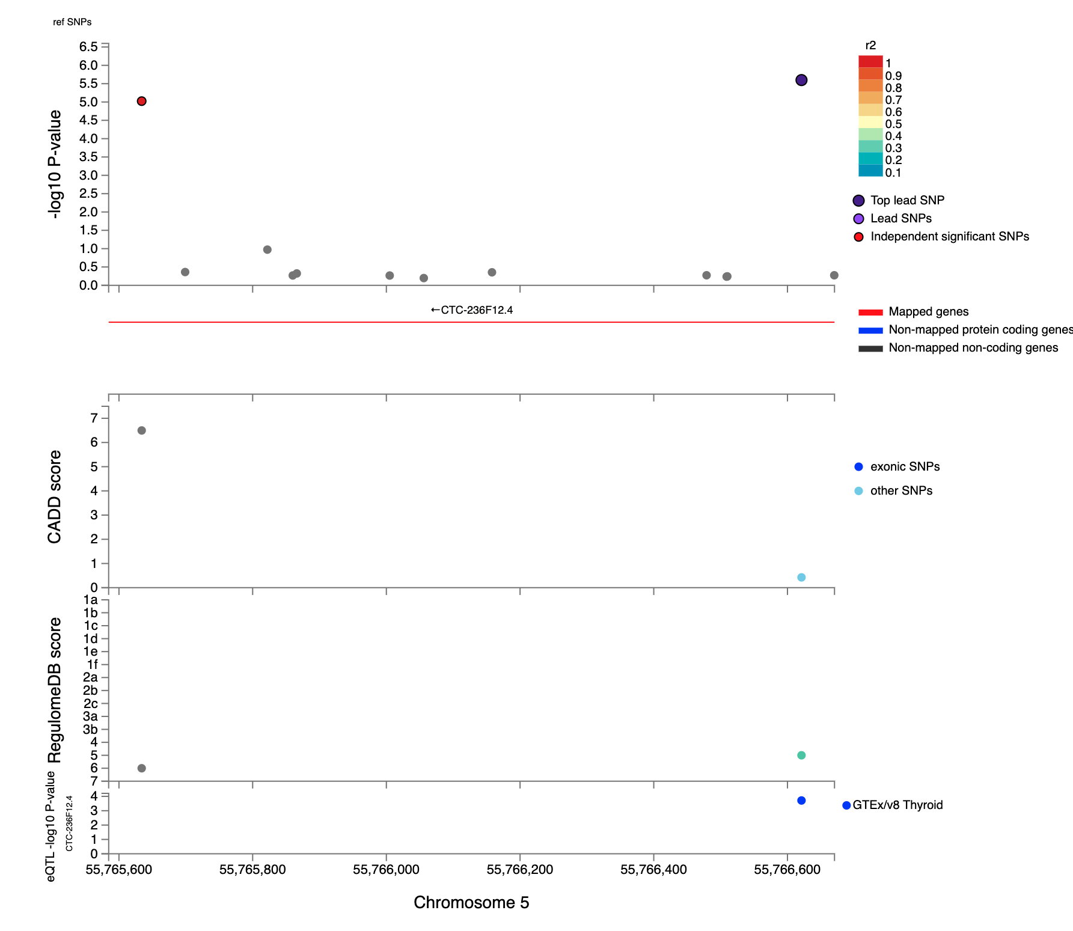
Supplementary Fig 7. Regional plot of genomic locus 7 around the lead variant rs16885512 identified in the Active Music Engagement Frequency (AME) GWAS (N=23,782). Top. Top panel presents the -log10(p-values) of the association between variants and AME and linkage LD r² information for the variants in the locus (variants are colored by LD r²) and any eQTL-mapped genes are in red below. Middle. The middle panel presents the CADD scores and RegulomeDB scores (top and bottom tracks, respectively). Bottom. The bottom panel has the -log10(p-values) of the associations between variants and expression of the gene (on the y-axis), with the colour legend representing the eQTL database.
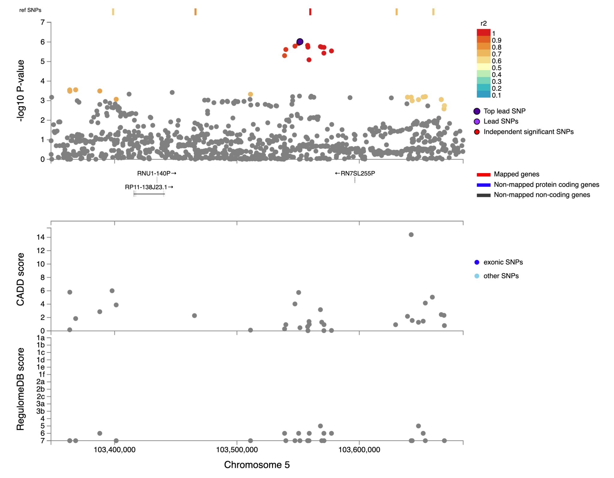
Supplementary Fig 8. Regional plot of genomic locus 8 around the lead variant rs10044788 identified in the Active Music Engagement Frequency (AME) GWAS (N=23,782). Top. Top panel presents the -log10(p-values) of the association between variants and AME and linkage LD r² information for the variants in the locus (variants are colored by LD r²) and any eQTL-mapped genes are in red below. Bottom. The bottom panel presents the CADD scores and RegulomeDB scores (top and bottom tracks, respectively).
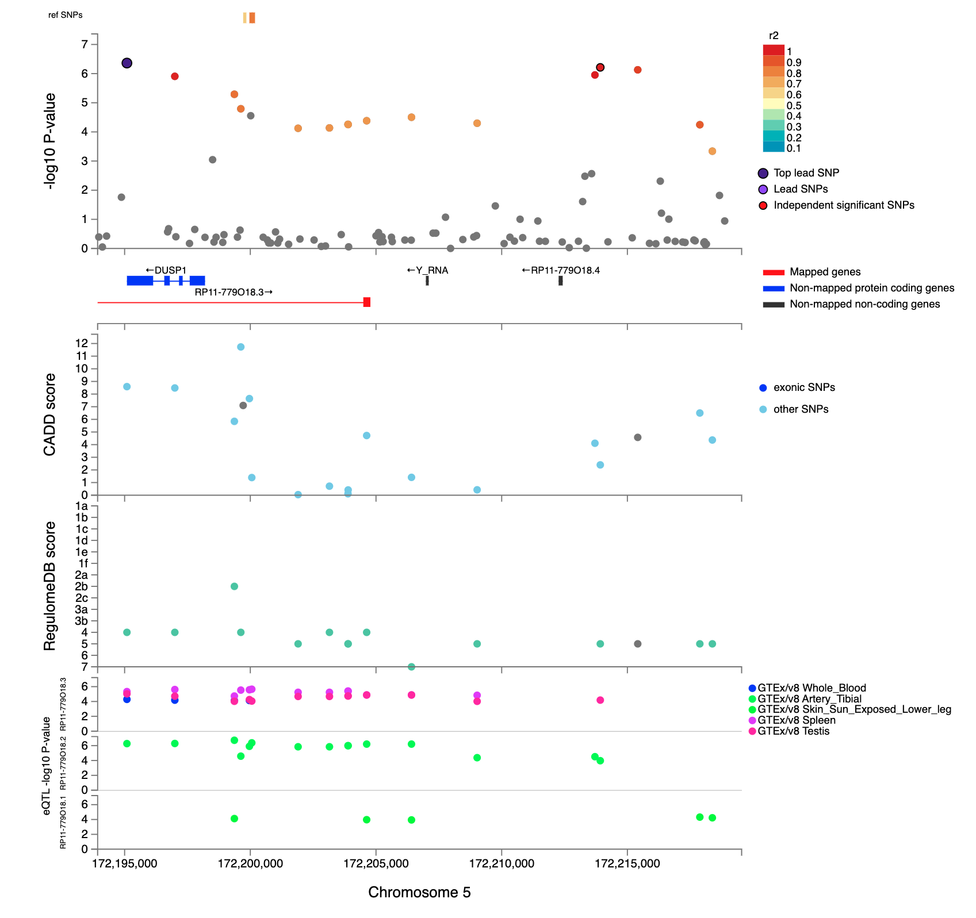Supplementary Fig 9. Regional plot of genomic locus 9 around the lead variant rs3805476 identified in the Active Music Engagement Frequency (AME) GWAS (N=23,782). Top. Top panel presents the -log10(p-values) of the association between variants and AME and linkage LD r² information for the variants in the locus (variants are colored by LD r²) and any eQTL-mapped genes are in red below. Middle. The middle panel presents the CADD scores and RegulomeDB scores (top and bottom tracks, respectively). Bottom. The bottom panel has the -log10(p-values) of the associations between variants and expression of the gene (on the y-axis), with the colour legend representing the eQTL database.
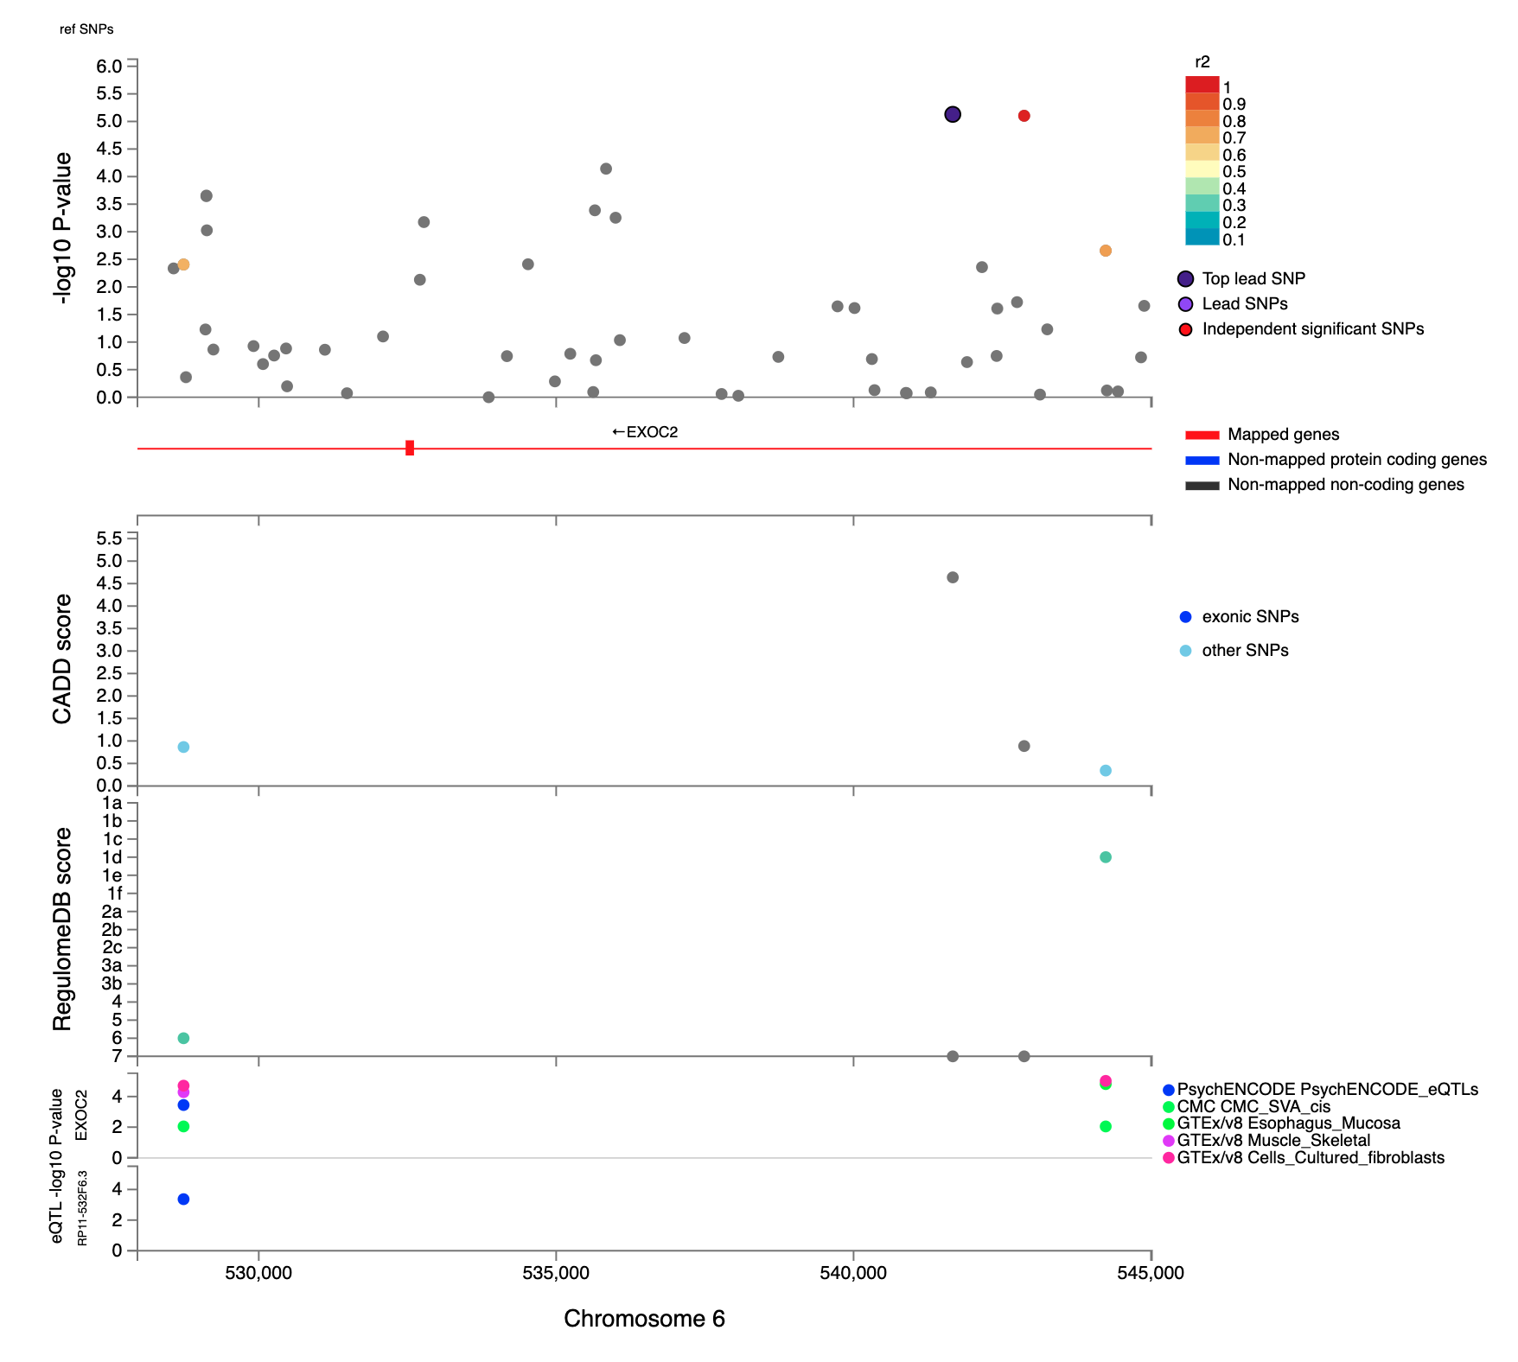Supplementary Fig 10. Regional plot of genomic locus 10 around the lead variant rs6904638 identified in the Active Music Engagement Frequency (AME) GWAS (N=23,782). Top. Top panel presents the -log10(p-values) of the association between variants and AME and linkage LD r² information for the variants in the locus (variants are colored by LD r²) and any eQTL-mapped genes are in red below. Middle. The middle panel presents the CADD scores and RegulomeDB scores (top and bottom tracks, respectively). Bottom. The bottom panel has the -log10(p-values) of the associations between variants and expression of the gene (on the y-axis), with the colour legend representing the eQTL database.
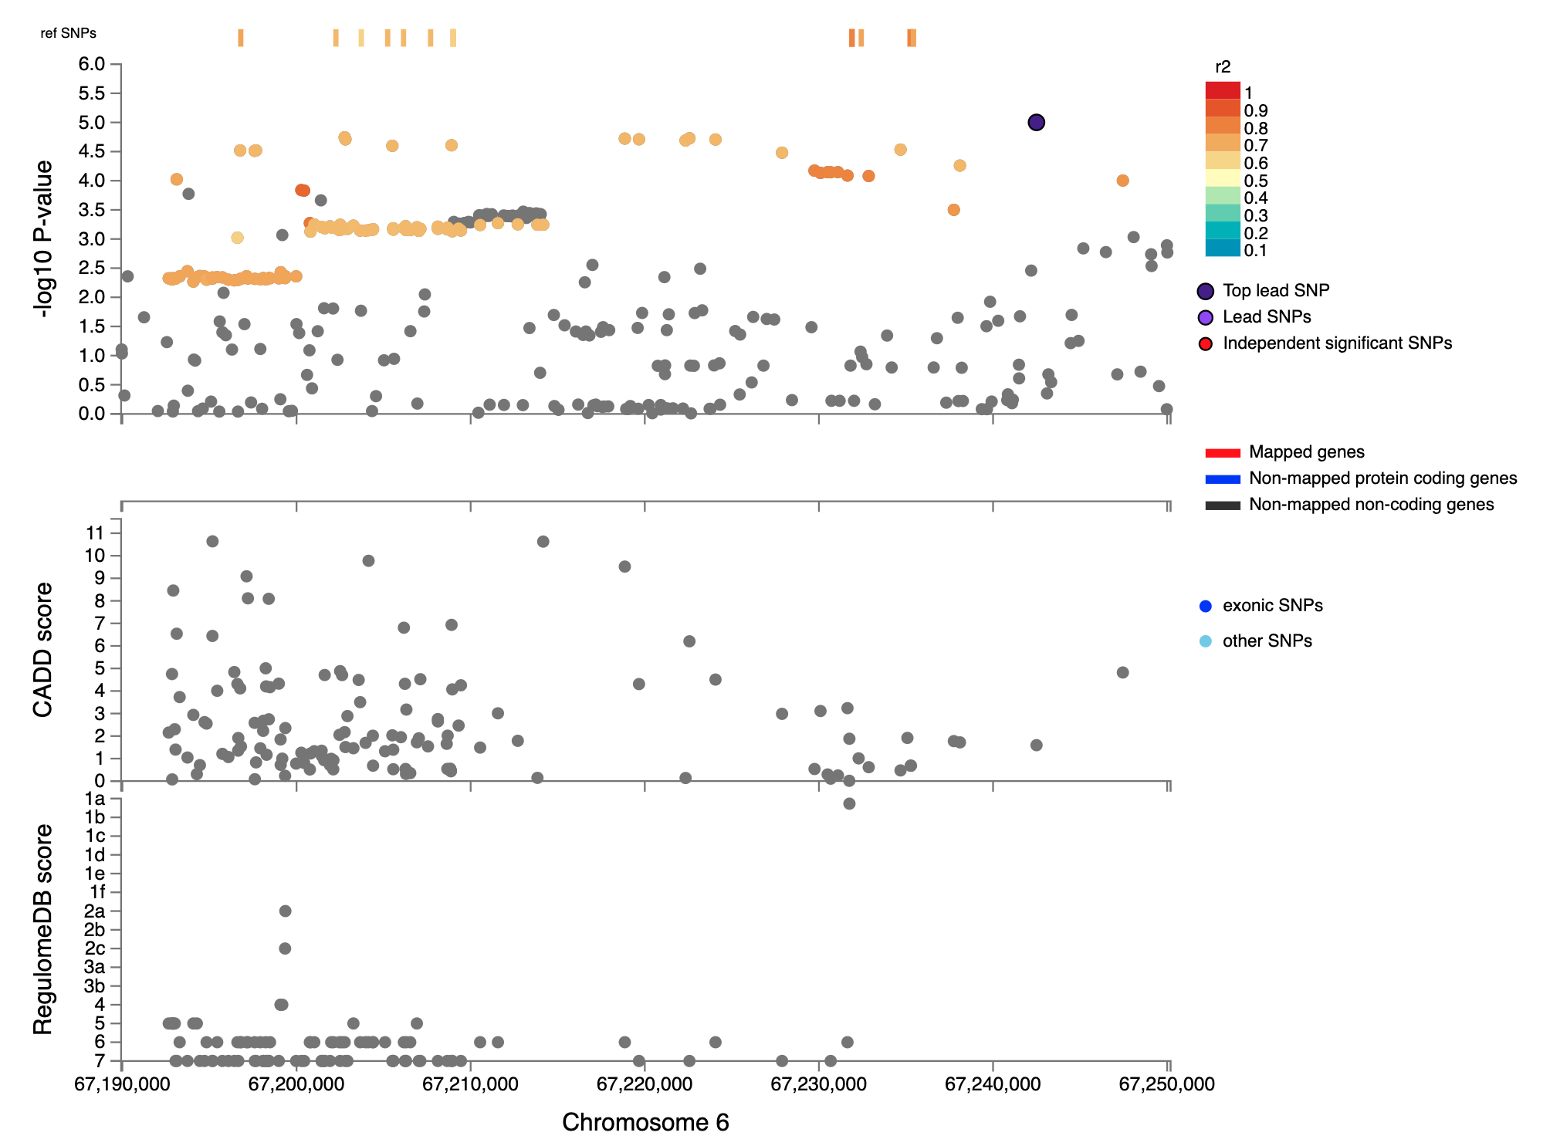Supplementary Fig 11. Regional plot of genomic locus 11 around the lead variant rs2765233 identified in the Active Music Engagement Frequency (AME) GWAS (N=23,782). Top. Top panel presents the -log10(p-values) of the association between variants and AME and linkage LD r² information for the variants in the locus (variants are colored by LD r²) and any eQTL-mapped genes are in red below. Bottom. The bottom panel presents the CADD scores and RegulomeDB scores (top and bottom tracks, respectively).
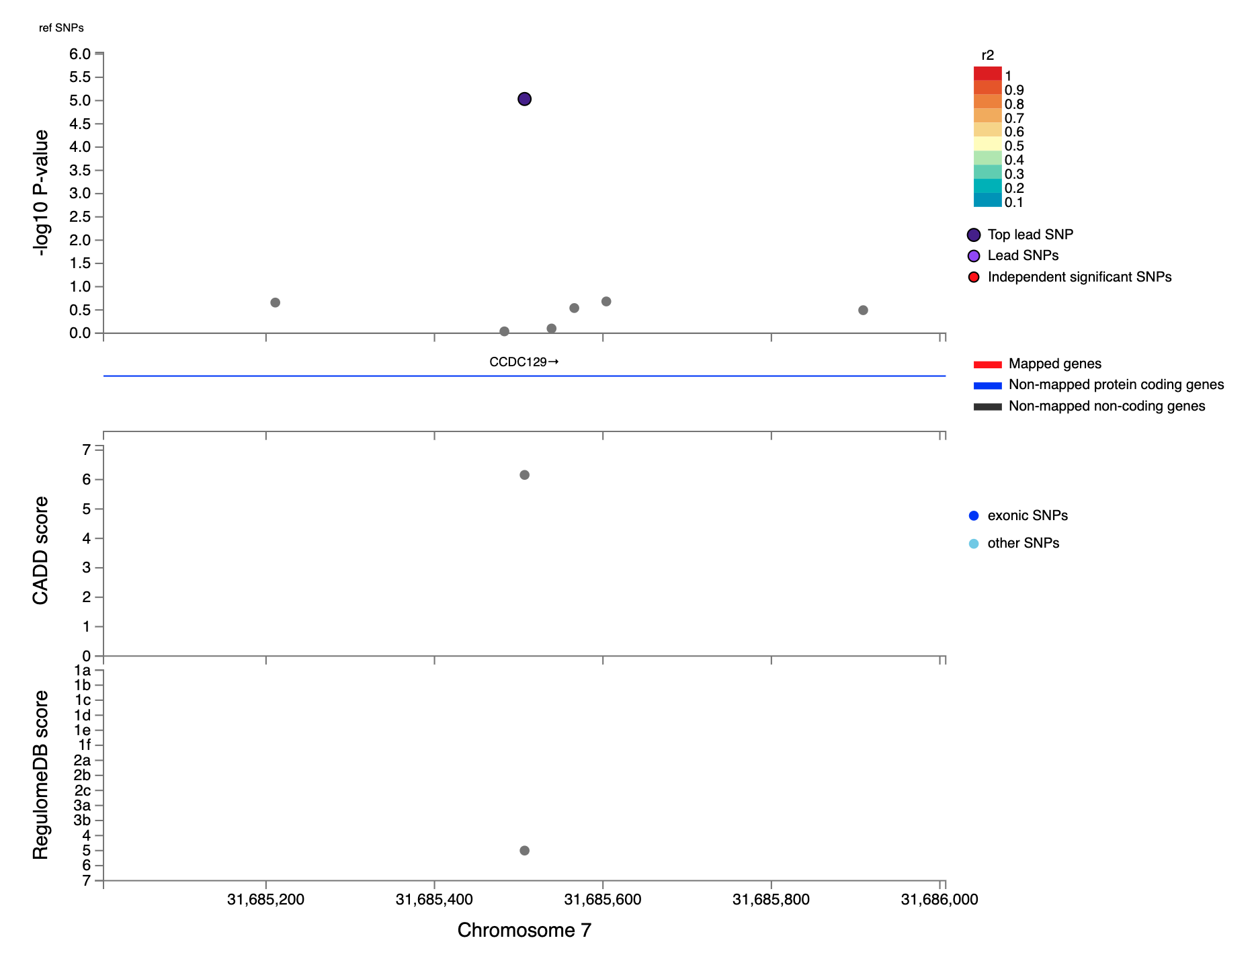Supplementary Fig 12. Regional plot of genomic locus 12 around the lead variant rs113114385 identified in the Active Music Engagement Frequency (AME) GWAS (N=23,782). Top. Top panel presents the -log10(p-values) of the association between variants and AME and linkage LD r² information for the variants in the locus (variants are colored by LD r²) and any eQTL-mapped genes are in red below. Bottom. The bottom panel presents the CADD scores and RegulomeDB scores (top and bottom tracks, respectively).

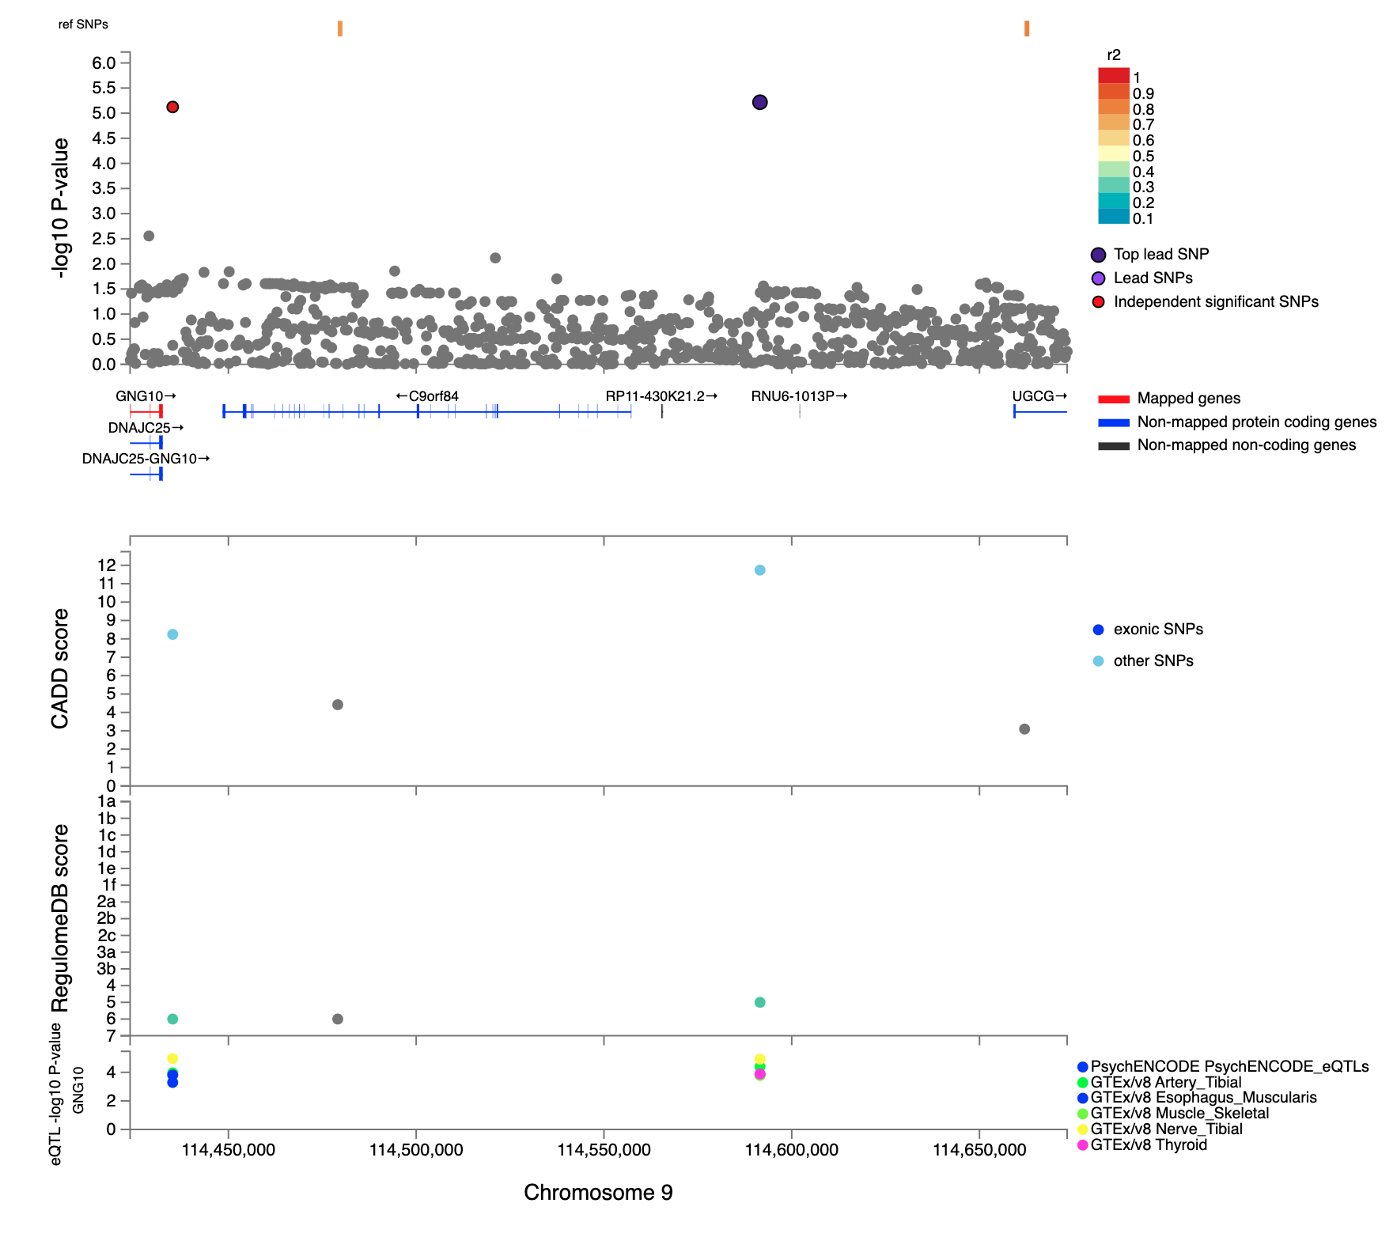Supplementary Fig 13. Regional plot of genomic locus 13 around the lead variant rs143824048 identified in the Active Music Engagement Frequency (AME) GWAS (N=23,782). Top. Top panel presents the -log10(p-values) of the association between variants and AME and linkage LD r² information for the variants in the locus (variants are colored by LD r²) and any eQTL-mapped genes are in red below. Middle. The middle panel presents the CADD scores and RegulomeDB scores (top and bottom tracks, respectively). Bottom. The bottom panel has the -log10(p-values) of the associations between variants and expression of the gene (on the y-axis), with the colour legend representing the eQTL database.

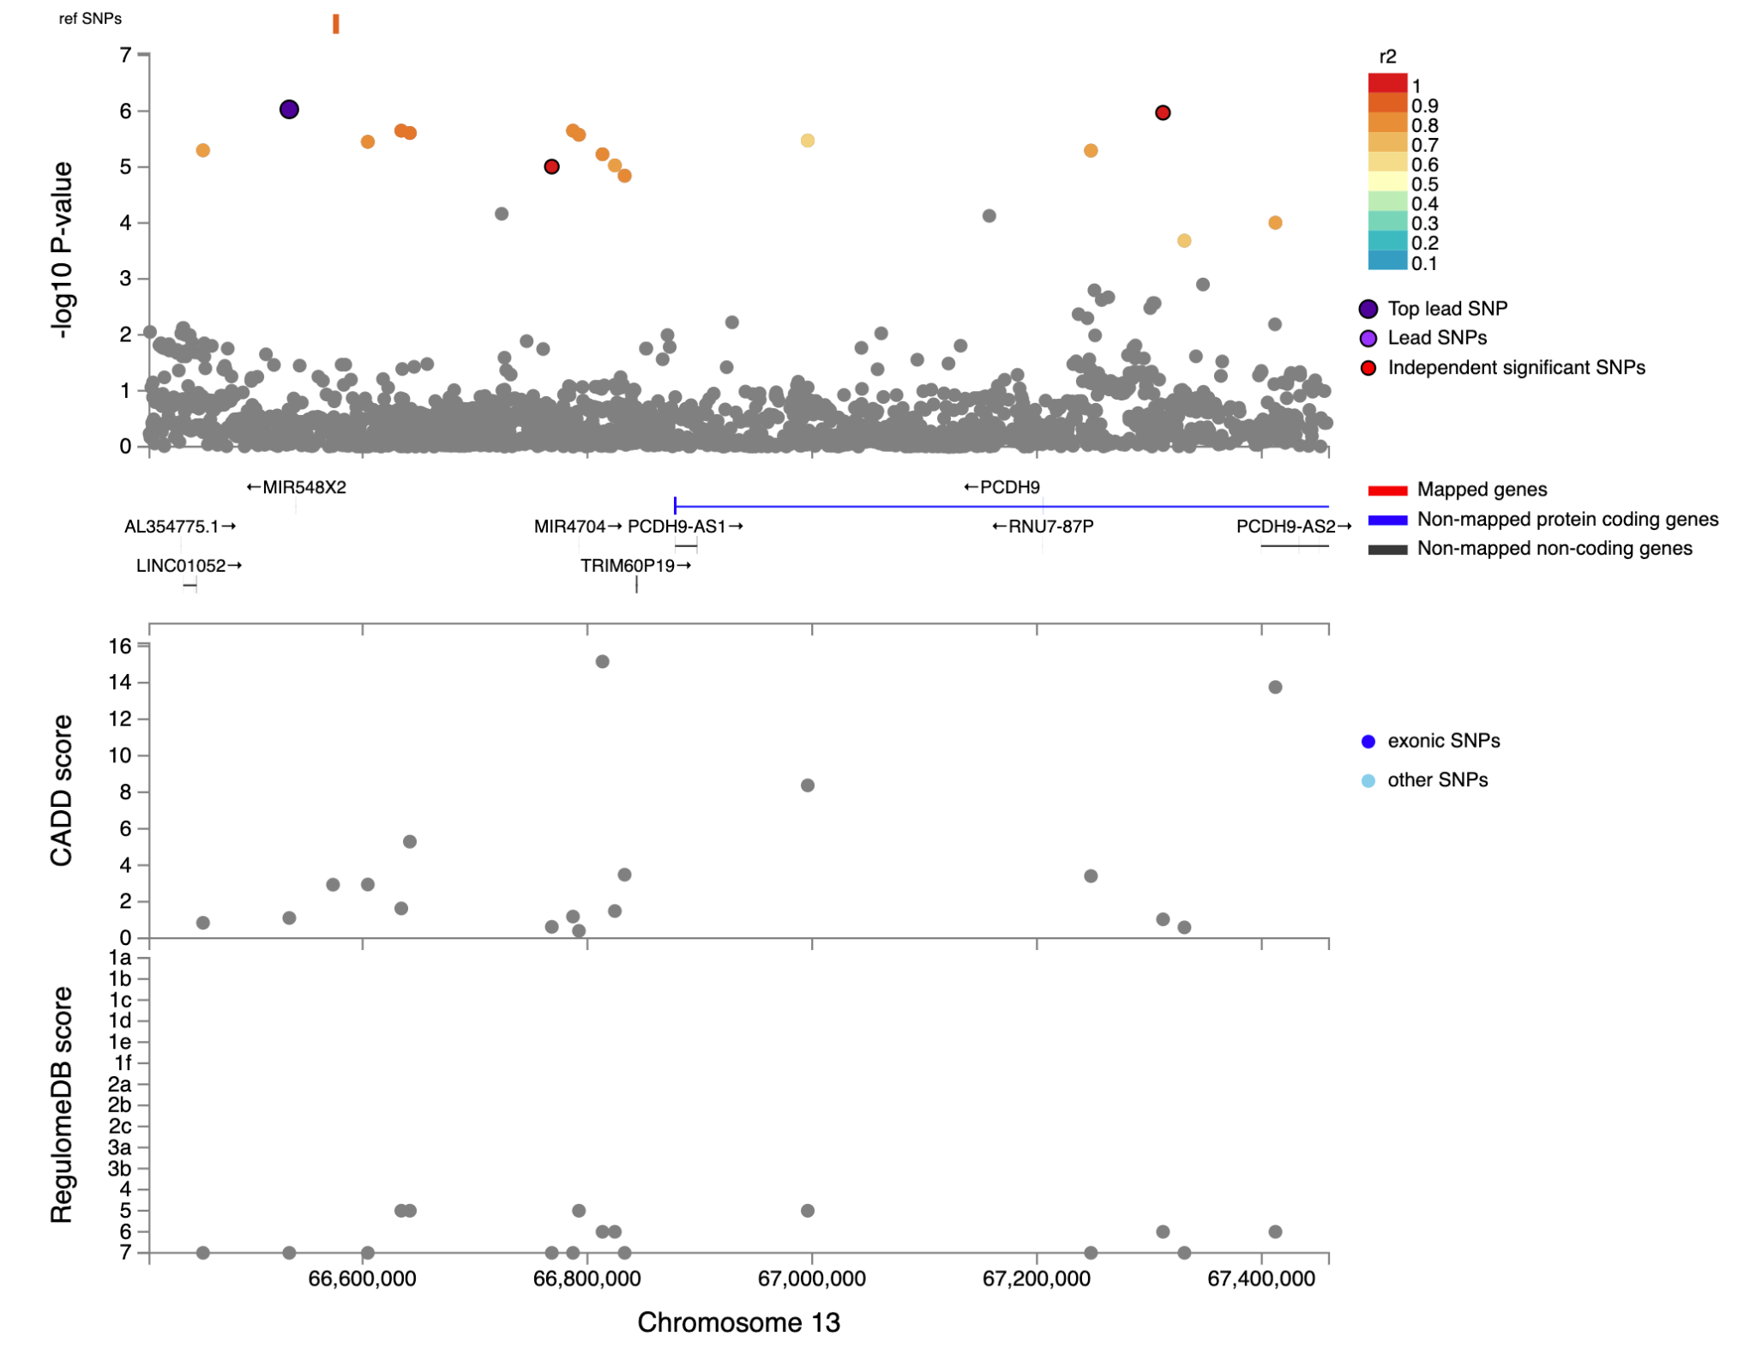Supplementary Fig 14. Regional plot of genomic locus 14 around the lead variant rs80055245 identified in the Active Music Engagement Frequency (AME) GWAS (N=23,782). Top. Top panel presents the -log10(p-values) of the association between variants and AME and linkage LD r² information for the variants in the locus (variants are colored by LD r²) and any eQTL-mapped genes are in red below. Bottom. The bottom panel presents the CADD scores and RegulomeDB scores (top and bottom tracks, respectively).

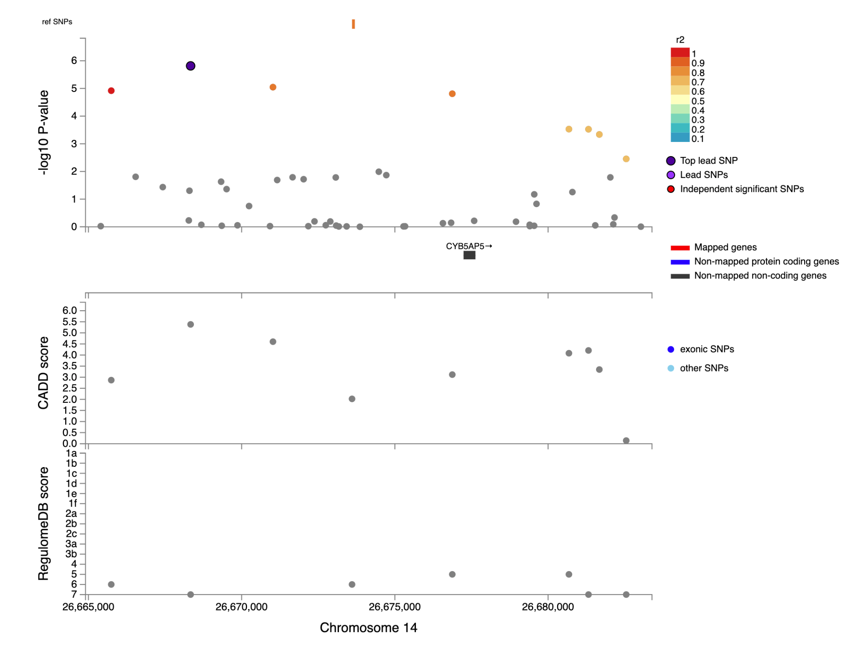Supplementary Fig 15. Regional plot of genomic locus 15 around the lead variant rs79292477 identified in the Active Music Engagement Frequency (AME) GWAS (N=23,782). Top. Top panel presents the -log10(p-values) of the association between variants and AME and linkage LD r² information for the variants in the locus (variants are colored by LD r²) and any eQTL-mapped genes are in red below. Bottom. The bottom panel presents the CADD scores and RegulomeDB scores (top and bottom tracks, respectively).

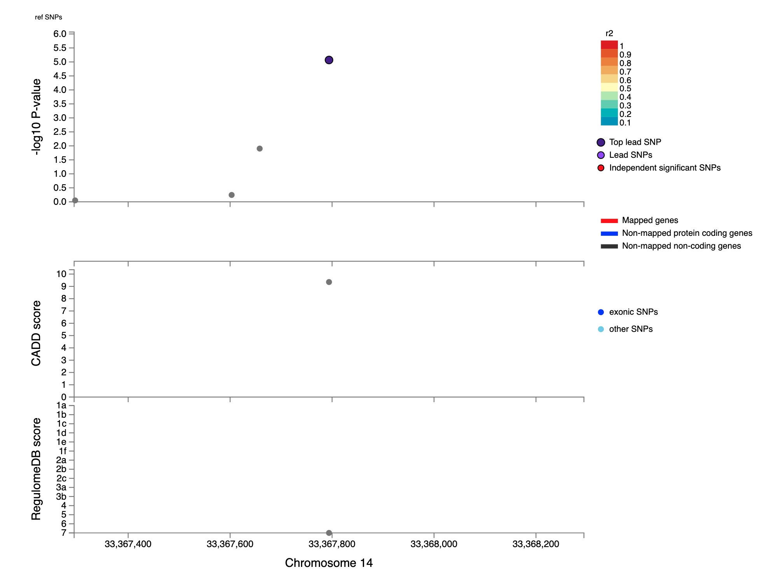Supplementary Fig 16. Regional plot of genomic locus 16 around the lead variant rs10145529 identified in the Active Music Engagement Frequency (AME) GWAS (N=23,782). Top. Top panel presents the -log10(p-values) of the association between variants and AME and linkage LD r² information for the variants in the locus (variants are colored by LD r²) and any eQTL-mapped genes are in red below. Bottom. The bottom panel presents the CADD scores and RegulomeDB scores (top and bottom tracks, respectively).
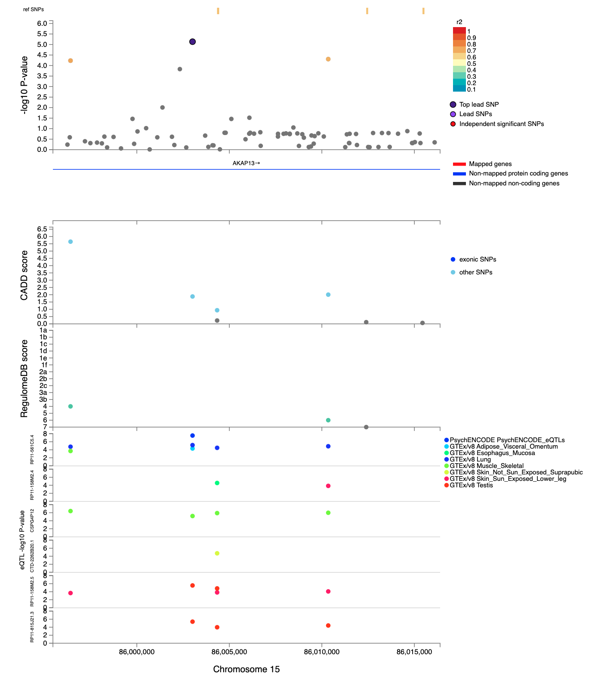Supplementary Fig 17. Regional plot of genomic locus 17 around the lead variant rs4572341 identified in the Active Music Engagement Frequency (AME) GWAS (N=23,782). Top. Top panel presents the -log10(p-values) of the association between variants and AME and linkage LD r² information for the variants in the locus (variants are colored by LD r²) and any eQTL-mapped genes are in red below. Middle. The middle panel presents the CADD scores and RegulomeDB scores (top and bottom tracks, respectively). Bottom. The bottom panel has the -log10(p-values) of the associations between variants and expression of the gene (on the y-axis), with the colour legend representing the eQTL database.
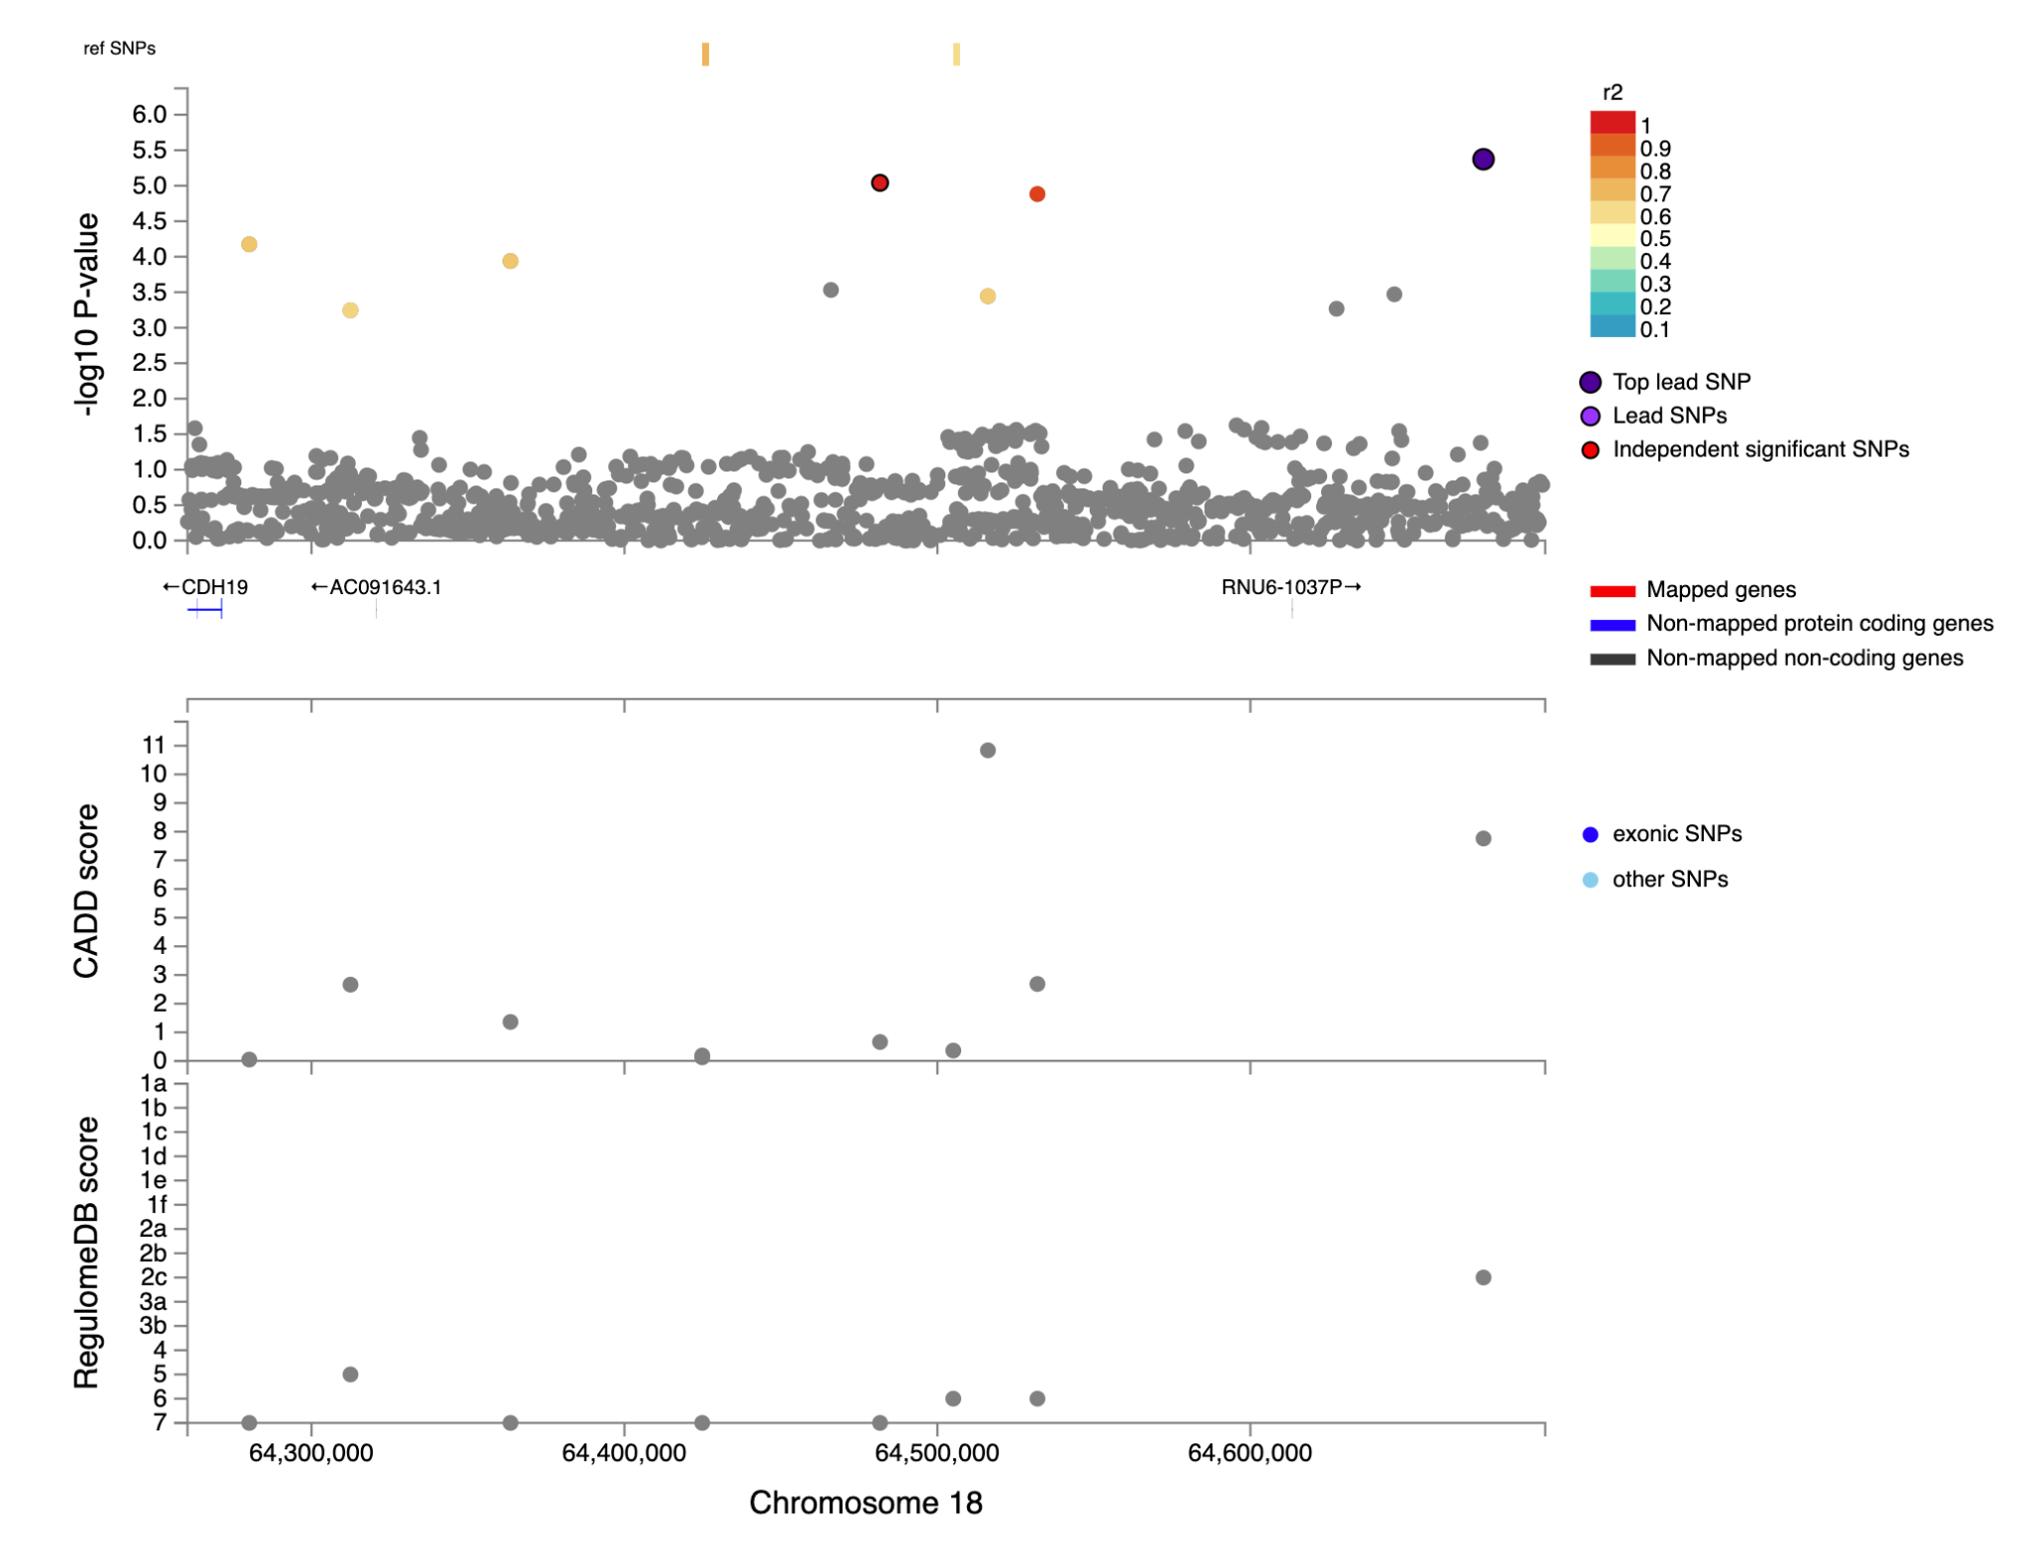Supplementary Fig 18. Regional plot of genomic locus 18 around the lead variant rs117450000 identified in the Active Music Engagement Frequency (AME) GWAS (N=23,782). Top. Top panel presents the -log10(p-values) of the association between variants and AME and linkage LD r² information for the variants in the locus (variants are colored by LD r²) and any eQTL-mapped genes are in red below. Bottom. The bottom panel presents the CADD scores and RegulomeDB scores (top and bottom tracks, respectively).
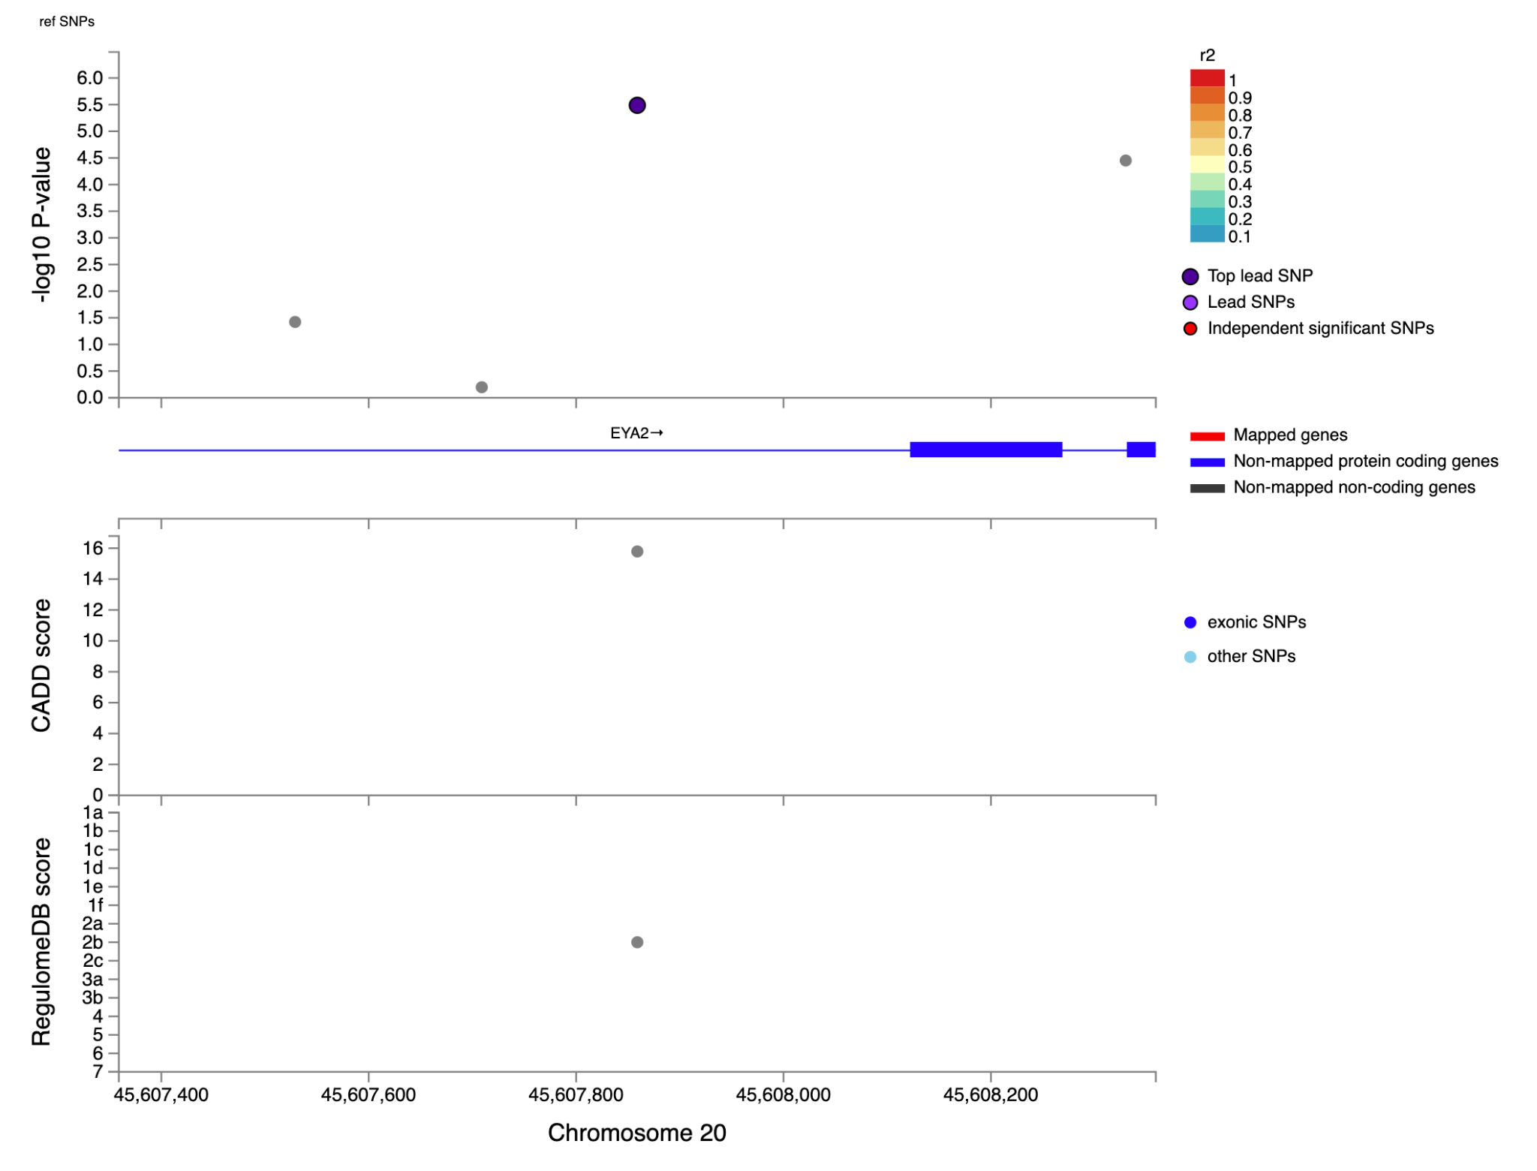Supplementary Fig 19. Regional plot of genomic locus 19 around the lead variant rs6124907 identified in the Active Music Engagement Frequency (AME) GWAS (N=23,782). Top. Top panel presents the -log10(p-values) of the association between variants and AME and linkage LD r² information for the variants in the locus (variants are colored by LD r²) and any eQTL-mapped genes are in red below. Bottom. The bottom panel presents the CADD scores and RegulomeDB scores (top and bottom tracks, respectively).
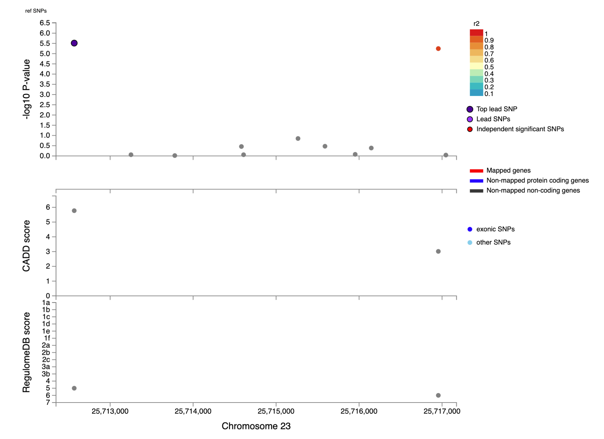
Supplementary Fig 20. Regional plot of genomic locus 20 around the lead variant rs5986261 identified in the Active Music Engagement Frequency (AME) GWAS (N=23,782). Top. Top panel presents the -log10(p-values) of the association between variants and AME and linkage LD r² information for the variants in the locus (variants are colored by LD r²) and any eQTL-mapped genes are in red below. Bottom. The bottom panel presents the CADD scores and RegulomeDB scores (top and bottom tracks, respectively).
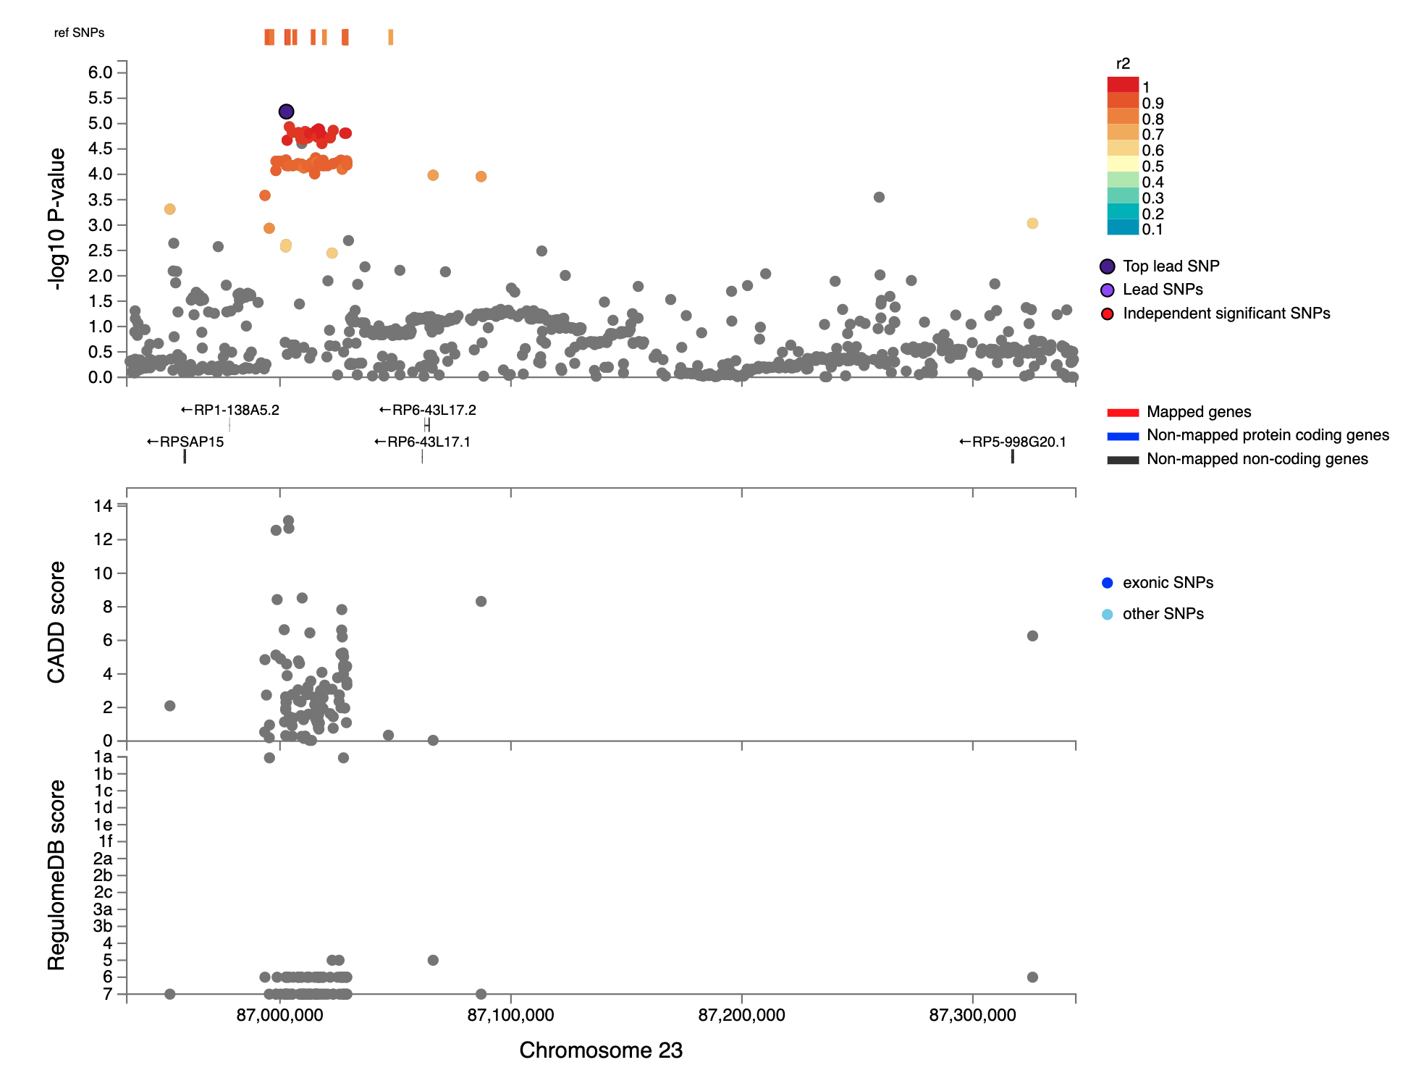
Supplementary Fig 21. Regional plot of genomic locus 21 around the lead variant rs5924107 identified in the Active Music Engagement Frequency (AME) GWAS (N=23,782). Top. Top panel presents the -log10(p-values) of the association between variants and AME and linkage LD r² information for the variants in the locus (variants are colored by LD r²) and any eQTL-mapped genes are in red below. Bottom. The bottom panel presents the CADD scores and RegulomeDB scores (top and bottom tracks, respectively).
Supplementary Fig 22. Leave-one-out analysis Results for the effect of Beat Synchronization on Active Music Engagement Frequency using MR-Egger regression.
Supplementary Fig 23. Leave-one-out analysis Results for the effect of Beat Synchronization on Active Music Engagement Frequency using Inverse Variance Weighted Meta-Analysis.

4. References
1. Bulik-Sullivan, B. K. et al. LD Score regression distinguishes confounding from polygenicity in genome-wide association studies. Nat. Genet. 47, 291–295 (2015).
2. Raina, P. et al. Cohort Profile: The Canadian Longitudinal Study on Aging (CLSA). Int. J. Epidemiol. 48, 1752–1753j (2019).
3. Forgetta, V. et al. Cohort profile: genomic data for 26 622 individuals from the Canadian Longitudinal Study on Aging (CLSA). BMJ Open 12, e059021 (2022).
4. Purcell, S. et al. PLINK: a tool set for whole-genome association and population-based linkage analyses. Am. J. Hum. Genet. 81, 559–575 (2007).
5. Staples, J. et al. PRIMUS: Rapid Reconstruction of Pedigrees from Genome-wide Estimates of Identity by Descent. Am. J. Hum. Genet. 95, 553–564 (2014).
6. Forgetta, V. et al. The Canadian Longitudinal Study on Aging.
7. Chang, C. C. et al. Second-generation PLINK: rising to the challenge of larger and richer datasets. GigaScience 4, 7 (2015).
8. Herd, P., Carr, D. & Roan, C. Cohort Profile: Wisconsin longitudinal study (WLS). Int. J. Epidemiol. 43, 34–41 (2014).
9. Lee, J. J. et al. Gene discovery and polygenic prediction from a genome-wide association study of educational attainment in 1.1 million individuals. Nat. Genet. 50, 1112–1121 (2018).
10. Zheng, X. et al. A high-performance computing toolset for relatedness and principal component analysis of SNP data. Bioinforma. Oxf. Engl. 28, 3326–3328 (2012).
11. Brumpton, B. M. et al. The HUNT study: A population-based cohort for genetic research. Cell Genomics 2, 100193 (2022).
12. Åsvold, B. O. et al. Cohort Profile Update: The HUNT Study, Norway. Int. J. Epidemiol. 52, e80–e91 (2023).
13. Næss, M. et al. Data Resource Profile: The HUNT Biobank. Int. J. Epidemiol. 53, dyae073 (2024).

