Table S1: Relationship of CNV burden (measured by number of CNVs or Genes) to “Any Psychiatric Disorders” or AUD. (Mann-Whitney Wilcoxon).
 | Plains Indians |  |  | Southwest Indians |  |  | NIH CC
Phenotype | Frequency | CNV Load (Mean ± SD) | Gene Load (Mean ± SD) | Frequency | CNV Load (Mean ± SD) | Gene Load (Mean ± SD) | Frequency* | CNV Load (Mean ± SD) | Gene Load (Mean ± SD)
AUD | 224 (0.60) | 3.6 ± 2.1 | 12.8 ± 74.4 | 233 (0.71) | 5.1 ± 5.2 | 17.4 ± 39.0 | 853 (0.62) | 2.9 ± 2.3 | 12.8 ± 22.5
Non-AUD | 151 (0.40) | 3.5 ± 2.2 | 13.8 ± 60.0 | 99 (0.29) | 4.8 ± 3.9 | 10.6 ± 20.4 | 521 (0.38) | 2.8 ± 2.2 | 11.5 ± 14.9
p-value |  | 0.3 | 0.8 |  | 0.1 | 0.5 |  | 0.9 | 0.8
Phobia | 41 (0.11) | 3.6 ± 1.6 | 7.6 ± 12.0 | 89 (0.27) | 4.8 ± 4.8 | 14.1 ± 24.6 | 145 (0.11) | 3.0 ± 2.4 | 10.8 ± 11.1
Non-Phobia | 334 (0.89) | 3.5 ± 2.2 | 14.0 ± 73.0 | 243 (0.73) | 4.9 ± 4.8 | 15.9 ± 37.6 | 1131 (0.89) | 2.9 ± 2.2 | 12.6 ± 21.1
p-value |  | 0.4 | 0.7 |  | 0.6 | 0.1 |  | 0.9 | 0.9
MDD | 27 (0.07) | 3.7 ± 2.1 | 5.8 ± 4.7 | 35 (0.11) | 5.1 ± 5.0 | 25.4 ± 62.0 | 250 (0.20) | 2.9 ± 2.3 | 12.0 ± 18.2
Non-MDD | 348 (0.93) | 3.6 ± 2.2 | 13.7 ± 71.3 | 297 (0.89) | 4.9 ± 4.8 | 14.2 ± 30.0 | 1027 (0.80) | 2.9 ± 2.2 | 12.8 ± 21.0
p-value |  | 0.5 | 0.5 |  | 0.9 | 0.5 |  | 0.1 | 0.07
PTSD | 17 (0.04) | 4.2 ± 3.8 | 39.5 ± 142.7 | 38 (0.11) | 7.2 ± 7.6 | 26.9 ± 46.9 | 167 (0.13) | 2.8 ± 2.3 | 13.1 ± 33.1
Non-PTSD | 353 (0.96) | 3.5 ± 2.0 | 12.5 ± 64.7 | 294 (0.89) | 4.7 ± 4.3 | 13.9 ± 32.5 | 1101 (0.87) | 3.0 ± 2.3 | 12.3 ± 17.6
p-value |  | 0.68 | 0.51 | 0.08 | 0.1 | 0.2 |  | 0.2 | 0.1
OCD | 4 (0.01) | 3.8 ± 1.2 | 6.0 ± 2.2 | 9 (0.03) | 4.0 ± 4.1 | 12.8 ± 19.4 | 13 (0.01) | 2.8 ± 1.4 | 9.7 ± 7.7
Non-OCD | 371 (0.99) | 3.5 ± 2.2 | 13.3 ± 69.1 | 323 (0.97) | 5.0 ± 4.8 | 15.3 ± 34.5 | 1262 (0.99) | 2.9 ± 2.3 | 12.5 ± 20.3
p-value |  | 0.8 | 0.9 |  | 0.3 | 0.4 |  | 0.6 | 0.9
ASPD | 46 (0.12) | 3.3 ± 1.8 | 4.5 ± 5.4 | 90 (0.27) | 4.5 ± 4.6 | 11.2 ± 22.7
Non-ASPD | 329 (0.88) | 3.6 ± 2.1 | 14.4 ± 73.3 | 242 (0.73) | 5.1 ± 4.9 | 17.1 ± 38.2 | __ | __ | __
p-value |  | 0.3 | 0.01 |  | 0.09 | 0.2
SUD | 42 (0.11) | 3.9 ± 1.7 | 28.6 ± 145.4 | 29 (0.09) | 5.0 ± 4.9 | 18.7 ± 47.7 | 531 (0.39) | 2.8 ± 2.3 | 12.6 ± 25.0
Non-SUD | 333 (0.89) | 3.5 ± 2.2 | 14.0 ± 72.8 | 303 (0.91) | 4.9 ± 4.8 | 15.1 ± 33.1 | 843 (0.61) | 2.9 ± 2.2 | 11.7 ± 15.4
p-value |  | 0.07 | 0.4 |  | 0.7 | 0.4 |  | 0.02 | 0.1

*For the various diagnoses the number of individuals represented differ due to missingness of data.
Cytogenetic region | CNV type | Size (kb) | Allele Frequencies |  | Genes Affected | Estimated Generations | Estimated Age in Years | Phenotype
 |  |  | SWI | PI
6p21.33 | Deletion | 98 | 0.14 | 0.08 | MICA, HCP5, PMSP, HCG26 | 1,405 | 28,100 | Located within the MHC region, MICA affects immune signalling, with roles in inflammation & autoimmunity. Deletions in the MHC region have been associated with psoriasis and other autoimmune diseases.
13q13.1 | Deletion | 55 | 0.07 | 0.1 | Non-genic region (near SLITRK1) | 813 | 16,270 | SLITRK1 is a brain-expressed gene involved in neuronal development and synaptic connectivity. SLITRK1 is associated with Tourette syndrome, OCD and ADHD.
3p25.2 | Duplication | 177 | 0.02 | 0.05 | RAF1, TMEM40 | 1,415 | 28,100 | RAF1 encodes a MAPK pathway kinase regulating cell proliferation and survival. RAF1 CNVs are associated with cardiovascular disease and cancer. TMEM40,is a transmembrane protein associated with cancer
22q11.23- q21.1 | Duplication | 260 | 0.11 | 0.03 | LRP5L, CRYBB2P1 | 178 | 3,570 | LRP5L is a member of the low-density lipoprotein receptor-related protein family, potentially influencing developmental processes, cell proliferation, and cholesterol homeostasis. CRYBB2P1 is a pseudogene important for lens structure.
20p12.1 | Deletion | 72 | 0.002 | 0.02 | MACROD2 | 411 | 8,220 | MACROD2 encodes a mono-ADP-ribosylhydrolase involved in DNA repair and transcription regulation. MACROD2 deletions are associated with neurodevelopmental disorders including autism and intellectual disability.
7q31.1 | Deletion | 156 | 0.02 | 0.007 | IMMP2L | 167-202 | 3,340-4,040 | IMMP2L encodes a mitochondrial inner membrane peptidase involved in mitochondrial protein processing and cellular energy metabolism. Variants are linked to neurodevelopmental disorders, including autism and ADHD,.
Table S2: rCNVs deleting or duplicating disease-associated genes, including cytogenetic locations, frequencies, and evolutionary ages as estimated by the conservation of haplotypes flanking the rCNVs.

7p22.3 | Deletion | 72 | - | 0.03 | SDK1 | 80 | 1,598 | SDK1 is a synaptic cell adhesion molecule involved in synapse formation and stability. It is associated with neurodevelopmental disorders including ASD and ADHD.
22q11.21 | Deletion | 354 | - | 0.03 | USP18, DGCR6, PRODDH | 113 | 2,260 | USP18 modulates interferon signaling and is linked to immune and neurological disorders. DGCR6, located in the DiGeorge syndrome critical region, influences neural crest cell migration and is implicated in DiGeorge syndrome. PRODH affects proline metabolism and is associated with hyperprolinemia and psychiatric conditions.
19q13.4 | Deletion | 118 | - | 0.03 | LILRA2, LILRA1, LILRB1, KIR3DX1 | 52 | 1,046 | LILRA1 and LILRA2 are immune-related receptors affecting innate immunity, hematopoietic signaling, and neural plasticity. LILRB1 is an inhibitory immune receptor that binds to MHC class I molecules and plays a key role in maintaining immune tolerance by suppressing excessive immune activation. KIR3DX1 is a pseudogene involved in modulating natural killer (NK) cell responses via HLA class I recognition.
1p36.21 | Deletion | 53 | - | 0.04 | AADACL3, CFAP107, PRAMEF11 | 109 | 2,180 | AADACL3, belongs to the serine esterase family and is involved in lipid metabolism. It has been implicated in metabolic disorders and cancer. CFAP107, is a structural component of cilia and flagella essential for flagellated sperm motility. PRAMEF11 is a member of the PRAME family, encoding leucine-rich repeat proteins expressed in the testis but also in various tumors. While their specific function is unclear, PRAME family members are known to act as transcriptional regulators involved in oncogenesis.
2q37.3 | Deletion | 71 | 0.05 | - | SCLY, ESPNL, KLHL30 | 448 | 8,960 | SCLY is highly expressed in liver and kidney, maintaining selenium homeostasis and redox balance. Disruption of SCLY has been associated with metabolic conditions such as obesity, hyperinsulinemia, glucose intolerance, and hepatic steatosis. ESPNL encodes an actin-binding protein critical for the elongation and maintenance of stereocilia in auditory cells. KLHL30 participates in protein ubiquitination via E3 ligase and is linked to Congenital Myopathy 23 and Nemaline Myopathy 8. Mutations in KLHL genes can disrupt muscle development and contribute to other pathological conditions due to their central role in protein regulation.
6p21.33 | Deletion | 18 | 0.03 | - | MUC22 | 1490 | 29,800 | MUC22 encodes a member of the mucin family glycoproteins that contribute to protective mucosal barriers. MUC22 has been implicated in inflammatory responses and innate immunity.
7p22.1 | Deletion | 159 | 0.08 | - | FOXK1, AP5Z1, RADIL | 879 | 17,580 | FOXK1 is a transcription factor involved in the regulation of cell growth, muscle development, and metabolic pathways.  AP5Z1 encodes a subunit of the adaptor protein complex AP5, essential for the sorting and trafficking of proteins within endosomes. Pathogenic variants of AP5Z1 have been linked to hereditary spastic paraplegia. RADIL (Ras Association and DIL Domains) regulates integrin-mediated cell adhesion and migration by modulating the actin cytoskeleton. Disruptions of RADIL may lead to congenital disorders involving neural crest migration, various cancers due to altered cell motility, and neurodevelopmental disorders stemming from aberrant neuronal positioning.
8q21.3 | Deletion | 66 | 0.04 | - | LRRC69 | 666 | 13,320 | LRRC69 encodes a signal transduction protein involved in cell adhesion. LRRC69 is primarily expressed in the testis and has been proposed as a risk factor for male infertility.
13q33.2 | Deletion | 87 | 0.03 | - | Non-genic region (near DAOA) | 107 | 2,140 | DAOA modulates D-amino acid oxidase activity thereby influencing NMDA receptor function. Through this mechanism, DAOA may contribute to altered glutamatergic signaling and increase susceptibility to multiple neuropsychiatric disorders.
3q26.31 | Duplication | 42 | 0.04 | - | NLGN1 | 148 | 2,960 | NLGN1 (neuroligin 1) is a member of the neuroligin family of neuronal cell surface proteins critical for synapse formation, maintenance, and function. NLGN1 modulates excitatory synaptic efficacy and plasticity. Alterations in NLGN1 have been implicated in autism spectrum disorder and various cognitive impairments.

Cytogenetic region | CNV type | Start (bp) | End (bp) | Size (Mb) | Carrier Frequency | Genes
1p36.33 | Deletion | 776546 | 1114668 | 0.33 | 15 (0.04) | Multigenic
1p36.33 | Deletion | 1138913 | 1179816 | 0.04 | 7 (0.02) | Multigenic
1p36.33 | Deletion | 1550992 | 1564064 | 0.01 | 6 (0.01) | MIB2
1p36.31 | Deletion | 3381698 | 3417211 | 0.03 | 2 (0.005) | ARHGEF16, MEGF6
1p36.31 | Deletion | 6181605 | 6697530 | 0.51 | 9 (0.02) | Multigenic
1p36.22 | Deletion | 12852872 | 12915847 | 0.06 | 4 (0.01) | PRAMEF1, RAMEF11, HNRNPCL1
1p36.21 | Deletion | 16015784 | 16188681 | 0.17 | 16 (0.04) | Multigenic
1p36.13 | Deletion | 17249219 | 17320122 | 0.07 | 2 (0.005) | CROCC, MFAP2
1p35.2 | Deletion | 30979276 | 31012257 | 0.03 | 3 (0.008) | Non-genic region
1p31.1 | Deletion | 55515618 | 55532142 | 0.01 | 2 (0.005) | PCSK9, USP24
1p31.1 | Deletion | 74492543 | 74649321 | 0.15 | 4 (0.01) | LRRIQ3
1p22.2 | Duplication | 89265248 | 89302955 | 0.03 | 8 (0.02) | PKN2
1p22.2 | Deletion | 91739270 | 91916880 | 0.17 | 3 (0.008) | HFM1
1p22.1 | Deletion | 93651547 | 93724389 | 0.07 | 3 (0.008) | CCDC18
1p21.1 | Duplication | 103354135 | 103548505 | 0.19 | 3 (0.008) | COL11A1
1p13.3* | Deletion | 109789795 | 109820919 | 0.03 | 5 (0.014) | CELSR2
1q21.1 | Duplication | 145610210 | 145762959 | 0.15 | 6 (0.01) | Multigenic
1q21.3 | Deletion | 151239051 | 151263530 | 0.02 | 3 (0.008) | PSMD4, ZNF687
1q21.3 | Deletion | 152526812 | 152552461 | 0.02 | 7 (0.02) | LCE3E, LCE3D
1q22 | Deletion | 155151048 | 155165892 | 0.01 | 2 (0.005) | TRIM46, MUC1, THBS3
1q25.3-q31.1 | Duplication | 185565704 | 186151390 | 0.58 | 7 (0.02) | HMCN1
1q31.3 | Deletion | 194083813 | 194564447 | 0.48 | 3 (0.008) | Non-genic region
1q31.3 | Duplication | 197019858 | 197644773 | 0.62 | 10 (0.02) | Multigenic
1q31.3 | Duplication | 197892733 | 198544730 | 0.65 | 2 (0.005) | LHX9, NEK7, ATP6V1G3
1q32.1 | Duplication | 201415592 | 201603081 | 0.18 | 7 (0.02) | PHLDA3, CSRP1
1q42.12 | Deletion | 225061843 | 225539363 | 0.47 | 2 (0.005) | DNAH14
1q42.13 | Deletion | 228520973 | 228564884 | 0.04 | 14 (0.04) | OBSCN
1q42.13 | Duplication | 230372099 | 230429143 | 0.05 | 7 (0.02) | GALNT2
1q44 | Deletion | 245848798 | 245861522 | 0.01 | 7 (0.02) | KIF26B
2p23.3 | Deletion | 27292534 | 27360863 | 0.06 | 9 (0.02) | Multigenic
2p22.2 | Duplication | 38510608 | 38580233 | 0.07 | 13 (0.03) | ATL2
2p16.3 | Deletion | 49676328 | 49764298 | 0.08 | 9 (0.02) | Non-genic region
Table S3: Cytogenetic region, CNV type, genomic coordinates (base pairs), CNV size (megabases), carrier frequency, and genes affected by rCNVs detected in Southwest Indians.
2p16.1 | Duplication | 57399830 | 57445335 | 0.04 | 3 (0.008) | Non-genic region
2p15 | Deletion | 61454010 | 61566536 | 0.11 | 2 (0.005) | USP34
2p13.1 | Deletion | 73847024 | 73900329 | 0.05 | 3 (0.008) | NAT8, ALMS1P
2q12.3 | Duplication | 107830992 | 107862981 | 0.03 | 2 (0.005) | Non-genic region
2q12.3 | Deletion | 109085455 | 109098854 | 0.01 | 3 (0.008) | GCC2
2q13 | Duplication | 110852875 | 110980346 | 0.12 | 8 (0.02) | MALL, NPHP1
2q14.3 | Deletion | 127804699 | 127834459 | 0.02 | 2 (0.005) | BIN1
2q14.3 | Deletion | 128327387 | 128471218 | 0.14 | 2 (0.005) | Multigenic
2q21.1* | Deletion | 132057166 | 132298468 | 0.24 | 5 (0.014) | Multigenic
2q31.2 | Duplication | 179365400 | 179618462 | 0.25 | 2 (0.005) | PLEKHA3, TTN
2q33.1 | Duplication | 201397345 | 201450068 | 0.05 | 11 (0.03) | SGOL2
2q37.3 | Deletion | 238999875 | 239071623 | 0.07 | 35 (0.10) | SCLY, ESPNL, KLHL30
2q37.3 | Duplication | 241800707 | 242212672 | 0.41 | 2 (0.005) | Multigenic
3p26.3 | Duplication | 61495 | 382547 | 0.32 | 9 (0.02) | CHL1
3p25.2* | Duplication | 12628920 | 12806123 | 0.17 | 19 (0.05) | RAF1, TMEM40
3p24.3 | Duplication | 21083986 | 21144408 | 0.06 | 5 (0.01) | Non-genic region
3q12.2 | Duplication | 100351696 | 100441716 | 0.09 | 2 (0.005) | GPR128, TFG
3q13.13 | Deletion | 108254751 | 108301920 | 0.04 | 5 (0.01) | KIAA1524
3q25.32 | Deletion | 158515499 | 158539294 | 0.02 | 2 (0.005) | MFSD1
3q26.1 | Deletion | 164709997 | 164750447 | 0.04 | 3 (0.008) | SI
3q26.31 | Duplication | 172321698 | 172397868 | 0.07 | 3 (0.008) | NCEH1
3q26.31 | Duplication | 173239453 | 173281958 | 0.04 | 28 (0.08) | NLGN1
3q26.33 | Deletion | 180320704 | 180386213 | 0.06 | 3 (0.008) | TTC14, CCDC39
4p16.3 | Deletion | 942006 | 1064557 | 0.12 | 29 (0.08) | Multigenic
4p16.1 | Deletion | 8212524 | 8239393 | 0.02 | 18 (0.05) | SH3TC1
4p12 | Duplication | 46038274 | 46086060 | 0.04 | 3 (0.008) | GABRG1
4q12* | Duplication | 58604281 | 58770663 | 0.16 | 7 (0.02) | Non-genic region
4q22.1 | Deletion | 92930924 | 93088664 | 0.15 | 12 (0.03) | Non-genic region
4q35.1 | Deletion | 186322002 | 186381059 | 0.05 | 2 (0.005) | UFSP2, CCDC110
4q35.2 | Duplication | 189139613 | 189388320 | 0.24 | 3 (0.008) | Non-genic region
4q35.2 | Deletion | 189519649 | 189557490 | 0.03 | 2 (0.005) | Non-genic region
5p15.1 | Deletion | 17697085 | 17745762 | 0.04 | 13 (0.03) | Non-genic region
5p13.3 | Duplication | 32101400 | 32159517 | 0.05 | 19 (0.05) | PDZD2, GOLPH3
5p12-p11 | Duplication | 45602976 | 46399093 | 0.79 | 7 (0.02) | HCN1
5q31.1 | Duplication | 130736800 | 130840385 | 0.10 | 11 (0.03) | RAPGEF6
5q31.1 | Deletion | 132150484 | 132161784 | 0.01 | 11 (0.03) | SOWAHA, SHROOM1
5q31.3 | Deletion | 140165568 | 140264271 | 0.09 | 20 (0.05) | PCDHA1-13
5q32 | Duplication | 146687393 | 146817347 | 0.13 | 3 (0.008) | STK32A, DPYSL3
5q35.3 | Deletion | 176730190 | 176958397 | 0.22 | 14 (0.04) | Multigenic
5q35.3 | Deletion | 179200919 | 179308012 | 0.11 | 7 (0.02) | Multigenic
6p22.3 | Deletion | 16186284 | 16326842 | 0.14 | 6 (0.01) | GMPR, ATXN1
6p22.2 | Deletion | 26020276 | 26056321 | 0.03 | 5 (0.01) | Multigenic
6p22.1 | Duplication | 29094696 | 29161435 | 0.06 | 4 (0.01) | OR2J2
6p22.1 | Deletion | 29849619 | 29896421 | 0.04 | 7 (0.02) | HLA-H, HLA-G, HLA-J
6p21.33 | Deletion | 30969527 | 30987786 | 0.01 | 25 (0.07) | MUC22
6p21.33* | Deletion | 31355318 | 31453640 | 0.09 | 93 (0.26) | MICA, HCP5, PMSP, HCG26
6p21.31 | Deletion | 34480637 | 34544384 | 0.06 | 5 (0.01) | PACSIN1, SPDEF
6q11.1-q12 | Duplication | 63136576 | 63610969 | 0.47 | 10 (0.02) | Non-genic region
6q22.31 | Duplication | 124681503 | 124900701 | 0.21 | 9 (0.02) | NKAIN2
7p22.3 | Duplication | 44935 | 68920 | 0.02 | 15 (0.04) | Non-genic region
7p22.3 | Duplication | 44935 | 81237 | 0.03 | 6 (0.01) | Non-genic region
7p22.3 | Duplication | 44935 | 162145 | 0.11 | 7 (0.02) | Non-genic region
7p22.3 | Duplication | 44935 | 171613 | 0.12 | 8 (0.02) | Non-genic region
7p22.1 | Deletion | 4721171 | 4880954 | 0.15 | 56 (0.16) | FOXK1, AP5Z1, RADIL
7p22.3 | Deletion | 9680160 | 9858697 | 0.17 | 7 (0.02) | Non-genic region
7p12.3 | Duplication | 47496258 | 47619815 | 0.12 | 3 (0.008) | TNS3
7q11.23* | Duplication | 76131646 | 76639871 | 0.51 | 6 (0.01) | Multigenic
7q22.1 | Duplication | 100634386 | 100686356 | 0.05 | 7 (0.02) | MUC12, MUC17
7q31.1* | Deletion | 110971919 | 111309224 | 0.33 | 16 (0.04) | IMMP2L
7q31.1 | Duplication | 113207209 | 113493772 | 0.28 | 2 (0.005) | Non-genic region
7p36.1 | Deletion | 149410638 | 149430847 | 0.02 | 26 (0.07) | KRBA1
7p36.1 | Deletion | 150639871 | 150883937 | 0.24 | 6 (0.01) | Multigenic
8p23.3 | Duplication | 1697573 | 1753497 | 0.05 | 13 (0.03) | CLN8
8p21.3 | Deletion | 21959728 | 21997479 | 0.03 | 11 (0.03) | FAM160B2, NUDT18, HR, REEP4
8p12 | Duplication | 30699708 | 30731171 | 0.03 | 8 (0.02) | TEX15
8q21.3 | Deletion | 92114936 | 92181214 | 0.06 | 31 (0.08) | LRRC69
8q22.2-q22.3 | Duplication | 101421798 | 101612659 | 0.19 | 6 (0.01) | ANKRD46, SNX31
8q24.3 | Deletion | 145101381 | 145114919 | 0.01 | 2 (0.005) | SPATC1, OPLAH
9p24.3* | Duplication | 483018 | 489338 | 0.006 | 2 (0.005) | KANK1
9p24.2 | Duplication | 3138608 | 3267584 | 0.12 | 3 (0.008) | RFX3
9p24.1 | Duplication | 6587200 | 6928789 | 0.34 | 22 (0.06) | GLDC, KDM4C
9p23 | Deletion | 12022175 | 12165758 | 0.14 | 6 (0.01) | Non-genic region
9q34.12 | Deletion | 133759566 | 133816023 | 0.05 | 5 (0.01) | ABL1, QRFP, FIBCD1
10p14 | Deletion | 11527215 | 11582344 | 0.05 | 4 (0.01) | USP6NL
10p11.21 | Duplication | 37487831 | 37529216 | 0.04 | 2 (0.005) | ANKRD30A
10q11.22 | Duplication | 47412588 | 47650490 | 0.23 | 6 (0.01) | FAM35DP
10q21.1 | Deletion | 57138742 | 57650954 | 0.51 | 2 (0.005) | PCDH15, MTRNR2L5
10q23.33 | Deletion | 94814907 | 94834581 | 0.01 | 6 (0.01) | EXOC6, CYP26C1, CYP26A1
10q24.1 | Duplication | 98792520 | 98876941 | 0.08 | 2 (0.005) | SLIT1
10q25.3 | Deletion | 116930870 | 117575619 | 0.64 | 2 (0.005) | ATRNL1
11p15.5 | Deletion | 280464 | 1015021 | 0.73 | 4 (0.01) | Multigenic
11p15.5 | Deletion | 2386636 | 2469915 | 0.08 | 9 (0.02) | CD81, TSSC4, TRPM5, KCNQ1
11q22.3 | Deletion | 102937178 | 103191959 | 0.25 | 3 (0.008) | DCUN1D5, DYNC2H1
11q22.3 | Deletion | 108097333 | 108352891 | 0.25 | 2 (0.005) | ATM, KDELC2
11q23.2 | Deletion | 113267957 | 113280724 | 0.01 | 7 (0.02) | ANKK1, DRD2
11q25 | Duplication | 134792477 | 134934063 | 0.14 | 4 (0.01) | Non-genic region
12p13.31* | Duplication | 8000912 | 8114429 | 0.11 | 2 (0.005) | SLC2A14, NANOGP1, SLC2A3
12p13.31 | Duplication | 9435244 | 9664352 | 0.22 | 16 (0.04) | DDX12P
12p11.11 | Deletion | 53439537 | 53454938 | 0.01 | 9 (0.02) | TENC1
12q14.2* | Duplication | 63946056 | 64118558 | 0.17 | 2 (0.005) | DPY19L2
12q21.31 | Duplication | 85070164 | 85755820 | 0.68 | 7 (0.02) | SLC6A15, TSPAN19, LRRIQ1, ALX1
13q12.11 | Duplication | 21728134 | 21746637 | 0.01 | 22 (0.06) | SKA3
13q14.11 | Duplication | 43718991 | 43828170 | 0.10 | 9 (0.02) | ENOX1
13q22.1 | Deletion | 73331944 | 73575455 | 0.24 | 2 (0.005) | DIS3, PIBF1
13q31.1* | Deletion | 84101480 | 84157927 | 0.05 | 51 (0.14) | Non-genic region
13q33.1 | Duplication | 103382660 | 103402638 | 0.02 | 9 (0.02) | CCDC168
13q33.2* | Deletion | 106219874 | 106307349 | 0.08 | 25 (0.07) | Non-genic region
14q11.2 | Duplication | 19700048 | 20416499 | 0.71 | 11 (0.03) | Multigenic
14q11.2 | Duplication | 20213937 | 20416499 | 0.20 | 2 (0.005) | Multigenic
14q11.2 | Deletion | 21358155 | 21393289 | 0.03 | 18 (0.05) | RNASE3, ECRP, RNASE2
14q12 | Deletion | 27596242 | 27714462 | 0.11 | 6 (0.01) | Non-genic region
14q22.1 | Duplication | 52354228 | 52416412 | 0.06 | 4 (0.01) | GNG2
14q23.1 | Deletion | 58666970 | 59006831 | 0.33 | 3 (0.008) | Multigenic
14q23.1 | Duplication | 60903572 | 60938407 | 0.03 | 10 (0.02) | Non-genic region
14q31.3 | Duplication | 89171711 | 89466033 | 0.29 | 4 (0.01) | EML5, TTC8
14q32.33 | Deletion | 104546893 | 104662014 | 0.11 | 3 (0.008) | ASPG, KIF26A
15q11.2 | Deletion | 22750305 | 23272733 | 0.52 | 3 (0.008) | Multigenic
15q11.2 | Duplication | 24357212 | 24472002 | 0.11 | 6 (0.01) | PWRN2
15q15.1 | Deletion | 42104826 | 42185482 | 0.08 | 18 (0.05) | Multigenic
15q15.1 | Deletion | 42143533 | 42164078 | 0.02 | 6 (0.01) | SPTBN5
15q15.2 | Deletion | 42869028 | 42934631 | 0.06 | 6 (0.01) | STARD9
15q21.3 | Deletion | 57720473 | 57754873 | 0.03 | 2 (0.005) | CGNL1
15q22.2 | Deletion | 62128861 | 62332980 | 0.20 | 10 (0.02) | VPS13C
15q26.3 | Duplication | 102264489 | 102461162 | 0.19 | 11 (0.03) | Multigenic
16p13.3 | Deletion | 514407 | 875050 | 0.36 | 32 (0.09) | Multigenic
16p13.3 | Deletion | 678430 | 726120 | 0.04 | 7 (0.02) | Multigenic
16p13.3 | Deletion | 767179 | 780615 | 0.01 | 3 (0.008) | Multigenic
16p13.3 | Deletion | 812700 | 825628 | 0.01 | 4 (0.01) | MSLN
16p13.3 | Deletion | 1799407 | 1858888 | 0.05 | 19 (0.05) | Multigenic
16p13.3 | Deletion | 2003399 | 2087547 | 0.08 | 22 (0.06) | Multigenic
16p13.3 | Deletion | 2130189 | 2199788 | 0.06 | 3 (0.008) | Multigenic
16p13.3 | Deletion | 2510603 | 2788281 | 0.27 | 5 (0.01) | Multigenic
16p13.3 | Deletion | 3170210 | 3191356 | 0.02 | 3 (0.008) | ZNF205, ZNF213
16p13.2 | Deletion | 8531584 | 8615618 | 0.08 | 4 (0.01) | TMEM114
16q22.1 | Deletion | 67180198 | 67320972 | 0.14 | 9 (0.02) | Multigenic
16q24.1 | Deletion | 84209816 | 84233596 | 0.02 | 4 (0.01) | DNAAF1, TAF1C, ADAD2
16q24.2 | Deletion | 88440878 | 88601281 | 0.16 | 5 (0.01) | ZNF469, ZFPM1
17p11.2 | Duplication | 21319849 | 21503147 | 0.18 | 3 (0.008) | KCNJ12
17p11.2-p11.1 | Deletion | 21539613 | 22242355 | 0.70 | 18 (0.05) | UBBP4, FAM27L, MTRNR2L1
17q12 | Duplication | 34443811 | 34466631 | 0.02 | 22 (0.06) | Non-genic region
17q25.3 | Duplication | 80391684 | 80544855 | 0.15 | 2 (0.005) | Multigenic
18q21.1 | Deletion | 63203008 | 63275241 | 0.07 | 7 (0.02) | Non-genic region
19q13.33 | Duplication | 50520133 | 50548187 | 0.02 | 10 (0.02) | VRK3, ZNF473
19q13.41 | Duplication | 53518590 | 53548950 | 0.03 | 22 (0.06) | ERVV-1, ERVV-2
19q13.42* | Deletion | 53932295 | 54011384 | 0.07 | 3 (0.008) | TPM3P9, ZNF761, ZNF813
20p12.1* | Deletion | 14815778 | 15171838 | 0.35 | 2 (0.005) | MACROD2
20q11.22 | Deletion | 33566722 | 33591284 | 0.02 | 10 (0.02) | MYH7B, TRPC4AP
20q13.33 | Deletion | 58416428 | 58500453 | 0.08 | 11 (0.03) | PHACTR3, SYCP2
20q13.33 | Deletion | 60788970 | 60912731 | 0.12 | 10 (0.02) | Multigenic
20q13.33 | Deletion | 62028210 | 62836184 | 0.80 | 7 (0.02) | Multigenic
20q13.33 | Deletion | 62117518 | 62203708 | 0.08 | 7 (0.02) | Multigenic
20q13.33 | Deletion | 62187669 | 62202150 | 0.01 | 4 (0.01) | HELZ2
20q13.33 | Deletion | 62193253 | 62722711 | 0.52 | 3 (0.008) | Multigenic
22q11.22 | Deletion | 22381327 | 22538738 | 0.15 | 3 (0.008) | Non-genic region
22q11.22 | Deletion | 22394144 | 23237674 | 0.84 | 8 (0.02) | Multigenic
22q11.22 | Duplication | 22508432 | 22734671 | 0.22 | 2 (0.005) | Multigenic
22q11.22 | Deletion | 22599238 | 22946825 | 0.34 | 6 (0.01) | Multigenic
22q11.22 | Deletion | 22770917 | 23010666 | 0.23 | 7 (0.02) | Multigenic
22q11.23-q12.1* | Duplication | 25650406 | 25910667 | 0.26 | 79 (0.22) | IGLL3P, LRP5L, CRYBB2P1
*Found in PI

Table S4: Cytogenetic region, CNV type, genomic coordinates (base pairs), CNV size (megabases), carrier frequency, and genes affected by rCNVs detected in Plains Indians.
Cytogenetic region | CNV type | Start (bp) | End (bp) | Size (Mb) | Carrier Frequency | Genes
1p36.32 | Duplication | 3211458 | 3249242 | 0.03 | 8 (0.02) | PRDM16
1p36.21 | Deletion | 12783336 | 12836483 | 0.05 | 31 (0.08) | AADACL3, CFAP107, PRAMEF12
1p36.13 | Duplication | 18027377 | 18650794 | 0.62 | 8 (0.02) | ACTL8, IGSF21
1p22.2 | Deletion | 90304817 | 90313153 | 0.008 | 7 (0.01) | LRRC8D
1p13.3 | Deletion | 109201183 | 109505884 | 0.30 | 3 (0.007) | Multigenic
1p13.3* | Deletion | 109705022 | 109832283 | 0.12 | 2 (0.005) | CELSR2
1q21.3 | Deletion | 150797134 | 150819989 | 0.02 | 95 (0.24) | ARNT
1q31.1 | Duplication | 187261219 | 187478245 | 0.21 | 4 (0.01) | Non-genic region
1q31.3 | Duplication | 194977690 | 195163711 | 0.18 | 3 (0.007) | Non-genic region
1q43 | Duplication | 239896209 | 240067411 | 0.17 | 3 (0.007) | Multigenic
2p16.3 | Deletion | 52035257 | 52074452 | 0.03 | 9 (0.02) | Non-genic region
2p12 | Deletion | 89390395 | 89877778 | 0.48 | 21 (0.05) | IGKV2-28, IGKV4-1
2q14.3 | Deletion | 128050883 | 128122391 | 0.07 | 3 (0.007) | ERCC3
2q21.1* | Deletion | 132077379 | 132311088 | 0.23 | 1 (0.002) | Multigenic
2q24.2 | Duplication | 160317408 | 160451108 | 0.13 | 4 (0.01) | BAZ2B
2q24.3 | Duplication | 169205375 | 169238400 | 0.03 | 8 (0.02) | Non-genic region
3p26.1 | Duplication | 5899967 | 6115317 | 0.21 | 3 (0.007) | Non-genic region
3p25.2* | Duplication | 12610706 | 12792622 | 0.18 | 43 (0.11) | MKRN2, RAF1, TMEM40
3p24.3 | Duplication | 20167830 | 20951147 | 0.78 | 5 (0.01) | KAT2B, SGOL1
3p14.1 | Deletion | 65159939 | 65187636 | 0.02 | 24 (0.06) | Non-genic region
3p12.1 | Deletion | 84832445 | 84882133 | 0.05 | 7 (0.01) | Non-genic region
3q29 | Duplication | 193668899 | 194233500 | 0.56 | 4 (0.01) | Multigenic
4p15.2 | Deletion | 22155404 | 22244178 | 0.08 | 5 (0.01) | Non-genic region
4q12* | Duplication | 58604281 | 58758826 | 0.15 | 1 (0.002) | Non-genic region
4q28.1 | Deletion | 127597069 | 127667944 | 0.07 | 9 (0.02) | Non-genic region
4q28.3 | Deletion | 136751948 | 136819237 | 0.06 | 7 (0.01) | Non-genic region
5p15.33 | Duplication | 1052360 | 1275528 | 0.22 | 9 (0.02) | SLC12A7, SLC6A19, SLC6A18, TERT
5p15.31 | Deletion | 8753487 | 8796390 | 0.04 | 8 (0.02) | Non-genic region
5p15.2 | Duplication | 10785424 | 11313232 | 0.52 | 3 (0.007) | CTNND2
5p12 | Duplication | 45905997 | 46348483 | 0.44 | 14 (0.03) | Non-genic region
5q13.3 | Duplication | 73999205 | 74066386 | 0.06 | 18 (0.04) | HEXB, GFM2, NSA2
5q23.1 | Deletion | 119867182 | 120009805 | 0.14 | 3 (0.007) | PRR16
5q35.3 | Duplication | 178728830 | 178935665 | 0.20 | 2 (0.005) | ADAMTS2
6p24.3 | Duplication | 7187246 | 7355518 | 0.16 | 2 (0.005) | RREB1, SSR1, CAGE1
6p21.33* | Deletion | 31355318 | 31451476 | 0.09 | 60 (0.15) | MICA, HCG-26, HCP-5, PMSP
6q12 | Deletion | 65577402 | 65837939 | 0.26 | 3 (0.007) | EYS
6q12 | Deletion | 67075448 | 67105019 | 0.03 | 9 (0.02) | Non-genic region
6q14.1 | Deletion | 74620278 | 74719628 | 0.09 | 2 (0.005) | Non-genic region
6q14.1 | Deletion | 78973201 | 79031742 | 0.05 | 26 (0.06) | Non-genic region
6q14.1 | Deletion | 142156294 | 142236578 | 0.08 | 11 (0.02) | Non-genic region
6q26 | Deletion | 162765089 | 162809009 | 0.04 | 7 (0.01) | PRKN
7p22.3 | Duplication | 140736 | 295765 | 0.15 | 2 (0.005) | Non-genic region
7p22.2 | Deletion | 3545955 | 3618143 | 0.07 | 28 (0.07) | SDK1
7p21.2 | Duplication | 13841798 | 13972307 | 0.13 | 2 (0.005) | ETV1
7p21.2 | Deletion | 14113503 | 14231680 | 0.11 | 10 (0.02) | DGKB
7p15.3 | Duplication | 21523467 | 21651293 | 0.12 | 13 (0.03) | SP4, DNAH11
7p12.1 | Deletion | 53460686 | 53590250 | 0.13 | 9 (0.02) | Non-genic region
7p11.2 | Deletion | 54938083 | 55072814 | 0.13 | 4 (0.01) | Non-genic region
7q11.1-q11.21 | Duplication | 61075979 | 62060344 | 0.98 | 9 (0.02) | Non-genic region
7q11.21 | Deletion | 64679561 | 64956181 | 0.27 | 3 (0.007) | ZNF117, INTS4P1, ZNF92
7q11.23* | Duplication | 76066189 | 76557212 | 0.49 | 1 (0.002) | Multigenic
7q31.1* | Deletion | 111085618 | 111242161 | 0.15 | 6 (0.01) | IMMP2L
7q34 | Deletion | 141407907 | 141441259 | 0.03 | 3 (0.007) | WEE2, SSBP1
7q36.2 | Deletion | 154062113 | 154088591 | 0.02 | 14 (0.03) | DPP6
7q36.3 | Duplication | 157707876 | 157860945 | 0.15 | 7 (0.01) | PTPRN2
8p23.2 | Deletion | 4692648 | 4711611 | 0.01 | 2 (0.005) | CSMD1
8p23.2 | Deletion | 5713881 | 5803581 | 0.09 | 25 (0.06) | Non-genic region
8p23.2 | Deletion | 6017976 | 6032282 | 0.01 | 6 (0.01) | Non-genic region
8p23.1 | Duplication | 6490665 | 6554615 | 0.06 | 3 (0.007) | MCPH1
8p23.1 | Duplication | 6867213 | 6994825 | 0.12 | 3 (0.007) | DEFA3, DEFA5
8p22 | Deletion | 13643825 | 13653134 | 0.009 | 4 (0.01) | Non-genic region
8p11.1 | Duplication | 43708027 | 43910848 | 0.20 | 3 (0.007) | Non-genic region
8p11.1 | Duplication | 47224322 | 47309786 | 0.08 | 2 (0.005) | Non-genic region
8p11.1 | Duplication | 47338235 | 47947701 | 0.60 | 2 (0.005) | Non-genic region
8p11.1 | Duplication | 47463201 | 47621326 | 0.15 | 6 (0.01) | Non-genic region
8p11.1 | Duplication | 47582366 | 48066866 | 0.48 | 6 (0.01) | Non-genic region
8q13.3 | Duplication | 71707472 | 71800113 | 0.09 | 2 (0.005) | Non-genic region
8q22.3 | Deletion | 103907253 | 104078514 | 0.17 | 3 (0.007) | ATP6V1C1
8q24.23 | Deletion | 137687955 | 137851655 | 0.16 | 6 (0.01) | Non-genic region
9p24.3 | Deletion | 36587 | 219826 | 0.18 | 2 (0.005) | Multigenic
9p24.3 | Duplication | 246995 | 360439 | 0.11 | 4 (0.01) | DOCK8
9p24.3* | Duplication | 526772 | 704075 | 0.17 | 7 (0.01) | KANK1
9p23 | Deletion | 11883047 | 11950277 | 0.06 | 2 (0.005) | Non-genic region
9p23 | Deletion | 11903938 | 12179991 | 0.27 | 27 (0.06) | Non-genic region
9p22.3 | Deletion | 14578049 | 14666870 | 0.08 | 2 (0.005) | ZDHHC21
9p21.31 | Duplication | 83636366 | 83674448 | 0.03 | 2 (0.005) | Non-genic region
9q34.11 | Deletion | 131689678 | 131843027 | 0.15 | 2 (0.005) | Multigenic
10p14 | Deletion | 6661779 | 6717773 | 0.05 | 7 (0.01) | Non-genic region
10q11.22 | Deletion | 46410734 | 47173619 | 0.76 | 2 (0.005) | Multigenic
10q11.22 | Deletion | 81577614 | 81972386 | 0.39 | 5 (0.01) | Multigenic
10q24.2 | Duplication | 100278017 | 100344136 | 0.06 | 3 (0.007) | HPSE2
10q26.12 | Deletion | 122759878 | 122774992 | 0.01 | 2 (0.005) | Non-genic region
10q26.3 | Duplication | 135266389 | 135377448 | 0.11 | 2 (0.005) | SCART1, CYP2E1, SYCE1
11p14.3 | Deletion | 24042316 | 24094782 | 0.05 | 10 (0.02) | Non-genic region
11p14.3 | Deletion | 24085740 | 24138206 | 0.05 | 18 (0.04) | Non-genic region
8p23.2 | Deletion | 6017976 | 6032282 | 0.01 | 6 (0.01) | Non-genic region
11p14.3 | Deletion | 25618242 | 25755821 | 0.13 | 2 (0.005) | Non-genic region
11p12 | Duplication | 50343409 | 51228612 | 0.88 | 8 (0.02) | LOC646813
11q11 | Deletion | 55127597 | 55204003 | 0.07 | 86 (0.22) | OR4A15
11q21 | Duplication | 95970204 | 96229007 | 0.25 | 3 (0.007) | MAML2, CCDC82
11q25 | Duplication | 133677241 | 133715739 | 0.03 | 6 (0.01) | Non-genic region
11q25 | Duplication | 134234452 | 134583198 | 0.34 | 3 (0.007) | Multigenic
12p13.31* | Duplication | 7996890 | 8123306 | 0.12 | 4 (0.01) | NANOG, SLC2A14, NECAP1, CLEC4A
12p12.1 | Deletion | 21270899 | 21319219 | 0.04 | 8 (0.02) | SLCO1B1
12p11.1 | Duplication | 33862326 | 34819926 | 0.95 | 4 (0.01) | ALG10
12q14.2* | Duplication | 63947694 | 64129108 | 0.18 | 2 (0.005) | DPY19L2
12q14.3 | Deletion | 67122427 | 67305277 | 0.18 | 4 (0.01) | GRIP1
12q24.22 | Deletion | 118010309 | 118032478 | 0.02 | 2 (0.005) | KSR2
12q24.33 | Deletion | 131730317 | 131814934 | 0.08 | 5 (0.01) | Non-genic region
13q13.3 | Deletion | 35597170 | 36202269 | 0.60 | 2 (0.005) | NBEA
13q31.1* | Deletion | 84102440 | 84157927 | 0.05 | 80 (0.20) | Non-genic region
13q31.1-q31.2 | Duplication | 85726019 | 88158837 | 2.43 | 10 (0.02) | SLITRK6
13q31.3 | Deletion | 94449198 | 94809726 | 0.36 | 2 (0.005) | GPC6
13q33.2* | Deletion | 105918084 | 106007135 | 0.08 | 2 (0.005) | Non-genic region
14q21.1 | Duplication | 42717951 | 43127730 | 0.41 | 7 (0.01) | Non-genic region
14q22.2 | Duplication | 53983732 | 54528067 | 0.54 | 3 (0.007) | BMP4
14q32.33 | Deletion | 106926025 | 107103272 | 0.17 | 16 (0.04) | IGHM
15q11.1-q11.2 | Duplication | 20306549 | 20777695 | 0.47 | 6 (0.01) | Multigenic
15q13.3 | Duplication | 32020066 | 32514926 | 0.49 | 13 (0.03) | OTUD7A, CHRNA7
15q22.2 | Duplication | 59942574 | 60127418 | 0.18 | 3 (0.007) | BNIP2
15q22.2 | Duplication | 62338797 | 62414014 | 0.07 | 3 (0.007) | VPS13C, C2CD4A
17p11.2-p11.1 | Duplication | 21704418 | 22242355 | 0.53 | 19 (0.04) | Multigenic
17q25.3 | Duplication | 77365079 | 77393602 | 0.02 | 4 (0.01) | RBFOX3
11p14.3 | Deletion | 25618242 | 25755821 | 0.13 | 2 (0.005) | Non-genic region
18p11.32 | Deletion | 1913316 | 1980668 | 0.06 | 3 (0.007) | Non-genic region
18q22.1 | Deletion | 66746208 | 66755508 | 0.009 | 8 (0.02) | Non-genic region
19q13.2-q13.31 | Duplication | 43322065 | 43539189 | 0.21 | 9 (0.02) | PSG3, PSG1, PSG6, PSG7, PSG11
19q13.42* | Deletion | 53932295 | 54014178 | 0.08 | 2 (0.005) | ZNF761, ZNF813
19q13.42 | Deletion | 55030183 | 55148487 | 0.11 | 28 (0.07) | KIR3DX1, LILRA2, LILRA1, LILRB1
20p12.1* | Deletion | 14758111 | 14830453 | 0.07 | 18 (0.04) | MACROD2
21q21.1 | Deletion | 20509659 | 20712858 | 0.20 | 8 (0.02) | Non-genic region
21q21.3 | Deletion | 31292936 | 31382068 | 0.08 | 4 (0.01) | GRIK1
22q11.21 | Duplication | 18642145 | 18996565 | 0.35 | 30 (0.07) | USP18, DGCR6, PRODDH
22q11.22 | Deletion | 22386617 | 23257051 | 0.87 | 7 (0.01) | Multigenic
22q11.22 | Deletion | 22512415 | 23224058 | 0.71 | 7 (0.01) | Multigenic
22q11.22 | Deletion | 22681312 | 23224058 | 0.54 | 26 (0.06) | Multigenic
22q11.22 | Deletion | 22740855 | 23224058 | 0.48 | 21 (0.05) | ZNF280B, ZNF280A, PRAME, GGTLC2
22q11.22 | Deletion | 22889528 | 22913629 | 0.02 | 3 (0.007) | Multigenic
22q11.22 | Deletion | 23059563 | 23224058 | 0.16 | 11 (0.02) | Non-genic region
22q11.23-q12.1* | Duplication | 25661725 | 25910667 | 0.24 | 25 (0.06) | IGLL3P, LRP5L, CRYBB2P1
*Found in SWI

Figure S1. Pairwise kinship coefficients for three populations comparing pairs of individuals in which both have at least one rCNV versus all pairs
Density plots of KING-robust kinship coefficients for all pairs of individuals in (A) Plains Indians (PI), (B) Southwest Indians (SWI) and (C) NIH Clinical Center (NIH CC) sample, there being 74,691 pairs for PI, 61,075 pairs for SWI and 1,033,203 pairs for the NIH CC sample. Blue/purple represents pairs with at least one rCNV, while red/purple indicates all pairs, purple being indicative of the area of overlap. Vertical dashed lines denote thresholds for kinship categories: unrelated, 3rd degree, 2nd degree, 1st degree, and monozygotic (MZ).

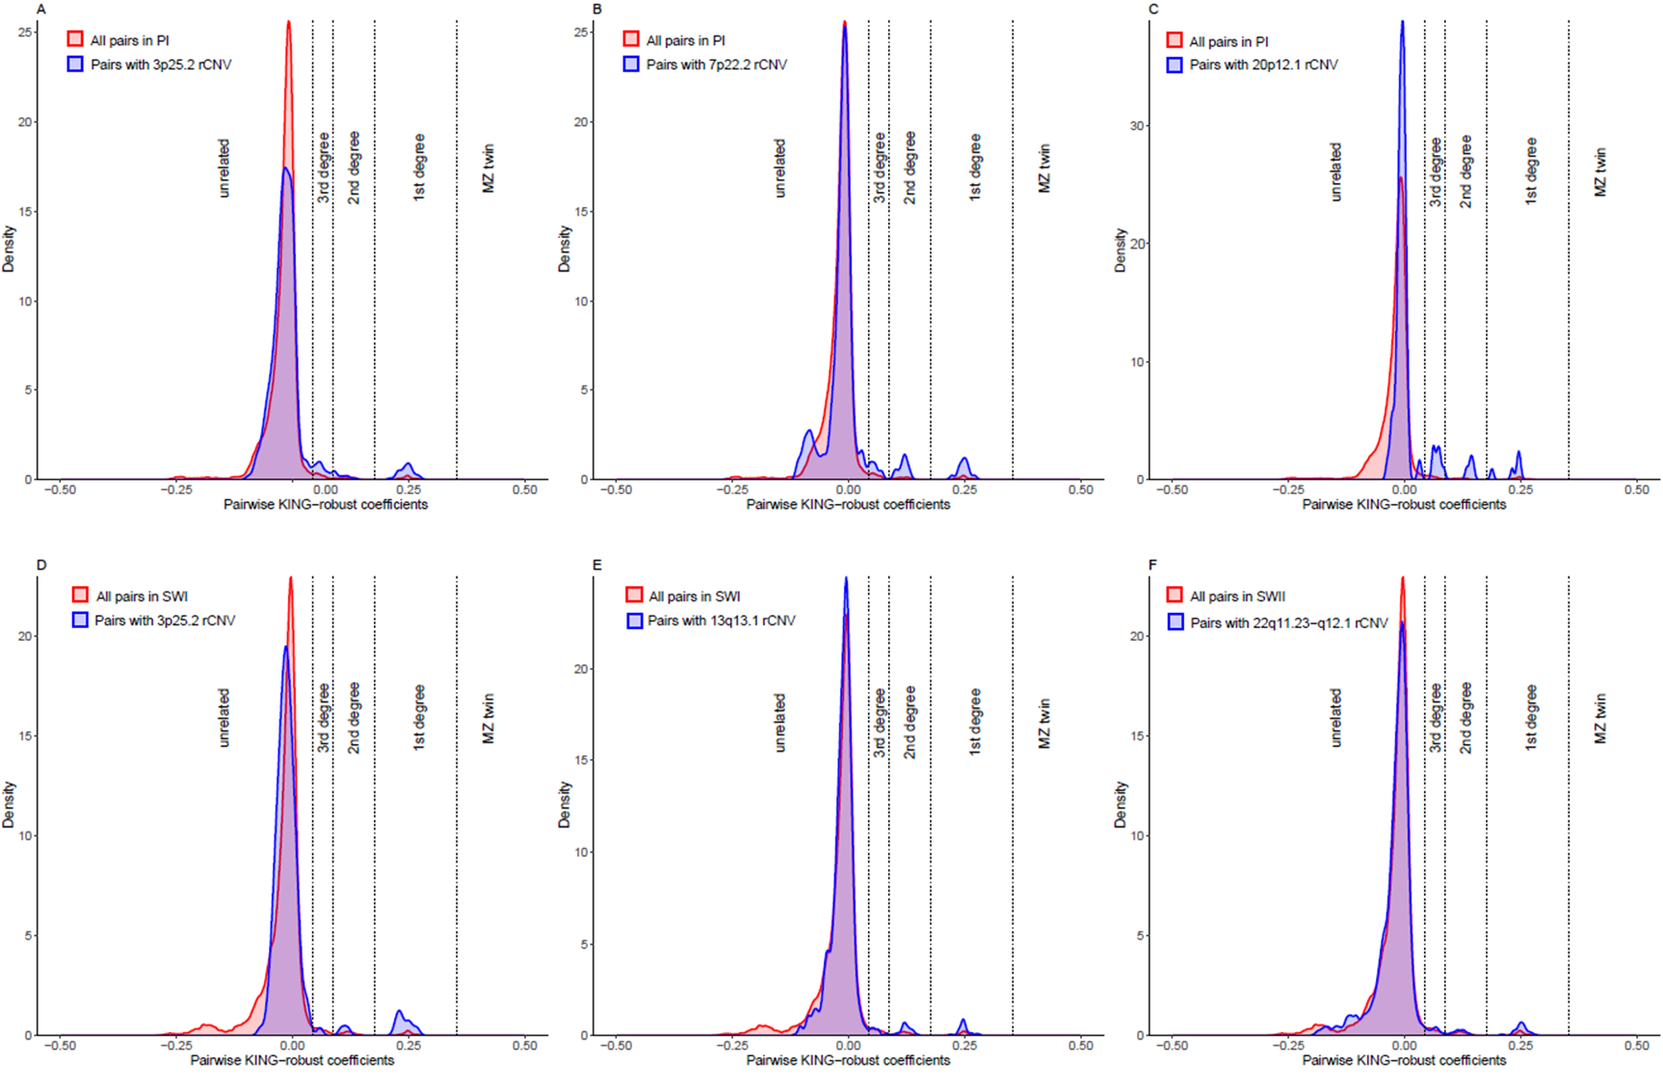
Figure S2. Distribution of pairwise kinship coefficients among carriers of various rCNVs in PI and SWI Native American populations versus all pairs
Density plots of KING-robust kinship coefficients for all pairs of individuals carrying specific rCNVs in Plains Indians (top) and Southwest Indians (bottom). The left panels represent a rCNV at 3p25.2 shared between PI and SWI. The middle and the right panels show population-specific rCNVs. As stated in the key, in each panel the blue/purple density histogram represents the pairs in which both members of the pair carry the rCNV and the red/purple density histogram represents all pairs formed in the sample (74,691 for PI and 61,075 for SWI), purple being indicative of the area of overlap. Vertical dashed lines denote thresholds for kinship categories: unrelated, 3rd degree, 2nd degree, 1st degree, and monozygotic (MZ).

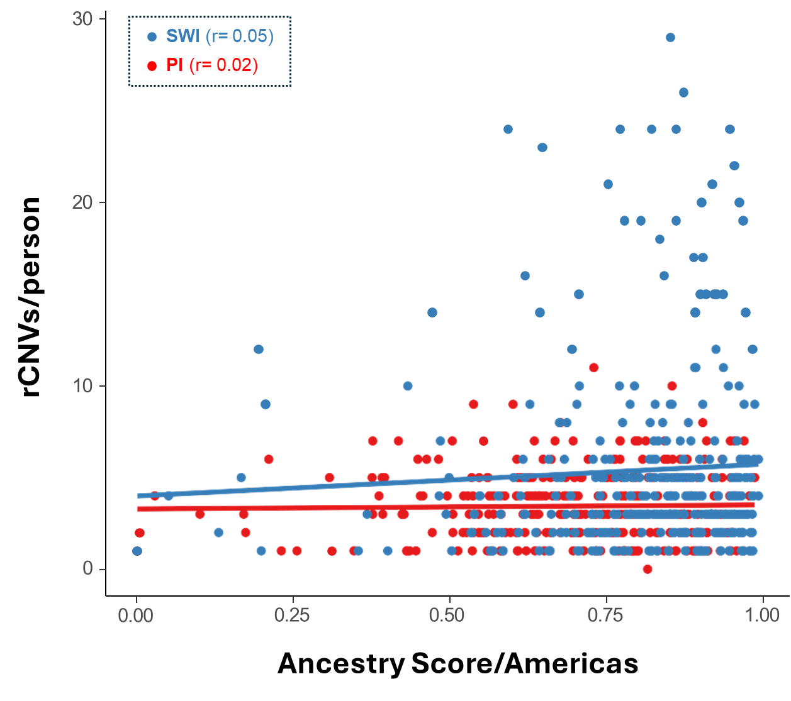

Figure S3. rCNV number per individual vs Americas ancestry
Americas ancestry score estimated via Ancestry Informative Markers (AIMs) in SWI and PI. Pearson correlations showed a lack of relationship between admixture and number of rCNVs/person.

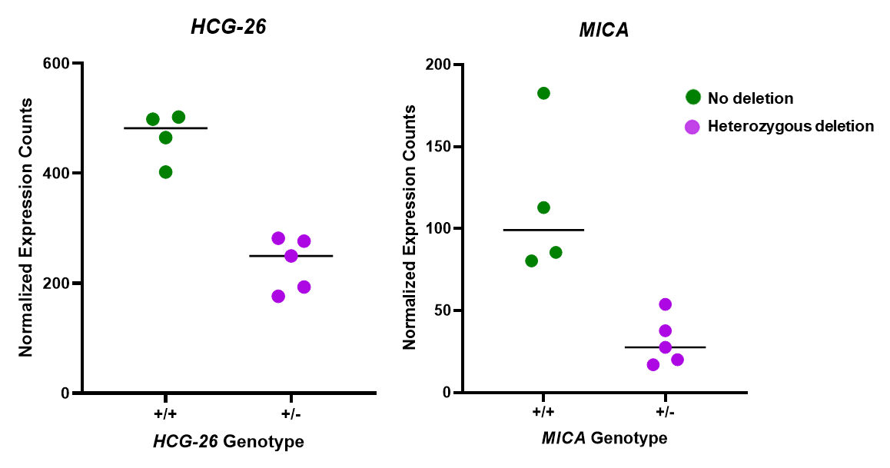

Figure S4. Expression profiles of genes deleted by the 6p21.33 rCNV
The expression profiles of MICA and HCG-26, two genes deleted by the 6p21.33 rCNV, in lymphoblastoid cell lines from individuals without the deletion and heterozygous for this rCNV, and putatively representing cis effects of this rCNV.

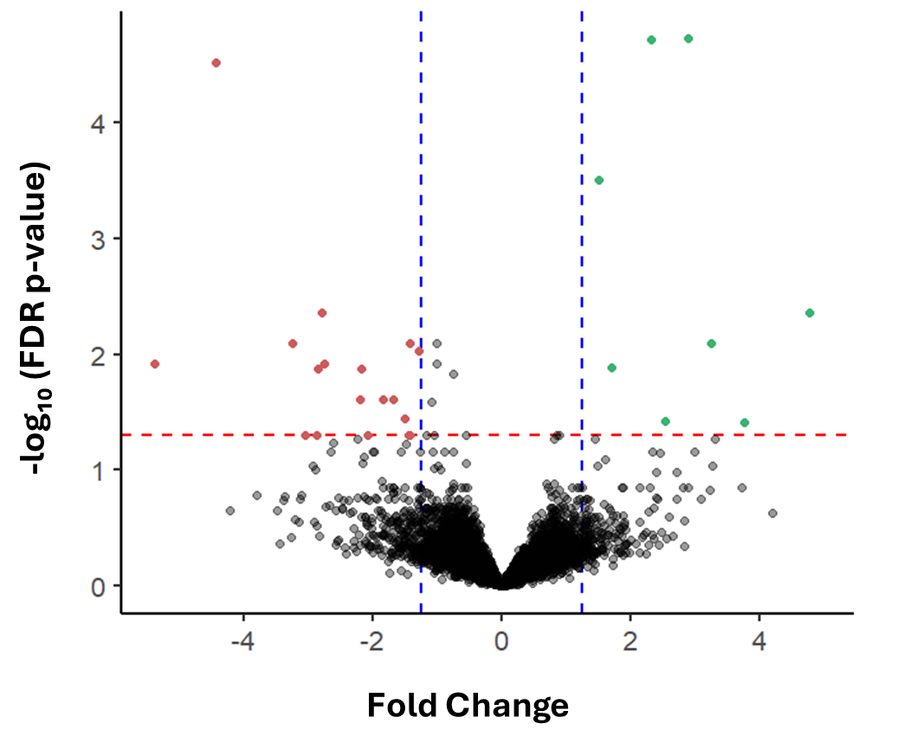

Figure S5. Trans effects on transcriptome in 6p21.33 rCNV deletion carriers versus non-carriers
Volcano plot showing differential expression of genes in LCLs from Plains Indians driven by the 6p21.33 rCNV deletion and predominantly representing trans effects of this rCNV. Red and green dots indicate significantly upregulated and downregulated genes, respectively (|fold change| >1.25; FDR < 0.05). The red dashed horizontal line represents a false discovery rate (FDR) threshold of 0.05 and the blue vertical lines represent the 1.25-fold change cutoffs.

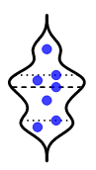
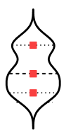
0
1
2
3
Duplications
Deletions
Relative Expression (Normalized Counts)

Figure S6. The normalized relative expression of genes putatively affected in cis by heterozygous (rCNVs) in lymphoblastoid cell lines (LCLs).
Blue circles represent duplications; red squares represent deletions. Each point corresponds to a unique gene-CNV combination. Expression levels were normalized to the mean (= 1) of non-CNV homozygotes.

