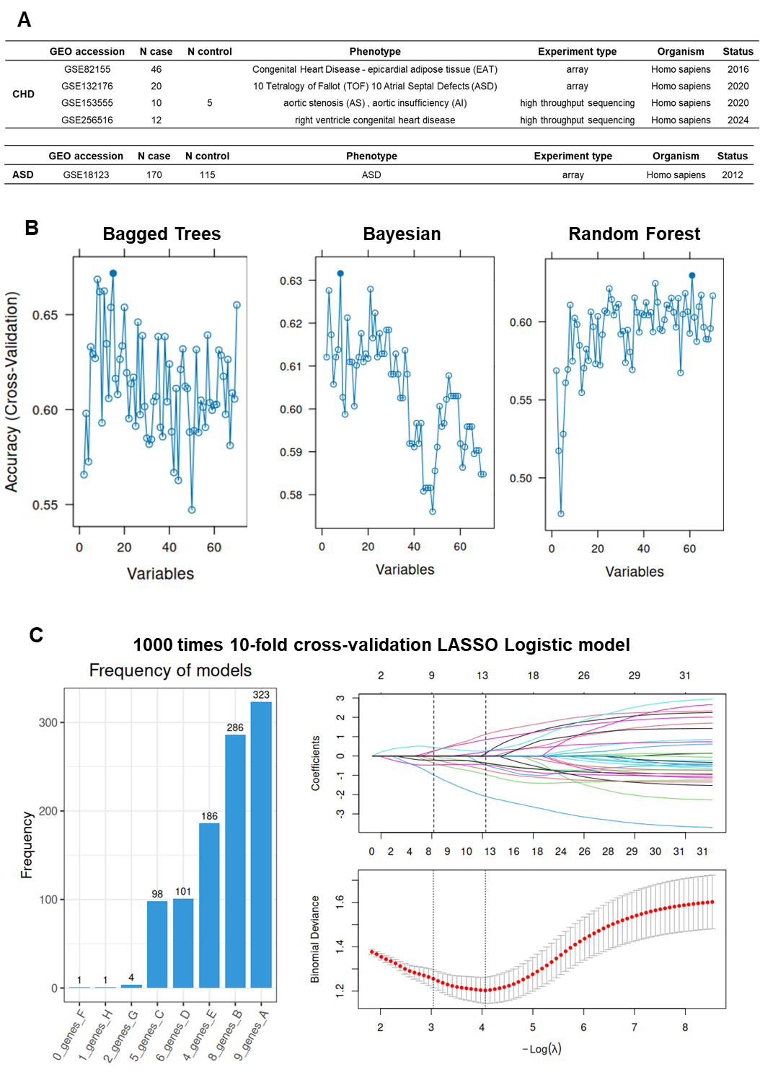
Supplemental Data
Supplemental Figure 1 | (A) Summary of the transcriptome data for CHD and ASD used in this study. (B) Performance assessment of three machine learning algorithms (Bagged Trees, Bayesian, and Random Forest) showing the accuracy of the models as a function of the number of genes. (C) Analysis of the LASSO Logistic model. The left panel shows the frequency of models and the number of genes. The middle panel displays the change in gene coefficients with varying lambda values. The right panel shows the binomial deviance of the model as a function of the lambda value.
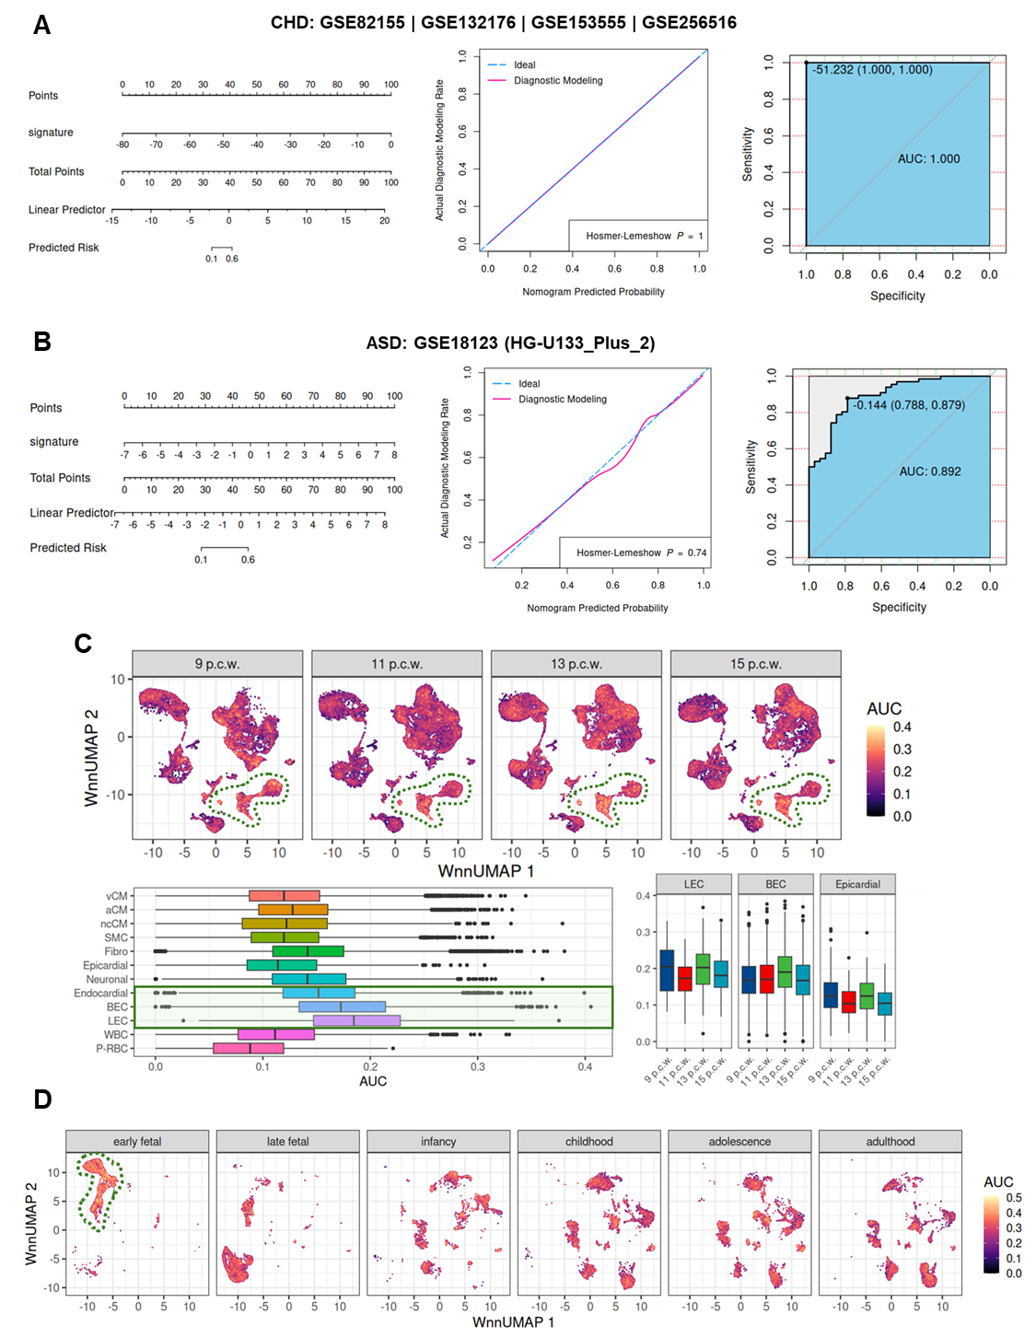
Supplemental Figure 2 | (A-B) Evaluation of the diagnostic model for CHD and ASD based on the 23 key genes. The plots show the nomogram, calibration curve, and ROC curve, respectively. (C) Box plots showing the diagnostic efficacy (AUC) of the 23-gene model across various heart cell types during different developmental stages (9 p.c.w. to 15 p.c.w.). (D) UMAP plots showing the diagnostic efficacy (AUC) of the 23-gene model across different brain cell types and developmental stages. The dashed green lines highlight cell clusters with higher diagnostic efficacy.

Supplemental Table 1 | Scores and Prioritization of the 73 Genes in the CHD&ASD GeneSet.
Supplemental Table 2 | KEGG and GO Enrichment Analysis of the 23 Key Genes.
Supplemental Table 3 | Enriched Transcription Factors Regulating 23 Shared Genes Between CHD and ASD.

