Additional File 1. Figures and Tables

Table S1. Newcastle-Ottawa Scale risk of bias for included studies.
Figure S1. Acute kidney injury (AKI) over time, according to age group
Figure S2. Acute kidney injury (AKI) incidence across studies and over time.
Figure S3. Association between AKI and mortality across studies with low risk-of-bias.
Figure S4. Association between AKI and mortality across studies with low risk-of-bias.
Figure S5. Association between age-based acute kidney injury (AKI) and mortality in African children with severe malaria
Figure S6. Association between acute kidney injury (AKI) and mortality in African children with severe malaria, excluding children with WHO-defined renal impairment
Table S2. Subgroup analysis of the association between AKI and mortality.
Table S3. Subgroup analysis of the association between hyperkalemia and mortality.
Table S4. Subgroup analysis of the association between elevated BUN and mortality.
Figure S7. Association between hyperkalemia (a) or elevated BUN (b) and mortality across studies in sub-Saharan Africa.

Table S1. Newcastle-Ottawa Scale risk of bias for included studies
 | Selection |  |  |  | Outcome |  |  | Comparability | Risk of Bias
 | Representative of severe malaria population | Selection of non-exposed cohort | Exposed vs. non-exposed matched or confounders adjusted | Ascertainment of exposure (creatinine-defined AKI) | Outcome not present at start | Assessment of outcome | Follow-up long enough for outcome | Adequate follow-up | Risk of Bias
Njuguna, Kenya, 1993- 2007 |  |  |  |  |  |  |  |  | Moderate
Njuguna, Kenya, 2008-2016 |  |  |  |  |  |  |  |  | Low
Anstey, Tanzania, 1995-1996 |  |  |  |  |  |  |  |  | High
Imani, Uganda, 2007-2010 |  |  |  |  |  |  |  |  | Low
Conroy, Uganda, 2008-2013 |  |  |  |  |  |  |  |  | Moderate
Conroy, Uganda, 2011-2013 |  |  |  |  |  |  |  |  | Low
Hawkes, Uganda, 2012-2013 |  |  |  |  |  |  |  |  | Low
Namazzi, Uganda, 2014-2017 |  |  |  |  |  |  |  |  | Low
Conradi, Uganda, 2020-2021 |  |  |  |  |  |  |  |  | Moderate
Sserunkuuma, Uganda, 2019-2023 |  |  |  |  |  |  |  |  | Low
Nakuya, Uganda, 2021-2022 |  |  |  |  |  |  |  |  | Moderate
Batte, Uganda, 2023-2025 |  |  |  |  |  |  |  |  | Low
Evans, Malawi, 2016 |  |  |  |  |  |  |  |  | Low
Bassat, Mozambique, 2006 |  |  |  |  |  |  |  |  | Low
Varo, Mozambique, 2016-2019 |  |  |  |  |  |  |  |  | Low
Afolayan, Nigeria, 2016-2017 |  |  |  |  |  |  |  |  | Low
Ibrahim, Nigeria, 2019-2020 |  |  |  |  |  |  |  |  | Low
Oluwadare, Nigeria, 2025 |  |  |  |  |  |  |  |  | Low
Wynkoop, multi-country, 2023 |  |  |  |  |  |  |  |  | Low

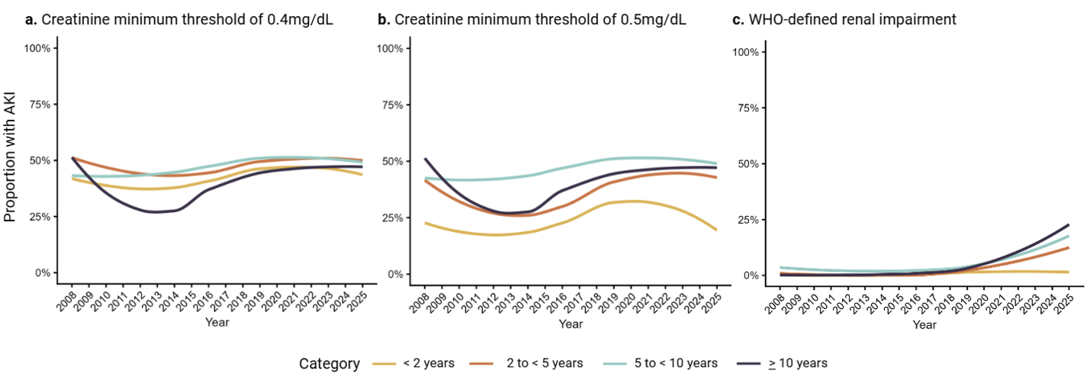
Figure S1. Acute kidney injury (AKI) over time, according to age group. Smoothed temporal trend in AKI incidence from 2008 to 2024. Plots show loess curves fit to annual AKI proportions according to age group, stratified by creatinine thresholds: a) creatinine minimum threshold of 0.4 mg/dL (35 umol/L) , b) minimum threshold of 0.5 mg/dL (44 umol/L), and c) WHO-defined renal impairment 3 mg/dL (265 umol/L).

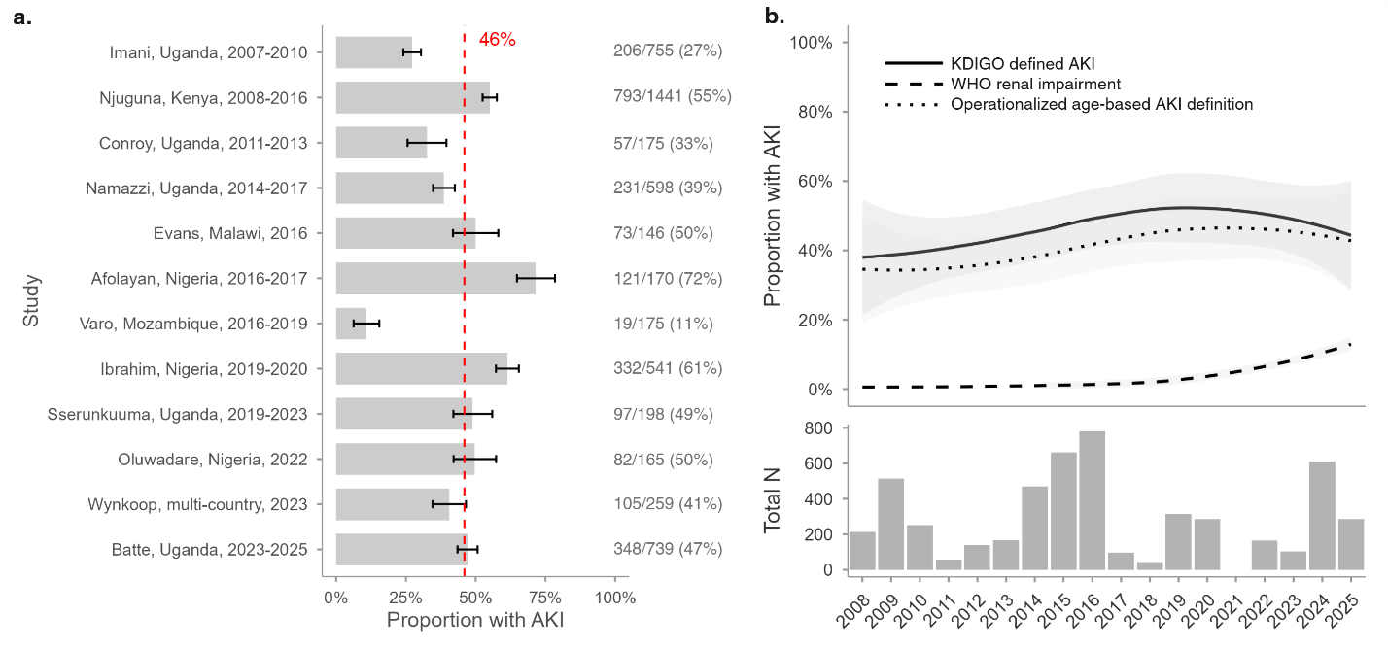
Figure S2. Acute kidney injury (AKI) incidence across studies and over time. a) Proportion of children with AKI across included studies after 2007. Bars represent point estimates of AKI incidence, and black error bars indicate 95% confidence intervals based on binomial standard errors. Total case numbers and sample sizes are displayed on the right. The red dashed line indicates the overall pooled AKI incidence. b) Smoothed temporal trend in AKI incidence from 2008 to 2024. The top panel shows LOESS curves (black lines), according to AKI definition, fit to annual AKI proportions, with shaded gray ribbons indicating 95% confidence interval. The bottom panel shows total sample sizes with available creatinine data for each year. The Sserunkuuma, Uganda (2019–2023) study is not shown in panel b, since year of enrollment was not recorded for individual participants (only overall totals were available). This figure only includes studies with low risk of bias.

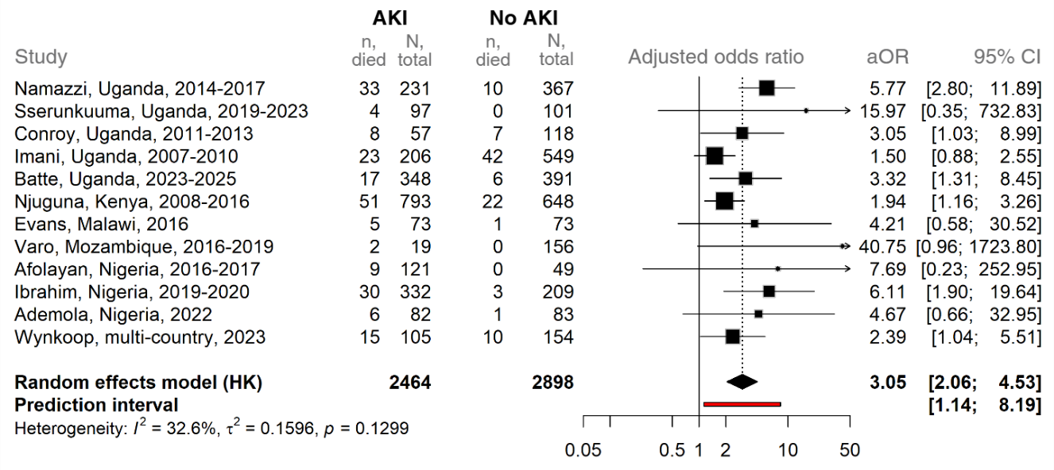
Figure S3. Association between AKI and mortality across studies with low risk-of-bias. Forest plot of age- and assay-adjusted odds ratios (aOR) for mortality associated with AKI, estimated using Firth logistic regression. Each square represents the study-specific effect estimate; horizontal lines indicate 95% confidence intervals. Square size is proportional to the study’s weight in the meta-analysis. The diamond shows the pooled random-effects estimate with its 95% confidence interval, while the red bar indicates the prediction interval (the expected range of effects in future similar studies). Numbers in the table denote, for each study: deaths and totals among participants with AKI, and deaths and totals among participants without AKI. Adjustment for assay type was applied only in studies where more than one method was used.
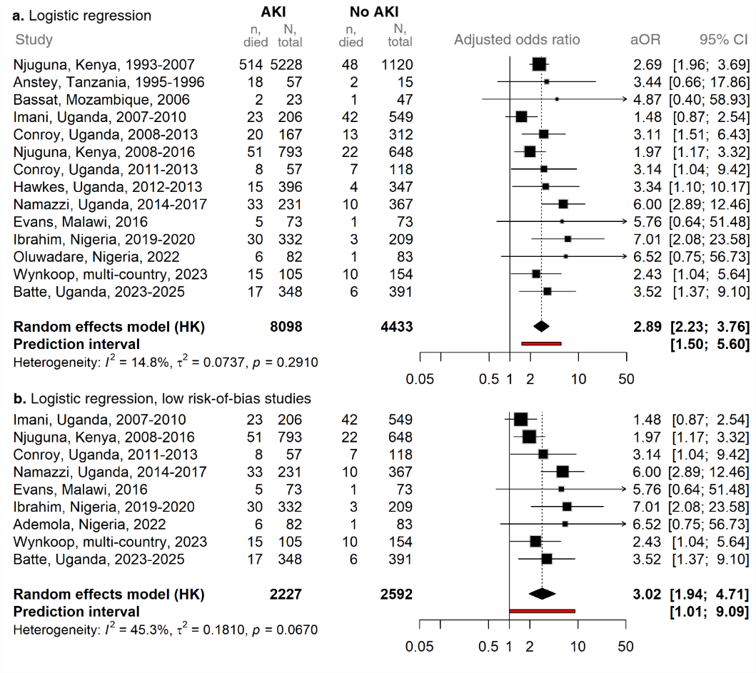
Figure S4. Association between AKI and mortality across studies with low risk-of-bias. Forest plot of age- and assay-adjusted odds ratios (aOR) for mortality associated with AKI, estimated using logistic regression. a) All studies are included that converged in logistic regression. b) Only includes studies with low risk-of-bias. Each square represents the study-specific effect estimate; horizontal lines indicate 95% confidence intervals. Square size is proportional to the study’s weight in the meta-analysis. The diamond shows the pooled random-effects estimate with its 95% confidence interval, while the red bar indicates the prediction interval (the expected range of effects in future similar studies). Numbers in the table denote, for each study: deaths and totals among participants with AKI, and deaths and totals among participants without AKI. Adjustment for assay type was applied only in studies where more than one method was used.

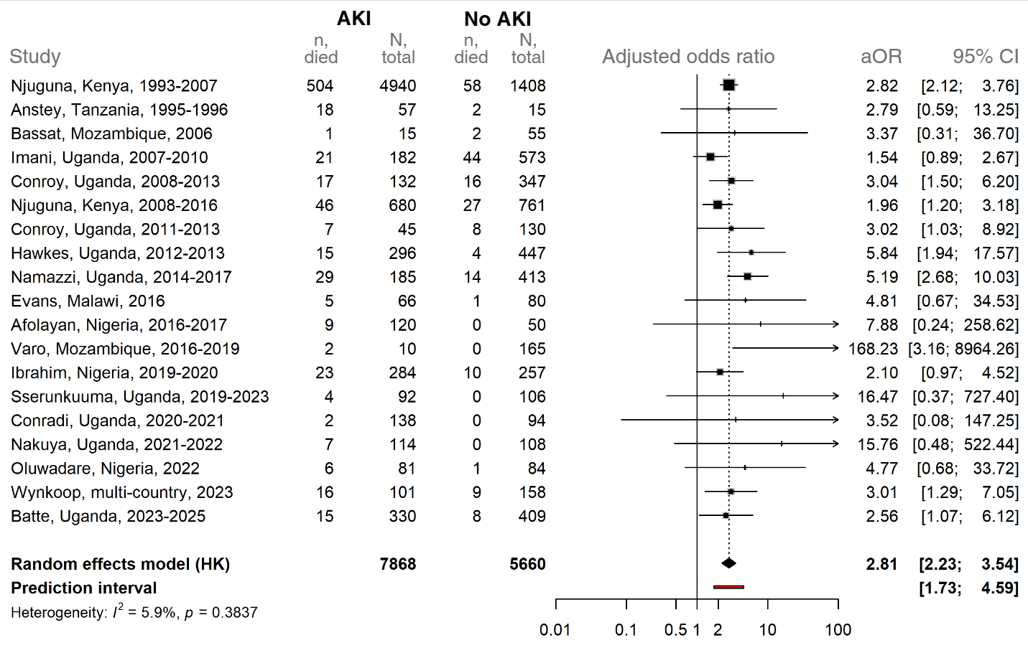
Figure S5. Association between age-based acute kidney injury (AKI) and mortality in African children with severe malaria. Forest plot of age- and assay-adjusted odds ratios (aOR) for mortality associated with operationalized age-based AKI definition, estimated using Firth logistic regression. Each square represents the study-specific effect estimate; horizontal lines indicate 95% confidence intervals. Square size is proportional to the study’s weight in the meta-analysis. The diamond shows the pooled random-effects estimate with its 95% confidence interval, while the red bar indicates the prediction interval (the expected range of effects in future similar studies). Numbers in the table denote, for each study: deaths and totals among participants with AKI, and deaths and totals among participants without AKI. Njuguna, Kenya, was separated into two study periods (1993–2007 and 2008–2016). Adjustment for assay type was applied only in studies where more than one method was used.

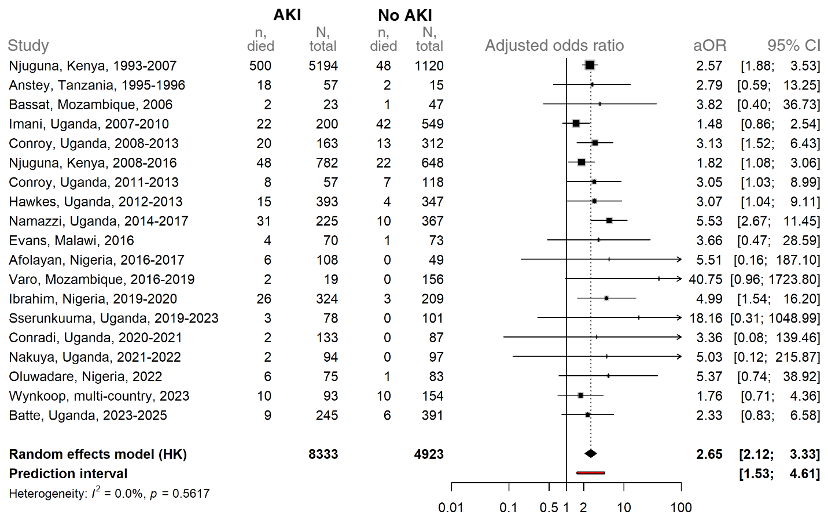
Figure S6. Association between acute kidney injury (AKI) and mortality in African children with severe malaria, excluding children with WHO-defined renal impairment. Forest plot of age- and assay-adjusted odds ratios (aOR) for mortality associated with KDIGO defined AKI, estimated using Firth logistic regression. Children with WHO-defined renal impairment were excluded from analysis. Each square represents the study-specific effect estimate; horizontal lines indicate 95% confidence intervals. Square size is proportional to the study’s weight in the meta-analysis. The diamond shows the pooled random-effects estimate with its 95% confidence interval, while the red bar indicates the prediction interval (the expected range of effects in future similar studies). Numbers in the table denote, for each study: deaths and totals among participants with AKI, and deaths and totals among participants without AKI. Njuguna, Kenya, was separated into two study periods (1993–2007 and 2008–2016). Adjustment for assay type was applied only in studies where more than one method was used.
Table S2. Subgroup analysis of the association between AKI and mortality
 | N obs.  (N studies) |  | AKI |  | No AKI
Group | N obs.  (N studies) | Category | n, died | N, total | n, died | N, total | OR (95% CI)
Age | 13,480  (19) | < 2 years | 296 | 3292 | 59 | 1686 | 2.79 (2.07, 3.76)
 | 13,480  (19) | 2 to <5 years | 350 | 3856 | 71 | 1859 | 2.56 (1.94, 3.38)
 | 13,480  (19) | 5 to <10 years | 110 | 1241 | 28 | 1023 | 3.42 (2.23, 5.26)
 | 13,480  (19) | >10 years | 22 | 206 | 8 | 317 | 4.48 (1.94, 10.31)
Decade | 13,528  (19) | Before 2000 | 213 | 1431 | 18 | 335 | 3.82 (2.19, 6.67)
 | 13,528  (19) | 2000-2010 | 346 | 4200 | 75 | 1384 | 1.82 (1.37, 2.42)
 | 13,528  (19) | 2011-2020 | 145 | 1886 | 58 | 2190 | 3.53 (2.56, 4.87)
 | 13,528  (19) | >2020 | 77 | 1088 | 19 | 1014 | 4.44 (2.64, 7.47)
Region | 13,528  (19) | East Africa | 712 | 7850 | 154 | 4152 | 2.66 (2.18, 3.23)
 | 13,528  (19) | Southern Africa | 10 | 129 | 5 | 301 | 4.49 (1.43, 14.11)
 | 13,528  (19) | Central Africa | 14 | 91 | 7 | 129 | 3.23 (1.24, 8.37)
 | 13,528  (19) | West Africa | 45 | 535 | 4 | 341 | 8.09 (2.87, 22.79)
Sex | 13,467  (19) | Female | 351 | 3912 | 75 | 2218 | 2.87 (2.20, 3.74)
 | 13,467  (19) | Male | 430 | 4682 | 95 | 2696 | 2.88 (2.26, 3.67)
Assay type | 13,528  (19) | Jaffe/Kinetic | 480 | 4707 | 48 | 1058 | 2.56 (1.86, 3.52)
 | 13,528  (19) | Modified Jaffe | 261 | 3388 | 99 | 3202 | 3.11 (2.42, 4.00)
 | 13,528  (19) | Enzymatic | 40 | 510 | 23 | 663 | 2.69 (1.57, 4.60)
Severe wasting | 3,961  (15) | No severe wasting | 117 | 1590 | 60 | 2059 | 3.26 (2.34, 4.53)
 | 3,961  (15) | Severe wasting | 17 | 164 | 11 | 148 | 1.79 (0.79, 4.04)
Severe anemia | 4,921  (16) | No severe anemia | 131 | 1358 | 58 | 1808 | 3.54 (2.54, 4.93)
 | 4,921  (16) | Severe anemia | 70 | 772 | 31 | 991 | 3.70 (2.38, 5.76)
Estimates are from mixed-effects logistic regression models with an interaction term between AKI and each subgrouping variable. Models are adjusted for age and assay type where appropriate, and study is treated as a random effect. Odds ratios (ORs) and 95% confidence intervals (CIs) represent contrasts of marginal linear predictions.

Table S3. Subgroup analysis of the association between hyperkalemia and mortality
 | N obs.  (N studies) |  | Hyperkalemia |  | No hyperkalemia
Group | N obs.  (N studies) | Category | n, died | N, total | n, died | N, total | OR (95% CI)
Age | 10,958  (10) | < 2 years | 109 | 369 | 215 | 3713 | 6.81 (5.23, 8.88)
 | 10,958  (10) | 2 to <5 years | 94 | 341 | 266 | 4264 | 5.84 (4.46, 7.66)
 | 10,958  (10) | 5 to <10 years | 21 | 96 | 94 | 1746 | 5.02 (2.94, 8.59)
 | 10,958  (10) | >10 years | 3 | 20 | 24 | 409 | 2.56 (0.69, 9.46)
Decade | 11,002  (10) | Before 2000 | 91 | 236 | 115 | 1440 | 7.43 (5.36, 10.31)
 | 11,002  (10) | 2000-2010 | 91 | 364 | 313 | 4950 | 5.01 (3.83, 6.55)
 | 11,002  (10) | 2011-2020 | 31 | 135 | 107 | 2248 | 5.90 (3.73, 9.36)
 | 11,002  (10) | >2020 | 16 | 96 | 69 | 1533 | 5.19 (2.80, 9.60)
Region | 11,002  (10) | East Africa | 224 | 794 | 546 | 9249 | 6.31 (5.27, 7.57)
 | 11,002  (10) | Southern Africa | 2 | 3 | 2 | 36 | 35.18 (2.13, 579.72)
 | 11,002  (10) | Central Africa | 2 | 9 | 18 | 209 | 3.08 (0.59, 16.04)
 | 11,002  (10) | West Africa | 1 | 25 | 38 | 677 | 0.68 (0.09, 5.14)
Sex | 10,991  (10) | Female | 103 | 390 | 276 | 4630 | 5.64 (4.35, 7.31)
 | 10,991  (10) | Male | 126 | 441 | 328 | 5530 | 6.40 (5.04, 8.14)
Severe wasting | 2,151  (7) | No severe wasting | 26 | 181 | 89 | 1756 | 3.05 (1.89, 4.94)
 | 2,151  (7) | Severe wasting | 3 | 15 | 20 | 199 | 2.26 (0.58, 8.88)
Severe anemia | 3,206  (8) | No severe anemia | 20 | 152 | 103 | 1950 | 2.52 (1.49, 4.25)
 | 3,206  (8) | Severe anemia | 27 | 127 | 46 | 983 | 5.58 (3.29, 9.47)
Estimates are from mixed-effects logistic regression models with an interaction term between hyperkalemia and each subgrouping variable. Models are adjusted for age (except for the age group model), and study is treated as a random effect. Odds ratios (ORs) and 95% confidence intervals (CIs) represent contrasts of marginal linear predictions.
Table S4. Subgroup analysis of the association between elevated BUN and mortality
 | N obs.  (N studies) |  | Elevated BUN |  | No elevated BUN
Group | N obs.  (N studies) | Category | n, died | N, total | n, died | N, total | OR (95% CI)
Age | 4,313  (12) | < 2 years | 36 | 236 | 55 | 1026 | 4.44 (2.73, 7.21)
 | 4,313  (12) | 2 to <5 years | 60 | 576 | 61 | 1340 | 2.82 (1.90, 4.19)
 | 4,313  (12) | 5 to <10 years | 21 | 336 | 26 | 540 | 1.74 (0.94, 3.20)
 | 4,313  (12) | >10 years | 4 | 117 | 5 | 142 | 1.08 (0.28, 4.20)
Decade | 4,319  (12) | Before 2000 | 9 | 26 | 11 | 46 | 1.71 (0.59, 4.94)
 | 4,319  (12) | 2000-2010 | 7 | 64 | 54 | 659 | 2.10 (0.86, 5.14)
 | 4,319  (12) | 2011-2020 | 59 | 490 | 39 | 1163 | 4.81 (3.07, 7.55)
 | 4,319  (12) | >2020 | 46 | 685 | 43 | 1186 | 1.95 (1.24, 3.05)
Region | 4,319  (12) | East Africa | 86 | 781 | 115 | 2399 | 3.55 (2.52, 4.99)
 | 4,319  (12) | Southern Africa | 4 | 39 | 2 | 174 | 7.85 (1.29, 47.63)
 | 4,319  (12) | Central Africa | 12 | 61 | 9 | 159 | 4.29 (1.7, 10.85)
 | 4,319  (12) | West Africa | 19 | 384 | 21 | 322 | 0.80 (0.42, 1.54)
Sex | 4,313  (12) | Female | 61 | 551 | 65 | 1333 | 3.29 (2.21, 4.89)
 | 4,313  (12) | Male | 60 | 714 | 82 | 1715 | 2.45 (1.68, 3.57)
Severe wasting | 2,937  (10) | No severe wasting | 61 | 683 | 85 | 1987 | 2.95 (2.01, 4.35)
 | 2,937  (10) | Severe wasting | 13 | 87 | 13 | 180 | 3.27 (1.38, 7.75)
Severe anemia | 4,137  (12) | No severe anemia | 77 | 771 | 91 | 1889 | 2.97 (2.08, 4.25)
 | 4,137  (12) | Severe anemia | 39 | 445 | 50 | 1038 | 2.83 (1.78, 4.48)
Estimates are from mixed-effects logistic regression models with an interaction term between elevated BUN and each subgrouping variable. Models are adjusted for age (except for the age group model), and study is treated as a random effect. Odds ratios (ORs) and 95% confidence intervals (CIs) represent contrasts of marginal linear predictions.

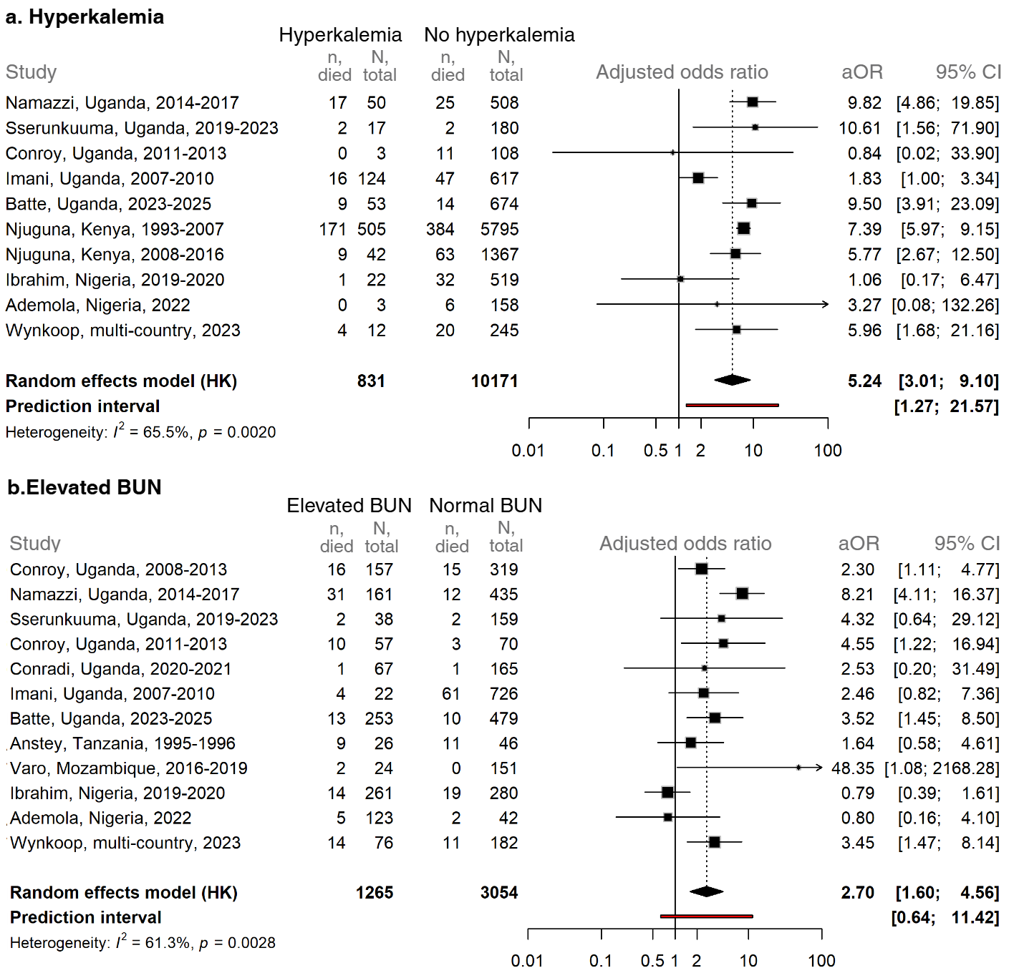
Figure S7. Association between hyperkalemia (a) or elevated BUN (b) and mortality across studies in sub-Saharan Africa. Forest plot of age-adjusted odds ratios (aOR) for mortality associated with hyperkalemia (a) and elevated BUN (b), estimated using Firth logistic regression. Each square represents the study-specific effect estimate; horizontal lines indicate 95% confidence intervals. Square size is proportional to the study’s weight in the meta-analysis. The diamond shows the pooled random-effects estimate with its 95% confidence interval, while the red bar indicates the prediction interval (the expected range of effects in future similar studies).

