TITLE
Novel methodology for the digital analysis of circulating tumor cells in ovarian cancer
Abigél Mészáros^{1,2}, Dávid Kis¹, Péter Hunyadi¹, Szabolcs Máté³, Ágnes Égető³, Szilárd Tóth⁴, Ines Lidia Haffaressas^{4,5}, András Füredi^{4,6}, Csaba Bödör⁷, András Rókusz⁷, János Rigó Jr.^{3,8}, Orsolya Biró^{1,2}
¹ Clinomics Europe Ltd, Budapest, Hungary
² Semmelweis University, Doctoral School, Department of Operative Medicine, Budapest, Hungary
³ Semmelweis University, Faculty of Medicine, Department of Obstetrics and Gynaecology, Budapest, Hungary
⁴ Drug Resistance Research Group, Institute of Enzymology, HUN-REN Research Centre for Natural Sciences, Budapest, Hungary
⁵ Doctoral School of Biology, Institute of Biology, ELTE Eötvös Loránd University, 1117 Budapest Pázmány Péter sétány 1/C, Hungary
⁶ Microsystems Laboratory, Institute of Technical Physics and Materials Science, HUN-REN Centre for Energy Research, Budapest, Hungary
⁷ Semmelweis University, Faculty of Medicine, Department of Pathology and Experimental Cancer Research
⁸ Semmelweis University, Faculty of Health Sciences, Department of Clinical Studies in Obstetrics and Gynaecology, Budapest, Hungary

Corresponding author:
Abigél Mészáros: balla.abigel@phd.semmelweis.hu
ORCID ID: 0009-0007-1738-0918

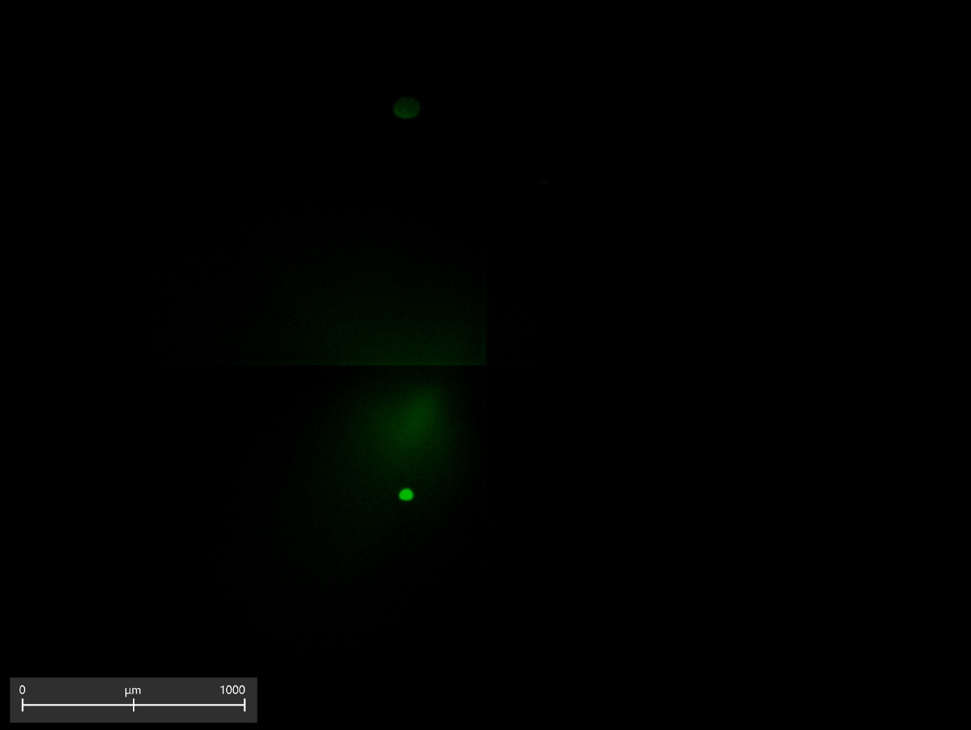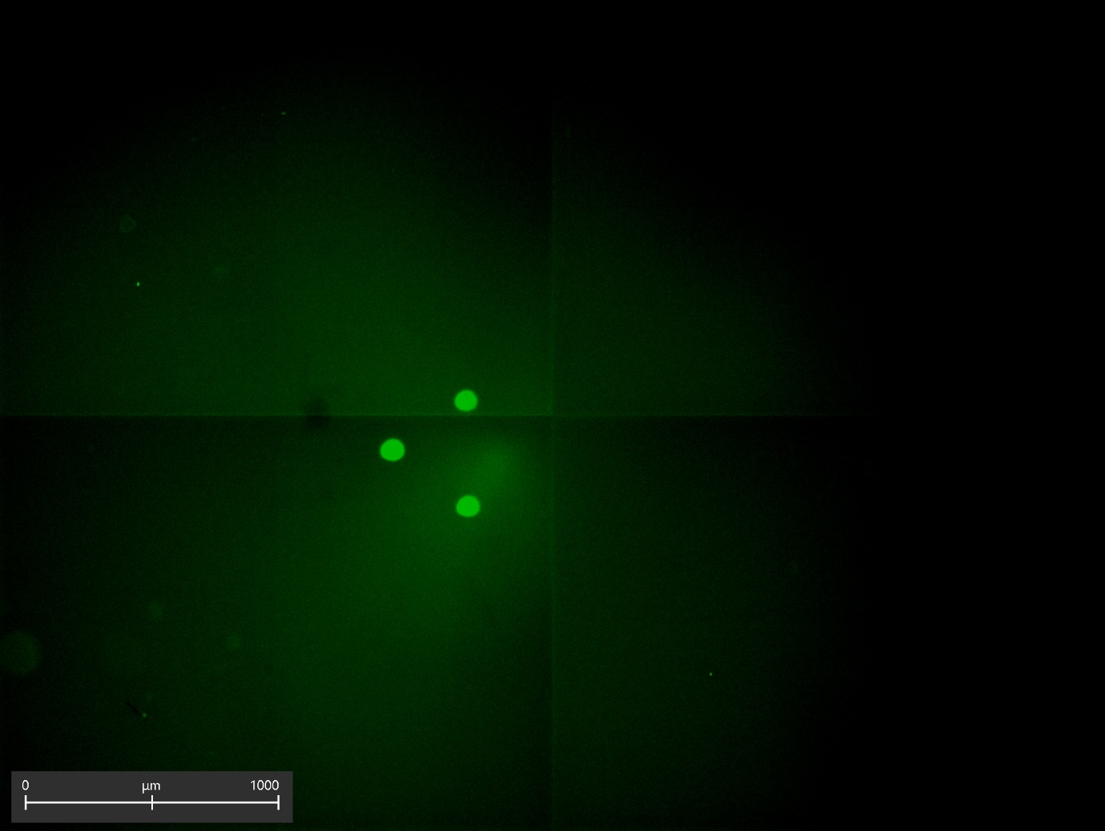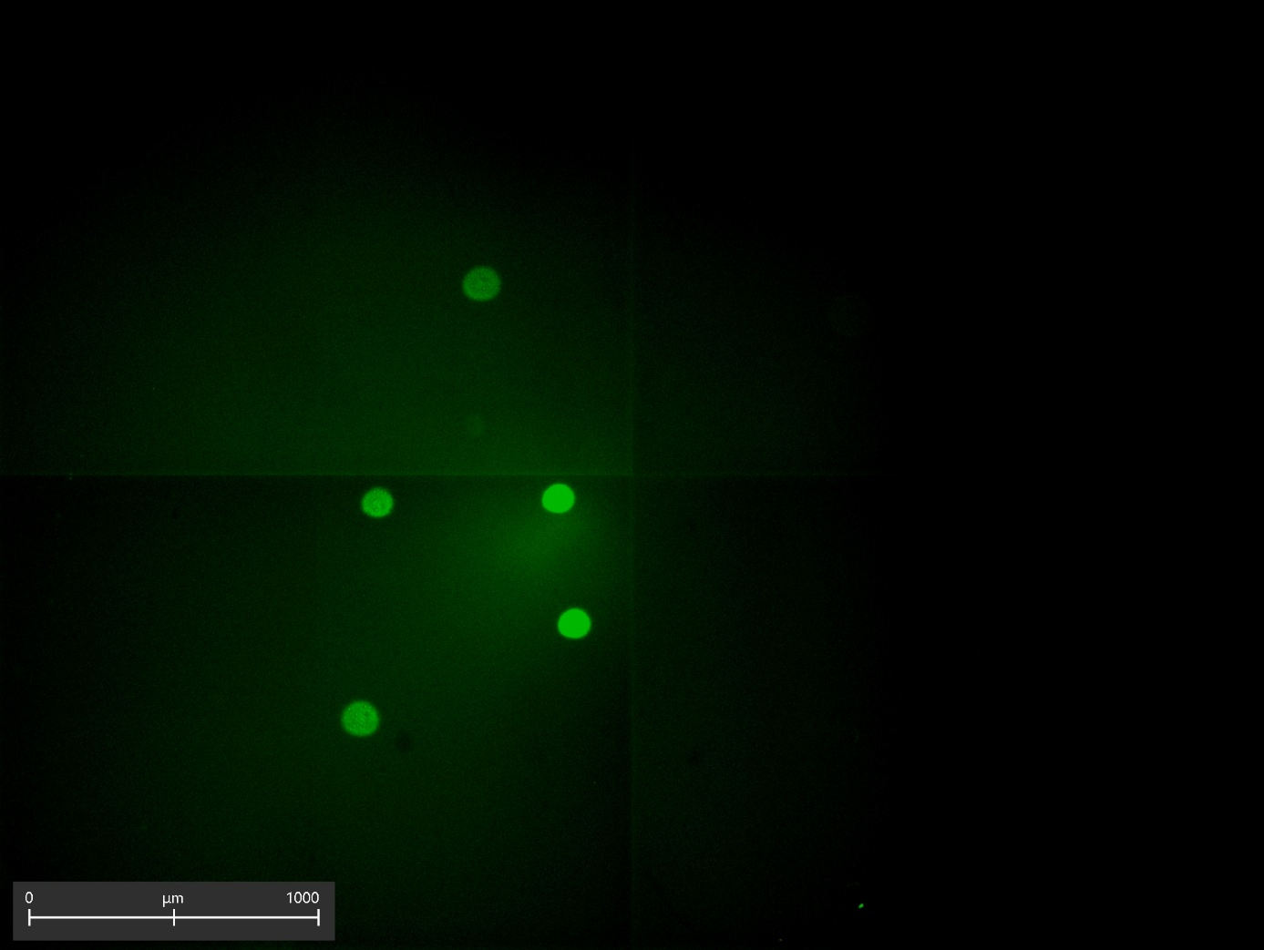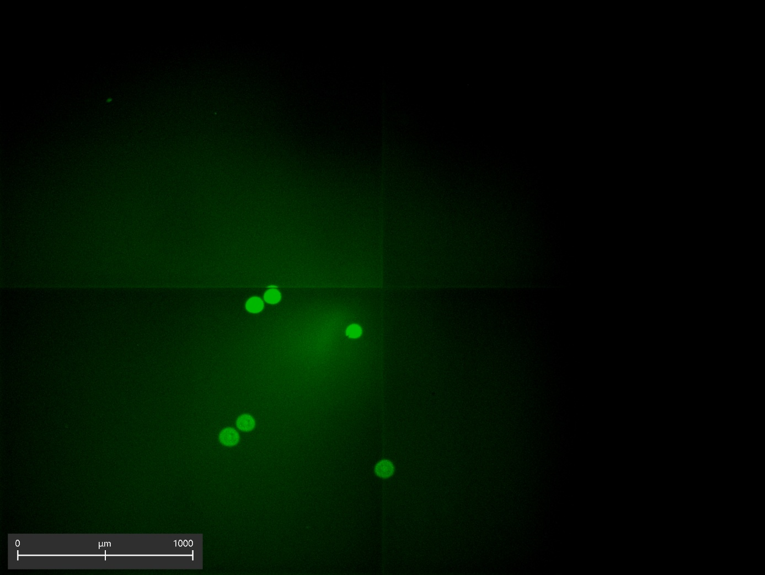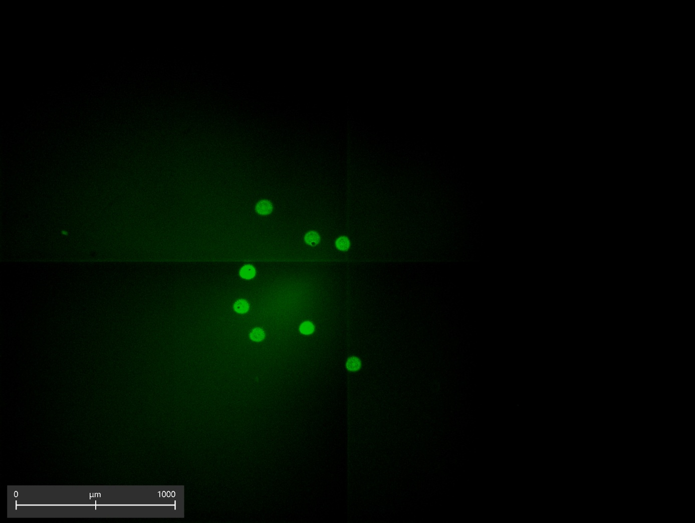

Supplementary Information 2 During the spiking experiment, live ovarian cancer cells were identified based on the Calcein fluorescent signal detected in the GFP channel of the JULI Stage live-cell imaging system. Representative images, showing viable cells, captured during the cell counting process, confirm that the required cell numbers were successfully achieved and available for the spiking experiment. Scale bar = 1000 µm.

