Development of a novel methodology for the digital analysis of circulating tumor cells in ovarian cancer
Abigél Mészáros^{1,2}, Dávid Kis¹, Péter Hunyadi¹, Szabolcs Máté³, Ágnes Égető³, Szilárd Tóth⁴, Lidia Ines Haffaressas⁴, András Füredi^{4,5}, Csaba Bödör⁶, András Rókusz⁶, János Rigó Jr.⁷, Orsolya Biró^{1,2}
¹ Clinomics Europe Kft, Budapest, Hungary,
² Semmelweis University, Doctoral School, Department of Operative Medicine, Budapest, Hungary,
³ Semmelweis University, Department of Obstetrics and Gynaecology, Baross Utca, Budapest, Hungary,
⁴ Drug Resistance Research Group, Institute of Enzymology, HUN-REN Research Centre for Natural Sciences, Budapest, Hungary
⁵ Microsystems Laboratory, Institute of Technical Physics and Materials Science, HUN-REN Centre for Energy Research, Budapest, Hungary
⁶ Semmelweis University, Department of Pathology and Experimental Cancer Research
⁷ Semmelweis University, Faculty of Health Sciences, Department of Obstetrics and Gynaecology, Budapest, Hungary

Corresponding author:
Abigél Mészáros: balla.abigel@phd.semmelweis.hu
ORCID ID: 0009-0007-1738-0918

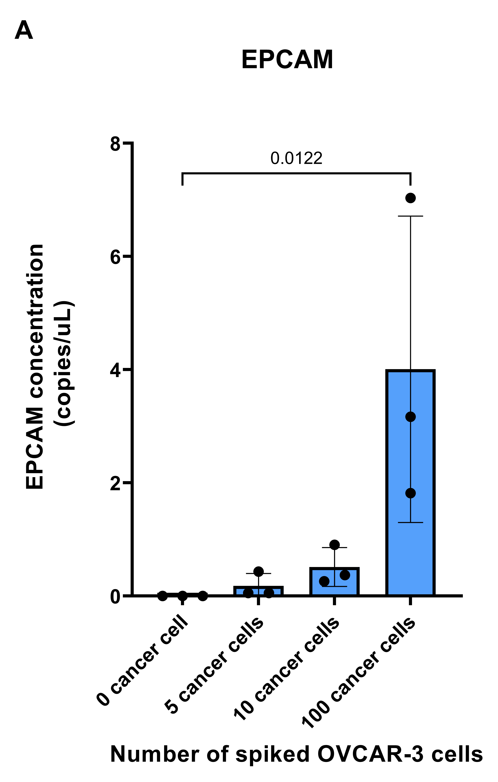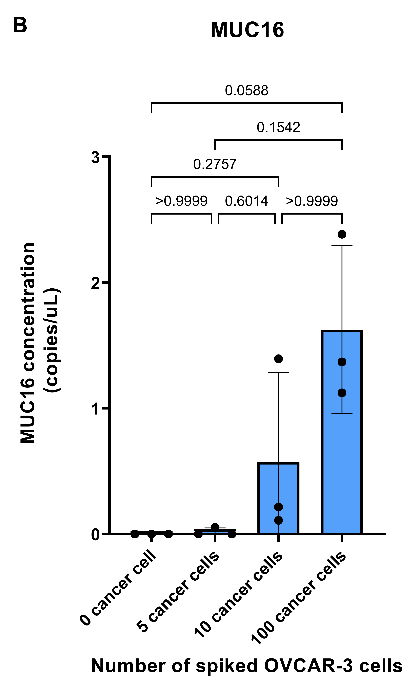

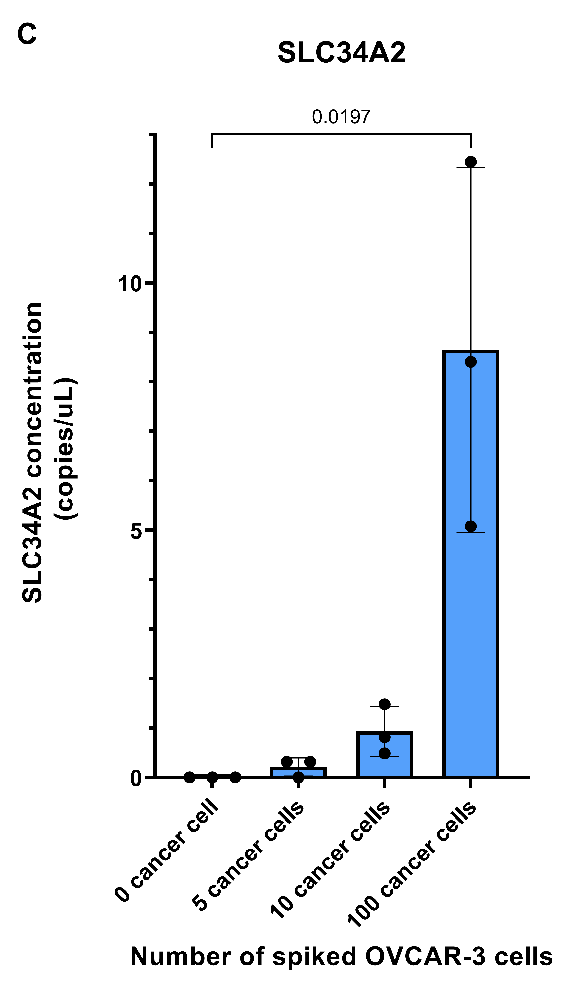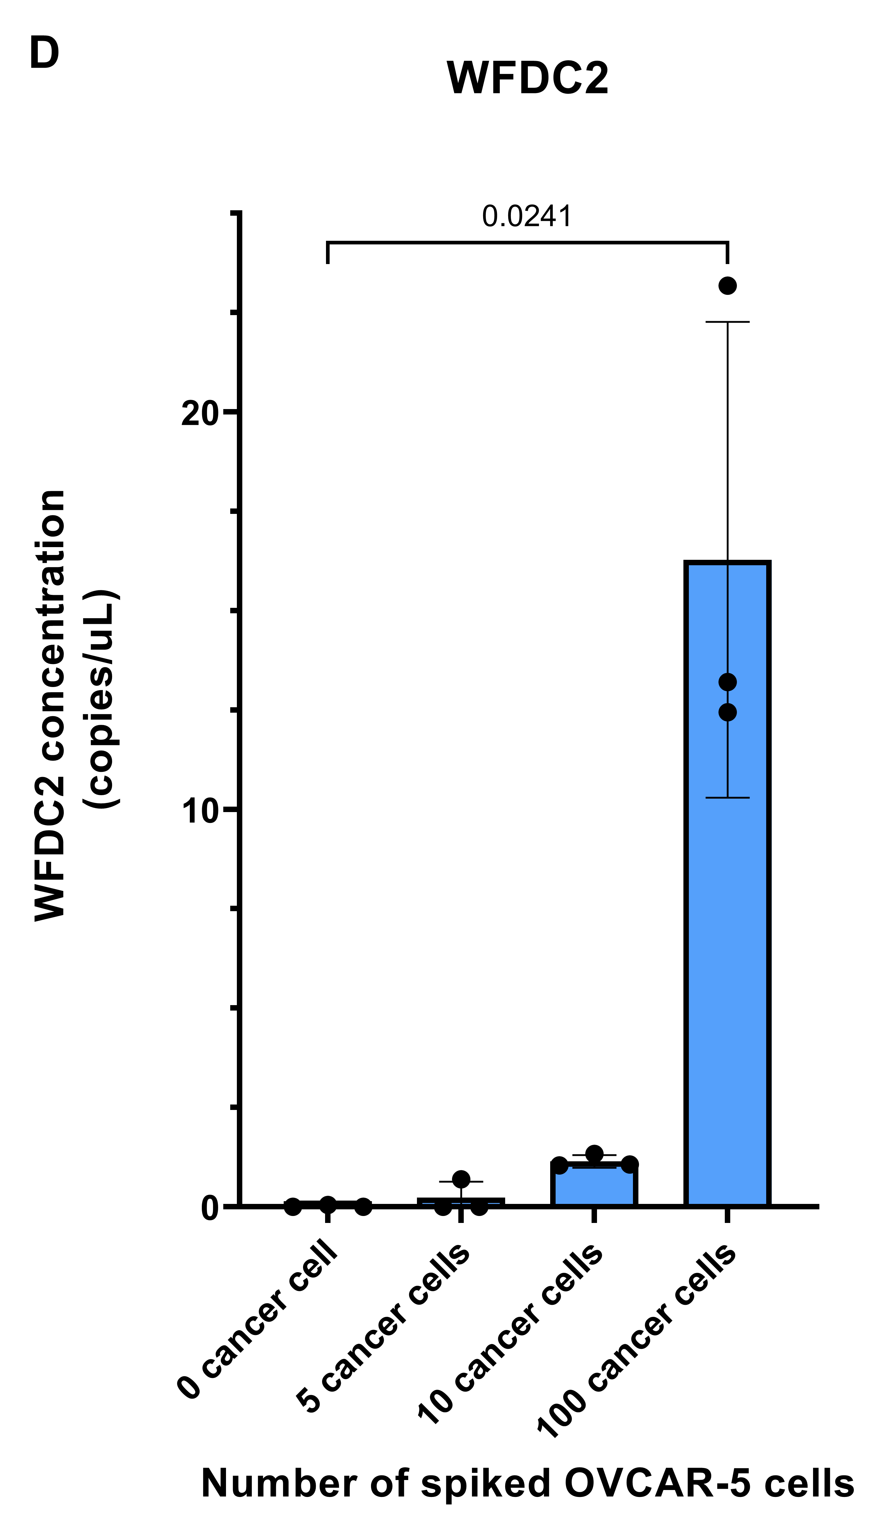

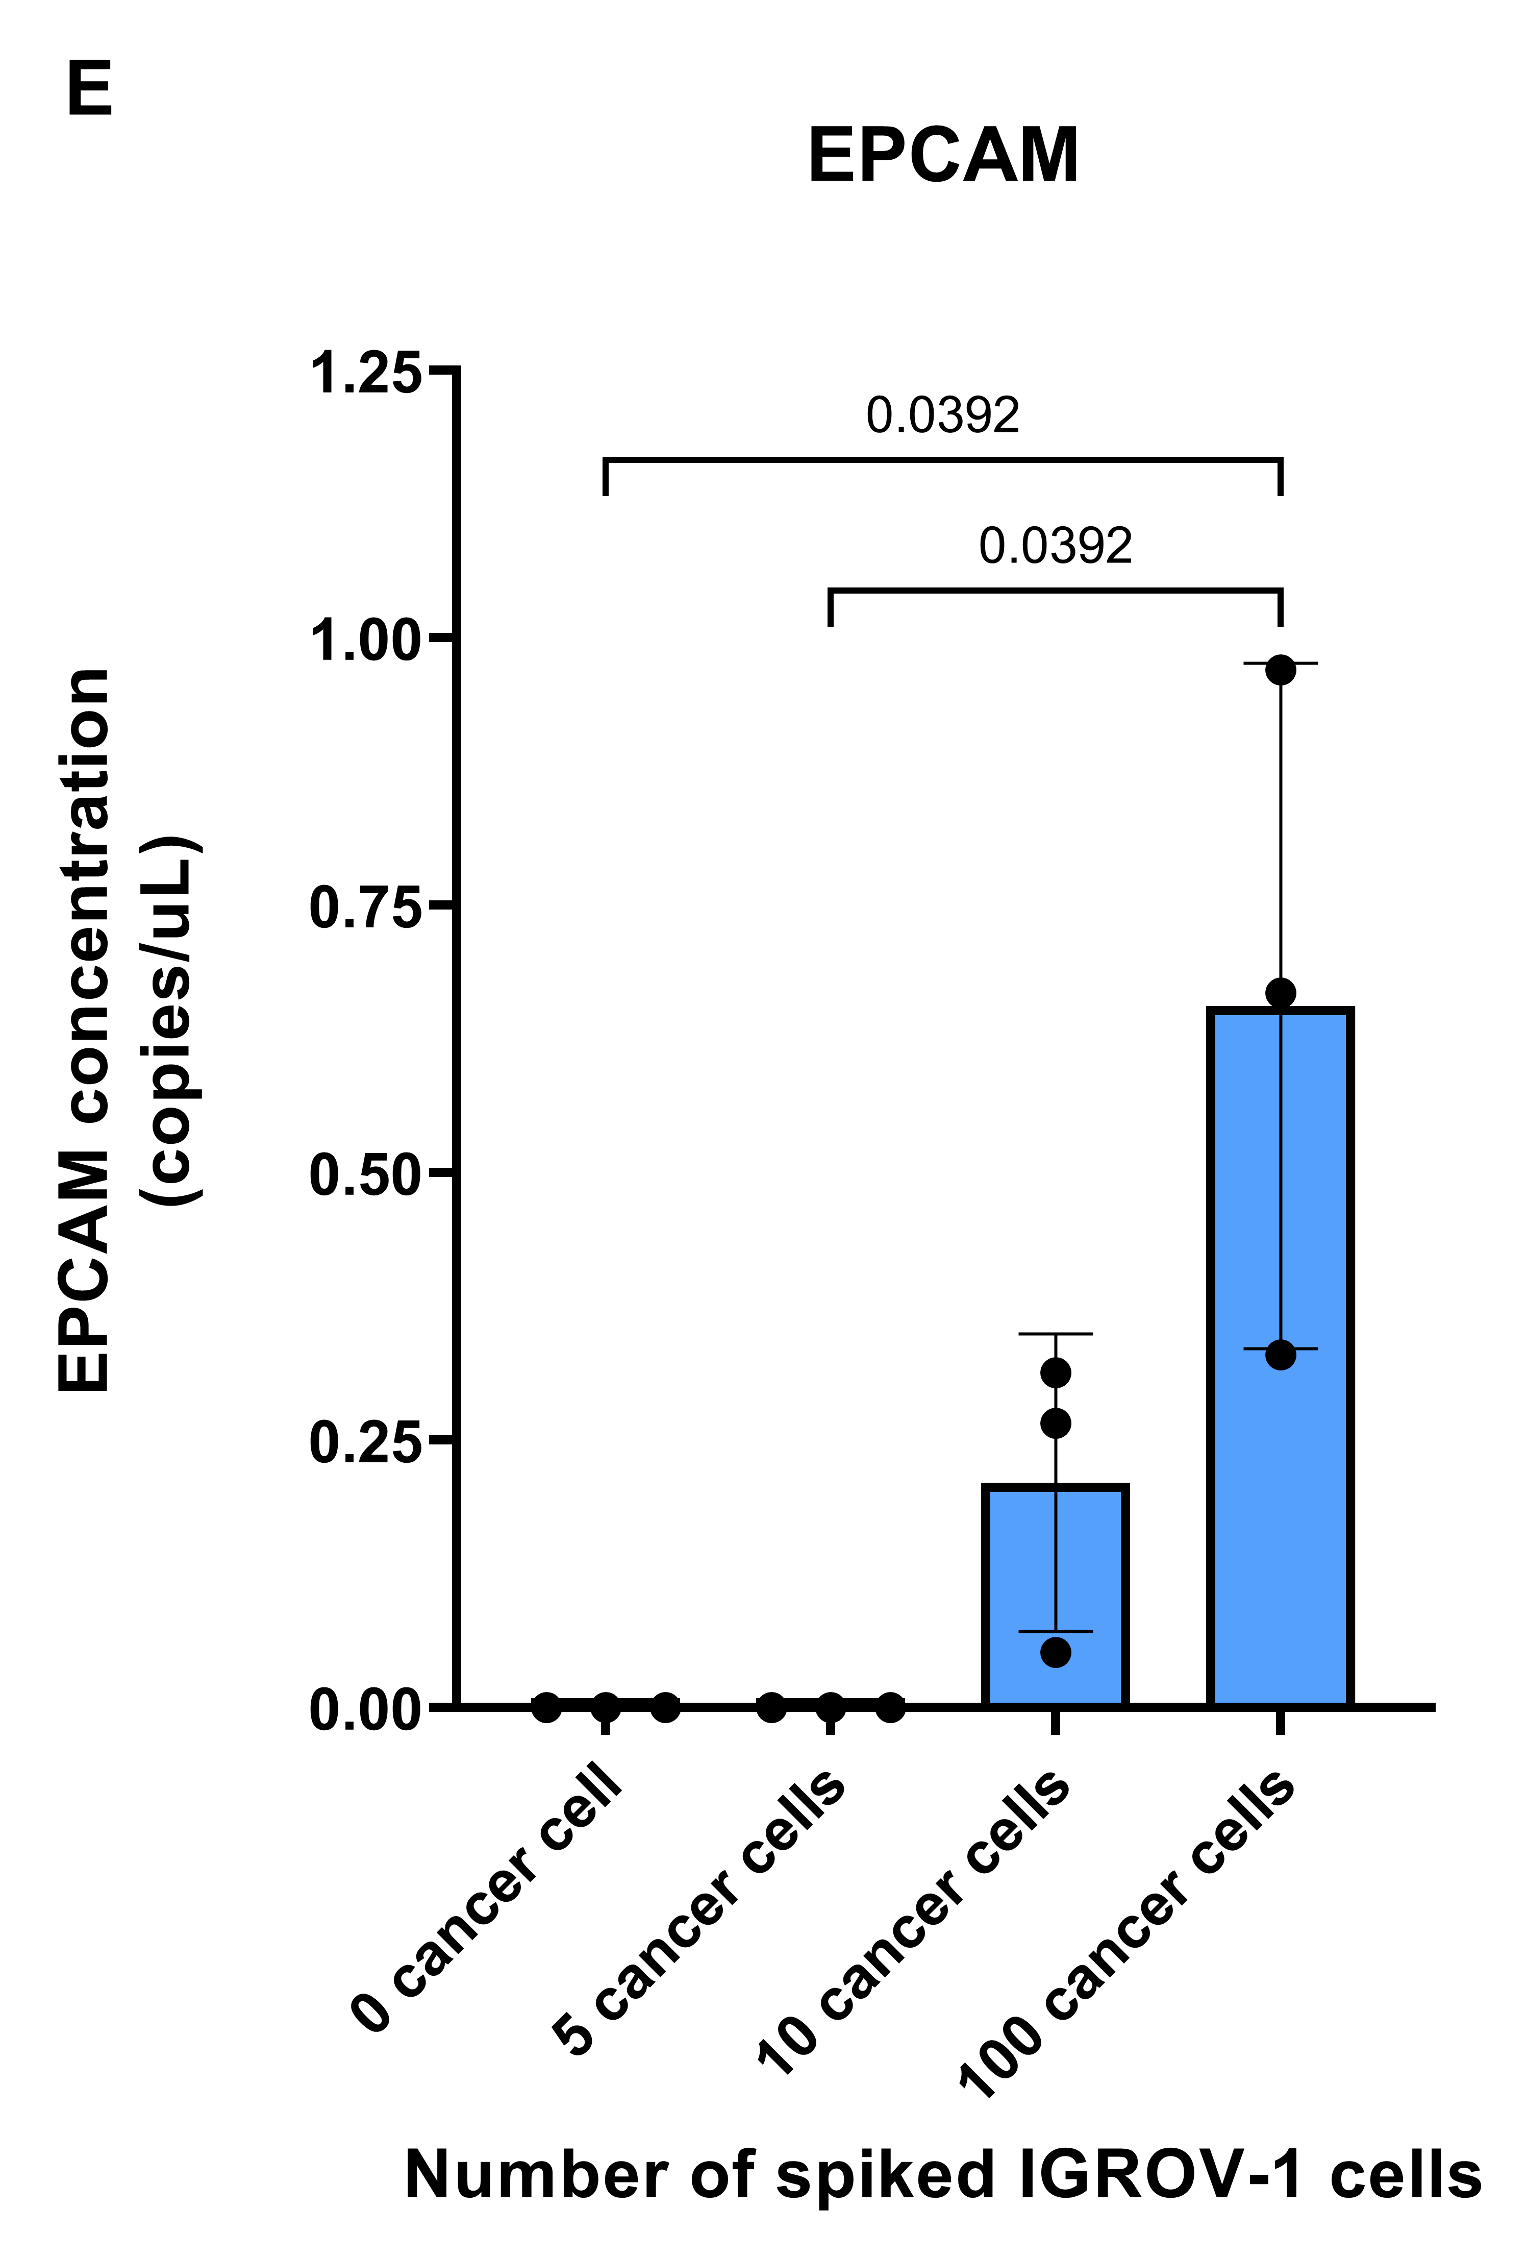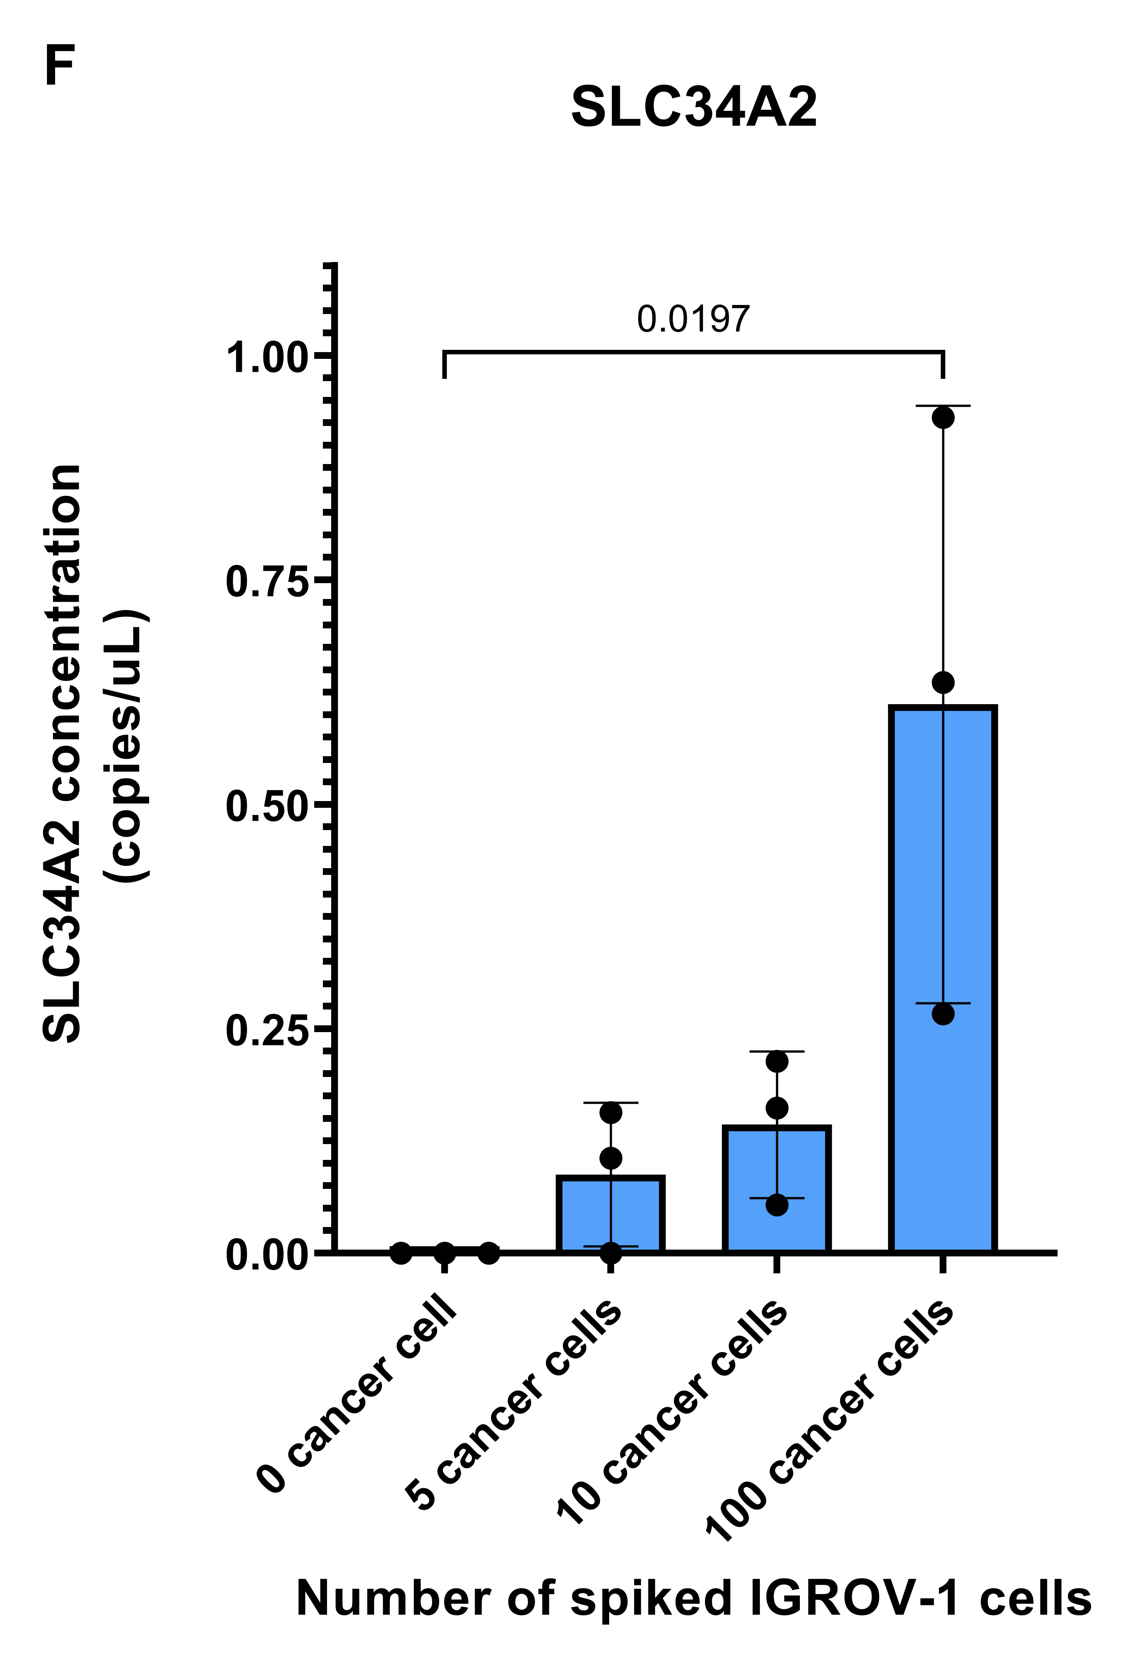

Supplementary Information 4 Spiking experiment results. Absolute gene expression levels in healthy female donor blood samples spiked with OVCAR-3 (A, B, C), OVCAR-5 (D), and IGROV-1 (E, F) tumor cells. The counted 0/5/10/100 cells were spiked into 3 mL of healthy donors’ blood. CTC enrichment protocol was operated by a fully automatic CD-PRIME device and FAST-Auto disc. RNA was extracted from membrane-captured cells. Gene expression studies with EPCAM (A, E), MUC16 (B), SLC34A2 (C, F), and WFDC2 (D) were performed on nanoplate-based digital PCR by absolute quantification. Bars represent mean values of absolute concentration (copies/μL), dots show individual values, error bars represent standard deviation (SD). N=3, significance tested by Kruskal-Wallis test and the post hoc Dunn's multiple comparisons test, p * < 0.05.

