Table 1: Results of the stationarity tests (Augmented Dickey-Fuller)
Source: Authors, from R Studio
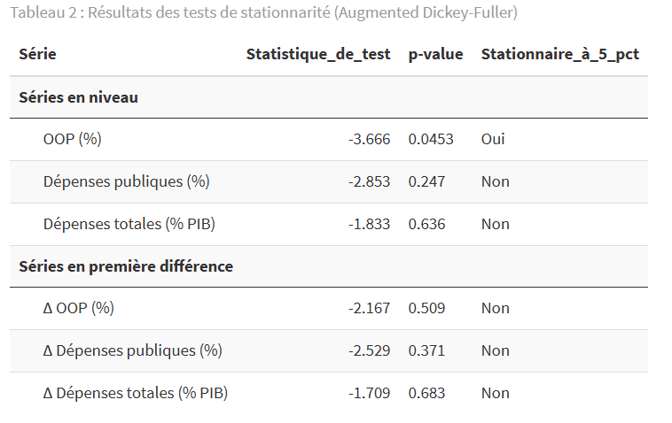
Table 2: Lag order selection criteria for the VAR model
Source: Authors, from R Studio
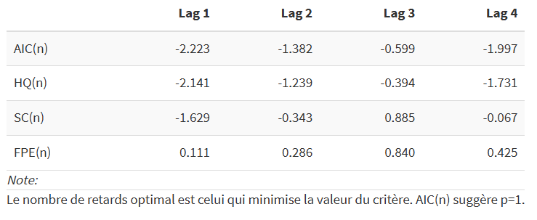
Table 3: Results of Granger causality tests (Lag=1)
Source: Authors, from R Studio
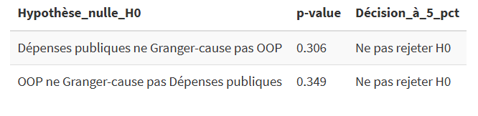
Tableau 4: Decomposition of the forecast error variance for the OOP variable (%)
Source: Authors, from R Studio
