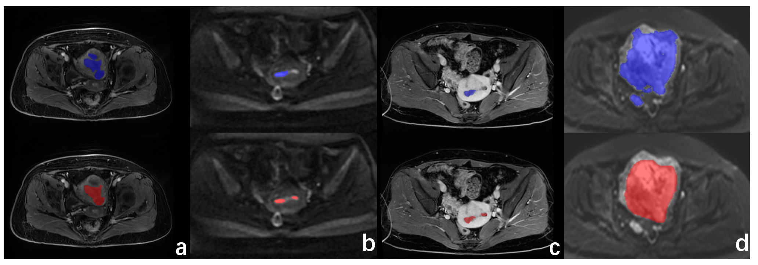
Supplementary Fig. S1: Examples of automatic segmentation failure (a-d; blue: automatically segmented ROIs; red: manually segmented ROIs). (a) (T2WI): Non-endometrial carcinoma (EC) lesions were incorrectly identified as EC. (b) (DWI), (c) (CE-T1WI): Slight discrepancies in small lesions resulted in significantly reduced Dice similarity coefficient (DSC) values. (d): Lymph node metastasis was misidentified as an EC ROI.

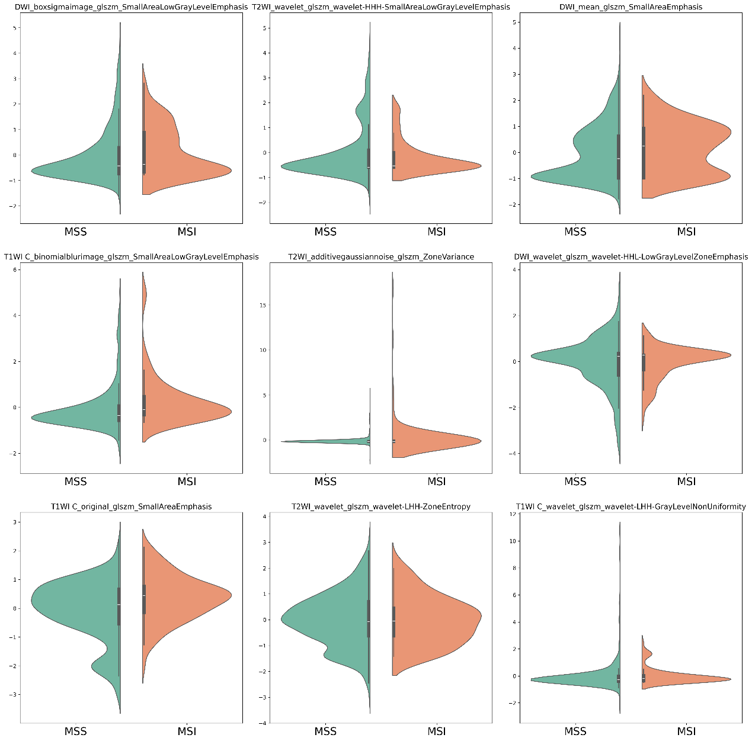
Supplementary Fig. S2: Violin plots of GLSZM features in the MSI and MSS groups.

