Strain-Tuned Structural, Mechanical and Electronic Properties of Two-
dimensional transition metal sulfides ZrS₂: A First Principles Study

Qi Song¹, Xin Liu¹, Hui Wang^{1,*}, Xiaoting Wang¹,Yuxiang Ni¹, Hongyan Wang¹
¹ School of Physical Science and Technology, Southwest Jiaotong University, Chengdu 611756, P.R. China
■ SUPPORTING INFORMATION
Fig.S1 The PBE and HSE06 band structures of ZrS₂ monolayer at each strain case.
Fig.S2 Strain energy of ZrS₂ under uniaxial, shear and biaxial in-plane strain, respectively.
Fig.S3 Fit results for ZrS₂ monolayer with different directional elastic constants C_{2d}, respectively.
Fig.S4 Deformation potential constant for different directions of ZrS₂ monolayer, respectively.

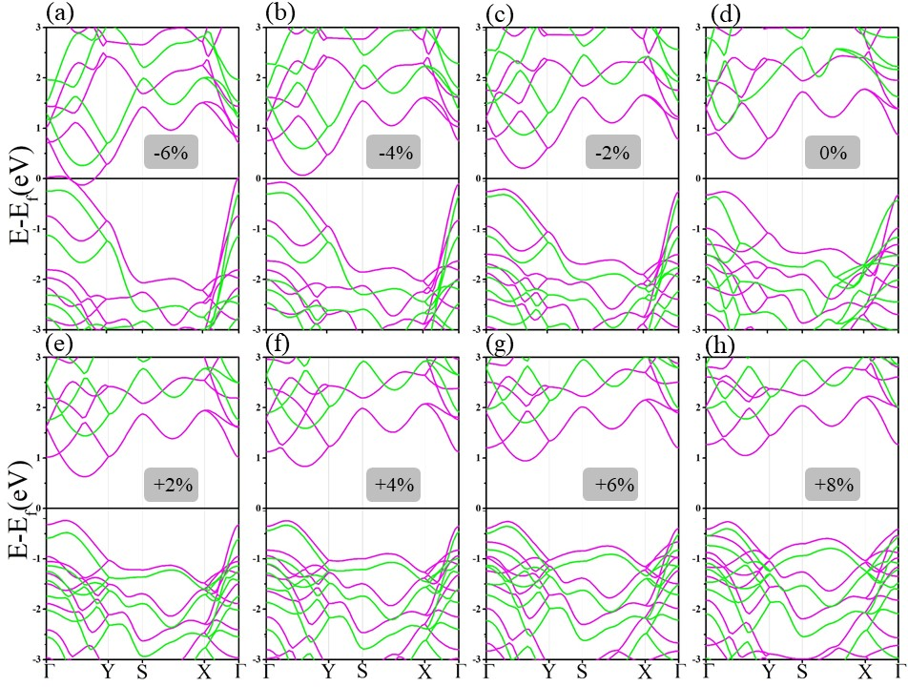
- uniaxial of x-axis.
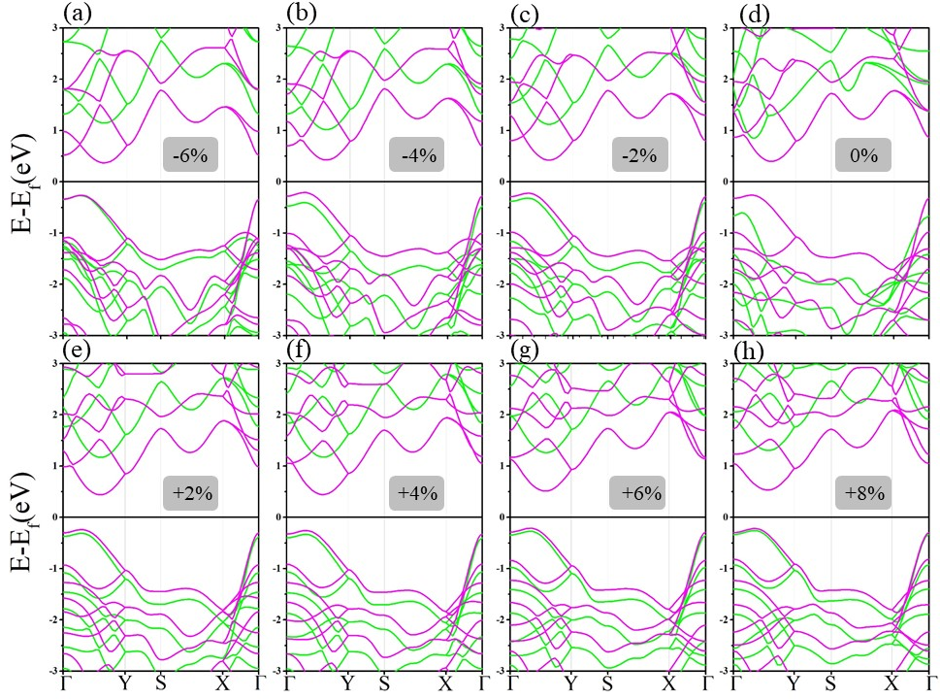
- uniaxial of y-axis
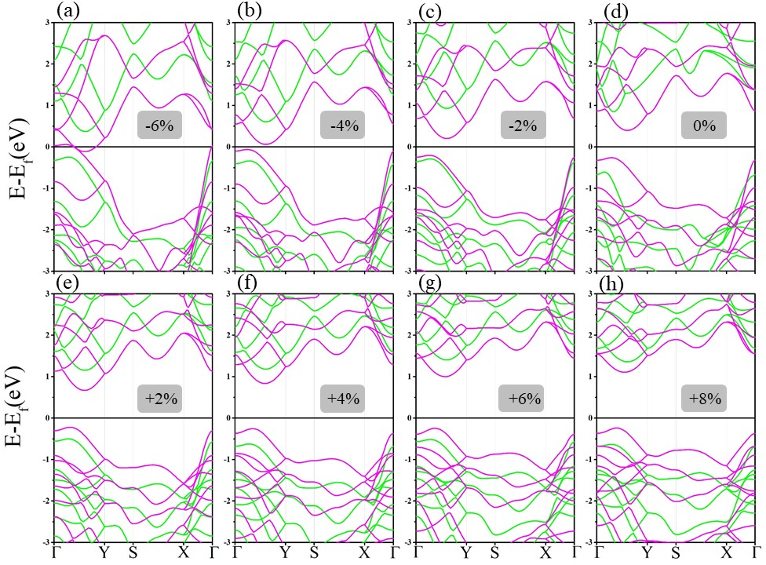
- biaxial
Fig.S1 The PBE and HSE06 band structures of ZrS₂ monolayer at each strain case. PBE method (showing with pink lines) and HSE06 method (showing with green lines).

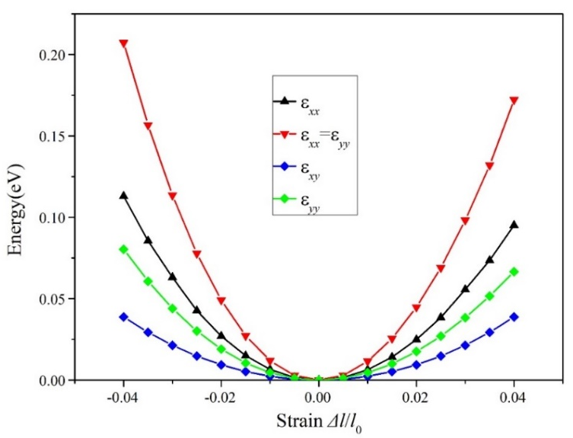
Fig.S2 Strain energy of ZrS₂ under uniaxial, shear and biaxial in-plane strain, respectively. (ε_{xx} means the elasticity coefficient C₁₁, ε_{xx}=ε_{yy} means the elasticity coefficient C_{12,}ε_{xy} means the elasticity coefficient C₆₆, ε_{yy} means the elasticity coefficient C₂₂).
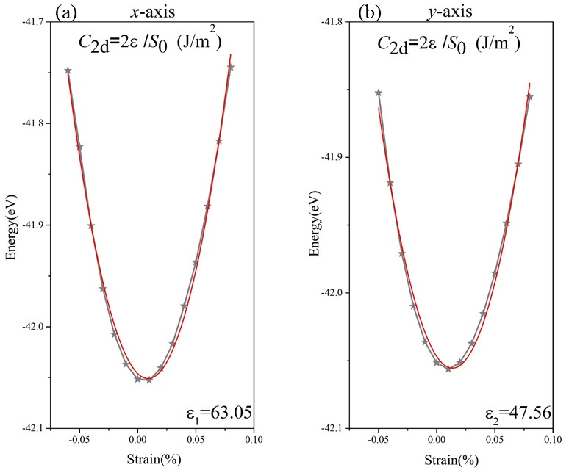

Fig.S3 Fit results for ZrS₂ monolayer with different directional elastic constants C_{2d}, respectively. (The gray line is the real lowest energy value obtained by plotting the line, and the red line indicates the result of the second-order polynomial fit.) Fig.3 (a) is the elastic constant in the x-axis direction. Fig.3 (b) is the elastic constant in the y-axis direction.

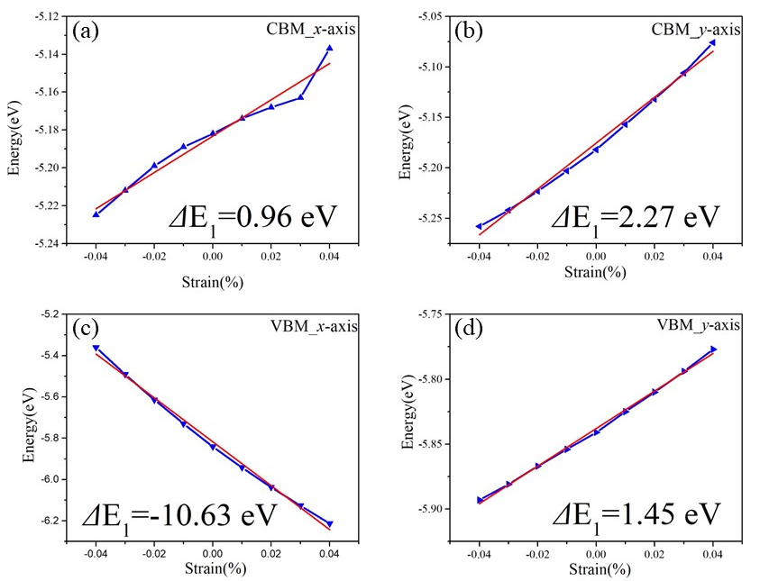
Fig.S4 Deformation potential constant for different directions of ZrS₂ monolayer, respectively. (The blue line is connected by real points, and the red line indicates the result of the linear fit.) In the Fig.4 (a) and (b), the vertical coordinates are obtained by the formula: E_{CBM}(eV)-E_{vacuum}(eV), which represents the value of the conduction band minimum when the vacuum energy level is 0. And in the (c) and (d), the valence band maximum positions are obtained by subtracting the bandgap from the conduction band maximum.

∗ Corresponding author: Hui Wang. E-mail: wanghui@swjtu.edu.cn

