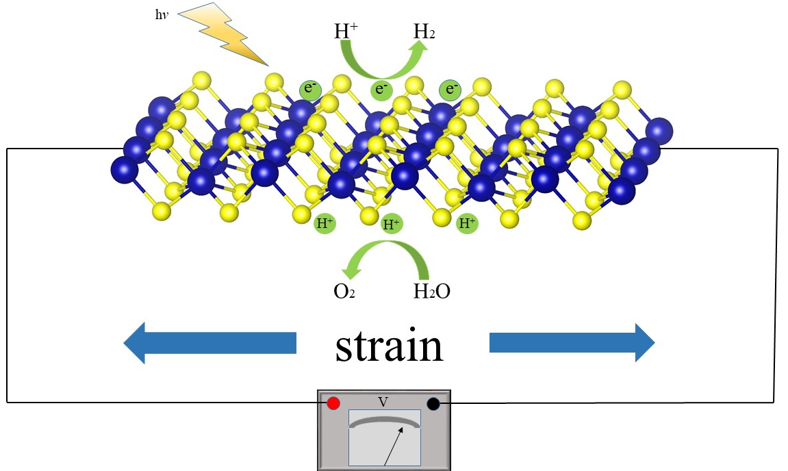
The electronic, mechanical and optical properties of the new ZrS₂ structure with a space group of 59_Pmmn under strain are studied theoretically, and further information on carrier mobility, optical absorption coefficients and energy band edge positions are obtained. The results confirm the ability of strain engineering to modulate electronic and mechanical properties of two-dimensional materials, which indicates that the new two-dimensional Pmmn-ZrS₂ monolayer is a potential material for photovoltaic devices and photocatalytic water decomposition.

