Table S1: Search strategy for online databases.
PubMed search
No. | Search term
1 | (((((((((((((((((((((Stroke[MeSH Terms]) OR (Cerebrovascular disorders[MeSH Terms])) OR (Brain ischemia[MeSH Terms])) OR (Brain infarction[MeSH Terms])) OR (Stroke*[Title/Abstract])) OR (Apoplexy[Title/Abstract])) OR (Cerebrovascular[Title/Abstract])) OR (Intracranial vascular[Title/Abstract])) OR (Brain vascular[Title/Abstract])) OR (vascular disorder*[Title/Abstract])) OR (vascular disease*[Title/Abstract])) OR (vascular accident*[Title/Abstract])) OR (Brain ischemi*[Title/Abstract])) OR (Brain ischaemi*[Title/Abstract])) OR (Cerebral ischemi*[Title/Abstract])) OR (Cerebral ischaemi*[Title/Abstract])) OR (Ischemic encephalopath*[Title/Abstract])) OR (Ischaemic encephalopath*[Title/Abstract])) OR (Brain infarct*[Title/Abstract])) OR (Cerebral infarct*[Title/Abstract])) OR (large vessel  occlusion[Title/Abstract])) OR (large-vessel occlusion[Title/Abstract])
2 | (((((((((((((((((((((((((((Endovascular Procedures[MeSH Terms]) OR (Thrombectomy[MeSH Terms])) OR (Embolectomy[MeSH Terms])) OR (Endovascular[Title/Abstract])) OR (Intravascular[Title/Abstract])) OR (Intra-arterial[Title/Abstract])) OR (Thrombectom*[Title/Abstract])) OR (Mechanical[Title/Abstract])) OR (Embolectom*[Title/Abstract])) OR (Mechanical clot disruption*[Title/Abstract])) OR (Clot retrieval[Title/Abstract])) OR (Revascularization[Title/Abstract])) OR (Recanalization[Title/Abstract])) OR (Recanalisation[Title/Abstract])) OR (Reperfusion[Title/Abstract])) OR (Stent retriever[Title/Abstract])) OR (Stent- retriever[Title/Abstract])) OR (Stentriever[Title/Abstract])) OR (Aspiration[Title/Abstract])) OR (Stents[Title/Abstract])) OR (Catheter[Title/Abstract])) OR (Microcatheter[Title/Abstract])) OR (Solitaire[Title/Abstract])) OR (Penumbra[Title/Abstract])) OR (Merci[Title/Abstract])) OR (Trevo[Title/Abstract])) OR  (Gateway[Title/Abstract])) OR (Sofia[Title/Abstract])
3 | (((((((((((((((((((((((((((((((((((((((((Mechanical Thrombolysis[MeSH Terms]) OR (Mechanical thrombolysis[Title/Abstract])) OR (Intra-arterial thrombolysis[Title/Abstract])) OR (Intra-arterial thrombolytic*[Title/Abstract])) OR (Intra- arterial fibrinolysis[Title/Abstract])) OR (Intra-arterial fibrinolytic*[Title/Abstract])) OR (Intra-arterial tissue plasminogen activator[Title/Abstract])) OR (Intra-arterial alteplase[Title/Abstract])) OR (Intra-arterial actilyse[Title/Abstract])) OR (Intra-arterial activase[Title/Abstract])) OR (Intra-arterial rt-PA[Title/Abstract])) OR (Intra-arterial tPA[Title/Abstract])) OR (Intra-arterial tenecteplase[Title/Abstract])) OR (Intra-arterial Metalyse[Title/Abstract])) OR (Intra-arterial TNK[Title/Abstract])) OR (Intra-arterial TNKase[Title/Abstract])) OR (Intra-arterial urokinase[Title/Abstract])) OR (Intra-arterial prourokinase[Title/Abstract])) OR (Intra-arterial pro-urokinase[Title/Abstract])) OR (Intra- arterial rhPro-UK[Title/Abstract])) OR (Intra-arterial r-proUK[Title/Abstract])) OR (Intra- arterial reteplase[Title/Abstract])) OR (Intraarterial thrombolysis[Title/Abstract])) OR (Intraarterial thrombolytic*[Title/Abstract])) OR (Intraarterial fibrinolysis[Title/Abstract])) OR (Intraarterial fibrinolytic*[Title/Abstract])) OR (Intraarterial tissue plasminogen activator[Title/Abstract])) OR (Intraarterial alteplase[Title/Abstract])) OR (Intraarterial  actilyse[Title/Abstract])) OR (Intraarterial activase[Title/Abstract])) OR (Intraarterial rt-

 | PA[Title/Abstract])) OR (Intraarterial tPA[Title/Abstract])) OR (Intraarterial tenecteplase[Title/Abstract])) OR (Intraarterial Metalyse[Title/Abstract])) OR (Intraarterial TNK[Title/Abstract])) OR (Intraarterial TNKase[Title/Abstract])) OR (Intraarterial urokinase[Title/Abstract])) OR (Intraarterial prourokinase[Title/Abstract])) OR (Intraarterial prourokinase[Title/Abstract])) OR (Intraarterial rhPro-UK[Title/Abstract])) OR (Intraarterial r-proUK[Title/Abstract])) OR (Intraarterial reteplase[Title/Abstract])
4 | (((((((((((Randomized controlled trial[MeSH Terms]) ) OR (Randomized Controlled Trials as Topic[MeSH Terms])) OR (Controlled clinical trial[MeSH Terms])) OR (Randomized[Title/Abstract])) OR (Randomised[Title/Abstract])) OR (randomly[Title/Abstract])) OR (random[Title/Abstract])) OR (placebo[Title/Abstract])) OR (trial[Title/Abstract])) OR (groups[Title/Abstract])) OR (RCT[Title/Abstract])
5 | #1 AND #2 AND #3 AND #4
Embase search
No. | Search term
1 | 'cerebrovascular accident'/exp OR 'ischemic stroke'/exp OR 'cerebrovascular':ti,ab OR 'intracranial vascular':ti,ab OR 'brain vascular':ti,ab OR 'stroke*':ti,ab OR 'cerebral infarct*':ti,ab OR 'brain infarct*':ti,ab OR 'brain ischemi*':ti,ab OR 'brain ischaemi*':ti,ab OR 'cerebral ischemi*':ti,ab OR 'cerebral ischaemi*':ti,ab
2 | 'thrombectomy'/exp OR 'endovascular surgery'/exp OR 'embolectomy'/exp OR 'thrombectom*':ti,ab OR 'embolectom*':ti,ab OR 'endovascular therap*':ti,ab OR 'endovascular treatment':ti,ab OR 'endovascular thrombectom*':ti,ab OR 'mechanic* thrombectom*':ti,ab
3 | 'intra-arterial thrombolysis':ti,ab OR 'intra-arterial thrombolytic*':ti,ab OR 'intra-arterial fibrinolysis':ti,ab OR 'intra-arterial fibrinolytic*':ti,ab OR 'intra-arterial tissue plasminogen activator':ti,ab OR 'intra-arterial alteplase':ti,ab OR 'intra-arterial actilyse':ti,ab OR 'intra- arterial activase':ti,ab OR 'intra-arterial rt-pa':ti,ab OR 'intra-arterial tpa':ti,ab OR 'intra- arterial tenecteplase':ti,ab OR 'intra-arterial metalyse':ti,ab OR 'intra-arterial tnk':ti,ab OR 'intra-arterial tnkase':ti,ab OR 'intra-arterial urokinase':ti,ab OR 'intra-arterial prourokinase':ti,ab OR 'intra-arterial pro-urokinase':ti,ab OR 'intra-arterial rhpro-uk':ti,ab OR 'intra-arterial r-prouk':ti,ab OR 'intra-arterial reteplase':ti,ab OR 'intraarterial thrombolysis':ti,ab OR 'intraarterial thrombolytic*':ti,ab OR 'intraarterial fibrinolysis':ti,ab OR 'intraarterial fibrinolytic*':ti,ab OR 'intraarterial tissue plasminogen activator':ti,ab OR 'intraarterial alteplase':ti,ab OR 'intraarterial actilyse':ti,ab OR 'intraarterial activase':ti,ab OR 'intraarterial rt-pa':ti,ab OR 'intraarterial tpa':ti,ab OR 'intraarterial tenecteplase':ti,ab OR 'intraarterial metalyse':ti,ab OR 'intraarterial tnk':ti,ab OR 'intraarterial tnkase':ti,ab OR 'intraarterial urokinase':ti,ab OR 'intraarterial prourokinase':ti,ab OR 'intraarterial rhpro- uk':ti,ab OR 'intraarterial r-prouk':ti,ab OR 'intraarterial reteplase':ti,ab
4 | 'controlled clinical trial'/exp OR 'randomized controlled trial'/exp OR 'randomized':ti,ab OR 'randomised':ti,ab OR 'randomly':ti,ab OR 'random':ti,ab OR 'placebo':ti,ab OR 'trial':ti,ab OR 'groups':ti,ab OR 'rct':ti,ab
5 | #1 AND #2 AND #3 AND #4
Cochrane Central Register of Controlled Trials search
No. | Search term
1 | MeSH descriptor: [Stroke] explode all trees
2 | MeSH descriptor: [Cerebrovascular Disorders] explode all trees
3 | MeSH descriptor: [Brain Infarction] explode all trees
4 | MeSH descriptor: [Brain Ischemia] explode all trees
5 | (stroke? OR cerebrovascular accident? OR cerebral infarct* OR brain infarct* OR large vessel occlusion OR large-vessel occlusion):ti,ab,kw
6 | #1 OR #2 OR #3 OR #4 OR #5
7 | MeSH descriptor: [Thrombectomy] explode all trees
8 | MeSH descriptor: [Embolectomy] explode all trees
9 | (Thrombectom* OR Embolectom* OR Endovascular thrombectom* OR Endovascular therap* OR Endovascular treatment OR mechanic* thrombectom*):ti,ab,kw
10 | #7 OR #8 OR #9
11 | MeSH descriptor: [Mechanical Thrombolysis] explode all trees
12 | (Intra-arterial thrombolysis OR Intra-arterial thrombolytic* OR Intra-arterial fibrinolysis OR Intra-arterial fibrinolytic* OR Intra-arterial tissue plasminogen activator OR Intra- arterial alteplase OR Intra-arterial actilyse OR Intra-arterial activase OR Intra-arterial rt-PA OR Intra-arterial tPA OR Intra-arterial tenecteplase OR Intra-arterial Metalyse OR Intra- arterial TNK OR Intra-arterial TNKase OR Intra-arterial urokinase OR Intra-arterial prourokinase OR Intra-arterial pro-urokinase OR Intra-arterial rhPro-UK OR Intra-arterial r-proUK OR Intra-arterial reteplase OR Intraarterial thrombolysis OR Intraarterial thrombolytic* OR Intraarterial fibrinolysis OR Intraarterial fibrinolytic* OR Intraarterial tissue plasminogen activator OR Intraarterial alteplase OR Intraarterial actilyse OR Intraarterial activase OR Intraarterial rt-PA OR Intraarterial tPA OR Intraarterial tenecteplase OR Intraarterial Metalyse OR Intraarterial TNK OR Intraarterial TNKase OR Intraarterial urokinase OR Intraarterial prourokinase OR Intraarterial pro-urokinase OR  Intraarterial rhPro-UK OR Intraarterial r-proUK OR Intraarterial reteplase):ti,ab,kw
13 | #11 OR #12
14 | MeSH descriptor: [Randomized Controlled Trial] explode all trees
15 | MeSH descriptor: [Controlled Clinical Trial] explode all trees
16 | MeSH descriptor: [Randomized Controlled Trials as Topic] explode all trees
17 | MeSH descriptor: [Controlled Clinical Trials as Topic] explode all trees
18 | (randomized OR randomised OR randomly OR random OR placebo OR trial OR groups OR RCT):ti,ab,kw
19 | #14 OR #15 OR #16 OR #17 OR #18
20 | #6 AND #10 AND #13 AND #19

Supplementary Figure S1. Quality assessment of included trials.
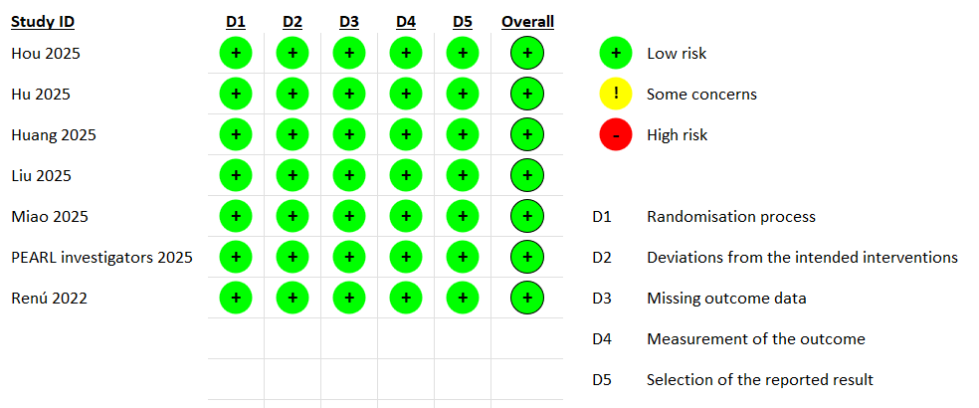
Supplementary Figure S2. Subgroup analysis by thrombolytic agent for excellent functional outcome.
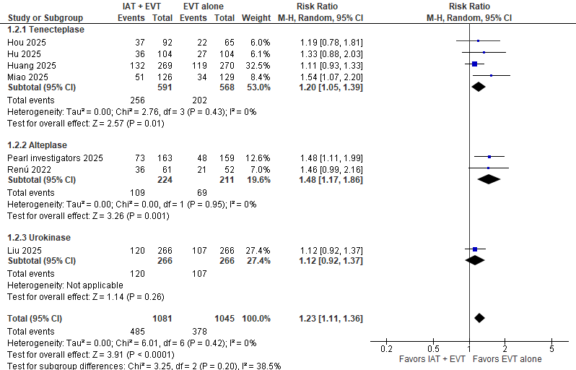

Supplementary Figure S3. Subgroup analysis by stroke severity for excellent functional outcome.
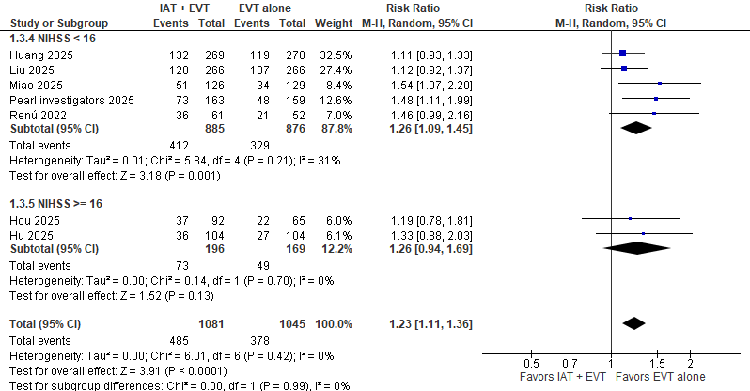

Supplementary Figure S4. Subgroup analysis by thrombolytic agent for all-cause mortality.
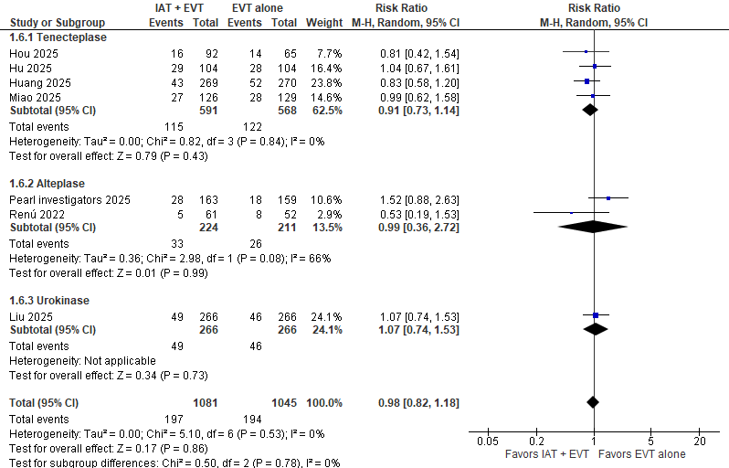

Supplementary Figure S5. Subgroup analysis by stroke severity for all-cause mortality.
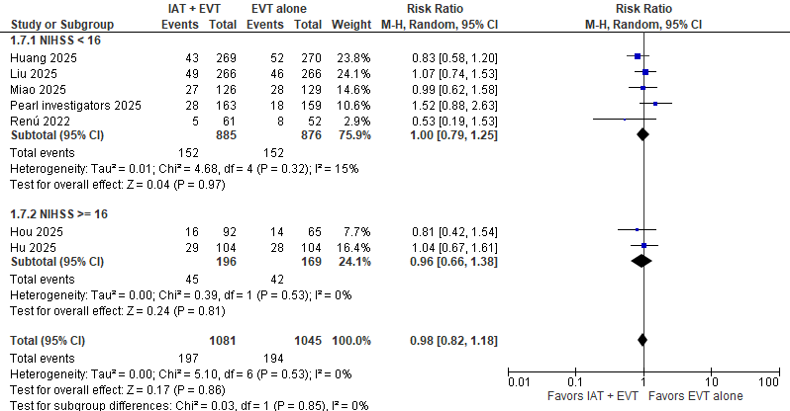

Supplementary Figure S6. Forest plot for good functional outcome.
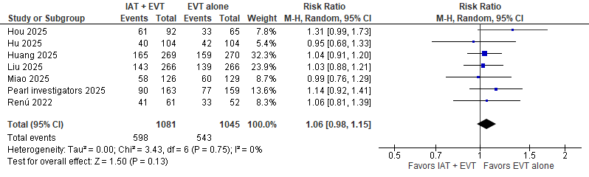

Supplementary Figure S7. Subgroup analysis by thrombolytic agent for good functional outcome.
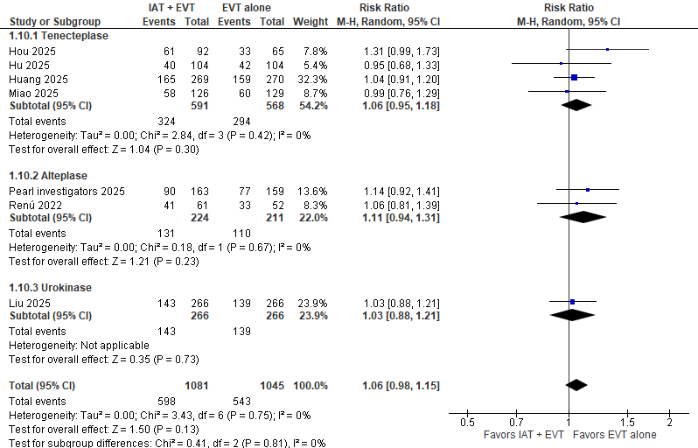

Supplementary Figure S8. Subgroup analysis by stroke severity for good functional outcome.
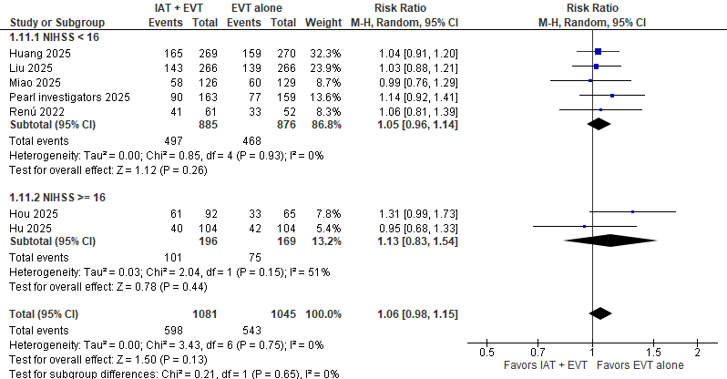

Supplementary Figure S9. Forest plot for any intracranial hemorrhage.
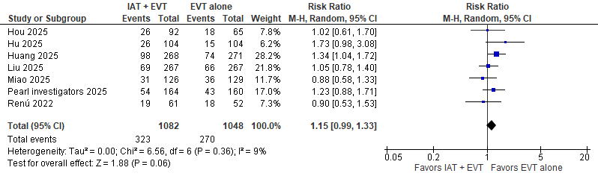

Supplementary Figure S10. Subgroup analysis by thrombolytic agent for intracranial hemorrhage.
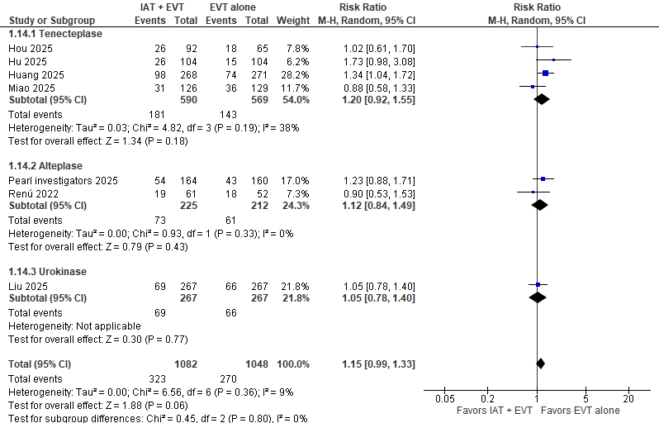

Supplementary Figure S11. Subgroup analysis by stroke severity for intracranial hemorrhage.
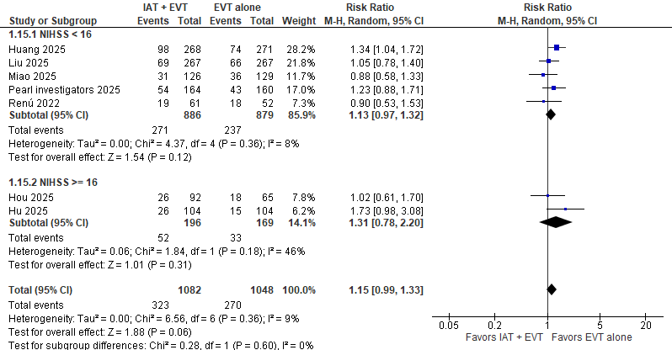

Supplementary Figure S12. Forest plot for symptomatic intracranial hemorrhage.
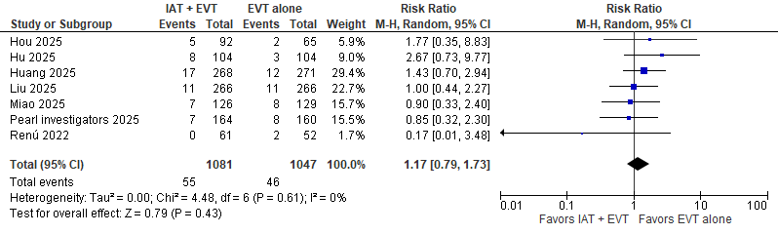

Supplementary Figure S13. Subgroup analysis by thrombolytic agent for symptomatic intracranial hemorrhage.
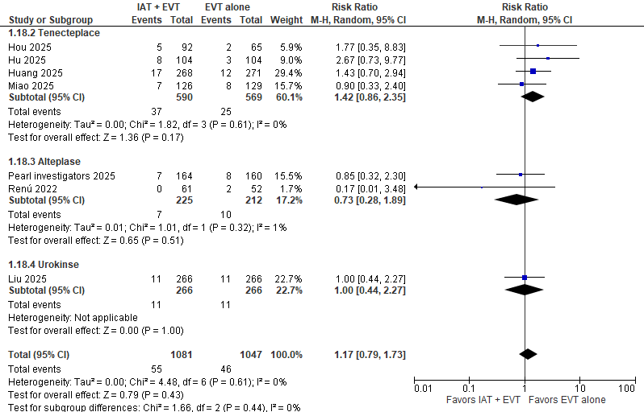

Supplementary Figure S14. Subgroup analysis by stroke severity for symptomatic intracranial hemorrhage.
