Supplementary Information for
Programmable ultra-broadband photonic chaos platform enabled by microwave-chaos-driven electro-optic frequency combs
Shiyu Shi^{1,2,4†}, Yiqun Zhang^{1,2†}, Mengjie Zhou^{3†}, Mingfeng Xu^{1,2,4*}, Xianglei Yan^{1,2}, Qiang Chen^{1,2,4}, Yunxia Yang^{1,2}, Yinghui Guo^{1,2,4}, Mingbo Pu^{1,2,4*}, and Xiangang Luo^{1,2,4*}
¹State Key Laboratory of Optical Field Manipulation Science and Technology, Institute of Optics and Electronics, Chinese Academy of Sciences, Chengdu 610209, China.
²Research Center on Vector Optical Fields, Institute of Optics and Electronics, Chinese Academy of Sciences, Chengdu 610209, China.
³Tianfu Xinglong Lake Laboratory, Chengdu 610299, China.
⁴College of Materials Science and Opto-Electronic Technology, University of Chinese Academy of Sciences, Beijing 100049, China.
†These authors contributed equally to this work.
*Email: xumf@ioe.ac.cn, pmb@ioe.ac.cn, lxg@ioe.ac.cn

Supplementary Note 1. Derivation and analysis of the theoretical model of the ultra-broadband photonic chaos
The programmable ultra-broadband photonic chaos is generated by driving an electro-optic frequency comb with a microwave chaotic signal. The optical chaotic seed, centered at angular frequency ω_{0,} is generated via a conventional external optical feedback structure. Its temporal dynamics can be described by the Lang–Kobayashi rate equations¹, which govern the evolution of the complex optical field E(t) of a semiconductor laser (SL) under delayed optical feedback:
where α is the linewidth enhancement factor, g is the differential gain coefficient, N₀ is the transparency carrier number, ε is the gain saturation factor, γ_{p} is the photon decay rate, κ_{f} is the external feedback strength, and τ is the round-trip feedback delay time. For compact representation and subsequent use, the optical field of the optical chaotic seed can be expressed as:
where A_{chaos}(t) and φ_{chaos}(t) denote the instantaneous amplitude and phase of the optical chaotic seed, respectively.
Next, spectral translation is performed by heterodyning the optical chaotic seed E_{chaos}(t) with a continuous-wave (CW) reference light E₁(t) at frequency ω₀+Δω to generate a microwave chaotic signal V(t). This process effectively maps the temporal and spectral characteristics of the optical chaos into the electrical domain:
where and . The resulting signal V(t) is a broadband microwave chaotic waveform that inherits the high-dimensional dynamics and wide bandwidth of the optical chaotic seed.
This microwave chaotic signal then simultaneously drives a cascaded electro-optic frequency comb architecture comprising an intensity modulator (IM) followed by two phase modulators (PMs). An independent CW optical carrier with amplitude A_{c} and angular frequency ω_{c} is first modulated by the IM driven by V(t), yielding the output field:
where is the modulation depth of the IM, is the phase shift determined by the bias voltage, and V_{π,IM} is the half-wave voltage of the IM. The output spectrum features symmetric sidebands around the carrier frequency ω_{c.} Unlike conventional single-tone modulation, the broadband nature of V(t) leads to the formation of continuous spectral envelopes centred at harmonics of Δω, effectively initiating optical bandwidth expansion.
The output from the IM is subsequently fed into two cascaded PMs, both synchronously driven by the same broadband microwave chaotic signal V(t). The optical field E_{PM}(t) after phase modulation can be expressed as:
where is the modulation depth of the PM and V_{π,PM} is the half-wave voltage of the PM. This stage plays a pivotal role in generating the ultra-broadband optical chaos. Unlike conventional single-frequency modulation that yields discrete spectral lines, the broadband nature of V(t) induces a continuous spectral broadening of each modulation sideband. Moreover, the number of generated high-order sidebands scales with the modulation depth. When the phase modulation depth is sufficiently large, the broadened sidebands overlap extensively, leading to spectral aliasing and merging across adjacent comb teeth. This process transforms the original frequency comb into a smooth, continuum-like optical spectrum with flat spectral density.
Finally, the spectrally broadened signal is propagated through a length of single-mode fiber (SMF). The resulting output field E_{out}(t) can be expressed as:
where β₂ is the group velocity dispersion parameter of the SMF, and L is its length. The primary role of the dispersive SMF is to perform phase-to-intensity conversion. Specifically, the temporally varying phase fluctuations induced by broadband chaotic modulation are translated into measurable intensity fluctuations via dispersion-induced group delay. This mechanism enables direct detection of the underlying chaotic dynamics using intensity-based photodetectors, thereby completing the generation of an ultra-broadband, measurable chaotic optical waveform.
Due to limitations in direct measurement across the full spectral range, this work employs co-simulation using VPIphotonics and MATLAB. The simulation parameters, listed in Supplementary Table 1, are consistent with those used in the experimental setup.
Supplementary Table 1. Parameter settings of the simulation system
 | Parameters | Symbol | Value
System parameters | Center frequency of COF chaos | ω₀ | 193.591 THz
System parameters | Frequency of reference CW light | ω₀+Δω | 193.5585 THz
System parameters | Frequency of the CW carrier | ω_{c} | 192.43 THz
Parameters of COF-chaos | Linewidth enhancement factor | α | 5
Parameters of COF-chaos | Differential gain coefficient | g | 1.5×10⁴ s⁻¹
Parameters of COF-chaos | Transparency carrier number | N₀ | 1.5×10⁸
Parameters of COF-chaos | Gain saturation factor | ε | 5×10⁻⁷
Parameters of COF-chaos | Photon attenuation rate | γ_{p} | 500 ns⁻¹
Parameters of COF-chaos | Feedback intensity | κ_{f} | -25 dB
Parameters of COF-chaos | Feedback time delay | τ | 83.2 ns
Parameters of EOM | Modulation depth of the IM | β_{IM} | 0.25π
Parameters of EOM | Phase shift of the IM | Ф_{b} | 0.33π
Parameters of EOM | Modulation depth of the PM | β_{PM} | 4.4π
Parameters of SMF | Dispersion parameter | β₂ | 16 ps/(nm∙km)
Parameters of SMF | Length | L | 10 km

Supplementary Note 2. Experiment results on generating multiple parallel chaotic channels via spectrum slicing of ultra-broadband chaos
Figure 1e of the main text presents the generation of a variable number of parallel chaotic channels through spectrum slicing of the ultra-broadband chaotic signal. Specifically, 18-, 40-, and 50-channel configurations are realized under uniform filtering conditions, with corresponding filter bandwidths and channel spacings of 40/40 GHz, 20/20 GHz, and 15/15 GHz, respectively. The representative radio-frequency spectra for each configuration are displayed in Fig. S1. The measured effective bandwidths exceed 17 GHz, 10 GHz, and 9 GHz for the 18-, 40-, and 50-channel cases, respectively, indicating consistent bandwidth performance across channels within each configuration. Notably, even when scaled to 50 parallel channels, the system maintains an effective bandwidth of approximately 9 GHz per channel, which is on par with state-of-the-art chaotic microcomb-based systems.
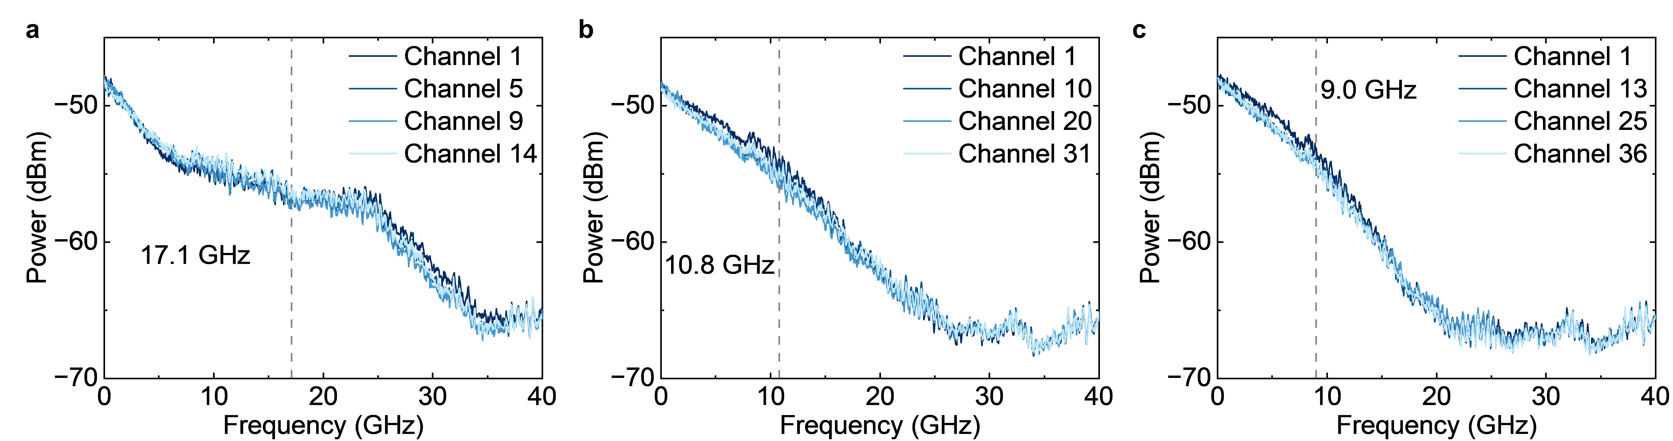
Fig. S1. The radio-frequency spectra of varying numbers of parallel chaotic channels. a-c, Radio-frequency spectra for 18-, 40-, and 50-channel configurations, respectively. Grey dotted lines indicate the minimum effective bandwidth observed among all channels in each case.

Supplementary Note 3. Characterization of chaotic state
In the main text, the autocorrelation function (ACF) and cross-correlation function (CCF) are used to characterize the temporal and statistical properties of the chaotic signals. Given an intensity time series I(t), its ACF is calculated as²:
where the operator <∙> denotes the time-averaged value over the discrete time series, and Δt is the time delay. The full width at half maximum (FWHM) of the ACF is used to evaluate the signal’s temporal decorrelation time, as shown in Fig. S2(a). A smaller FWHM corresponds to faster temporal fluctuations, which is advantageous in applications such as random bit generation and LiDAR.
Similarly, for two different chaotic signals I₁(t) and I₂(t), the CCF is calculated as³:
To quantify inter-channel correlation, the maximum absolute value of the CCF over all delays is taken as the cross-correlation coefficient (CC). A lower CC value indicates weaker statistical correlation between channels, which is essential for achieving high-quality parallel chaotic outputs with statistical independence.
The radio-frequency (RF) spectrum of chaotic signals serves as a widely adopted metric to characterize their spectral properties. As shown in Fig. S2(b), the RF spectrum of the signal obtained from the ultra-broadband chaotic signal exhibits a continuous and spectrally flat profile. The bandwidth of the chaotic signal, an essential figure of merit, is quantified using the effective bandwidth, defined as the frequency range that encompasses 80% of the total spectral energy starting from the DC component⁴. In the main text, both the 3-dB spectral bandwidth and the effective bandwidth are used to provide a more comprehensive and accurate description of the spectral extent of the chaotic signals.
Correlation dimension (CD) is a key metric for characterizing chaotic signals, serving to both confirm the presence of chaos and quantify the signal’s dynamic complexity. In this work, the intensity time series are evaluated using the Grassberger-Procaccia (G-P) algorithm to estimate the CD⁵. The first step involves reconstructing the phase space via time-delay embedding, generating state vectors of the form:
where x_{i} is the time series composed of points, m is the embedding dimension, and τ is the time delay.
Next, the algorithm computes the correlation integral C_{D}(r), which quantifies the probability that two randomly chosen points in phase space are separated by a distance less than r:
where Θ is the Heaviside step function, and N is the total number of state vectors.
The correlation dimension CD is then extracted as the slope of the linear region in the log-log plot of ln C_{D}(r) versus ln r:
In practice, this slope is determined by linear fitting within the scaling region where the relationship is approximately linear, as illustrated in Fig. S2(c) and Fig. S2(d). This approach provides a robust estimation of the correlation dimension and facilitates deeper insight into the underlying nonlinear dynamics of the system.
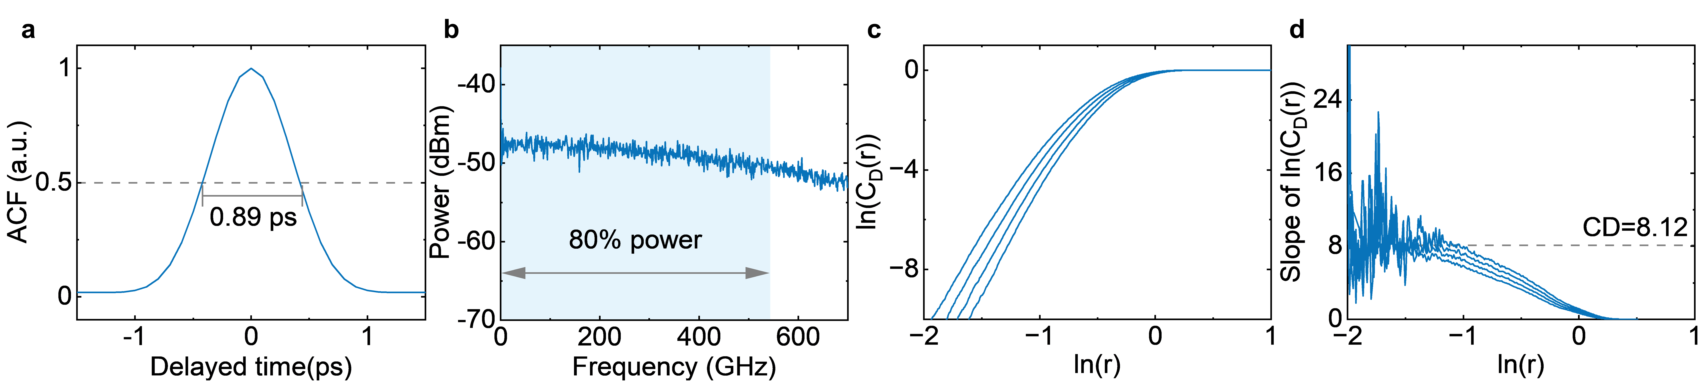
Fig. S2. Characterization of the chaotic signal. a, FWHM of the ACF. b, Representative radio-frequency spectrum and effective bandwidth of a chaotic signal. c, Correlation integral curve C_{D}(r) as a function of sphere radius r for embedding dimensions D = 12 to 15, based on the Grassberger-Procaccia algorithm. d, Slopes of the log-log correlation integral in c.

Supplementary Note 4. Simulation analysis of the influence of detuning Δω
As described in the main text and Supplementary Note 1, the frequency detuning Δω between the optical chaotic seed and the CW reference plays a pivotal role in determining the characteristics of the generated ultra-broadband optical chaos. Specifically, Δω directly sets the center frequency of the microwave chaotic signal produced via optical heterodyning, as shown in Fig. S3(a). A larger Δω results in a higher central frequency of the microwave chaos, which in turn increases the spacing between adjacent sidebands in the electro-optic frequency comb.
To maximize the spectral bandwidth of the resulting chaotic optical signal, Δω should, in principle, be made as large as possible. However, due to the finite bandwidth (~9 GHz) of the chaotic seed signal, there exists an upper limit for Δω to ensure sufficient spectral overlap between neighboring sidebands—a necessary condition for achieving a continuous and spectrally flat chaotic output. Figure S3(b) presents the output spectra under varying Δω values. When Δω is less than 35 GHz, the resulting spectra exhibit good continuity and flatness. As Δω exceeds this threshold, insufficient overlap between broadened sidebands leads to discrete spectral features and degraded spectral smoothness. Balancing spectral performance and system constraints, we set Δω to 32.5 GHz in our experiments.
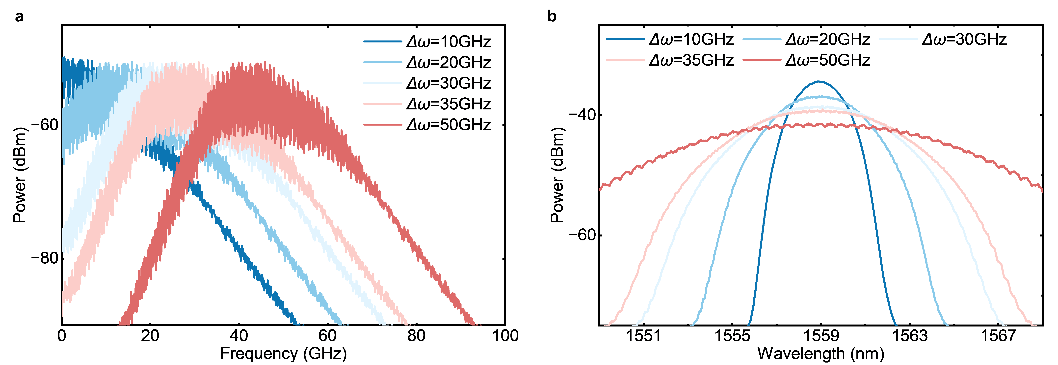
Fig. S3 Influence of detuning Δω. a, The radio-frequency spectra of microwave chaos with different Δω. b, Influence of detuning Δω on the optical spectra of the ultra-broadband optical chaos.

Supplementary Note 5. Simulation analysis of the influence of modulation depth and phase shift
In this section, we investigate the influence of key electro-optic modulation (EOM) parameters on the characteristics of the ultra-broadband optical chaos, using the 3 dB spectral bandwidth as the primary performance metric. Figure S4(a) shows the variation of the 3 dB-bandwidth with the modulation depth of the PMs. A clear increasing trend is observed as the modulation depth increases. When the PM modulation depth is below 1π, the generated sidebands exhibit insufficient spectral overlap, resulting in a discrete comb-like structure and limited bandwidth. As the modulation depth increases, higher-order sidebands emerge and begin to overlap, yielding a broader and flatter spectrum. These results highlight that PM modulation depth is a critical factor in determining the effective spectral span of the generated chaotic signal.
Figure S4(b) and (c) present the influence of the IM on the 3 dB optical spectral bandwidth, specifically its modulation depth and phase shift. It is observed that when the PM modulation depth is sufficiently large, the 3 dB-bandwidth becomes largely insensitive to variations in the IM parameters. This is because the primary role of the IM is to introduce a symmetric spectral structure centered around the carrier frequency, which acts as the initial seed for subsequent spectral broadening through phase modulation. The IM primarily generates a limited number of low-order sidebands, and its modulation depth and phase bias chiefly influence the power distribution among these sidebands, rather than the overall spectral breadth. Consequently, once the PM modulation depth is high enough to enable full overlap of high-order sidebands, the impact of the IM parameters on total bandwidth becomes negligible.
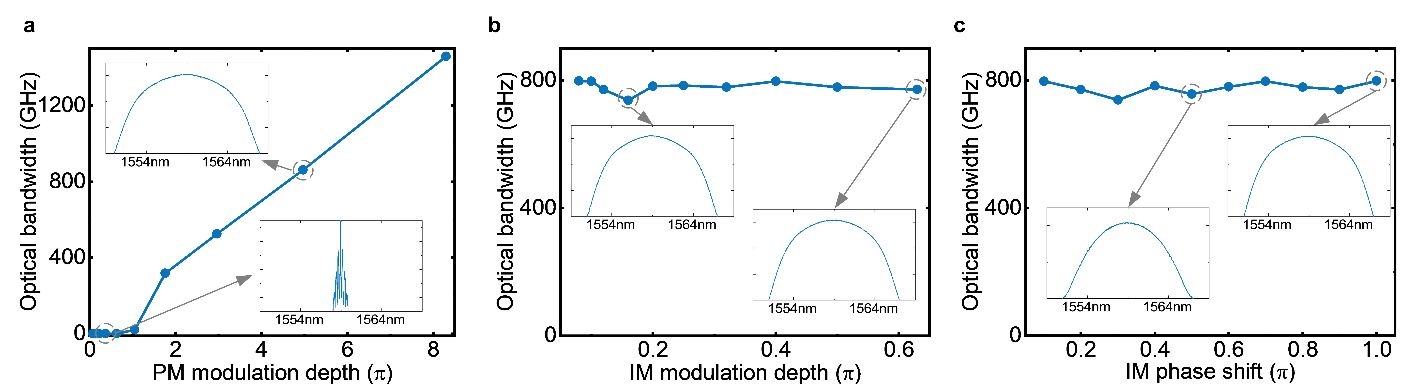
Fig. S4. Influence of EOM comb parameters on the 3 dB-bandwidth of the optical spectrum. a-c, Evolution of the optical 3 dB-bandwidth under varying PM modulation depth (a), IM modulation depth (b), and IM phase shift (c). Insets show the corresponding optical spectra under each parameter configuration.

Supplementary Note 6. Simulation analysis of the influence of chromatic dispersion
In our system, the modulated chaotic optical signal is transmitted through a SMF to introduce chromatic dispersion, which converts phase fluctuations into measurable intensity variations. The SMF length directly determines the dispersion strength and plays a key role in shaping the final output of the ultra-broadband chaotic signal.
To evaluate its impact, we fix all EOM parameters and vary the SMF length. The results are summarized in Fig. S5. As shown in Fig. S5(a), the 3 dB optical bandwidth remains largely unaffected by dispersion, since chromatic dispersion alters only the relative phase of the spectral components without changing the overall power distribution. In contrast, the radio-frequency effective bandwidth (Fig. S5(b)) increases markedly with dispersion, particularly within the range of 0-16 ps/nm, and saturates beyond this point. This saturation occurs because the RF bandwidth is primarily constrained by the phase modulation depth, as discussed in Supplementary Note 5. These results indicate that proper tuning of the frequency detuning Δω, phase modulation depth, and chromatic dispersion is essential to maximize the performance of ultra-broadband chaotic photonic generation.
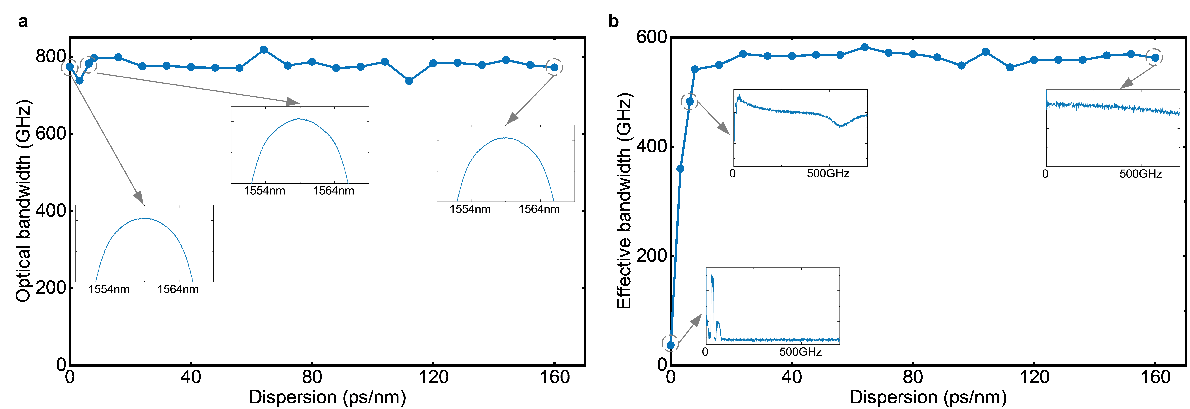
Fig. S5. Influence of chromatic dispersion. a, 3 dB optical bandwidth and b, effective bandwidth of the ultra-broadband chaotic signal under varying chromatic dispersion. Insets show representative optical and radio-frequency spectra under corresponding dispersion conditions.

Supplementary Note 7. Characterization of arbitrary programmable chaotic outputs
The proposed ultra-broadband photonic chaos platform offers high spectral configurability, enabling parallel generation of multi-channel chaotic signals with arbitrarily tunable center wavelengths and bandwidths. To further verify this programmability beyond uniform slicing (as shown in Fig. S1), we examine non-uniform filtering configurations. Each chaotic channel is extracted from a programmable waveshaper, permitting flexible spectral allocation. Figure S6(a) shows the optical spectrum of the original chaotic signal overlaid with filtered outputs of multiple channels with unequal bandwidths and spacing. The colored shaded regions denote the selected spectral slices. Figures S6(b-d) present the time-domain waveforms, radio-frequency spectra, and ACFs of each channel. All filtered outputs retain strong chaotic properties, confirming that the system enables versatile, application-specific spectral partitioning.
Fig. S6. Characteristics of programmable chaotic outputs under non-uniform filtering conditions. a, Optical spectrum of the original ultra-broadband chaotic signal overlaid with four filtered chaotic outputs with different center wavelengths and bandwidths. Colored shaded regions represent the extracted channels: CH1 (1555.98 nm, 10 GHz), CH2 (1558.58 nm, 20 GHz), CH3 (1558.98 nm, 30 GHz), and CH4 (1559.38 nm, 40 GHz). b-d, Time series (b), radio-frequency spectra (c), and ACF (d) of the chaotic signals for CH1-CH4.

Supplementary Note 8. Characterization of the 16 parallel chaotic signals
To demonstrate the applicability of the proposed system in accelerating the multi-armed bandit problem, we generate 16 uncorrelated parallel chaotic signals using a filtering bandwidth of 40 GHz and a channel spacing of 50 GHz. These channels are evenly spaced and symmetrically distributed around the central wavelength of the ultra-broadband optical chaotic spectrum. Figures S7(a–c) show representative results for the time series, radio-frequency spectra, and ACFs of the chaotic channels. The time traces exhibit rapid and irregular fluctuations, indicative of strong aperiodicity. The corresponding RF spectra are continuous with no visible relaxation oscillation peaks. The ACFs display sharp delta-like features with time-delay signature suppressed below 0.05, indicating short temporal correlation and fast chaotic dynamics. These results confirm that each channel maintains high-quality chaotic characteristics, fulfilling the requirements for reliable and scalable parallel processing in photonic decision-making tasks.
The correlation matrix in Fig. 3e of the main text reveals relatively higher CC between symmetric channels. Figures S7(d) and (e) further analyze these symmetric channels in terms of effective bandwidth and CC. The CC initially decreases and then increases as the spectral distance from the center wavelength increases. This behavior arises due to the variation in sideband overlap across the spectrum. Symmetric channels near the center wavelength experience limited sideband contributions, leading to higher correlation. As the spectral distance from the carrier center increases, the number of contributing sidebands rises, and therefore lowers their correlation. However, at the spectral edges of the 3 dB bandwidth, limited modulation efficiency and microwave chaos bandwidth result in fewer dominant sidebands, again increasing correlation. Despite this variation, the CCs of all symmetric channel pairs remain below 0.4, which is sufficiently low for effective parallel operation. These results validate the capability of our architecture to generate high-performance, low-correlation parallel chaotic outputs under symmetric filtering conditions. More importantly, when combined with the fully programmable filtering functionality described in Supplementary Note 7, the system offers full flexibility in tailoring channel center frequencies and bandwidths. This enables the on-demand generation of user-defined parallel chaotic channels, providing a powerful entropy source for advanced applications such as high-speed secure communication and scalable photonic computing.
Fig. S7. Characteristics of the 16 parallel chaotic signals. a-c, Time series (a), radio-frequency spectra (b), and ACFs (c) of representative channels: CH4, CH8, CH9, and CH16. d, Effective bandwidths of all 16 parallel chaotic channels. e, CCs between symmetric channel pairs, denoted as x-y, where x and y represent channels located symmetrically on either side of the center wavelength.

Supplementary Note 9. Influence of channel spacing on cross-correlation between channels
The inter-channel correlation is a key metric for evaluating the performance of parallel chaotic outputs. As shown in Fig. 3e, low cross-correlation is achieved when the 16-channel parallel chaotic signals are configured with non-overlapping spectral bands via appropriate filter settings. To quantitatively assess the influence of filter spacing on inter-channel correlation, we examine a representative two-channel system. In the experiment, the ultra-broadband chaotic signal is split into two identical paths using a fiber coupler, each followed by a tunable optical filter. The filter bandwidth is fixed at 40 GHz, with one filter’s center wavelength held constant while the other is tuned to vary the spectral separation between channels.
Figure S8 shows the dependence of the CC on the filter spacing. When the spacing is below 0.3 nm, spectral overlap occurs, and shared frequency components result in a relatively high CC. As the spacing increases, spectral overlap diminishes, leading to a monotonic decrease in CC. Once the spacing exceeds 0.3 nm, corresponding to the 40 GHz filter bandwidth, the CC drops below 0.1, indicating minimal correlation. These results confirm that non-overlapping spectral filtering is a sufficient condition for achieving low inter-channel correlation.
However, it is also important to note that excessive spacing unnecessarily wastes spectral resources. Therefore, an optimal design should minimize inter-channel correlation while maximizing spectral utilization of the ultra-broadband photonic chaos.
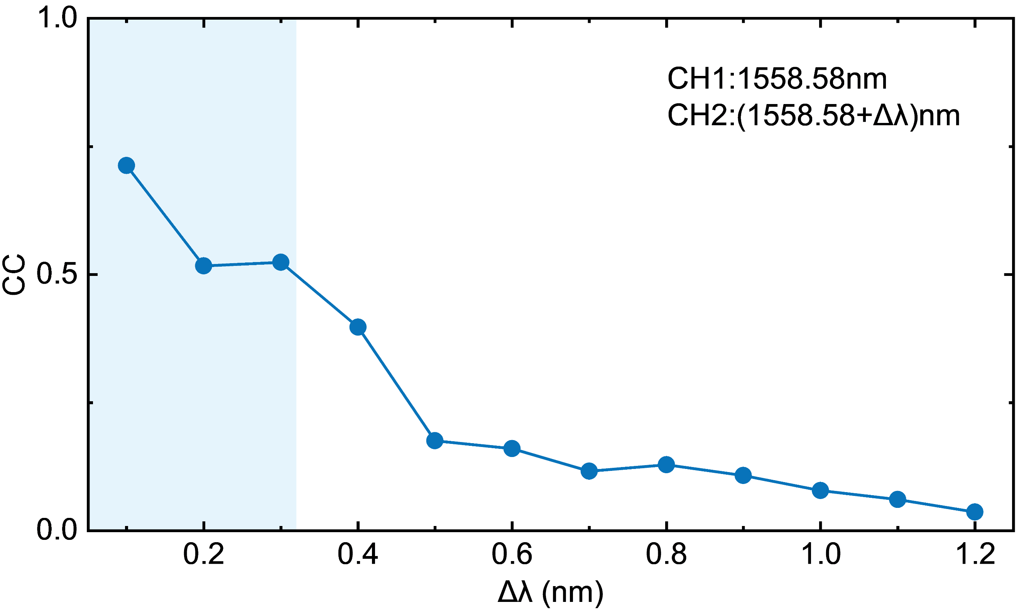
Fig. S8. Dependence of cross-correlation coefficient on filtering spacing between two chaotic channels. The filter bandwidth is fixed at 40 GHz, and the shaded blue region marks the range where the spectra of the two channels partially overlap.

Supplementary Note 10. Influence of frequency detuning between the ultra-broadband chaotic signal and CW light on noise source ENR
Key parameters for evaluating the performance of a noise source include its operational frequency range, excess noise ratio (ENR), and ENR flatness. In this work, the noise source operates over the 0-500 GHz range, matching the effective bandwidth (543.8 GHz) of the ultra-broadband chaotic signal. The ENR flatness is defined as half the difference between the maximum and minimum ENR values within the operational frequency range, and it serves as an indicator of spectral uniformity. To improve the ENR flatness, the chaotic signal is optically combined with a CW laser to reshape the RF spectral distribution⁶. The resulting flatness strongly depends on the frequency detuning between the ultra-broadband chaotic signal and the CW light. To assess this dependence, the center frequency of the chaotic signal is held constant while the CW laser frequency is varied. As shown in Fig. S9, the ENR flatness initially improves with increasing frequency detuning, but begins to degrade beyond a certain point. Based on this analysis, a detuning of 320 GHz is selected in our system to achieve optimal ENR flatness.
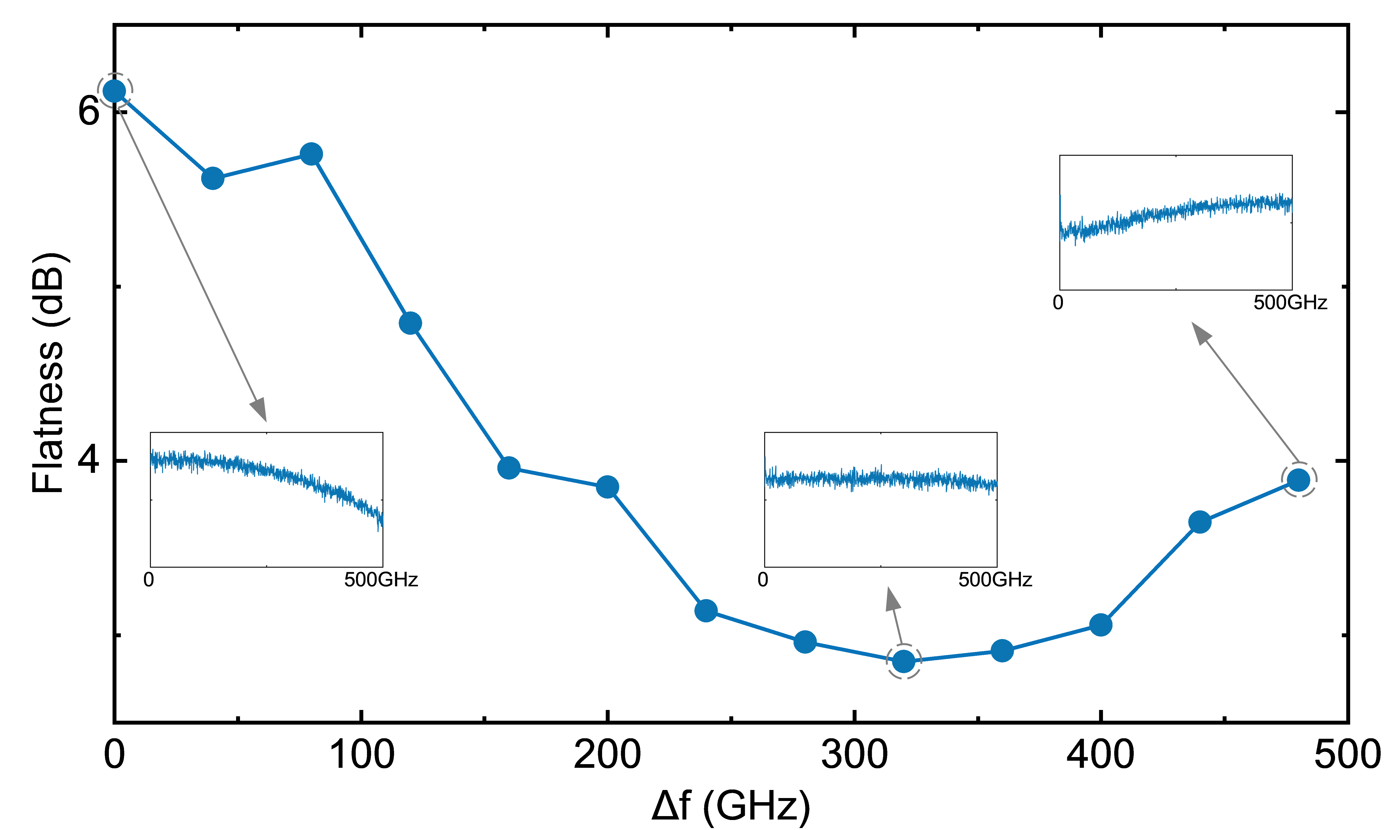
Fig. S9. ENR flatness as a function of frequency detuning between the ultra-broadband chaotic signal and the CW light. The inset panels display the corresponding ENR spectra under each detuning configuration. Optimal flatness is achieved at a detuning of 320 GHz.

Supplementary Note 11. Calculation of ENR and Equivalent Noise Temperature
The excess noise ratio (ENR) is a key performance metric of a noise source, quantifying the additional noise power output relative to the thermal noise generated by a standard resistive load at room temperature. It is typically derived from the measured power spectral density using an electrical spectrum analyzer. The ENR at a given frequency is calculated as⁷:
where T_{h}(f) and T_{c}(f) are the equivalent hot and cold noise temperatures, respectively. T₀ is the standard reference temperature of 290 K. P(f) denotes the measured power spectral density of the noise source, while P_{NF}(f) is the noise-floor power level of the measurement system. RBW is the resolution bandwidth of the ESA with 1 MHz in our system, and -174 dBm/Hz corresponds to the thermal noise power at 290 K.
The equivalent noise temperature T_{e} of the noise source can then be derived as:

1. Lang, R. & Kobayashi, K. External optical feedback effects on semiconductor injection laser properties. IEEE J. Quantum Electron. 16, 347-355 (1980).
2. Rontani, D., Locquet, A., Sciamanna, M., Citrin, D. S. & Ortin, S. Time-delay identification in a chaotic semiconductor laser with optical feedback: A dynamical point of view. IEEE J. Quantum Electron. 45, 879-1891 (2009).
3. Li, X., Pan, W., Luo, B. & Ma, D. Mismatch robustness and security of chaotic optical communications based on injection-locking chaos synchronization. IEEE J. Quantum Electron. 42, 953-960 (2006).
4. Lin, F.-Y., Chao, Y.-K. & Wu, T.-C. Effective bandwidths of broadband chaotic signals. IEEE J. Quantum Electron. 48, 1010-1014 (2012).
5. Grassberger, P. & Procaccia, I. Estimation of the Kolmogorov entropy from a chaotic signal. Phys. Rev. A 28, 2591-2593 (1983).
6. Sun, Y. et al. Flat millimeter-wave noise generation by optically mixing multiple wavelength-sliced ase lights. IEEE Photonics Technol. Lett. 33, 1270-1273 (2021).
7. Song, H.-J. & Yaita, M. On-wafer noise measurement at 300 Ghz using UTC-PD as noise source. IEEE Microwave Wireless Compon. Lett. 24, 578-580 (2014).

