Supplementary Material
Field and Experimental Investigations of the Effect of Hyporheic Exchange on Nitrogen Transport in Lakeshore Lacustrine Sedimentary Aquifers, SW China
Ronggao Qin^{,2}, Haoyi Li¹, Wan, Xu¹,Ciming Kong^{3*}, Wang¹,Yiming Xie¹, Guangzhu Cao^{1,2*}, Ruoyu, Mao^{1,2} , Yi Qiang^{1,2}, Yanfeng Lu^{1,2}
¹ School of Land and Resources Engineering, Kunming University of Science and Technology，Kunming, Yunnan 650031 China;
² Key Laboratory of Geohazard Forecast and Geoecological Restoration in Plateau Mountainous Area，Ministry of Natural Resources of the People's Republic of China，Kunming, Yunnan 650228 China.
³ Qujing Environmental Engineering Evaluation Center, Qujing, 655000, PR China
* Corresponding authors:
qinronggao@126.com(R,Qin), cgzhu@163.com (G, Cao), 1035417670@qq.com(C,Kong).

Section 1 Temperature sensor
From April 14 to June 6, 2023, temperature sensors were installed at various depths near the Taoxi River inlet downstream, close to Lake Erhai (Figure S2). The sensors were positioned at depths of 0 centimeter (water surface), 10 centimeters, 20 centimeters, 30 centimeters, 40 centimeters, and 50 centimeters, with measurements taken every 10 minutes. During the 51-day monitoring period, a total of 7,648 temperature data points were collected.
Section 2 Dynamic water exchange

A. Wet Season
As shown in Figure S3, from April 16 to April 25, the Taoxi river had abundant water flow, with a velocity of 0.14 m/s, a width of 6.2 m, an average depth of 0.3 m, and a flow rate of 0.3038 m³/s. This period is classified as the wet season. During this time, all computed hyporheic flux values were positive, indicating a downward direction, which replenished the groundwater from surface water. As the depth increased, the average vertical hyporheic flux also increased, and the range of flux variation gradually decreased. The most active exchange occurred at depths of 0.15 m and 0.2 m, where the flux values were highest and exhibited the widest variation. The smallest hyporheic flux values appeared at depths of 0.375 m and 0.425 m, indicating the weakest exchange. Overall, the total hyporheic exchange diminished with increasing depth and stabilized after reaching a certain range.
As illustrated in Table S1, the variability of water exchange within the 0 to 25 centimeters range beneath the riverbed surface was more pronounced than in deeper layers (0.25 to 0.425 meters). This variability is primarily due to the significant influence of both river water and air temperatures on the riverbed surface layer temperature, leading to substantial fluctuations in temperature and, consequently, considerable changes in water exchange within the hyporheic zone.

B. Dry Period
From April 25 to May 13, a continuous rise in temperature in Dali and a prolonged absence of rainfall caused the upstream river channels to cease flowing, leaving the test points dry and exposed. This period is defined as the dry period (Figure S4). Despite the lack of river flow, hyporheic exchange persisted. As indicated in Figure S5, most of the hyporheic flux at a depth of 0.15 meters was negative, suggesting that groundwater was replenishing the surface water. This negative flux was due to continuous evaporation from the river surface to the sediment at 0.15 meters depth, showing an increasing trend over time. The hyporheic flux at 0.2 meters depth was positive, it was continuously decreasing, closely paralleling the trend at 0.15 meters depth.
As shown in Table S2, the hyporheic fluxes between depths of 0.25 meters and 0.375 meters decreased by an order of magnitude compared to the wet season. This decrease was due to the drying of the river surface and the cessation of surface water replenishing the groundwater, further compounded by strong evaporation, which reduced the hyporheic flux. At a depth of 0.425 meters, the average hyporheic flux during the wet season was 7×10⁻⁶L/m²·s, compared to 5.03×10⁻⁶L/m²·s during the dry period, showing only a slight difference, indicating that the hyporheic flux at this depth was less affected by climatic variability and changes in river water levels.

C. Rainfall
During the period from May 13 to May 24, there was a significant rainfall event. On May 14, from 3 PM to 6 PM, the rainfall reached 33.1 millimeters, classified as heavy rain by the China Meteorological Administration. On May 15, the rainfall of 1.92 millimeters was classified as light rain.
As illustrated in Figure S6 and Table S3, the hyporheic flux at a depth of 0.15 meters responded to the rainfall with a certain delay. The brief and intense rainfall on May 14 caused significant surface runoff, rather than infiltrating the sediments to increase the hyporheic flux. Following a prolonged drought, the riverbed gravel was very dry and required time to absorb and store the rainwater before reaching saturation; only then did the excess water begin to flow downstream. Consequently, there was a delay in the increase of hyporheic flux, which reached its post-rainfall peak of 1.05×10⁻⁴L/m²·s at 9 AM on May 16, approximately 15-17 hours after the rainfall. The hyporheic flux at a depth of 0.2 meters exhibited a trend synchronous with that at 0.15 meters, but with smaller amplitude fluctuations. Following the rainfall, the hyporheic fluxes at depths from 0.25 meters to 0.375 meters increased by an order of magnitude compared to during the dry period but did not return to the levels observed during the wet season. This was likely due to the short duration and intensity of the rainfall and the rapid flow of water into Erhai Lake along the river channel, which did not reach the flow levels of the wet season. The hyporheic flux at a depth of 0.425 meters showed virtually no response to the rainfall, with its average value (4.00×10⁻⁶) closely matching those from the dry period (5.03×10⁻⁶) and the wet season (7.00×10⁻⁶), indicating that the hyporheic flux at this depth is minimally affected by climatic variability and changes in river water levels.

Section 3 Filling the sandbox
As depicted in Figure S8, the experiment replicated the characteristics of the Dali alluvial fan deposit layers with in-situ collected soil samples. The sandbox was set with a slope of 3 degrees from left to right. Vertically, it was divided into two layers based on actual geological stratification: the top 10 centimeters consisted of loess with particles smaller than 0.05 millimeters, and the lower 40 centimeters was filled with sandy loam, with particle sizes ranging from 0.05 to 2 millimeters. A semicircular shape, 10 centimeters deep and 20 centimeters wide, was created on the surface of the sandbox to simulate the circum-lake sewage interception engineering around Erhai Lake.
The sandbox features a total of 55 sampling ports, arranged in four vertical columns on the front, with each column consisting of four ports spaced 10 centimeters apart vertically. The first column is located 10 centimeters from the left side outlet, with each subsequent column spaced 70 centimeters apart. Additionally, there is one horizontal row of sampling ports, situated 4 centimeters from the bottom of the sandbox, with 23 ports spaced 10 centimeters apart. Each side has two columns with five sampling ports each, spaced 10 centimeters apart vertically, primarily used for monitoring inflow and outflow; the left side is designated for outflow and the right side for inflow. The inflow utilizes a fixed flow rate head device, and the outflow is used to collect leachate. The first column to the right of the vertical sampling ports on the front side, from top to bottom, is labeled A1 to A4, and so forth, with the subsequent columns named as B, C, and D columns.
The sandbox's outflow boundary simulated Erhai Lake. Two scenarios were established: Scenario 1 simulated the wet season with the saturated aquifer at a height of 40 centimeters, where the groundwater phreatic surface was above the bottom of the circum-lake sewage interception engineering; Scenario 2 simulated the dry period with the saturated aquifer at a height of 30 centimeters, where the groundwater phreatic surface was below the bottom of the circum-lake sewage interception engineering.
The experimental procedure included:
1. Air-drying the soil samples retrieved from field layering to remove moisture;
2. Sifting the soil through a 0.1 millimeters mesh to remove larger clods and roots;
3. Filling in two layers: placing 40 centimeters of sandy loam in the lower layer and covering it with 10 centimeters of loess on top, compacting the soil as the sandbox was filled;
4. Excavating channels in the top layer of soil to simulate agricultural ditches, the circum-lake sewage interception engineering, and inlets to Erhai Lake, and then adding pure water;
5. Steadily introducing water flow through the inlet until water emerged at the outlet, indicating saturation of the aquifer;
6. Continuously injecting water containing dye into the top loess layer using a constant head method until dye began to emerge from the outlet, using red and blue-black ink to represent pollutant migration during dry and rainy seasons, respectively;
7. Photographing and recording the migration dynamics of the dye plume every 24 hours.

Section 4 The pollutant transport process
The pollutant transport process can be discussed in two stages based on the paths of pollutant migration:
Step 1: Before reaching the base flow, the pollutants primarily migrated vertically through seepage from the surface (Day 1). The plume, centered around the pollution source, took on a nearly circular shape and migrated laterally along the loess voids.
Step 2: Once the pollutants infiltrated the saturated aquifer where the base flow was present, the migration primarily shifted to horizontal seepage (Days 2-7). On the second day, when the pollution plume reached a vertical depth of 40cm, it encountered the base flow, shifting from vertical to horizontal flow, and rapidly migrated downstream along the flow lines of the base flow. Since the water table was above the bottom of the circum-lake sewage interception engineering, some blue-black dye continuously entered the engineering and, under the influence of gravity, infiltrated down into the aquifer, migrating downstream with the base flow.

Section 5 Index testing
The Nessler reagent method was employed to detect ammonia nitrogen, where the water sample is mixed with a masking agent, and the ammonia nitrogen (present as free ammonia or ammonium ions) reacts chemically with Nessler's reagent to form a colored complex. The analyzer then detects the change in color to determine the concentration of ammonia nitrogen. Nitrate nitrogen testing was conducted using the cadmium reduction method, which quantitatively reduces nitrate nitrogen to nitrite nitrogen in the water sample, followed by the diazo-azo photometric method to detect nitrite nitrogen. The initial nitrite nitrogen content is subtracted to determine the nitrate nitrogen concentration.

Section 6 contribute to denitrification
- After 25 days, the concentrations of both ammonia and nitrate nitrogen in the effluent remained lower compared to the inflow, indicating a proliferation of denitrifying microbes and an adequate carbon source in the soil. Despite a significant increase in the combined concentrations of nitrate and ammonia nitrogen in the inflow, the effluent maintains lower combined concentrations. The ongoing denitrification of nitrate nitrogen in the system, converting it into N₂O or N₂ (nitrogen gas), thereby reducing inorganic nitrogen.
- Given that nitrate nitrogen represents the highest oxidation state of nitrogen under anaerobic conditions, it is unstable and easily reducible, making it particularly susceptible to denitrification.
3. Theoretical considerations suggest that bacteria prefer reactions with a higher energy yield. In denitrification, bacteria obtain an energy yield of 2333.84 kJ/mol, compared to only 679.605 kJ/mol during the dissimilatory reduction of nitrate. Therefore, bacteria are more inclined to reduce nitrate nitrogen to nitrogen gas (N₂) rather than to ammonia nitrogen.
4. Observations of the sandbox sediment layers indicated that areas of the sediment changed from black-gray to gray-white. This change is likely due to the introduction of the pollutant solution and subsequent denitrification processes, which lead to a significant release of nitrogen gas (N₂). In the denitrification process, nitrate nitrogen serves as the substrate, and the process is directly influenced by its concentration. With continuous input of leachate, the concentration of nitrate nitrogen in the output liquid decreases. An anaerobic environment gradually forms within the sandbox, with substantial accumulation of organic matter in the soil medium, creating favorable conditions for denitrification. The consumption of oxygen tips the system toward more anaerobic conditions, further promoting denitrification.
5. Additionally, during the experiment, the pH value remained between 7.1 and 7.4 (Figure S9(B)), an increase from the initial phase of the experiment and within the optimal range for denitrification of 5.5 to 8.0. The continuous anaerobic environment and appropriate pH value facilitated the denitrification process.
In summary, both experimental and field research indicate that the growth of algae and phytoplankton is significantly more abundant near the eastern coastal zone of the lake's sewage interception system compared to other areas (Figure 2). Analysis of water samples from various parts of this system, including ponds and channels, shows that the concentrations of ammonia nitrogen and nitrate nitrogen in these accumulated surface water bodies are relatively low (less than 1.5 mg/L). However, the concentration of ammonia nitrogen in local shallow wells reaches up to 6.09 mg/L, and nitrate nitrogen concentrations as high as 56.7 mg/L. This data suggest that various concentrations of nitrogen pollutants have accumulated in the vadose zone soil and shallow groundwater aquifer layers of the lake's sedimentary deposits due to long-term agricultural irrigation and local drainage projects lacking anti-seepage measures. After initiating water storage through the lake's sewage interception system, a hydraulic gradient is established between the storage area and Erhai Lake, the water storage in ponds and channels of the sewage interception system provides the hydrodynamic conditions necessary for hyporheic exchange and base flow replenishment between the system and the nearshore of Erhai Lake. The nitrogen pollutants accumulated in the lake deposits between the sewage interception system and the eastern coast of Erhai Lake serve as a continuous source of pollution during the hyporheic exchange process. Additionally, as illustrated in Figure 2, densely populated villages are located in the nearshore lake deposits between the lake sewage interception system and Erhai Lake. The domestic wastewater from these villages has only recently been collected and treated collectively; previously, potential leaks and enrichment into shallow aquifers were also significant sources of pollution during the hyporheic exchange and base flow replenishment processes following the construction of the lake sewage interception system.

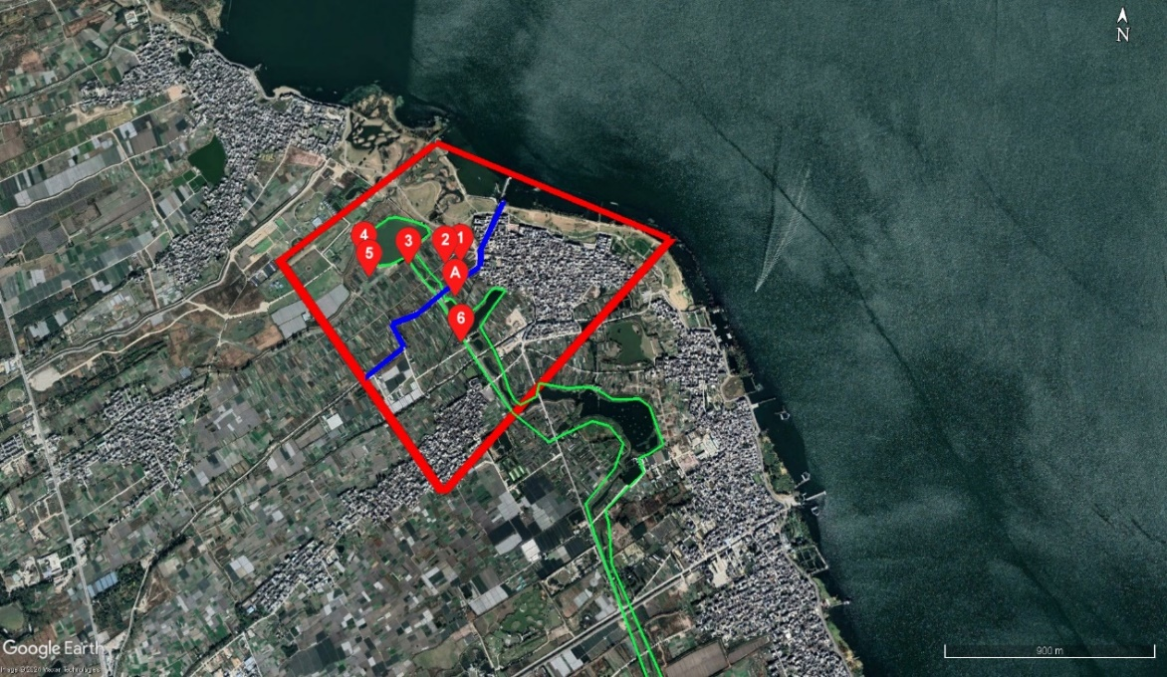
Figure S1 Scope of field study area
In Figure S1, Point 1 to 6 is the location of groundwater/surface water quality monitoring and A is the field monitoring site location for the riverbed hyporheic flux by temperature sensor.
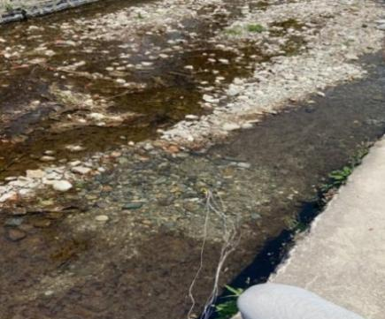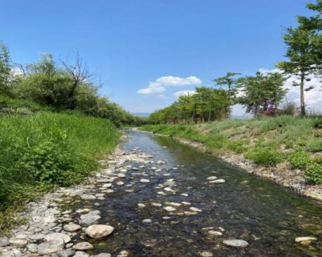
Figure S2 Temperature sensor layout and Taoxi river course during the wet period
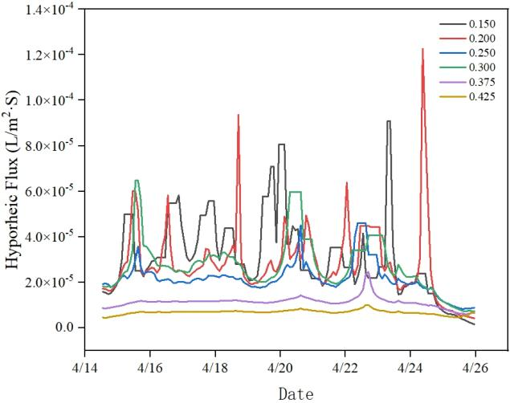
Figure S3 Hyporheic flow flux diagram during the wet season
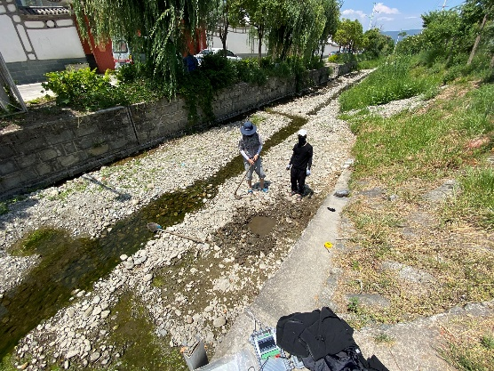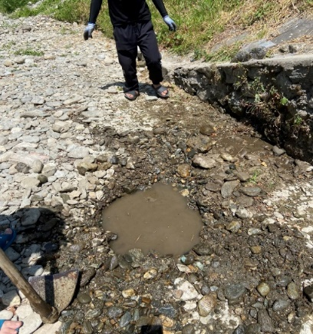
Figure S4 Low water period of Taoxi
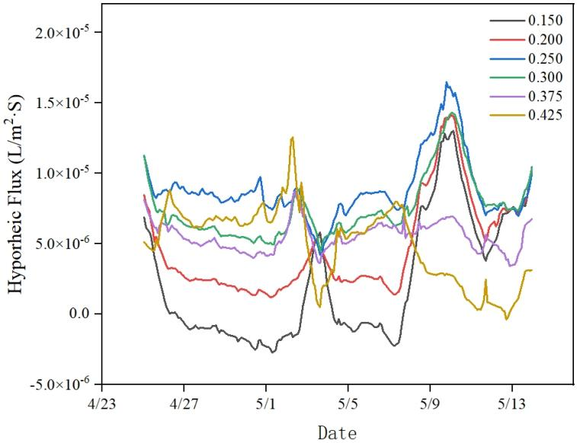
Figure S5 Hyporheic flux during the dry season
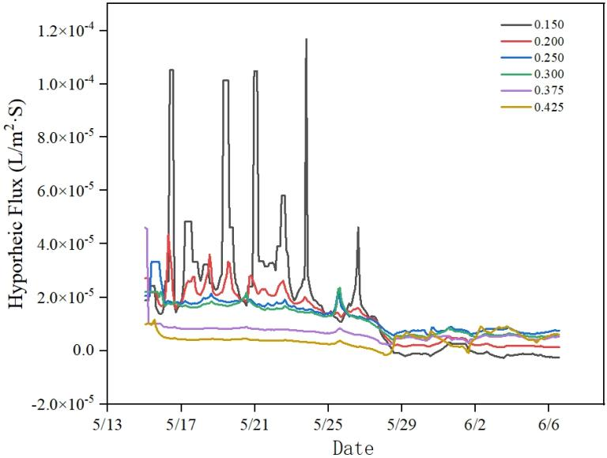
Figure S6 Hyporheic flux during rainfall
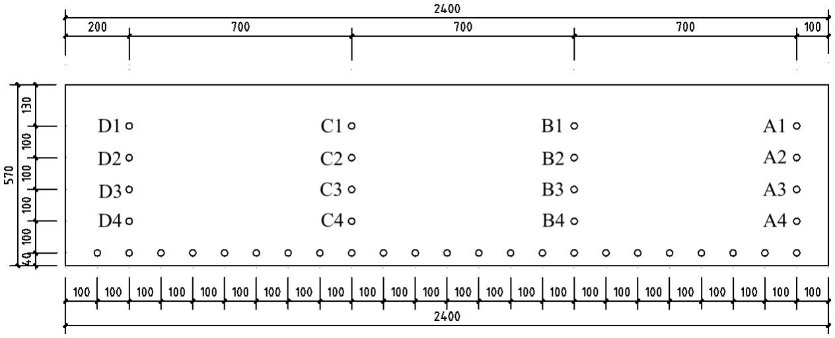
Figure S7 Indoor sandbox model
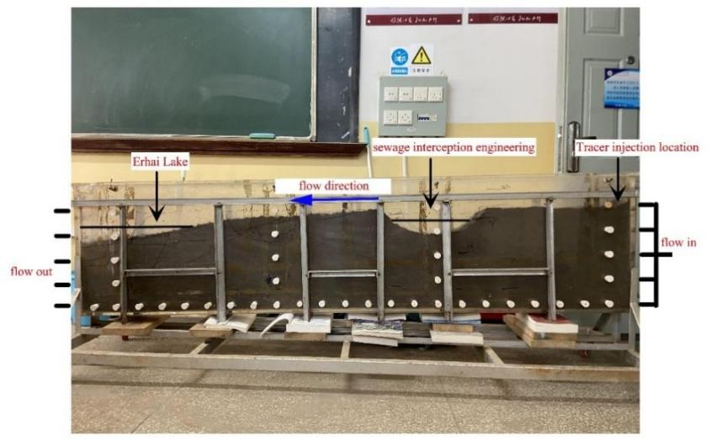
Figure S8 Diagram of the sandbox
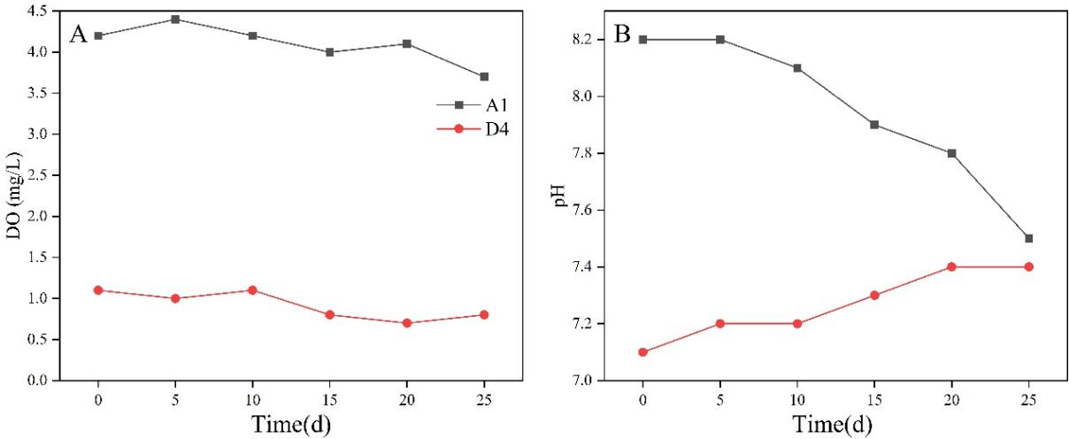
Figure S9 (A) Changes in dissolved oxygen at sampling point A1, D4 in the sandbox over time
(B) changes in dissolved pH at sampling point A1, D4 in the sandbox over time
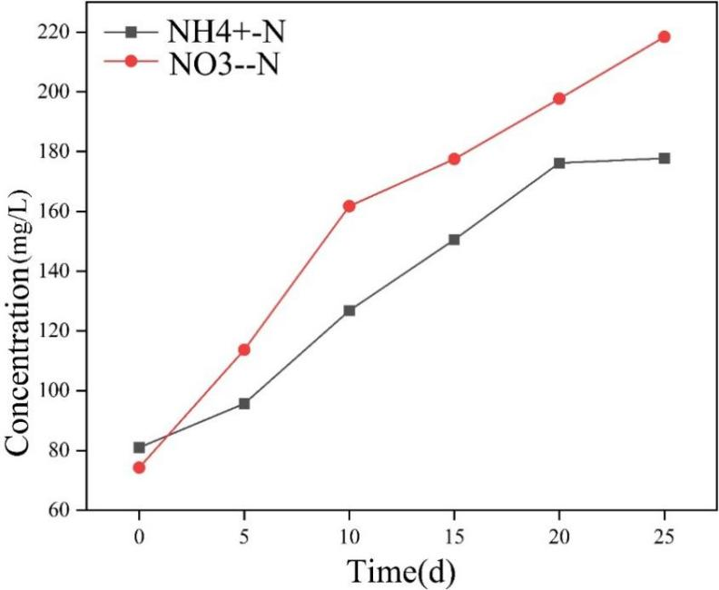
Figure S10 Time variation graph of total Ammonia nitrogen and nitrate nitrogen concentrations

Table S1 Hyporheic current flux (L/m²·s) during the wet season
Depth(m) | Mean | Minimum | Maximum | Standard deviation | Variable coefficient
0.15 | $${\text{3.0×10}}^{\text{-5}}$$ | $${\text{1.0×10}}^{\text{-6}}$$ | $$\text{9.1}{\text{×10}}^{\text{-5}}$$ | $${\text{1.7×10}}^{\text{-5}}$$ | 0.55
0.2 | $${\text{2.9×10}}^{\text{-5}}$$ | $${\text{4.0×10}}^{\text{-6}}$$ | $${\text{1.23×10}}^{\text{-4}}$$ | $${\text{4.6×10}}^{\text{-5}}$$ | 0.57
0.25 | $${\text{2.7×10}}^{\text{-5}}$$ | $${\text{7.0×10}}^{\text{-6}}$$ | $${\text{6.3×10}}^{\text{-4}}$$ | $${1\text{.1×10}}^{\text{-5}}$$ | 0.42
0.3 | $${\text{2.2×10}}^{\text{-5}}$$ | $${\text{8.0×10}}^{\text{-6}}$$ | $${\text{4.6×10}}^{\text{-5}}$$ | $${\text{7.0×10}}^{\text{-6}}$$ | 0.33
0.375 | $${\text{1.1×10}}^{\text{-5}}$$ | $${\text{6.0×10}}^{\text{-6}}$$ | $${\text{2.5×10}}^{\text{-5}}$$ | $${\text{2.0×10}}^{\text{-6}}$$ | 0.22
0.425 | $${\text{7.0×10}}^{\text{-6}}$$ | $${\text{4.0×10}}^{\text{-6}}$$ | $${\text{1.0×10}}^{\text{-5}}$$ | $${\text{1.0×10}}^{\text{-6}}$$ | 0.14
Table S2 Hyporheic flux (L/m²·s) during the low water period
Depth(m) | Mean | Minimum | Maximum | Standard deviation | Variable coefficient
0.15 | $${\text{2.68×10}}^{\text{-6}}$$ | $${\text{-2.8×10}}^{\text{-6}}$$ | $${\text{1.88×10}}^{\text{-5}}$$ | $${\text{4.92×10}}^{\text{-6}}$$ | 1.84
0.2 | $${\text{5.12×10}}^{\text{-6}}$$ | $${\text{1.19×10}}^{\text{-6}}$$ | $${\text{2.71×10}}^{\text{-5}}$$ | $${\text{4.20×10}}^{\text{-6}}$$ | 0.82
0.25 | $${\text{8.30×10}}^{\text{-6}}$$ | $${\text{4.46×10}}^{\text{-6}}$$ | $${\text{3.80×10}}^{\text{-5}}$$ | $${\text{5.13×10}}^{\text{-6}}$$ | 0.62
0.3 | $${\text{9.16×10}}^{\text{-6}}$$ | $${\text{4.08×10}}^{\text{-6}}$$ | $${\text{2.14×10}}^{\text{-5}}$$ | $${\text{2.89×10}}^{\text{-6}}$$ | 0.31
0.375 | $${\text{5.85×10}}^{\text{-6}}$$ | $${\text{3.4×10}}^{\text{-6}}$$ | $${\text{3.78×10}}^{\text{-5}}$$ | $${\text{2.80×10}}^{\text{-6}}$$ | 0.48
0.425 | $${\text{5.03×10}}^{\text{-6}}$$ | $${\text{-3.9×10}}^{\text{-6}}$$ | $${\text{1.25×10}}^{\text{-5}}$$ | $${\text{2.75×10}}^{\text{-6}}$$ | 0.55

Table S3 Hyporheic flux (L/m²·s) during rainfall
Depth(m) | Mean | Minimum | Maximum | Standard deviation | Variable coefficient
0.15 | $${\text{3.40×10}}^{\text{-5}}$$ | $${1\text{.40×10}}^{\text{-5}}$$ | $${1\text{.17×10}}^{\text{-4}}$$ | $${\text{2.50×10}}^{\text{-5}}$$ | 0.72
0.2 | $${\text{2.20×10}}^{\text{-5}}$$ | $${1\text{.40×10}}^{\text{-5}}$$ | $${\text{4.40×10}}^{\text{-5}}$$ | $${\text{5.00×10}}^{\text{-6}}$$ | 0.22
0.25 | $${\text{1.90×10}}^{\text{-5}}$$ | $${\text{1.40×10}}^{\text{-5}}$$ | $${\text{3.30×10}}^{\text{-5}}$$ | $${\text{4.00×10}}^{\text{-6}}$$ | 0.21
0.3 | $${\text{3.40×10}}^{\text{-5}}$$ | $${\text{1.12×10}}^{\text{-5}}$$ | $${\text{3.80×10}}^{\text{-5}}$$ | $${\text{9.61×10}}^{\text{-6}}$$ | 0.48
0.375 | $${\text{9.0×10}}^{\text{-6}}$$ | $${\text{7.0×10}}^{\text{-6}}$$ | $${\text{4.60×10}}^{\text{-5}}$$ | $${\text{5.00×10}}^{\text{-6}}$$ | 0.56
0.425 | $${4\text{.0×10}}^{\text{-6}}$$ | $${\text{2.0×10}}^{\text{-6}}$$ | $${\text{1.20×10}}^{\text{-5}}$$ | $${\text{2.00×10}}^{\text{-6}}$$ | 0.38
Table S4 Summary of test instruments
Instrument and equipment | Model | Usage
Balance | LT1002（0.01g） | Weigh rock, reagent
Balance | EX225DZH（0.001mg） | Weigh rock, reagent
Balance | ACS-30Kg | Weigh rock, reagent
Peristaltic pump | BT-300CA/153YxPPS | Water supply installation
Portable conductivity meter | Bante902P | pH, conductivity
Electric blast drying oven | Model 101-1 | Drying soil samples, reagents
Swinging sieve analyzer | Model YS-4 | Sieve out the soil sample
Acrylic glass box | 2.40m×0.57m×0.1m | flow test
Hero ink | Red, blue | tracer test
Nessler reagent spectrophotometer | DR1900 | Measurement of ${NH}_{4}^{+}$ and ${NO}_{3}^{−}$
Dissolved oxygen meter | JPB-607A | Measurement of DO
Ultra pure water preparation machine | YTUP60S | Preparation of pure water

Corresponding Author: E-mail address: qinronggao@126.com(R,Qin), cgzhu@163.com (G, Cao), 1035417670@qq.com(C,Kong).

