Learner Pregnancy Support Package
Design Incubator
Friday August 26 - Sunday August 28, 2022

Workshop programme – Friday, 26 August 2022
Time | Duration | Activity | Details | Resources
13.00-15.00 | 2:00 | TAG advisors travel to venue | Safe transportation from home to On-the-Summit Lodge (30 & 34 Summit Road) | ORSA Mahindras / cars
15.00-1630  17.00h | 2:00 | TAG advisors arrive  Transport to venue | Welcoming;  Settling in;  Assigning rooms. | Travel + accommodation_August TAG camp_2022  Sanitary packs  Snacks
17.30-18.30h | 1:00 | Opening circle (check-in routine).  Icebreaker focused on introductions (Tallest Newspaper structure)  Re-visit / add to “Ground Rules” (shared via Facebook group)  Expectations | Check-in activity to see how everyone is feeling (weather chart flipchart);  Re-connect and meet new team members  Have fun;  Begin the process of building a safe space, by inviting discussion on and creation of new ground rules (which may be more specific to the in-person space).  Expectations prompts:  “This weekend, I would like to achieve...“. | Flipchart  Stickynotes  To make: weather flipchart  Ground rules flipchart heading  Expectations flipchart heading  + prompt.
18.30-20.00h | 1:30 | Braai @ Venue  Fun activity | Nourish and hydrate;  Make TAG tote bags with creative materials and journaling notebook (to be used throughout weekend and taken home). | Food & drink  Tote bags  Sani-packs  Art supplies

Proposed programme - Saturday 27 August 2022
Time | duration | Activity | Details | Resources
8.00 - 845 | 0:45 | 8am pick up  815-845am BREAKFAST @ venue | Nourish and hydrate;  Welcome and more reunions;  Fill and share TAG-totes (bags) with TAGaZine, pens and sketch/notebooks for the weekend’s activities. | Food & drink  Music  TAGbag contents  Sketch/notebook  Pencils/pens
845. – 9.15 | 0:45 | Opening circle – check-in  Reminder about ground rules and where everything is located at the venue.  Energizer: “Choose your moooove!” | Continue building a safe space;  Share overview of the day’s activities (flipchart);  Ground rules;  Introduce the “Talking Wall” (each day will have prompts that will be visited during breaks and reviewed at closing circle).  Energizer: everyone chooses a dance move that the others will have to imitate; facilitators call out names at random, the person has to do their “move” and we all copy the move and break into dance) | To make:  - Overview of the day  - Rewrite Ground Rules from previous day’s session and put up on wall  - Talking wall heading / prompt  - Venue map (ask Ilna/Ansa for this)  Talking wall (rainbow style?) -  Morning prompt:  Evening reflection prompt:
9.15 - 10.30 | 1:15 | 1) Connecting the dots: Research?!  +  2) What do we mean by “Consent”? and consenting procedures | WHAT IS RESEARCH?  [20min] In 3x small groups, each receives a blank flipchart, wool, sticky notes, drawings and a set of keywords they must use and connect. Each group must make a mind-map of what research is using wool to connect the dots. Make sure there are facilitators or members of Team in each group to help them along.  Include key questions they must address:  Overarching Q: what is research?  - Participants – who are we doing research with? How do we recruit them?  - Data collection/methods – How will we collect information?  - Researcher – What is the role of the researcher?  - What is ethics?  - What does consent mean? And why is it important?  [15min] Each group must present their mind-maps. [put mind maps up on the wall].  [10min] Discuss briefly what we take away from this activity and if what we’ve learned.  CONSENT  [30min] As part of re-recruitment into new research activities, share additional information on benefits and risks of HB and Informed Consent [everyone].  NB: For remote methods, phone consent was completed using recently approved TAG at a distance script: A29d. Amended TAG at a distance phone consent script.docx  For in-person activities, HB RAs will also go through HB (slightly adapted for TAG DBE activities) form and request participants sign: A7a. HB infosheet consent EN WP1 and WP3 Quant and Qual v2 20211006.docx |   To make:  Key questions flipchart  Example mind map flipchart  Resources:  Flipchart  Sticky-notes  Key words  Wool  Stickers  Presstick  Pritt (glue stick)  Printed HB infosheets (adapted for TAG weekend)  TAG Camp 2022_consent and info sheet (English).docx  Relevant HB posters on the wall for reference.  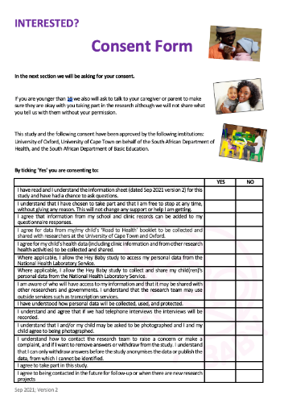
10.30 -11.45 | 1:15 | - “Memory Lane” - where are we coming from? Gallery Walk (40 mins)  - “Young Advisors”: Where are we going, this weekend and beyond? (35 mins) | Recall and honour previous TAG engagements, themes, unpack new outputs and publications together. Situate in the bigger picture of TAG.  Music will accompany movement through 6 discussion stations (10 mins per station) with large-format printed conference posters, external reports (UNICEF & toolkit), publications (My Life is Stuck, Vaccines, other?), FB Time Capsule imagery  Each station has 2 questions, a facilitator (who determines the prompts), and stickies to prompt and document discussion.  Bridge focus to this weekend: rewind to discussion from 1:1 phone calls and FB (2020-2021) - how do findings and methods from previous TAG research relate / link to this camp’s activities? Re-introduce DBE’s policy and that they are coming to visit and listen to us. Recall with TAGers the experience during Alien Time Capsule activities, where they gave recommendations and solutions as “young advisors” during COVID-19 lockdown. They took on different roles as advisors including Ramaphosa’s advisor or representing their communities.  [policy prompts / discussion]  Remind us - what is the DBE (“learner pregnancy prevention and support”) policy about again?  1) School retention  2) School return  3) Prevent future (repeat) pregnancy  Indicate that we will be co-constructing next phase of TAG journey together with advisors – share reflection questions to think about over tea, we will start doing this after the tea break! | Slideshow with photos, music, videos from previous TAG engagements  Printed large-format versions of:  1) TAGaZine and compiled Time Capsule image library  2) Toolkit  3) “Now my life is stuck!” paper  4) Anathi’s story  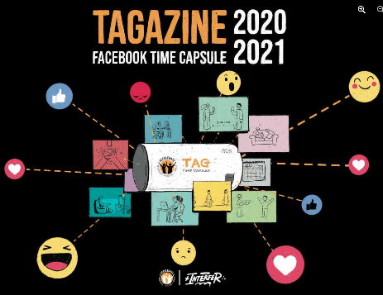  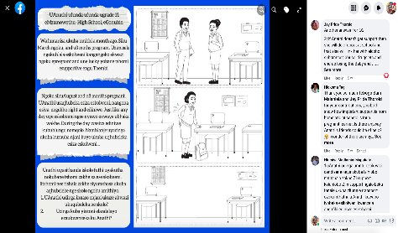  Project imagery from previous “Ramaphosa’s advisors” (Time Capsule activity)  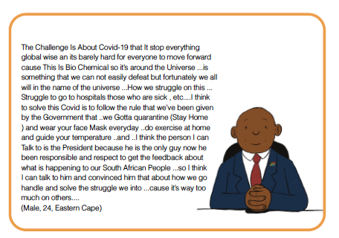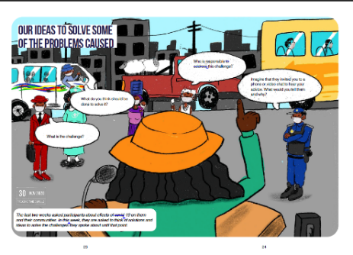
11.45 -12.00 | 0:15 | TEA BREAK  Energizer: Zip-Zap-Zop | Nourish and hydrate;  Visit talking wall;  Fun.  With everyone standing in a circle, the first improviser begins the pattern of “Zip, Zap, Zop” by clapping their hands at someone and saying “Zip.” The person that they indicated will then clap at someone and say “Zap.” Then the third person will do the same but say “Zop.” After this, the next person starts back over with “Zip.”  The group should begin at a comfortable pace and gradually speed up during the pattern. Every time that you clap and send the zip, zap, or zop to another player, you have to make eye contact. Whenever someone makes a mistake and says the wrong word in the series, that person is “out.” Celebrate the mistake then start the pattern over. The game can be played with or without elimination. | Food & drink  Music  Camera (time-lapse setting)
12.00 -13.30 | 1:30 | “Advisor-informed": collaborative methods | Envisioning ways forward together, ensuring TAG advisor-informed process and meaningful engagement.  15min – free expression in free writing, drawing, advisor-chosen style.  30min – Turning expression into action. Using free expression activity content to develop a set of priorities and action items that could be developed for continued collaboration. Remind / reference previous TAG priorities shared.  30min – Developing an activity collaboratively. | Flipcharts:  Step 1, 2 and 3 prompts.
13.30-14.30 | 1:00 | LUNCH | Nourish and hydrate;  Bonding;  Visit the talking wall (what was your favourite part of today’s workshop? Was there anything more you’d like to add?) | Food  Water  Juice  Music
14.30-15.00 | 0:30 | Closing circle & conclude | Explore highs and lows of the day; what was your best moment of the day? what can we do differently tomorrow? | To make:  Highs and lows flipchart
15-16.00 | 1:00 | TAGers free time and snacks |  | Snacks
15.00-16.00 | 1:00 | Facilitators & support team debrief  Start data capture | Learning | Easels  Poster paper  Markers
16.00-17.30 | 1:30 | Free time activities  Continue data capture (cameras, artwork physical data scan, check voice recordings) | Gather @ braai area  Opportunity to participate in 1.5-hour activities loosely guided and supported by team members  Relaxed space for debrief and hear feedback, ideas, questions/concerns while doing fun activities
17.30-19.30 | 2:00 | Dinner @ venue braai area | Nourish and have fun;  Practice for tomorrow’s dance competition  Voluntary collaborative mural - sharing ideas on “how can government listen to young people’s ideas and voices?” | Music  Long roll of paper  Arts supplies
19.30-19.35 | 0:05 | Transport back to lodge | Rest | Venue’s vehicles

Workshop programme – Sunday, 28 August 2022
Time | Duration | Activity | Details | Resources
8.00 - 8.45 | 0:45 | 8am pick up  815-845am BREAKFAST @ venue | Nourish and hydrate;  Settle in  Look for your name, and eventually sit there! | Tea  Juice  Food  Music
8.45– 9.15 | 0:30 | Opening circle & energiser  Sneak peak of the day’s activities and materials  Venue map reminders | Check-in on everyone; have fun; draw attention to today’s “talking wall” | Colourful ball  Talking wall prompt (for afternoon):  1. What was your favourite part of today’s workshop?  2. Is there anything more you would have added to your care package for pregnant learners and young moms?  3. Is there anything else you think young mom learners might need from their schools, or need to know?
9.15 - 9.45 | 0:30 | Revisit yesterday’s talking wall & prompts for today |  | Talking wall prompts for today
9.45 - 11.30 | 1:45 | Dreamy Care Package | In an aspirational priority-setting activity, participants will be asked to creatively identify, create and/ assemble important objects, services, and people to envision and build their ‘dreamy care package’, that could be used to support the everyday lives of [pregnant / parenting] learners.  - Move into pairs/groups (TAG team members can join whoever they want)  - [15-20min][part 1] Introduction and scene setting - Briefly present the antenatal and postnatal stages of motherhood and get participants to think back to their own pregnancies. Describe the activity and explain why it is important to put emphasis on thinking imaginatively and through aspirations.  Participants must choose 5 people that they feel has played a role in their pregnancy and early parenthood.  - [45min][part 2] What’s in the bag.  Making a package for pregnant learner and the person who helped her care for herself and her baby during pregnancy.  Choose a variety of items or services this person will need to look after the baby.  Design the bag (use boxes).  Make the items and put them in the bag.  Quiet Walkabout. Everyone has a chance to present their care package on their station, while everyone else gets to do a quiet walkabout. Name the Dreamy care package and write a short blurb about who it’s for and what’s inside.  In this session there is no need to justify items, rather to view and reflect on our own packages and decisions. | Creative materials (clay, stickers, magazines to cut out objective, textiles with different textures)  Print-outs: services & people  Boxes (for dreamy care package design)  Easels  Poster paper  Poster paints  Relationship cards  To make:  Part 1 instructions flipchart  Part 2 instructions flipchart  Part 3 instructions flipchart
11.30 - 11.45 | 0:15 | TEA BREAK  Energiser: “what animal are you-yoga" | Nourish;  Yoga – animal poses/stretches | Food & drink  Music  Light snack
11.45- 13.00 | 1:30 | “Special Delivery”: school-based dramatic performances and collaborative design: who & how?  +  SHOWCASE. | This activity will be a school-based simulation and use role playing, performance or other forms of expression to enact/demonstrate aspects of their ideal implementation package across key moments in their pregnancy and new motherhood journey. It will ultimately answer the questions: “what, where, with/by whom, and when?” for their dreams school pathway of support.  Skit-based OR story-telling OR song/music (participants choose the performance medium) | Dreamy care packages  Creative materials  Easels  Poster paper  Poster paints  Magazines  Storytelling arc  Story elements
13.30 -14.30 | 0:45 | LUNCH | Nourish;  Visit the talking wall & mural one last time  Closing dance competition | Food & drink  Music
14.30-15.00 | 0:45 | Concluding: thank you, closing circle & way forward |  | Colourful ball  Showcase mural
15.00-17.00 | 2:00 | TAG advisors return home (this might require a stop at lodge to collect things) | Safe transportation home | ORSA Mahindras/cars
14.30 -16.00 | 2:30 | Facilitators & support team debrief  Data capture | Physical data scan with cameras, check voice recordings | Easels  Poster paper  Markers

