Supplementary Information 1.
Teen Advisory Group (TAG) closed facebook group: SoP and content
SoP for uploading content onto TAG group:
Week before Monday upload the following must be completed:-
- FB Post text
- Prompt activity card (A brief visual aid to help with pizzazz)
- Isixhosa translation
Friday before Monday upload the following must be completed:-
- Post text confirmed
- Prompt activity card confirmed with isiXhosa text incorporated
Monday upload day, the following procedure must be completed:-
- 10am: Post and prompt are uploaded together onto FB group (Everyone should receive notification)
- Airtime is given to young people to participate
Wednesday after Monday upload day:-
- If participation has been slow, facilitators can prompt young people to participate.
Repeat for 3 weeks

Week 0: 27 June – 1 July
Preparation
TAG calls
- Re-visit informed consent, as we are re-recruiting into new activities
- Ask about accessibility, discuss preparation for activities, logistics, and planning ahead for activities: [link to script]

Week 1: 4 – 8 July 2022
Introduction and check-in week.
Post:
Hello everyone! We hope you are doing well and feeling ready to engage with us on the important topics of learner pregnancy, schooling and parenthood amongst young people in South Africa. This post marks the start of our remote Facebook activities and we will be active for the next few weeks. During this time, let us share experiences, brainstorm and imagine together. We truly value what you have to say and we have the opportunity, once again, to add our contributions.
Molweni bethuna! Siyathemba ukuba nise right and niready ukuthetha nathi nge topics ezibalulekileyo ezidibene nokukhulelwa kwabantwana besikolo, ukufunda nokuba ngabazali phakathi kwabantu abatsha eMzantsi Afrika. Le post kukuqalisa kwee activities zethu zika-Facebook esizaube sizenza kweziveki zimablwa zizayo. Ngeli xesha, masabelane ngamava, sibonisane kwaye sicingeni kunye. Sizixabise kakhulu izinto enizithethayo , lets share iexperiences zethu, ngoba siphinde sanethuba, kwakhona, lokuba sibene contribution kokwenzekayo around thina.

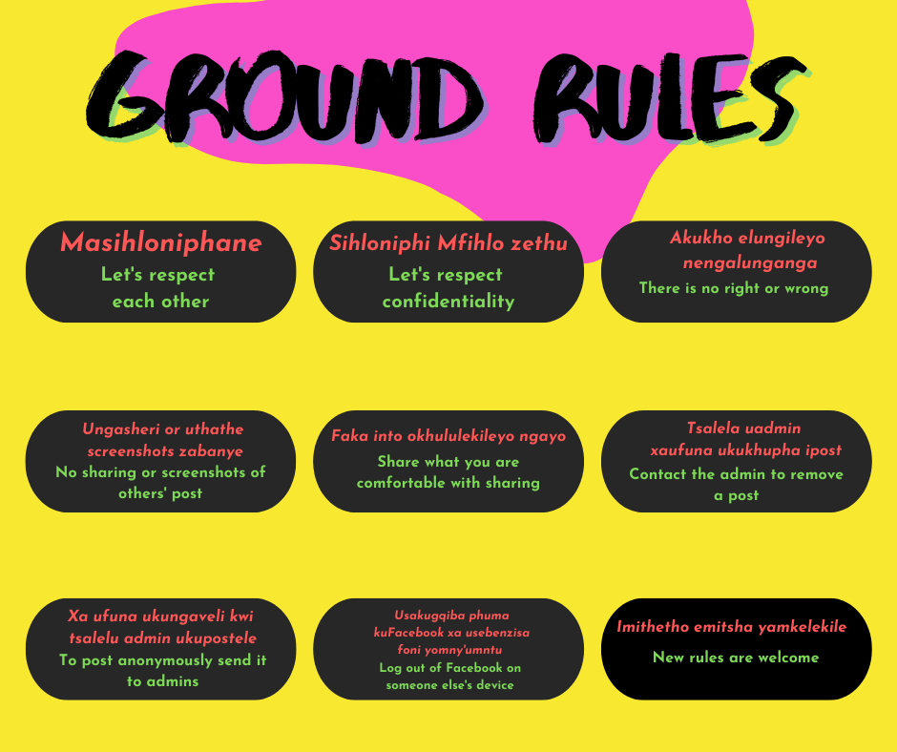

Every week, we will post an activity that we will all engage with. It won’t be too long until we all come together for our in-person workshop camp in August and take part in more fun activities like the Dreamy Care package. We have a lovely journey ahead of us ☺
Every week sizau posta iactivity esizaube ssithetha ngayo. Ayizubande deske sikwazi ukuba sibeni kunye kwi workshop camp yethu ngo-August, apho ke saube sisenza iactivities ezimandi ezifana ne Dreamy care package. Kusezaubamandi 😊
Before we begin, we must be mindful of where we are doing our research and how to conduct ourselves on this Facebook group. The “ground rules”, which we have pinned, are there for everyone so that we can create a virtual place that is safe to share in. Let us know if you have any questions or would like to add anything more to the ground rules?
Phambi koba siqalise, sicela ukaba siyikhumbule indaow esenza kuyo iresearch nendlela ekufanele ukuba siziphathe ngayo kule Facebook group. Iground rules ezibekuweyo apha zezomntu wonke ukuze zikwazi ukwenza indawo ezauba safe nokuba sabelane kuyo. Nisazise ke bethuna ukuba niththe nanemibuzo okanye kukhona into enibawela ukuyi add’a kwezi ground rules.

TAG GROUND RULES
1. Masihloniphane / Let's respect each other
2. Sihloniphi Mfihlo zethu / Let's respect confidentiality
3. Akukho elungileyo nengalunganga / There is no right or wrong
4. Ungasheri or uthathe screenshots zabanye / No sharing or screenshots of others' post
5. Faka into okhululekileyo ngayo / Let us not share or take screenshots or tag others' posts
6. Tsalela uadmin xaufuna ukukhupha ipost / Contact the admin to remove a post
7. Xa ufuna ukungaveli kwi tsalelu admin ukupostele/ To post anonymously send it to admins
8. Usakugqiba phuma kuFacebook xa usebenzisa foni yomny'umntu / Log out of Facebook on someone else's device
9. Imithetho emitsha yamkelekile / New rules are welcome
Now let's introduce ourselves. It’s been a while! Just like we did last year during the FB Time Capsule activities, let’s start off by choosing a colour that represents each of us right now and explain why. Don’t forget to tell us who are you and a little about yourself.
Kengoku masizaziseni. Lide kakhulu elithuba sigqebelene! Njenga last year ngoku besikhe senza iiFacebook activities, masiqale ngokukhetha icolour erepresenta wena ngoku uchaze ukuba kutheni. Ungalibali ukusixelela ukuba ungubane na something ngawe.
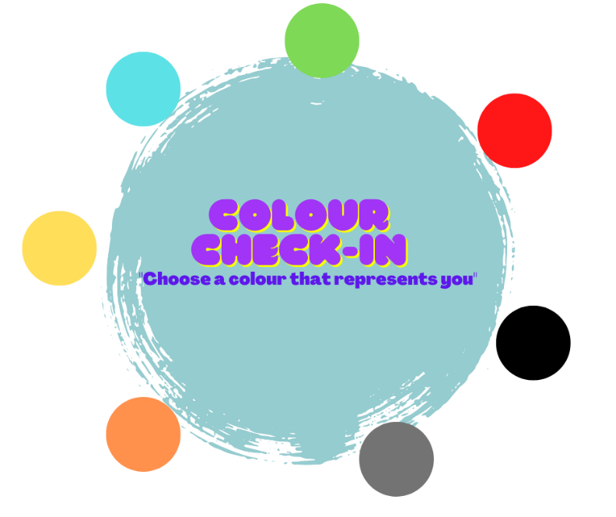


Finally, we wanted to share something really special with you. Drum roll please....
Finally, kukhona into especial esirhalela ukuyi sharisha nani. Drum roll please....
This TAGAZINE is a snapshot of this group and other TAG advisors’ experiences and a tribute to your collective efforts over the last two years. Even though we couldn’t be together with you in person, our virtual hang outs helped us stay together in heart and in spirit. We hope you find the TAGAZINE engaging, insightful and useful in your own life.
LeTAGAZINE si snapshot se experiences zale group nezinye iadvisors ne tribute se collective effort kule minyaka mibini idlulileyo. Nangona besingakwazi ukuba sibonane, ionline activities zisincede ukuba sihlaleni sihleli kunye ezintliziyweni na in spirit. Siyathemba ukuba iTAGAZINE nizauyifumana inikisa umdla, ifundisa kwaye iuseful kakhulu ebomini benu.
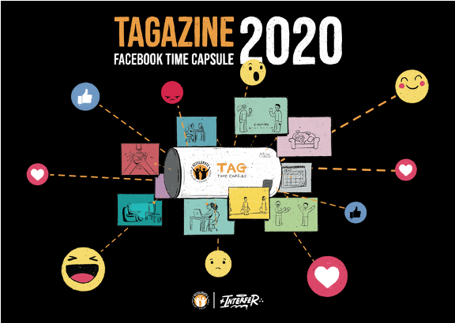

--------
Feedback / Debrief (for facilitators ):
How did participants engage with the first week?
What kinds of challenges emerged during the week that prevented or hindered participation?
What was successful about this week’s prompts?

---------

Week 2: 11 – 15 July 2022
Pictorial Evidence Review (“Research Download!”) Part 1:
Post: Hello everyone! Thank you for introducing yourselves and we hope to get to know each of you in the oncoming weeks and the camp in August whoop!
Molweni bethu! Siyabulela ngokuba nizazise, siyathemba ukuba sizuaye sisazana kweziveki zizayo nakwi camp yethu ngo August.
This week we start with our first activity. We call it a “Research Download”: that’s basically a visual way of sharing with you what we’ve found in our research so far when it comes to learner pregnancy. We want to hear what you think of this, and see where these research stories might lead us together.
Kule veki sizauqalisa nge activity yethu yokuqala. Siyibiza ipictorial evidence review, lonto ithetha ukuba kusetyenziswa iipictures ukunibonsa ukuba sifumene ntoni kwi research ukuzofika ngoku malunga ne leaner pregnancy.
Look at the set of pictures and read the story that goes with it.
Jonga ezi pictures zingazantsi ufune ukuba ibali lazo nganye lithini.

Week 2: 11 – 15 July 2022
Pictorial Evidence Review (“Research Download!”) Part 1:

Post: Hello everyone! Thank you for introducing yourselves and we hope to get to know each of you in the oncoming weeks and the camp in August whoop!

Molweni bethu! Siyabulela ngokuba nizazise, siyathemba ukuba sizuaye sisazana kweziveki zizayo nakwi camp yethu ngo August.

This week we start with our first activity. We call it a “Research Download”: that’s basically a visual way of sharing with you what we’ve found in our research with young mothers in the HEY BABY study has told us so far, when it comes to learner pregnancy and what the government and its partners can do to help learners return to school, pass grades, and prevent additional pregnancies while learners are still in school.

There will be three weeks of activities, where we share pictures with you that illustrate the experience of a young pregnant learner named Anathi, and then follow her until after she has had her baby.

We want to hear what you think of her story, and talk together about where her story goes next.

Kule veki sizauqalisa nge activity yethu yokuqala. Siyibiza ipictorial evidence review, lonto ithetha ukuba kusetyenziswa iipictures ukunibonsa ukuba sifumene ntoni kwi research ukuzofika ngoku malunga ne leaner pregnancy.

Look at the set of pictures and read the story that goes with it.
Jonga ezi pictures zingazantsi ufune ukuba ibali lazo nganye lithini.

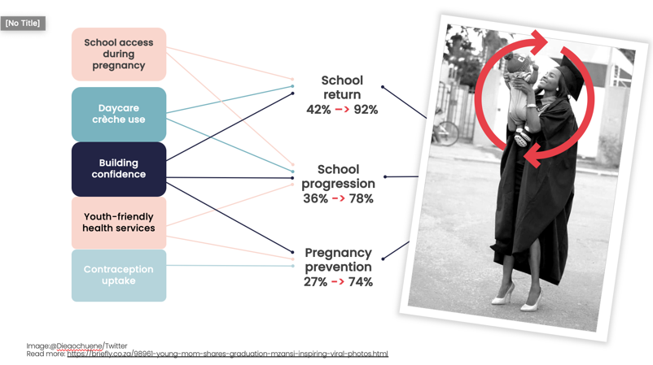
SCHOOL ACCESS DURING PREGNANCY

Anathi is a grade 11 learner at Bulungula College, in Xhora Mouth.

1st frame: She found out she was pregnant a month or so ago, and is now March and she is 4 months pregnant. She is determined to stay in school for as long as possible while she is pregnant and is fortunate to have the support of her friend Thembi…

2nd frame: A few months later, in August, Anathi has continued to attend her College even when she has felt a bit sick to her stomach or tired. Like every other day, today she walked to school with her backpack. When she arrived at school, she felt very tired and has a lot of back pain.

Prompt: Anathi wants to keep coming to school until she is eight months pregnant if she can. What would Anathi need at school to make sure she can do this? What do you think might happen next for Anathi?

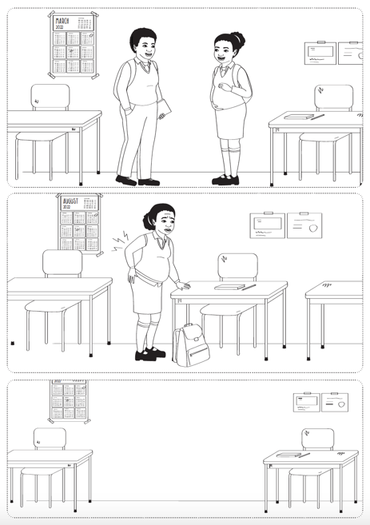

Feedback (for facilitators – whoever remembers 😊):
How did participants engage with the first week?
What kinds of challenges emerged during the week that prevented or hindered participation?
What was successful about this week’s prompts?

Week 3: 18 – 22 July 2022
Pictorial Evidence Review part 2-3
See Supplementary Information 2.

