Supplementary Figures

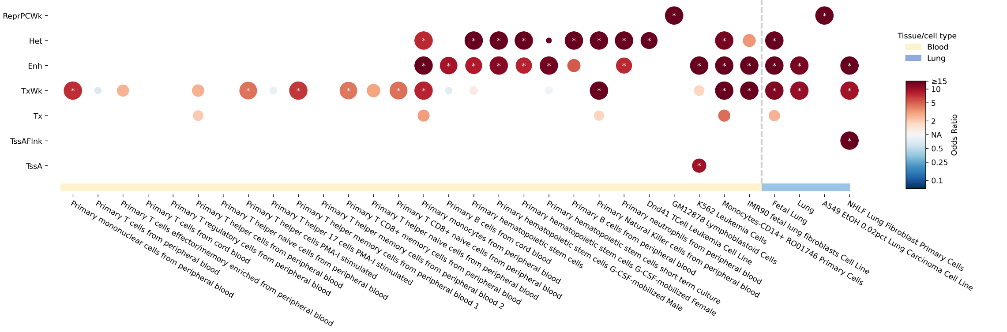
Supplementary Figure 1. Enrichment of the genome-wide significant SNPs in chromatin states. Dot plot displayed enrichments results for all the significant SNPs within the identified risk locus across 15 distinct chromatin states in blood and lung tissues/cells data using hypergeometric distribution test. Blue, negative association (odds ratio [OR]<1); red, positive association (OR>1); white, null association (OR=NA). Larger circles correspond to smaller adjusted P-value. Chromatin states showing enrichment with a false discovery rate adjusted P-value <0.05 were marked with asterisks. These states include weak repressed PolyComb (ReprPCWk), heterochromatin (Het), enhancers (Enh), weak transcription (TxWk), strong transcription (Tx), flanking active transcription start site (TssAFlnk), active transcription start site (TssA) (not shown in this figure as none of the enrichment results were valid for this chromatin state).

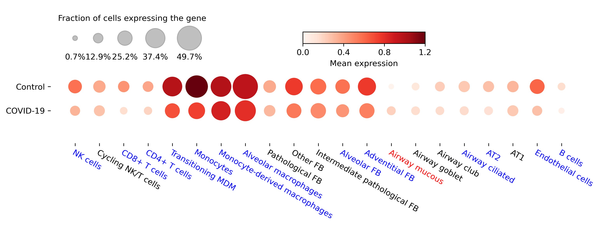
Supplementary Figure 2. CPQ expression for lung tissues in severe COVID-19 patients compared to healthy controls. Dot plot displaying the expression levels of the CPQ gene across 21 different cell types within the lung scRNA-seq data. Cell types exhibiting lower CPQ expression levels in severe COVID-19 patients compared to healthy controls are highlighted in blue, while higher CPQ expression levels are in red.

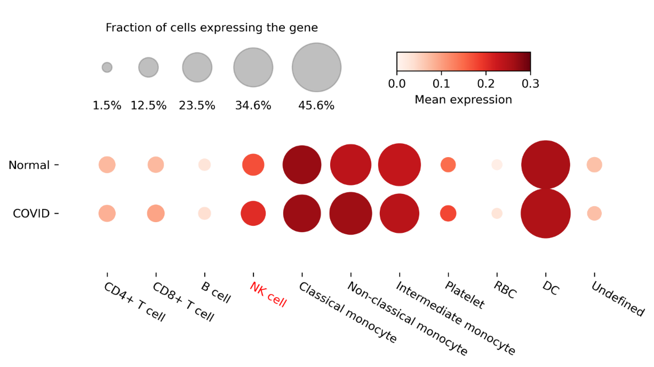
Supplementary Figure 3. CPQ expression for peripheral blood mononuclear (PBMCs) cells in severe COVID-19 patients compared to healthy controls. Dot plot displaying the expression levels of the CPQ gene across 11 cell types within the PBMCs scRNA-seq data. Cell types exhibiting higher CPQ expression levels in severe COVID-19 patients compared to healthy controls are highlighted in red.

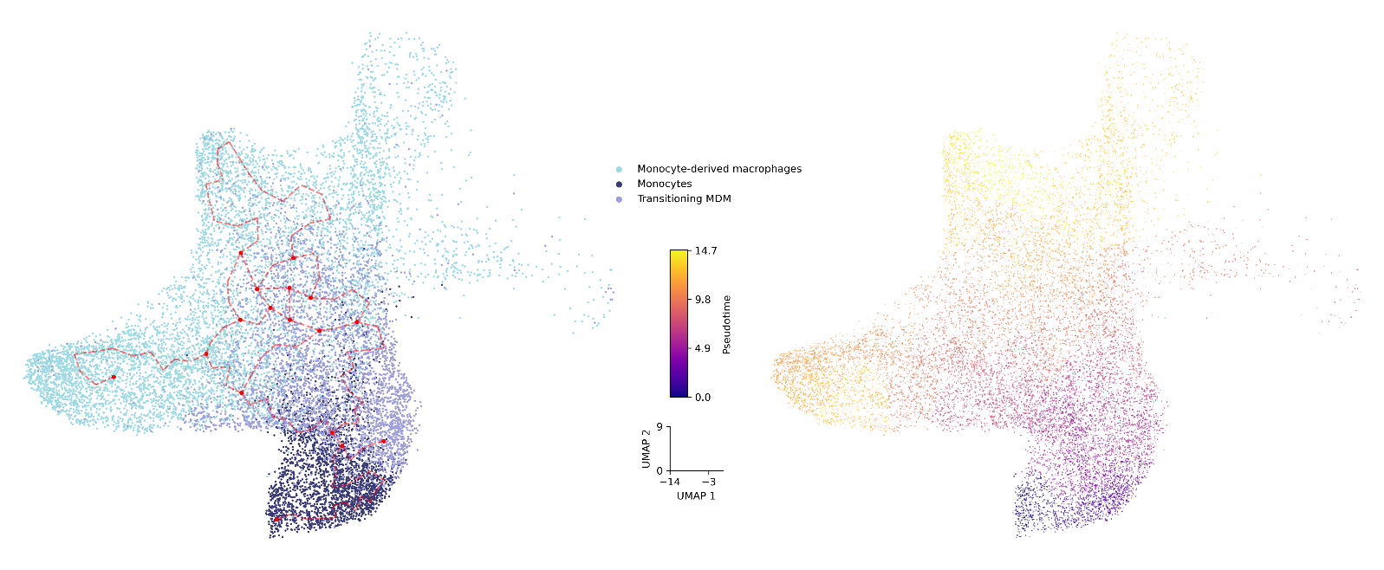
Supplementary Figure 4. Pseudotime trajectory for monocyte-derived macrophages (MDM) and its precursor cells, monocytes and transitioning MDM. Each cell was assigned a pseudotime value, where 0 indicated no progress in the transition from monocyte to MDM, and the maximum value of 100 represented 100% progress. The red curve indicated the trajectory for the relative progression in the transition process.


Supplementary Figure 5. Protein-protein interaction network of the ubiquitination-related genes using STRING. Analysis was based on protein-protein interactions that were backed by high-throughput experiments and possessed association scores exceeding the median score (i.e., 0.04). Protein-protein interaction network analysis of these six ubiquitination-related genes revealed functional connections among USP48 (formerly known as USP31), GSK3B, and FBXW11 (connected by lines).

Supplementary Figure 6. Construction of THP-1 cells and mouse inflammation models. a. Construction and validation (by western blotting) of a THP-1 cell line stably overexpressing carboxypeptidase Q (CPQ). Technical replicates used 1 × 10⁶ cells each. b. TNF-α expression levels measured by ELISA in THP-1 wild-type (WT) cells treated with LPS (100 ng ml⁻¹) at different time points (n = 3). c. IL-6 expression levels measured by ELISA in THP-1 wild-type (WT) and CPQ-overexpressing (CPQ OE) cells treated with different LPS concentrations for 24 h (n = 3). d. Systemic inflammation was induced in mice via intraperitoneal injection of LPS (10 mg per kg) for 6 h (model group). TNF-α and IL-6 expression in lung tissue from wild-type (WT) and model mice were analyzed by western blot and normalized to β-actin. Data are shown as the mean of three independent experiments ± s.e.m. P values were determined by unpaired two-tailed t-tests. NS, not significant.

Supplementary Methods
- Questionnaire for COVID-19 infection status
We used a standardized questionnaire to collect data on COVID-19 infection status, medical treatment received, and symptoms experienced during and after the infection.
Supplementary Methods Table 1. The detailed information of questionnaires for COVID-19
Category | Items | Option
COVID-19 infection status | How many times have you had COVID-19? | Numeric variable
 | How to confirm COVID-19 infection this time? | (0) SARS-CoV-2 PCR test
 |  | (1) Antigen test
 |  | (2) No test
 | Have you been vaccinated against COVID-19? | (0) No
 |  | (1) YES—Specifying the type of vaccine
Symptoms experienced during and after the infection. | Did you have any symptoms of COVID-19 during your illness? | (0) No
 |  | (1) YES—Specifying the time of first onset of COVID-19 symptoms
 | Duration of symptoms (days) | (0) 0
 |  | (1) 1-2
 |  | (2) 3-4
 |  | (3) 5-8
 |  | (4) >8
 | Fever (days) | (0) 0
 |  | (1) 1-2
 |  | (2) 3-4
 |  | (3) 5-8
 |  | (4) >8
 | Cough (days) | (0) 0
 |  | (1) 1-2
 |  | (2) 3-4
 |  | (3) 5-8
 |  | (4) >8
 | Running nose (days) | (0) 0
 |  | (1) 1-2
 |  | (2) 3-4
 |  | (3) 5-8
 |  | (4) >8
 | Sore throat (days) | (0) 0
 |  | (1) 1-2
 |  | (2) 3-4
 |  | (3) 5-8
 |  | (4) >8
 | Polypnea/dyspnea (days) | (0) 0
 |  | (1) 1-2
 |  | (2) 3-4
 |  | (3) 5-8
 |  | (4) >8
 | Chill (days) | (0) 0
 |  | (1) 1-2
 |  | (2) 3-4
 |  | (3) 5-8
 |  | (4) >8
 | Headache (days) | (0) 0
 |  | (1) 1-2
 |  | (2) 3-4
 |  | (3) 5-8
 |  | (4) >8
 | Muscle soreness (days) | (0) 0
 |  | (1) 1-2
 |  | (2) 3-4
 |  | (3) 5-8
 |  | (4) >8
 | Taste decline (days) | (0) 0
 |  | (1) 1-2
 |  | (2) 3-4
 |  | (3) 5-8
 |  | (4) >8
 | Smell decline (days) | (0) 0
 |  | (1) 1-2
 |  | (2) 3-4
 |  | (3) 5-8
 |  | (4) >8
 | Weakness (days) | (0) 0
 |  | (1) 1-2
 |  | (2) 3-4
 |  | (3) 5-8
 |  | (4) >8
 | Diarrhea (days) | (0) 0
 |  | (1) 1-2
 |  | (2) 3-4
 |  | (3) 5-8
 |  | (4) >8
 | Nausea/vomiting (days) | (0) 0
 |  | (1) 1-2
 |  | (2) 3-4
 |  | (3) 5-8
 |  | (4) >8
Medical treatment received | Medical treatment received | (0) No medical treatment
 |  | (1) Oral medication at drug store—Specifying the type of medication
 |  | (2) Home oxygen therapy
 |  | (3) Medical interventions at primary care centers—Specifying the type of medical interventions (a. Oral medication; b.Injection; c. Transfusion; d. Oxygen therapy; e. Nebulization; f. Not known; g. Others)
 |  | (4) Inpatient medical care—Specifying the type of medical interventions (a. Oral medication; b.Injection; c. Transfusion; d. Oxygen therapy; e. Nebulization; f. Non-invasive ventilation; g. Invasive ventilation; h. ECMO; i. Not known; k. Others)
 |  | (5) Other medical treatment—Specifying the type of medical intervention

2. Imputation for genotype data
We performed rigorous quality control and imputation using the Rapid Imputation and Computational Pipeline for Genome-Wide Association Studies (RICOPILI)¹. Specifically, we first performed a quality control before imputation to avoid false positives from technical artifacts and remove noise hiding real signals, then we calculated principal components to check the population structures and remove duplicated samples using a subset of high-quality variants. Last, we performed the imputation based on east Asian population from 1000 Genomes Project Phrase 3. A detailed flowchart is shown in Supplementary Methods Figure 1.
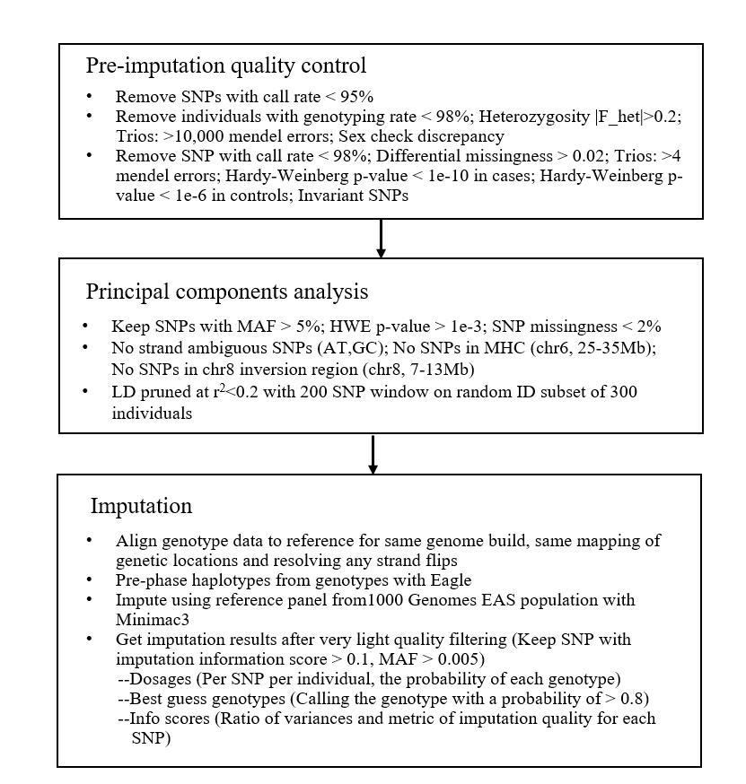
Supplementary Methods Figure 1. Detailed flowchart of genotyping QC and imputation

3. The quality control for whole genome sequencing (WGS) data
In summary, the clean reads were obtained by processing the raw sequencing data through trimmomatic, which involved the removal of adapter contamination and trimming low-quality sequences ². Subsequently, these clean reads were aligned to the human reference genome (GRCh38) using the Burrows–Wheeler Alignment tool ³, and further we converted base position to GRC37 for calculating concordance rate between genotypic and WGS data using liftOver Reads with ambiguous mappings (MAPQ < 10) and duplicated reads were filtered out using SAMtools⁴ and PicardTools [http://broadinstitute.github.io/picard/], respectively. We also calculated two important metrics, PCT_10X (the proportion of bases with at least 10X sequence coverage in post-filtering) and PCT_30X (the proportion of bases with at least 30X sequence coverage in post-filtering) using Picard. If a sample's sequencing data shows either PCT_10X<0.9372 or PCT_30X<0.68912, we initiated a resequencing process for that sample. Subsequently, we conducted a reanalysis by integrating additional measurements with the original WGS data from the samples. Single-nucleotide variants (SNVs) and small insertions and deletions (indels; <50bp) were called following the recommended practices of the Genome Analysis Toolkit software ⁵.

4. Consensus-based gene mapping – eQTL colocalization analyses
To find genes that exhibit significant colocalization between eQTL signals and GWAS signals, we conducted eQTL colocalization analyses using the R package "Coloc"⁶. The eQTL colocalization analyses were run for 49 GTEx V8 tissues/cells (Supplementary Methods Table 1)⁷. For each tissue/cell, the analysis was restricted to genes within a 500 KB region of the identified risk loci and genes that were identified as eGene in the datasets (i.e., a gene that is significantly expressed in the tissue/cell). For each eligible gene, the analysis was performed using GWAS P-values and eQTL P-values from all the variants within the risk loci, under the default parameters. Colocalization pairs with a posterior probability of hypothesis 4 (PP4, both traits share a single causal variant in the region) ≥0.8 were considered significant.
Supplementary Methods Table 2. Detailed information on the tissues/cells used for eQLT colocalization analyses
Tissues/cell name | Tissue/cell type
Brain Amygdala | Brain
Brain Anterior cingulate cortex BA24 | Brain
Brain Caudate basal ganglia | Brain
Brain Cerebellar Hemisphere | Brain
Brain Cerebellum | Brain
Brain Cortex | Brain
Brain Frontal Cortex BA9 | Brain
Brain Hippocampus | Brain
Brain Hypothalamus | Brain
Brain Nucleus accumbens basal ganglia | Brain
Brain Putamen basal ganglia | Brain
Brain Spinal cord cervical c-1 | Brain
Brain Substantia nigra | Brain
Subcutaneous | Adipose
Visceral (Omentum) | Adipose
Artery – Aorta | Blood Vessel
Artery – Coronary | Blood Vessel
Artery – Tibial | Blood Vessel
Cells - EBV-transformed lymphocytes | Blood Vessel
Colon – Sigmoid | Colon
Colon – Transverse | Colon
Esophagus - Gastroesophageal Junction | Esophagus
Esophagus – Mucosa | Esophagus
Esophagus - Muscularis | Esophagus
Heart - Atrial Appendage | Heart
Heart - Left Ventricle | Heart
Cells - Cultured fibroblasts | Skin
Skin - Not Sun Exposed (Suprapubic) | Skin
Skin - Sun Exposed (Lower leg) | Skin
Breast - Mammary Tissue | \
Kidney – Cortex | \
Adrenal Gland | \
Liver | \
Lung | \
Minor Salivary Gland | \
Muscle - Skeletal | \
Nerve – Tibial | \
Ovary | \
Pancreas | \
Pituitary | \
Prostate | \
Small Intestine - Terminal Ileum | \
Spleen | \
Stomach | \
Testis | \
Thyroid | \
Uterus | \
Vagina | \
Whole Blood | \

5. Consensus-based gene mapping – sQTL colocalization analyses
To find genes that exhibit significant colocalization between sQTL signals and GWAS signals, we conducted sQTL colocalization analyses using the R package "Coloc"⁶. The sQTL colocalization analyses were run for 49 GTEx V8 tissues/cells (Supplementary Methods Table 1)⁷. For each tissue/cell, the analysis was restricted to genes within a 500 KB region of the identified risk loci and genes that were identified as sGene in the datasets (i.e., gene shows evidence of alternative splicing in the tissue/cell). For each eligible gene, the analysis was performed using GWAS P-values and sQTL P-values from all the variants within the risk loci, under the default parameters. Colocalization pairs with a posterior probability of hypothesis 4 (PP4, both traits share a single causal variant in the region) ≥0.8 were considered significant.

6. Consensus-based gene mapping – pQTL colocalization analyses
To find genes that exhibit significant colocalization between pQTL signals and GWAS signals, we conducted pQTL colocalization analyses using the R package "Coloc"⁶. The pQTL colocalization analyses were run for serum protein from AGES cohort⁸. The analysis was restricted to genes within a 500 KB region of the identified risk loci and genes that can be successfully measure in the serum. For each eligible gene, the analysis was performed using GWAS P-values and serum pQTL P-values from all the variants within the risk loci, under the default parameters. Colocalization pairs with a posterior probability of hypothesis 4 (PP4, both traits share a single causal variant in the region) ≥0.8 were considered significant.

7. Consensus-based gene mapping – protein-altering variants linkage
We performed protein-altering variants (PAVs) linkage to identify genes with PAVs that are in strong LD with the lead SNP of each risk locus. We employed the Ensembl variant effect predictor (VEP)⁹ to annotate all variants in strong LD (r²≥0.8) with the lead SNPs (i.e., proxy variant), as estimated in the European ancestry reference genome from 1000 Genomes Project Phrase 3. All proxy variants predicted to be loss of function (pLOF) or missense variants were extracted, and the protein-coding genes associated with these selected PAVs were recorded.

8. Consensus-based gene mapping – similarity-based gene prioritization
We applied a new similarity-based gene prioritization approach, the Polygenic Priority Score (PoPS), to prioritize the candidate causal genes for each identified risk locus¹⁰. In summary, the PoPS combines data from genome-wide association with gene features from a variety of sources, producing a priority score for each protein-coding gene. We processed and included a total of 61,487 features from bulk and single-cell gene expression, biological pathways, and protein–protein interaction networks as input for PoPS (Supplementary Methods Table 2). For each risk locus, we extracted the PoPS scores for all the protein-coding genes located within 500 KB of the locus and prioritized the top 3 genes with the highest scores.

Supplementary Methods Table 3. Summary of datasets used as inputs for PoPS
Feature ID | Species | Tissue/Cell type | PMID
Gene expression
human_airway | human | airway | 32109386
human_prostate | human | prostate | 30566875
human_bladder | human | bladder | 31462402
human_retina | human | retina | 32386599
human_bonemarrow | human | bone marrow | 30518681
human_retina2 | human | retina | 31653841
human_brain2 | human | brain | 24695229
human_synovialfibroblast | human | synovial fibroblast | 32499639
human_brain3_adult | human | brain | 30545854
human_tcell | human | T cell | 31624246
human_brain3_prenatal | human | brain | 30545854
human_testis | human | testis | 30404016
human_brain4 | human | brain | 31178122
human_thymus | human | thymus | 29884461
human_brain_cerebellarhem | human | cerebellum | 27339989
mouse_adipocyte | mouse | adipocyte | 32286228
human_brain_frontalcortex | human | frontal cortex | 27339989
mouse_airway | mouse | airway | 32109386
human_brain_visualcortex | human | visual cortex | 27339989
mouse_aorta | mouse | aorta | 31146585
human_colon | human | colon | 30270042
mouse_brain | mouse | brain | 30096299
human_colon2 | human | coloc | 32066951
mouse_brain2 | mouse | brain | 29545511
human_coloncancer | human | colon cancer | 32302573
mouse_brain4_bnst | mouse | brain BNST | 31178122
human_csf | human | CSF | 31937773
mouse_brain4_neurons | mouse | brain neurons | 31178122
human_embryo | human | embryo | 31435013
mouse_development | mouse | development | 30787437
human_eye | human | eye | 31995762
mouse_digestive_adult | mouse | digestive | 29802404
human_fetalblood | human | fetal blood | 31597962
mouse_digestive_fetal | mouse | fetal digestive | 29802404
human_gut_epi | human | gut epithelium | 31348891
mouse_endothelium | mouse | endothelium | 32059779
human_gut_fib | human | gut fibroblast | 31348891
mouse_epithelium | mouse | epithelium | 31481792
human_gut_imm | human | gut immune | 31348891
mouse_gastrulation | mouse | gastrulation | 30787436
human_heme | human | heme | 27526324
mouse_gutendoderm | mouse | gut endoderm | 30959515
human_hippocampus | human | hippocampus | 31942070
mouse_hairfollicle | mouse | hair follicle | 32315612
human_ileum | human | ileum | 31474370
mouse_heart_control | mouse | heart | 30254108
human_immune | human | immune
mouse_heart_ko | mouse | heart | 30254108
human_intestine | human | intestine | 31753849
mouse_hemogenicendothelium | mouse | hemogenic endothelium | 32392346
human_kidney | human | kidney | 31896769
mouse_immune | mouse | immune | 30686579
human_kidney2 | human | kidney | 31604275
mouse_islets | mouse | islets | 30661759
human_kidney3 | human | kidney | 31506348
mouse_kidney | mouse | kidney | 31689386
human_liver | human | liver | 31722201
mouse_lung | mouse | lung | 30318149
human_lung | human | lung | 32832599
mouse_microglia | mouse | microglia | 30471926
human_lymphnodes | human | lymph nodes | 31402260
mouse_multiple | mouse | multiple | 29474909
human_monocytes | human | monocyte | 28428369
mouse_multiple2_bulk | mouse | multiple | 30283141
human_multiple | human | multiple | 29022597
mouse_multiple2_droplet | mouse | multiple | 30283141
human_muscle | human | muscle | 31937892
mouse_multiple2_facs | mouse | multiple | 30283141
human_nk | human | natural killer cells | 31801909
mouse_muscle | mouse | muscle | 32160558
human_pancreas | human | pancreas | 27693023
human_pancreasductal | human | pancreas duct | 32354994
mouse_nerve | mouse | nerve | 32295886
human_pbmc | human | PBMC | 28091601
mouse_thymus | mouse | thymus | 29884461
human_placenta | human | placenta | 30042384
mouse_vagina | mouse | vagina | 32023462
Biological pathways and protein-protein interactions
GO | human | NA | 25428369
Reactome | human | NA | 31691815
PPI | human | NA | 30476243
HPO | human | NA | 33264411
KEGG | human | NA | 10592173
Detail information about each feature can be found at: https://github.com/FinucaneLab/pops. PMID: PubMed reference number

Supplementary Methods Table 4. Reagents and chemicals for experimental validation

Experiment | Reagents | Company names | Catalog Numbers
Elisa | Human TNF-α ELISA kit | NEO Bioscience | EHC103a
 | Human IL-6 ELISA kit | Boster | EK0410
Western blot | Mammalian Protein Extraction Reagent | Thermo Scientific | 78501
 | Modified Bradford Protein Assay Kit | Sangon Biotech | C503041
 | Protease and phosphatase inhibitor cocktail for general use | Beyotime | P1045
 | SDS-PAGE Sample Loading Buffer，5X | Beyotime | P0015
 | MOPS-SDS Running Buffer | ACE Biotechnology | BR0001-02
 | FuturePAGE™ 10% 12 Wells | ACE Biotechnology | ET12010Gel
 | PVDF membrane | Millipore | IPVH00010
 | UltraSignal ECL Chemiluminescent Substrate | 4A Biotech | 4AW011
Cell culture | RPMI 1640 | Gibco
 | Pen Strep | Gibco | 15140148
 | Fetal Bovin Serum | Sigma Aldrich | F0193
 | Phorbol 12-myristate 13-acetate | MCE | HY-18739
 | Lipopolysaccharides | Solarbio | L8880

References
1. Lam, M. et al. RICOPILI: Rapid Imputation for COnsortias PIpeLIne. Bioinformatics 36, 930-933 (2020).
2. Bolger, A.M., Lohse, M. & Usadel, B. Trimmomatic: a flexible trimmer for Illumina sequence data. Bioinformatics 30, 2114-20 (2014).
3. Li, H. & Durbin, R. Fast and accurate short read alignment with Burrows-Wheeler transform. Bioinformatics 25, 1754-60 (2009).
4. Li, H. et al. The Sequence Alignment/Map format and SAMtools. Bioinformatics 25, 2078-9 (2009).
5. McKenna, A. et al. The Genome Analysis Toolkit: a MapReduce framework for analyzing next-generation DNA sequencing data. Genome Res 20, 1297-303 (2010).
6. Giambartolomei, C. et al. Bayesian test for colocalisation between pairs of genetic association studies using summary statistics. PLoS Genet 10, e1004383 (2014).
7. Consortium, G.T. The Genotype-Tissue Expression (GTEx) project. Nat Genet 45, 580-5 (2013).
8. Gudjonsson, A. et al. A genome-wide association study of serum proteins reveals shared loci with common diseases. Nat Commun 13, 480 (2022).
9. McLaren, W. et al. The Ensembl Variant Effect Predictor. Genome Biol 17, 122 (2016).
10. Weeks, E.M. et al. Leveraging polygenic enrichments of gene features to predict genes underlying complex traits and diseases. 2020.09. 08.20190561 (2020).

