Online Supplement A
Data source: Korean Youth Risk Behavior Survey (2020 – 2024)

Online Supplement B
Data source: Korean Youth Risk Behavior Survey (2020 – 2024)

Panel A: Suicide ideation
Panel B: Suicide plan
Panel C: Suicide attempt

Online Supplement C
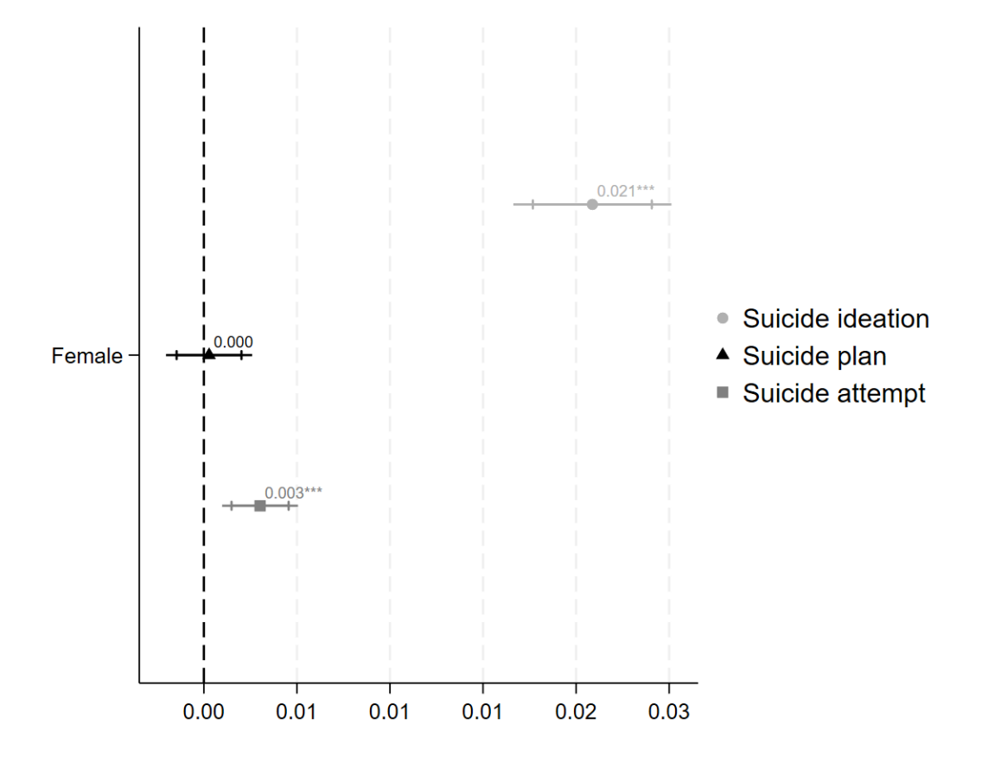
Note: Models control for individual-level covariates and Year x region FEs.

Online Supplement D
Panel A: Reference group includes boys in same gender/coed schools and girls in coed schools.
Outcome: | Model 1 (full sample)  Suicide ideation | Model 2 (full sample)  Suicide plan | Model 3 (full sample)  Suicide attempt
All-girl school | -0.005 (0.003) | -0.005* (0.002) | -0.006*** (0.001)
Female | 0.07*** (0.002) | 0.021*** (0.001) | 0.017*** (0.001)
Individual controls | ✓ | ✓ | ✓
Time-region FEs | ✓ | ✓ | ✓
Sample size | 214,078 | 214,078 | 214,078
Constant | 0.148*** (0.004) | 0.064*** (0.003) | 0.047*** (0.003)
R-squared | 0.023 | 0.009 | 0.009

Panel B: Reference group only includes girls in coed schools.
Outcome: | Model 4 (subsample)  Suicide ideation | Model 5 (subsample)  Suicide plan | Model 6 (subsample)  Suicide attempt
All-girl school | -0.005 (0.003) | -.004* (0.002) | -0.006*** (0.002)
Individual controls | ✓ | ✓ | ✓
Time-region FEs | ✓ | ✓ | ✓
Sample size | 104,427 | 104,427 | 104,427
Constant | 0.222*** (0.006) | 0.091*** (0.005) | 0.069*** (0.004)
R-squared | 0.017 | 0.01 | 0.009
Notes: FEs = fixed effects. All models adjust for age, living arrangement, academic achievement, family socioeconomic status, and self-rated health. Standard errors are clustered at the time-region level. Results in Panel A are based on the full sample containing both genders. Those in Panel B are based on the female subsample.
Data source: Korean Youth Risk Behavior Survey (2020 – 2023)
* p < .05, *** p < .001

Online Supplement E
Panel A
Panel B
Panel C

Note: Results are based on Panel A in Table 3 using general suicide rate as the contextual moderator. None of the interactions is statistically significant (Panel A: p = .859, Panel B: p = .572, Panel C: p = .293).

