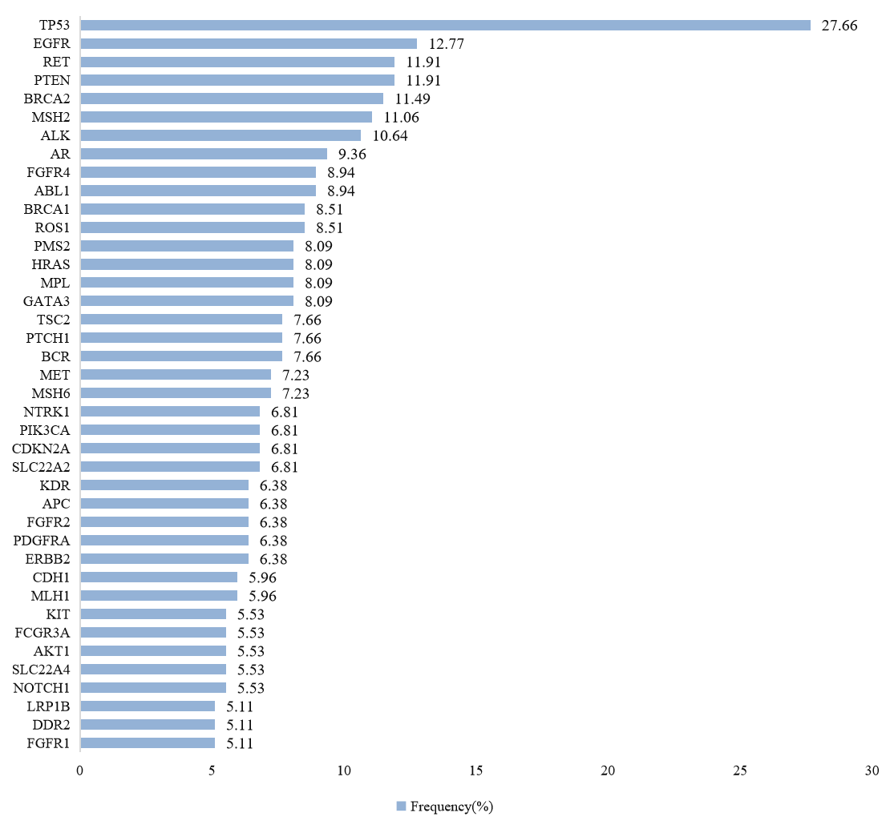
Supplement Figure 1. Histogram of high-frequency co-alterations in surgical patients with classical EGFR mutations.

Supplement Table 1. Silhouette scores for different cluster numbers.
Num of clusters | Silhouette score
2 | 0.472
3 | 0.490
4 | 0.505
5 | 0.498

