Electronic Supporting Information

IN SITU GREEN SYNTHESIS OF MIL-100(Fe) MODIFIED EDTA AS AN ENHANCED CANDIDATE DETOXIFYING AGENT OF LEAD HEAVY METAL (Pb) AND ITS ADSORPTION CHARACTERISTICS

Witri Wahyu Lestari, Rika Meilani, I. F. Nurcahyo, Larasati
Department of Chemistry, Faculty of Mathematics and Natural Science, Universitas Sebelas Maret., Jl. Ir. Sutami No. 36 A Kentingan, Jebres, Surakarta. 57126. Indonesia
Corresponding author: witri@mipa.uns.ac.id

Section S1. XRD pattern of the as synthesized materials and the standard patterns of MIL-100(Fe) and H₃BTC ligand 2
Section S2. Thermogram of MIL-100(Fe) and MIL-100(Fe)-EDTA 3
Section S3. SEM imaging and particle size distribution histogram 4
Section S4. TEM imaging and particle size distribution histogram 5
Section S5. FTIR of MIL-100(Fe) and MIL-100(Fe)-EDTA after suspension in H₂O, gastric, and intestinal media compared with the initial materials 6
Section S6. The experimental data and result of the adsorption efficiency measurement 7
Section S7. Adsorption Kinetics 12
Section S8. Adsorption Isotherm 14

Section S1. XRD pattern of the as synthesized materials and the standard patterns of MIL-100(Fe) and H₃BTC ligand
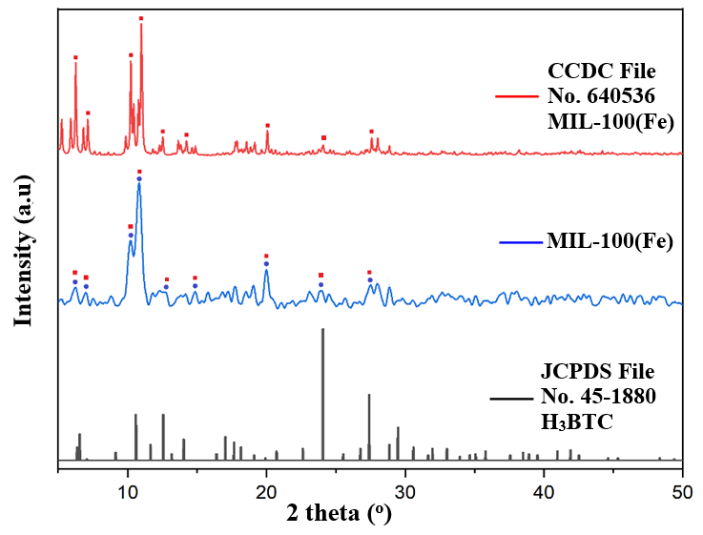
Figure S1. Diffractogram of the as-synthesized MIL-100(Fe) compared to standard pattern (CCDC No. 640536) and H₃BTC ligand (JCPDS No. 45-1880)

Section S2. Thermogram of MIL-100(Fe) and MIL-100(Fe)-EDTA
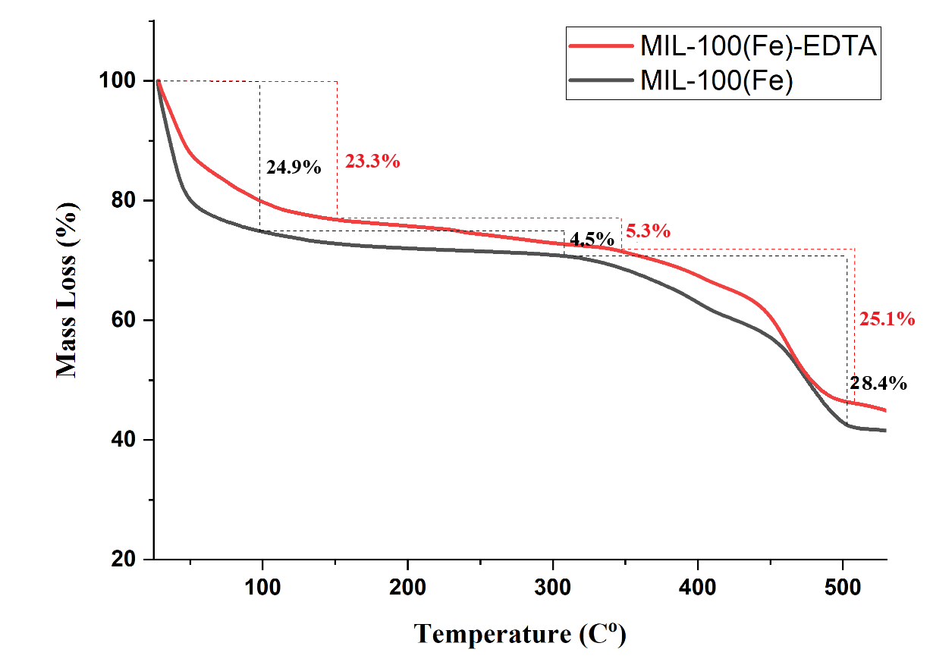
Figure S2. Thermogram of MIL-100(Fe) (black) and MIL-100(Fe)-EDTA (red)

Section S3. SEM imaging and particle size distribution histogram
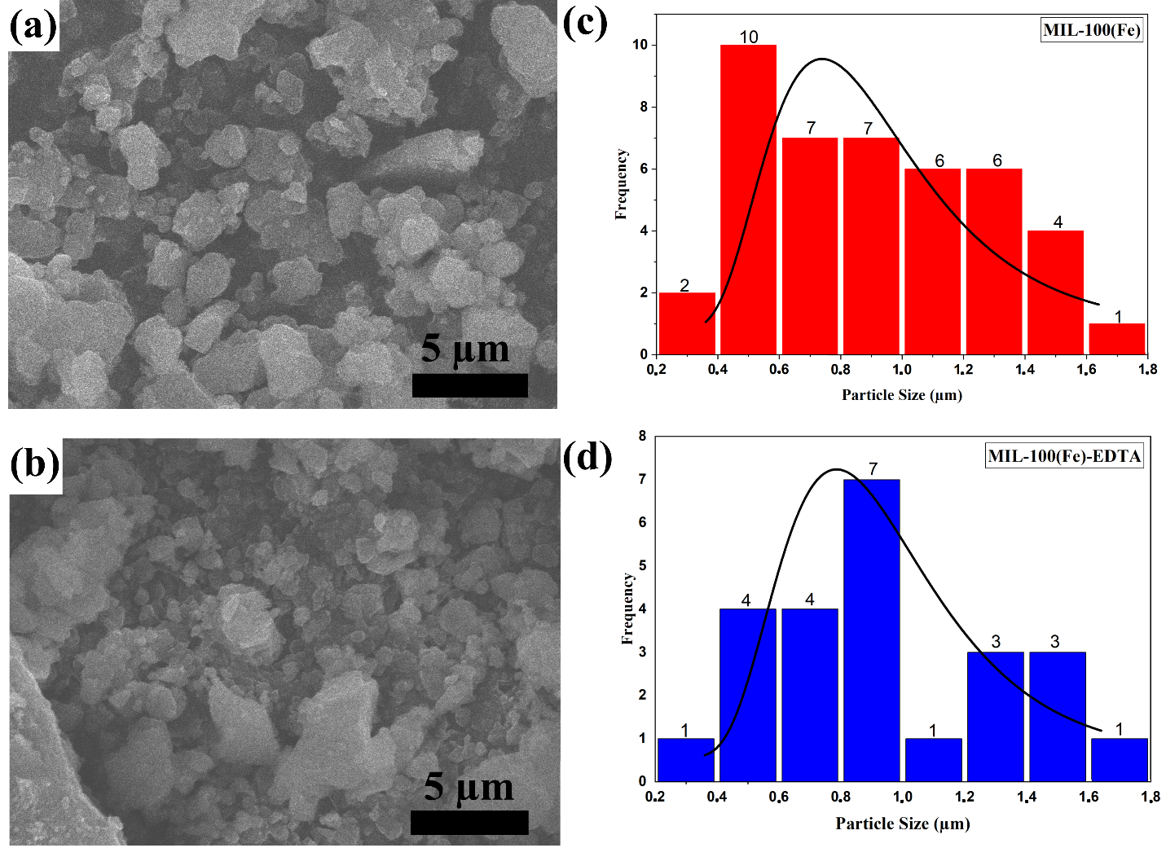
Figure S3. SEM imaging of MIL-100(Fe) (a) and MIL-100(Fe)-EDTA (b) and particle size distribution histogram of MIL-100(Fe) (c) and MIL-100(Fe)-EDTA (d)

Section S4. TEM imaging and particle size distribution histogram
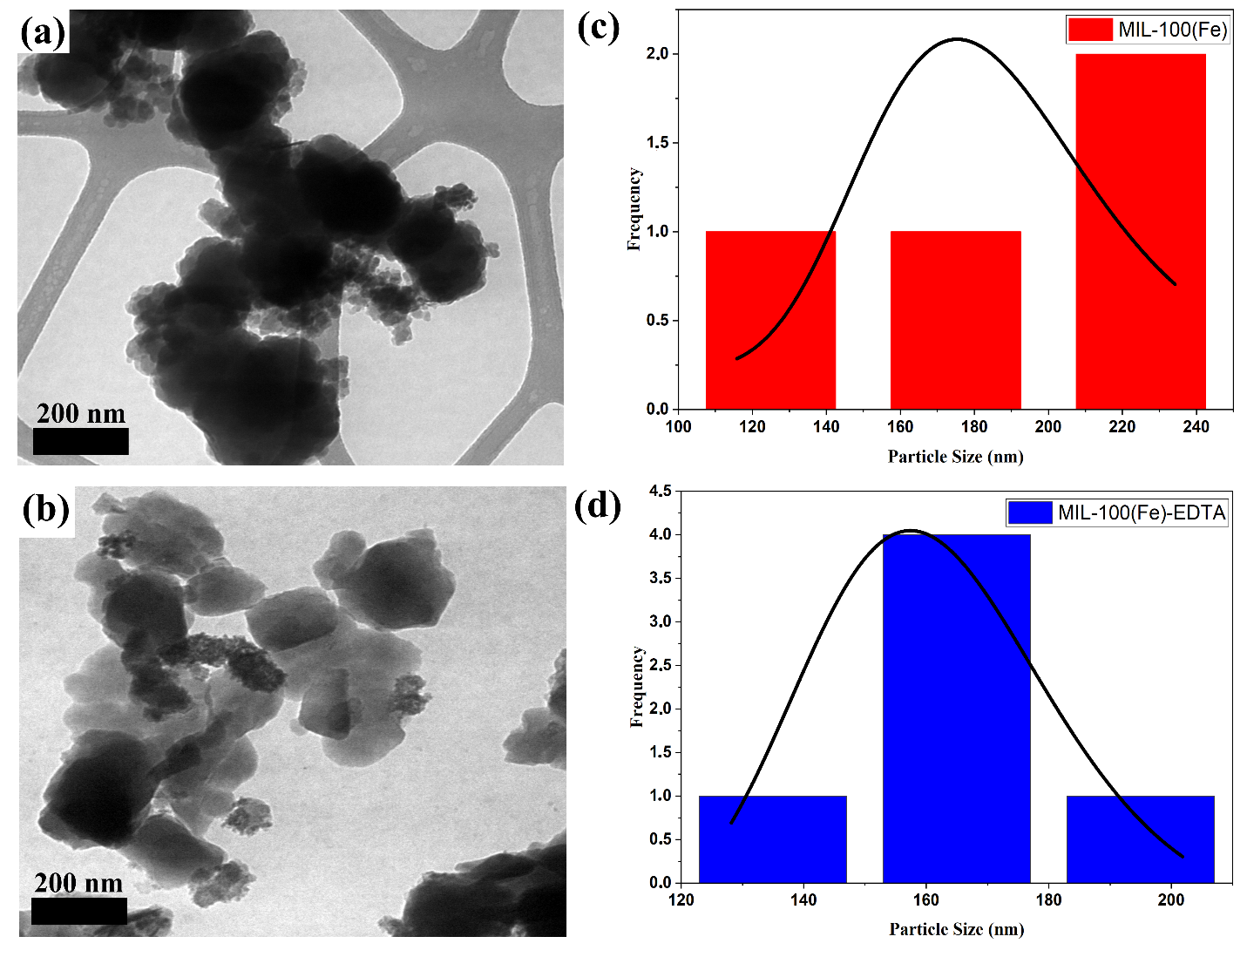
Figure S4. TEM imaging of MIL-100(Fe) (a) and MIL-100(Fe)-EDTA (b) and particle size distribution histogram of MIL-100(Fe) (c) and MIL-100(Fe)-EDTA (d)

Section S5. FTIR of MIL-100(Fe) and MIL-100(Fe)-EDTA after suspension in H₂O, gastric, and intestinal media compared with the initial materials
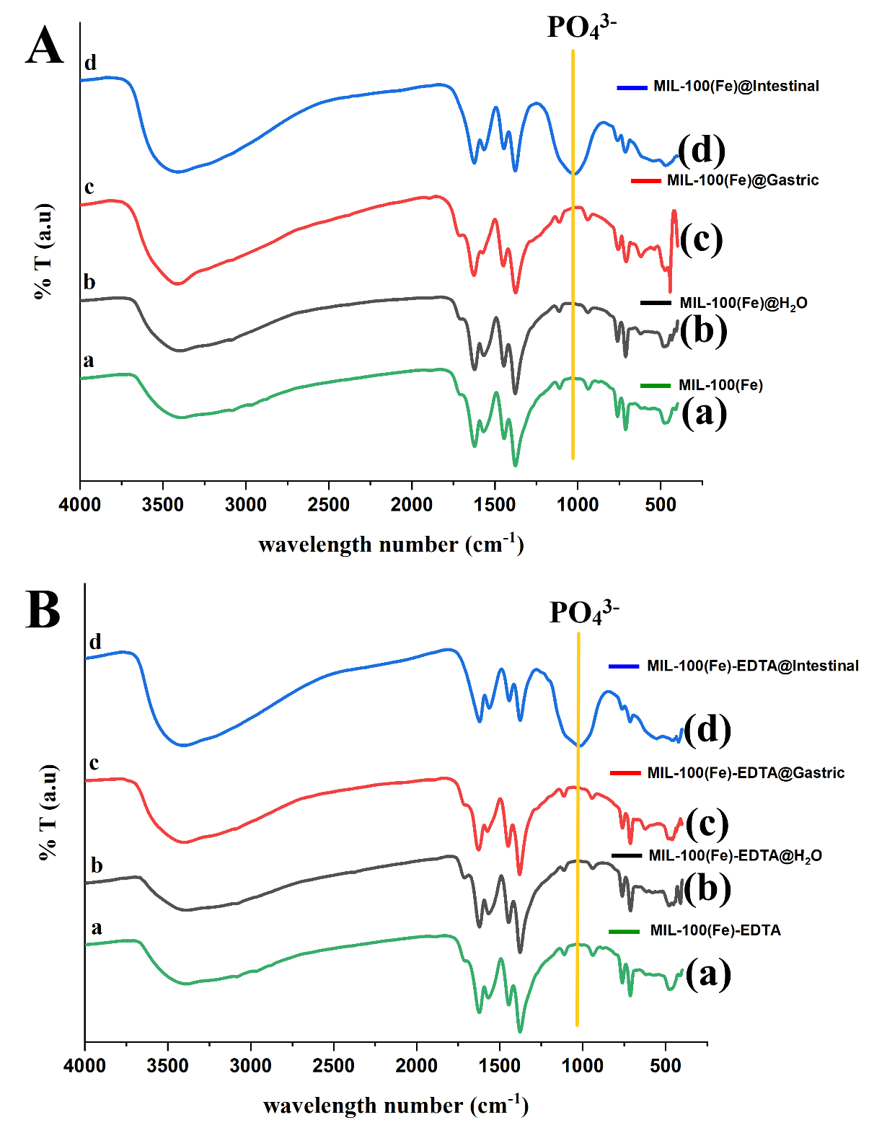
Figure S5. FTIR spectra of MIL-100(Fe) (A) and MIL-100(Fe)-EDTA (B): initial materials (a) and after the stability test in water media (b), gastric (HCL, pH 1.2 for 2h) (c) and intestinal simulation media (Ringer media, pH 6.0 for 24 h) (d)
Section S6. The experimental data and result of the adsorption efficiency measurement
- Adsorption efficiency of MIL-100(Fe) and MIL-100(Fe)-EDTA
Standard curve of Pb²⁺ ions
Concentration (ppm) | Absorbance
0 | 0.0000
2 | 0.0245
4 | 0.0464
6 | 0.0698
8 | 0.0863
10 | 0.1065
12 | 0.1275

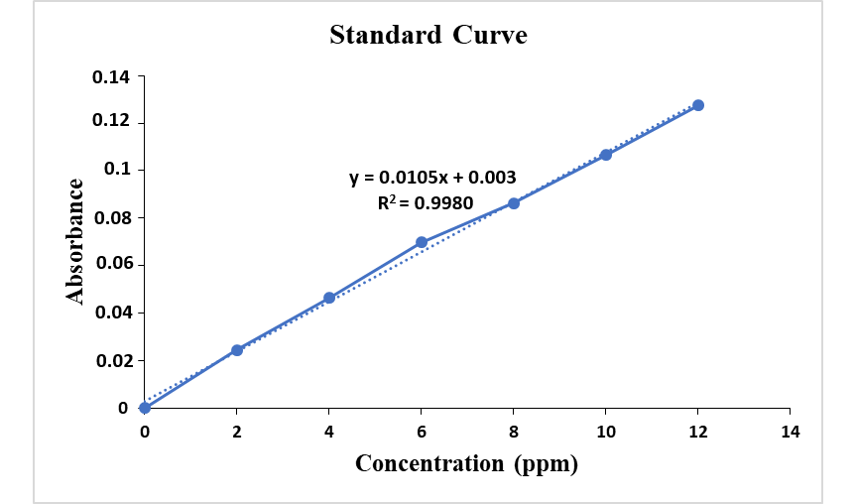
Figure S6a. Standard curve of Pb²⁺ ions in determining the adsorption efficiency
Table S6. Adsorption efficiency of MIL-100(Fe) and MIL-100(Fe)-EDTA
Adsorbent | Absorbance | C_{o} (ppm) | C_{e} (ppm) | Adsorption efficiency (%) | q (mg/g)
MIL-100(Fe) | 0.0486 | 4.7227 | 4.4054 | 6.7186 | 0.3173
MIL-100(Fe)-EDTA | 0.0425 | 4.7227 | 3.8525 | 18.4259 | 0.8702

- Effect of pH on the Pb²⁺ ions adsorption efficiency
Standard curve of Pb²⁺ ions
Concentration (ppm) | Absorbance
0 | 0.0000
2 | 0.0245
4 | 0.0464
6 | 0.0698
8 | 0.0863
10 | 0.1065
12 | 0.1275

Figure S6b. Standard curve of Pb²⁺ ions in determining the optimum pH

- Before adsorption
Control | Absorbance | Cₒ (ppm)
pH 1.2 | 0.0246 | 2.2299
pH 2 | 0.0272 | 2.4656
pH 3 | 0.0191 | 1.7313
pH 4 | 0.0083 | 0.7524
pH 5 | 0.0045 | 0.4079
pH 6 | 0.0055 | 0.4986
pH 6.8 | 0.0024 | 0.2176
pH 8.2 | 0.0055 | 0.4986
- After adsorption
pH | Absorbance | Cₑ (ppm) | Adsorption efficiency (%) | q (mg/g)
1.2 | 0.0234 | 2.1211 | 4.8791 | 0.1088
2 | 0.0054 | 0.4895 | 80.1468 | 1.9761
3 | 0.0011 | 0.0997 | 94.2413 | 1.6316
4 | 0.0007 | 0.0635 | 91.5603 | 0.6889
5 | 0.0016 | 0.1450 | 64.4521 | 0.2629
6 | 0.0013 | 0.1178 | 76.3738 | 0.3808
6.8 | 0.0014 | 0.1269 | 41.6819 | 0.0907
8.2 | 0.0024 | 0.2176 | 56.378 | 0.2810

Effect of Contact Time
Standard curve of Pb²⁺ ions
C (ppm) | Absorbansi
0 | 0.0000
2 | 0.0244
4 | 0.0500
6 | 0.0768
8 | 0.1034
10 | 0.1299

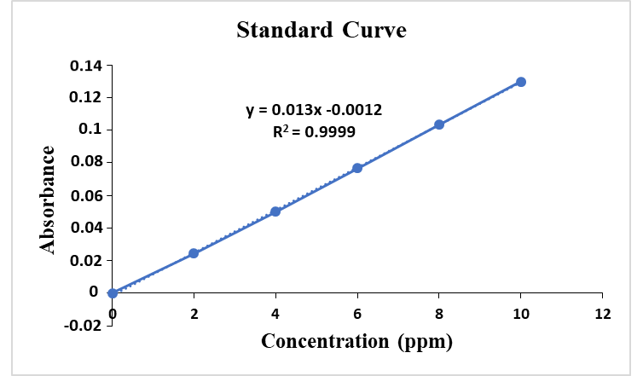
Figure S6c. Standard curve of Pb²⁺ ions in determining the optimum contact time
t (time) | Absorbance |  | Cₒ (ppm) | C_{e} (ppm) |  | Adsorption efficiency (%) | q (mg/g)
15 minute |  | 0.0302 | 3.8976 | 2.4030 | 38.3466 |  | 1.4946
60 minute |  | 0.0234 | 3.8976 | 1.8818 | 51.7190 |  | 2.0158
90 minute |  | 0.0132 | 3.8976 | 1.1000 | 71.7775 |  | 2.7976
120 minute |  | 0.0123 | 3.8976 | 1.0311 | 73.5452 |  | 2.8665
360 minute |  | 0.0152 | 3.8976 | 1.2533 | 67.8443 |  | 2.6443
720 minute |  | 0.0076 | 3.8976 | 0.6708 | 82.7894 |  | 3.2268
1440 minute |  | 0.0086 | 3.8976 | 0.7475 | 80.8215 |  | 3.1501

- Effect of Lead Concentration
Standard curve of Pb²⁺ ions
Concentration (ppm) |  | Absorbance
0 | 0.0000
2 | 0.0253
5 | 0.0634
10 | 0.1254
20 | 0.2433
30 | 0.3476
40 | 0.4455
50 | 0.5336

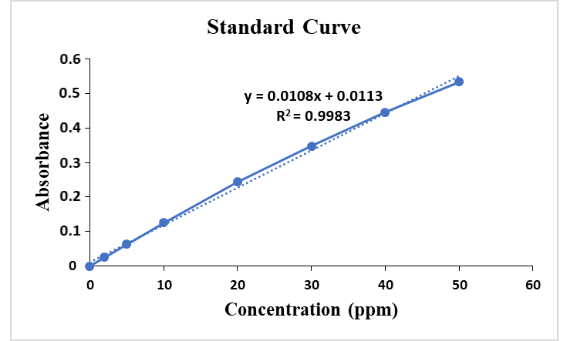
Figure S6d. Standard curve of Pb²⁺ ions in determining the optimum concentration
C_{o} (ppm) | Absorbance | C_{e} (ppm) | Adsorption efficiency (%) | q_{e} (mg/g)
2 | 0.0054 | 0.4861 | 75.7870 | 1.5215
5 | 0.0063 | 0.5672 | 86.6516 | 3.6820
10 | 0.0232 | 2.0886 | 74.3931 | 6.0678
20 | 0.0564 | 5.0775 | 66.3684 | 10.0199
30 | 0.1673 | 15.0613 | 31.2938 | 6.8600

Section S7. Adsorption Kinetics
- Pseudo first order
t (time) | qₑ (mg/g) | qₜ (mg/g) | Log (qₑ- qₜ)
15 minute | 3.2268 | 1.4946 | 0.2386
60 minute | 3.2268 | 2.0158 | 0.0831
90 minute | 3.2268 | 2.7976 | -0.3673
120 minute | 3.2268 | 2.8665 | -0.4433
360 minute | 3.2268 | 2.6443 | -0.2347
1440 minute | 3.2268 | 3.1501 | -1.1152
Determination of qₑ and k₁ on pseudo first order kinetics models:
Log (q_{e} – q_{t}) = log q_{e} - $\frac{k₁}{2.303}$ t
From Excel obtained equation y = -0.0008x - 0.0458 and R² = 0.7493
- Adsorption Capacity Determination
а = log qₑ
qₑ = antilog а
qₑ = 10^{-0.0458}
qₑ = 0.8999 mg/g
- Rate Constant Determination
b = - $\frac{k₁}{2.303}$
-0.0008 = - $\frac{k₁}{2.303}$
k₁ = 0.0018/min

- Pseudo second order
t (time) | qₑ (mg/g) | q_{t} (mg/g) | t/qt
15 minute | 3.2268 | 1.4946 | 10.0361
60 minute | 3.2268 | 2.0158 | 29.7649
90 minute | 3.2268 | 2.7976 | 32.1704
120 minute | 3.2268 | 2.8665 | 41.8629
360 minute | 3.2268 | 2.6443 | 136.1419
1440 minute | 3.2268 | 3.1501 | 457.1283
Determination of qₑ and k₂ on pseudo second order kinetics models:
$$\frac{t}{qₜ}=\frac{1}{k₂qₑ²}+\frac{1}{qₑ}t$$
From Excel obtained equation y = 0.3132x + 9.0021 dan R² = 0.9981
- Adsorption Capacity Determination
b = $\frac{1}{qₑ}$
0.3132 = $\frac{1}{qₑ}$
qₑ = 3.1928 mg/g
- Rate Constant Determination
a = $\frac{1}{k₂qₑ²}$
k₂ = $\frac{1}{aqₑ²}$
k₂ = $\frac{1}{9.0021 x (3.1928)²}$
k₂ = 0.0109 g/mg.min
Results and parameter associated with Pseudo first order and Pseudo second order models
Pseudo first order |  |  |  |  | Pseudo second order
k₁  (min⁻¹) |  | q  (mg/g) |  | R² | k₂  (g/mg.min) |  | q  (mg/g) |  | R²
0.0018 | 0.8999 |  | 0.7493 |  | 0.0109 | 3.1928 |  | 0.9981

Section S8. Adsorption Isotherms
- Langmuir Models
C_{o}  (mg/L) | C_{e}  (mg/L) | C_{e}  (mmol/L) | q_{e}  (mg/g) | q_{e}  (mmol/g) | Cₑ/qₑ  (g/L)
2 | 0.4861 | 0.0023 | 1.5215 | 0.0074 | 0.3108
5 | 0.5672 | 0.0074 | 3.6820 | 0.0178 | 0.4157
10 | 2.0886 | 0.0101 | 6.0678 | 0.0293 | 0.3447
20 | 5.0775 | 0.0245 | 10.0199 | 0.0484 | 0.5062
30 | 15.0613 | 0.0728 | 6.8600 | 0.0331 | 2.1994
$$\frac{Cₑ}{qₑ}=\frac{1}{Kb}+\frac{1}{b} Cₑ$$
From Excel obtained equation y= 27.514x + 0.111 dan R² = 0.9559
- Maximum Adsorption Capacity (b)
$\frac{1}{b}$ = 27.514
b = 0.0363 mmol/g
b = 3.63 x 10⁻⁵ mol/g
b = 7.5141 mg/g
- Langmuir Adsorption Constant
$$a=\frac{1}{Kb}$$
$$0.111 =\frac{1}{K(0.0363 )}$$
K_{L} = 248.1821 L/mmol
K_{L} = 248182.0664 L/mol
- Energy Adsorption
E_{ads} = R T ln K
E_{ads} = 8.314 J/mol.K x 303 K x ln (248182.0664)
E_{ads} = 31292.5751 J/mol
E_{ads} = 31.2926 kJ/mol
- Freundlich Models
C_{o}  (mg/L) | C_{e}  (mg/L) | C_{e}  (mmol/L) | q_{e}  (mg/g) | q_{e}  (mmol/g) | Log Cₑ  (g/L) | Log qₑ  (g/L)
2 | 0.4861 | 0.0023 | 1.5215 | 0.0074 | -2.6383 | -2.1308
5 | 0.5672 | 0.0074 | 3.6820 | 0.0178 | -2.1308 | -1.7496
10 | 2.0886 | 0.0101 | 6.0678 | 0.0293 | -1.9957 | -1.5331
20 | 5.0775 | 0.0245 | 10.0199 | 0.0484 | -1.6108 | -1.3152
30 | 15.0613 | 0.0728 | 6.8600 | 0.0331 | -1.1379 | -1.4802
$$\log{qₑ}=\log{K}+\frac{1}{n}\log{Cₑ}$$
From Excel obtained equation y= 0.4663x - 0.7545 dan R² = 0.6996
- Freundlich Adsorption Constant
a= log K_{f}
K_{f} = antilog a
K_{f} = 10^{-0.7545}
K_{f} = 0.1759 mg/g
- Adsorption Intensity
$$b=\frac{1}{n}$$
$$n=\frac{1}{0.4663}$$
$$n=2.1445$$
Results and parameter associated with Freundlich and Langmuir models
Freundlich |  |  | Langmuir
K_{f}  (mol/g) | n | R² | K_{L}  (L/mol) | R² | E_{ads}  (kJ/mol) | q_{max}  (mg/g)
0.1759 | 2.1445 | 0.6996 | 248182.0664 | 0.9559 | 31.2926 | 7.5141

