Nanoscopic and Correlative Porosity Analysis by Electron Microscopy of Biobased Porous Materials
Kai Shen1† , Liwei Xia2† , Zhi Wang2 , Boka Xiang1 , Fanda Pan1 ,
Hua Huang1 , Yuedian Shou1 , Kaixuan Jiao1 , Xuefeng Gao1 ,
Chen Xia1 , Zhangnan Zhong2 , Xinru Jiang2 , Xiaoyuan Gao2 ,
Jingru Gao2 , Cuiyu Li2 , Ping Sung2 , Yikuan Liu2 , Bin Deng2 ,
Luyi Zhou2 , Hu Fan1* , TuLai Sun2*
†These authors contributed equally to this work and share first
authorship.
1 Department, Technology Centre, China Tobacco Zhejiang Industrial Co. Ltd, Street, Hangzhou, 310024, Zhejiang, China.
2 Department, College of Chemical Engineering, Zhejiang University of Technology, Street, Hangzhou, 310024, Zhejiang, China.
*Corresponding author：
[1]Hu Fan 18347551@qq.com (H.S.)
[2] TuLai Sun tlsun2020@zjut.edu.cn (T.S.)

Supplementary Information
Supplementary Tables 1. Pore size data of differen groups of tobacco samples obtained by mercury intrusion porosimetry (including tota pore area, Median pore diameter ( volume) ,Median pore diameter ( area), Average pore diameter (4V/A ), Bulk density /g/ mL, Apparent (skeletal) density and Porosity)
Serial  number | Year | Province | Prefecture  city | County  city | Variety | Part | Total pore  area  (m²/g) | Median pore diameter  (volume)  /nm | Median pore  diameter(area)  /nm | Average pore  diameter (4V/A )  / nm | Bulk density  /g/ mL | Apparent  density  /g/ mL | Porosity  /%
1 | 21 | Henan | Nanyang | Neixiang | C2FB2 | upper | 9.335 | 34626.80 | 8.94 | 278. 11 | 0.6525 | 1. 1319 | 42.3486
2 | 21 | Henan | Nanyang | Sheqi | C2FB2 | upper | 3.813 | 17950.57 | 37.27 | 817.55 | 0.5947 | 1. 1085 | 46.3501
3 | 21 | Henan | Nanyang | Dengzhou | C2FB2 | upper | 2.814 | 42528.46 | 53. 19 | 1449.71 | 0.5335 | 1. 1705 | 54.4196
4 | 22 | Henan | Nanyang | Fangcheng | C2FB2 | upper | 5. 182 | 15771.27 | 30.09 | 611.65 | 0.6360 | 1.2822 | 50.3997
5 | 22 | Henan | Nanyang | Xixia | C2FB2 | upper | 4.325 | 13955.62 | 41. 15 | 727.05 | 0.6285 | 1.2424 | 49.4117
6 | 21 | Henan | Luoyang | Luoning | C2FB2 | upper | 7.691 | 37665.83 | 29.44 | 379.81 | 0.6560 | 1.2592 | 47.9024
7 | 22 | Henan | Luoyang | Songxian | C2FB2 | upper | 5.905 | 15944.01 | 34.93 | 556.49 | 0.6122 | 1.2315 | 50.2933
8 | 22 | Henan | Sanmenxia | Lingbao | C3 FB2 | upper | 8.275 | 19089.32 | 22.28 | 314.64 | 0.6415 | 1. 1014 | 41.7539
9 | 22 | Henan | Sanmenxia | Lushi | C3 FB2 | upper | 5.826 | 38272 .34 | 43.52 | 540. 18 | 0.5408 | 0.9413 | 42.5512
10 | 21 | Henan | Zhumadian | Biyang | C3 FB2 | upper | 2.781 | 15298.53 | 47.96 | 1015.45 | 0.5814 | 0.9863 | 41.0500
11 | 21 | Guangxi | Baise | Jingxi | C3 FB2 | upper | 4.723 | 33741 .89 | 49.93 | 939.35 | 0.4929 | 1.0874 | 54.6707
12 | 22 | Guangxi | Hezhou | fuchuan | C3 FB2 | upper | 5.078 | 14447.78 | 34.82 | 796.78 | 0.5492 | 1.2354 | 55.5464
13 | 22 | Sichuan | Luzhou | Gulin | C3 FB2 | upper | 5.219 | 21121 .41 | 33. 15 | 757.75 | 0.5446 | 1. 1802 | 53.8528
14 | 21 | Sichuan | Yibin | Yunlian | C3 FB2 | upper | 1.844 | 11673.94 | 51.77 | 720. 11 | 0.6275 | 0.7927 | 20.8378
15 | 21 | Sichuan | Liangshan | Yanyuan | C3 FB2 | upper | 7.770 | 30446. 14 | 28.03 | 409.95 | 0.5810 | 1.0812 | 46.2656
16 | 21 | Sichuan | Panzhihua | Miyi | C3 FB2 | upper | 7.452 | 17190.12 | 31.29 | 385.53 | 0.6629 | 1.2653 | 47.6099
17 | 21 | Yunnan | Dali | Xiangyun | C3 FB2 | upper | 5.610 | 15923.15 | 31.81 | 529.89 | 0.6411 | 1.2243 | 47.6375
18 | 21 | Yunnan | Honghe | Luxi | C1FB2 | upper | 8.088 | 12434.51 | 21.08 | 420.37 | 0.5876 | 1. 1740 | 49.9481
19 | 21 | Yunnan | Wenshan | Qiubei | C1FB2 | upper | 5.395 | 9431.66 | 21.43 | 298. 11 | 0.6050 | 0.7995 | 24.3254
20 | 22 | Yunnan | Qujing | Luliang | B2FA1 | upper | 8. 173 | 14424.65 | 23.63 | 395.96 | 0.6053 | 1. 1861 | 48.9719
21 | 21 | Yunnan | Puer | Jingdong | C2FB2 | upper | 4.843 | 13567.83 | 33.36 | 696.54 | 0.0588 | 0.0618 | 4.9570
22 | 21 | Yunnan | Yuxi | Tonghai | C2FB2 | upper | 10.236 | 29113.53 | 10.22 | 251. 17 | 0.6943 | 1.2539 | 44.6265
23 | 21 | Hunan | Yongzhou | Jianghua | B2FA1 | upper | 5.514 | 30319.24 | 45.73 | 807.85 | 0.5056 | 1. 1573 | 56.3089
24 | 21 | Hunan | Chenzhou | Guiyang | B2FA1 | upper | 4.865 | 21578.54 | 44.41 | 794.68 | 0.5432 | 1. 1436 | 52.4994
25 | 21 | Hunan | Changsha | Ningxiang | B2FA1 | upper | 4.653 | 38180.46 | 32.38 | 814.92 | 0.5267 | 1.0517 | 49.9230
26 | 21 | Guizhou | Tongren | Dejiang | B3FA1 | upper | 4.070 | 12363.70 | 25.84 | 467 .61 | 0.5534 | 0.7512 | 26.3292
27 | 22 | Guizhou | Bijie | Qixingguan | B2FB3 | upper | 7.092 | 21639.70 | 32.82 | 402 .28 | 0.6659 | 1.2682 | 47.4917
28 | 21 | Hubei | Enshi | Lichuan | B2FA1 | upper | 6.229 | 27446. 15 | 39.28 | 550.59 | 0.5879 | 1. 1853 | 50.4020
29 | 22 | Henan | Nanyang | Neixiang | C2FC4 | middle | 4.250 | 52900.26 | 38.27 | 912.71 | 0.5403 | 1. 1350 | 52.3965
30 | 21 | Henan | Nanyang | Sheqi | C3 FC4 | middle | 2.920 | 8281.64 | 38. 15 | 717.34 | 0.5635 | 0.7994 | 29.5113
31 | 21 | Henan | Nanyang | Dengzhou | C3 FC4 | middle | 3.528 | 53639.91 | 35.92 | 1041.09 | 0.0626 | 0.0664 | 5.7481
32 | 21 | Henan | Nanyang | Fangcheng | C3 FC4 | middle | 5.600 | 56369.80 | 20.57 | 621.52 | 0.5516 | 1.0608 | 48.0001
33 | 22 | Henan | Nanyang | Xixia | C2FC4 | middle | 3.228 | 56750.37 | 52.08 | 1366.91 | 0.5115 | 1. 1738 | 56.4208
34 | 22 | Henan | Nanyang | Neixiang | X2 FA1 | lower | 3.833 | 60360.21 | 40.79 | 1016.11 | 0.5534 | 1.2002 | 53.8874
35 | 22 | Henan | Nanyang | Sheqi | X2 FA1 | lower | 4.272 | 64103.33 | 35.65 | 875.99 | 0.5147 | 0.9926 | 48. 1490
36 | 21 | Henan | Nanyang | Dengzhou | C3 LX2 | lower | 2.477 | 78271 . 11 | 41.39 | 1257.42 | 0.5821 | 1.0646 | 45.3221
37 | 22 | Henan | Nanyang | Fangcheng | X2 FA1 | lower | 3.706 | 54007 .39 | 37.49 | 980.27 | 0.5770 | 1.2123 | 52.4063
38 | 21 | Henan | Nanyang | Xixia | C3 LX2 | lower | 3.360 | 71946.78 | 39.85 | 1131.89 | 0.5591 | 1. 1936 | 53. 1582
39 | 21 | Yunnan | Dali | Xiangyun | C2LC3 | middle | 6.717 | 64065. 16 | 25.82 | 383.70 | 0.6383 | 1.0841 | 41. 1261
40 | 21 | Yunnan | Honghe | Luxi | C3 FC4 | middle | 7. 161 | 49482 .24 | 42. 17 | 621.04 | 0.4831 | 1.0435 | 53.7070
41 | 21 | Yunnan | Wenshan | Qiubei | C3 FC4 | middle | 4. 124 | 83525. 12 | 39.82 | 1025.48 | 0.5059 | 1.0876 | 53.4820
42 | 21 | Yunnan | Qujing | Luliang | C3 FC4 | middle | 5.742 | 53956.77 | 49.75 | 771.74 | 0.5124 | 1. 1853 | 56.7705
43 | 21 | Yunnan | Puer | Jingdong | C2FA1 | middle | 6.589 | 42277 .85 | 31.65 | 621.63 | 0.4969 | 1.0116 | 50.8805
44 | 21 | Yunnan | Yuxi | Tonghai | C2FC4 | middle | 9.597 | 52510.92 | 17.29 | 349.46 | 0.6207 | 1.2942 | 52.0415
45 | 22 | Yunnan | Wenshan | Qiubei | X2 FA1 | lower | 5.343 | 61759.70 | 29.71 | 754.86 | 0.5094 | 1.0472 | 51.3569
46 | 22 | Yunnan | Qujing | Luliang | X2 FA1 | lower | 5.658 | 82139.98 | 33.52 | 707.32 | 0.5373 | 1. 1619 | 53.7572
47 | 22 | Yunnan | Puer | Jingdong | X2 FA1 | lower | 3.849 | 82815.35 | 37.06 | 888.92 | 0.5719 | 1. 1195 | 48.9164
48 | 22 | Yunnan | Yuxi | Tonghai | X2 FA1 | lower | 6.375 | 64962.07 | 30.68 | 559.95 | 0.5723 | 1. 1699 | 51.0770
Detailed geographical information of tobacco samples and results of mercury porosimetry tests are available. It was observed that samples from different regions exhibited overall similar properties but displayed geographic specificity.
Samples from the same region but different parts showed significant distinctions, with upper samples being the densest and the middle to lower parts being more porous.

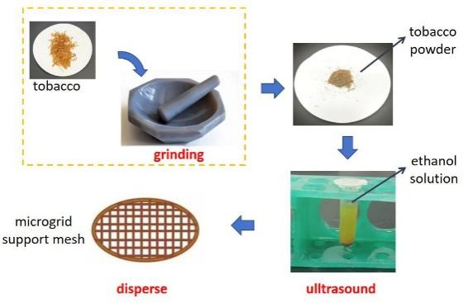
Supplementary Figures 1. Tobacco sample preparation process diagram .

Supplementary Tables 2. The results of principal component analysis ( PCA): Eigenvalues and Percentage of Variance corresponding to each principal component.
Principal Component Number | Eigenvalue | Percentage of Variance (%) | Cumulative (%)
1 | 2.69683 | 38.52615 | 38.52615
2 | 1.54435 | 22.06217 | 60.58832
3 | 1.46322 | 20.9031 | 81.49142
4 | 0.86117 | 12.30244 | 93.79386
5 | 0.4189 | 5.9843 | 99.77815
6 | 0.01317 | 0.1881 | 99.96625
7 | 0.00236 | 0.03375 | 100

Supplementary Tables 3. The components involved in PCA analysis along with their mean and standard deviation.
Number | Component | Mean | Standard Deviation
a | Average Feret diameter / nm | 2.51611 | 0.27969
b | Median Feret diameter /nm | 1.47018 | 0.15378
c | Porosity ( TEM)/% | 0.40036 | 0.0869
d | Bulk density /g/ mL | 0.55363 | 0.11644
e | Apparent (skeletal) density /g/mL | 1.07204 | 0.249
f | Porosity ( Mercury intrusion method) /% | 45.97498 | 11.71932
g | Pore volume | 0.84361 | 0.1845
PC1= -1.14e⁻⁰³*a -1.58e⁻⁰³*b +9.93e⁻⁰⁴*c -5.29e⁻⁰³*d -1.89e⁻⁰²*e -9.99e⁻⁰¹*f -9.51e⁻⁰³*g
PC2 = 9.66e⁻⁰¹*a +2.13e⁻⁰¹*b -5.66e⁻⁰²*c -5.90e⁻⁰²*d -7.96e⁻⁰²*e -5.12e⁻⁰⁴*f +8.83e⁻⁰²*g
are the two principal components with the highest variance obtained from the principal component analysis of components in Supplementary Table 3, primarily contributed by the porosity measured by mercury intrusion porosimetry and the Feret diameter measured by TEM.

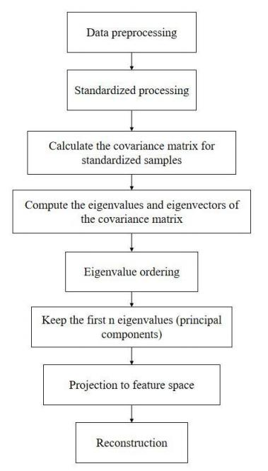
Supplementary Figures 2. Principal Component Analysis ( PCA) flowchart .
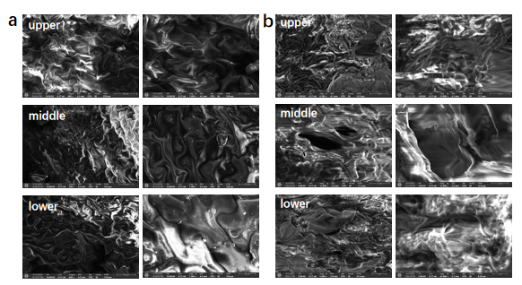
Supplementary Figures 3. SEM images for different parts ((a ) surface and (b) cross-section) within the same region , using Tonghai County ,Yuxi City ,Yunnan Province , as an example .

Supplementary Table 4. EDX Results Statistical Table for the Surface and Cross-section of Tobacco Samples ( Unit: Wt%) .

Element Position |  | C | O | Mg | Al | Si | P | S | Cl | K | Ca
Surface | Upper | 54.82 | 40. 14 | 0.28 | 0 | 0.81 | 0.18 | 0.44 | 0.16 | 2.04 | 1.14
Surface | Middle | 55.91 | 40.98 | 0.35 | 0.26 | 0.64 | 0 | 0 | 0 | 0.91 | 0.94
Surface | Lower | 54.96 | 41.22 | 0.54 | 0 | 0.21 | 0 | 0 | 0 | 1.04 | 2.03
Cross-section | Upper | 64.35 | 35.65 | 0 | 0 | 0 | 0 | 0 | 0 | 0 | 0
Cross-section | Middle | 64.02 | 35.98 | 0 | 0 | 0 | 0 | 0 | 0 | 0 | 0
Cross-section | Lower | 66.99 | 31.96 | 1.05 | 0 | 0 | 0 | 0 | 0 | 0 | 0

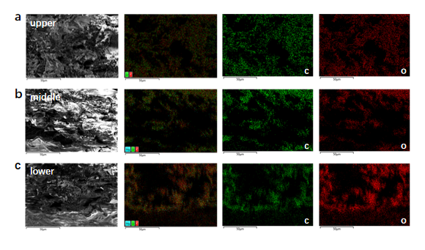
Supplementary Tables 4. EDX mapping results for cross-sections of tobacco form different parts ((a )top ,(b)middle and (c ) lower) within the same region using Tonghai County ,Yuxi City ,Yunnan Province , as an example.

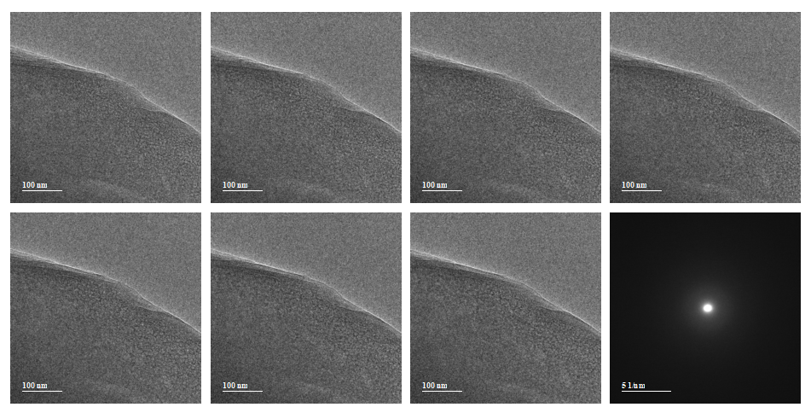
Supplementary Figures 5. The tobacco dosage threshold chart (2 e⁻/Å²s). In each chart, the top right corner represents the cumulative electron dosage (using the example of the central sample from Tonghai, Yuxi, Yunnan). The bottom right shows the electron diffraction pattern of the tobacco sample.
Due to its biomaterial nature, tobacco samples are susceptible to electron beam irradiation damage. Our electron sensitivity test indicates that tobacco undergoes significant electron beam damage when the dose rate reaches 2e⁻/Å²s, resulting in structural disruption.
The samples discussed in the text are flue-cured tobacco of the variety Yunyan 87. Each plant is calculated to have 18 leaves. The upper leaves, designated as B, correspond to the 4th to 6th leaves counted from the top; the middle leaves, designated as C, correspond to the 8th to 10th leaves; and the lower leaves, designated as X, correspond to the 14th to 16th leaves. Although these samples are from the same variety, the growth conditions vary across different regions, leading to differences in plant height and internode spacing, making it difficult to use distance as a metric. However, for this variety, we generally retain around 18 effective leaves per plant. The leaves we collected, labeled as B2F, C3F, and X2F, originate from the 4th to 6th, 8th to 10th, and 14th to 16th leaves, respectively.
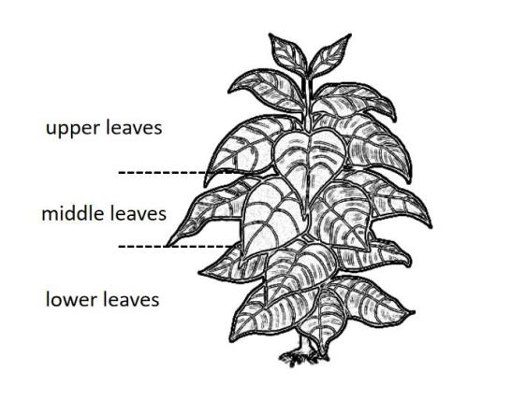
Supplementary Figures 6. Diagram of the upper, middle, and lower parts of tobacco plant.

