Synthesis and anti-liver fibrotic activity study of a chalcone derivative through anti-inflammatory effects and inhibition of JNK/NF-κB signaling pathways
Chunwei Lv^{1,#}, Lei Zhang^{2,#}, Chenxu Wang¹,Tingting Jin¹,Zhishun Zhang¹,Yixi Li¹,Dian He¹*, Quanyi Zhao¹, Lifang Zheng¹

(¹ Institute of Medicinal Chemistry, School of Pharmacy of Lanzhou University, Lanzhou 730000, China.² Gansu Medical Device Inspection And Testing Institute,Lanzhou 730000, China.)
*Corresponding author: hed@lzu.edu.cn (Dian He).
# These authors contributed equally to the work

1.Compound Safety Concentration Assay 1
2. The data of NMR and HRMS of target compounds. 2
3. ¹H NMR, ¹³C NMR and ESI-HRMS spectrum of target compounds. 8
4.Analytical RP-HPLC chromatograms of Compounds. 48

1.Compound Safety Concentration Assay
RAW264.7 cells cultured to the logarithmic growth phase were seeded at a density of 7 × 10⁴ cells/mL in a 96-well plate and incubated overnight in a culture incubator. Once the cells have fully adhered, the target compounds at final concentrations of 50 μM and 100 μM are added to the cells, with DMSO-treated control wells included. The plates are then incubated in the incubator for an additional 24 hours. After incubation, 10 μL of MTT solution at a concentration of 5 mg/mL is added to each well, and the plates are incubated in the incubator for another 4 hours. The supernatant is then removed, add 100 μL of DMSO to each well to dissolve the formed purple methylene blue, and measure the absorbance at 570 nm using a microplate reader. All experiments were independently repeated three times, and the cell survival rate was calculated in the presence of target compounds at concentrations of 50 μM and 100 μM.
Fig.S1 Effect of the target compound on the viability of RAW264.7 cells. (A) Cell viability after treatment with 100 μM of the target compound; (B) Cell viability after treatment with 50 μM of the target compound.
- The data of NMR and HRMS of target compounds.
c1: White solid,yield: 69.3%.¹H NMR (400 MHz, DMSO-d₆) δ 14.00 (s, 1H), 8.81 (s, 1H), 8.71 (d, J = 2.2 Hz, 1H), 8.27 – 8.18 (m, 2H), 7.99 (d, J = 15.5 Hz, 1H), 7.89 (dd, J = 7.2, 2.4 Hz, 2H), 7.76 (d, J = 15.5 Hz, 1H), 7.48 (m, 4H), 7.06 (d, J = 8.7 Hz, 1H); ¹³C NMR (100 MHz, DMSO-d₆) δ 187.19, 172.29, 166.04, 143.91, 135.28, 134.86, 131.01, 130.08, 129.41, 129.25, 129.00, 122.17, 118.71, 114.27; ESI-MS: calcd. for C₁₆H₁₃NO₃ [M+H]⁺ 268.0974, found 268.0983.
c2: White solid,yield: 21.7%.¹H NMR (400 MHz, DMSO-d₆) δ 13.95 (s, 1H), 8.79 (s, 1H), 8.69 (d, J = 2.2 Hz, 1H), 8.20 (dd, J = 8.7, 2.2 Hz, 2H), 8.15 – 8.06 (m, 1H), 8.02 (d, J = 15.7 Hz, 1H), 7.84 (d, J = 15.7 Hz, 1H), 7.53 (dd, J = 7.6, 5.4 Hz, 1H), 7.34 (m, 2H), 7.05 (d, J = 8.7 Hz, 1H). ¹³C NMR (100 MHz, DMSO-d₆) δ 187.07, 172.17, 166.20, 162.59, 160.09, 134.91, 133.12, 133.04, 130.29, 129.25, 128.73, 125.45, 125.42, 124.39, 124.35, 123.00, 122.89, 118.77, 116.72, 116.51, 114.48. ESI-MS: calcd. for C₁₆H₁₂FNO₃ [M-H]⁻ 284.0729, found 284.0729.
c3: White solid,yield: 45.2%. ¹H NMR (400 MHz, DMSO-d₆) δ 13.97 (s, 1H), 8.76 (s, 1H), 8.69 (d, J = 2.2 Hz, 1H), 8.27 – 8.18 (m, 2H), 8.02 (d, J = 15.5 Hz, 1H), 7.84 – 7.74 (m, 2H), 7.74 – 7.65 (m, 2H), 7.52 (td, J = 7.9, 6.0 Hz, 1H), 7.30 (td, J = 8.6, 2.6 Hz, 1H), 7.05 (d, J = 8.7 Hz, 1H). ¹³C NMR (100 MHz, DMSO-d₆) δ 187.12, 172.23, 166.11, 164.18, 161.76, 142.41, 142.38, 137.91, 137.83, 134.92, 131.42, 131.34, 130.22, 128.84, 125.90, 125.88, 123.65, 118.70, 117.76, 117.55, 115.12, 114.91, 114.36. ESI-MS: calcd. for C₁₆H₁₂FNO₃ [M-H]⁻ 284.0729, found 284.0728.
c4: White solid,yield: 41.7%. ¹H NMR (400 MHz, DMSO-d₆) δ 13.98 (s, 1H), 8.80 (s, 1H), 8.71 (d, J = 2.2 Hz, 1H), 8.27 – 8.19 (m, 2H), 7.96 (m,3H), 7.77 (d, J = 15.5 Hz, 1H), 7.34 (t, J = 8.8 Hz, 2H), 7.06 (d, J = 8.7 Hz, 1H). ¹³C NMR (100 MHz, DMSO-d₆) δ 187.12, 172.27, 166.01, 165.05, 162.58, 142.61, 134.83, 131.98, 131.95, 131.57, 131.48, 130.10, 128.98, 122.11, 122.08, 118.64, 116.52, 116.30, 114.31. ESI-MS: calcd. for C₁₆H₁₂FNO₃ [M+H]⁺ 286.0873, found 286.0890.
c5: white solid,yield: 23.5%.¹H NMR (400 MHz, DMSO-d₆) δ 13.96 (s, 1H), 8.78 (s, 1H), 8.70 (d, J = 2.2 Hz, 1H), 8.28 – 8.17 (m, 2H), 8.06 (d, J = 15.5 Hz, 1H), 7.97 – 7.88 (m, 2H), 7.77 (d, J = 15.6 Hz, 1H), 7.62 (t, J = 7.9 Hz, 1H), 7.46 (d, J = 8.3 Hz, 1H), 7.05 (d, J = 8.7 Hz, 1H). ¹³C NMR (100 MHz, DMSO-d₆) δ 187.10, 172.24, 166.06, 142.39, 135.46, 134.87, 134.27, 130.91, 130.16, 129.45, 128.91, 122.94, 118.68, 114.33. ESI-MS: calcd. for C₁₆H₁₂ClNO₃ [M-H]⁻ 300.0434, found 300.0436.
c6: White solid,yield: 39.7%.¹H NMR (400 MHz, DMSO-d₆) δ 13.97 (s, 1H), 8.77 (s, 1H), 8.69 (d, J = 2.2 Hz, 1H), 8.22 (dd, J = 8.7, 2.1 Hz, 2H), 8.06 – 7.98 (m, 2H), 7.82 (d, J = 6.0 Hz, 1H), 7.72 (d, J = 15.5 Hz, 1H), 7.51 (m, 2H), 7.05 (d, J = 8.7 Hz, 1H). ¹³C NMR (100 MHz, DMSO-d₆) δ 187.11, 172.22, 166.11, 142.16, 137.56, 134.94, 134.28, 131.21, 130.55, 130.26, 128.84, 128.29, 128.24, 123.74, 118.68, 114.37. ESI-MS: calcd. for C₁₆H₁₂ClNO₃ [M+Na]⁺ 324.0398, found 324.0410.
c7: White solid,yield: 42.1%.¹H NMR (400 MHz, DMSO-d₆) δ 13.98 (s, 1H), 8.79 (s, 1H), 8.70 (d, J = 2.2 Hz, 1H), 8.28 – 8.16 (m, 2H), 8.00 (d, J = 15.6 Hz, 1H), 7.92 (d, J = 8.3 Hz, 2H), 7.75 (d, J = 15.6 Hz, 1H), 7.55 (d, J = 8.2 Hz, 2H), 7.06 (d, J = 8.7 Hz, 1H). ¹³C NMR (100 MHz, DMSO-d₆) δ 187.09, 172.24, 166.06, 142.38, 135.46, 134.86, 134.26, 130.90, 130.16, 129.44, 128.90, 122.93, 118.68, 114.33. ESI-MS: calcd. for C₁₆H₁₂ClNO₃ [M-H]⁻ 300.0434, found 300.0434.
c8: White solid,yield: 20.3%.¹H NMR (400 MHz, DMSO-d₆) δ 13.98 (s, 1H), 8.78 (s, 1H), 8.70 (d, J = 2.2 Hz, 1H), 8.27 – 8.19 (m, 2H), 8.16 (t, J = 1.8 Hz, 1H), 8.03 (d, J = 15.6 Hz, 1H), 7.86 (d, J = 7.7 Hz, 1H), 7.72 (d, J = 8.4 Hz, 1H), 7.71 – 7.62 (m, 2H), 7.44 (t, J = 7.9 Hz, 1H), 7.05 (d, J = 8.7 Hz, 1H). ¹³C NMR (100 MHz, DMSO-d₆) δ 187.10, 172.23, 166.10, 141.64, 137.82, 134.95, 133.44, 131.46, 131.17, 129.82, 128.85, 128.59, 123.71, 122.88, 118.66, 114.37. ESI-MS: calcd. for C₁₆H₁₂BrNO₃ [M-H]⁻ 343.9929, found 343.9928.
c9: White solid,yield: 37.8%. ¹H NMR (400 MHz, DMSO-d₆) δ 13.98 (s, 1H), 8.79 (s, 1H), 8.70 (d, J = 2.2 Hz, 1H), 8.23 (dd, J = 8.8, 2.2 Hz, 2H), 8.17 (t, J = 1.8 Hz, 1H), 8.03 (d, J = 15.6 Hz, 1H), 7.86 (d, J = 7.9 Hz, 1H), 7.72 (d, J = 15.6 Hz, 1H), 7.66 (ddd, J = 8.0, 2.0, 1.0 Hz, 1H), 7.44 (t, J = 7.9 Hz, 1H), 7.06 (d, J = 8.8 Hz, 1H). ¹³C NMR (100 MHz, DMSO-d₆) δ 187.17, 172.30, 166.17, 142.17, 137.88, 135.02, 133.51, 131.52, 131.24, 130.33, 128.91, 128.66, 123.78, 122.94, 118.73, 114.43. ESI-MS: calcd. for C₁₆H₁₂BrNO₃ [M+Na]⁺ 369.9878, found 369.9879.
c10: White solid,yield: 45.7%. ¹H NMR (400 MHz, DMSO-d₆) δ 13.98 (s, 1H), 8.79 (s, 1H), 8.69 (d, J = 2.2 Hz, 1H), 8.25 – 8.18 (m, 2H), 8.01 (d, J = 15.5 Hz, 1H), 7.89 – 7.80 (m, 2H), 7.77 – 7.65 (m, 3H), 7.05 (d, J = 8.8 Hz, 1H). ¹³C NMR (100 MHz, DMSO-d₆) δ 187.17, 172.31, 166.14, 142.55, 134.94, 134.66, 132.44, 131.19, 130.23, 128.97, 124.39, 123.04, 118.75, 114.40. ESI-MS: calcd. for C₁₆H₁₂BrNO₃ [M+H]⁺ 346.0073, found 346.0082.
c13: White solid,yield: 71.5%. ¹H NMR (400 MHz, DMSO-d₆) δ 13.97 (s, 1H), 8.79 (s, 1H), 8.68 (d, J = 2.2 Hz, 1H), 8.26 – 8.16 (m, 2H), 7.93 (d, J = 15.5 Hz, 1H), 7.80 – 7.67 (m, 3H), 7.29 (d, J = 8.0 Hz, 2H), 7.04 (d, J = 8.7 Hz, 1H), 2.35 (s, 3H). ¹³C NMR (100 MHz, DMSO-d₆) δ 187.14, 172.32, 165.97, 143.96, 141.06, 134.81, 132.56, 130.03, 129.98, 129.28, 129.10, 121.07, 118.66, 114.24, 21.56. ESI-MS: calcd. for C₁₇H₁₅NO₃ [M+H]⁺ 282.1124, found 282.1228.
c14: White solid,yield: 70.3%. ¹H NMR (400 MHz, DMSO-d₆) δ 14.00 (s, 1H), 8.83 (s, 1H), 8.70 (d, J = 2.2 Hz, 1H), 8.28 – 8.18 (m, 2H), 7.97 (d, J = 15.5 Hz, 1H), 7.76 – 7.71 (m, 2H), 7.69 (d, J = 7.8 Hz, 1H), 7.39 (t, J = 7.6 Hz, 1H), 7.31 (d, J = 7.7 Hz, 1H), 7.05 (d, J = 8.7 Hz, 1H), 2.66 (q, J = 7.6 Hz, 2H), 1.22 (t, J = 7.6 Hz, 3H). ¹³C NMR (100 MHz, DMSO-d₆) δ 187.25, 172.36, 166.08, 145.09, 135.30, 135.11, 134.83, 130.23, 130.05, 129.06, 128.79, 128.65, 119.08, 118.39, 114.32, 28.63, 16.25, 16.13. ESI-MS: calcd. for C₁₈H₁₇NO₃ [M-H]⁻ 294.1136, found 294.1147.
c15: White solid,yield: 66.7%.¹H NMR (400 MHz, DMSO-d₆) δ 14.04 (s, 1H), 8.83 (s, 1H), 8.71 (d, J = 2.2 Hz, 1H), 8.25 (s, 1H), 8.19 (dd, J = 8.8, 2.1 Hz, 1H), 8.03 (d, J = 15.3 Hz, 1H), 7.98 (dd, J = 7.7, 1.5 Hz, 1H), 7.91 (d, J = 15.3 Hz, 1H), 7.38 (td, J = 7.4, 1.5 Hz, 1H), 7.35 – 7.27 (m, 2H), 7.05 (d, J = 8.7 Hz, 1H), 2.79 (q, J = 7.6 Hz, 2H), 1.16 (t, J = 7.5 Hz, 3H). ¹³C NMR (100 MHz, DMSO-d₆) δ 187.22, 172.39, 166.19, 144.55, 140.82, 135.01, 134.79, 133.23, 129.44, 129.02, 128.98, 127.53, 126.47, 123.20, 118.44, 114.19, 26.32, 16.61. ESI-MS: calcd. for C₁₈H₁₇NO₃ [M-H]⁻ 294.1136, found 294.1134.
c16: White solid,yield: 73.2%.¹H NMR (400 MHz, DMSO-d₆) δ 14.00 (s, 1H), 8.82 (s, 1H), 8.69 (d, J = 2.2 Hz, 1H), 8.25 (s, 1H), 8.20 (dd, J = 8.7, 2.1 Hz, 1H), 7.94 (d, J = 15.5 Hz, 1H), 7.79 (d, J = 8.1 Hz, 2H), 7.73 (d, J = 15.4 Hz, 1H), 7.31 (d, J = 8.2 Hz, 2H), 7.04 (d, J = 8.7 Hz, 1H), 2.64 (q, J = 7.6 Hz, 2H), 1.19 (t, J = 7.6 Hz, 3H). ¹³C NMR (100 MHz, DMSO-d₆) δ 187.19, 172.40, 166.08, 147.36, 135.02, 134.79, 132.88, 130.08, 129.56, 129.36, 129.14, 129.10, 128.83, 128.49, 118.36, 114.25, 28.68, 15.89. ESI-MS: calcd. for C₁₈H₁₇NO₃ [M-H]⁻ 294.1136, found 294.1134.
c17: Light yellow solid,yield: 67.1%. ¹H NMR (400 MHz, DMSO-d₆) δ 14.01 (s, 1H), 8.85 (s, 1H), 8.73 (d, J = 2.2 Hz, 1H), 8.29 – 8.19 (m, 2H), 8.13 (d, J = 15.6 Hz, 1H), 8.02 (d, J = 7.8 Hz, 1H), 7.96 (d, J = 15.7 Hz, 1H), 7.54 – 7.48 (m, 1H), 7.17 (d, J = 8.4 Hz, 1H), 7.10 (t, J = 8.6 Hz, 2H), 3.94 (s, 3H). ¹³C NMR (100 MHz, DMSO-d₆) δ 187.30, 172.27, 165.90, 158.61, 138.19, 134.80, 132.73, 129.99, 129.15, 128.35, 123.59, 121.84, 121.12, 118.64, 114.33, 112.31, 56.20. ESI-MS: calcd. for C₁₇H₁₅NO₄ [M+H]⁺ 298.1073, found 298.1220.
c19: Light yellow solid,yield: 59.6%. ¹H NMR (400 MHz, DMSO-d₆) δ 13.96 (s, 1H), 8.80 (s, 1H), 8.69 (d, J = 2.2 Hz, 1H), 8.26 – 8.14 (m, 2H), 7.88 – 7.78 (m, 3H), 7.72 (d, J = 15.5 Hz, 1H), 7.02 (t, J = 8.2 Hz, 3H), 3.81 (s, 3H). ¹³C NMR (101 MHz, DMSO-d₆) δ 187.08, 172.37, 165.87, 161.75, 143.82, 134.73, 131.07, 129.89, 129.26, 127.92, 119.66, 118.57, 114.85, 114.23, 55.79. ESI-MS: calcd. for C₁₇H₁₅NO₄ [M+Na]⁺ 320.0893, found 320.0902.
c20: White solid,yield: 74.2%. ¹H NMR (400 MHz, DMSO-d₆) δ 13.98 (s, 1H), 8.80 (s, 1H), 8.69 (d, J = 2.3 Hz, 1H), 8.18 (dd, J = 8.7, 2.2 Hz, 2H), 8.09 (d, J = 15.3 Hz, 1H), 7.85 – 7.74 (m, 2H), 7.26 (d, J = 7.4 Hz, 1H), 7.19 (t, J = 7.5 Hz, 1H), 7.04 (d, J = 8.6 Hz, 1H), 2.32 (s, 3H), 2.29 (s, 3H). ¹³C NMR (100 MHz, DMSO-d₆) δ 187.27, 172.36, 166.05, 141.01, 140.77, 138.50, 134.85, 132.02, 131.17, 130.06, 129.16, 127.60, 127.25, 121.96, 118.78, 114.28, 21.48, 19.74. ESI-MS: calcd. for C₁₈H₁₇NO₃ [M-H]⁻ 294.1136, found 294.1146.
c21: White solid,yield: 72.1%. ¹H NMR (400 MHz, DMSO-d₆) δ 13.96 (s, 1H), 8.79 (s, 1H), 8.68 (d, J = 2.2 Hz, 1H), 8.18 (dd, J = 8.7, 2.1 Hz, 2H), 7.97 (d, J = 15.3 Hz, 1H), 7.89 (d, J = 7.8 Hz, 1H), 7.83 (d, J = 15.4 Hz, 1H), 7.12 (m, 2H), 7.04 (d, J = 8.7 Hz, 1H), 2.41 (s, 3H), 2.31 (s, 3H). ¹³C NMR (100 MHz, DMSO-d₆) δ 187.27, 172.37, 166.05, 141.01, 140.77, 138.50, 134.85, 132.03, 131.17, 130.06, 129.17, 127.60, 127.26, 121.97, 118.78, 114.28, 21.48, 19.75. ESI-MS: calcd. for C₁₈H₁₇NO₃ [M-H]⁻ 294.1136, found 294.1136.
c22: White solid,76.9%. ¹H NMR (400 MHz, DMSO-d₆) δ 13.97 (s, 1H), 8.81 (s, 1H), 8.70 (d, J = 2.2 Hz, 1H), 8.23 – 8.15 (m, 2H), 7.97 (d, J = 15.3 Hz, 1H), 7.84 (d, J = 15.3 Hz, 1H), 7.76 (s, 1H), 7.16 (s, 2H), 7.04 (d, J = 8.8 Hz, 1H), 2.38 (s, 3H), 2.34 (s, 3H). ¹³C NMR (100 MHz, DMSO-d₆) δ 187.27, 172.28, 165.99, 141.17, 135.81, 135.41, 134.82, 133.70, 131.54, 131.19, 130.10, 129.07, 127.50, 122.79, 118.68, 114.28, 21.07, 19.32. ESI-MS: calcd. for C₁₈H₁₇NO₃ [M-H]⁻ 294.1136, found 294.1148.
c23: White solid,yield: 63.4%. ¹H NMR (400 MHz, DMSO-d₆) δ 13.96 (s, 1H), 8.79 (s, 1H), 8.68 (d, J = 2.2 Hz, 1H), 8.26 – 8.14 (m, 2H), 8.01 (d, J = 15.7 Hz, 1H), 7.92 (d, J = 15.7 Hz, 1H), 7.60 (dd, J = 6.7, 2.7 Hz, 1H), 7.20 – 7.13 (m, 2H), 7.04 (d, J = 8.6 Hz, 1H), 3.82 (d, J = 16.4 Hz, 6H). ¹³C NMR (100 MHz, DMSO-d₆) δ 187.30, 172.25, 166.00, 153.29, 148.70, 137.83, 134.81, 130.07, 129.03, 128.85, 124.74, 123.00, 119.30, 118.71, 115.39, 114.30, 61.50, 56.29. ESI-MS: calcd. for C₁₈H₁₇NO₅ [M-H]⁻ 326.1035, found 326.1035.
c24: Yellow solid,yield: 76.2%. ¹H NMR (400 MHz, DMSO-d₆) δ 13.90 (s, 1H), 8.78 (s, 1H), 8.66 (d, J = 2.2 Hz, 1H), 8.22 – 8.13 (m, 2H), 8.03 (d, J = 15.6 Hz, 1H), 7.93 (d, J = 8.6 Hz, 1H), 7.79 (d, J = 15.6 Hz, 1H), 7.03 (d, J = 8.7 Hz, 1H), 6.66 (m, 2H), 3.91 (s, 3H), 3.85 (s, 3H). ¹³C NMR (100 MHz, DMSO-d₆) δ 187.20, 172.30, 165.67, 163.55, 160.29, 138.34, 134.70, 129.83, 129.43, 119.04, 118.52, 116.99, 116.48, 114.31, 106.89, 98.72, 56.32, 56.03. ESI-MS: calcd. for C₁₈H₁₇NO₅ [M+H]⁺ 328.1179, found 328.1198.
c26: White solid,yield: 61.3%. ¹H NMR (400 MHz, DMSO-d₆) δ 13.73 (s, 1H), 8.75 (s, 1H), 8.57 (s, 1H), 8.17 – 7.95 (m, 4H), 7.38 (t, J = 8.4 Hz, 1H), 7.03 (d, J = 8.5 Hz, 1H), 6.75 (d, J = 8.5 Hz, 2H), 3.90 (s, 6H). ¹³C NMR (100 MHz, DMSO-d₆) δ 189.36, 172.49, 165.77, 160.91, 135.43, 135.10, 133.20, 130.52, 130.24, 124.91, 118.89, 115.60, 112.73, 105.19, 57.08. ESI-MS: calcd. for C₁₈H₁₇NO₅ [M-H]⁻ 326.1035, found 326.1031.
c30: Fluorescent yellow solid,yield: 65.2%.¹H NMR (400 MHz, DMSO-d₆) δ 13.87 (s, 1H), 8.76 (s, 1H), 8.65 (s, 1H), 8.24 – 8.16 (m, 2H), 8.06 (d, J = 15.5 Hz, 1H), 7.76 (d, J = 15.5 Hz, 1H), 7.50 (s, 1H), 7.03 (d, J = 8.7 Hz, 1H), 6.75 (s, 1H), 3.89 (d, J = 10.3 Hz, 6H), 3.82 (s, 3H). ¹³C NMR (100 MHz, DMSO-d₆) δ 187.24, 172.29, 165.72, 151.69, 149.46, 144.40, 134.85, 130.00, 129.33, 128.09, 123.86, 119.87, 118.43, 114.47, 112.13, 111.79, 56.23, 56.10, 55.39. ESI-MS: calcd. for C₁₉H₁₉NO₆ [M-H]⁻ 356.1140, found 356.1139.

- ¹H NMR, ¹³C NMR and ESI-HRMS spectrum of target compounds.
Compound c1
¹H NMR
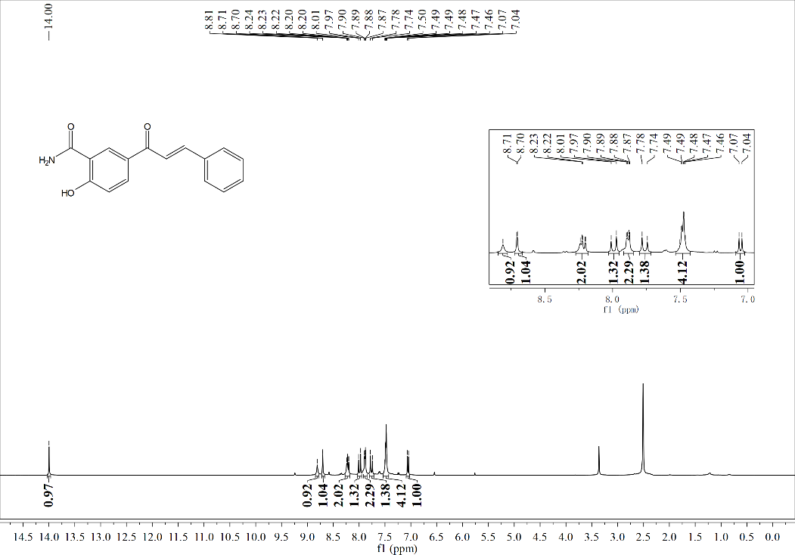
¹³C NMR
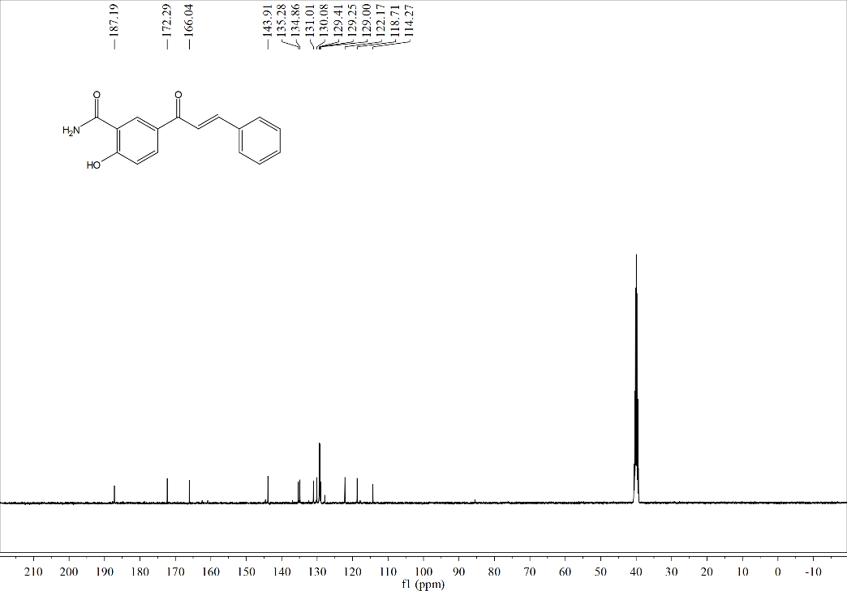
HRMS
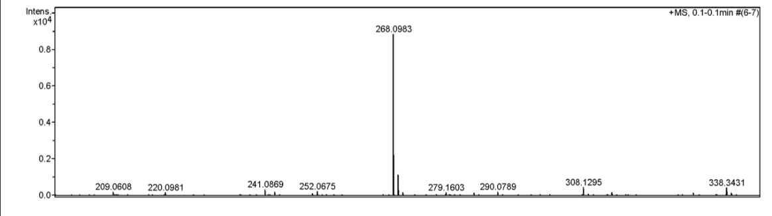
Compound c2
¹H NMR
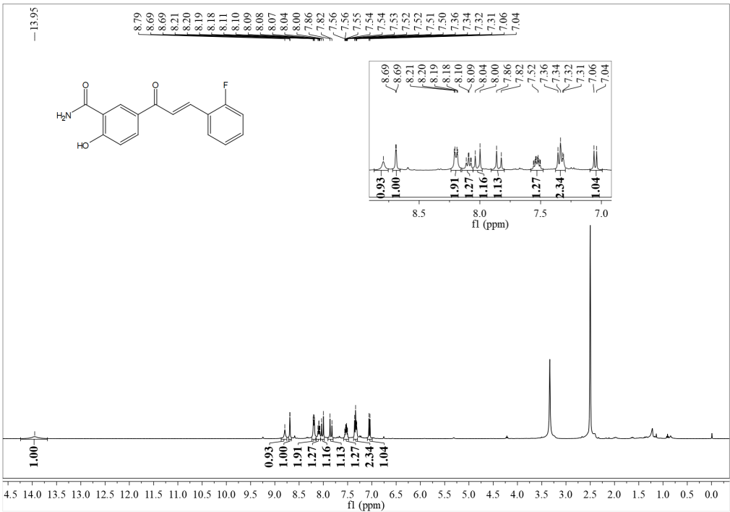
¹³C NMR
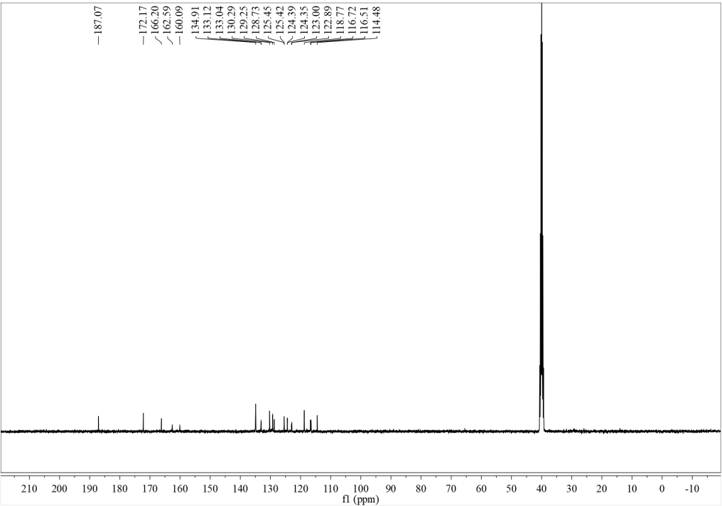

HRMS
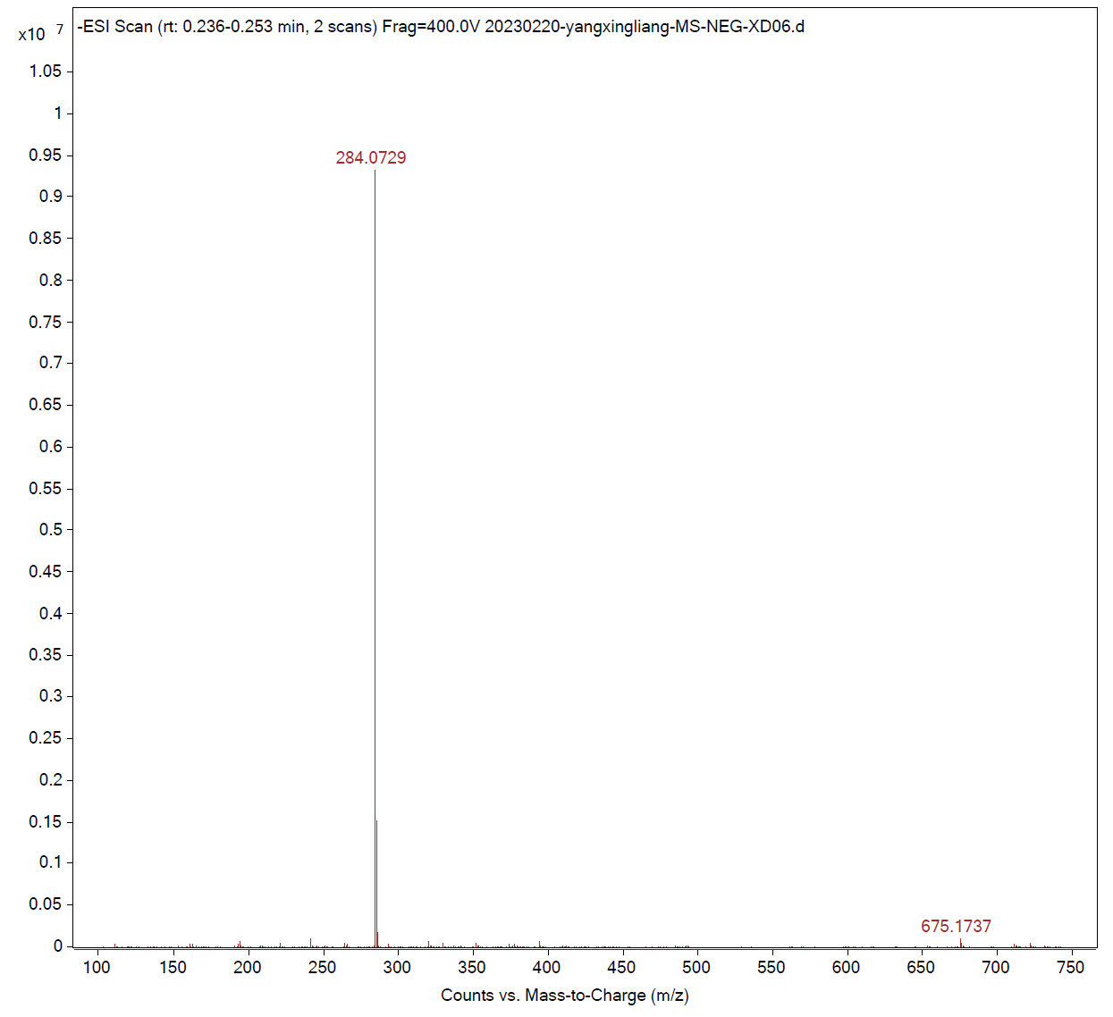
Compound c3
¹H NMR
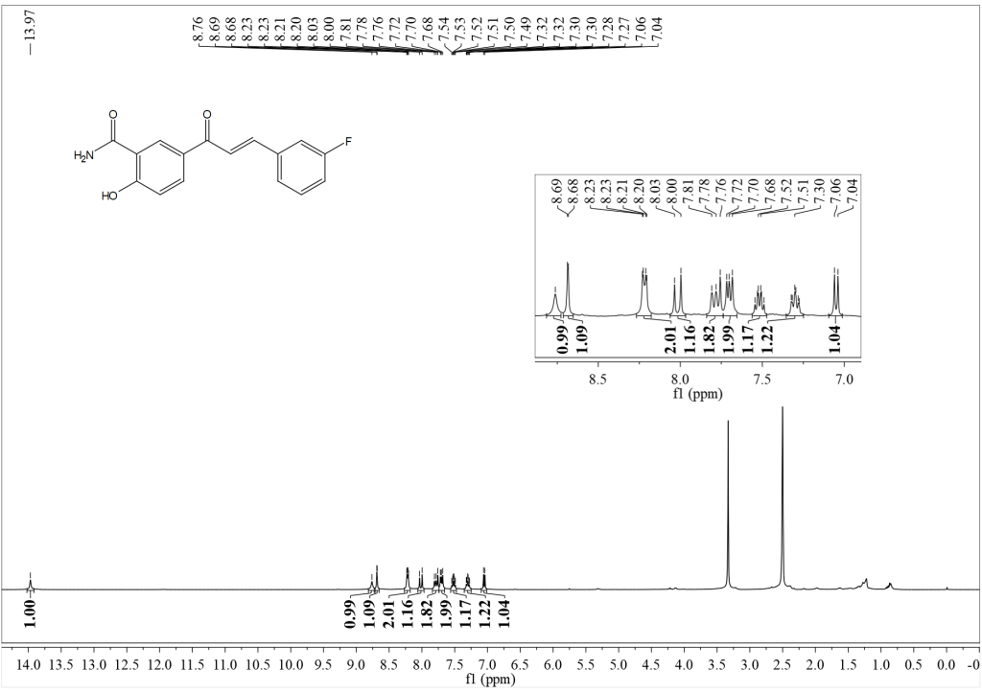

¹³C NMR
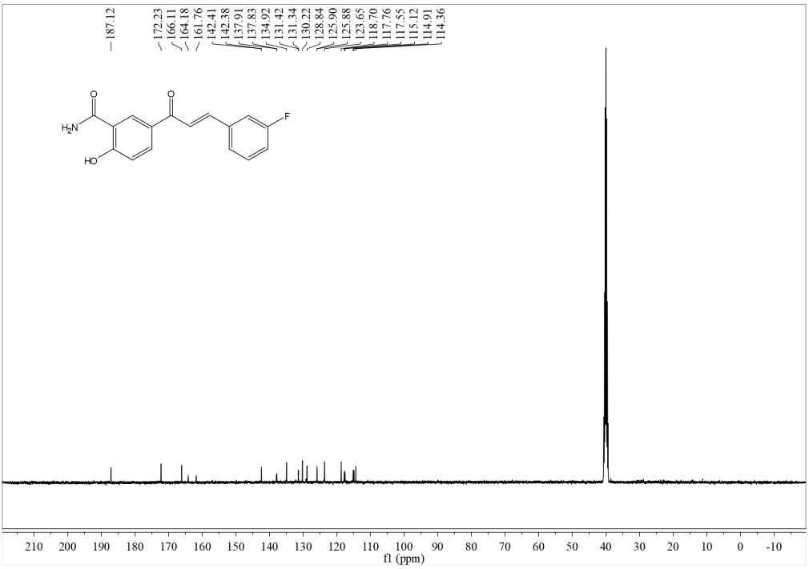
HRMS
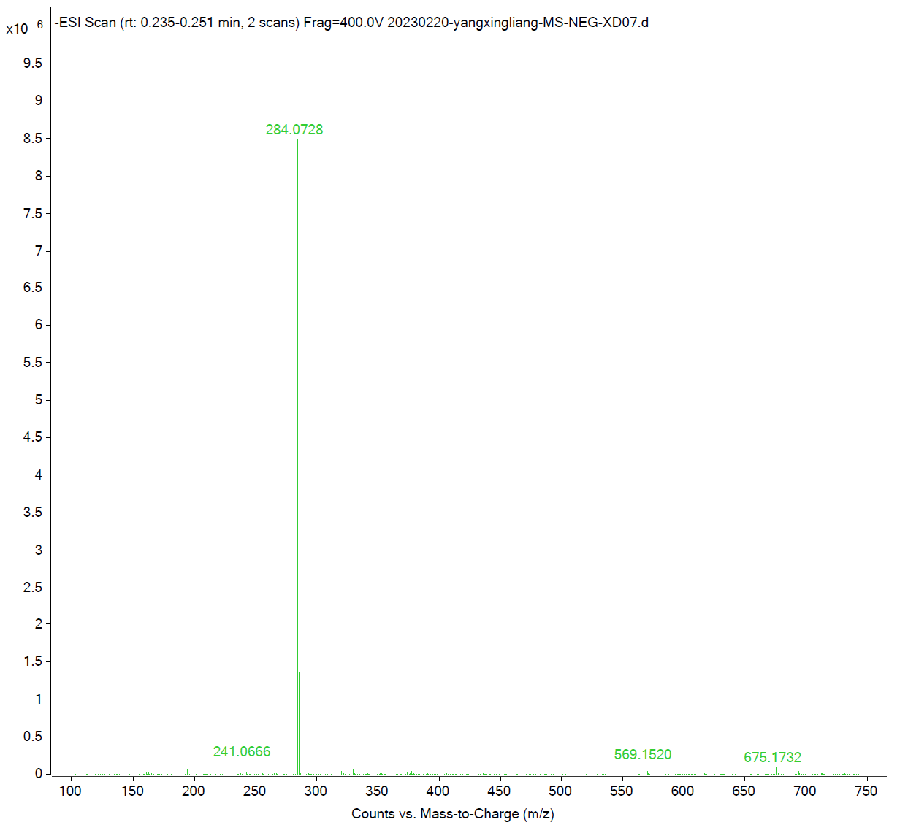

Compound c4
¹H NMR
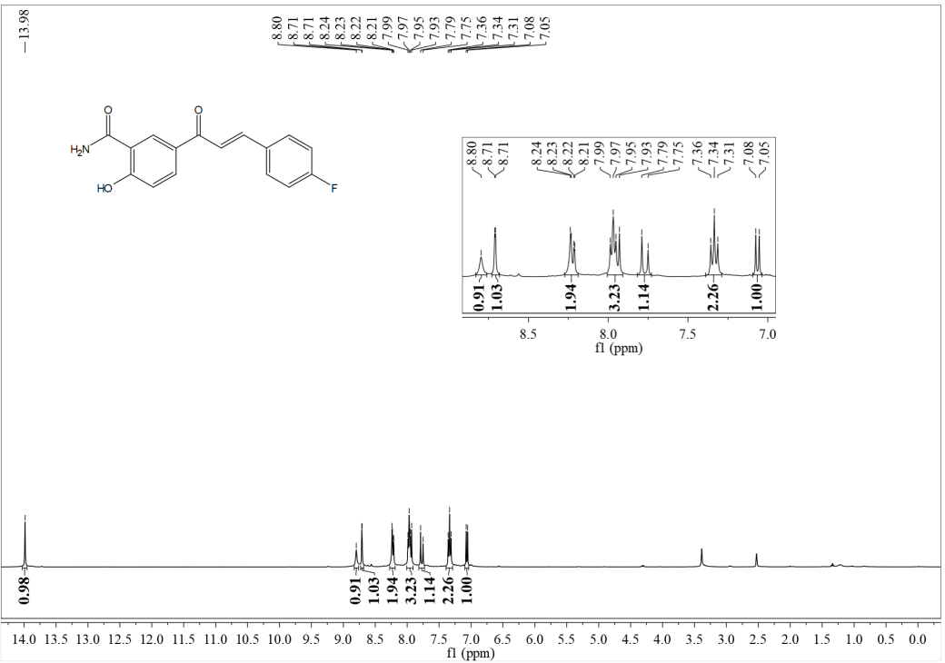
¹³C NMR
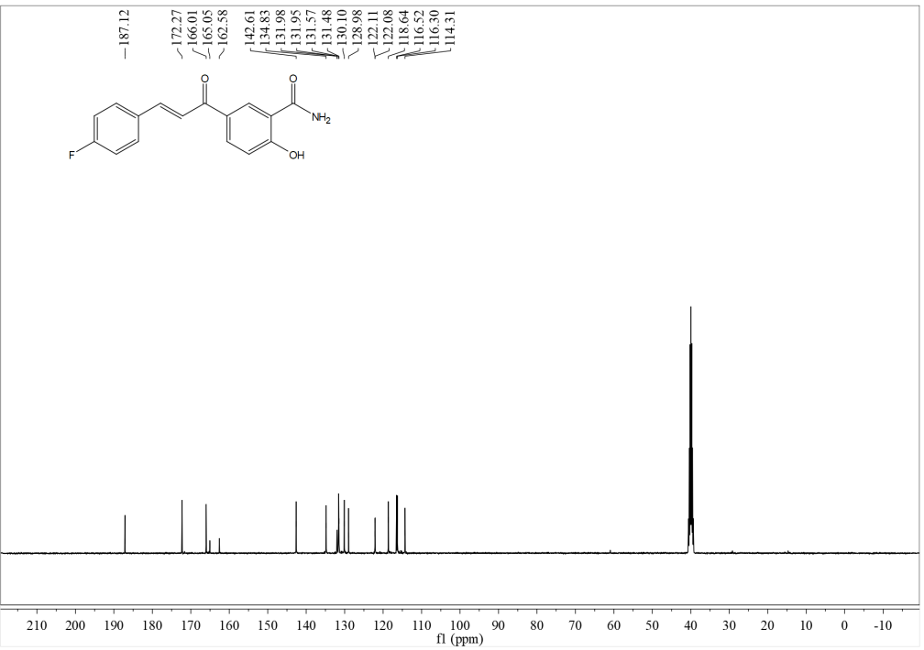
HRMS

Compound c5
¹H NMR
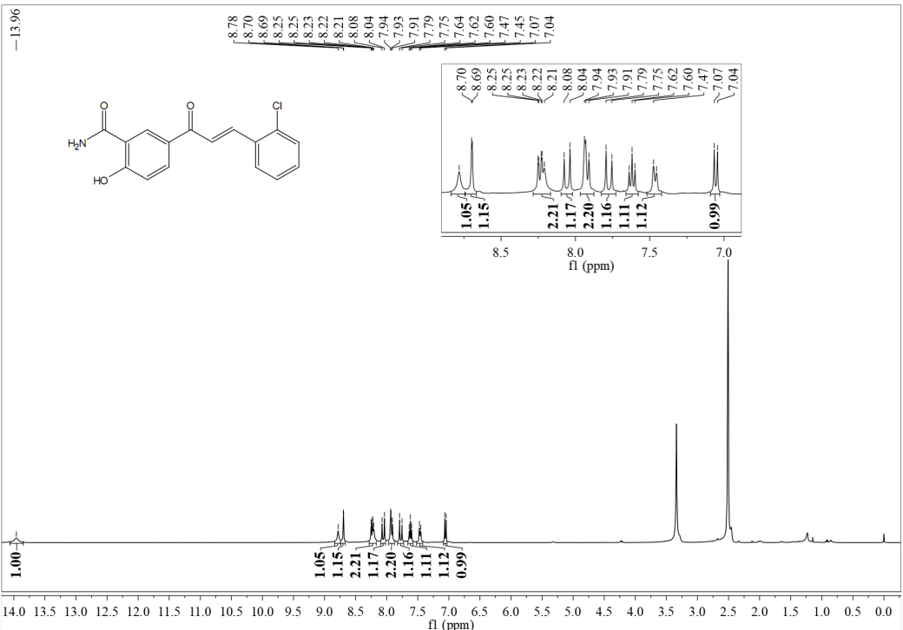
¹³C NMR
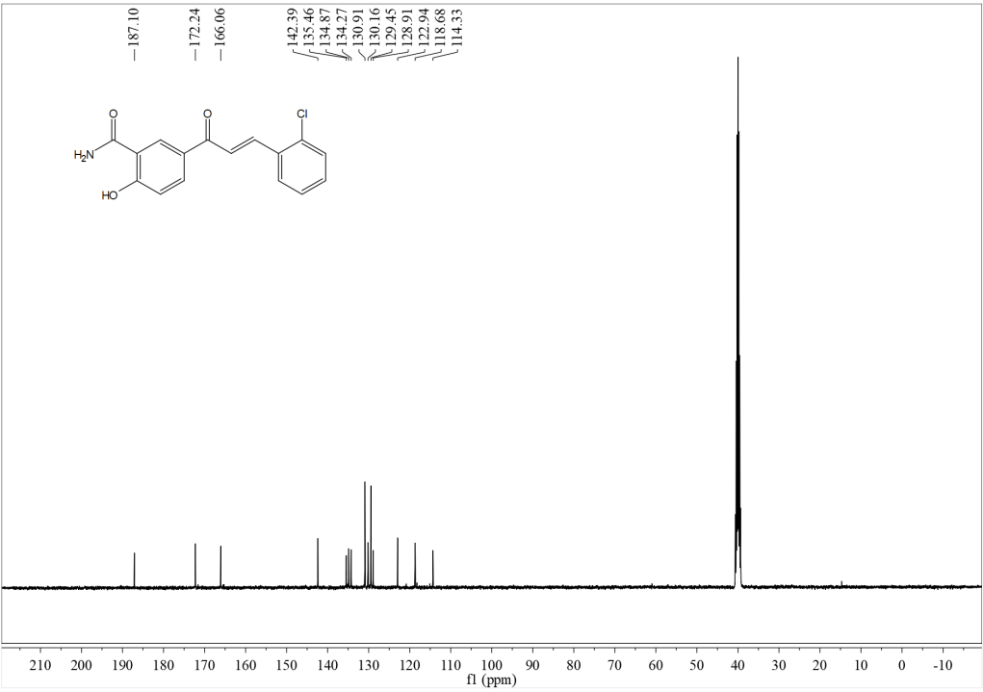

HRMS
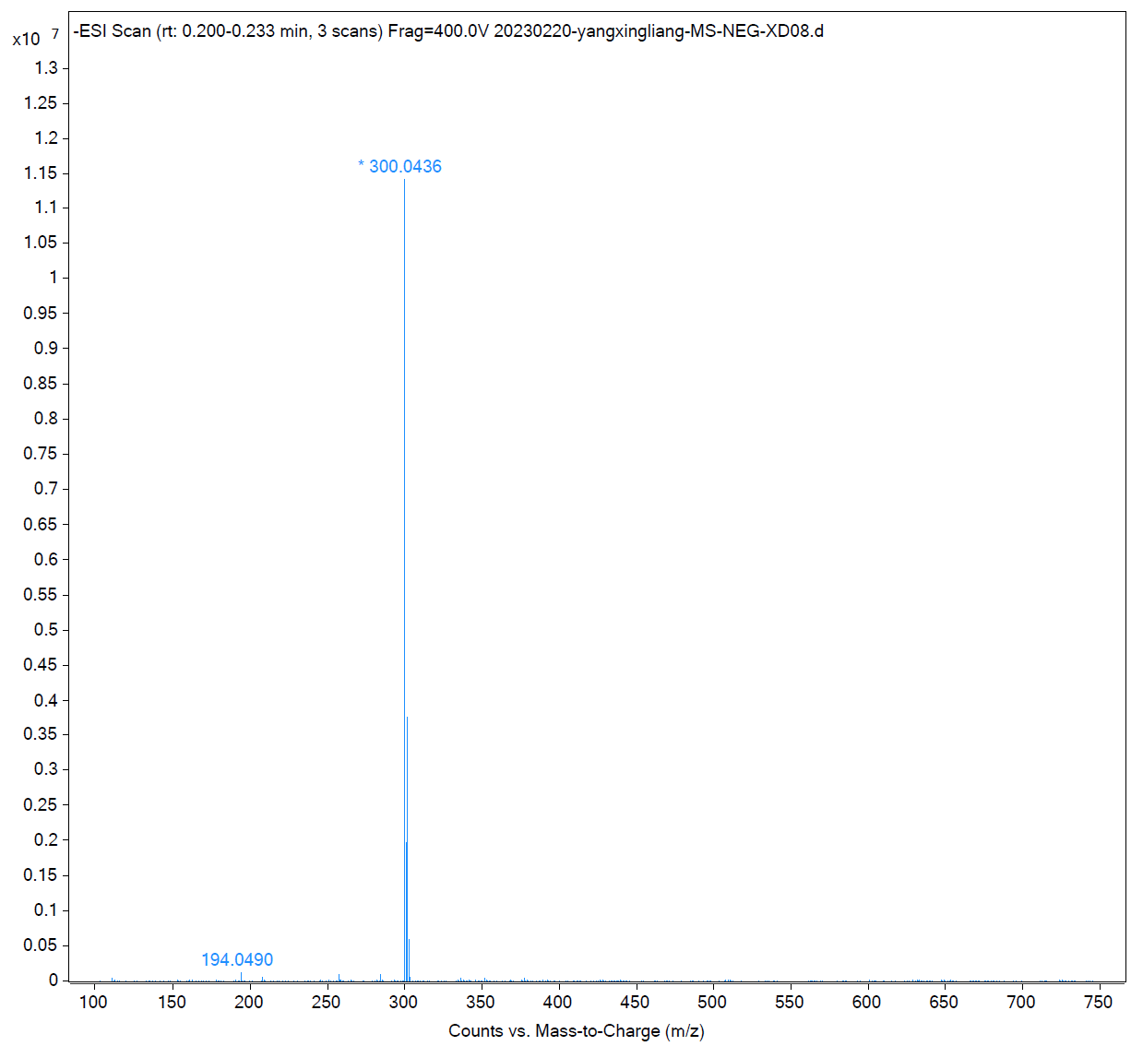
Compound c6
¹H NMR
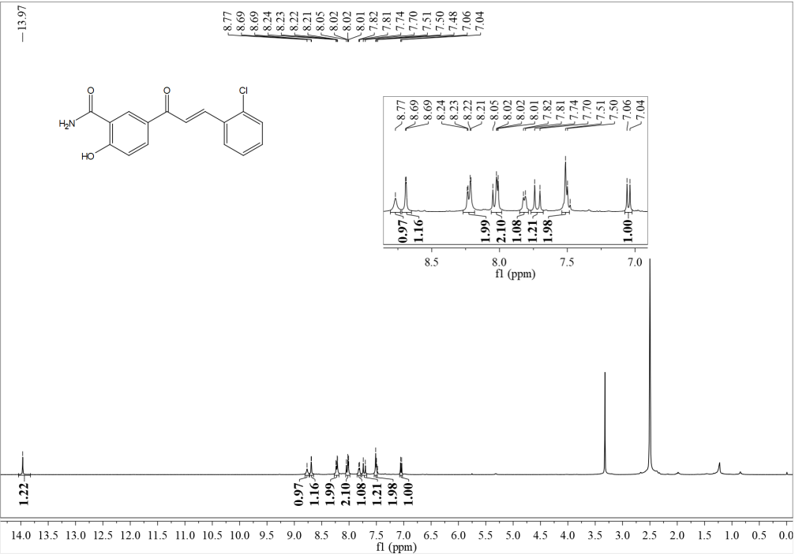

¹³C NMR
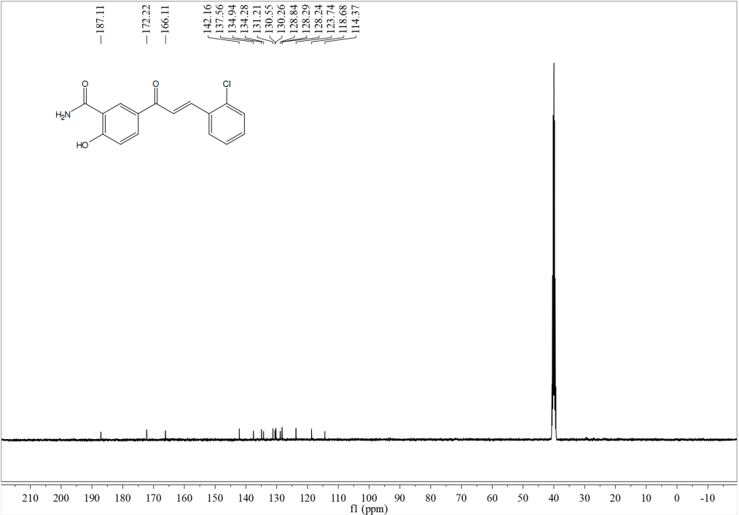
HRMS
Compound c7
¹H NMR
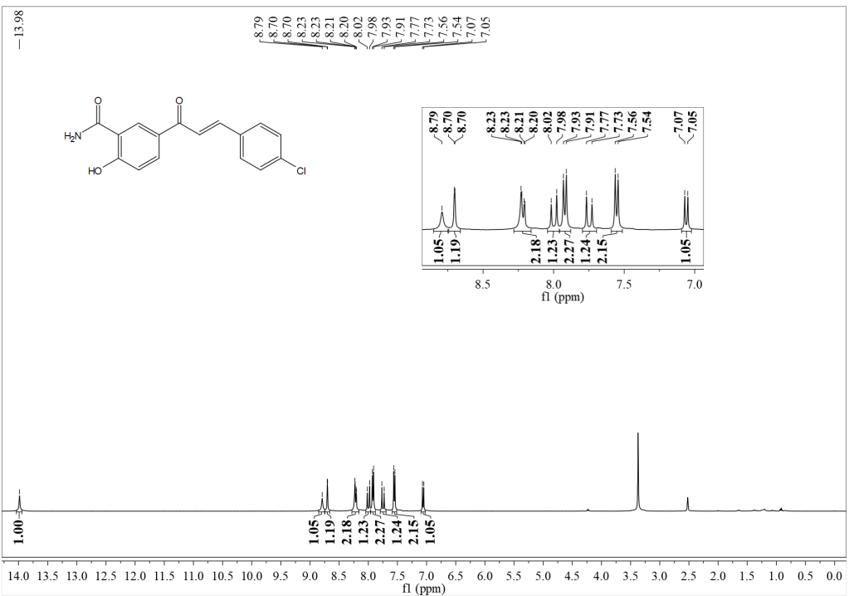

¹³C NMR
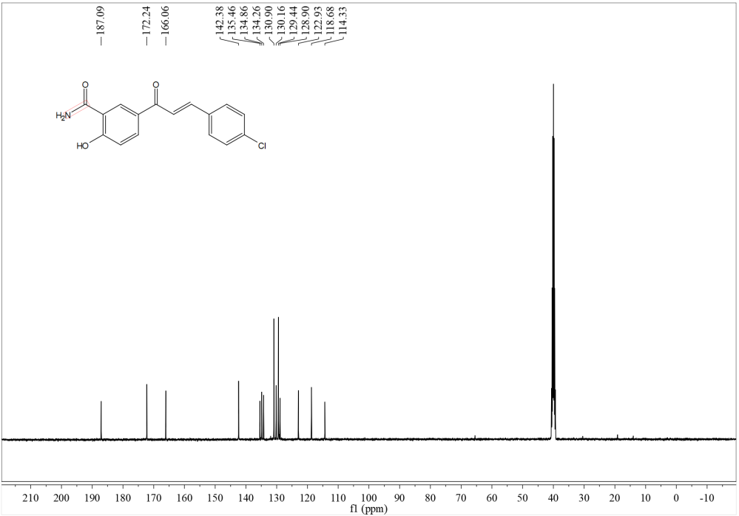
HRMS
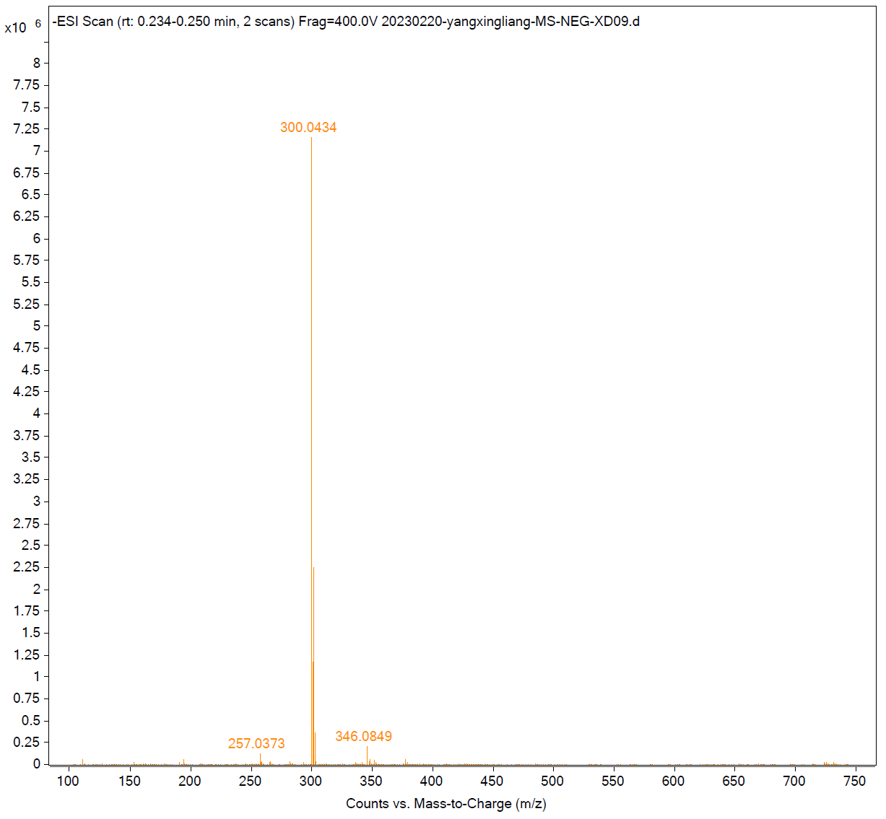

Compound c8
¹H NMR
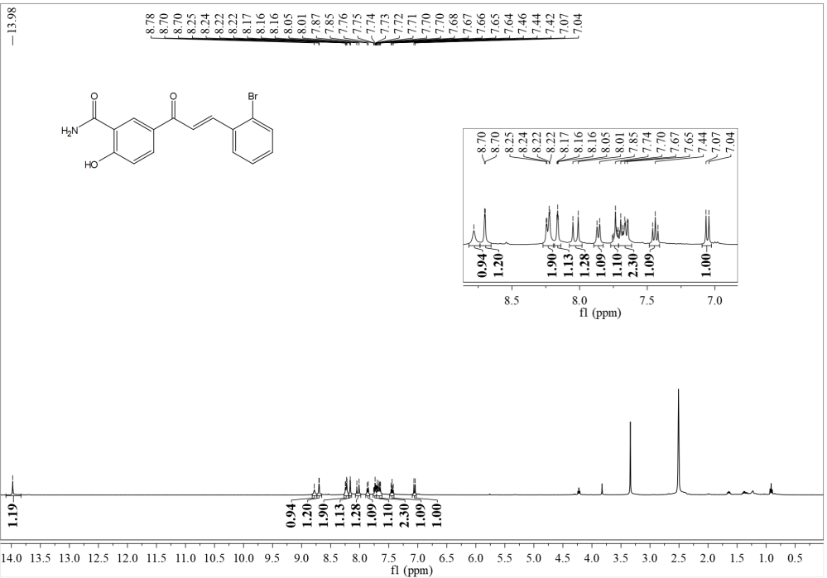
¹³C NMR
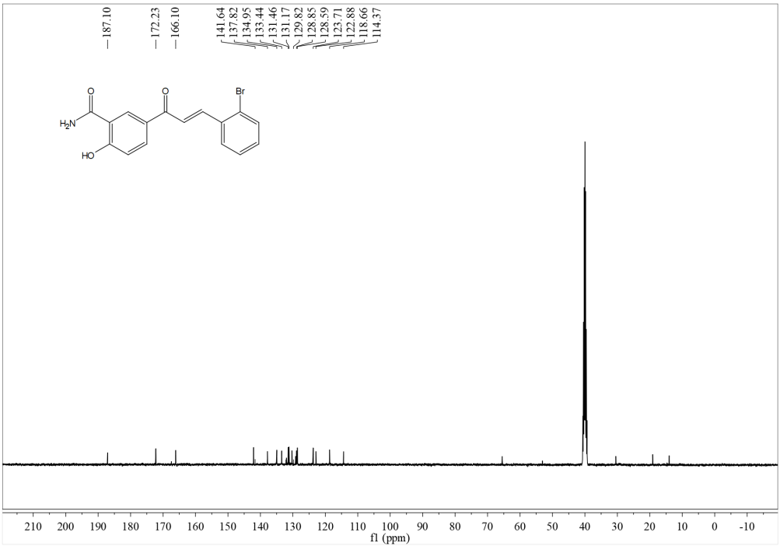

HRMS
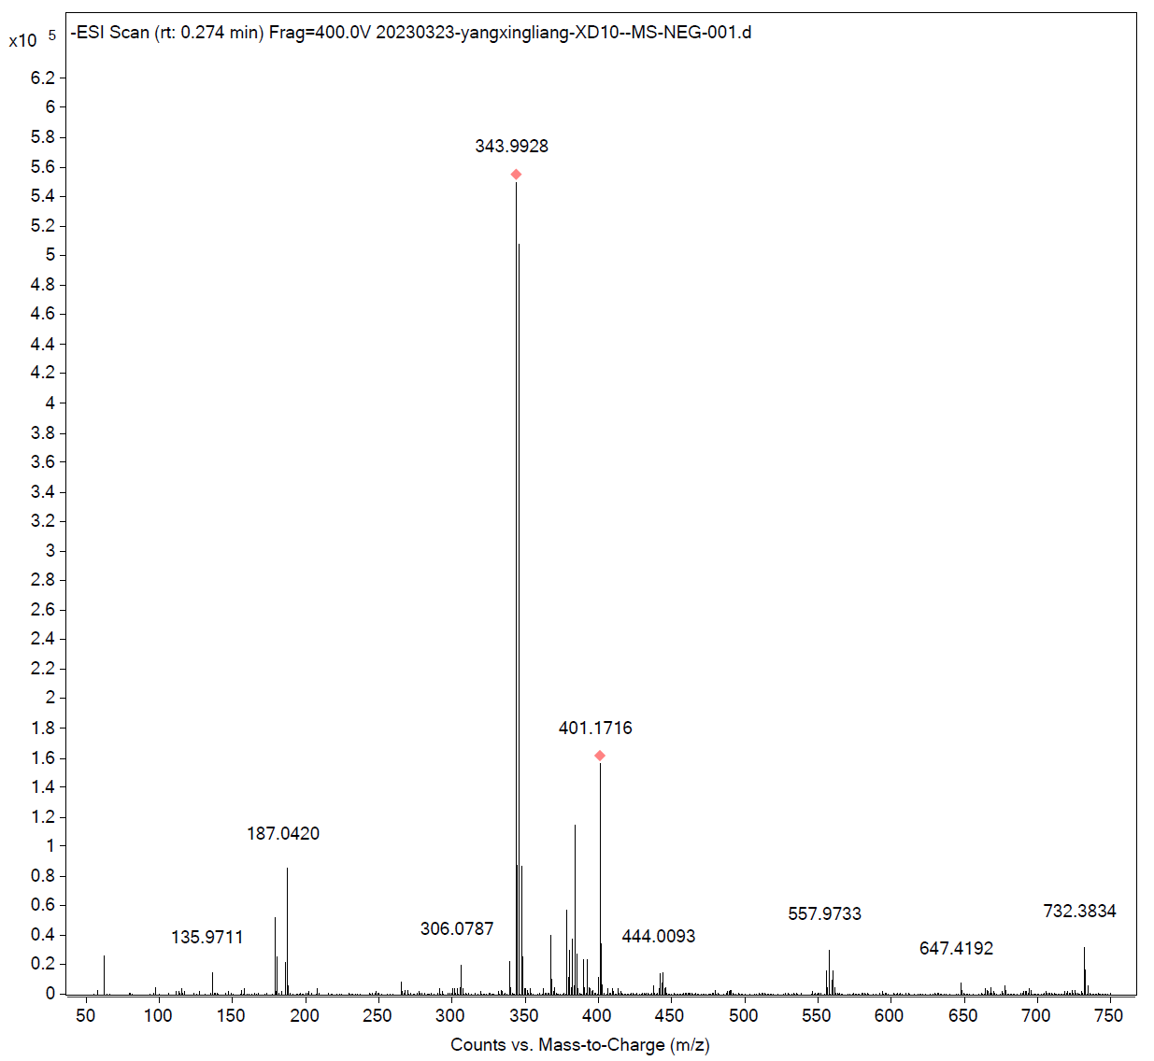
Compound c9
¹H NMR
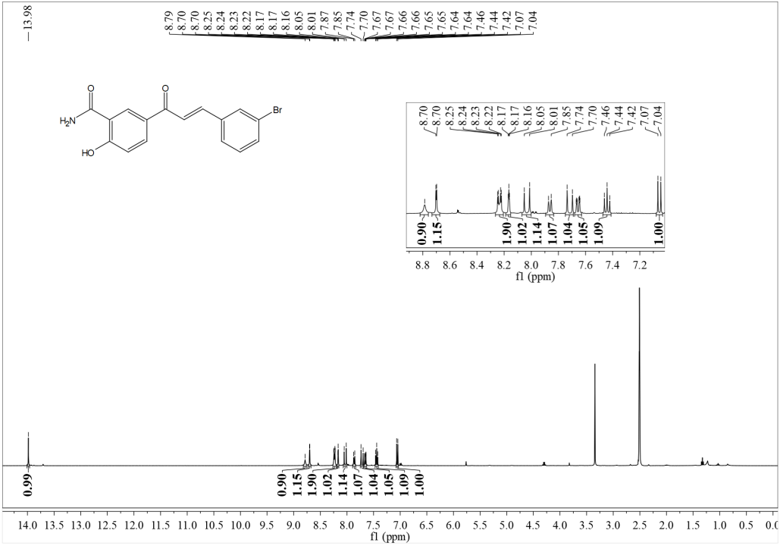

¹³C NMR
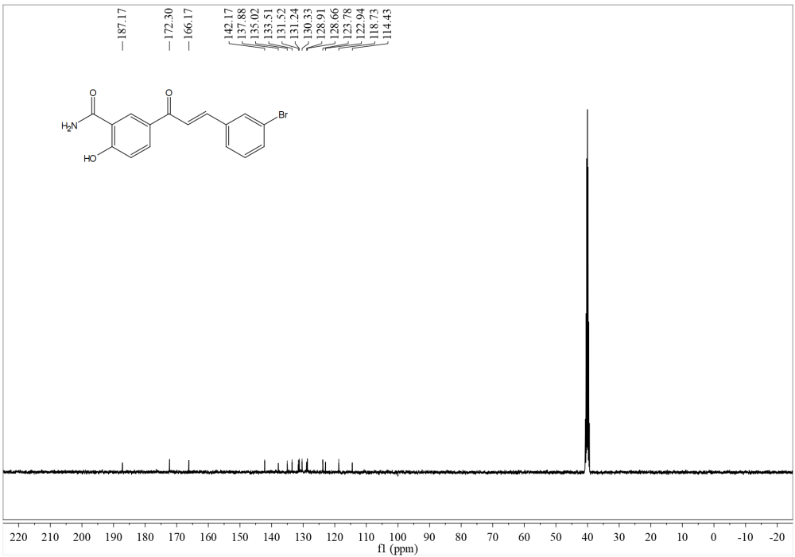
HRMS
Compound c10
¹H NMR
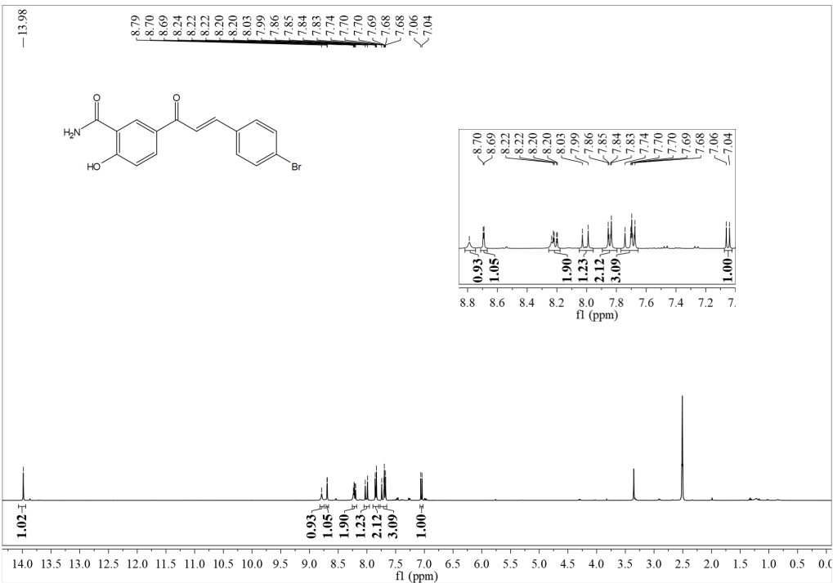

¹³C NMR
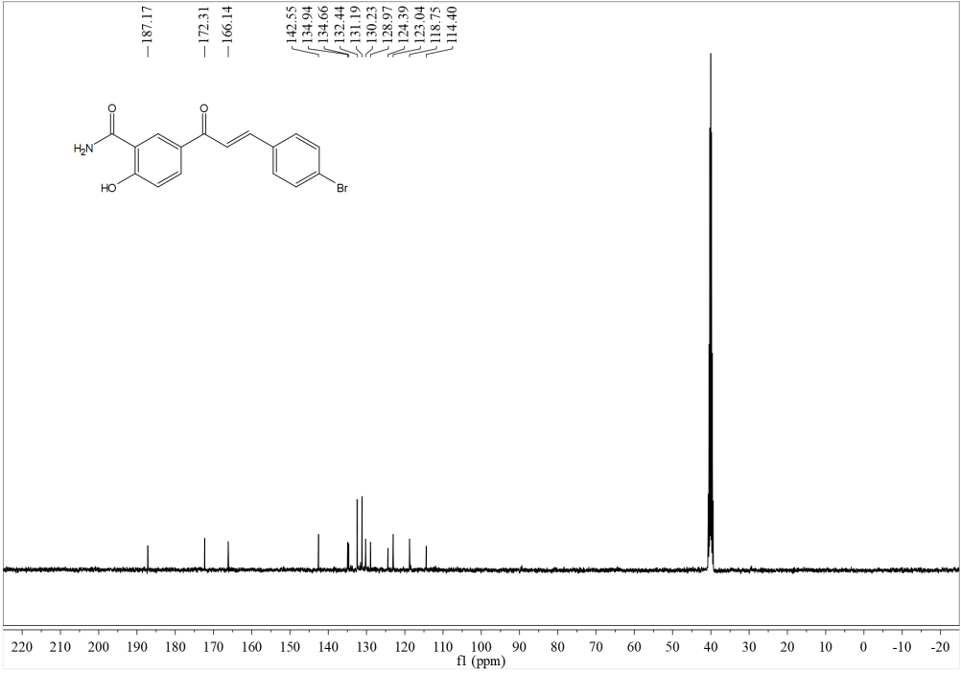
HRMS
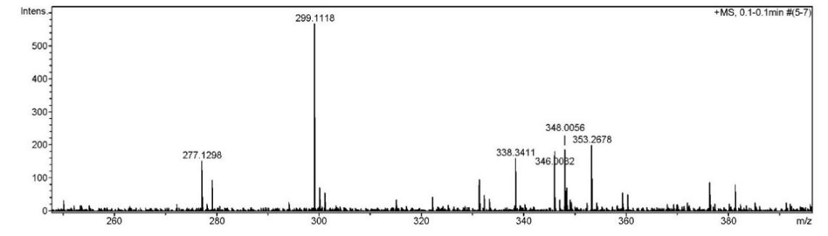
Compound c11
¹H NMR
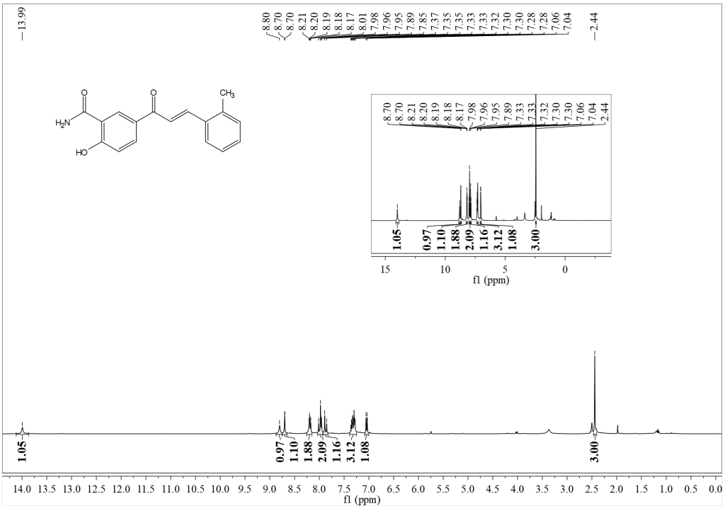

¹³C NMR
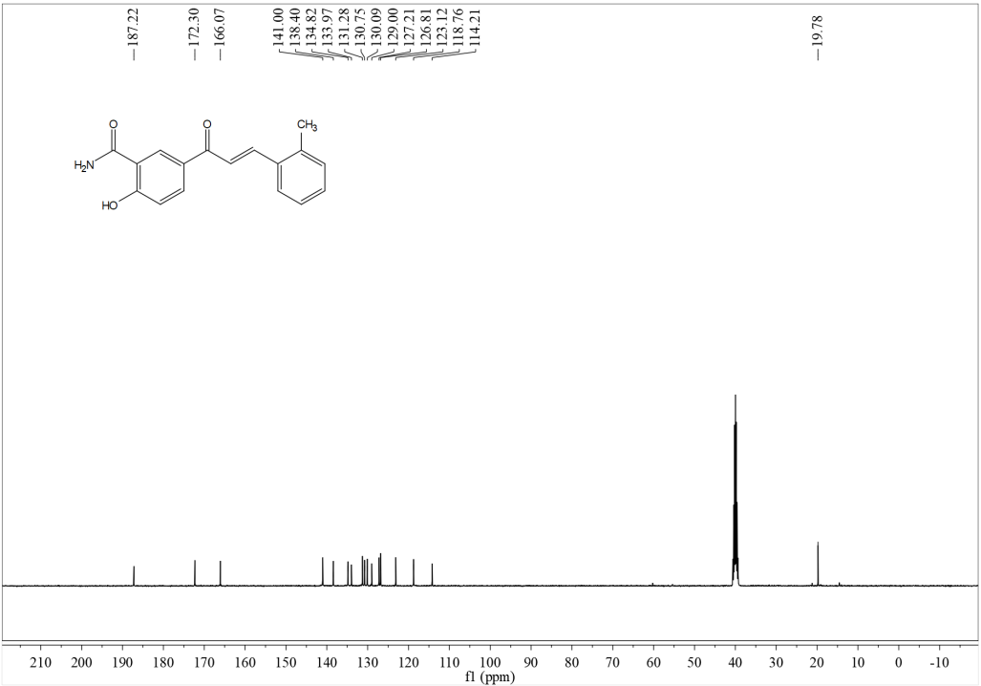
HRMS
Compound c12
¹H NMR
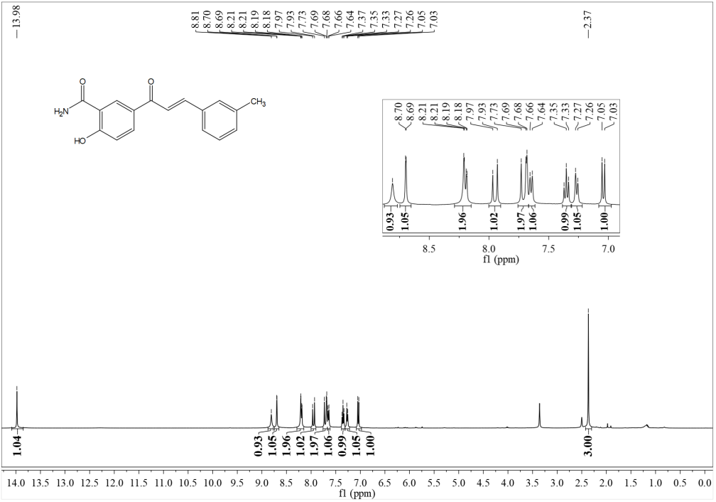

¹³C NMR
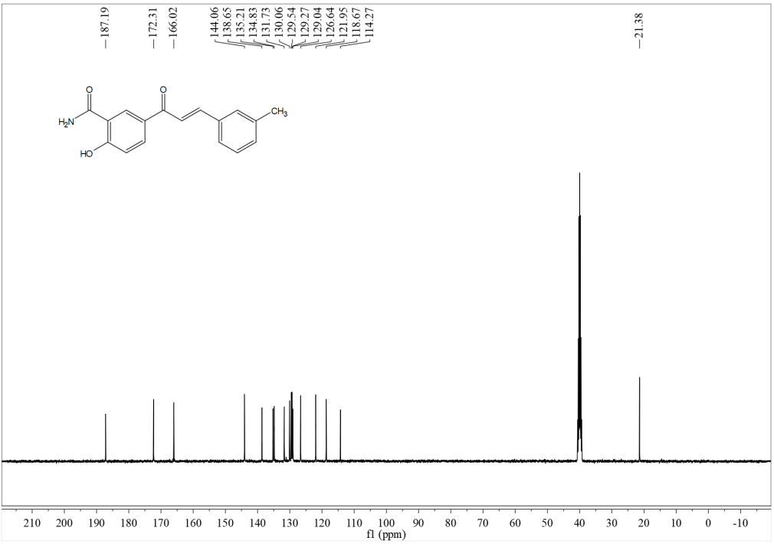
HRMS
Compound c13
¹H NMR
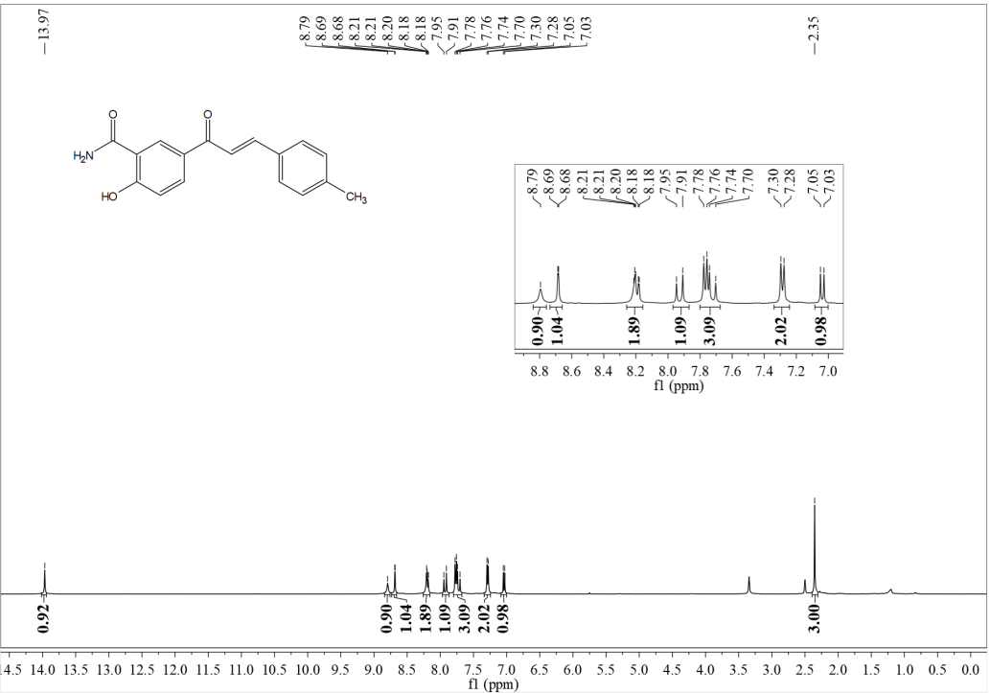

¹³C NMR
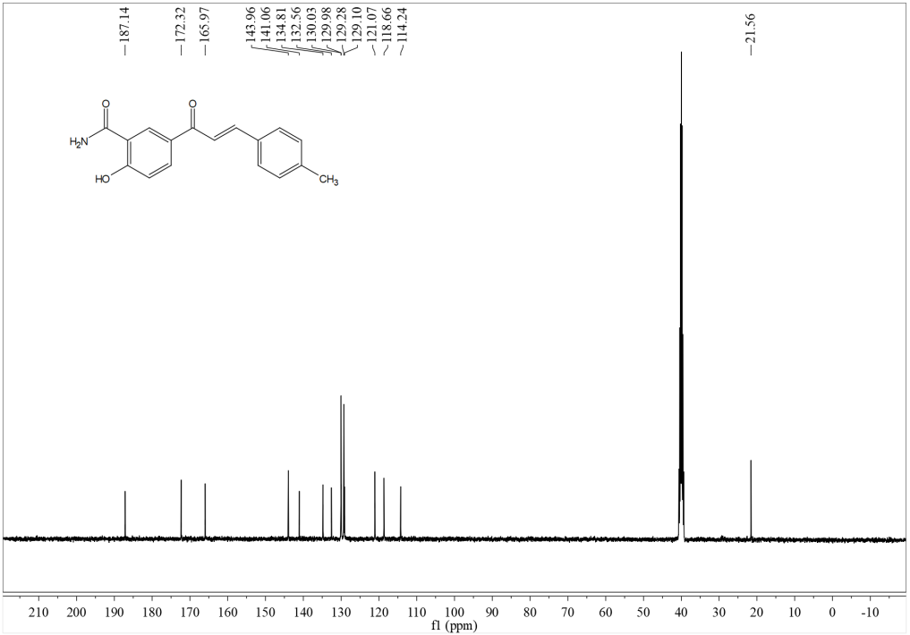
HRMS
Compound c14
¹H NMR
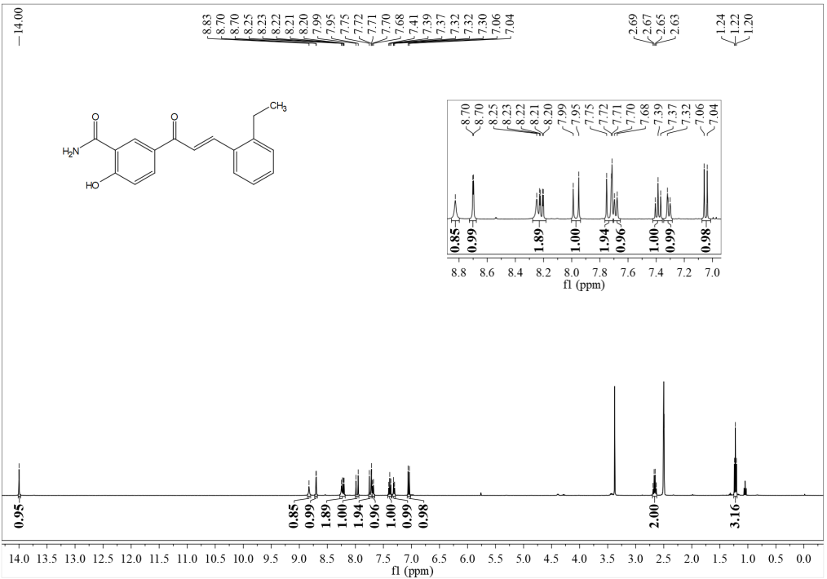

¹³C NMR
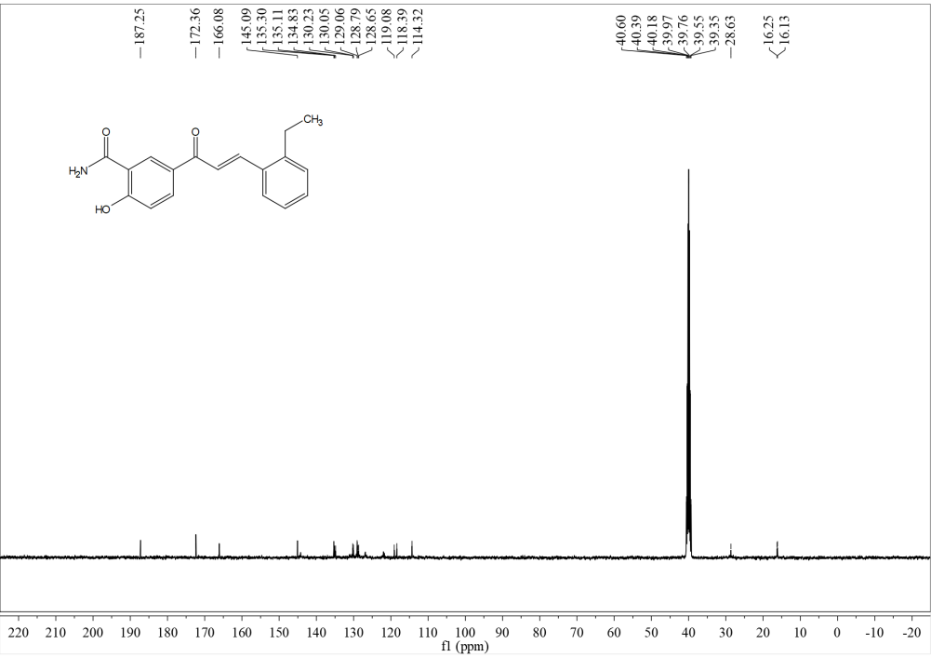
HRMS
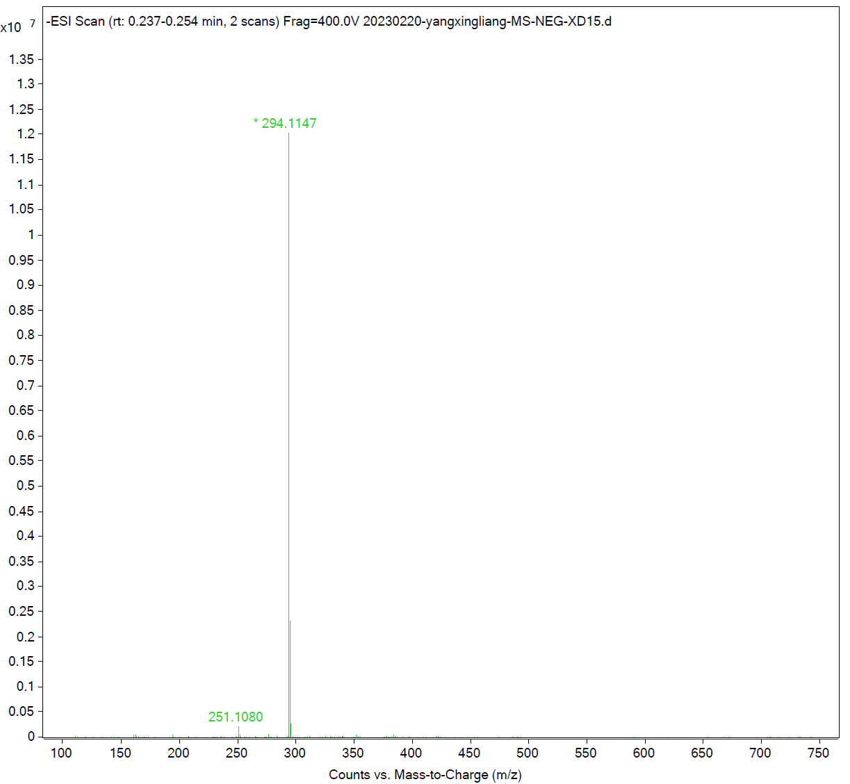

Compound c15
¹H NMR
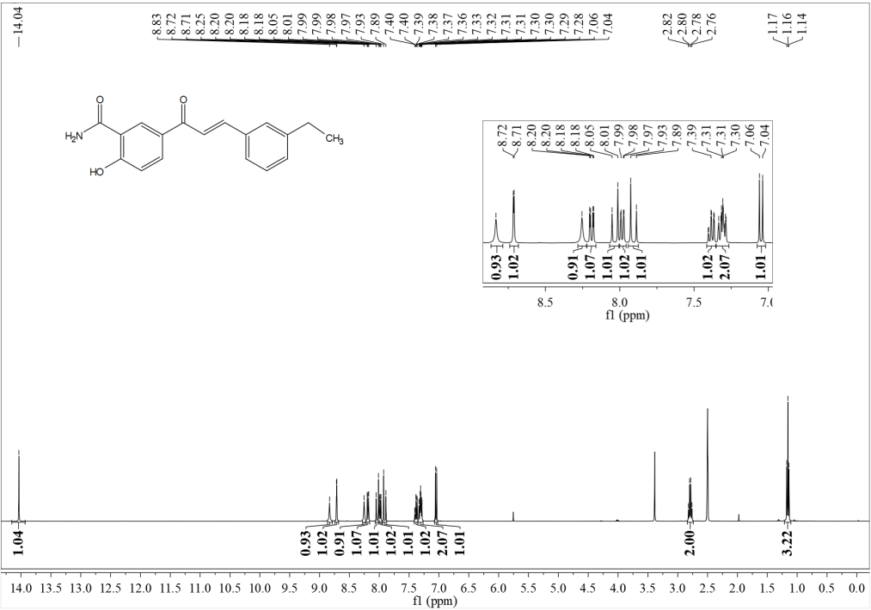
¹³C NMR
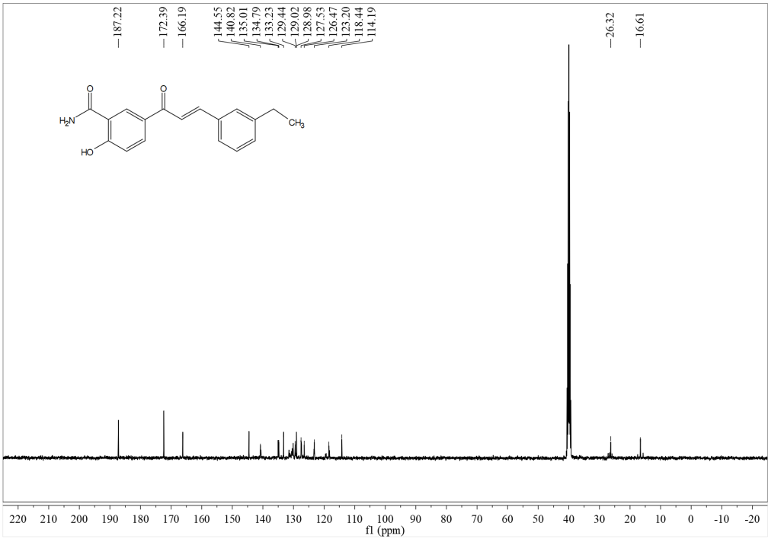

HRMS
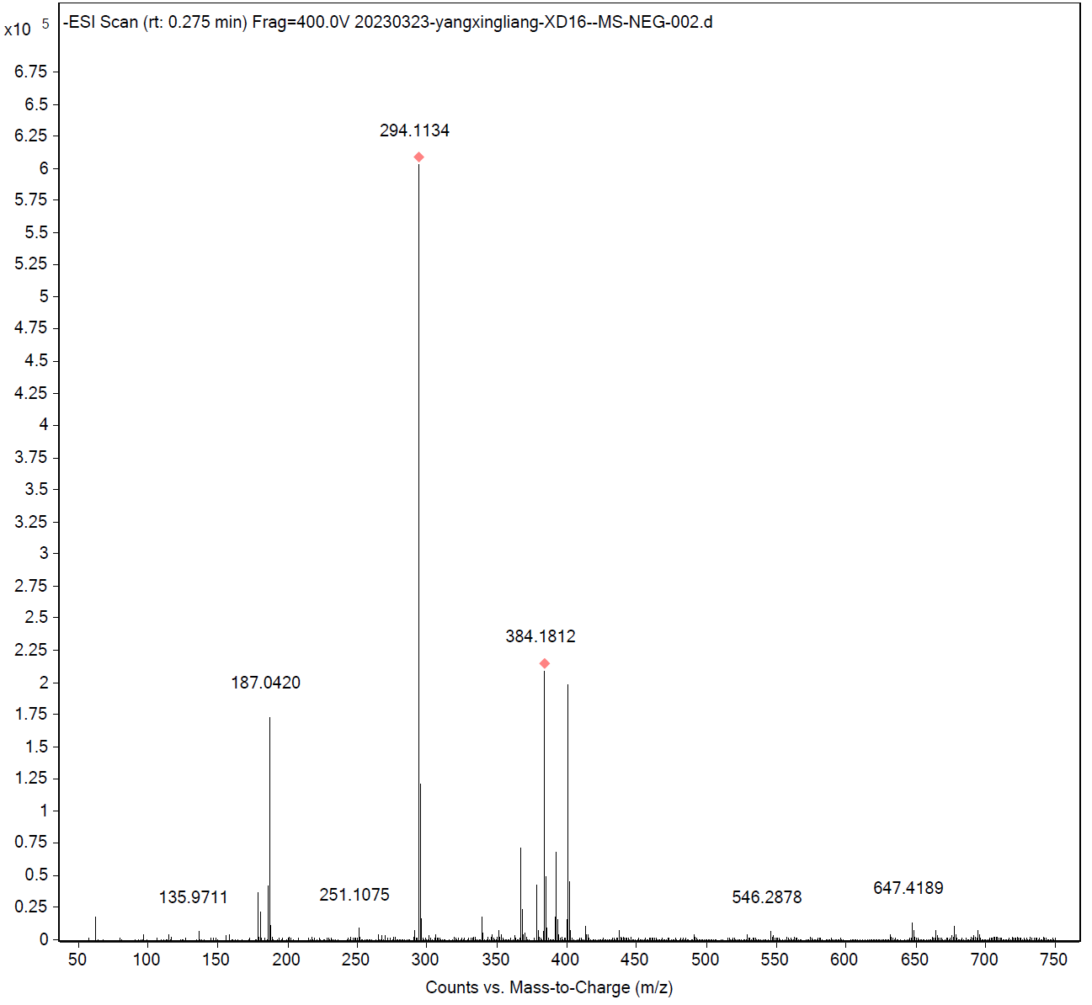
Compound c16
¹H NMR
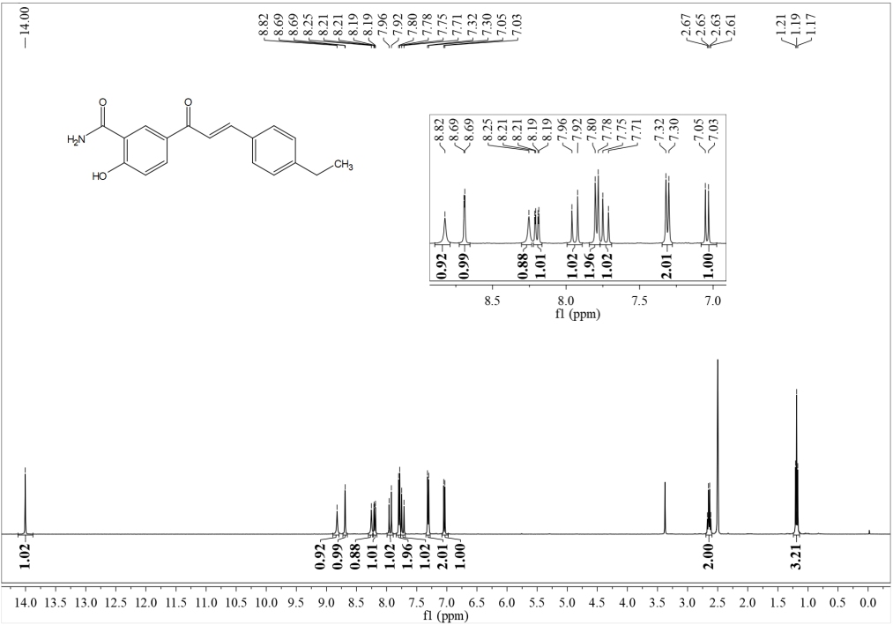

¹³C NMR
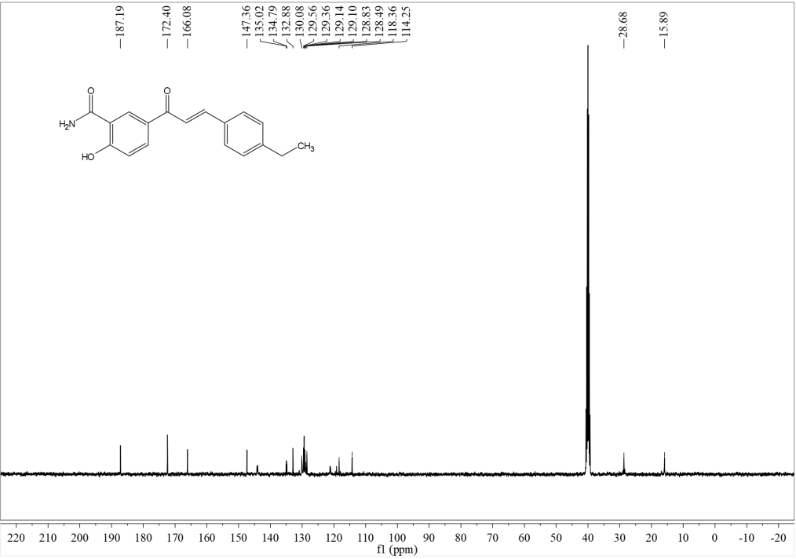
HRMS
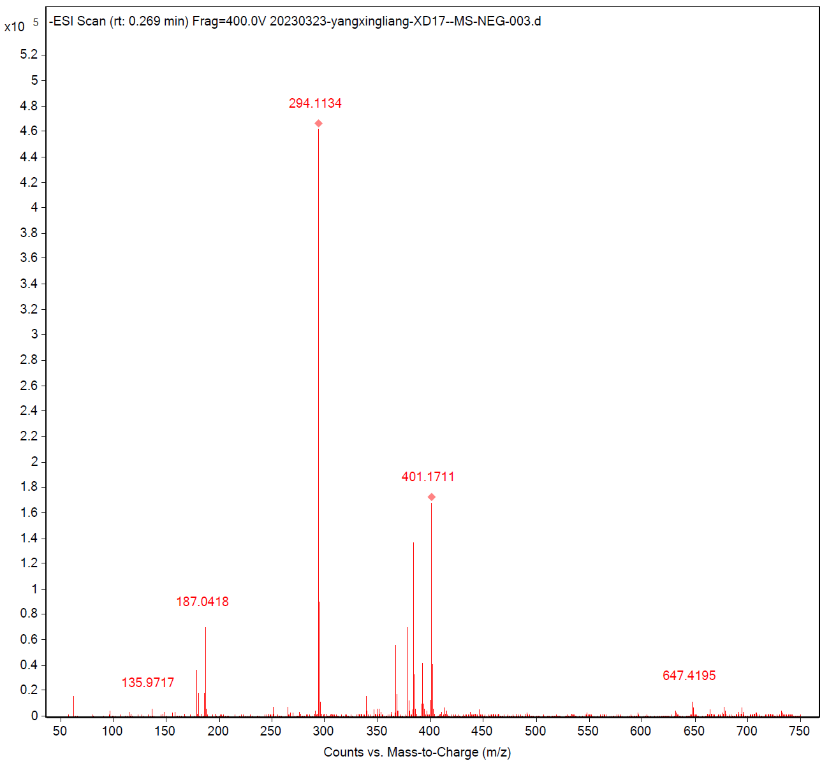

Compound c17
¹H NMR
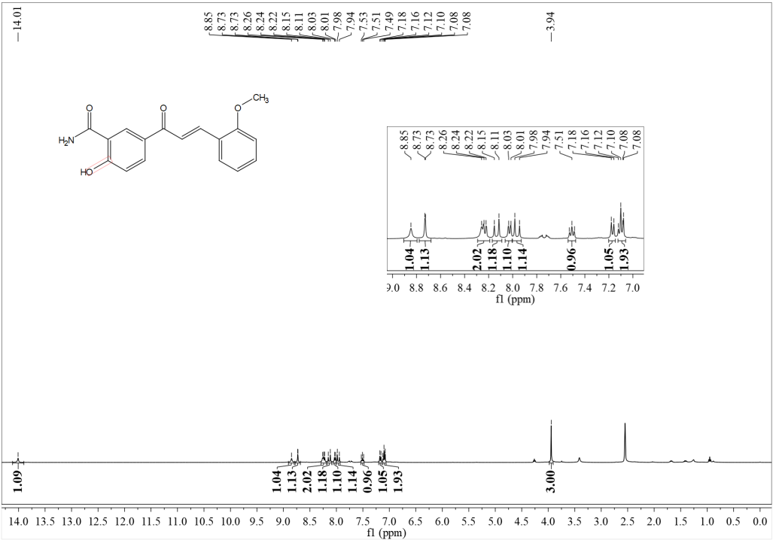
¹³C NMR
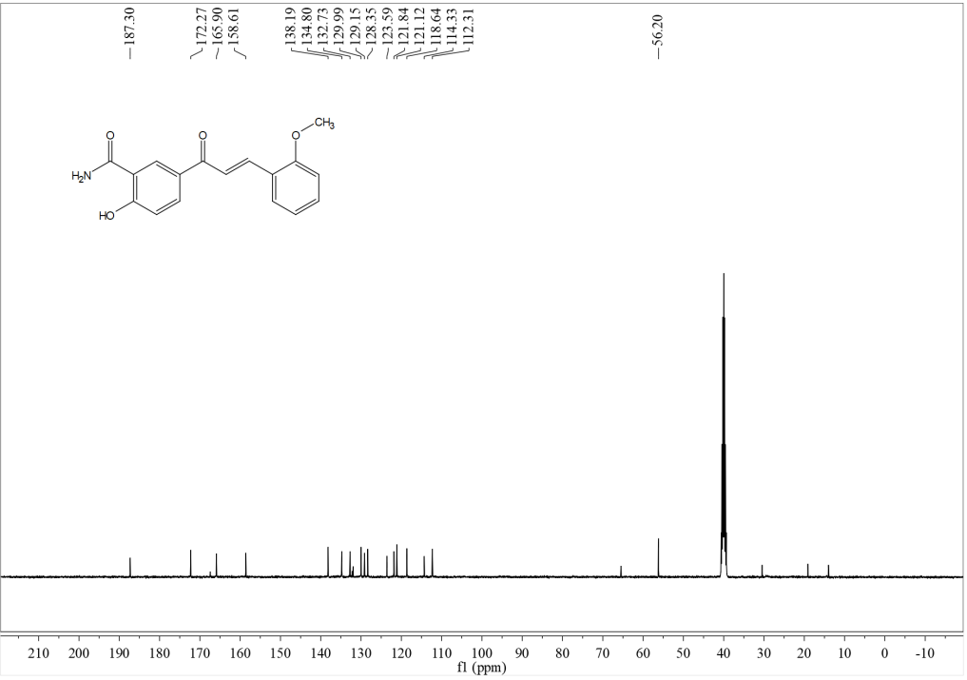
HRMS

Compound c18
¹H NMR
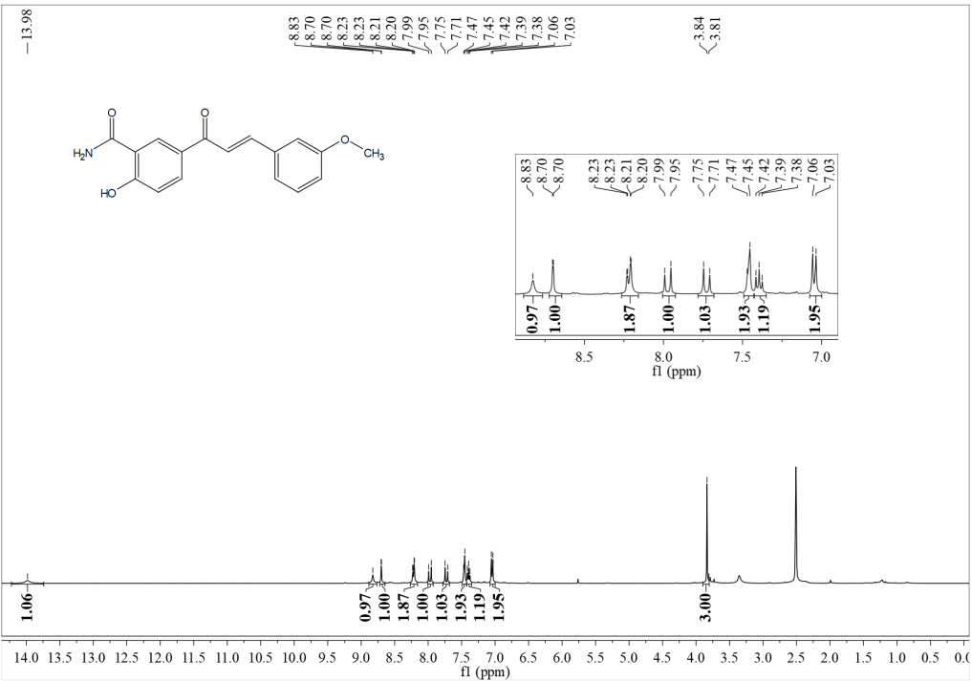
¹³C NMR
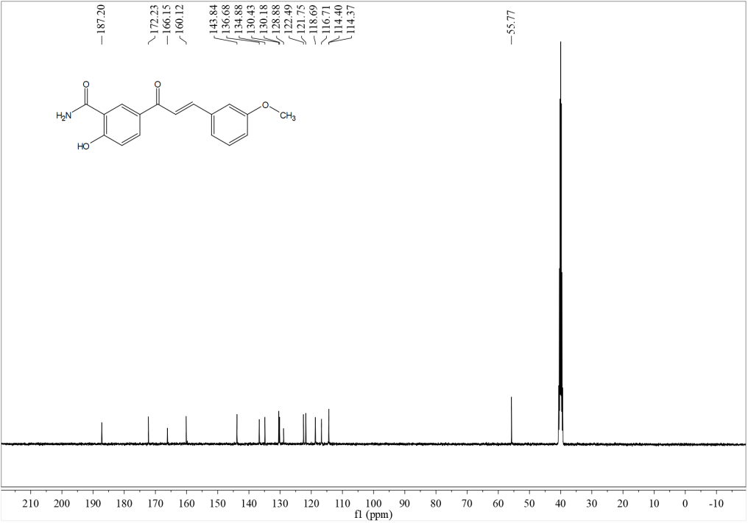
HRMS

Compound c19
¹H NMR
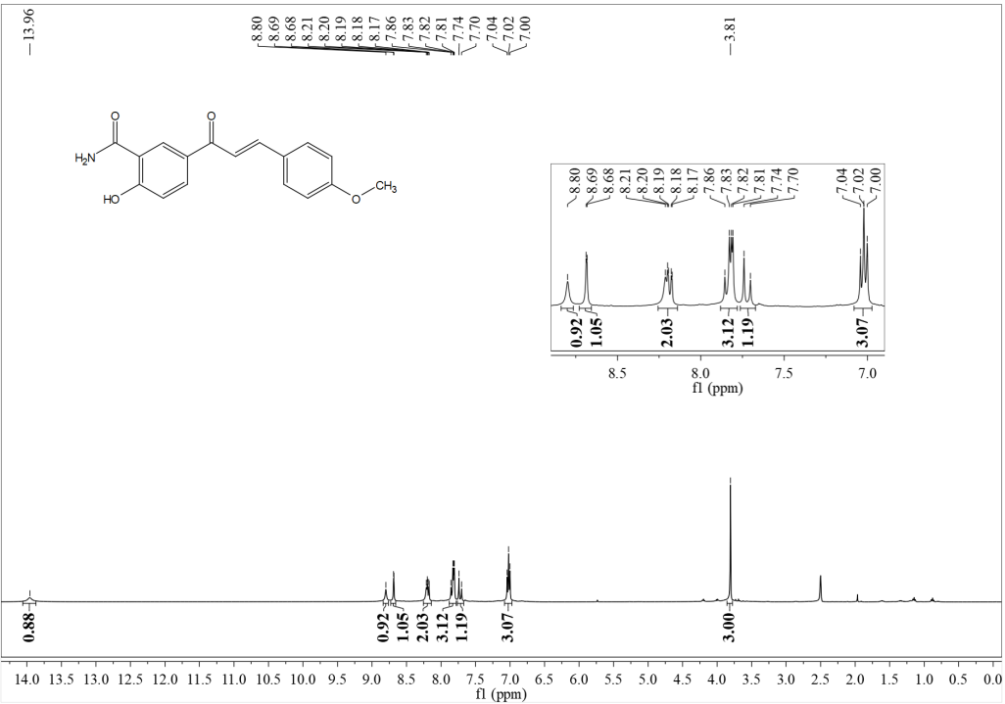
¹³C NMR
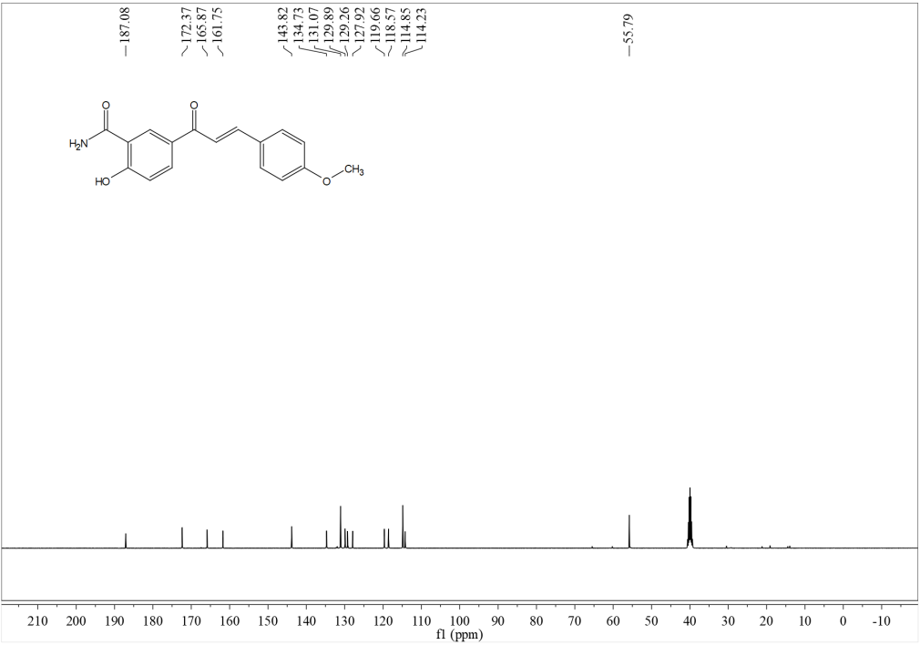
HRMS

Compound c20
¹H NMR
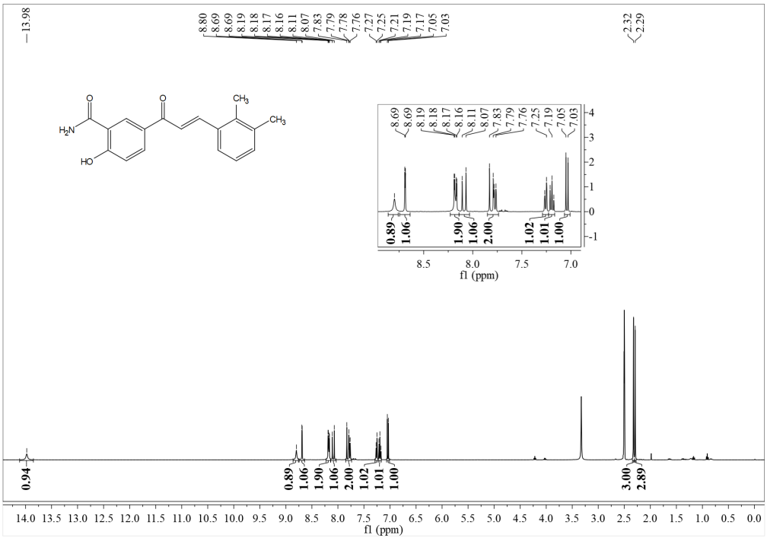
¹³C NMR
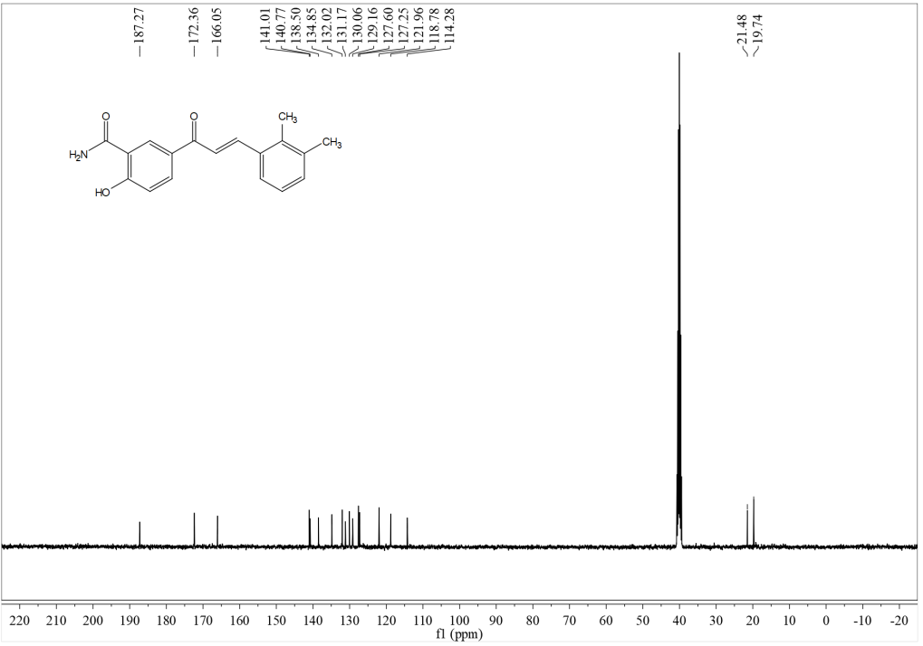

HRMS
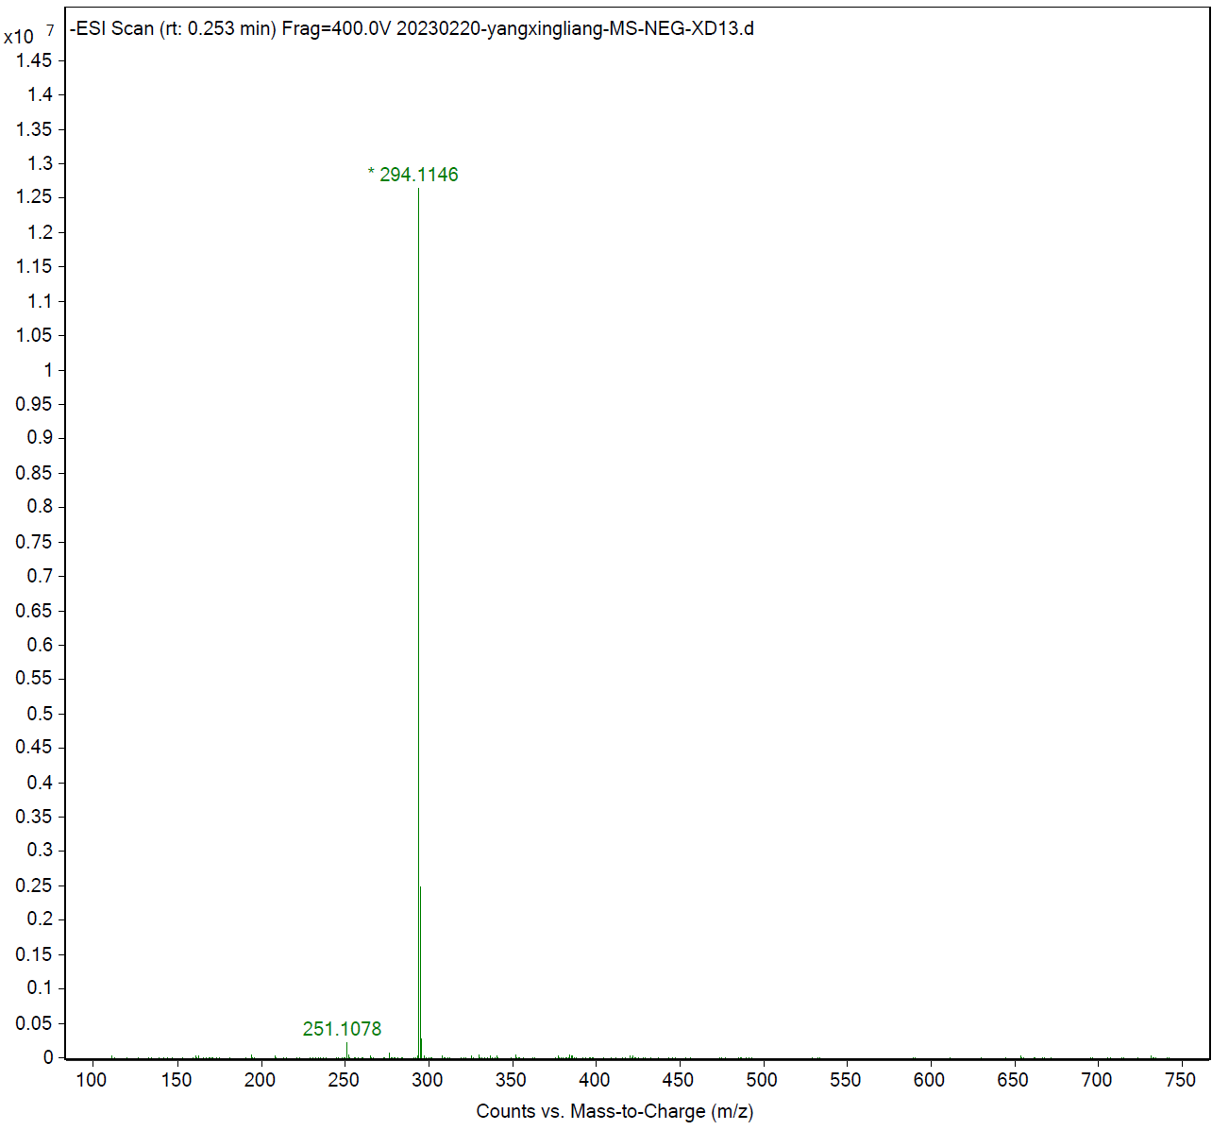
Compound c21
¹H NMR
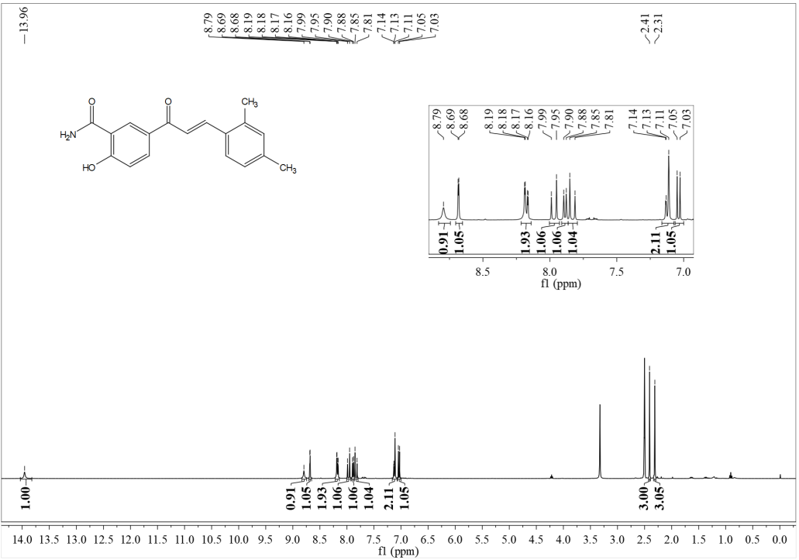

¹³C NMR
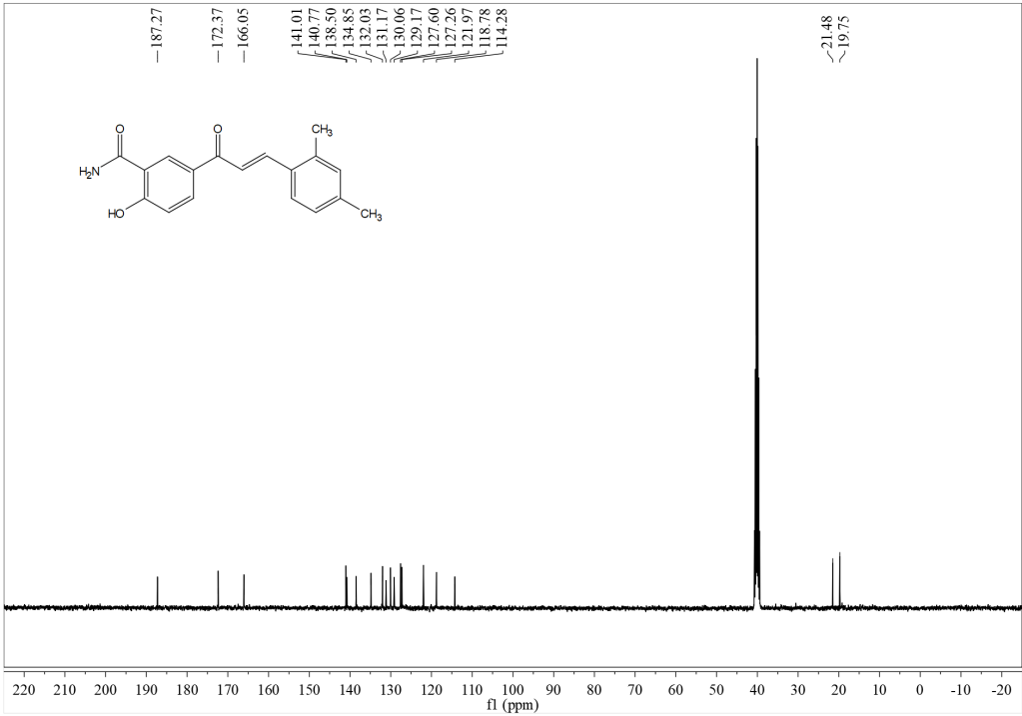
HRMS
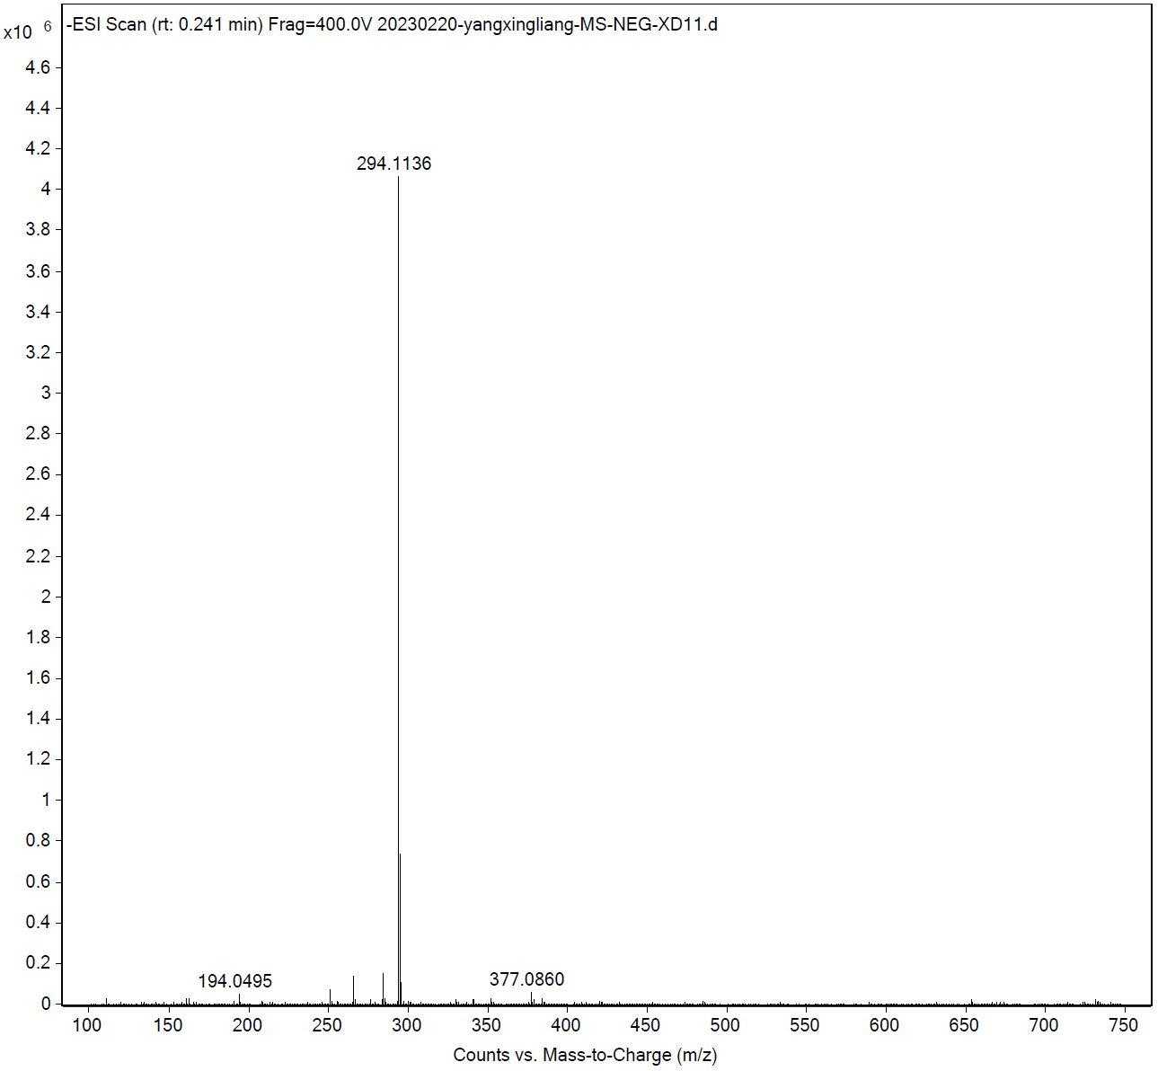

Compound c22
¹H NMR
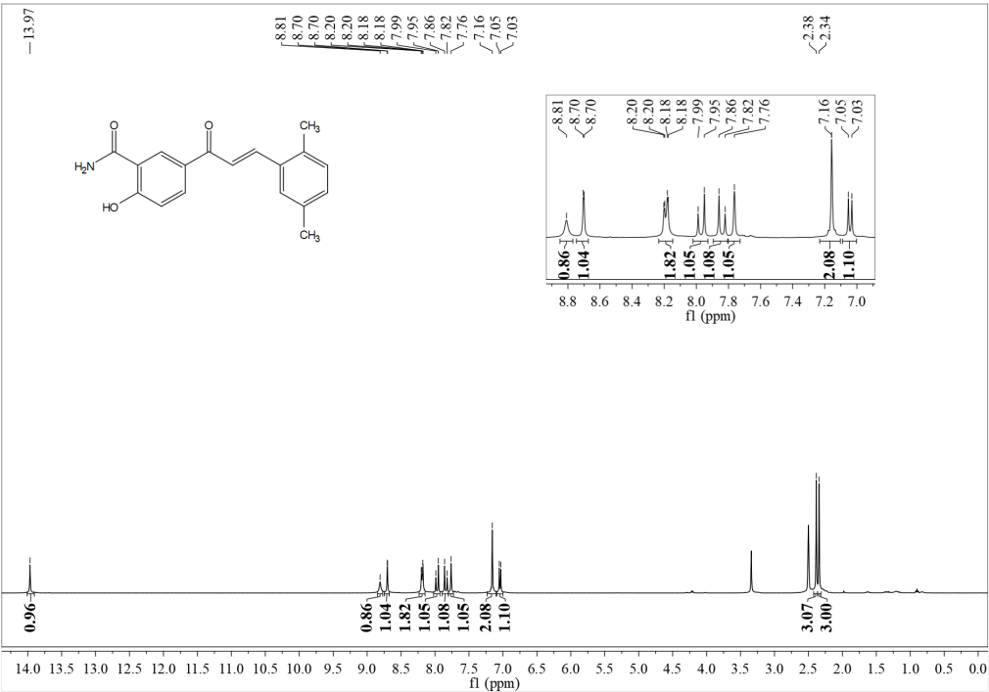
¹³C NMR
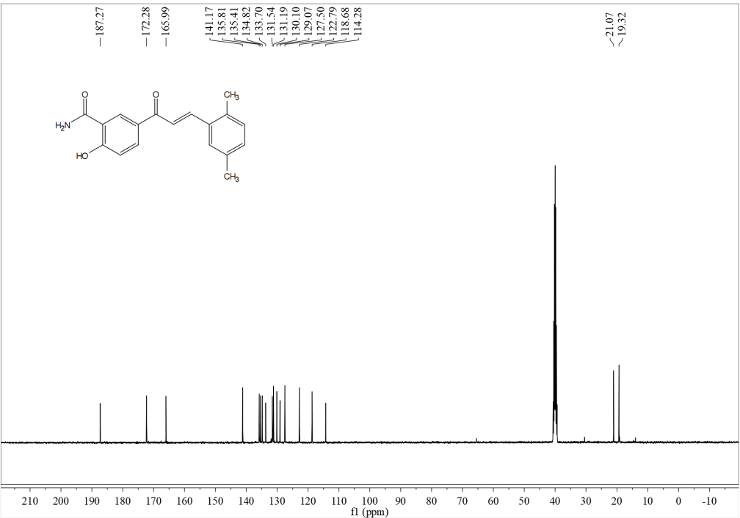

HRMS
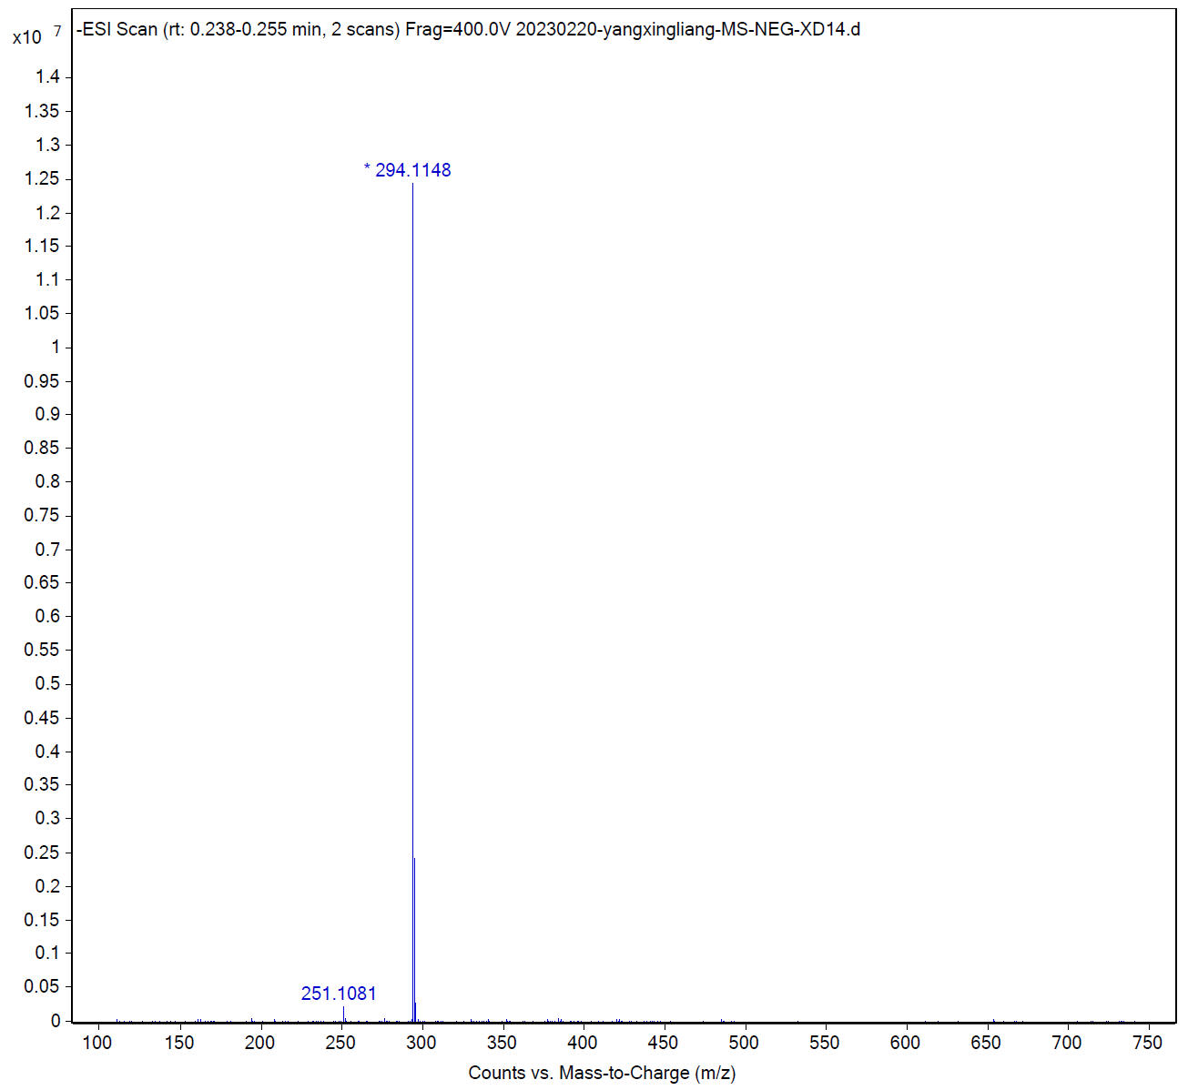
Compound c23
¹H NMR
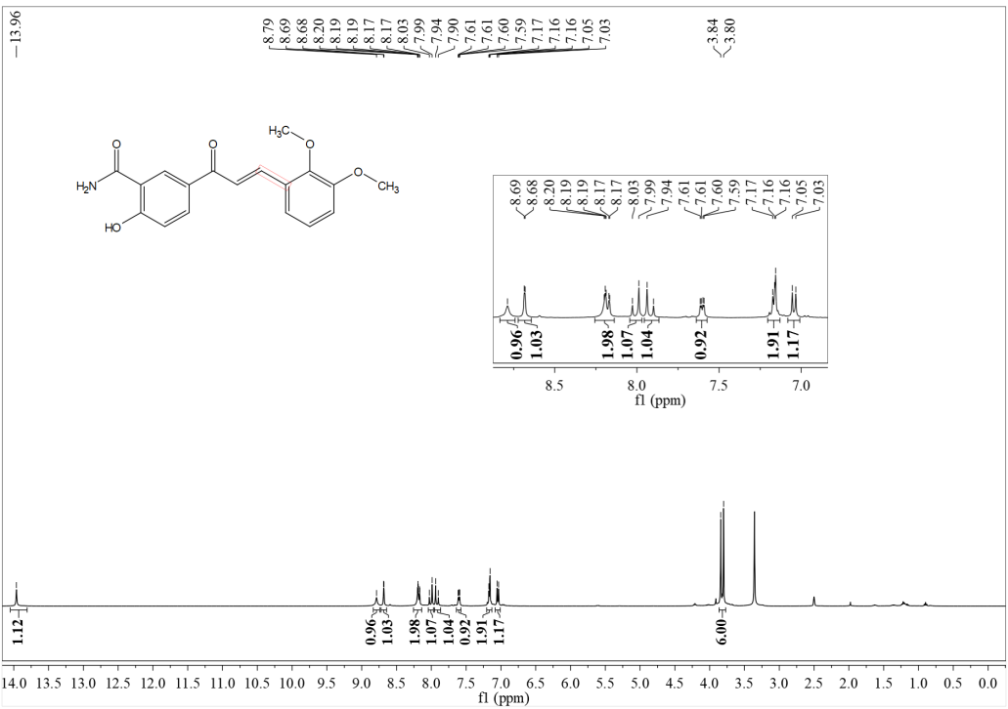

¹³C NMR
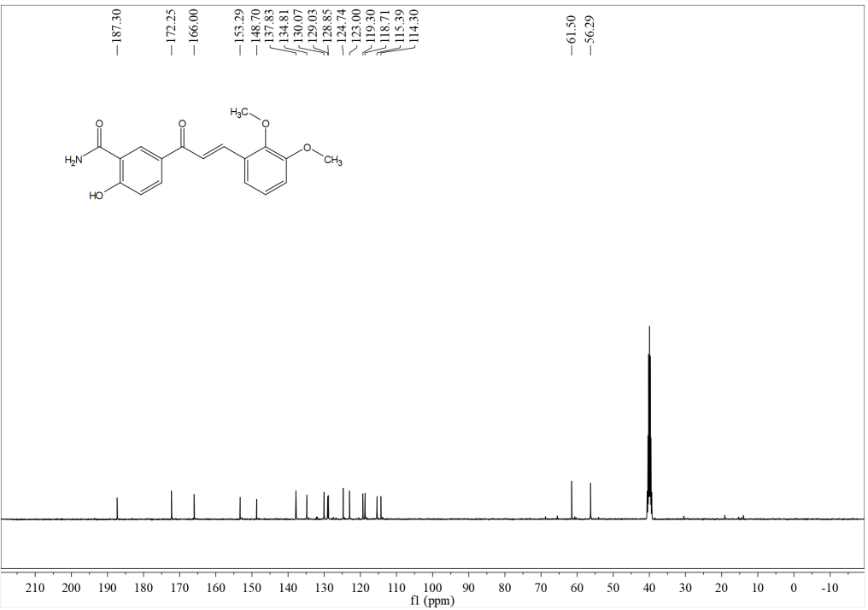
HRMS
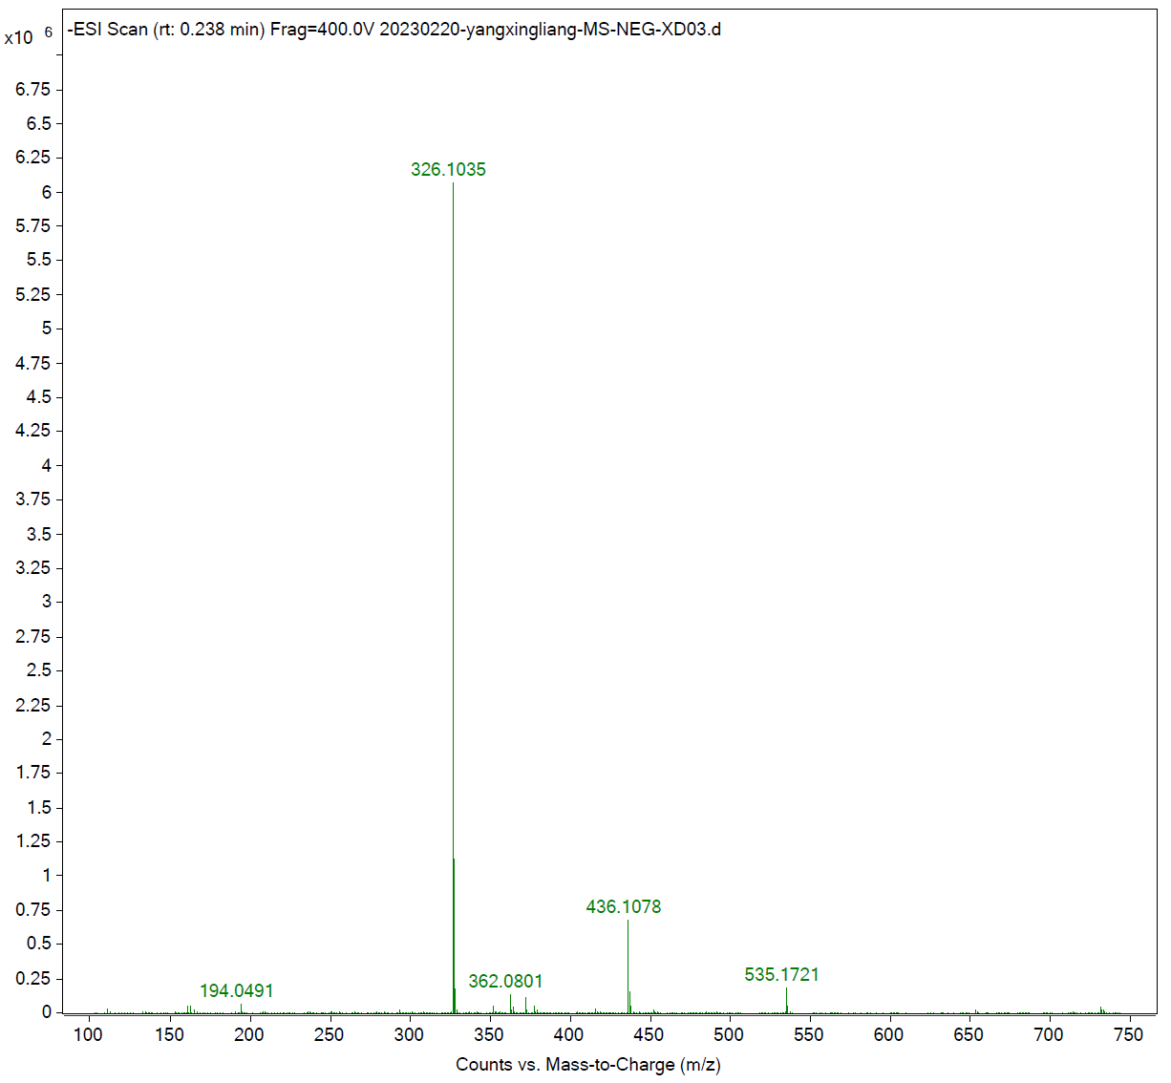

Compound c24
¹H NMR
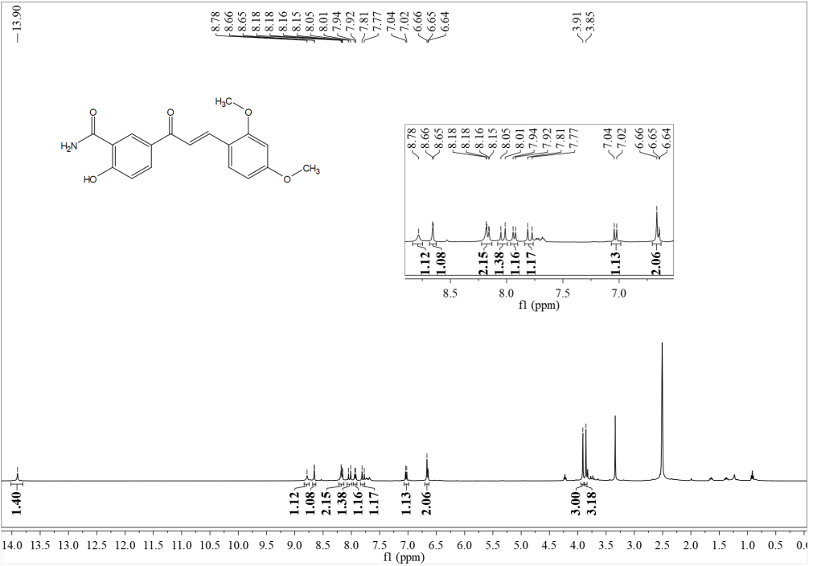
¹³C NMR
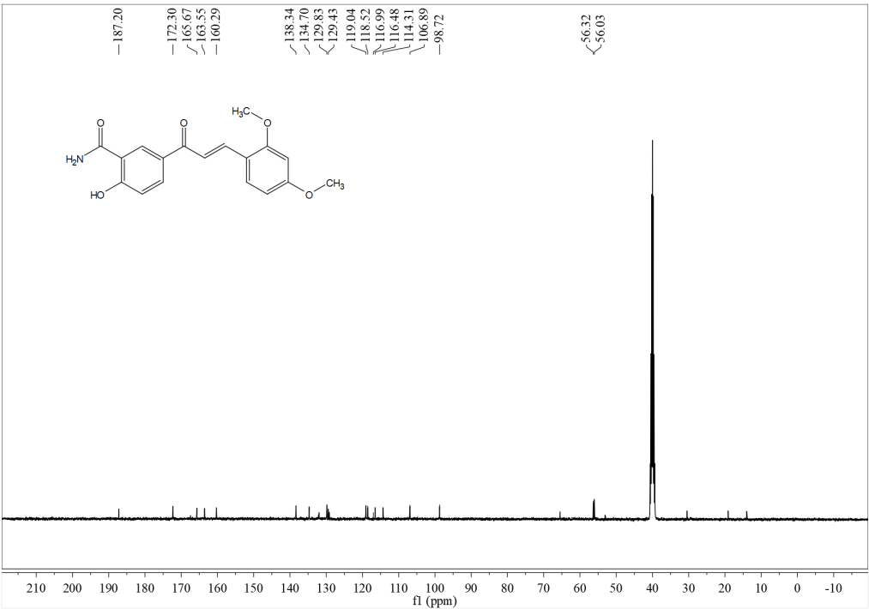
HRMS

Compound c25
¹H NMR
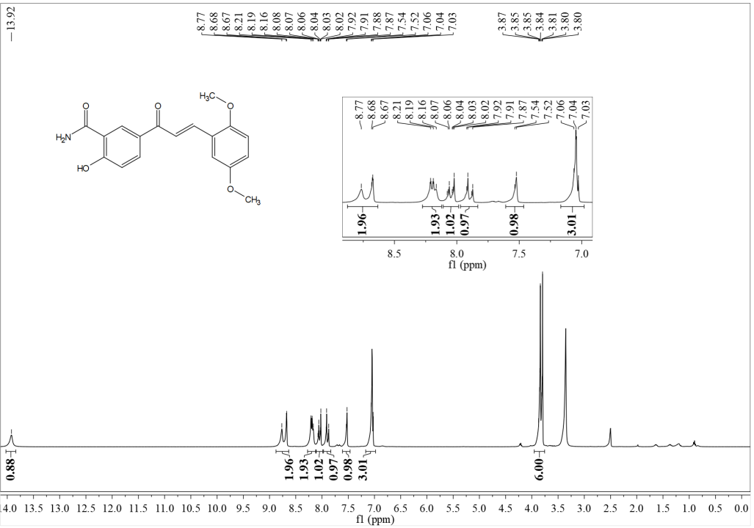
¹³C NMR
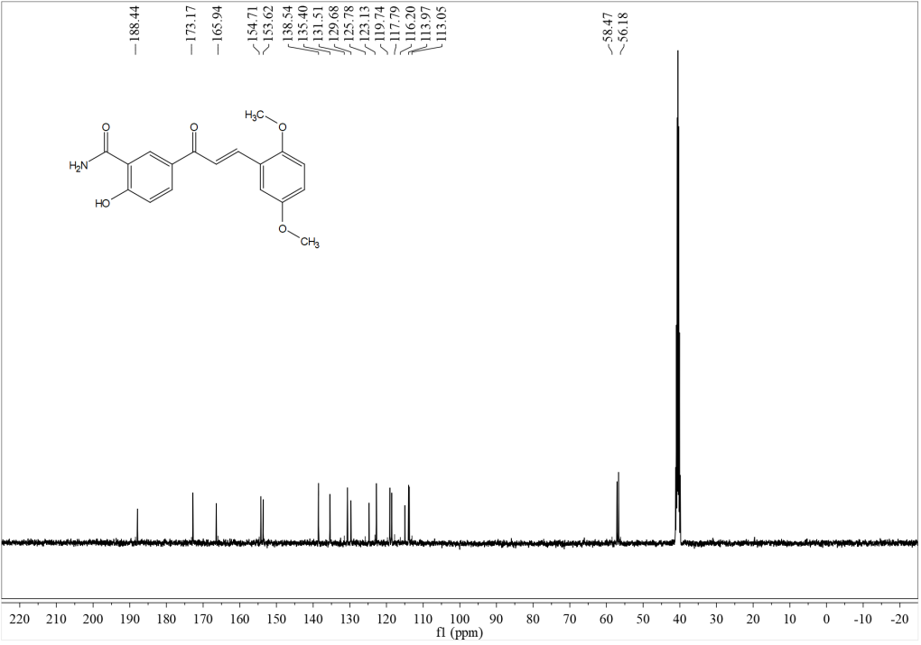

HRMS
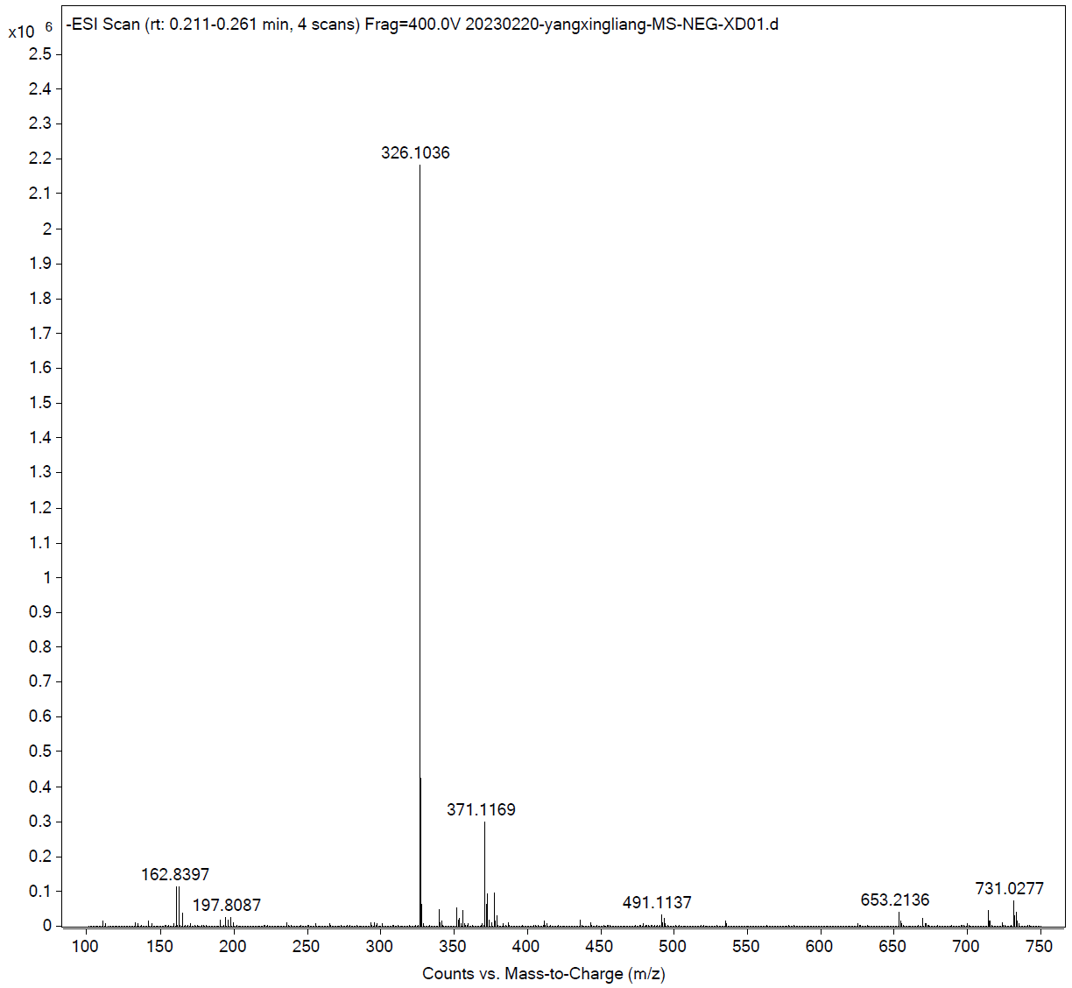
Compound c26
¹H NMR
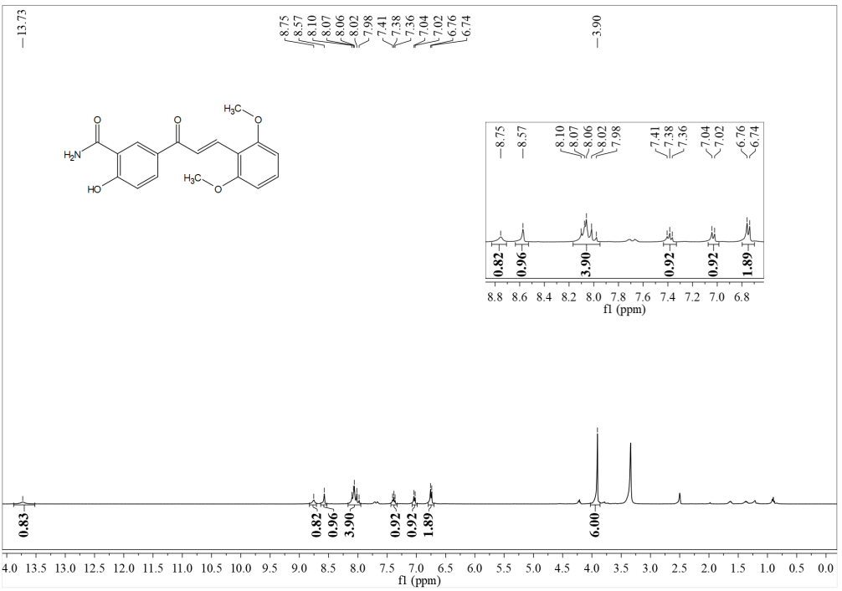

¹³C NMR
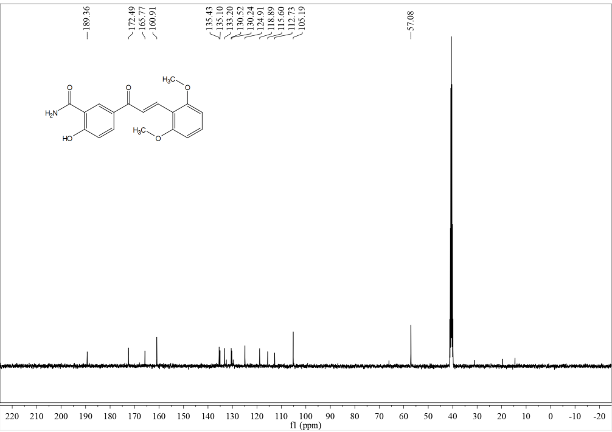
HRMS
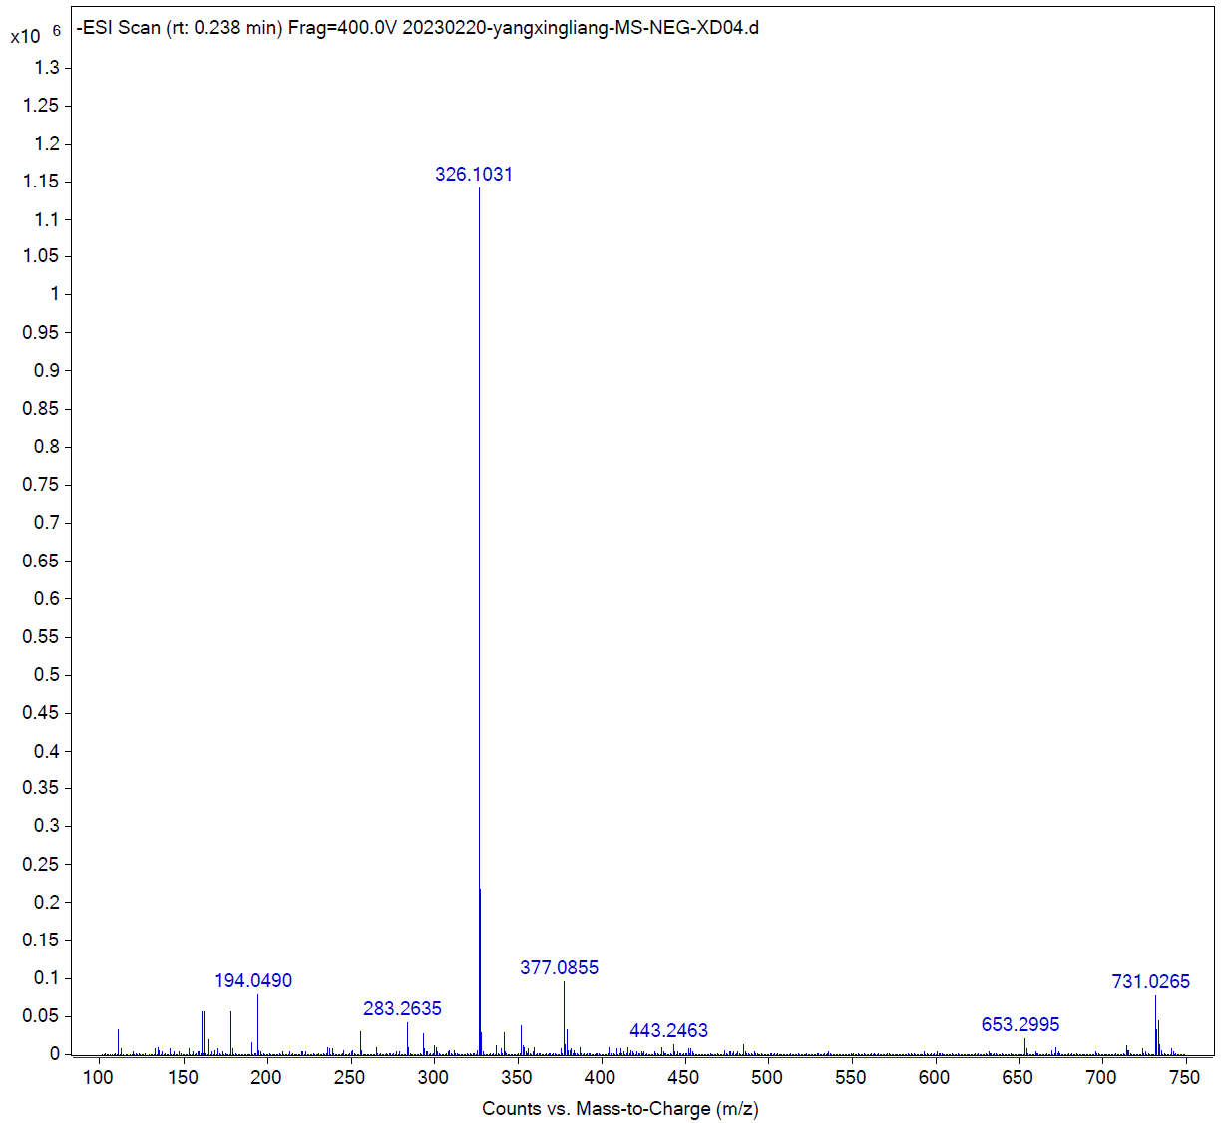

Compound c27
¹H NMR
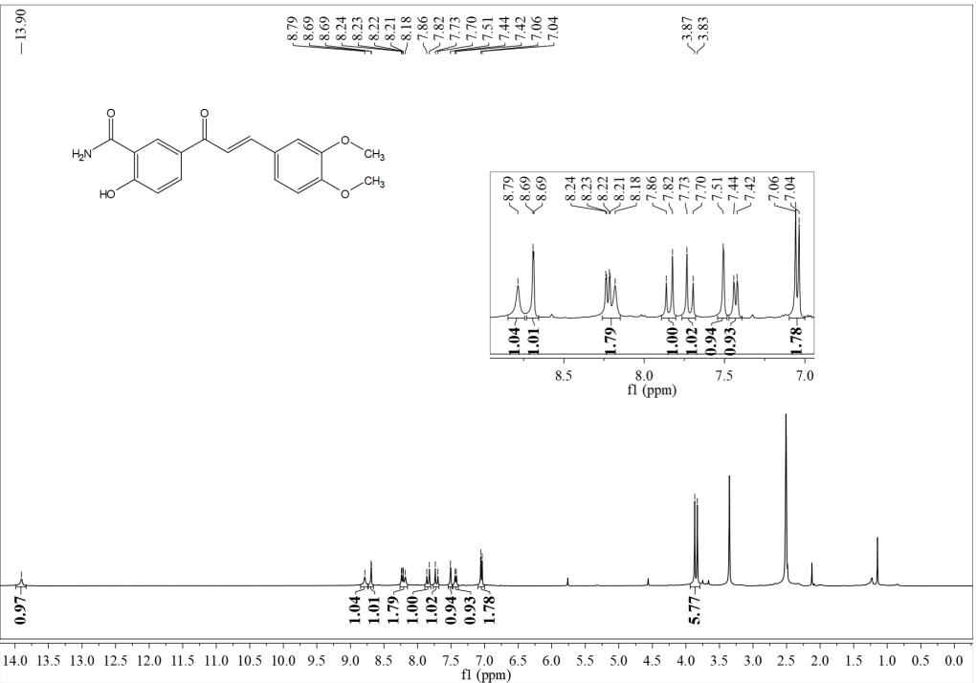
¹³C NMR
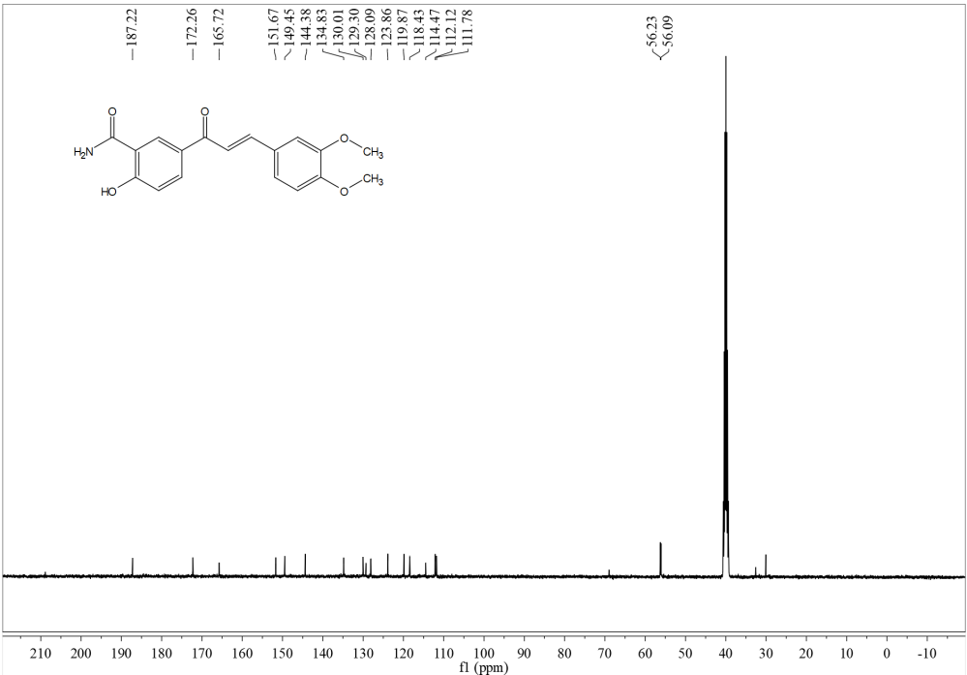
HRMS

Compound c28
¹H NMR
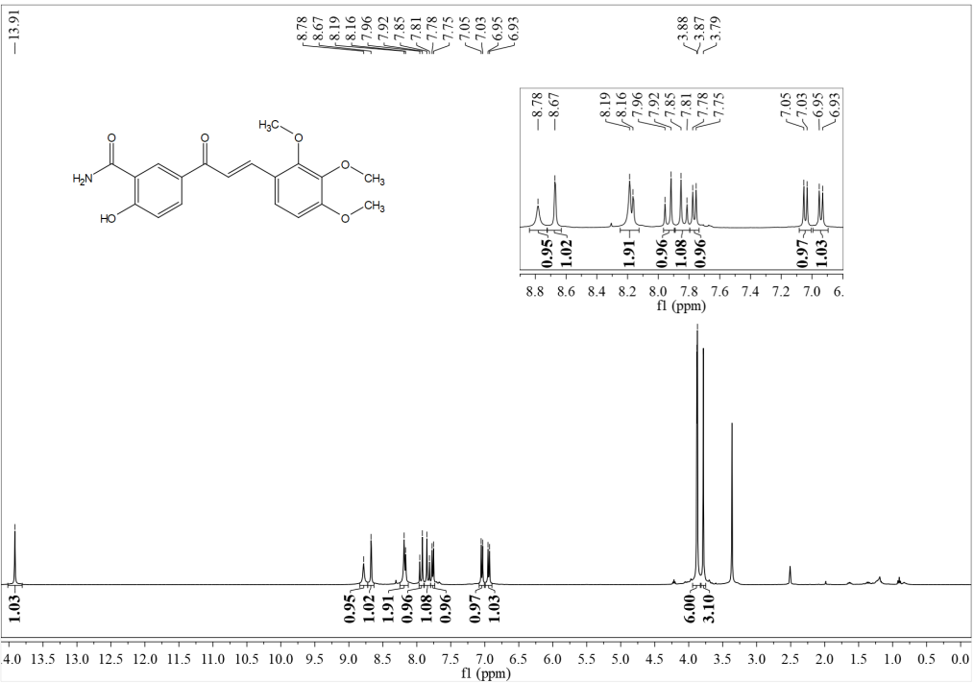
¹³C NMR
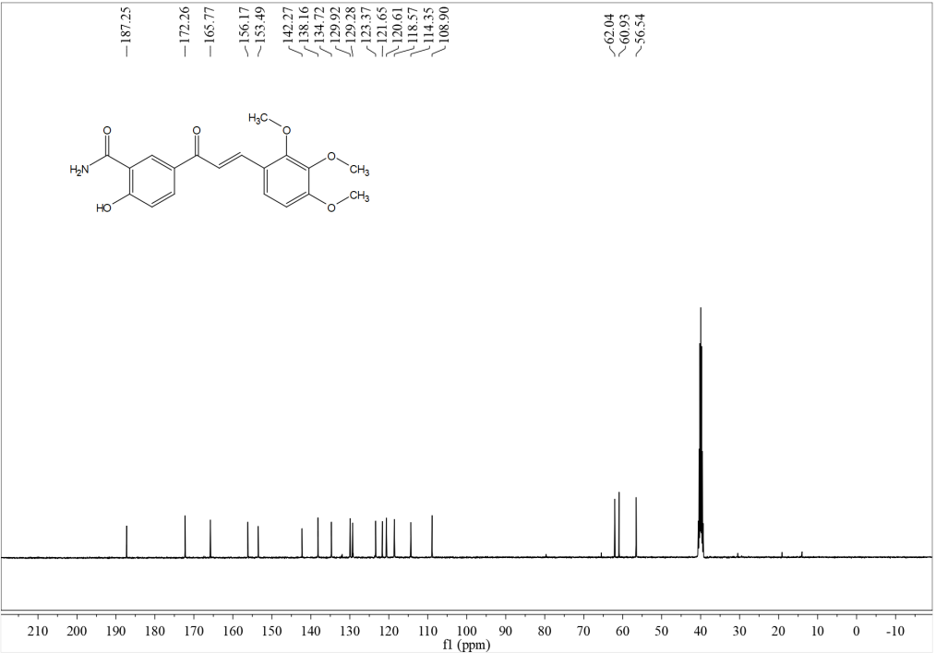

HRMS
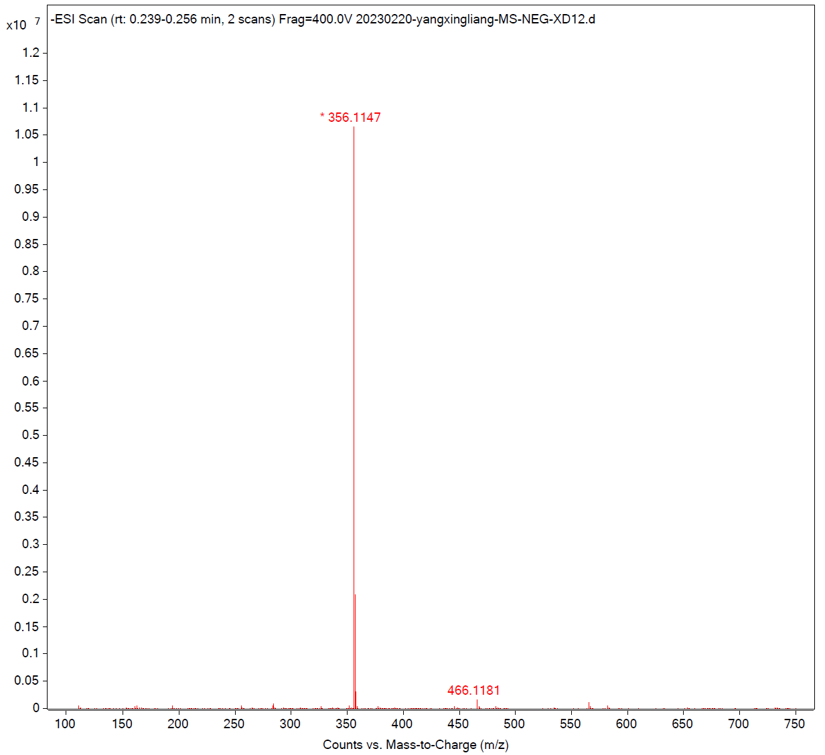
Compound c29
¹H NMR
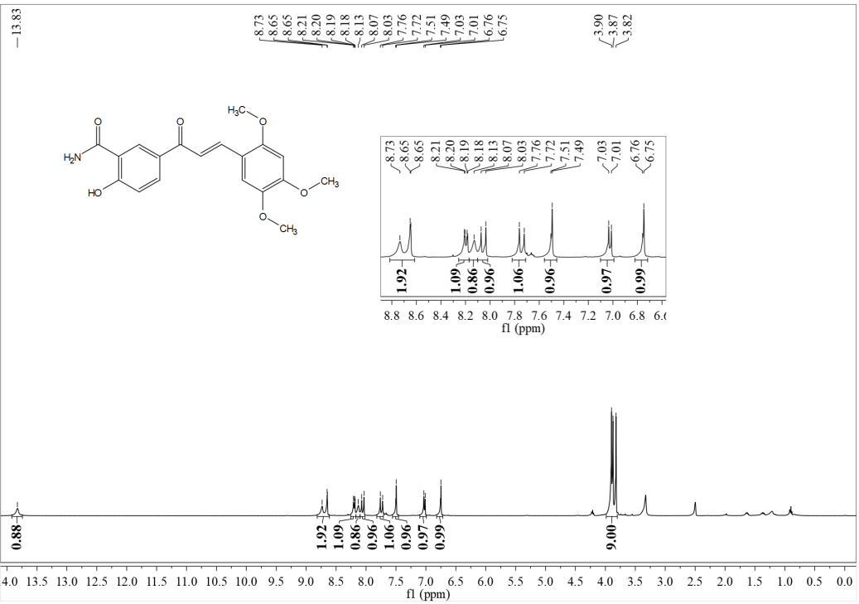

¹³C NMR
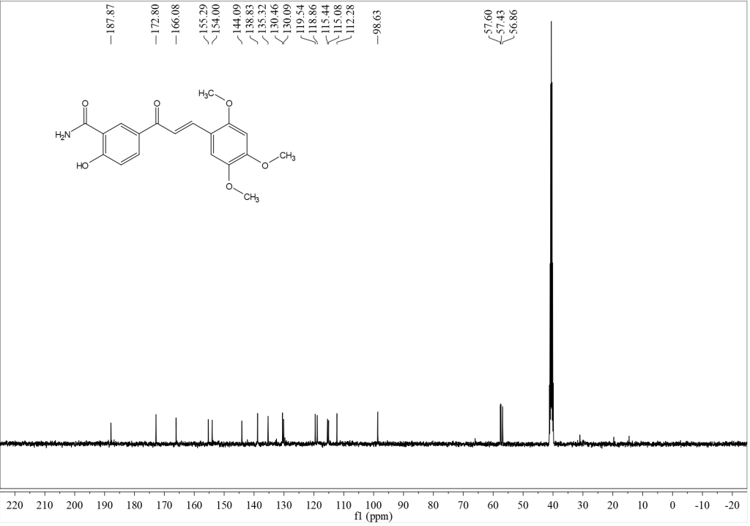
HRMS
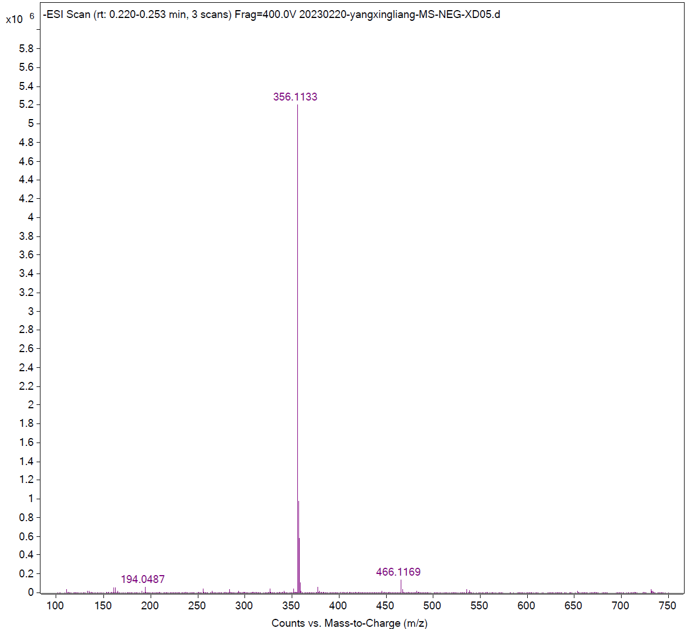

Compound c30
¹H NMR
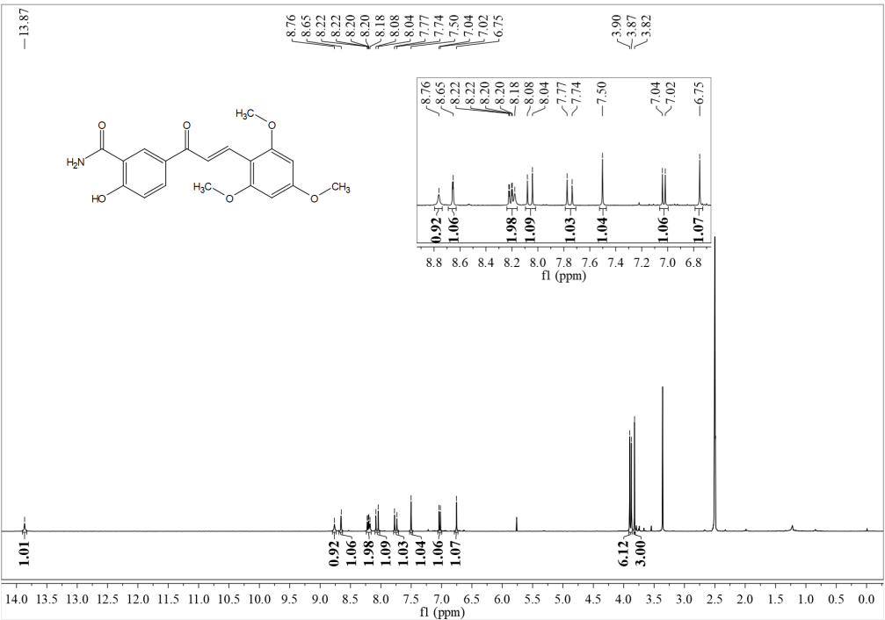
¹³C NMR
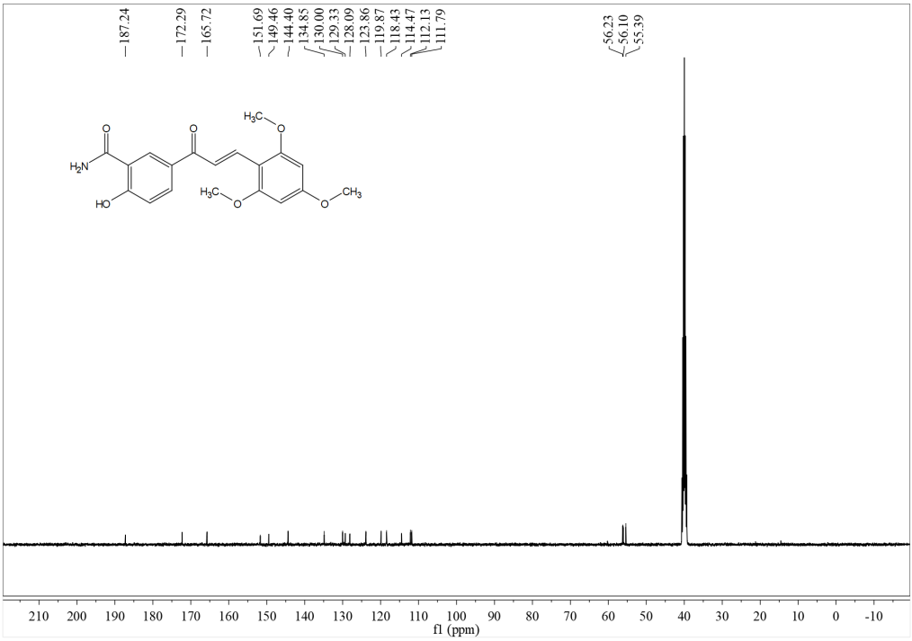

HRMS
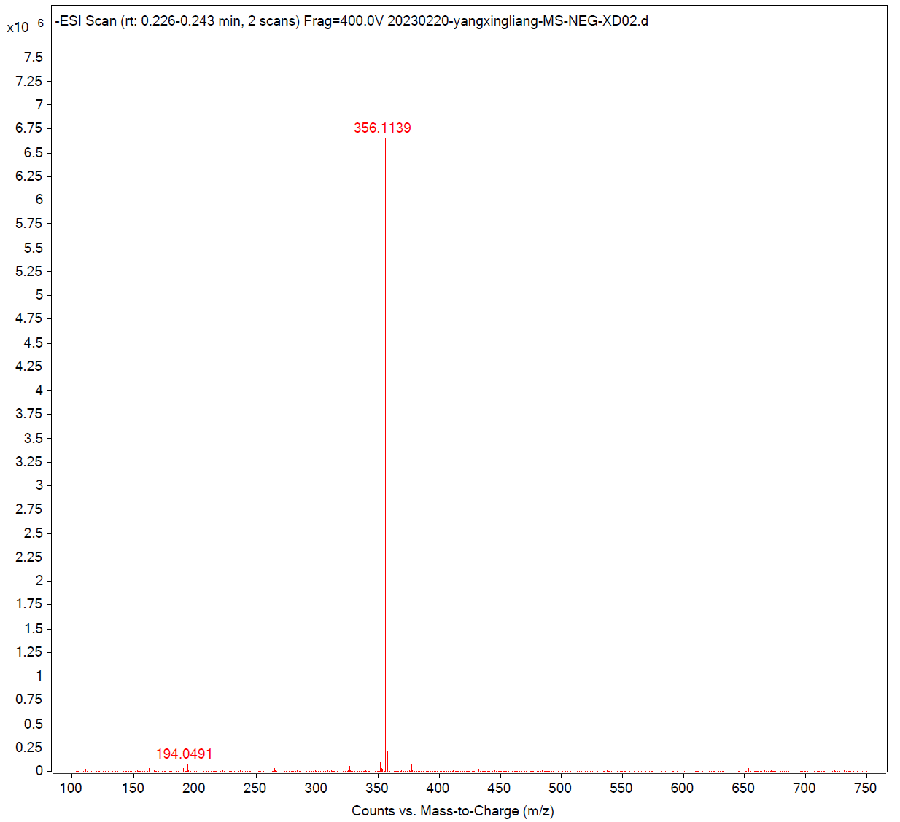
Compound c31
¹H NMR
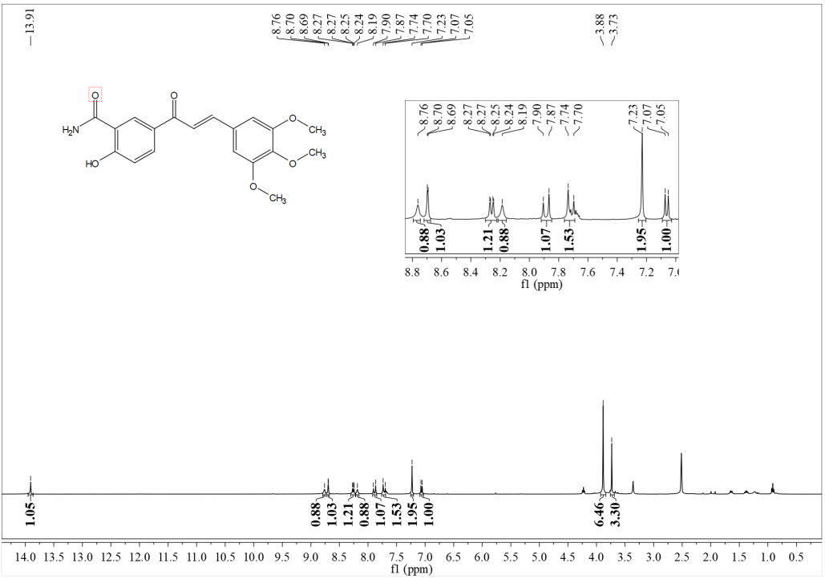

¹³C NMR
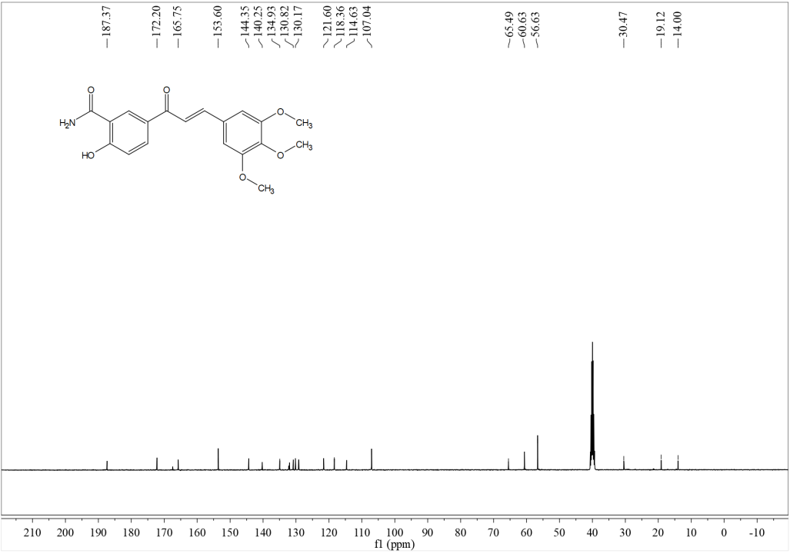
HRMS

4.Analytical RP-HPLC chromatograms of Compounds.
The purity of the synthesized compounds was analyzed using a Chromaster® System Manager high-performance liquid chromatography (HPLC) system equipped with a diode array detector (DAD) (Hitachi High-Tech, Japan). Chromatographic separation was performed on a LaChrom C18 column (P/N 891-5055, 4.6 mm × 250 mm, 5 μm) under isocratic elution with a mobile phase consisting of 20% aqueous solution (A) and 80% methanol (B). The flow rate was set at 1.0 mL/min, the column temperature was maintained at 30 °C, and the detection wavelength was 254 nm with an injection volume of 10 μL. All samples were dissolved in methanol at a concentration of approximately 0.5 mg/mL and filtered through a 0.45 μm polytetrafluoroethylene (PTFE) syringe filter prior to injection. The purity was determined by calculating the percentage of the target compound peak area relative to the total peak area at 254 nm, with additional peak purity assessment supported by DAD spectral analysis.
Table S1 Purity analysis by RP-HPLC of the target compounds c1-c31
Compd. | Purity% Retention time | Compd. | Purity% Retention time
c1 | 95.50% rt = 16.01min | c17 | 98.93% rt = 10.44 min
c2 | 99.74% rt = 11.39 min | c18 | 95.69% rt = 11.28 min
c3 | 98.14% rt = 11.82 min | c19 | 97.01% rt = 22.48 min
c4 | 99.43% rt = 14.70 min | c20 | 97.88% rt = 10.19 min
c5 | 96.17% rt = 15.66 min | c21 | 97.08% rt = 23.22 min
c6 | 96.06% rt = 18.60 min | c22 | 98.68% rt = 23.82 min
c7 | 99.64% rt = 17.83 min | c23 | 95.32% rt = 9.00 min
c8 | 97.52% rt = 17.83 min | c24 | 98.82% rt = 6.45 min
c9 | 99.14% rt = 21.29 min | c25 | 98.12% rt = 10.45 min
c10 | 95.69% rt = 20.58 min | c26 | 97.43% rt = 10.46 min
c11 | 96.70% rt = 14.84 min | c27 | 95.87% rt = 7.34 min
c12 | 95.50% rt = 16.01 min | c28 | 98.89% rt = 8.93 min
c13 | 97.68% rt = 15.42 min | c29 | 95.20% rt = 7.38 min
c14 | 95.10% rt = 23.93 min | c30 | 97.40% rt = 6.78 min
c15 | 99.55% rt = 20.74 min | c31 | 97.99% rt = 7.76 min
c16 | 99.71% rt = 24.68 min

Compand c1 (95.50%)
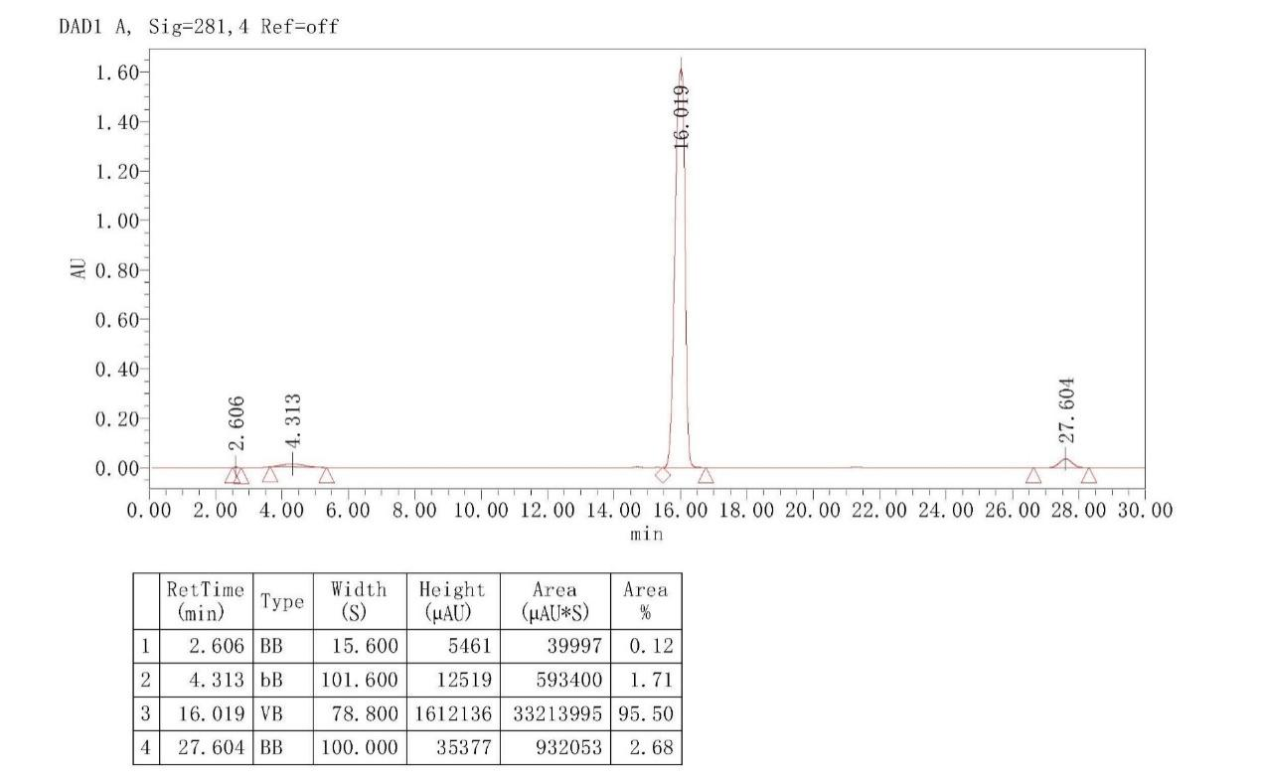

Compand c2 (99.74%)
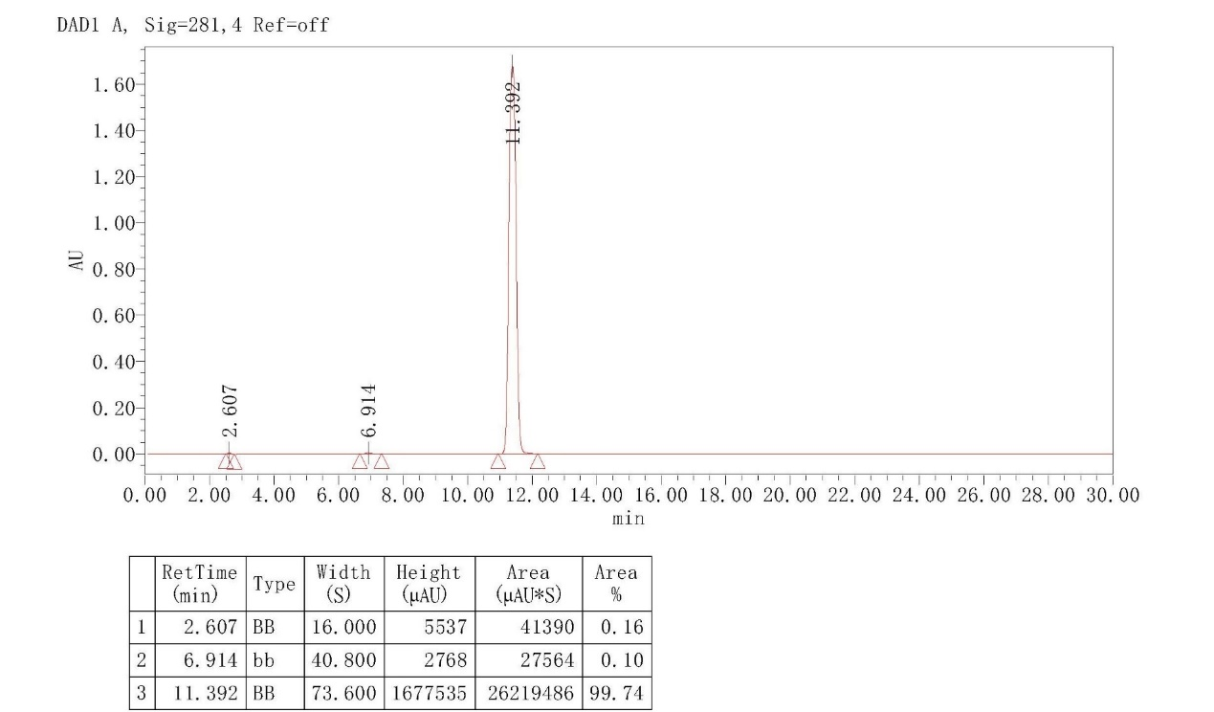

Compand c3 (98.14%)
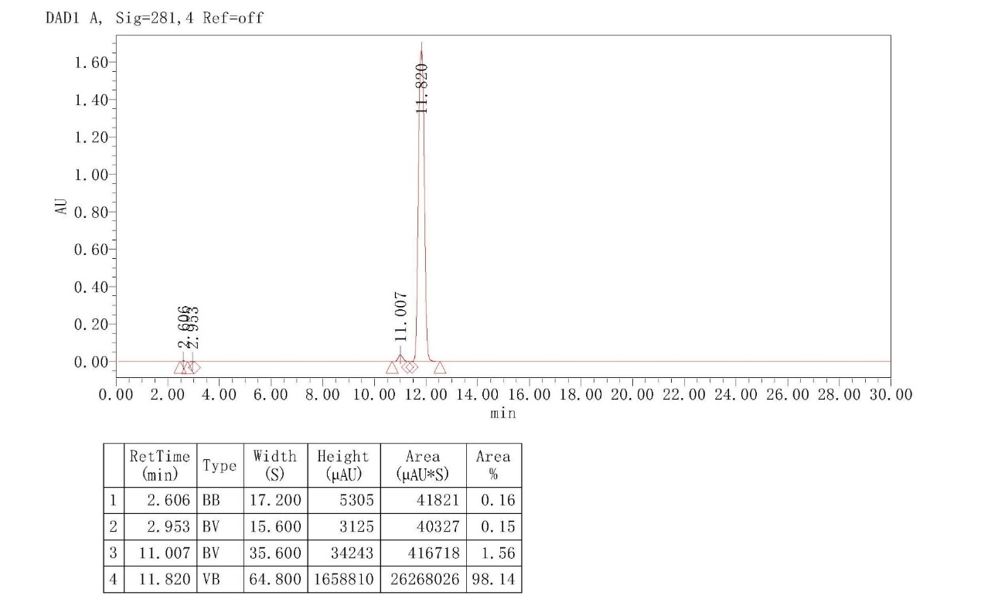

Compand c4 (99.43%)
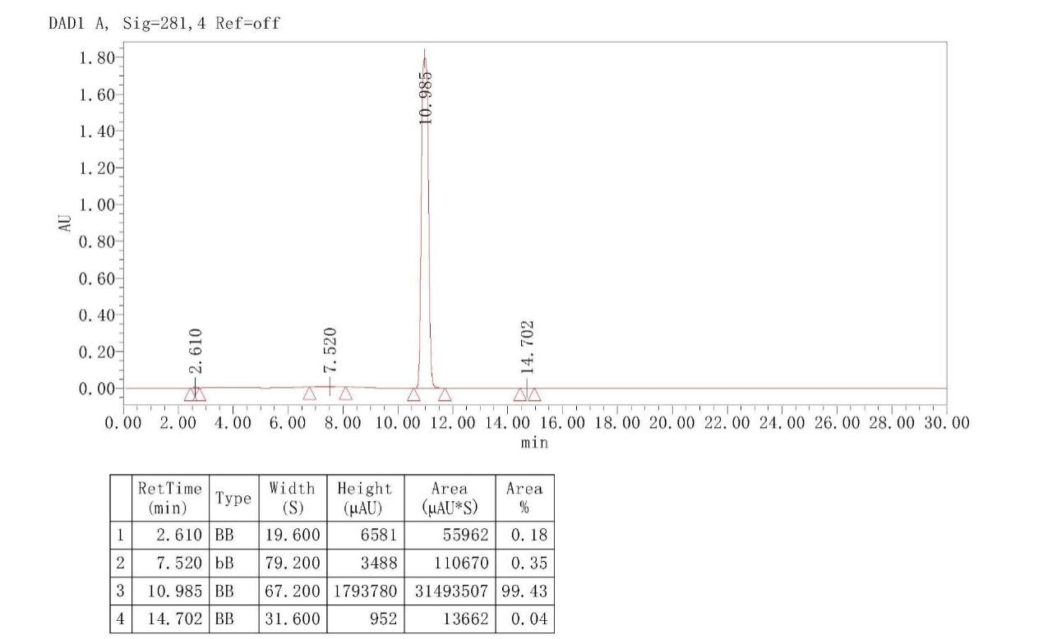

Compand c5 (96.17%)
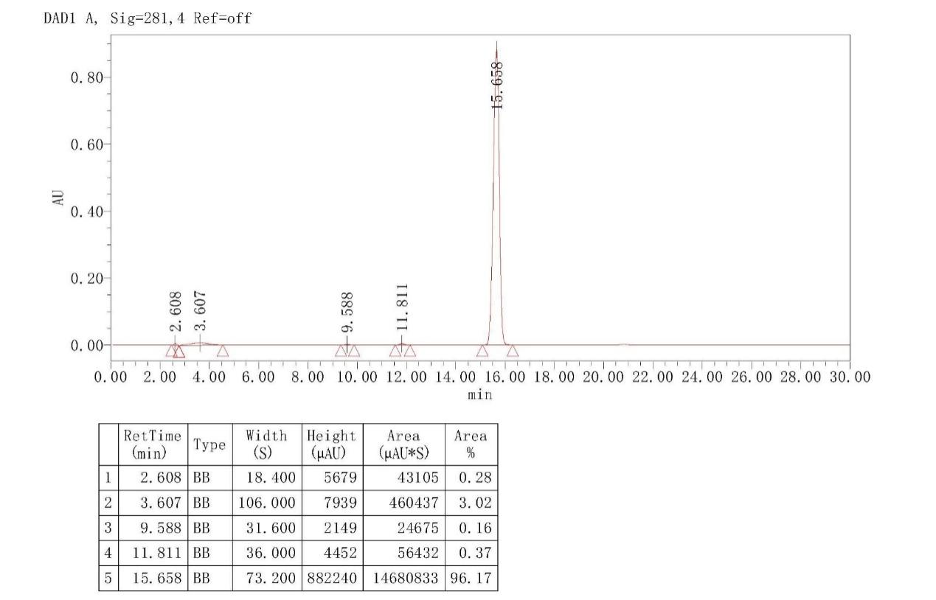

Compand c6 (96.06%)
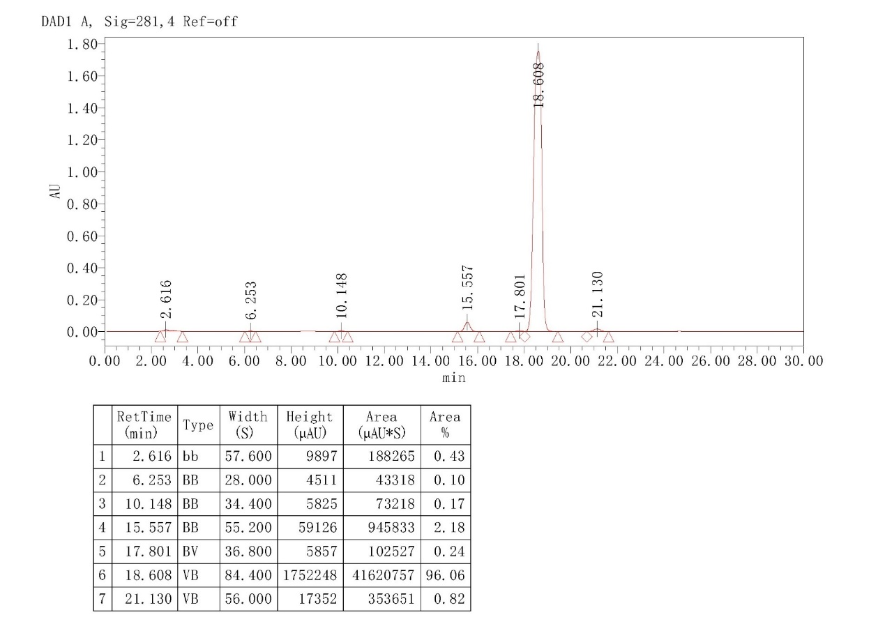

Compand c7 (99.64%)
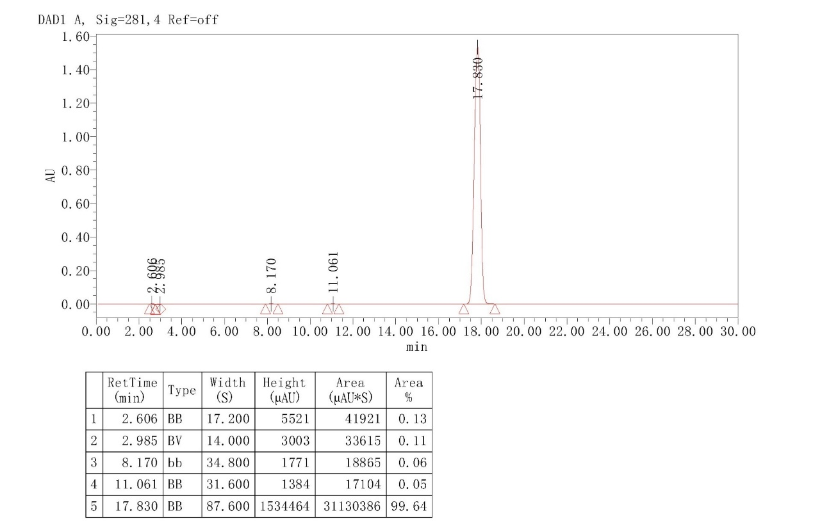

Compand c8 (97.52%)
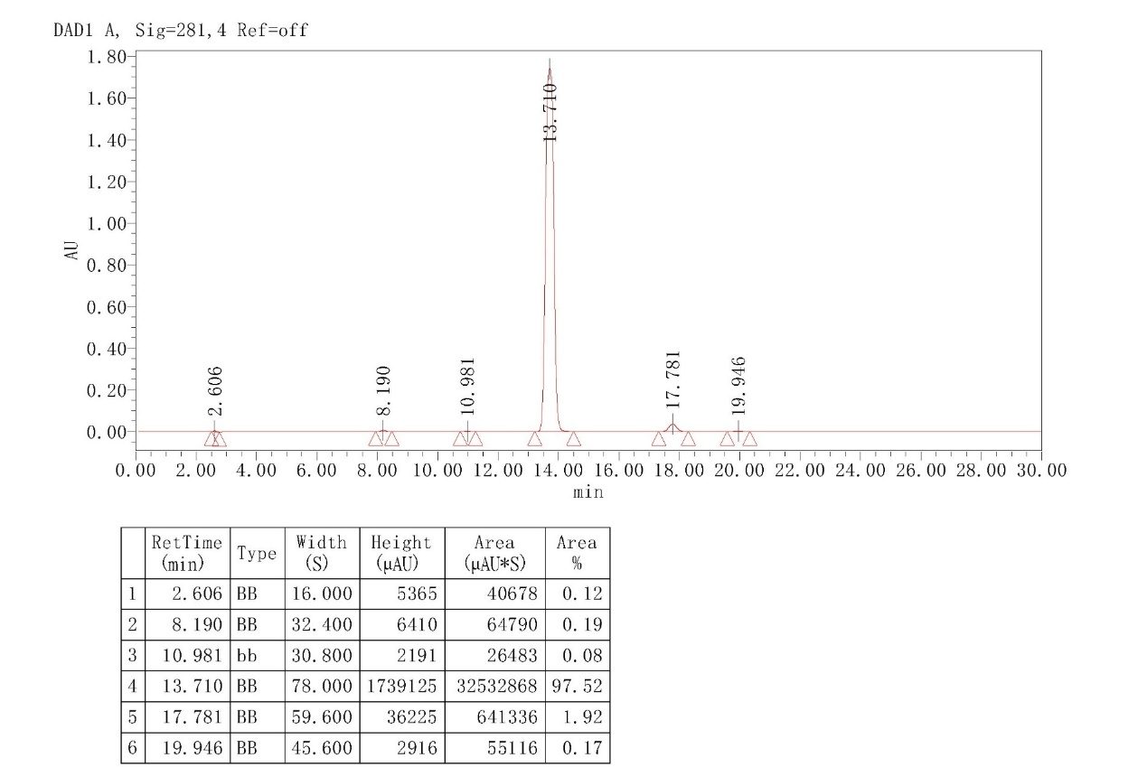

Compand c9 (97.52%)
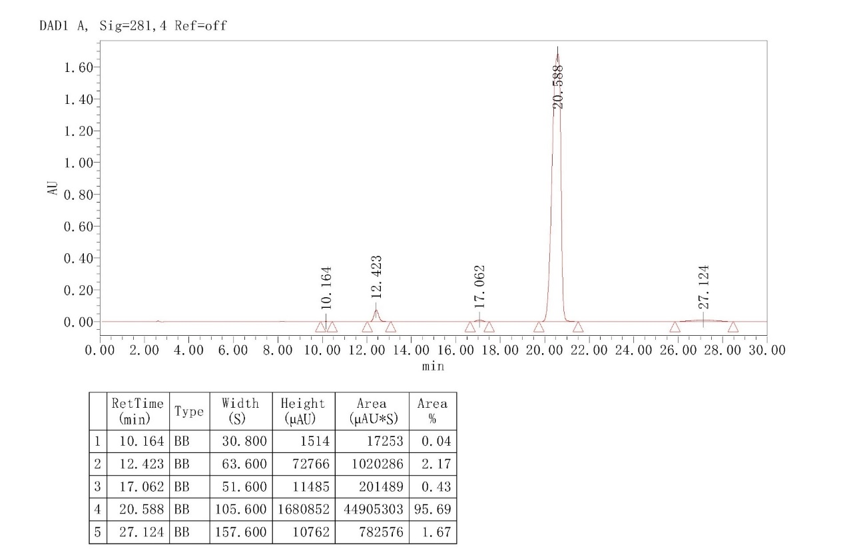

Compand c10 (95.69%)

Compand c11 (96.70%)
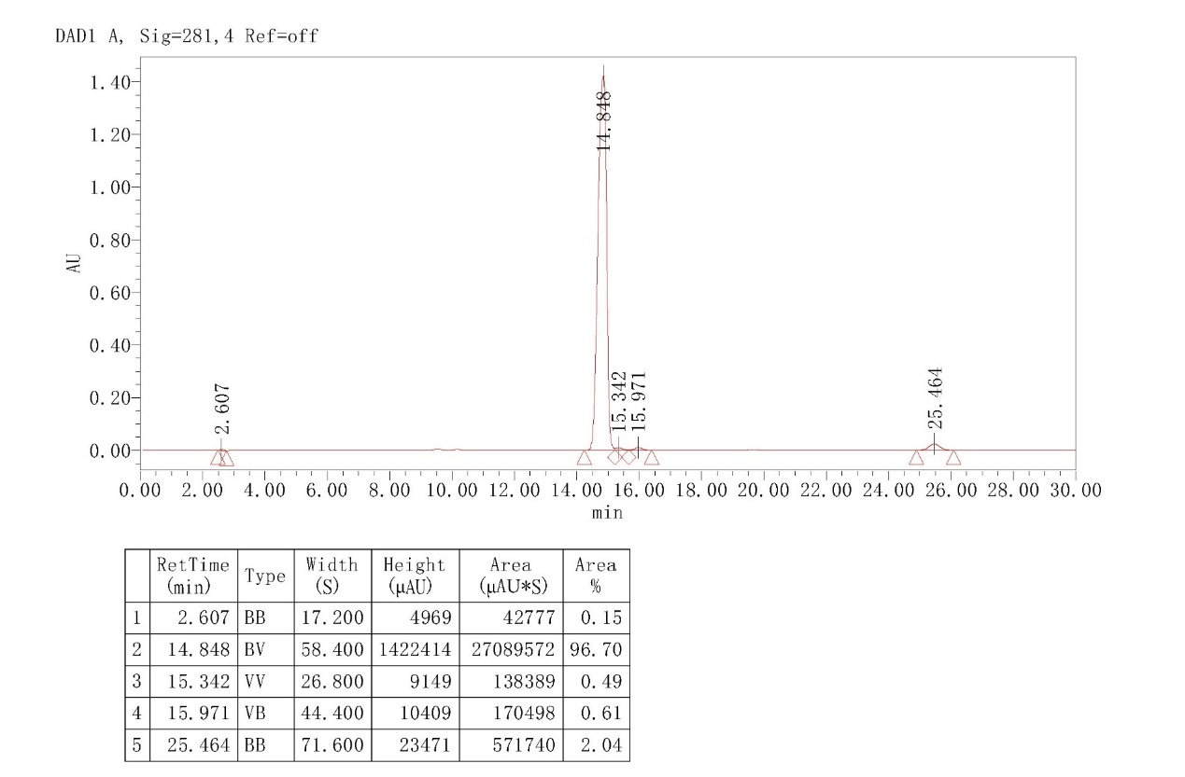

Compand c12 (95.50%)
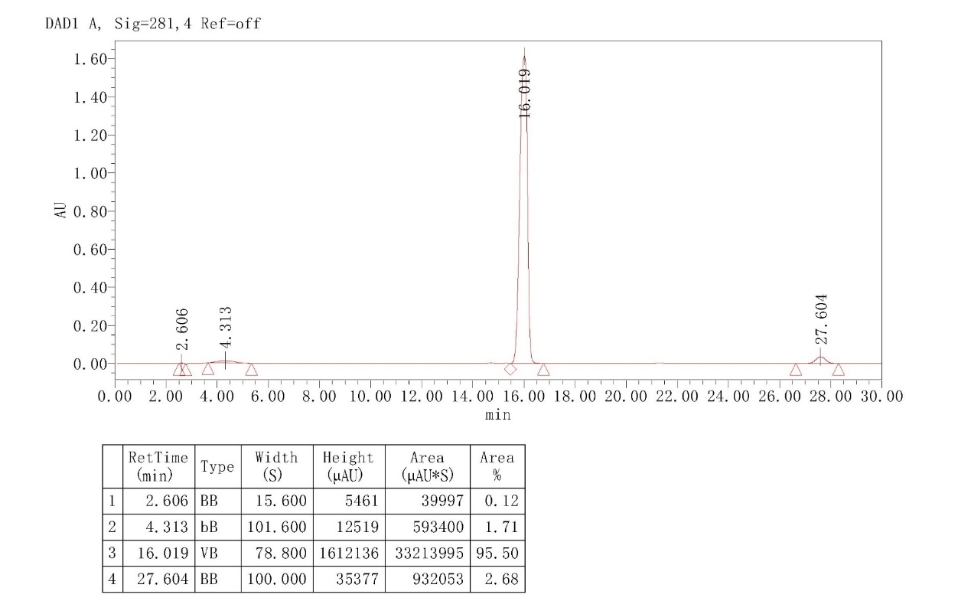

Compand c13 (97.68%)
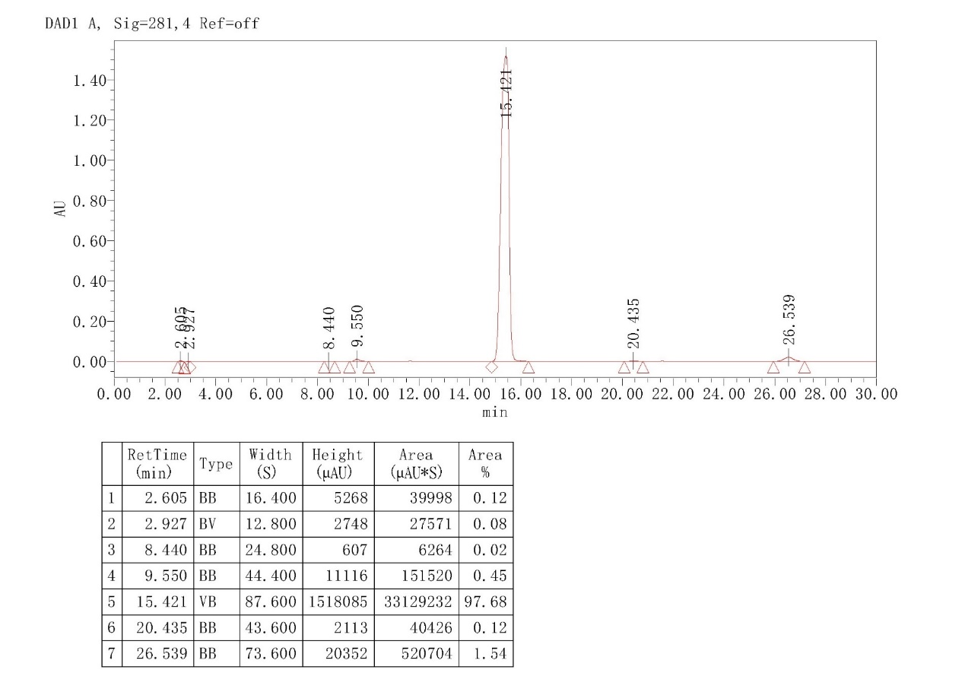

Compand c14 (95.10%)
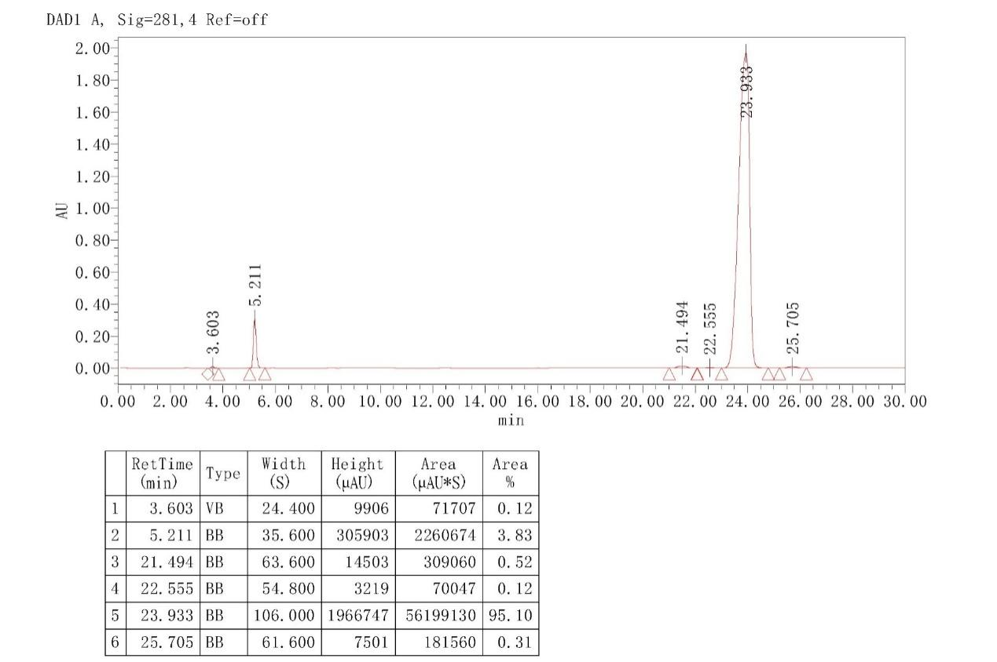

Compand c15 (99.55%)
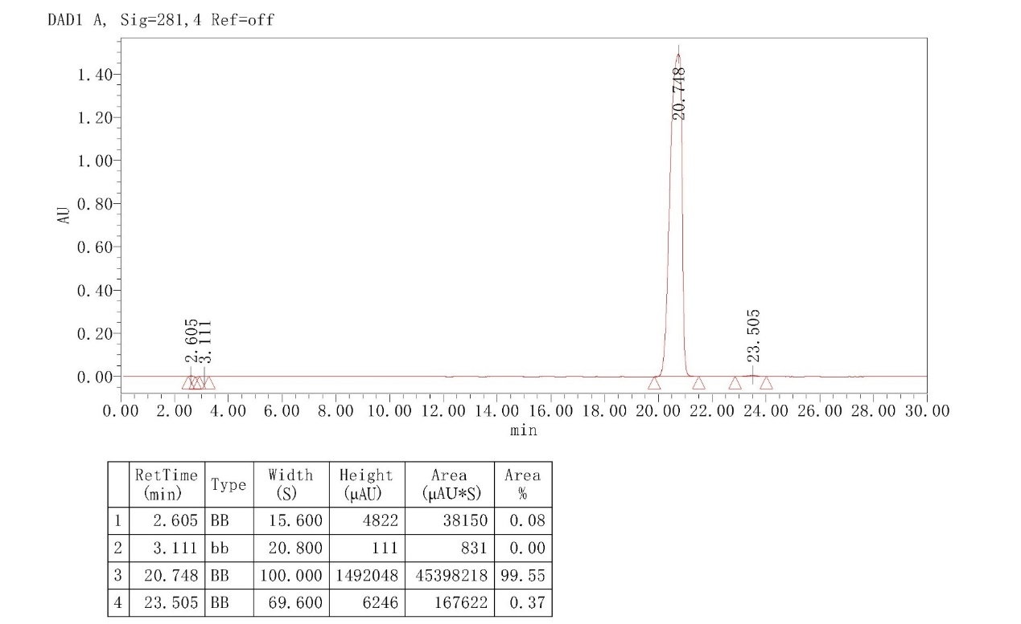

Compand c16 (99.71%)
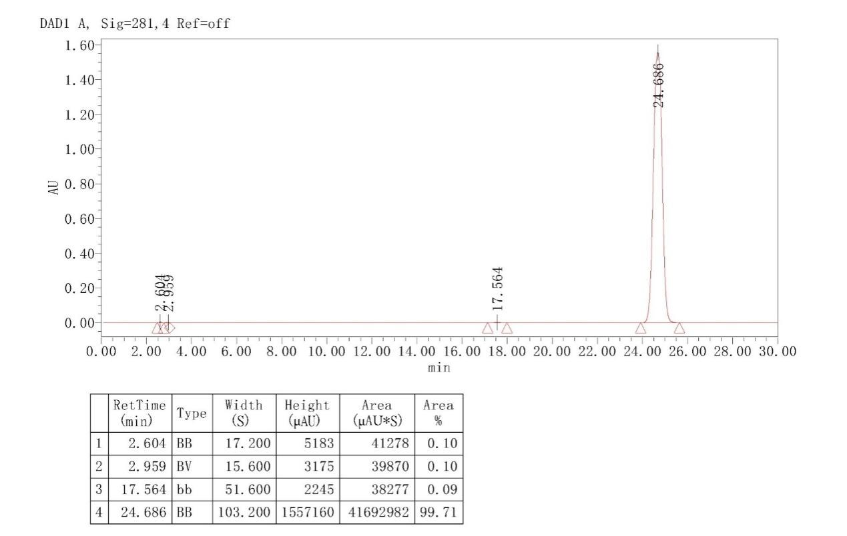

Compand c17 (98.93%)
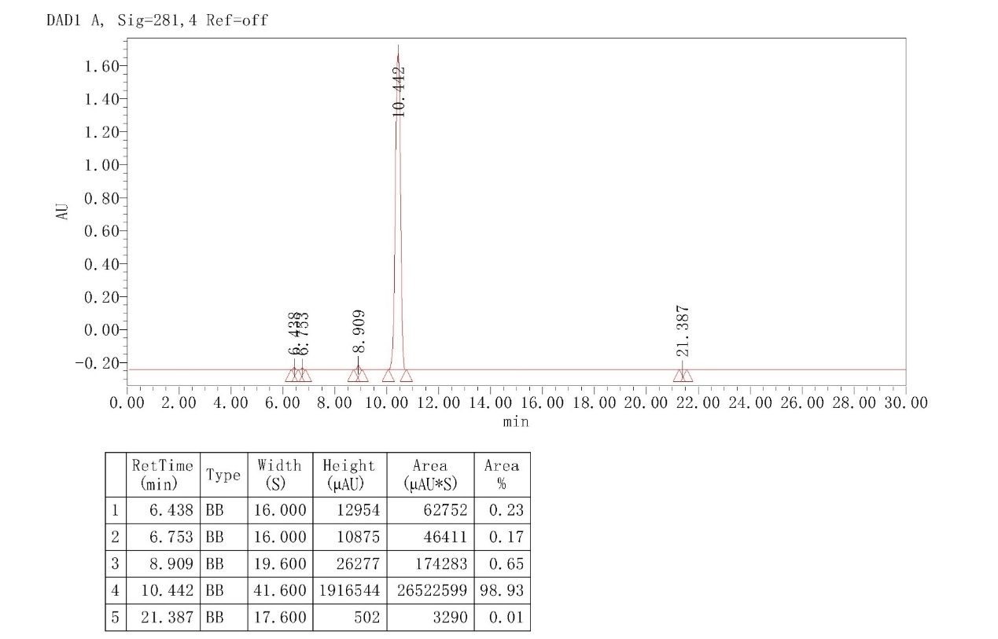

Compand c18 (95.69%)
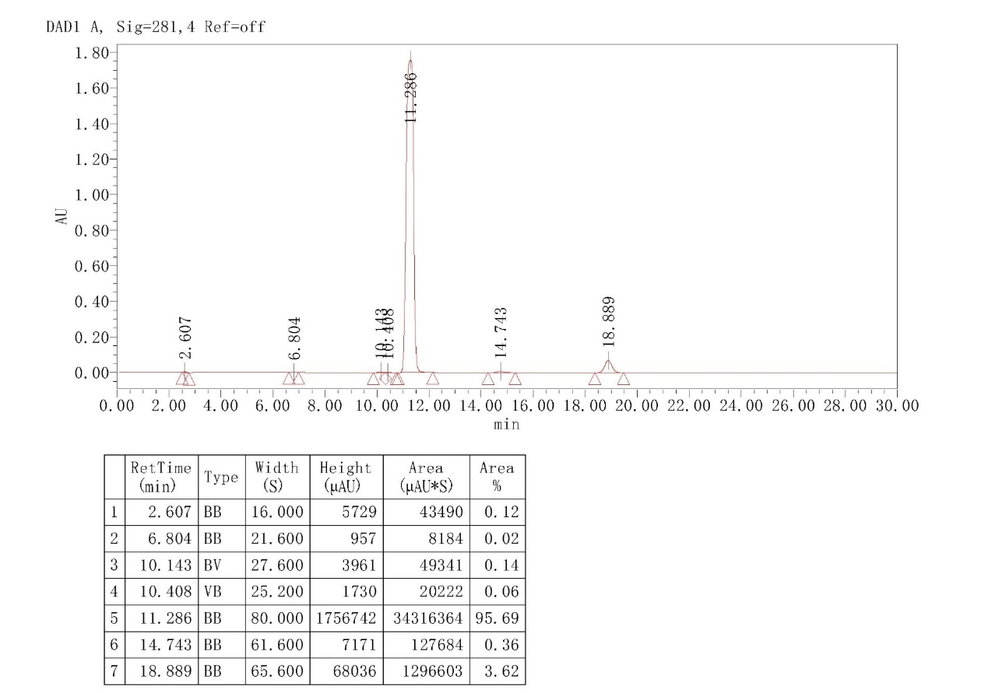

Compand c19 (97.01%)
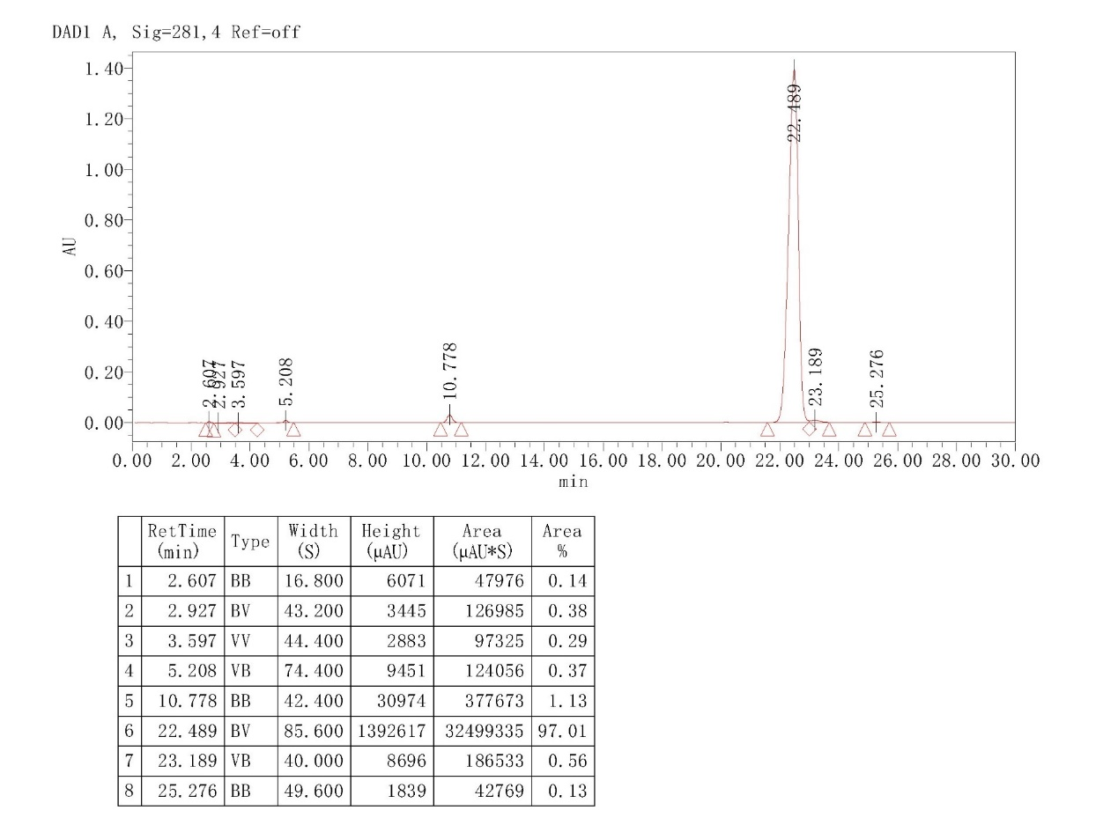

Compand c20 (97.88%)
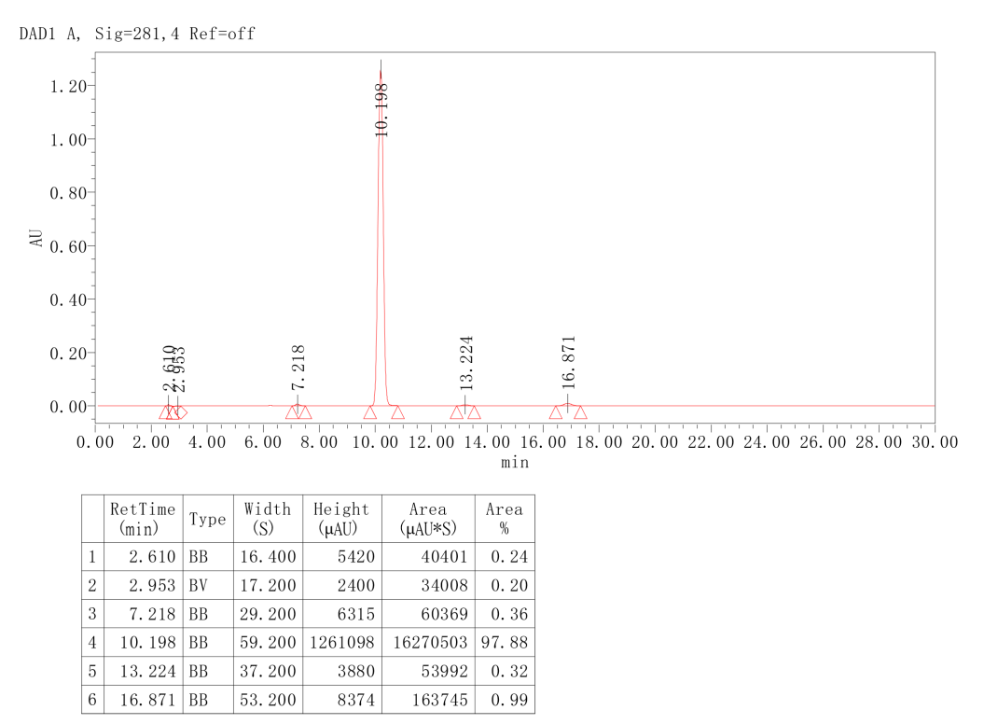

Compand c21 (97.08%)
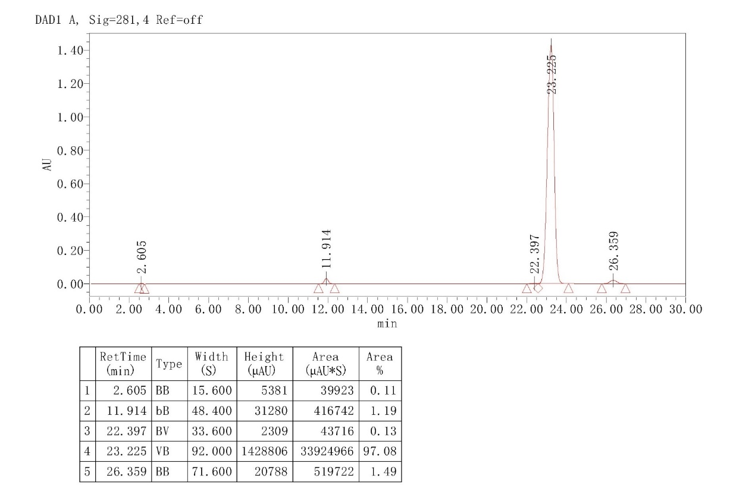
Compand c22 (98.68%)
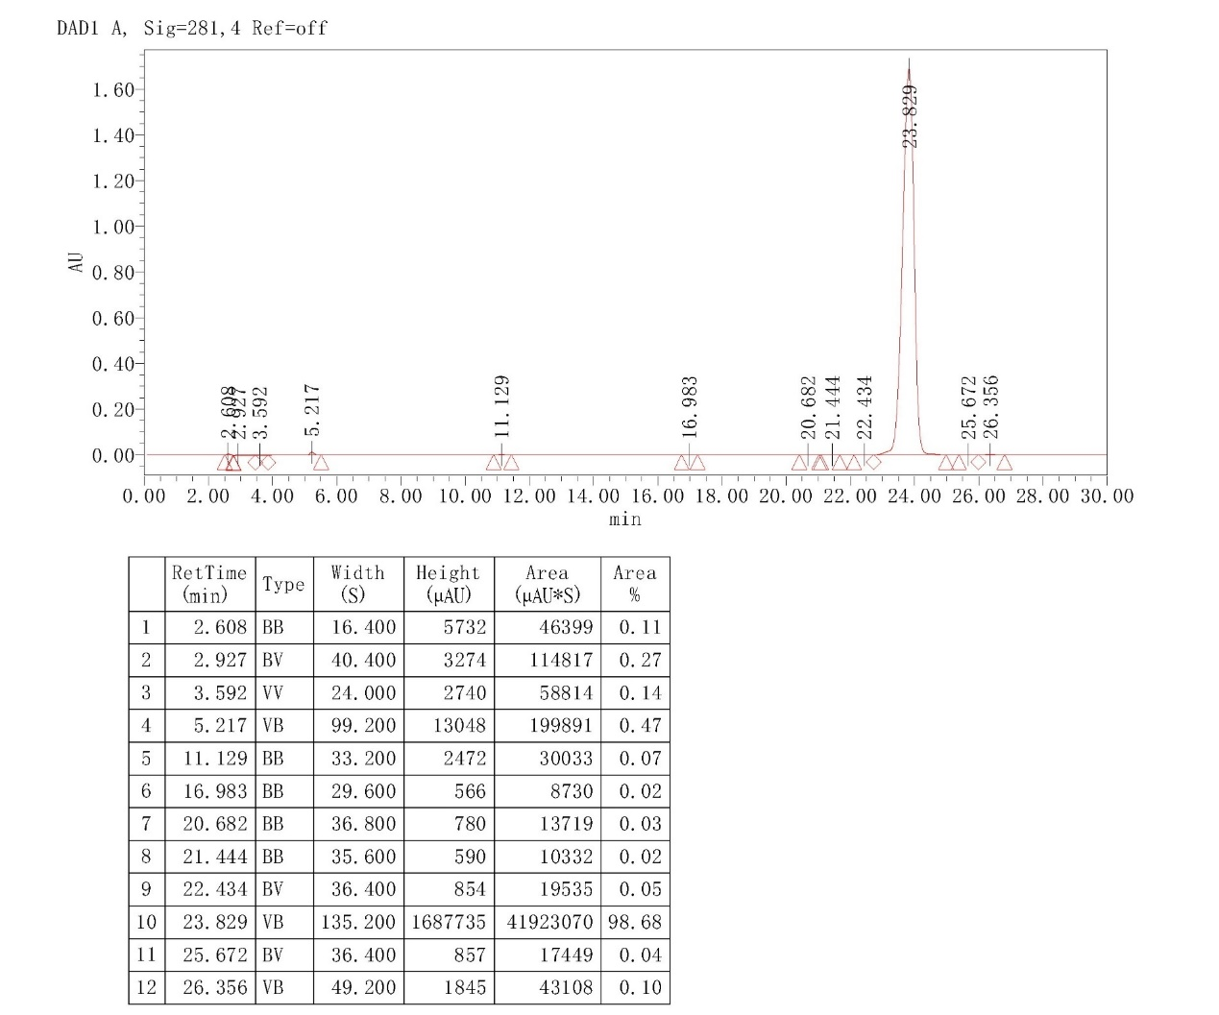

Compand c23 (95.32%)
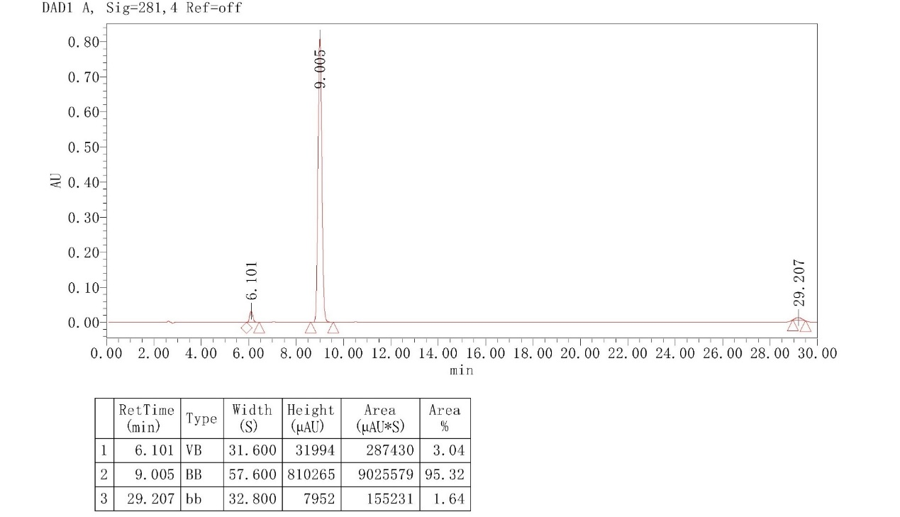

Compand c24 (98.82%)
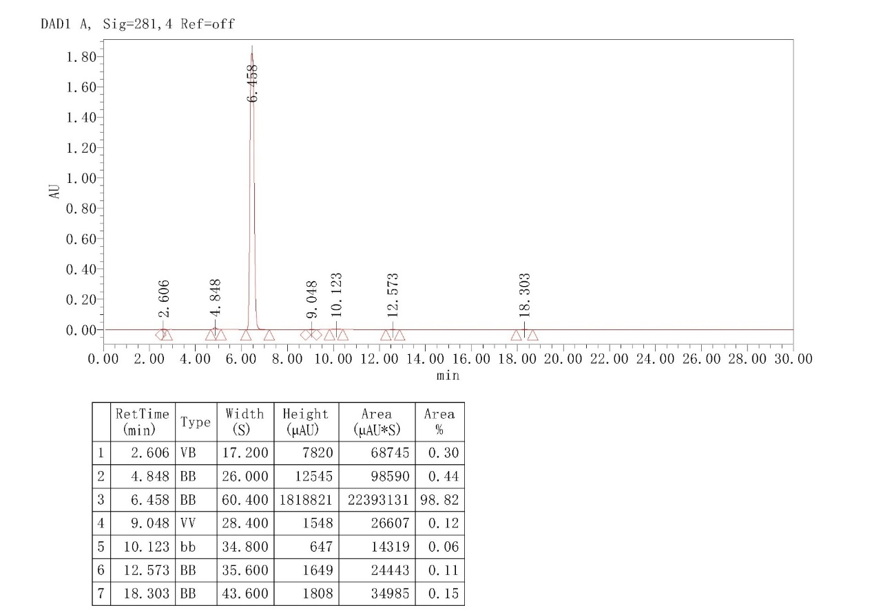

Compand c25 (98.12%)
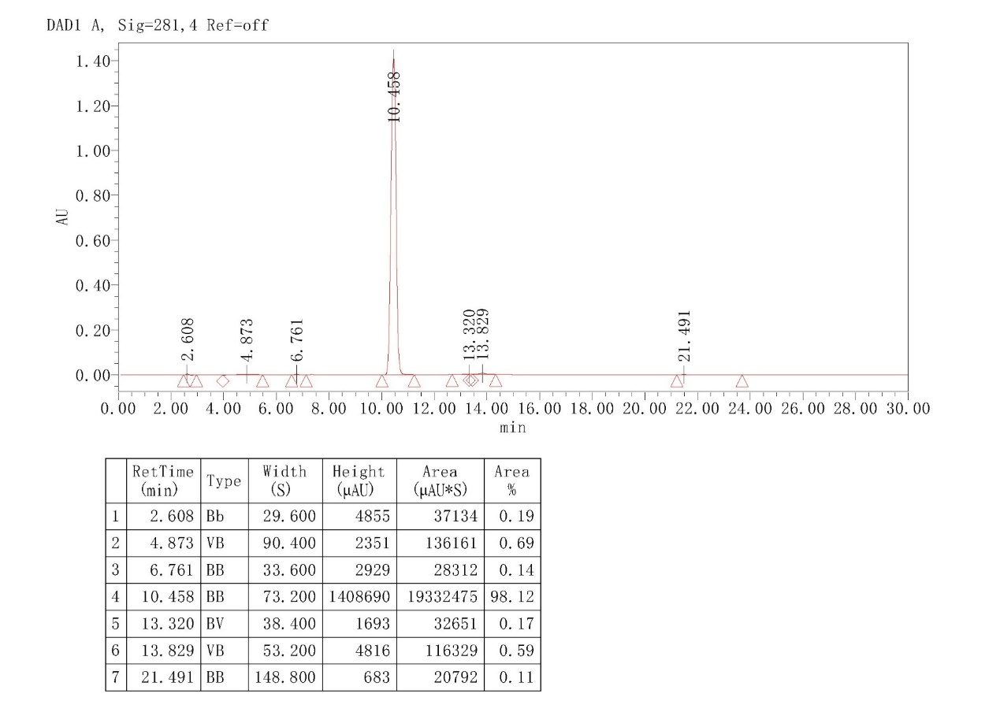

Compand c26 (97.43%)
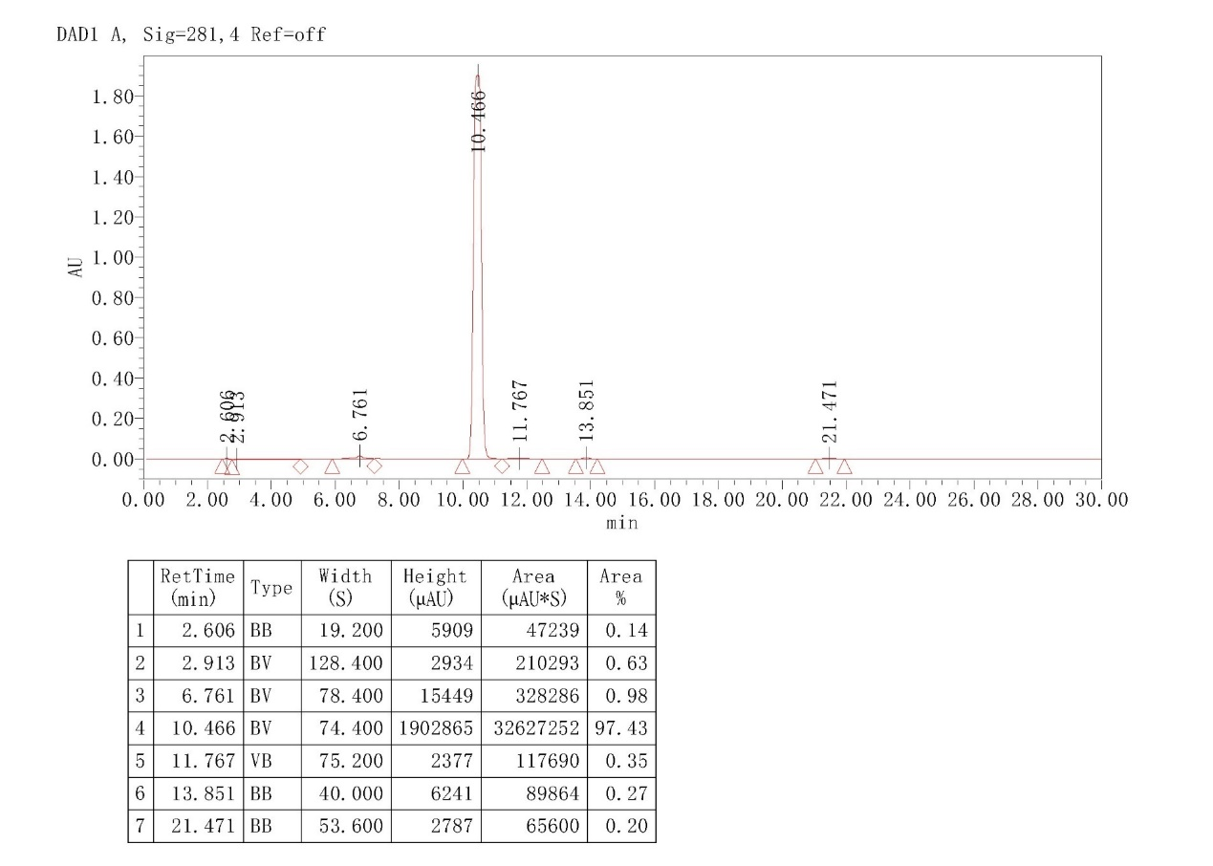

Compand c27 (95.87%)
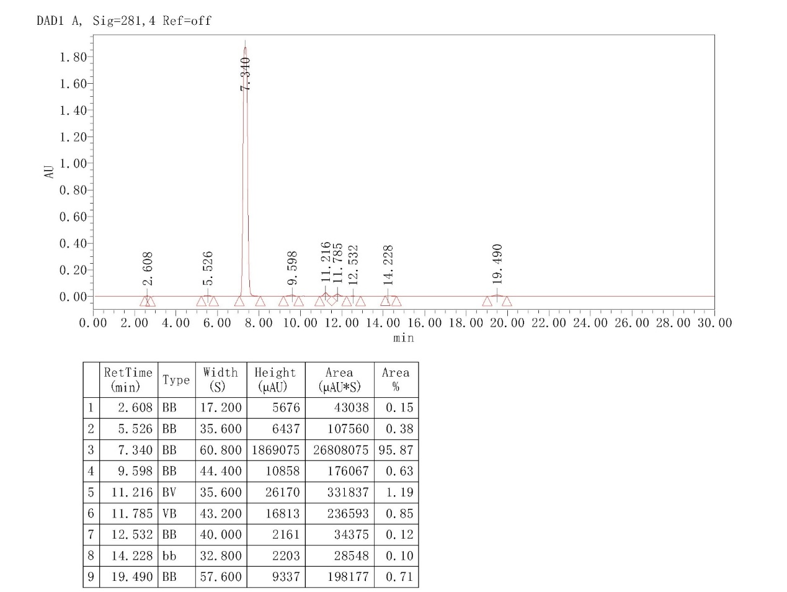
Compand c28 (98.89%)
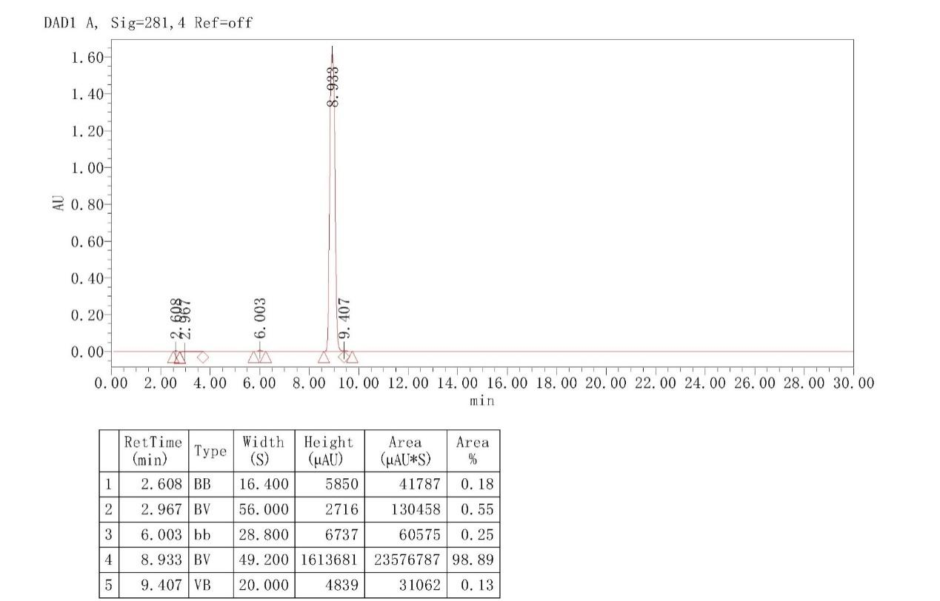

Compand c29 (95.20%)
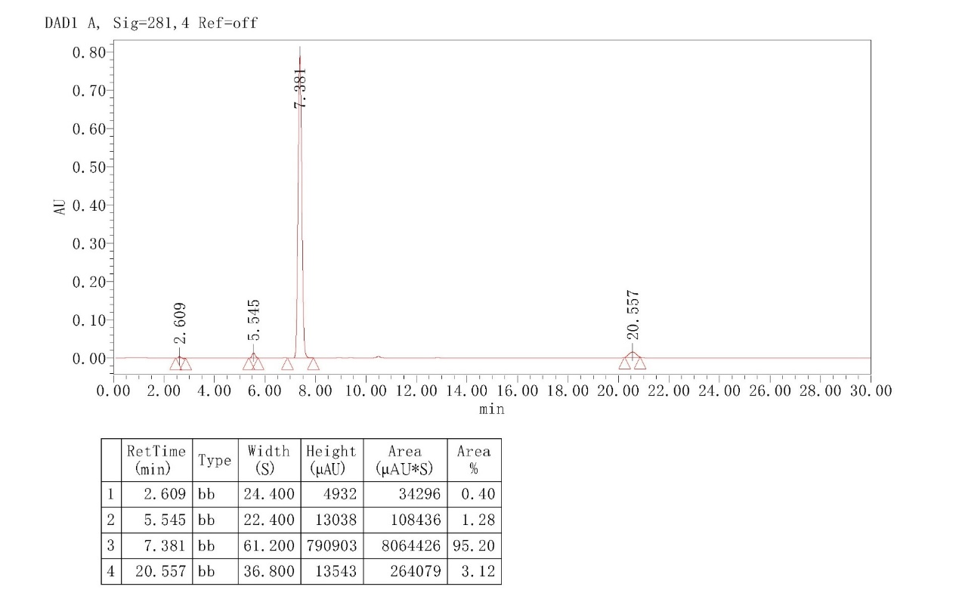
Compand c30 (97.40%)
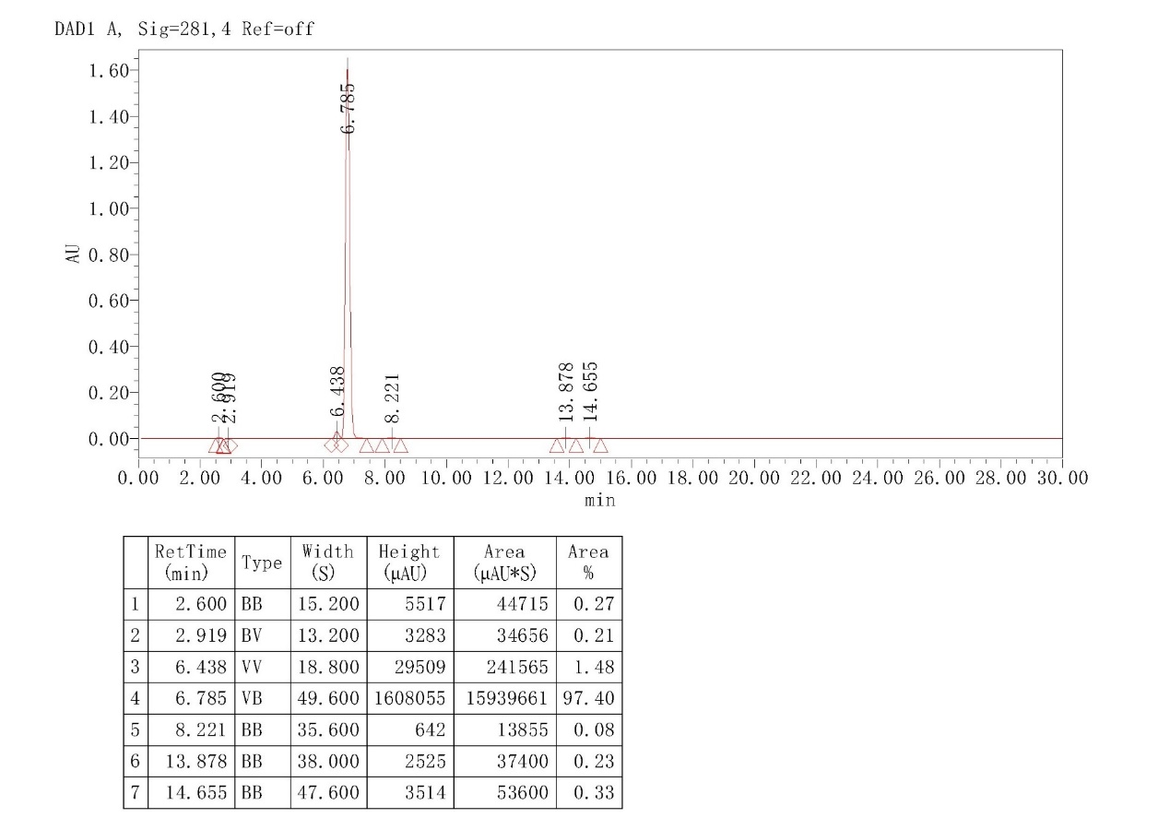

Compand c31 (97.99%)
