Supplementary Information

DNA breathing initiated strand displacement circuits for mimicking ant foraging with nanopore readout

Jinbo Zhu, Jinglin Kong, Ulrich F. Keyser* and Erkang Wang*

S1 Experiment details and data analysis
S1.1 Materials
DNA oligonucleotides were synthesized by Integrated DNA Technologies, Inc. (IDT). M13mp18 ssDNA was purchased from Guild BioSciences, Inc. BamHI-HF and EcoRI-HF were purchased from New England Biolabs. Other chemicals were of reagent grade and were used without further purification.

S1.2 Preparation of DNA flower (7-way junction)
Four DNA flowers (7-way junctions, 7WJa, 7WJb, 7WJc and 7WJd) were prepared separately for the four carriers. Taking 7WJa as an example, 4 μM DNA strand J1, J2, J3 and J4a were mixed together in TM buffer (10 mM Tris-HCl, 10 mM MgCl₂, pH 8.0) and heated at 90 ℃ for 5 min, then cooled down to 65 ℃ for 15 min, 45 ℃ for 15 min, 37 ℃ for 20 min, 25 ℃ for 20 min and finally 4 ℃ for 20 min. Strand J4a was substituted by J4b, J4c and J4d to prepared 7WJb, 7WJc and 7WJd, respectively.

S1.3 Synthesis of DNA carriers
The carrier synthesis follows our previous study.^{[1]} The carrier consists of one linear M13 scaffold and 190 short DNA staples. The 7228 nt DNA scaffold was linearized from M13mp18 ssDNA using the published protocol.^{[1]} Sequences of the 190 DNA staples can be found in our previous work.^{[1]} As shown in Figure S4, to construct the structures for barcodes on the carrier, staples 26-32, 40-46, 54-60, 68-74 and 82-88 were logically substituted by the relevant dumbbell sequences (Table S1) according to the barcode of the carrier. Staple 142 at the sensing site was substituted by RA, RB, RC or RD for carrier A, B, C or D, respectively. The staples need to be accurately mixed before preparation of the DNA carrier, and then the linear M13 scaffold was added into the solution (20 nM M13 scaffold, 60 nM staples, 120 nM dumbbell strands and 120 nM RX, X=A, B, C or D). The mixture was heated to 70°C followed by a linear cooling ramp to 25°C over 50 minutes. 1 μL of 4 μM DNA flower was added into the 40 μL DNA carrier solution (7WJa for carrier A, 7WJb for carrier B, 7WJc for carrier C and 7WJd for carrier D) and incubated at room temperature for 2 h. Finally, the resulting solution was diluted with a washing buffer (10 mM Tris-HCl, 0.5 MgCl₂, pH 8.0) to 500 μL and centrifuged with an Amicon Ultra 100kDa filter to remove the excess DNA strands and 7WJ at 6000 g for 10 mins (repeated 3 times). About 35 μL of DNA carrier solution was obtained and quantified with NanoDrop 2000 spectrophotometer.

S1.4 Strand displacement on DNA carrier
Carrier A, B, C and D were mixed and diluted by TM buffer to 1 nM for each carrier (4 nM for total carrier concentration). For the detection of strand Oa4 in Figure 3c, 10 nM Oa4 was added into the carrier mixture solution (4 nM for total carrier concentration) and incubated at room temperature for 20 min. The same volume of 8 M LiCl was added after incubation and the sample was diluted by 4 M LiCl (in 1 × TE, pH 9.0) to 0.5 nM (total carrier concentration) for nanopore measurements.

To detect the outputs of DNA circuits by nanopore sensing, DNA complexes of the 4 circuits were premixed in TM buffer solution at concentrations of 100 nM for Gate 3 and 4, 120 nM for Gate 1 and 2, and 500 nM for strand Ant. It was incubated at room temperature for 3 hours, then 1 μL of the resulting solution was mixed with 4 μL of the carrier mixture (5 nM for total carrier concentration) to react for 20 min. 5 μL of 8 M LiCl was added after incubation and subsequently diluted by 30 μL of 4 M LiCl (in 1 × TE, pH 9.0) for nanopore measurement.

S1.5 Native polyacrylamide gel electrophoresis (PAGE)
DNA complexes for each section of the ACSD circuit were separately annealed and then mixed to react for 3 hours at room temperature before gel analysis. 10 μL of DNA sample was mixed with 2 μL of 6 × loading buffer, and then analyzed by 15% native PAGE. Concentrations of DNA strands were 1 μM for I, O4, I∙W1, W3∙O3 and W4∙O4∙O5, and 1.2 μM for W1∙O1 and W2∙O2. 2 μM strand I was added into the mixture of lane 9 to trigger the reaction. Low molecular weight DNA ladder was mixed with 6 × loading buffer and added into the first lane. The electrophoresis was conducted in 1 × TBE buffer (pH 8.0) with 10 mM MgCl₂ at a constant voltage of 110V (10 V/cm) for 1.5 hour. The gel was stained by GelRed for 15 min before visualization on a UV transilluminator.

S1.6 Displacement efficiency (DE) comparison
We proposed DE to compare the fluorescence signal changes in ACSD and TMSD caused by initiator I and its mutant strands M1-M5. It is calculated by the following equation:
$${DE}_{X}=\frac{I_{X}-I_{B}}{I_{I}-I_{B}}$$
where DE_{X} is the displacement efficiency of strand X (X= I, M1, M2, M3, M4 or M5), I_{X} is the fluorescence intensity of the circuit triggered by strand X, I_{B} is the fluorescence intensity of the circuit without any initiator, and $I_{I}$is the fluorescence intensity of the circuit triggered by strand I.

S1.7 Nanopore data analysis
We use home-made LabVIEW algorithms to collect and analyze the nanopore data, which were introduced in detail in our previous work.^{[1-3]} The workflow can be divided into three main steps and they are briefly described as below.

Step 1: Event filter and search
The raw current data collected from the amplifier was firstly filtered by the home-made LabVIEW programs to remove the noise. Thresholds for minimum single standard deviation, current change and duration of translocation were set to conduct the first-round event search. Then event charge deficit (ECD) and nanopore dsDNA level were determined and used to exclude any fragments.

Step 2: Remove folded events
We applied two more strict filter limits to remove the folded events, which are large current drops (> I_{event} + 0.02 nA) at the beginning (first 5% of the translocation, folding at the entry) and deep current drops with less than 50% current points lying between I_{event} ± 0.05 nA (folding in the middle). This algorithm was introduced in detail in our former work.^{[2]} After that only the unfolded events with clear peaks were left.

Step 3: Barcode determination and occupied fraction calculation
Finally, we used a peak detection program to find the peaks in the unfolded events, readout the barcodes to classify them and calculate the occupied fraction at the sensing site. Threshold of 0.2 (ΔI/I_{event}, Figure S5) was used to find the peaks of dumbbells and DNA flowers.

S2 Figures
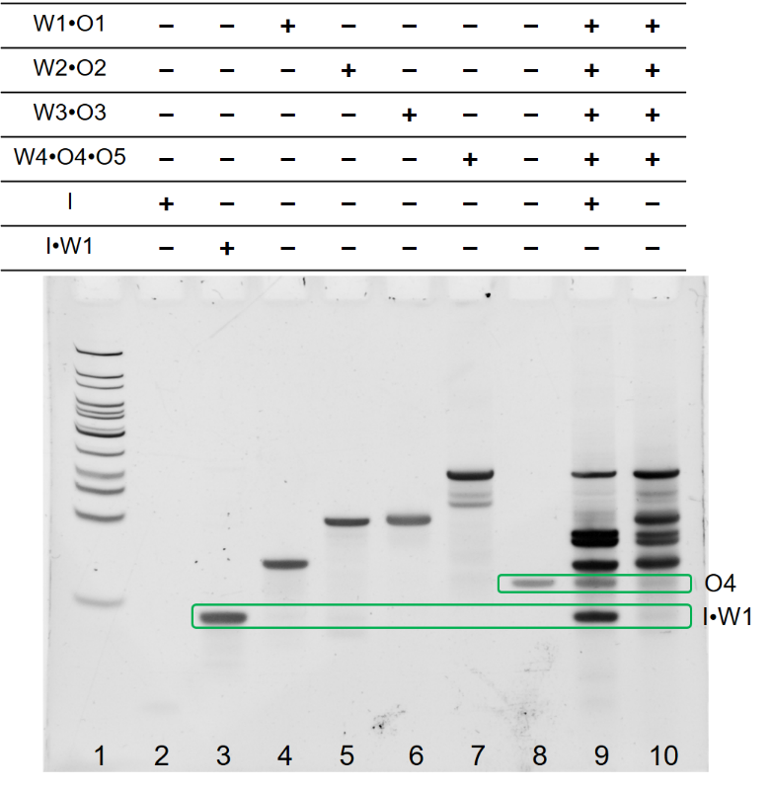
Figure S1. PAGE result of the ACSD circuit. DNA ladder is added in lane 1 and strand O4 is added in lane 8 as a reference. The DNA strands added in each lane are given in the table above the gel.

Figure S2. Scheme of the detection of target strand I and its mutants using the toehold-mediated strand displacement reaction (TMSD). Single base substitution is designed in the mutant strands M1-M5 at specific position. 25 nM target or mutant strand was mixed with 25 nM Ft∙Qt complex in TM buffer at the beginning of the kinetics measurement. The sample was excited at 535 nm and the emission intensity was recorded at 556 nm.

Figure S3. Scheme of the strand Linker controlled ACSD circuit and its fluorescent kinetics result. Strand Linker was prehybridized with W2p1, W2p2 and O2 in TM buffer (2 μM for all strands) to form the designed 4-way junction structure for Gate 2. The groups ‘Blank’ and ‘Initiator added’ are the same date as shown in Figure 1e. Strand Initiator was both added in the groups ‘No Linker’ and ‘Linker added’, but strand Linker is absent in ‘No Linker’. When strand Linker is absent, strand O1 released from Gate 1 can hybridize with W2p1 but not W2p2,^{[4]} hence strand O1 fails to displace O2 from Gate 2.

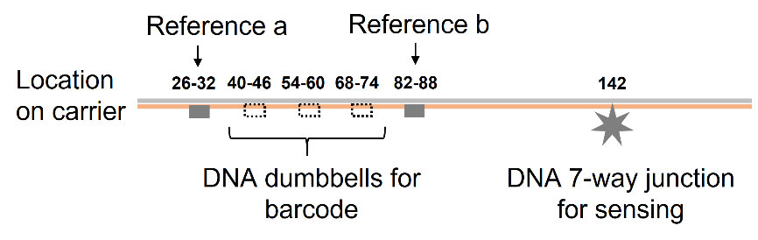
Figure S4. Design of carrier A-D for DNA output detection. There are 190 short staple strands (38 nt for each) hybridized with the linear M13 scaffold. The numbers above the DNA nanostructures indicate its location on the carrier.

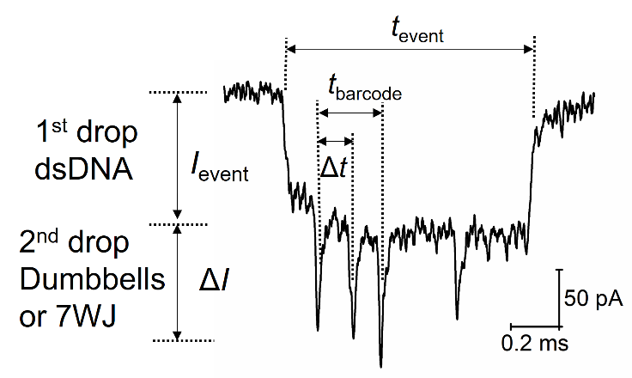

Figure S5. Analysis of a translocation event from the carrier B as an example. I_{event} is the first level current drop caused by the DNA carrier. ΔI is the second level current drop caused by DNA nanostructures on the carrier. Barcode can be determined by the relative presence time (Δt/t_{barcode}) of the downward peak between the two references. The single downward peak caused by DNA flower at the other side is used to detect the DNA target. Direction of the event can be easily judged by the asymmetric distribution of these two groups of secondary current drops.

Figure S6. First ten unfolded translocation events of each carrier before (a) and after (b) the addition of strand Oa4.

Figure S7. Fluorescence kinetics measurements of the 4 parallel paths selection system for (a) path A and (b) path B under different conditions. The same DNA complexes were used as Figure 3d except the reporters. Nanopore reporter Rep C and D were absent, and Rep A and B were replaced by fluorescent reporters used in Figure 2d. Concentrations of the DNA complexes were 75 nM for reporter, 50 nM for Gate 3 and 4, 60 nM for Gate1 and 2. 250 nM strand Ant was added to initiate the reaction.

S3 Tables

Table S1. Sequences of DNA strands used in this work.
Type | Strand Name | Sequence
Reporter | F (Fa) | HEX- TGAGGATGTGTAGGTTGAGG AGTGATG
Reporter | Q (Qa) | CCTCAACCTACACATCCTCA-IBFQ
 | Ft | HEX-TGGATGATGATG AGTGAG
 | Qt | CATCATCATCCA-IBFQ
 | Fb | FAM - CGAGTGCTGTATGAGAGGTG AGTGATG
 | Qb | CACCTCTCATACAGCACTCG – IBFQ
 | RA | GATGGTTTAATTTCAACTTTAATCATTGTGAATTACCT TT TGAGGATGTGTAGGTTGAGG AGTGATG
 | RB | GATGGTTTAATTTCAACTTTAATCATTGTGAATTACCT TT CGAGTGCTGTATGAGAGGTG AGTGATG
 | RC | GATGGTTTAATTTCAACTTTAATCATTGTGAATTACCT TT TGAGAGATTGGATTGTGGTG AGTGATG
 | RD | GATGGTTTAATTTCAACTTTAATCATTGTGAATTACCT TT AGAGAGTAGGTAGGTGAAGG AGTGATG
Initiator | I1 | CTCACT CATCATCATCCA
 | M1 | CTAACT CATCATCATCCA
 | M2 | CTCACT AATCATCATCCA
 | M3 | CTCACT CATAATCATCCA
 | M4 | CTCACT CATCATAATCCA
 | M5 | CTCACT CATCATCAACCA
ACSD circuit (Path A) | O1 (Oa1) | ACCAACTACATC CTCACT CATCATCATCCA
ACSD circuit (Path A) | O1s (Oa1s) | TCC ACCAACTACATC CTCACT CATCATCATCCA
ACSD circuit (Path A) | W1 (Wa1) | GAAGAG TGGATGATGATG AGTGAG
ACSD circuit (Path A) | O2 (Oa2) | TACATTCACCAG TCAGCATCACTC CTATCC ACCAACTACATC
 | W2 (Wa2) | AGTGAG GATGTAGTTGGT GGATAG
 | W2s (Wa2s) | GAG GATGTAGTTGGT GGATAG
 | W2p1 | AGTGAG GATGTA TAAGAGACGAAG
 | W2p2 | GGCTATTGGAGA GTTGGT GGATAG
 | Linker | CTTCGTCTCTTA TCTCCAATAGCC
 | O3 (Oa3) | CATCTACATTCACCAG GTCTTTAC TCAGCATCACTC
 | W3 (Wa3) | GGATAG GAGTGATGCTGA CTGGTGAATGTA
 | O4 (Oa4) | GTCTTTACTCAG CATCACTC CTCAACCT ACACATCC
 | O5 (Oa5) | CATCATCATCCA CTCTTC CATCTACATTCA
 | O5s | CTCTTC CATCTACATTCA
 | W4 (Wa4) | GAGTGATG CTGAGTAAAGAC CTGG TGAATGTAGATG GAAGAG
Path B | Ob1 | TTCAGATACATC CTCACT CATCATCATCCA
 | Wb1 | GTGTAG TGGATGATGATG AGTGAG
 | Ob2 | CATTACTCTCCCTCAG CATCACTC GTTACC TTCAGATACATC
 | Wb2 | AGTGAG GATGTATCTGAA GGTAAC
 | Ob3 | CAACCATTACTCTCCC GTCTTTAC TCAGCATCACTC
 | Wb3 | GGTAAC GAGTGATGCTGA GGGAGAGTAATG
 | Ob4 | GTCTTTACTCAG CATCACTC ACCTCTCA TACAGCAC
 | Ob5 | CATCATCATCCA CTACAC CAACCATTACTC
 | W4 | GAGTGATG CTGAGTAAAGAC GGGA GAGTAATGGTTG GTGTAG
Path C | Oc1 | CTCTACTCAACT CTCACT CATCATCATCCA
 | Wc1 | GAGTTG TGGATGATGATG AGTGAG
 | Oc2 | TCCACATC CTCG CTTC CATCACTC CACTCT CTCTACTCAACT
 | Wc2 | AGTGAG AGTTGAGTAGAG AGAGTG
 | Oc3 | ACAATCCACATC CTCG TCTCTCAT CTTC CATCACTC
 | Wc3 | AGAGTG GAGTGATG GAAG CGAG GATGTGGA
 | Oc4 | TCTCTCATCTTC CATCACTC ACCACAAT CCAATCTC
 | Oc5 | CATCATCATCCA CAACTC ACAATCCACATC
 | Oc5s | CAACTC ACAATCCACATC
 | Wc4 | GAGTGATG GAAGATGAGAGA CGAG GATGTGGATTGT GAGTTG
Path D | Od1 | CAATCACCTTCA CTCACT CATCATCATCCA
 | Wd1 | AGTGAG TGGATGATGATG AGTGAG
 | Od2 | ACTATCAC ACCG TCAGCATCACTC CTTCAC CAATCACCTTCA
 | Wd2 | AGTGAG TGAAGGTGATTG GTGAAG
 | Od3 | TCCT ACTATCAC ACCG GTCTTTAC TCAG CATCACTC
 | Wd3 | GTGAAG GAGTGATGCTGA CGGT GTGATAGT
 | Od4 | GTCTTTACTCAG CATCACTC CTTCACCT ACCTACTC
 | Od5 | CATCATCATCCA CTCACT TCCTACTATCAC
 | Wd4 | GAGTGATG CTGAGTAAAGAC CGGT GTGATAGTAGGA AGTGAG
DNA flower | J1 | GGATCAGAGCTGGACG ACAATGACGTAGGTCC TTTT GGACCTACGTCATTGT ACTATGGCACACATCC
 | J2 | GCAAGACTCGTGCTCA CCGAATGCCACCACGC TTTT GCGTGGTGGCATTCGG CGTCCAGCTCTGATCC
 | J3 | GGTTCAGCCGCAATCC TCGCCTGCACTCTACC TTTT GGTAGAGTGCAGGCGA TGAGCACGAGTCTTGC
 | J4a | GGATGTGTGCCATAGT GGATTGCGGCTGAACC TT CCTCAACCTACACATCCTCA
 | J4b | GGATGTGTGCCATAGT GGATTGCGGCTGAACC TT CACCTCTCATACAGCACTCG
 | J4c | GGATGTGTGCCATAGT GGATTGCGGCTGAACC TT CACTCCTACTCCAACTCACT
 | J4d | GGATGTGTGCCATAGT GGATTGCGGCTGAACC TT CCTTCACCTACCTACTCTCT
Dumbbells for barcodes | Staple 26-32 Substitutes
Dumbbells for barcodes | CTGAAAGCGTAAGAATACGTGGCACAGACAATATTTTTGAATGGCT
Dumbbells for barcodes | ACATCACTTGTCCTCTTTTGAGGAACAAGTTTTCTTGTCCTGAGTAGA
Dumbbells for barcodes | AGAACTCAAATCCTCTTTTGAGGAACAAGTTTTCTTGTCTATCGGCCT
 | TGCTGGTAATTCCTCTTTTGAGGAACAAGTTTTCTTGTATCCAGAACA
 | ATATTACCGCTCCTCTTTTGAGGAACAAGTTTTCTTGTCAGCCATTGC
 | AACAGGAAAATCCTCTTTTGAGGAACAAGTTTTCTTGTACGCTCATGG
 | AAATACCTACTCCTCTTTTGAGGAACAAGTTTTCTTGTATTTTGACGC
 | TCAATCGTCTTCCTCTTTTGAGGAACAAGTTTTCTTGTGAAATGGATT
 | ATTTACATTGTCCTCTTTTGAGGAACAAGTTTTCTTGTGCAGATTCAC
 | CAGTCACACGTCCTCTTTTGAGGAACAAGTTTTCTTGTACCAGTAATA
 | AAAGGGACATTCCTCTTTTGAGGAACAAGTTTTCTTGTTCTGGCCAAC
 | AGAGATAGAATCCTCTTTTGAGGAACAAGTTTTCTTGTCCCTTCTGAC
 | Staple 40-46 Substitutes
 | AATATAATCCTGATTGTTTGGATTATACTTCTGAATAATGGAAGGG
 | CACTAACAACTCCTCTTTTGAGGAACAAGTTTTCTTGTTAATAGATTA
 | GAGCCGTCAATCCTCTTTTGAGGAACAAGTTTTCTTGTTAGATAATAC
 | ATTTGAGGATTCCTCTTTTGAGGAACAAGTTTTCTTGTTTAGAAGTAT
 | TAGACTTTACTCCTCTTTTGAGGAACAAGTTTTCTTGTAAACAATTCG
 | ACAACTCGTATCCTCTTTTGAGGAACAAGTTTTCTTGTTTAAATCCTT
 | TGCCCGAACGTCCTCTTTTGAGGAACAAGTTTTCTTGTTTATTAATTT
 | TAAAAGTTTGTCCTCTTTTGAGGAACAAGTTTTCTTGTAGTAACATTA
 | TCATTTTGCGTCCTCTTTTGAGGAACAAGTTTTCTTGTGAACAAAGAA
 | ACCACCAGAATCCTCTTTTGAGGAACAAGTTTTCTTGTGGAGCGGAAT
 | TATCATCATATCCTCTTTTGAGGAACAAGTTTTCTTGTTTCCTGATTA
 | TCAGATGATGTCCTCTTTTGAGGAACAAGTTTTCTTGTGCAATTCATC
 | Staple 54-60 Substitutes
 | TGTAAATGCTGATGCAAATCCAATCGCAAGACAAAGAACGCGAGAA
 | TACCTTTTTTTCCTCTTTTGAGGAACAAGTTTTCTTGTAATGGAAACA
 | GTACATAAATTCCTCTTTTGAGGAACAAGTTTTCTTGTCAATATATGT
 | GAGTGAATAATCCTCTTTTGAGGAACAAGTTTTCTTGTCCTTGCTTCT
 | GTAAATCGTCTCCTCTTTTGAGGAACAAGTTTTCTTGTGCTATTAATT
 | AATTTTCCCTTCCTCTTTTGAGGAACAAGTTTTCTTGTTAGAATCCTT
 | GAAAACATAGTCCTCTTTTGAGGAACAAGTTTTCTTGTCGATAGCTTA
 | GATTAAGACGTCCTCTTTTGAGGAACAAGTTTTCTTGTCTGAGAAGAG
 | TCAATAGTGATCCTCTTTTGAGGAACAAGTTTTCTTGTATTTATCAAA
 | ATCATAGGTCTCCTCTTTTGAGGAACAAGTTTTCTTGTTGAGAGACTA
 | CCTTTTTAACTCCTCTTTTGAGGAACAAGTTTTCTTGTCTCCGGCTTA
 | GGTTGGGTTATCCTCTTTTGAGGAACAAGTTTTCTTGTTATAACTATA
 | Staple 68-74 Substitutes
 | TCATCGAGAACAAGCAAGCCGTTTTTATTTTCATCGTAGGAATCAT
 | AGAATATAAATCCTCTTTTGAGGAACAAGTTTTCTTGTGTACCGACAA
 | AAGGTAAAGTTCCTCTTTTGAGGAACAAGTTTTCTTGTAATTCTGTCC
 | AGACGACGACTCCTCTTTTGAGGAACAAGTTTTCTTGTAATAAACAAC
 | ATGTTCAGCTTCCTCTTTTGAGGAACAAGTTTTCTTGTAATGCAGAAC
 | GCGCCTGTTTTCCTCTTTTGAGGAACAAGTTTTCTTGTATCAACAATA
 | GATAAGTCCTTCCTCTTTTGAGGAACAAGTTTTCTTGTGAACAAGAAA
 | AATAATATCCTCCTCTTTTGAGGAACAAGTTTTCTTGTCATCCTAATT
 | TACGAGCATGTCCTCTTTTGAGGAACAAGTTTTCTTGTTAGAAACCAA
 | TCAATAATCGTCCTCTTTTGAGGAACAAGTTTTCTTGTGCTGTCTTTC
 | CTTATCATTCTCCTCTTTTGAGGAACAAGTTTTCTTGTCAAGAACGGG
 | TATTAAACCATCCTCTTTTGAGGAACAAGTTTTCTTGTAGTACCGCAC
 | Staple 82-88 Substitutes
 | AGATAGCCGAACAAAGTTACCAGAAGGAAACCGAGGAAACGCAATA
 | AAAAATGAAATCCTCTTTTGAGGAACAAGTTTTCTTGTATAGCAGCCT
 | TTACAGAGAGTCCTCTTTTGAGGAACAAGTTTTCTTGTAATAACATAA
 | AAACAGGGAATCCTCTTTTGAGGAACAAGTTTTCTTGTGCGCATTAGA
 | CGGGAGAATTTCCTCTTTTGAGGAACAAGTTTTCTTGTAACTGAACAC
 | CCTGAACAAATCCTCTTTTGAGGAACAAGTTTTCTTGTGTCAGAGGGT
 | AATTGAGCGCTCCTCTTTTGAGGAACAAGTTTTCTTGTTAATATCAGA
 | GAGATAACCCTCCTCTTTTGAGGAACAAGTTTTCTTGTACAAGAATTG
 | AGTTAAGCCCTCCTCTTTTGAGGAACAAGTTTTCTTGTAATAATAAGA
 | GCAAGAAACATCCTCTTTTGAGGAACAAGTTTTCTTGTATGAAATAGC
 | AATAGCTATCTCCTCTTTTGAGGAACAAGTTTTCTTGTTTACCGAAGC
 | CCTTTTTAAGTCCTCTTTTGAGGAACAAGTTTTCTTGTAAAAGTAAGC

Table S2. Statistic of translocation events of carrier A-D under different conditions.
Samples | I_{event} (nA)^{[b]} | OF of carrier A | OF of carrier B | OF of carrier C | OF of carrier D
Only 4 carriers | 0.140 | 66/76=86.8% | 47/52=90.4% | 49/55=89.1% | 62/74=83.8%
4 carriers + Oa4 | 0.123 | 45/121=37.2% | 64/95=67.4% | 72/96=75.0% | 72/109=66.1%
No Ant^{[a]}  (4 carriers + circuits) | 0.127 | 110/157=70.1% | 77/112=68.8% | 79/107=73.8% | 98/147=66.7%
No Ant^{[a]}  (4 carriers + circuits) | 0.148 | 61/84=72.6% | 49/64=76.6% | 36/43=83.7% | 50/61=82.0%
No Ant^{[a]}  (4 carriers + circuits) | 0.122 | 57/74=77.0% | 31/43=72.1% | 34/55=61.8% | 54/73=74.0%
Only Path A activated^{[a]} | 0.111 | 57/146=39.0% | 93/137=67.9% | 99/151=65.6% | 115/194=59.3%
Only Path A activated^{[a]} | 0.124 | 19/59=32.2% | 23/34=67.6% | 24/46=52.2% | 41/64=64.1%
Only Path A activated^{[a]} | 0.106 | 32/81=39.5% | 34/48=70.8% | 31/54=57.4% | 54/83=65.1%
Path A and D activated^{[a]} | 0.125 | 33/93=35.5% | 55/97=56.7% | 57/98=58.2% | 46/138=33.3%
Path A and D activated^{[a]} | 0.152 | 20/69=29.0% | 42/70=60.0% | 39/74=52.7% | 39/126=31.0%
Path A and D activated^{[a]} | 0.125 | 55/136=40.4% | 79/108=73.1% | 39/61=63.9% | 22/66=33.3%
All paths activated^{[a]} | 0.131 | 18/108=16.7% | 18/70=25.7% | 26/84=31.0% | 36/135=26.7%
All paths activated^{[a]} | 0.141 | 23/101=22.8% | 16/72=22.2% | 35/106=33.0% | 19/72=26.4%
All paths activated^{[a]} | 0.133 | 22/90=24.4% | 22/72=30.6% | 32/110=29.1% | 33/115=28.7%
^{[a]} The same sample was measured by three different nanopores and the average data was given in Figure S3d.
^{[b]} I_{event} was determined by the nanopore size.

Reference
[1] N. A. W. Bell, U. F. Keyser, Nat. Nanotech. 2016, 11, 645.
[2] K. Chen, M. Juhasz, F. Gularek, E. Weinhold, Y. Tian, U. F. Keyser, N. A. W. Bell, Nano Letters 2017, 17, 5199-5205.
[3] J. Zhu, N. Ermann, K. Chen, U. F. Keyser, Small 2021, 17, 2100711.
[4] J. Zhu, L. Zhang, S. Dong, E. Wang, ACS Nano 2013, 7, 10211.

